Nimesh Neupane

23090879

Lab 3

Section A:

Section B:

Section C:

Section D:

I created model and DAO classes for each of my database tables:

* Admin.java and AdminDAO.java
* Employee.java and EmployeeDAO.java
* LoginDAO.java

These classes are used for mapping database records to Java objects and performing CRUD operations using JDBC.

These files are provided in the Github link attached.

Section E:

Section F:

In this section, I configured the MySQL JDBC driver to enable database connectivity in my JavaFX application.  
The JDBC JAR file allows my program to connect to and interact with the MySQL database using Java.

Section G:

In this section, I created Java classes that map directly to the database tables using Object-Oriented Programming. These classes, called models and DAO (Data Access Object) classes, simplify the interaction between the JavaFX application and the MySQL database. I have created AdminDAO.java, EmployeeDAO.java and Login DAO.java. These model classes have fields, constructors, getters, and setters that correspond to table columns.

These files are provided in the Github link attached.

Section H:

I created a Login page in JavaFX that checks the user’s email and password against records in the MySQL login table.

Section I:

When I login using the correct credentials, the dashboard appears as below:

We have welcome message and date above the 4 buttons.

When I press logout, It closes the entire application as shown below:

Section J:

Original Admin record viewed along with back button:

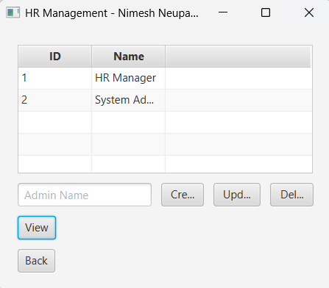

Admin record created and updated:

Admin record deleted:

Section K:

Original Employee record viewed along with back button:

Employee record created and updated:

Employee record deleted:

Section L:

In this section, I attempted to implement JUnit test cases to calculate the yearly salary of employees based on monthly salary, bonus, and deductions. I created a SalaryCalculator class with methods to compute the yearly income using base values, and a SalaryCalculatorTest class to write unit tests for different salary scenarios. While I successfully set up the classes and methods, I faced challenges in configuring the test environment and running the tests correctly in my IDE. So, I undo my original Dashboard code on the final file DashboardPage.java