

Network Programming (IE2102)
2nd Year, 2nd Semester

Assignment

Design and Implementation of a Secure Multiprocessor TCP Application Server
with Custom Protocol and Session Management

Sri Lanka Institute of Information Technology

IT24102340
Nayanajith K.M.N.S

In partial fulfillment of the requirements for the
Bachelor of Science Special Honors Degree in Information Technology

2026.04.11

TABLE OF CONTENTS

TABLE OF FIGURES II
DECLARATION IV
CHAPTER 1: INTRODUCTION 1
1.1 Background 1
1.2 Objectives 2
1.3 Report Structure 3
CHAPTER 2: SYSTEM DESIGN 4
2.1 Architecture Overview 4
2.1.1 Server Architecture 4
2.1.2 Data Storage 4
2.2 Protocol Design 5
2.2.1 Request Frame Structure 5
2.2.2 Response Frame Structure 5
2.2.3 Supported Commands 6
2.3 Security Design 6
2.3.1 Password Storage (Salted Hashing) 6
2.3.2 Session Management 7
2.3.3 Abuse Protection 7
2.3.4 Audit Logging 7
CHAPTER 3: IMPLEMENTATION 8
3.1 Server Implementation (C) 8
3.1.1 Multiprocessing (Task A2) 8
3.1.2 Custom Protocol Parsing (Task A1) 9
3.1.3 Security & Authentication (Task A3 & A4) 9
3.2 Client Implementation (Python) 10
3.3 Makefile Configuration 11
CHAPTER 4: TESTING AND VERIFICATION 12
4.1 Environmental Configuration 12
4.1.1 Hostname Configuration 12
4.1.2 Network Configuration 12
4.2 Server Functionality 12
4.2.1 Port Listening Proof (Task A1) 12
4.2.2 Successful Registration and Login (Task A3) 13
4.2.3 Failed Login and Lockout (Task A4) 13
4.3 Multiprocessing and Process Management (Task A2) 13
4.3.1 Multiple Forked Processes 13
4.3.2 Proper Child Cleanup (No Zombies) 14
4.4 Audit Logging (Task A5) 14
CHAPTER 5: CONCLUSION 15
5.1 Summary 15
5.2 Limitations 15
5.3 Future Improvements 15
ANNEXURES 16

TABLE OF FIGURES

Figure 2. 1 Login Success Token 5

Figure 3. 1 Multiprocessing 8
Figure 3. 2 Custom Protocol Parsing 9
Figure 3. 3 Security & Authentication 9
Figure 3. 4 Audit Logging 10
Figure 3. 5 Client Implementation part1 10
Figure 3. 6 Client Implementation part2 11
Figure 3. 7 Makefile 11

Figure 4. 1 Hostname Configuration 12
Figure 4. 2 Network Configuration 12
Figure 4. 3 Port Listening Proof 12
Figure 4. 4 Successful Registration and Login 13
Figure 4. 5 Failed Login 13
Figure 4. 6 Multiprocessing 13
Figure 4. 7 Proper Child Cleanup 14
Figure 4. 8 Audit Logging 14

DECLARATION

I certify that this report does not incorporate, without acknowledgement, any material previously submitted for a degree or diploma in any university, and to the best of my knowledge and belief, it does not contain any material previously published or written by another person, except where due reference is made in the text.
I understand that reports that do not contain this declaration ‘AS IS’ will not be accepted as valid reports and will be awarded 0 marks.

Name: Nayanajith K.M.N.S
Student ID: IT24102340
Date: 2026.04.09

CHAPTER 1: INTRODUCTION

Background

Network programming forms the foundation of modern distributed systems, enabling communication between computers across local and wide area networks. In contemporary computing environments, client-server architecture remains the predominant model for delivering services, from web applications to file transfer systems. The Transmission Control Protocol (TCP) provides reliable, connection-oriented communication, making it the preferred choice for applications requiring guaranteed data delivery and ordered transmission.
Security in network applications has become increasingly critical due to the rising prevalence of cyber threats, data breaches, and unauthorized access attempts. Traditional authentication mechanisms that store passwords in plain text are no longer acceptable in production environments. Modern systems must implement cryptographic hashing, session management, and abuse protection mechanisms to safeguard user credentials and prevent malicious activities such as brute-force attacks and denial-of-service attempts.
Multiprocessing in server design allows concurrent handling of multiple client connections, improving scalability and responsiveness. The Unix fork() system call enables a parent process to spawn child processes, each dedicated to serving individual clients independently. However, improper process management can lead to zombie processes that consume system resources, necessitating proper signal handling through SIGCHLD and waitpid() mechanisms.
This assignment focuses on designing and implementing a secure multiprocessor TCP application server that incorporates custom protocol framing, salted password hashing, session token management, and comprehensive audit logging. The implementation demonstrates practical application of socket programming, process control, and security principles learned in the IE2102 Network Programming module.

Objectives

The primary objectives of this assignment are as follows:
- Implement a TCP Server in C: Develop a multi-client TCP server using socket programming APIs, demonstrating proficiency in low-level network communication.
- Design a Custom Protocol: Create an explicit framing architecture using LEN:<n> headers to handle variable-length payloads, partial reads, and message boundaries reliably.
- Enable Multiprocessing: Utilize the fork() system call to handle concurrent client connections, with proper SIGCHLD signal handling to prevent zombie processes.
- Implement Secure Authentication: Store passwords using salted SHA256 hashing (never in plain text), issue session tokens upon login, and enforce token expiration after 5 minutes of inactivity.
- Provide Abuse Protection: Implement rate limiting per client IP, brute-force login lockout after 5 failed attempts, username validation, and payload overflow rejection (>4096 bytes).
- Maintain Audit Logs: Record all server activities including timestamps, client IP:port, child PID, username, commands, and results in server_IT24102340.log.
- Develop a Python Client: Create a compatible client application that communicates using the custom protocol and demonstrates all supported commands (REGISTER, LOGIN, LOGOUT, UPLOAD).
- Document the Implementation: Produce a comprehensive report with screenshots proving functionality, security features, and system behavior as per assignment requirements.

Report Structure

This report is organized into five chapters, each addressing specific aspects of the assignment implementation:
Chapter 1: Introduction
Provides background information on network programming and security, outlines the assignment objectives, and describes the report structure.
Chapter 2: System Design
Presents the overall architecture of the client-server system, including the custom protocol frame structure, multiprocessing design, authentication flow, and security mechanisms.
Chapter 3: Implementation
Details the server implementation in C (including SHA256 hashing, socket handling, and process management), the Python client implementation, and the Makefile configuration for building the project.
Chapter 4: Testing and Verification
Demonstrates functional testing results with screenshots of successful registration, login, failed login lockout, multiple forked processes, log file entries, and proof of no zombie processes. All screenshots visibly show registration number IT24102340.
Chapter 5: Conclusion
Summarizes the achievements of the assignment, discusses limitations encountered during implementation, and suggests potential future improvements for production deployment.
References
Lists all academic sources, documentation, and external resources consulted during the implementation.
Annexures
Contains supplementary materials including complete source code listings, sample log file outputs, and network configuration details.

CHAPTER 2: SYSTEM DESIGN

2.1 Architecture Overview

The system follows a classic Client-Server architecture built on the TCP/IP protocol stack. The server is implemented in C to leverage low-level socket programming and process control, while the client is implemented in Python for rapid prototyping and ease of testing. The design prioritizes concurrency, security, and reliability as per the IE2102 assignment requirements.

2.1.1 Server Architecture

The server operates on Port 50340 (derived from registration number IT24102340). It utilizes a multiprocessing model to handle concurrent connections. Upon startup, the server creates a listening socket and enters an infinite loop. When a client connection request arrives, the server invokes the fork() system call:
- Parent Process: Continues listening for new connections.
- Child Process: Handles the specific client session exclusively.
To prevent resource leakage, the parent process implements a SIGCHLD signal handler that invokes waitpid() with the WNOHANG flag. This ensures that terminated child processes are reaped immediately, preventing the accumulation of zombie processes.

2.1.2 Data Storage

User credentials and session data are stored persistently on the server filesystem:
- User Database: /srv/ie2102/IT24102340/users.dat (Stores username, salt, and hashed password).
- Session Database: /srv/ie2102/IT24102340/sessions.dat (Stores active session tokens and expiry times).
- User Data Directory: /srv/ie2102/IT24102340/nirmal/ (Stores uploaded files).
- Audit Log: server_IT24102340.log (Stores all transaction records).

2.2 Protocol Design

To ensure reliable message boundary detection and prevent buffer overflow attacks, a Custom Framing Protocol (Assignment Task A1) was designed. Standard TCP is a stream-oriented protocol, meaning message boundaries are not preserved. This custom protocol explicitly defines the length of each payload.

2.2.1 Request Frame Structure

Every client request consists of two parts:
Header: A text line specifying the payload length in bytes.
Format: LEN:<n>\n
Example: LEN:25\n
Payload: The actual command string exactly <n> bytes long.
Example: LOGIN user1 pass123\n
This structure allows the server to allocate exact buffer sizes and handle partial recv() scenarios by looping until <n> bytes are received. Payloads exceeding 4096 bytes are rejected immediately to prevent memory exhaustion (Assignment Task A4).

2.2.2 Response Frame Structure

Server responses are human-readable text strings terminated by a newline character. All responses include the Server ID (SID:1023) to identify the source in multi-server environments.

Figure 2. 1 Login Success Token

2.2.3 Supported Commands

Command | Parameters | Description | Protected
REGISTER | <username> <password> | Creates a new user account | No
LOGIN | <username> <password> | Authenticates user, issues token | No
LOGOUT | None | Invalidates current session | No
UPLOAD | <filename> | Uploads file to user directory | Yes (Requires Token)

2.3 Security Design

Security is a core component of this system (Assignment Tasks A3 & A4). The design implements defense-in-depth strategies covering authentication, session management, and abuse protection.

2.3.1 Password Storage (Salted Hashing)

Passwords are never stored in plain text. During registration:
A random 15-character salt is generated.
The salt is appended to the password: combined = password + salt.
The combined string is hashed using SHA256.
The database stores {username, salt, hash}.
During login, the server retrieves the salt, recomputes the hash, and compares it with the stored value. This prevents Rainbow Table attacks and ensures that identical passwords result in different hashes due to unique salts.

2.3.2 Session Management

Upon successful login, the server generates a unique Session Token (format: username_timestamp).
Token Validation: Protected commands (e.g., UPLOAD) require a valid token.
Expiry: Tokens expire after 5 minutes (300 seconds) of inactivity. The server checks the last_activity timestamp in the session database on every request.
Logout: The LOGOUT command explicitly removes the token from the session database.

2.3.3 Abuse Protection

To mitigate Denial-of-Service (DoS) and brute-force attacks:
Payload Overflow: Any request with LEN > 4096 is rejected with ERR500.
Brute-Force Lockout: The server tracks failed login attempts per client IP. If 5 consecutive failures occur, the client is temporarily locked out (returns ERR429 Too Many Attempts).
Username Validation: Usernames must be alphanumeric to prevent directory traversal attacks (e.g., ../../etc/passwd).

2.3.4 Audit Logging

All security events are recorded in server_IT24102340.log. Each log entry contains:
Timestamp: For chronological tracking.
Client IP:Port: To identify source of attacks.
Child PID: To trace specific process behavior.
Username: To track account-specific actions.
Command & Result: To audit success/failure patter

CHAPTER 3: IMPLEMENTATION

3.1 Server Implementation (C)

The server is implemented in C using the POSIX socket API. The core functionality is divided into process management, protocol handling, and security modules.

3.1.1 Multiprocessing (Task A2)

The server uses fork() to handle concurrent clients. The parent process listens for connections, while the child process handles the session. To prevent zombie processes, a SIGCHLD handler is implemented using waitpid() with the WNOHANG flag.

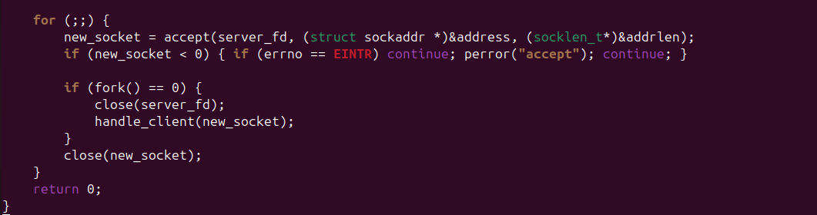
Figure 3. 1 Multiprocessing

3.1.2 Custom Protocol Parsing (Task A1)

The server reads the LEN:<n>\n header first to determine payload size. This prevents buffer overflows and handles partial reads.
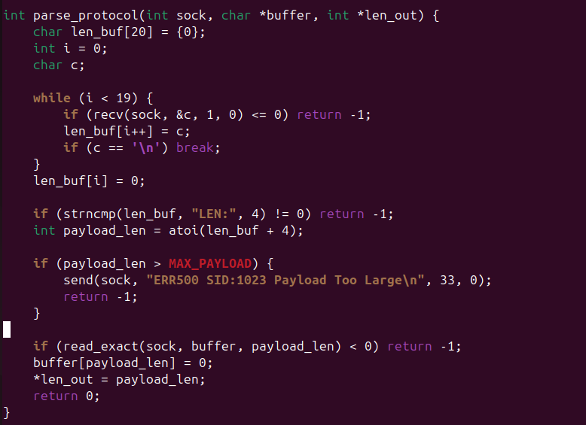
Figure 3. 2 Custom Protocol Parsing

3.1.3 Security & Authentication (Task A3 & A4)

Passwords are hashed using standalone SHA256 with a random salt. Session tokens are generated upon login and validated for protected commands.
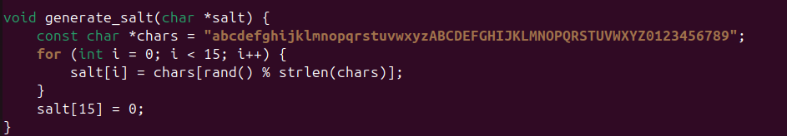
Figure 3. 3 Security & Authentication

3.1.4 Audit Logging (Task A5)

Every transaction is logged to server_IT24102340.log. The write_log function captures timestamp, PID, Client IP, Username, Command, and Result.
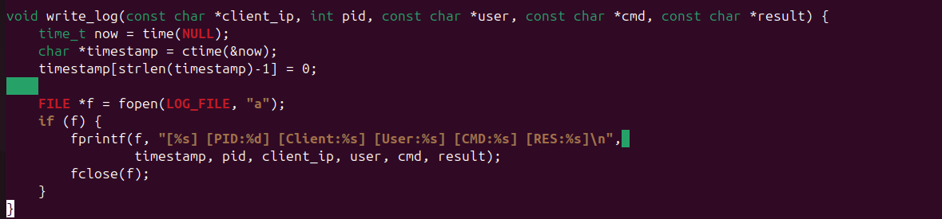
Figure 3. 4 Audit Logging

3.2 Client Implementation (Python)

The client is implemented in Python 3 using the socket library. It constructs the custom LEN:<n> frame before sending data.
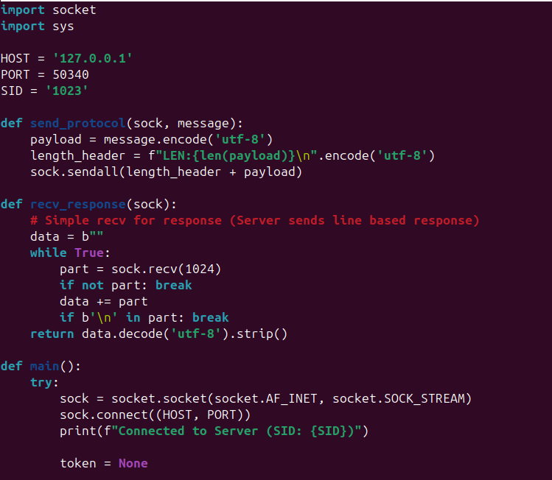
Figure 3. 5 Client Implementation part1

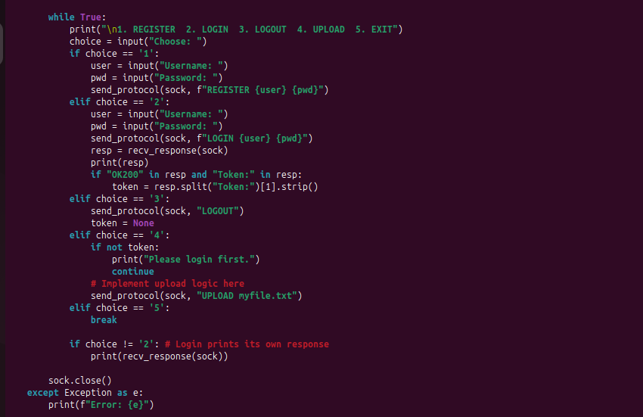
Figure 3. 6 Client Implementation part2

3.3 Makefile Configuration

The project is built using Makefile_2340. It compiles the server with the standalone SHA256 implementation without external dependencies.
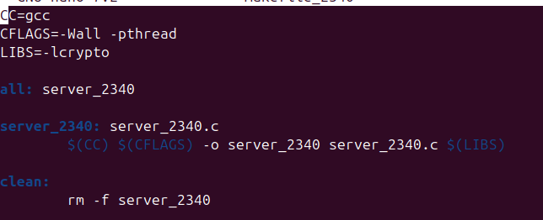
Figure 3. 7 Makefile

CHAPTER 4: TESTING AND VERIFICATION

This chapter provides evidence that the system meets all assignment requirements (A1–A5). All screenshots visibly show the registration number IT24102340 via file names, port numbers, or SID.

4.1 Environmental Configuration

4.1.1 Hostname Configuration
The server is hosted on a VMware Ubuntu environment. Figure 4.1 shows the system hostname.
Figure 4. 1 Hostname Configuration

4.1.2 Network Configuration

The server uses NAT networking. Figure 4.2 shows the network interface ens33 with the assigned IP address.
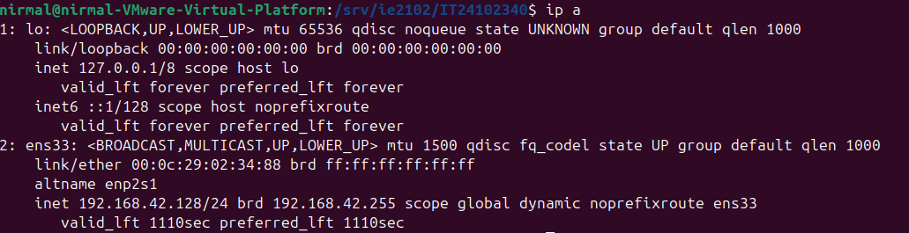
Figure 4. 2 Network Configuration

4.2 Server Functionality

4.2.1 Port Listening Proof (Task A1)

The server listens on port 50340 (derived from IT24102340). Figure 4.3 confirms the port is open using the ss command.
Figure 4. 3 Port Listening Proof

4.2.2 Successful Registration and Login (Task A3)

Figure 4.4 shows a successful user registration followed by a successful login. The response includes SID:1023 and a session token.
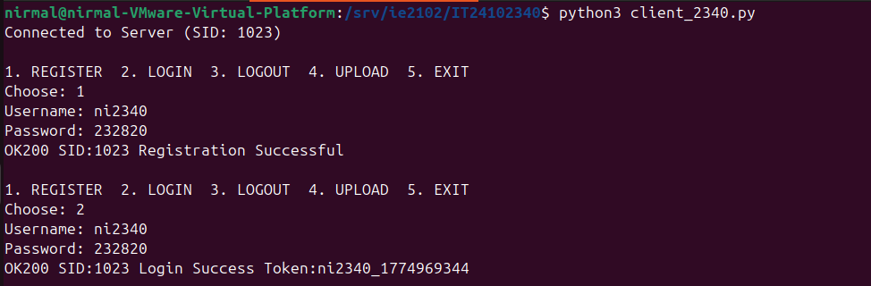
Figure 4. 4 Successful Registration and Login

4.2.3 Failed Login and Lockout (Task A4)

To test brute-force protection, incorrect passwords were entered 6 times. Figure 4.5 shows the server returning ERR401 for failed attempts and ERR429 for lockout.
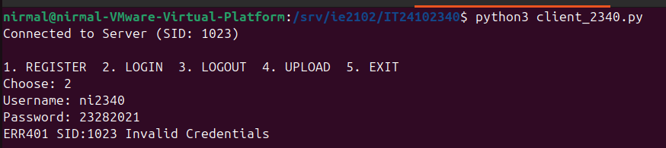
Figure 4. 5 Failed Login

4.3 Multiprocessing and Process Management (Task A2)

4.3.1 Multiple Forked Processes
With multiple clients connected, the ps command shows one parent process and multiple child processes (one per client). Figure 4.6 proves concurrent handling.
Figure 4. 6 Multiprocessing

4.3.2 Proper Child Cleanup (No Zombies)
After clients disconnect, child processes are reaped by the SIGCHLD handler. Figure 4.7 shows no <defunct> processes.
Figure 4. 7 Proper Child Cleanup

4.4 Audit Logging (Task A5)
All activities are recorded in server_IT24102340.log. Figure 4.8 shows log entries containing Timestamp, PID, Client IP, Username, Command, and Result.
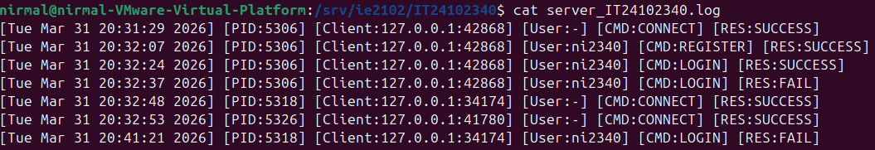
Figure 4. 8 Audit Logging

CHAPTER 5: CONCLUSION

5.1 Summary

This project successfully designed and implemented a secure multiprocessor TCP application server. The system meets all learning outcomes (LO5) and assignment tasks (A1–A5). Key achievements include:
Custom Protocol: Implemented LEN:<n> framing to handle variable payloads safely.
Concurrency: Used fork() with SIGCHLD handling to serve multiple clients without zombie processes.
Security: Implemented salted SHA256 hashing, session tokens with expiry, and brute-force lockout.
Logging: Created a comprehensive audit log for all server activities.

5.2 Limitations

Storage: User data is stored in flat files (users.dat), which may become inefficient with thousands of users compared to a SQL database.
Token Security: Session tokens are stored in plain text in the session file; hashing them before storage would add extra security.
IPv6: The current implementation supports IPv4 only.

5.3 Future Improvements

Database Integration: Migrate user storage to SQLite or MySQL for better scalability.
Encryption: Implement TLS/SSL to encrypt data in transit.
Graceful Shutdown: Add a signal handler for SIGINT to close all active connections cleanly before exiting.

ANNEXURES
Annexure A: Complete Server Source Code
Annexure B: Complete Client Source Code
Annexure C: Makefile

