::: {.cell _cell_guid=‘b1076dfc-b9ad-4769-8c92-a6c4dae69d19’ _uuid=‘8f2839f25d086af736a60e9eeb907d3b93b6e0e5’ execution=‘{“iopub.execute_input”:“2023-05-18T13:45:05.122442Z”,“iopub.status.busy”:“2023-05-18T13:45:05.122109Z”,“iopub.status.idle”:“2023-05-18T13:45:05.152481Z”,“shell.execute_reply”:“2023-05-18T13:45:05.151239Z”,“shell.execute_reply.started”:“2023-05-18T13:45:05.122418Z”}’ trusted=‘true’ execution_count=1}

import numpy as np # linear algebra  
import pandas as pd # data processing, CSV file I/O (e.g. pd.read_csv)  
import matplotlib.pyplot as plt  
import os  
for dirname, _, filenames in os.walk('/kaggle/input'):  
 for filename in filenames:  
 print(os.path.join(dirname, filename))

/kaggle/input/transformer/DatasetB.csv  
/kaggle/input/transformer/DatasetA.csv

:::

Here, we have loaded the data and set Furan as the label. At first, we have used 25 percent of the dataset A as the test set to come up with a good model, and then use this model to test in the dataset B.

ds_A = pd.read_csv("/kaggle/input/transformer/DatasetA.csv")  
ds_B = pd.read_csv("/kaggle/input/transformer/DatasetB.csv")  
  
# Splitting train and test  
from sklearn.model_selection import train_test_split  
train_set_A, test_set_A = train_test_split(ds_A, test_size = 0.25, random_state = 11)  
  
# Setting the labels  
y_train_A = train_set_A['Furan']  
y_test_A = test_set_A['Furan']  
  
# Dropping the Furan and Health Index columns  
X_train_A = train_set_A.drop(["Furan", "HI"], axis = 1)  
X_test_A = test_set_A.drop(["Furan", "HI"], axis = 1)  
  
# For DatasetB  
y_B = ds_B['Furan']  
X_B = ds_B.drop(["Furan", "HI"], axis = 1)  
  
# The code below is for the second case, where we train the data for the whole  
# Dataset A and test it on Dataset B  
y_A = ds_A['Furan']  
X_A = ds_A.drop(["Furan", "HI"], axis = 1)

/opt/conda/lib/python3.10/site-packages/scipy/__init__.py:146: UserWarning: A NumPy version >=1.16.5 and <1.23.0 is required for this version of SciPy (detected version 1.23.5  
 warnings.warn(f"A NumPy version >={np_minversion} and <{np_maxversion}"

The code below, drops the columns that we don’t need, and only keeps the common features between dataset A and B.

X_train_A = X_train_A.drop(set(ds_A.columns) - set(ds_B.columns), axis=1)  
X_test_A = X_test_A.drop(set(ds_A.columns) - set(ds_B.columns), axis=1)  
X_A = X_A.drop(set(ds_A.columns) - set(ds_B.columns), axis=1)  
X_B = X_B[X_train_A.columns]  
X_train_A

|  | H2 | Methane | Acetylene | Ethylene | Ethane | Water | Acid | BDV | IFT |
| --- | --- | --- | --- | --- | --- | --- | --- | --- | --- |
| 109 | 12.2 | 53.50 | 6.9 | 127.4 | 48.0 | 3 | 0.043 | 83.0 | 20 |
| 566 | 30.2 | 0.00 | 0.0 | 2.6 | 1.1 | 3 | 0.005 | 84.0 | 39 |
| 410 | 45.6 | 18.20 | 0.0 | 1.6 | 1.7 | 5 | 0.005 | 87.0 | 30 |
| 316 | 19.7 | 38.50 | 0.0 | 2.7 | 41.6 | 7 | 0.005 | 50.0 | 32 |
| 678 | 11.0 | 7.60 | 0.0 | 0.3 | 1.6 | 3 | 0.005 | 61.0 | 42 |
| ... | ... | ... | ... | ... | ... | ... | ... | ... | ... |
| 269 | 13.7 | 5.10 | 0.0 | 0.4 | 1.1 | 1 | 0.005 | 94.0 | 36 |
| 337 | 32.9 | 3.77 | 0.0 | 0.6 | 2.4 | 6 | 0.005 | 79.0 | 32 |
| 91 | 22.8 | 3.30 | 0.0 | 4.9 | 3.0 | 11 | 0.140 | 88.0 | 16 |
| 80 | 61.2 | 27.30 | 0.0 | 25.6 | 20.8 | 9 | 0.099 | 70.0 | 17 |
| 703 | 58.1 | 9.40 | 0.0 | 1.4 | 1.9 | 5 | 0.005 | 86.0 | 33 |

The code below, discretizes the Furan data into 3 classes.

# define the bin edges for each class  
bins = [-1, 0.1, 1, 100]  
  
# define the labels for each class  
labels = [0, 1, 2]  
  
y_train_A = pd.DataFrame(y_train_A)  
y_B = pd.DataFrame(y_B)  
y_test_A = pd.DataFrame(y_test_A)  
y_A = pd.DataFrame(y_A)  
  
# discretize the data into 3 classes  
y_train_A['Class'] = pd.cut(y_train_A['Furan'], bins=bins, labels=labels)  
y_B['Class'] = pd.cut(y_B['Furan'], bins=bins, labels=labels)  
y_test_A['Class'] = pd.cut(y_test_A['Furan'], bins=bins, labels=labels)  
y_A['Class'] = pd.cut(y_A['Furan'], bins=bins, labels=labels)  
  
y_train_A = np.array(y_train_A.drop("Furan", axis = 1)).ravel()  
y_B = np.array(y_B.drop("Furan", axis = 1)).ravel()  
y_test_A = np.array(y_test_A.drop("Furan", axis = 1)).ravel()  
y_A = np.array(y_A.drop("Furan", axis = 1)).ravel()

The below code is a function to plot the confusion matrix

from sklearn.metrics import confusion_matrix  
import itertools  
def plot_confusion_matrix(cm, classes, normalize=False, cmap=plt.cm.Blues, title='Confusion matrix'):  
 if normalize:  
 cm = cm.astype('float') / cm.sum(axis=1)[:, np.newaxis]  
 print("Normalized confusion matrix")  
 else:  
 print('Confusion matrix, without normalization')  
 print(cm)  
  
 plt.imshow(cm, interpolation='nearest', cmap=cmap)  
 plt.title(title)  
 plt.colorbar()  
 tick_marks = np.arange(len(classes))  
 plt.xticks(tick_marks, classes, rotation=45)  
 plt.yticks(tick_marks, classes)  
  
 fmt = '.2f' if normalize else 'd'  
 thresh = cm.max() / 2.  
 for i, j in itertools.product(range(cm.shape[0]), range(cm.shape[1])):  
 plt.text(j, i, format(cm[i, j], fmt),  
 horizontalalignment="center",  
 color="white" if cm[i, j] > thresh else "black")  
  
 plt.tight_layout()  
 plt.ylabel('True label')  
 plt.xlabel('Predicted label')

# First case: Training using 75% of the data and testing on the remaining 25%

We have experimented a combination of different models in the ensemble. Although the results were quite similar, we found that a combination of KNN, XGB and logistic regression works best. In the code below we have created a voting classifier consist of these models.

# from sklearn.ensemble import RandomForestClassifier  
from sklearn.ensemble import VotingClassifier  
from sklearn.linear_model import LogisticRegression  
from sklearn.svm import SVC  
from sklearn.neighbors import KNeighborsClassifier  
from xgboost import XGBClassifier  
from sklearn.neural_network import MLPClassifier  
from sklearn.naive_bayes import GaussianNB  
from sklearn.ensemble import AdaBoostClassifier  
  
#log_clf = LogisticRegression(max_iter=1000)  
svm_clf = SVC(probability=True, gamma=0.001)  
knn_clf = KNeighborsClassifier(n_neighbors=3)  
xgb_clf = XGBClassifier(learning_rate=0.01, n_estimators=300, max_depth=3, subsample=0.7)  
mlp_clf = MLPClassifier(hidden_layer_sizes=(100,), max_iter=1000)  
nb_clf = GaussianNB()  
ada_clf = AdaBoostClassifier(n_estimators=50, learning_rate=0.003)  
lr_clf = LogisticRegression(max_iter=10000)  
  
voting_clf = VotingClassifier(  
 estimators=[#('nn', mlp_clf),  
 #('svc', svm_clf),  
 ('knn', knn_clf), #('ada', ada_clf),('nb', nb_clf)  
 ('xgb', xgb_clf), ('lr', lr_clf)],  
 voting='hard')  
voting_clf.fit(X_train_A, np.array(y_train_A).ravel())

VotingClassifier(estimators=[('knn', KNeighborsClassifier(n_neighbors=3)),  
 ('xgb',  
 XGBClassifier(base_score=None, booster=None,  
 callbacks=None,  
 colsample_bylevel=None,  
 colsample_bynode=None,  
 colsample_bytree=None,  
 early_stopping_rounds=None,  
 enable_categorical=False,  
 eval_metric=None,  
 feature_types=None, gamma=None,  
 gpu_id=None, grow_policy=None,  
 importance_type=None,  
 interaction_constraints=None,  
 learning_rate=0.01, max_bin=None,  
 max_cat_threshold=None,  
 max_cat_to_onehot=None,  
 max_delta_step=None, max_depth=3,  
 max_leaves=None,  
 min_child_weight=None, missing=nan,  
 monotone_constraints=None,  
 n_estimators=300, n_jobs=None,  
 num_parallel_tree=None,  
 predictor=None, random_state=None, ...)),  
 ('lr', LogisticRegression(max_iter=10000))])

Here is a comparison of different models and the voting classifier.

from sklearn.metrics import accuracy_score  
for clf in (mlp_clf, svm_clf, #ada_clf,  
 knn_clf, xgb_clf, #nb_clf,  
 lr_clf, voting_clf):  
 clf.fit(X_train_A, y_train_A)  
 y_pred_A = clf.predict(X_test_A)  
 y_pred_B = clf.predict(X_B)  
 print(clf.__class__.__name__ + " for dataset A:", accuracy_score(y_test_A, y_pred_A))  
 print(clf.__class__.__name__ + " for dataset B:", accuracy_score(y_B, y_pred_B))

/opt/conda/lib/python3.10/site-packages/sklearn/neural_network/_multilayer_perceptron.py:686: ConvergenceWarning: Stochastic Optimizer: Maximum iterations (1000) reached and the optimization hasn't converged yet.  
 warnings.warn(

MLPClassifier for dataset A: 0.8688524590163934  
MLPClassifier for dataset B: 0.7828746177370031  
SVC for dataset A: 0.8797814207650273  
SVC for dataset B: 0.8103975535168195  
KNeighborsClassifier for dataset A: 0.8360655737704918  
KNeighborsClassifier for dataset B: 0.8042813455657493  
XGBClassifier for dataset A: 0.8961748633879781  
XGBClassifier for dataset B: 0.764525993883792  
LogisticRegression for dataset A: 0.8633879781420765  
LogisticRegression for dataset B: 0.7951070336391437  
VotingClassifier for dataset A: 0.8961748633879781  
VotingClassifier for dataset B: 0.8195718654434251

class_names = ['A', 'B', 'C']  
voting_clf.fit(X_train_A, y_train_A)  
y_pred_A = clf.predict(X_test_A)  
cnf_matrix = confusion_matrix(y_test_A, y_pred_A)  
np.set_printoptions(precision=2)  
plt.figure()  
plot_confusion_matrix(cnf_matrix, classes=class_names,  
 title='Confusion matrix for ' + clf.__class__.__name__)  
plt.show()

Confusion matrix, without normalization  
[[130 0 2]  
 [ 4 11 11]  
 [ 1 1 23]]

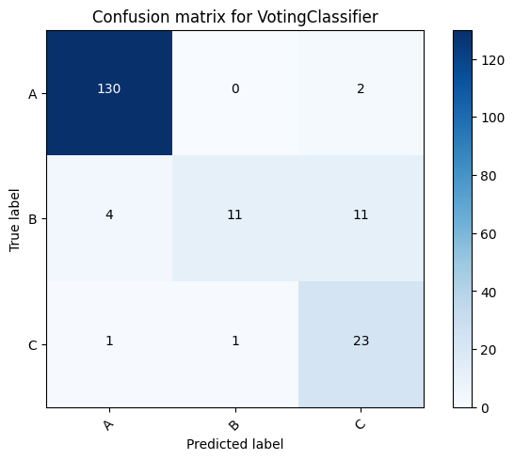

# Second case: Training using all of the data from Dataset A

So far we have used 75% of Dataset A to train the data and 25% to test it. Here, we used all of the data from Dataset A to train, and then test it on Dataset B.

from sklearn.ensemble import RandomForestClassifier  
from sklearn.ensemble import VotingClassifier  
from sklearn.linear_model import LogisticRegression  
from sklearn.svm import SVC  
from sklearn.neighbors import KNeighborsClassifier  
from xgboost import XGBClassifier  
from sklearn.neural_network import MLPClassifier  
from sklearn.naive_bayes import GaussianNB  
from sklearn.ensemble import AdaBoostClassifier  
  
lr_clf = LogisticRegression(max_iter=10000)  
svm_clf = SVC(probability=True)  
knn_clf = KNeighborsClassifier()  
xgb_clf = XGBClassifier(learning_rate=0.01, n_estimators=300, max_depth=3, subsample=0.7)  
mlp_clf = MLPClassifier(hidden_layer_sizes=(100,), max_iter=1000)  
nb_clf = GaussianNB()  
#ada_clf = AdaBoostClassifier(n_estimators=50, learning_rate=0.003)  
  
voting_clf = VotingClassifier(  
 estimators=[#('nn', mlp_clf),  
 #('svc', svm_clf),  
 ('knn', knn_clf), #('ada', ada_clf),('nb', nb_clf)  
 ('xgb', xgb_clf), ('lr', lr_clf)],  
 voting='hard')  
voting_clf.fit(X_A, y_A)

VotingClassifier(estimators=[('knn', KNeighborsClassifier()),  
 ('xgb',  
 XGBClassifier(base_score=None, booster=None,  
 callbacks=None,  
 colsample_bylevel=None,  
 colsample_bynode=None,  
 colsample_bytree=None,  
 early_stopping_rounds=None,  
 enable_categorical=False,  
 eval_metric=None,  
 feature_types=None, gamma=None,  
 gpu_id=None, grow_policy=None,  
 importance_type=None,  
 interaction_constraints=None,  
 learning_rate=0.01, max_bin=None,  
 max_cat_threshold=None,  
 max_cat_to_onehot=None,  
 max_delta_step=None, max_depth=3,  
 max_leaves=None,  
 min_child_weight=None, missing=nan,  
 monotone_constraints=None,  
 n_estimators=300, n_jobs=None,  
 num_parallel_tree=None,  
 predictor=None, random_state=None, ...)),  
 ('lr', LogisticRegression(max_iter=10000))])

from sklearn.metrics import accuracy_score  
  
for clf in (#mlp_clf, svm_clf, #ada_clf,  
 knn_clf, xgb_clf, lr_clf, #nb_clf,  
 voting_clf):  
 clf.fit(X_A, y_A)  
 y_pred_B = clf.predict(X_B)  
 print(clf.__class__.__name__ + " for dataset B:", accuracy_score(y_B, y_pred_B))

KNeighborsClassifier for dataset B: 0.8379204892966361  
XGBClassifier for dataset B: 0.7706422018348624  
LogisticRegression for dataset B: 0.8134556574923547  
VotingClassifier for dataset B: 0.8256880733944955

The code below is a function to visualize the confusion matrix

from sklearn.metrics import confusion_matrix  
import itertools  
def plot_confusion_matrix(cm, classes, normalize=False, cmap=plt.cm.Blues, title='Confusion matrix'):  
 if normalize:  
 cm = cm.astype('float') / cm.sum(axis=1)[:, np.newaxis]  
 print("Normalized confusion matrix")  
 else:  
 print('Confusion matrix, without normalization')  
 print(cm)  
  
 plt.imshow(cm, interpolation='nearest', cmap=cmap)  
 plt.title(title)  
 plt.colorbar()  
 tick_marks = np.arange(len(classes))  
 plt.xticks(tick_marks, classes, rotation=45)  
 plt.yticks(tick_marks, classes)  
  
 fmt = '.2f' if normalize else 'd'  
 thresh = cm.max() / 2.  
 for i, j in itertools.product(range(cm.shape[0]), range(cm.shape[1])):  
 plt.text(j, i, format(cm[i, j], fmt),  
 horizontalalignment="center",  
 color="white" if cm[i, j] > thresh else "black")  
  
 plt.tight_layout()  
 plt.ylabel('True label')  
 plt.xlabel('Predicted label')

Confusion Matrix:

class_names = ['A', 'B', 'C']  
  
for clf in (#mlp_clf, svm_clf, #ada_clf,  
 knn_clf, xgb_clf, lr_clf, #nb_clf,  
 voting_clf):  
 clf.fit(X_A, y_A)  
 y_pred_B = clf.predict(X_B)  
 cnf_matrix = confusion_matrix(y_B, y_pred_B)  
 np.set_printoptions(precision=2)  
 plt.figure()  
 plot_confusion_matrix(cnf_matrix, classes=class_names,  
 title='Confusion matrix for ' + clf.__class__.__name__)  
 plt.show()

Confusion matrix, without normalization  
[[245 8 4]  
 [ 11 11 18]  
 [ 8 4 18]]

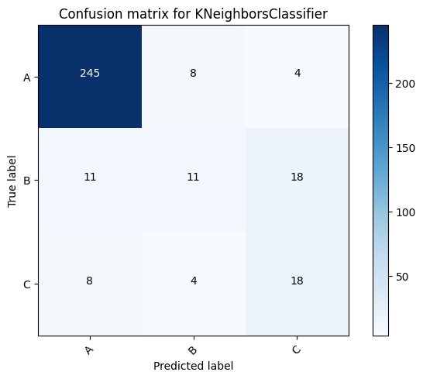

Confusion matrix, without normalization  
[[222 20 15]  
 [ 6 3 31]  
 [ 3 0 27]]

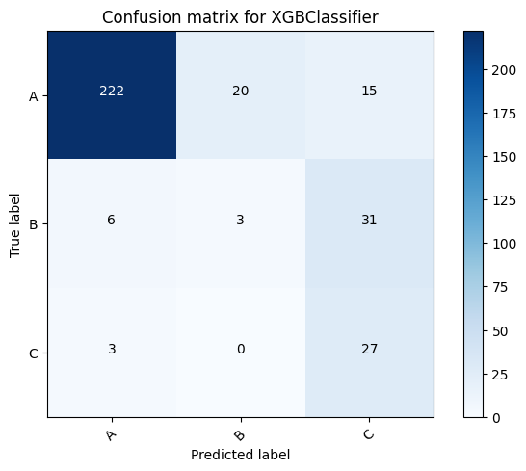

Confusion matrix, without normalization  
[[235 17 5]  
 [ 10 7 23]  
 [ 5 1 24]]

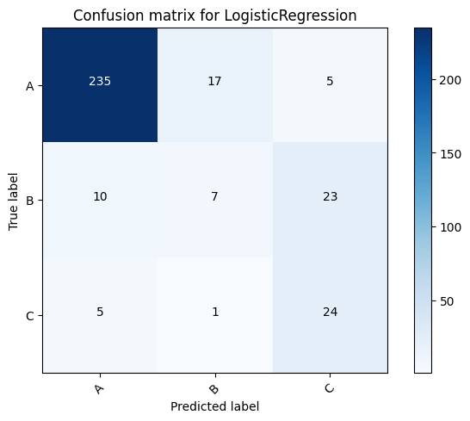

Confusion matrix, without normalization  
[[242 10 5]  
 [ 10 3 27]  
 [ 5 0 25]]

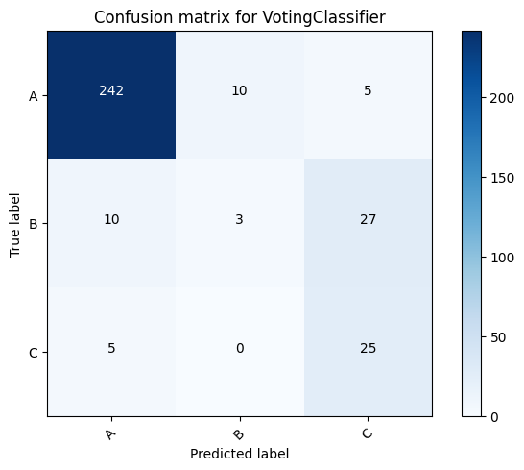

class_names = ['A', 'B', 'C']  
voting_clf.fit(X_A, y_A)  
y_pred_B = voting_clf.predict(X_B)  
cnf_matrix = confusion_matrix(y_B, y_pred_B)  
np.set_printoptions(precision=2)  
plt.figure()  
plot_confusion_matrix(cnf_matrix, classes=class_names,  
 title='Confusion matrix for ' + clf.__class__.__name__)  
plt.show()

Confusion matrix, without normalization  
[[242 10 5]  
 [ 10 3 27]  
 [ 5 0 25]]

