FACULTY OF TECHNOLOGY

Agriculture Group

Sanaz Haghighi
Miglio Krajewski
Nima Marchin
Luanna Draskoczy

Oulu Hydrogen Challenge

University of Oulu

March 2026

TABLE OF CONTENTS
TABLE OF CONTENTS 2
1 Introduction 3
2 Methodology & Simulation Architecture 3
2.1 The Core: Electrolyzer Unit 4
2.2 Mass Flow Systems (Hydrogen & Oxygen) 4
2.3 Thermal Recovery & Distribution 5
3 Model Parameters and Logic 5
3.1 Wind Farm (P_electrolyzer) 6
3.2 Fish Farm Design 6
3.2.1 Sizing the Fish Tank 6
3.2.2 Fish Tank Heat Losses 7
3.3 Vertical Farm Design 8
3.4 Control Strategy Heat 10
3.5 Control Strategy Oxygen 10
3.6 Storage Tanks 11
3.7 Parameters 11
3.8 Stocks 12
3.9 Flows 12
3.10 Key Equations 13
3.10.1 Variables 14
3.10.2 Hydrogen Production Rate 15
3.10.3 Oxygen Production Rate 15
3.10.4 Fish Tank Oxygen Concentration 15
3.10.5 Heat Production Rate 15
3.10.6 Greenhouse Temperature 15
3.10.7 Fish Tank Temperature 15
4 16
4.1 Real-time Energy Efficiency Analysis 16
4.2 Technical Resilience and Biological Stability 16
4.3 Economic Viability and Value Creation 17
4.4 Oxygen Mass Flow and Life Support 18
Bibliography 20

Introduction
The Superfarm project represents a transition from traditional linear industrial models to a circular "Waste-to-Value" framework. The project’s core philosophy, "Using Waste to Grow Fish and Plants," addresses the inherent inefficiencies in green hydrogen production, where byproduct oxygen and thermal energy are often treated as secondary waste streams rather than valuable resources.
This simulation acts as a Digital Twin, providing a high-fidelity environment to validate the technical and economic viability of integrating electrolysis with localized agriculture. The primary objectives of the model are:
- System Sustainability & Stability: To evaluate if the intermittent and fluctuating byproduct streams (oxygen and heat) can maintain a stable biological environment for a fish tank and a vertical greenhouse module.
- Engineering Design & Component Sizing: To assist in the precise sizing of physical infrastructure, such as buffer capacities and tank volumes, based on dynamic mass and energy flow rates.
- Economic & Financial Grounding: To generate empirical data necessary for performing accurate Return on Investment (ROI) and operational cost calculations.
By focusing on the dynamic balance of these flows within a symbiotic module, this simulation ensures technical reliability before moving to physical implementation.

Methodology & Simulation Architecture
The simulation is constructed using a System Dynamics (SD) framework, which allows for the modeling of complex interactions through stocks, flows, and feedback loops. The architecture is designed to replicate the physical "Industrial Symbiosis" by connecting three primary layers (Hydrogen, Oxygen, and Thermal Energy) of energy and mass transfer.
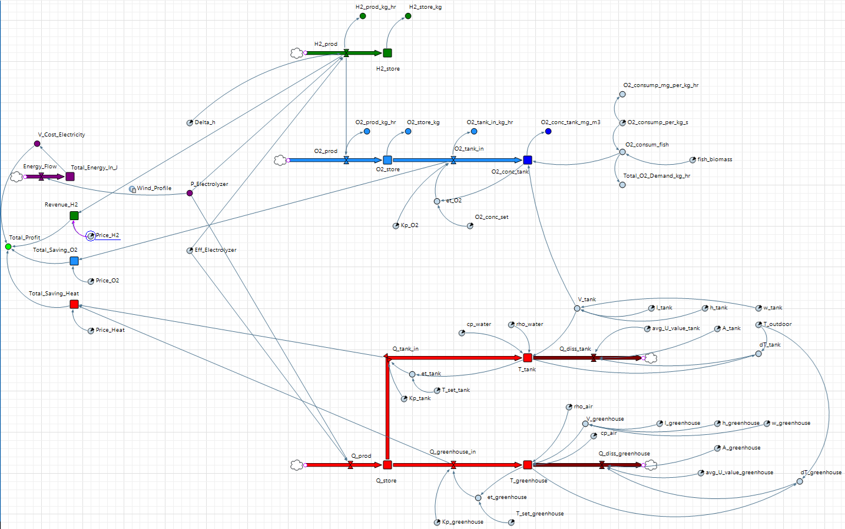
Figure 1: System Dynamics Architecture of the Superfarm Digital Twin in AnyLogic.
To ensure a high-fidelity representation of the Superfarm system, the model employs a multilayered modular design:

The Core: Electrolyzer Unit
The electrolyzer acts as the primary source node in the simulation. It takes electrical power input (P_Electrolyzer) and, based on the reaction enthalpy (Delta_h) and efficiency (Eff_Electrolyzer), generates three simultaneous outputs: Hydrogen gas, Oxygen gas, and Dissipated Heat (Q_prod).

Mass Flow Systems (Hydrogen & Oxygen)
The model treats the byproduct gas as a critical resource for biological life support:
- Hydrogen Circuit: Captures the main product flow (H2_prod) into a storage stock (H2_store) for industrial use.
- Oxygen Symbiosis: Instead of venting, the oxygen produced (O2_prod) accumulated in the buffer (O2_store). It is then regulated through a flow (O2_tank_in) to maintain the oxygen concentration in the fish tank (O2_conc_tank) according to the biological consumption of the fish.
- Biological Respiration: The model accounts for a 200,000 kg fish biomass, where oxygen consumption (O2_consum_fish) is dynamically calculated based on specific respiration rates per kilogram.

Thermal Recovery & Distribution
This model features a dual-sink thermal distribution system to maximize energy efficiency:
- Thermal Storage: The dissipated heat (Q_prod) is captured and stored in a central energy storage unit (Q_store).
- Aquaculture Heating: Energy is routed via a heat transfer flow (Q_tank_in) to regulate the fish tank temperature (T_tank), considering water properties such as density (rho_water) and specific heat capacity (cp_water).
- Greenhouse Heating: Simultaneously, heat is transferred through a heat flow (Q_greenhouse_in) to the vertical farm module to maintain the greenhouse temperature (T_greenhouse).
- Dissipation Analysis: The model accounts for environmental heat loss through two heat flows (Q_diss_tank and Q_diss_greenhouse) to evaluate the system's thermal efficiency.

Model Parameters and Logic
The model is of a hypothetical hydrogen plant with PEM electrolyzers. The power for plant operation comes from an islanded wind farm with a similar capacity. It is assumed that the heat output of the electrolyzer is very large compared with the oxygen output. Therefore, the fish farm is sized first, based on the oxygen output, and the greenhouse is sized based on the heat remaining after the fish farm demand has been calculated.

Wind Farm (P_electrolyzer)
The power capacity of the wind farm for the simulation was scaled from proposed projects in Norway [1]. The capacity factor was taken from the same source and the power output over 24 hours was scaled to data from Fingrid [2]. Although Fingrid data is for all of Finland, data for specific wind farms is not easily found. Therefore, the profile is the best approximation for our project. The power output was scaled as follows:
- Hourly Averaging: The raw 3-minute real-time production data from Fingrid (March 6th-7th) was aggregated into hourly mean values to provide a consistent daily profile.
- Normalization: Each hourly mean was divided by the total national wind capacity ($9,394 MW$) to derive the dimensionless 'k-factor' representing the regional wind volatility.
- Calibration: Since the raw mean was $38.5 \%$, a multiplier of $1.16739$ was applied to scale the daily average to our target $45 \%$ Capacity Factor.
- Energy Scaling: The calibrated factors were multiplied by the farm capacity ($2.9 MW$) to generate the final hourly energy output (MWh).
The resulting profile ensures the total energy output over 24 hours is exactly $2.9 MW*0.45*24 hr$, with no hourly peak exceeding the $2.9 MW$.

Fish Farm Design

Sizing the Fish Tank
- The electrolyzer plant has a capacity of $2.5 MW$; This assumption is made, as the model is vaguely based on the $2.5 MW$ Berlevag project [3], [4].
- The electrolyzer plant is PEM, with an efficiency of $70 \%$.
- The wind farm has a capacity of $2.9 MW$; scaled from the $175 MW$ electrolyzer project and assuming that the entire power output is used for hydrogen production [1].
- The wind farm has a capacity factor of $45 \%$ [1] (The lower capacity factor from the projects in the source is selected for safety margin).
- Fish are assumed to consume $350\frac{mg_{O_{2}}}{kg_{Biomass}⋅hr}$ [5], variable oxygen consumption based on feeding times is not considered (this value depends on the type of fish).
- The biomass content of the fish farm is considered to be $2.5 \%$ [6].
To calculate the size of the fish tank, the average production of oxygen per hour must be calculated. The first step is to calculate how much energy is available for electrolysis per hour on average:
$$capacityFactor*1hr*capacity*eff=E_{electrolysis}=0.917\frac{MWh}{hr}$$
$$=3.29\frac{GJ}{hr}$$

The energy produced per hour can be divided by the formation enthalpy of one mol of hydrogen and multiplied by a factor of 0.5 to give the amount of oxygen produced per hour in mol:
$$\frac{E_{electrolysis}}{∆H}*0.5={O_{2}}_{prod}=5754.97 mol/hr=184.16 kg/hr$$
The amount of oxygen produced per hour can be divided by the amount of oxygen required by the fish per kilogram per hour to give the amount of fish in kilograms:
$$\frac{{O_{2}}_{prod}}{{O_{2}}_{consum}}=m_{fish}=526 171.43 kg=526.17 t$$
This value can be used to calculate the total volume of the fish tank using the biomass content:
$$\frac{m_{fish}}{biomassContent}*100=m_{tank}=V_{tank}=21 046.86 m^{3}$$

Fish Tank Heat Losses
The heat losses are calculated from U-Values and temperatures in the model. The U-Values and design temperatures are based on the following data:
- The fish tank is considered to be in a closed space based on images of a facility from a similar project utilizing waste heat form a data centre [7], [8], [9]
- Based on data form two tank manufacturers, including one that manufactures aquaculture tanks, a U-Values of $0.6\frac{W}{m^{2}K}$ is used as an average U-Value [10], [11], [12]
  - Note: This assumption places the U-Value at the lower end, as the non-water filled section of the facility will likely have lower U-Values and is neglected entirely
- The temperature in the fish tank is assumed to be $12 °C$. This is optimal for rainbow trout [13], which are commonly farmed in Nordic regions [14] and are also farmed in the project utilizing waste heat from the data centre [7].
- The thermal mass of the fish is assumed to be similar to that of water and is thus neglected.
- The area of the fish tank envelope is estimated roughly from the geometry, which itself is estimated form images of the project utilizing waste heat from a data centre [7].
From the proportional lengths of the rectangular prism and the volume calculated during fish tank sizing, the lengths of the sides can be calculated:
$$20H=L;4H=W$$
$$80H^{3}=21 046.86 m^{3}$$
$$H=\sqrt[3]{\frac{21046.86 m^{3}}{80}}=6.41 m;W=25.63 m;L=128.15 m$$

The area is calculated from the length of the sides and the heat loss can be calculated using the area, the temperature difference and the assumed U-Values.

Vertical Farm Design
The vertical farm is designed by estimating the maximum volume, within sensible limits, from the calculated maximum possible area. The maximum possible area is itself calculated form an assumed U-value, a design temperature and the available excess heat after subtraction of the heat-losses from the fish tank. The actual size of the greenhouse depends on the thermal capacity of the heat-storage, which is not sized in this simulation design. The calculation is based on the following assumptions/data:
- Although data on the design temperature in Berlevag could not be found, $-14 °C$ is selected as a conservative assumption based on weather data [15].
  - The simulation calculates a heat loss of $0.1332 MW$ at an outdoor temperature of $-14 °C$ for the fish tank and a power input of $1.305 MW$ (the average power input based on capacity, capacity factor and efficiency) , leaving approximately $0.2582 MW$ to be dissipated from the vertical farm (based on calculations in the simulation).
- The vertical farm is designed to grow lettuce, as is the case in the Berlevag project [16]. The optimal growing temperature for lettuce and thus the indoor temperature of the vertical farm is assumed to be $17°C$ [17].
- The U-Value is calculated based on data from [18], where investment cost and output of vertical farms are compared with a focus on the thermal properties of the envelope. It is assumed that similar insulation would be used in this project.
  - For the climate zone of Helsinki the optimal insulation material is Expanded Polystyrene (EPS)
  - The optimal insulation thickness is 200 mm
  - Using an online U-value calculator, the resulting U-value is $0.18\frac{W}{m^{2}K}$ [19]
- The thermal mass of the plants, auxiliaries (soil/hydroponics/structures) is neglected entirely. In consequence, the thermal inertia of the simulated system is lower than it would be in a real system.
With the above data, the sizing of the vertical farm can be performed. First the area of the envelope is calculated by dividing the thermal power output which remains after subtracting the thermal losses of the fish tank from the total thermal power output at the design temperature of $-14 °C$.
$$Q_{remaining}=Q_{diss_greenhouse}={Q_{prod}-Q}_{diss,_tank}≈0.258 MW$$
The area can be calculated by rearranging the following equation:
$$U⋅A_{greenhouse}⋅dT=Q_{diss, greenhouse}$$
To:
$$A_{greenhouse}=\frac{Q_{diss, greenhouse}}{U⋅dT}=46 284.829 m^{2}$$
The volume of a rectangular prism would be maximized in a cube, resulting in a height, width and length of $87.83 m$. However, for logistical reasons the height of the vertical farm is likely limited. The (self-reported) tallest vertical farm in the world, the Greenphyto Innovation Centre in Singapore, is 23.3m tall [20]. Google earth images show that the proportion of the length to width of the Greenphyto vertical farm are 5:1 [21]. Using this data, a sensible geometry of the vertical farm can be calculated by solving the resulting quadratic equation (one real solution):
$$H=20 m;5W=L$$
$$2H⋅W+2H⋅L+2W⋅L=240 m⋅W+10⋅W^{2}=46284.829 m^{2}$$
$$W=-12 m+\sqrt[2]{{\left(12 m\right)}^{2}+4628.483 m^{2}}=57.083 m;L=285.416 m;H=20 m$$

The size/geometry of the property may lead to other geometries. this geometry is chosen for simplicity, as there is no real information on the property location.

Control Strategy Heat
A simple proportional controller is used to keep the temperatures of the fish tank and the greenhouse in range. The simulation calculates a heat loss of $0.051 MW$ from the fish tank and $0.125 MW$ from the greenhouse at an outdoor temperature of $2 °C$. These values are used as the constant terms, ${K_{p}}_{tank}$ and ${K_{p}}_{greenhouse}$. The error $e\left(t\right)$ is calculated form $T_{set}-T_{measured}$, with $T_{measured}$ being the temperature calculated for the fish tank/greenhouse in the simulation.

Control Strategy Oxygen
The control strategy for oxygen works analogous to the control strategy for heat. The setpoint for oxygen concentration lies at $9.7\frac{mg}{L}$, the saturation-point at $17 °C$ [22]. The error, $e(t)$, is calculated by $C_{set}-C_{measured}$, with $C_{measured}$ being the oxygen concentration calculated for the fish tank. The constant, ${K_{p}}_{O_{2}}$, is the oxygen consumption of the entire fish stock multiplied by $5000$ (this value is empirical from the simulation; it results from the small absolute value of $C_{set}-C_{measured}$).

Storage Tanks
The storage tanks can be understood as a black box. They are neither defined nor sized. Researching materials and sizes would have been beyond the scope of the project. However, the simulation offers an excellent tool for the sizing of the storage tanks. Sizing the heat storage and introducing a heat pump can change the sizing of the greenhouse. This results in an optimization problem, where the benefits of high temperature storage need to be weighed against the increased heat losses resulting from the greater temperature gradient. The optimization is likely iterative, with many simulations being required to determine optimal storage size.
In the current model, the heat storage tanks are defined as infinitely large, with no losses. The entire stretch from the electrolyzer to the fish tank/greenhouse can encompass a heat pump, a heat storage of any size or material and pipes. There is no potential variable (temperature) determining flow to or from the storage tank. The assumption is that all the heat is stored at a sufficiently high temperature level for a gradient to exist between the heat storage and the greenhouse/fish tank, at all times. Heat transfer from and to the storage is assumed to be ideal (the tank can run empty). There is currently no measure to prevent negative values in the heat storage tank.
The oxygen tank is similarly undefined, with no potential variable (pressure), pumps, piping, material or dimension. Oxygen is assumed to dissolve in tank water entirely with no losses. There is currently no measure to prevent emptying or negative values in the oxygen tank.

Parameters
Parameters | Value/Unit | Description
P_Electrolyzer | variable | Power output of a $2.9 MW$ wind farm for a $2.5 MW$ industrial pilot scale PEM electrolyzer plant. [23]
Eff_Electrolyzer | $$0.7$$ | Mid-range efficiency of alkaline or PEM electrolyzers (considered constant). [24]
Delta_h | $$285 840 \frac{J}{mol}$$ | Formation enthalpy (energy required to form $1 mol$ of $H_{2}$ from $H_{2}O$). [25]
V_tank | $$21 046.86 m^{3}$$ | Calculated from Oxygen production, oxygen consumption of fish and space required for resulting amount of fish.
V_greenhouse | $$1500 m^{3}$$ | Volume of the greenhouse
cp_water | $$4180 \frac{J}{kg.K}$$ | The specific heat capacity of water.
cp_air | $$1005 \frac{J}{kg.K}$$ | The specific heat capacity of air.
O2_consum_fish | $$1.59\frac{mol}{s}$$ | See “Fish Farm Design” for calculation; result converted to mol to match units in simulation.
rho_air | $$1.225\frac{kg}{m^{3}}$$ | Density of air
rho_water | $$1000\frac{kg}{m^{3}}$$ | Density of water

Stocks
Stock | Unit | Description
H2_store | $$mol$$ | Produced hydrogen
O2_conc_tank | $$\frac{mol}{m^{3}}$$ | Concentration of oxygen in fish tank
O2_store | $$mol$$ | Oxygen in buffer
Q_store | $$J$$ | Heat in heat storage
T_tank | $$K$$ | Temperature of the fish tank
T_greenhouse | $$K$$ | Temperature of the greenhouse

Flows
Flow | Unit | Description
H2_prod | $$\frac{mol}{s}$$ | Hydrogen production rate
O2_prod | $$\frac{mol}{s}$$ | Oxygen production rate
O2_tank_in | $$\frac{mol}{s}$$ | Oxygen transfer rate from buffer to fish tank
Q_diss_greenhouse | $$\frac{J}{s}$$ | A dummy value representing heat loss from the greenhouse
Q_diss_tank | $$\frac{J}{s}$$ | A dummy value representing heat loss from the fish tank
Q_greenhouse_in | $$\frac{J}{s}$$ | A dummy value representing the heat flow to the greenhouse
Q_tank_in | $$\frac{J}{s}$$ | A dummy value representing the flow of heat to the fish tank
Q_prod | $$\frac{J}{s}$$ | Heat production rate

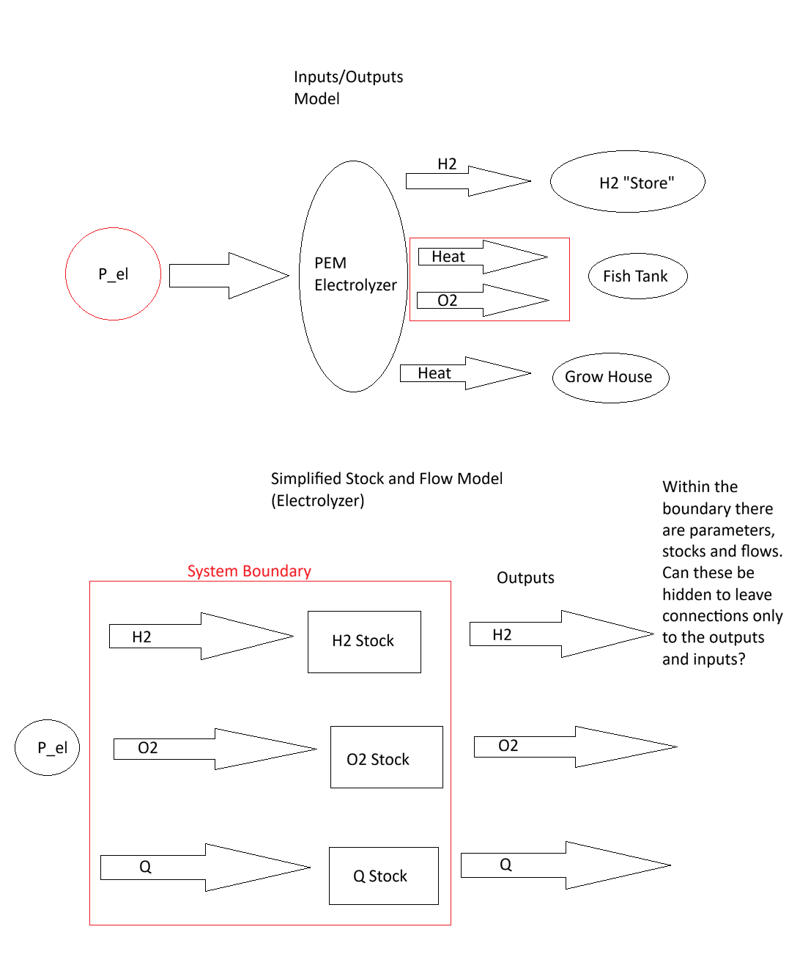
Figure 2: Conceptual Architecture of the Superfarm Symbiosis.
This obviously needs to be digitalized; it is just preliminary (original idea).

Key Equations
Each equation is represented in a part of the model. The variable names are not the same as in the model, to make the equations more easily recognizable at a glance. The equation is described shortly and the section of the model where it can be found is named. The variables for the equations below are listed under Variables.

Variables
$${\dot{n}}_{H_{2}, prod}$$
$$P_{Electrolyzer}$$
$${Eff}_{Electrolyzer}$$
$${∆H}_{H_{2}}$$
$${\dot{n}}_{O_{2}}$$
$${\dot{n}}_{H_{2}}$$
$${\dot{n}}_{O_{2}, in}$$
$${\dot{n}}_{O_{2}, consumed}$$
$$V_{tank}$$
$$Q_{ prod}$$
$$Q_{in}$$
$$Q_{diss}$$
$$m_{air,greenhouse}$$
$$m_{water,tank}$$
$$C_{P_{water}}$$
$$C_{P_{air}}$$
$$T_{greenhouse}$$
$$T_{tank}$$
$$C_{O_{2}, tank}$$

Hydrogen Production Rate
Description: calculates hydrogen production rate ($mol/s$) from electrical power input ($kW$).
$${\dot{n}}_{H_{2},prod}=\frac{P_{Electrolyzer}⋅{Eff}_{Electrolyzer}}{{∆H}_{H_{2}}}$$

Oxygen Production Rate
Description: Based on the molar ratio of $H_{2}$ to $O_{2}$ in $H_{2}O$
$${\dot{n}}_{O_{2}}={\dot{n}}_{H_{2}}×0.5$$

Fish Tank Oxygen Concentration
Description: concentration of oxygen in the fish tank water as an integral of:
$$C_{O_{2}, tank}=\frac{{\dot{n}}_{O_{2}, in}-{\dot{n}}_{O_{2}, consumed}}{V_{tank}}$$

Heat Production Rate
Description: Based on the efficiency of the electrolyzer. Assumption is that all the electrical energy not used for hydrolysis becomes usable waste heat.
$$Q_{ prod}=P_{Electrolyzer}×{(1-Eff}_{Electrolyzer})$$

Greenhouse Temperature
Description: Calculates temperature in the greenhouse as an integral of:
$$T_{greenhouse}=\frac{Q_{in}-Q_{diss}}{m_{air,greenhouse}*C_{p_{air}}}$$
This function of the simulation is incomplete, as there are no temperature gradients determining the heat flow.

Fish Tank Temperature
Calculates temperature in the fish tank as an integral of:
$$T_{tank}=\frac{Q_{in}-Q_{diss}}{m_{water,tank}*C_{P_{water}} }$$
This function of the simulation is incomplete, as there are no temperature gradients determining the heat flow.

Real-time Energy Efficiency Analysis
The simulation results validate a total system energy efficiency of 95%. While the primary energy carrier, hydrogen, accounts for 69% of the output, the integration of a thermal recovery loop successfully captures 26% of the dissipated heat from the Electrolyzer. This circular approach reduces total energy losses to a mere 5%, demonstrating the superior performance of the industrial symbiosis model compared to traditional standalone electrolysis plants.
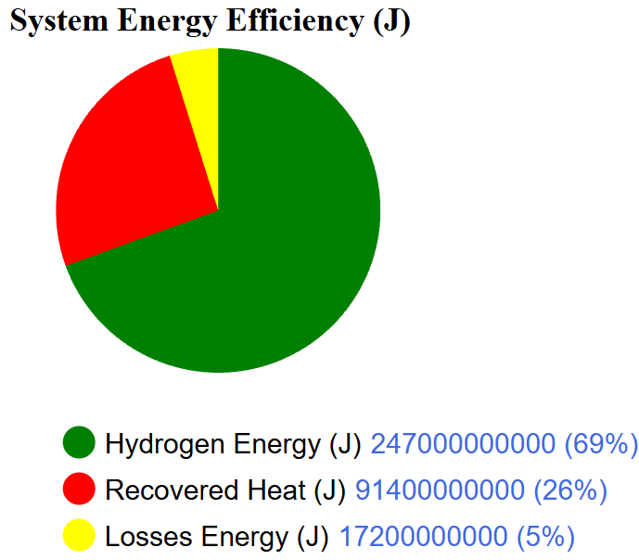
Figure 3. Cumulative System Energy Efficiency over a 24-hour cycle.

Technical Resilience and Biological Stability
To test the technical sustainability of the Superfarm, the model was subjected to a highly volatile wind power profile during a day. Despite these sharp fluctuations in energy input and resultant heat production (Q_prod), the proportional controllers maintained a stable thermal environment. The fish tank temperature remained constant at 12°C and the greenhouse at 17°C, proving that the system can protect sensitive biological components from external energy intermittency.
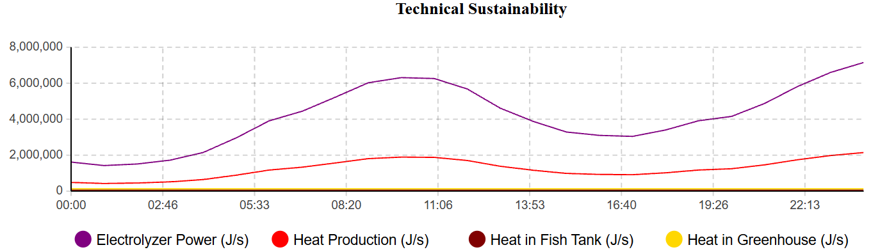
Figure 4. Technical Sustainability and Thermal Resilience Analysis.

Economic Viability and Value Creation
The financial dashboard confirms the project's economic viability with a daily net profit of €1,803.58. Although hydrogen sales remain the primary revenue stream, the 'Avoided Costs', specifically €663 from internal oxygen supply and €334 from waste heat recovery; are critical to maintaining a positive margin. This validates the 'Waste-to-Value' framework by converting secondary waste streams into significant operational savings.
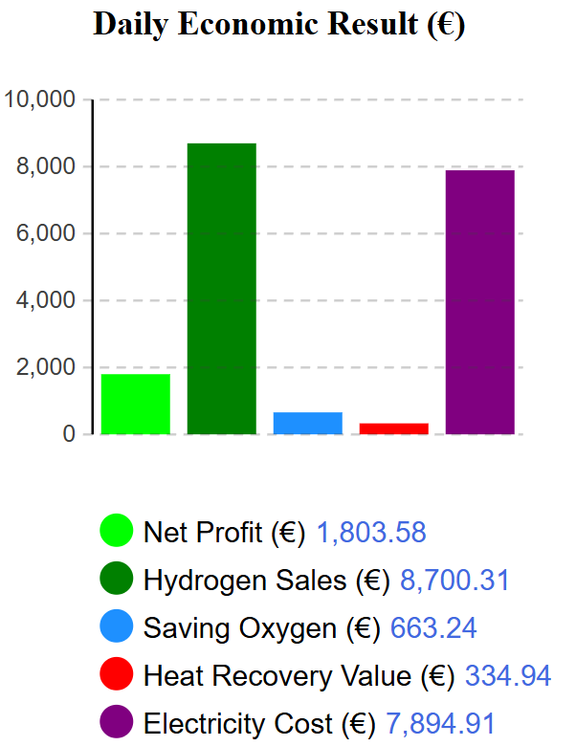
Figure 5. Daily Operational Economic Performance.

Oxygen Mass Flow and Life Support
Mass balance calculations and real-time monitoring confirm that the byproduct oxygen flow of approximately 184.16 kg/hr consistently exceeds the maximum respiratory demand of the 526,171 kg fish biomass. This ensures a sustainable biological environment without the need for supplementary oxygen procurement, further enhancing the system's circularity and self-sufficiency.
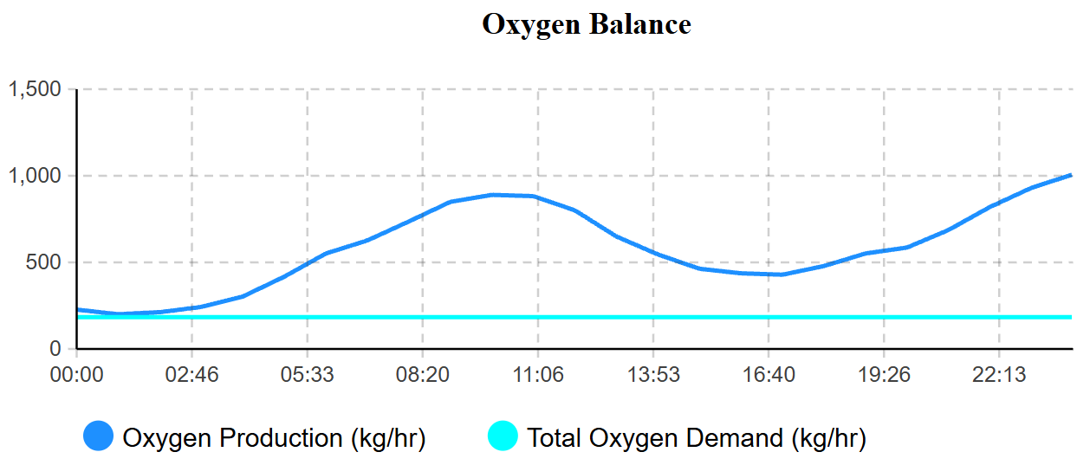
Figure 6. Dynamic Oxygen Supply vs. Biological Demand.
To validate the symbiotic relationships within the Digital Twin, a real-time visualization dashboard was integrated into the AnyLogic environment. This dashboard monitors four critical Performance Indicators:
- Economic Results (Euro): Compares total operational revenue (Hydrogen sales and savings from O2/Heat recovery) against electricity costs. Manual calculations confirm a positive net margin, supporting the financial grounding of the circular model.
- System Energy Efficiency: A dynamic representation of energy flows, validating that 95% of the input energy is effectively captured as Hydrogen chemical energy or recovered thermal energy, with only 5% designated as losses.
- Technical Sustainability: Real-time monitoring of the Fish Tank (12°C) and Greenhouse (17°C) temperatures. This ensures that the proportional controllers accurately manage the intermittent heat flows from the electrolyzer (Q_prod) to maintain stable biological environments.
- Oxygen Balance (kg/hr): A supply-vs-demand analysis confirming that the oxygen production rate (~184.16 kg/hr) consistently meets the respiratory needs of the 526,171 kg fish biomass (~184.16 kg/hr at peak demand).

Bibliography
[1] ‘PowerPoint Presentation’. Accessed: Mar. 06, 2026. [Online]. Available: https://www.hydrogen.no/files/documents/medlemsmoter/h2carrier.pdf
[2] ‘Download datasets’. Accessed: Mar. 09, 2026. [Online]. Available: https://data.fingrid.fi/en/data?datasets=181
[3] ‘NIB lends to Varanger Kraft´s hydrogen and power grid projects’, Nordic Investment Bank. Accessed: Mar. 08, 2026. [Online]. Available: https://www.nib.int/news/nib-lends-to-varanger-krafts-hydrogen-and-power-grid-projects/
[4] ‘Hydrogen-Aeolic Energy with Optimised eLectrolysers Upstream of Substation | H2020’, CORDIS | European Commission. Accessed: Mar. 08, 2026. [Online]. Available: https://cordis.europa.eu/project/id/779469/reporting
[5] ‘Dissolved oxygen requirements in aquatic animal respiration - Responsible Seafood Advocate’, Global Seafood Alliance. Accessed: Mar. 06, 2026. [Online]. Available: https://www.globalseafood.org/advocate/dissolved-oxygen-requirements-in-aquatic-animal-respiration/
[6] ‘Fish density on our farms’. Accessed: Mar. 07, 2026. [Online]. Available: https://griegseafood.com/our-impact-fish-density-on-our-farms
[7] Amit, ‘Land-based trout farm will use data center waste heat’, Green Mountain Data Center. Accessed: Mar. 21, 2026. [Online]. Available: https://greenmountain.no/land-based-trout-farm-will-use-data-center-waste-heat/
[8] ‘Green Mountain and Hima Seafood launch groundbreaking heat reuse project’, Mynewsdesk. Accessed: Mar. 21, 2026. [Online]. Available: https://www.mynewsdesk.com/green-mountain/pressreleases/green-mountain-and-hima-seafood-launch-groundbreaking-heat-reuse-project-3430566
[9] A. Furuset, ‘“The only thing that can save the planet”: Hima Seafood’s bold bet on land-based trout farming’, intrafish.com. Accessed: Mar. 21, 2026. [Online]. Available: https://www.intrafish.com/aquaculture/-the-only-thing-that-can-save-the-planet-hima-seafood-s-bold-bet-on-land-based-trout-farming/2-1-1879098
[10] ‘7. FRP Tanks 2’. Accessed: Mar. 21, 2026. [Online]. Available: https://almfiberglass.com/wp-content/uploads/2024/07/7.-FRP-Tanks-2.pdf
[11] ‘U-values’. Accessed: Mar. 21, 2026. [Online]. Available: https://www.designingbuildings.co.uk/wiki/U-values
[12] ‘GRP sectional tanks’, Balmoral Tanks. Accessed: Mar. 21, 2026. [Online]. Available: https://www.balmoraltanks.com/solutions/grp-sectional-tanks
[13] ‘Small Scale Rainbow Trout Farming - Ideal Temperature For Rainbow Trout Farming’. Accessed: Mar. 21, 2026. [Online]. Available: https://sites.google.com/view/smallscalerainbowtroutfarm/ideal-temperature-for-rainbow-trout-farming
[14] ‘5. Marine aquaculture in the Nordics - Nordic Oceans 2050’. Accessed: Mar. 21, 2026. [Online]. Available: https://pub.norden.org/nordicinnovation2025-05/5-marine-aquaculture-in-the-nordics.html
[15] ‘Berlevåg Climate, Weather By Month, Average Temperature (Norway) - Weather Spark’. Accessed: Mar. 22, 2026. [Online]. Available: https://weatherspark.com/y/96283/Average-Weather-in-Berlev%C3%A5g-Norway-Year-Round
[16] ‘Visiting Berlevåg: Winds of Change’, Arctic Economic Council. Accessed: Mar. 22, 2026. [Online]. Available: https://arcticeconomiccouncil.com/news/winds-of-change/
[17] ‘Lettuce Growing Guide’, Southern Exposure Seed Exchange. Accessed: Mar. 22, 2026. [Online]. Available: https://www.southernexposure.com/lettuce-growing-guide/
[18] F. Pelella et al., ‘Thermo-economic optimization of vertical farms exploring multiple design options for the built environment and HVAC system’, Appl. Therm. Eng., vol. 279, p. 127623, Nov. 2025, doi: 10.1016/j.applthermaleng.2025.127623.
[19] ‘U-Value Calculator : ChangePlan’. Accessed: Mar. 22, 2026. [Online]. Available: https://www.changeplan.co.uk/u_value_calculator.php
[20] ‘Home’, Greenphyto. Accessed: Mar. 25, 2026. [Online]. Available: https://greenphyto.com/
[21] Google Earth Pro. (Sep. 03, 2025). Google.
[22] A. Dmitry, ‘Effect of water quality on rainbow trout performance’.
[23] ‘Haeolus – Hydrogen-Aeolic Energy with Optimised eLectrolysers Upstream of Substation’. Accessed: Mar. 06, 2026. [Online]. Available: https://haeolus.eu/
[24] D. Virah-Sawmy, F. J. Beck, and B. Sturmberg, ‘Ignore variability, overestimate hydrogen production – Quantifying the effects of electrolyzer efficiency curves on hydrogen production from renewable energy sources’, Int. J. Hydrog. Energy, vol. 72, pp. 49–59, Jun. 2024, doi: 10.1016/j.ijhydene.2024.05.360.
[25] A. Godula-Jopek, Hydrogen Production by Electrolysis. 2015.

