AI-Assisted Geothermal Feasibility and Optimisation Workflow
For Sustainable Urban Heating and Cooling
Team: Thermal Edge Geo AI
SPE Africa Geothermal Datathon 2026

Team Overview
The Thermal Edge Geo AI team consists of five specialized roles that bridge geoscience, data science, engineering and economics:

Member | Role | Key Responsibility
Neemah | Team Lead & AI Engineer | Coordinates the project and develops the XGBoost machine learning models to predict missing reservoir data, fulfilling the Bonus Challenge.
Tosin | Reservoir & Subsurface Lead | Evaluates the Rotliegend sandstone reservoir parameters (temperature, porosity, permeability) to confirm it can sustain the district's energy demands.
Sakeenah | Surface Energy Systems Analyst | Designs the surface architecture, sizing the heat pumps, absorption chillers and thermal storage to meet the exact heating and cooling targets.
Hafsah | Strategy, GIS & Reporting Lead | Owns spatial mapping, strategic policy framing and the final presentation of the project narrative.
Habeeb | Economic & Financial Lead | Builds the financial models to calculate the Levelized Cost of Energy (LCoE) and runs sensitivity analyses to prove economic viability.

End to End Workflow: AI-Assisted Feasibility and Optimization
The team's end to end workflow successfully automates the evaluation of the Utrecht district geothermal project across four main phases:

- Phase 1: AI-Powered Subsurface Assessment: Uses an XGBoost quantile regression model trained on data rich wells (BLT-01, PKP-01) to mathematically predict missing permeability and well logs in EVD-01 and JUT-01, generating P10, P50 and P90 confidence estimates.
- Phase 2: Automated Feasibility Reporting: The pipeline evaluates subsurface capacity and uses the Groq llama-3.3-70b large language model to automatically generate structured petrophysical viability reports.
- Phase 3: Surface System Balancing: Extracts exactly 14.14 MWth of geothermal energy to power a heat pump (COP 4.0) and an absorption chiller (COP 0.7). This meets the 10 MWth heating and 5 MWth cooling targets while bottlenecking grid electricity usage to just 0.9 MW.
- Phase 4: Economic Optimization Engine: An automated Python parametric sweep runs sensitivity analyses on high-risk variables such as drilling costs and electricity prices. This calculates a resilient baseline LCoE of €28.53/MWhth and generates Tornado charts to prove the system's financial stability.

1. Executive Summary and Strategic Motivation
This project presents an integrated geothermal based heating and cooling system designed for a mixed use urban district in the Utrecht region. Driven by the need to reduce greenhouse gas emissions and natural gas dependency, our design targets the Rotliegend sandstone reservoir to supply a baseline demand of at least 10 MWth for heating and 5 MWth for cooling. By employing an AI-assisted workflow and rigorous surface system balancing, our solution successfully meets the target, utilizing 14.14 MW of total geothermal power while minimizing electrical load.

2. Methodology and Assumptions
Our integrated workflow bridges subsurface capacity with surface demand using the following baseline assumptions:

- Subsurface and Reservoir: We assumed an average geothermal gradient of 32 °C/km, a surface temperature of 15 °C, a reservoir area of 8 km², a heat recovery factor of 20%, and a thermal lifetime of 30 years. Permeability was estimated empirically based on available porosity trends.
- Surface System: The system assumes a heat pump Coefficient of Performance (COP) of 4.0 and an absorption chiller COP of 0.7.

3. External Data and GIS Mapping
To supplement the provided data pack, we extracted external spatial and subsurface distributions from ThermoGIS (thermogis.nl). Specifically, we utilized the platform to assess the Rotliegend formation's top depth, thickness and permeability distributions (P10, P50 and P90). OpenStreetMap data was utilized to classify and map the urban district into residential, office and public facility zoning to route the thermal network effectively.
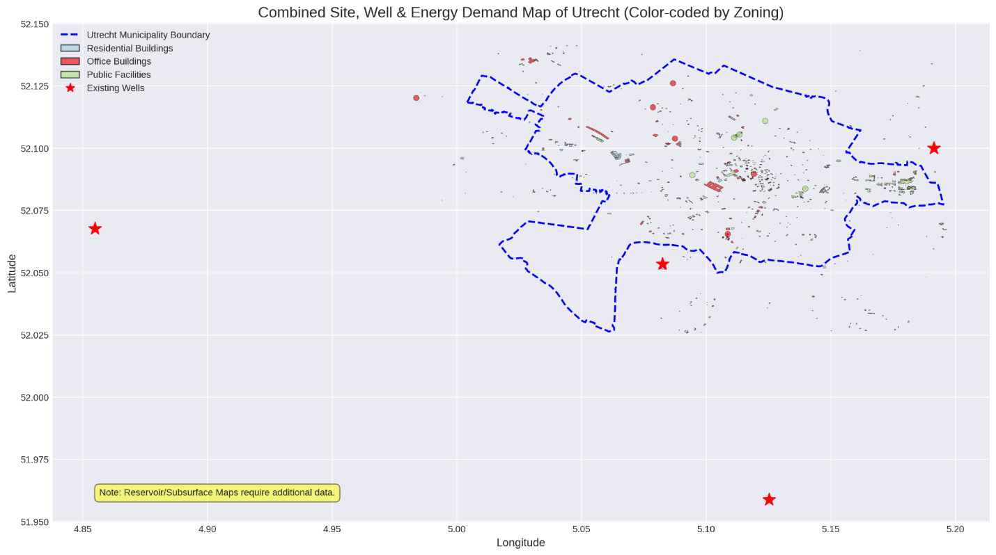
Figure 1: Combined Site, Well and Energy Demand Map of Utrecht, mapping the 4 Rotliegend wells against the colour coded residential, office and public facility zoning.

4. Reservoir Assessment (Challenge 1)
Our reservoir assessment was conducted in two phases to handle the incomplete datasets provided for the Rotliegend sandstone formation.

Phase 1: Preliminary Assessment (Raw Data)
An initial evaluation of the four provided wells revealed significant data gaps:
- BLT-01: Exhibited the best preliminary reservoir quality with an average porosity of 16.4%, a temperature of 78.6 °C and a potential of 34.62 MWth.
- PKP-01: While deeper and hotter at 97.1 °C, it exhibited a lower average porosity (9.0%), suggesting tighter reservoir conditions and a potential of 25.35 MWth.
- Data Gaps: Wells EVD-01 and JUT-01 had limited porosity and permeability data, requiring data imputation to properly assess the region.

Phase 2: AI-Optimized Reservoir Model
To resolve the missing data and refine our preliminary estimates, we applied our XGBoost machine learning workflow to predict the missing petrophysical properties. This generated finalised P50 confidence estimates across all wells:
- BLT-01 Final P50: Temperature refined to 77.0 °C with a permeability of 752.1 mD.
- PKP-01 Final P50: Temperature refined to 88.0 °C with a permeability of 367.95 mD.
- EVD-01 and JUT-01 Final P50: The AI successfully imputed the missing data, confirming viable temperatures of 72.0 °C for both wells, with EVD-01 showing a permeability of 519.12 mD.
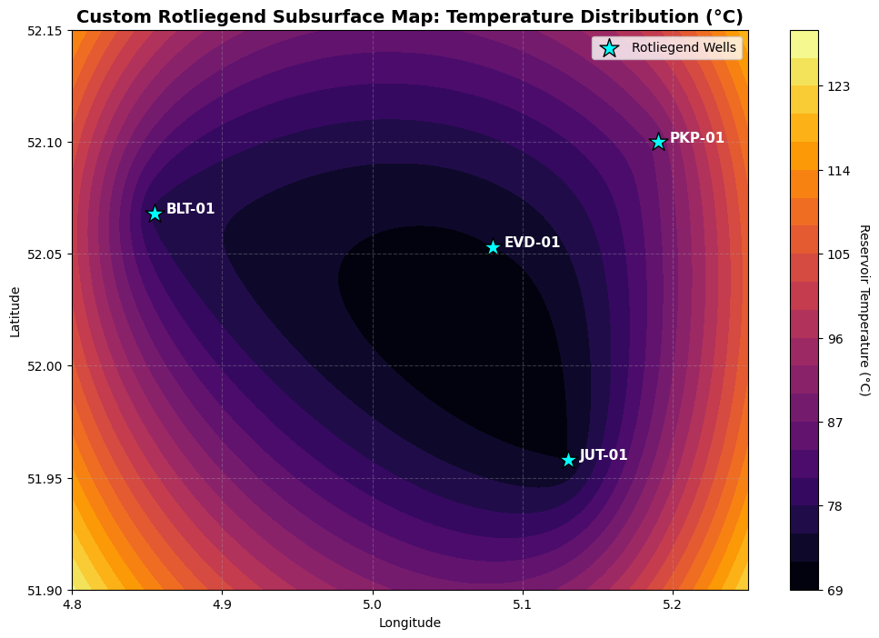

Reservoir data and supporting files

5. Integrated Surface System Design (Challenge 2)
To meet the specific urban district demands, we designed an integrated surface architecture featuring heat pumps, chillers and thermal energy storage (TES).

- Heating Balance: The 10 MWth heating demand is met by a direct geothermal contribution of 7 MW, supplemented by 3 MW of heat pump output which consumes 0.75 MW of electricity.
- Cooling Balance: The 5 MWth cooling demand is met using absorption chillers, which require 7.14 MW of geothermal heat input.
- System Totals: The complete system requires 14.14 MW of total geothermal energy and consumes a highly efficient 0.9 MW of total electricity including pumps and auxiliaries.
- Peak Load Balancing: To handle peak mismatches, the system incorporates a Thermal Energy Storage (TES) capacity of 10 MWh.
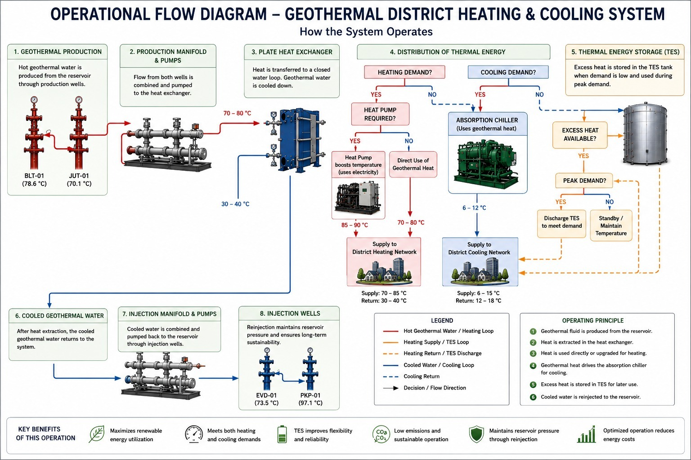
Figure 2: Operational flow diagram.
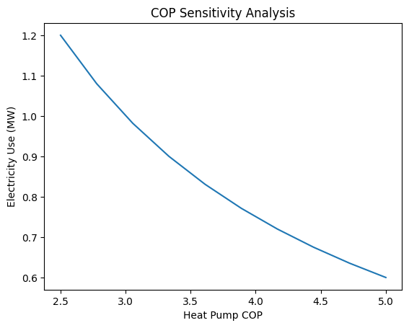
Figure 3: COP sensitivity analysis.

Surface system notebook (Google Colab)

6. AI-Assisted Workflow (Bonus Challenge)
To predict missing permeability values for EVD-01 and JUT-01, we trained an XGBoost quantile regression model using well log curves from the data rich BLT-01 and PKP-01 wells as training data. The input curves used were gamma ray (GR), bulk density (RHOB), neutron porosity (NPHI) and sonic transit time (DT). The model outputs three probabilistic estimates (P10, P50 and P90) to capture subsurface uncertainty. Where input curves were also missing, a secondary XGBoost imputer trained on formation depth relationships was applied first to fill those gaps before permeability prediction.
The complete AI assessment pipeline, which covers feasibility scoring on a 0 to 100 composite scale, economic integration and structured well reports generated via the Groq llama-3.3-70b large language model, is fully reproducible through our eight Jupyter notebooks. All source code has been documented and submitted via our team GitHub repository. An interactive scenario dashboard is also available online.
GitHub Repository
Interactive Scenario Dashboard

7. Economic Evaluation (LCoE)
Our economic evaluation utilises the official datathon Levelized Cost of Energy (LCoE) formula to assess financial viability over the 30-year thermal lifecycle. By balancing 14.14 MWth of total geothermal extraction with a minimised electrical load of just 0.9 MW, the system achieves a highly competitive base LCoE of €28.53/MWhth (€7.92/GJ). Initial CAPEX totals €11.72 million, comprising €9.0 million for two wells incorporating the 1.5× scaling factor, €600,000 for circulation pumps and €2.12 million for surface facilities. Annual OPEX is €1,398,920, which includes €588,920 for fixed and variable O&M and €810,000 for electricity consumption based on 6,000 heat load hours at €150/MWhe. The financial model assumes a 7.8% discount rate (WACC) and a heat pump COP of 4.0.
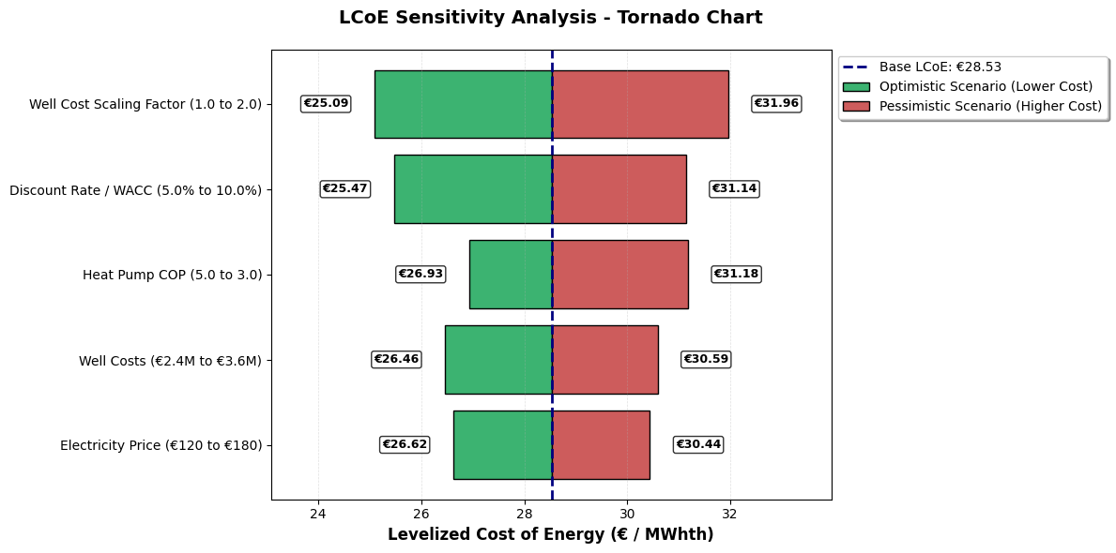
Figure 4: LCoE Sensitivity Analysis (Tornado Chart).

As shown in the figure above, the well cost scaling factor (ranging from 1.0 to 2.0) is the most sensitive variable, causing the largest LCoE swing between €25.09 and €31.96/MWhth. Conversely, fluctuations in the electricity price tested from €120 to €180/MWhe have the lowest overall impact. This insensitivity validates a key design achievement: by maximizing direct raw heat utilization and bottlenecking grid reliance to just 0.9 MW, the project is effectively insulated against volatile European energy markets. The system thus proves economically resilient across a wide range of technical and market uncertainties.

8. Conclusion and Recommendations
The Thermal Edge Geo AI workflow confirms that the Rotliegend sandstone reservoir has the capacity to reliably sustain the Utrecht district. By pairing 14.14 MW of geothermal extraction with a 10 MWh thermal storage unit and highly efficient heat pumps, our system meets the 10 MWth heating and 5 MWth cooling targets while minimizing electrical load. This AI-assisted workflow provides a scalable, cost effective blueprint for the future of African and European sustainable urban heating.

