Wavefront
Animation Studio



User Manual

Karsten Pedersen
Daniel Lisle
Table of Contents
Installing Wavefront Animation Studio 3
Exporting Models For Use In Wavefront Animation Studio 4
Blender 4
Grouping the model by object 4
Naming the parts 4
Saving the model 5
3D Studio Max 6
Naming the parts 6
Exporting the model 7
Maya 8
Naming the parts 8
Enabling Object Exporter 8
Exporting the model 9
Import a Model 10
Naming an Animation 10
Saving an Animation 10
Animating a model 11
Menu Items 11
File Menu 11
Animation Menu 12
Help Menu 12
Bottom Menu 13
Parts Box 14
Information Box 14
Controls 15
Keyboard Interface Controls 15
Mouse Interface Controls 15
Minimum System Requirements 15

Installing Wavefront Animation Studio

Windows
Once you have downloaded the Wavefront Animation Studio installer, locate the file and double click on it. Administrator privileges will be required in order to install the product.
Once you have loaded the installer you will be presentented with the licence agreement, to which you will have to accept before being able to installl the application.
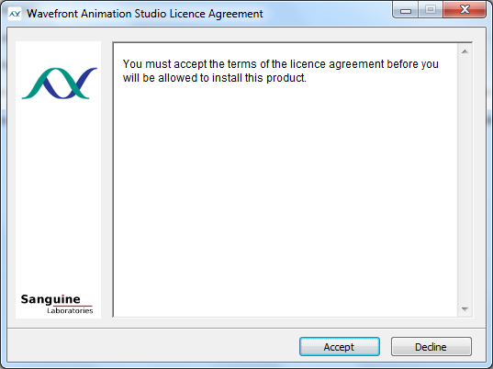
Once you have accepted the licence agreement you will then be presented with the installation window.
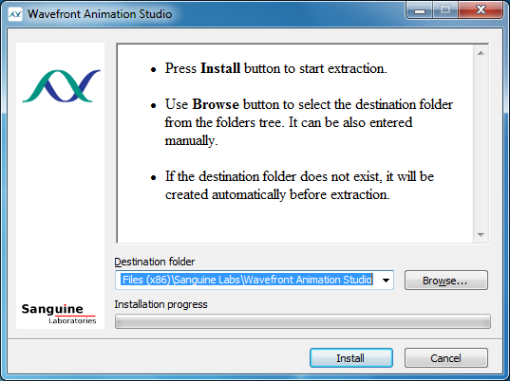
The default the extraction folder for this product is set to Wavefront Animation Studio, located in the Sanguine Labs directory alongside any of our other products within the default Program Files directory, any of these directories can be changed. Once you are satisfied with the installation parameters you may proceed to click on install. Shortcuts for Wavefront Animation Studio will be created on the desktop and within the start menu.

Linux
To install this product on a Linux system, you must first install the libwavefront library first since Wavefront Animation Studio depends on it to run. This can also be downloaded from our website. The commands to install the software are as follows:-
cd /location/of/downloaded/files
rpm -i libwavefront-x.x.x.rpm
rpm -i wastudio-x.x.x.rpm

The program can now be run by executing `wastudio` in the command line.

Exporting Models For Use In Wavefront Animation Studio
Exporting models correctly for use within wavefront animation studio is important, this is to ensure that the animation studio will load and work correctly. There are many applications that are used to produce models in the object format, below we have covered 3 most commonly used applications and provided a step by step guide on how to export your models correctly using these applications.

Blender

Grouping the model by object
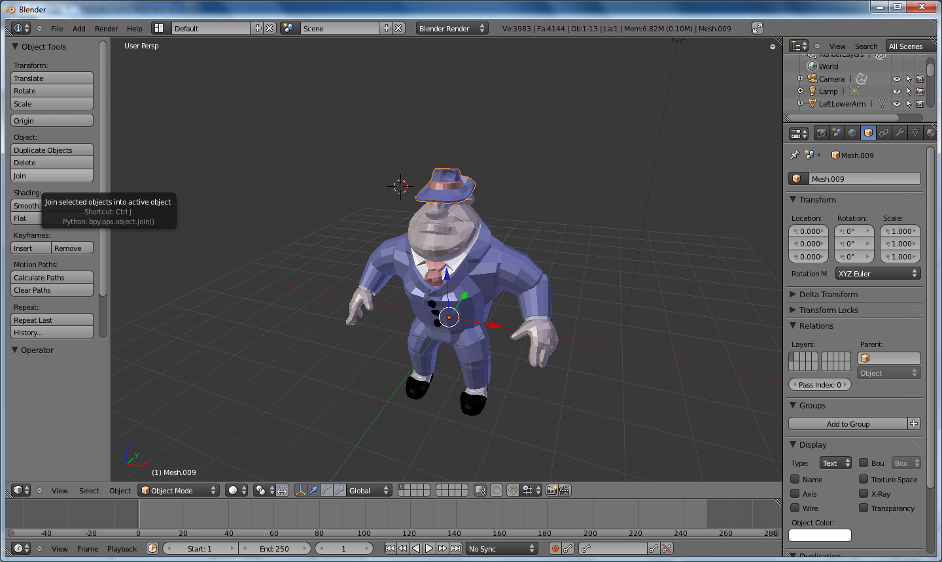
After completing your model, you should group all the parts by object, this is to ensure that the parts you are moving within the animation studio will be obvious. An example of this going wrong could be not grouping the hat band to the hat, then when moving the hat for an animation, you could potentially move the band seperate to the hat, this might be something that you want to be able to do, however for this guide we shall just group all parts of the hat as the hat group. To do this you need to select all of the parts which relate to the object and choose 'join' under the object menu located on the left.
Note: Different versions of blender may have this menu in a different location.

Naming the parts
The model parts should be named correctly for them to show up in the animation studio parts list correctly, there are 2 locations within blender in which you must name the grouped body part correctly.
For this demonstration we have chosen the left lower arm from the perspective view of being inside Al... in the 'Object' menu on the right hand side we must ensure that the name is related to the grouped object, such as in this example we have named it LeftLowerArm.
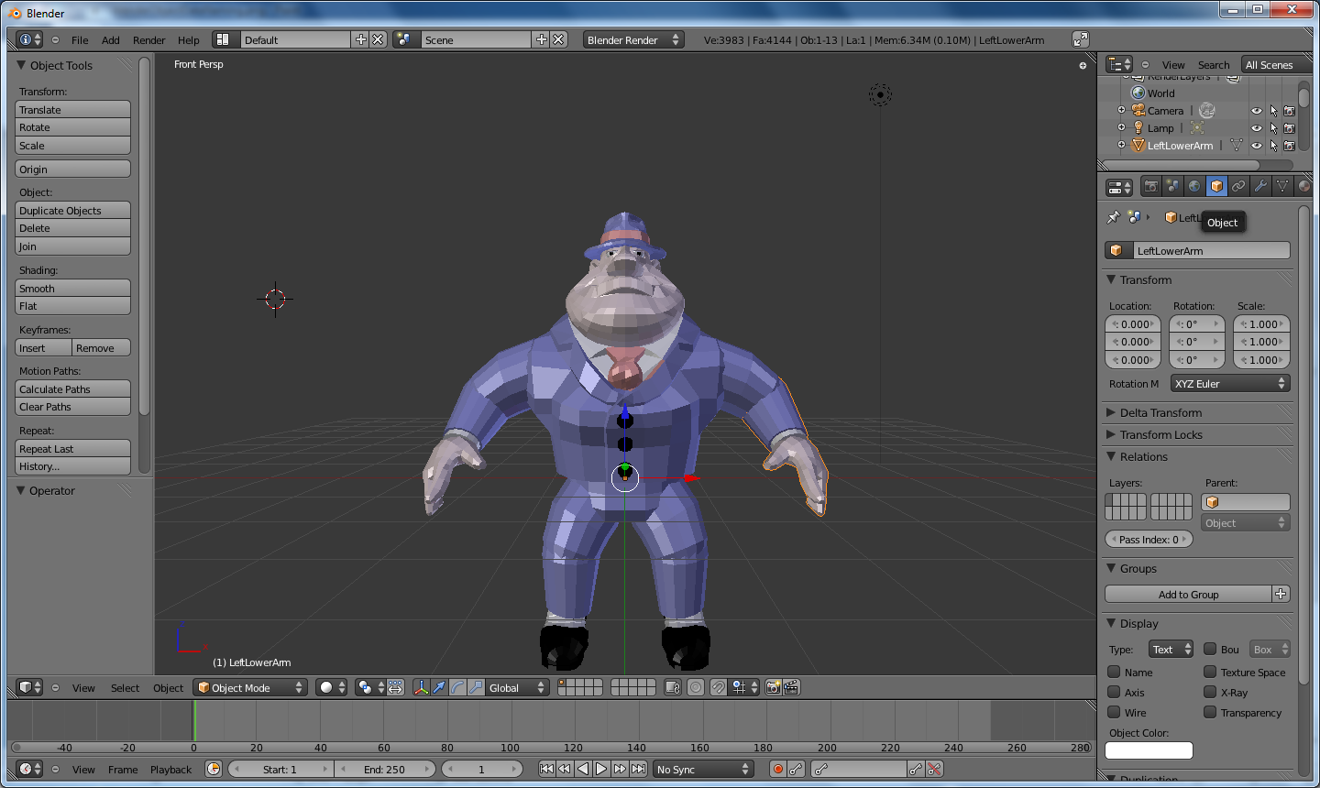
You must ensure that this name is also duplicated in the 'Object Data' menu also in the same location.
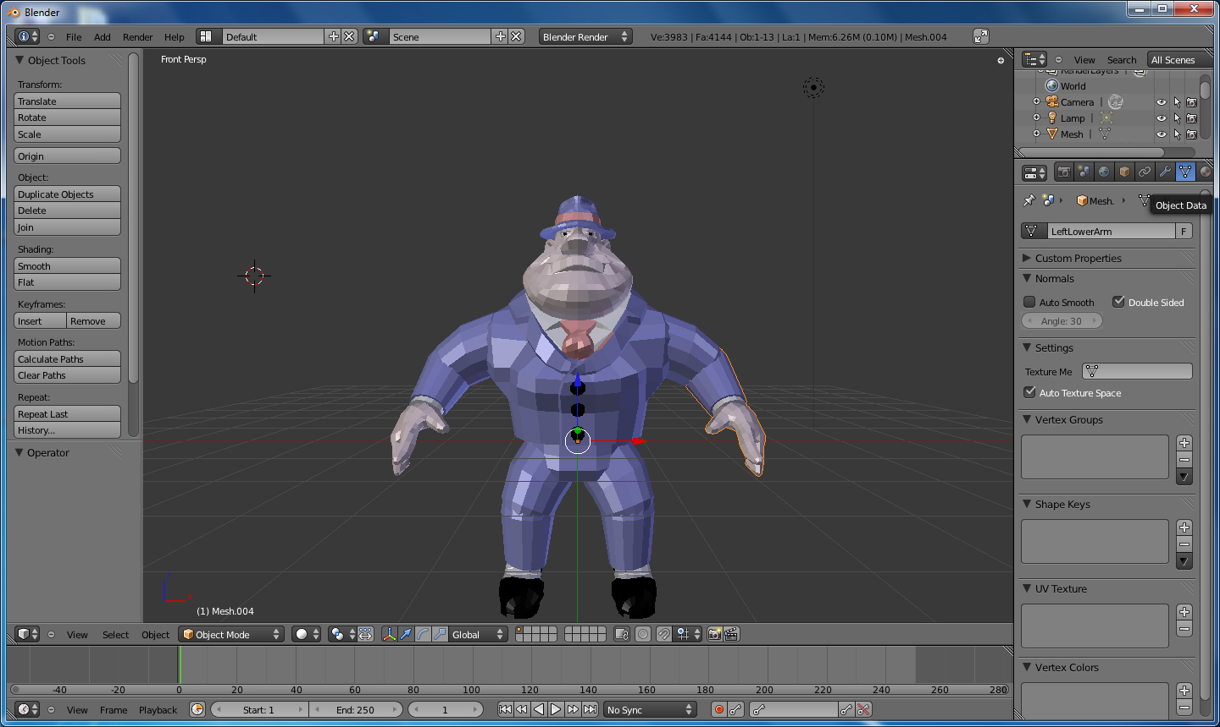

Saving the model
You must ensure that when you save your model, you save it as a wavefront .obj object file.
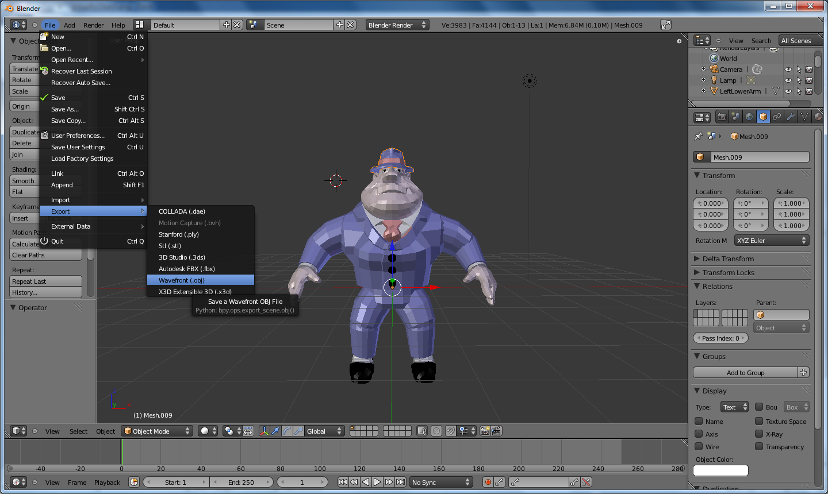
When you are presented with the save menu, you must ensure that you also export the model with normals to ensure that it works correctly within the animation studio.
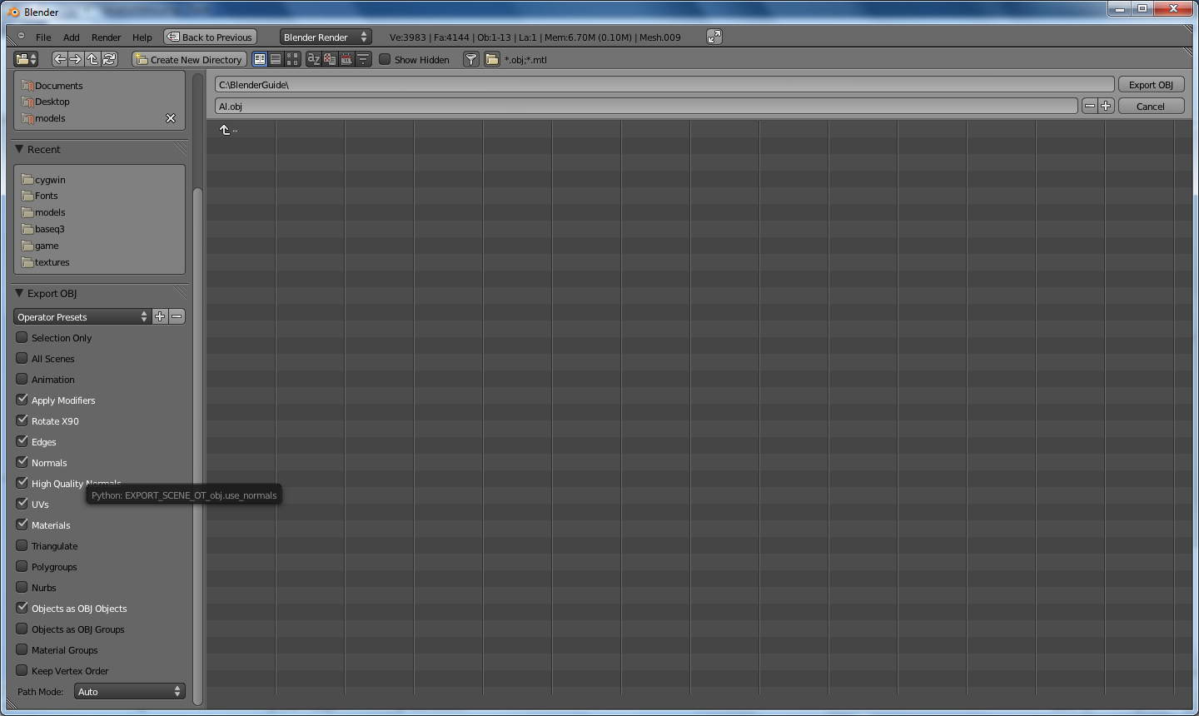
Tip: The first selection you make of the ungrouped body part will be the final name of the grouped body part object after you have chosen to group. e.g. Selecting the head, lips then eye and grouping them by object will mean the body part object will be called 'head'.

3D Studio Max

Naming the parts
As with most applications which will be used in conjuction with wavefront animation studio, you must ensure that parts are relevantly named this is essential when animating the model, having ambiguous names would make it quite difficult to locate which parts you will be animating.
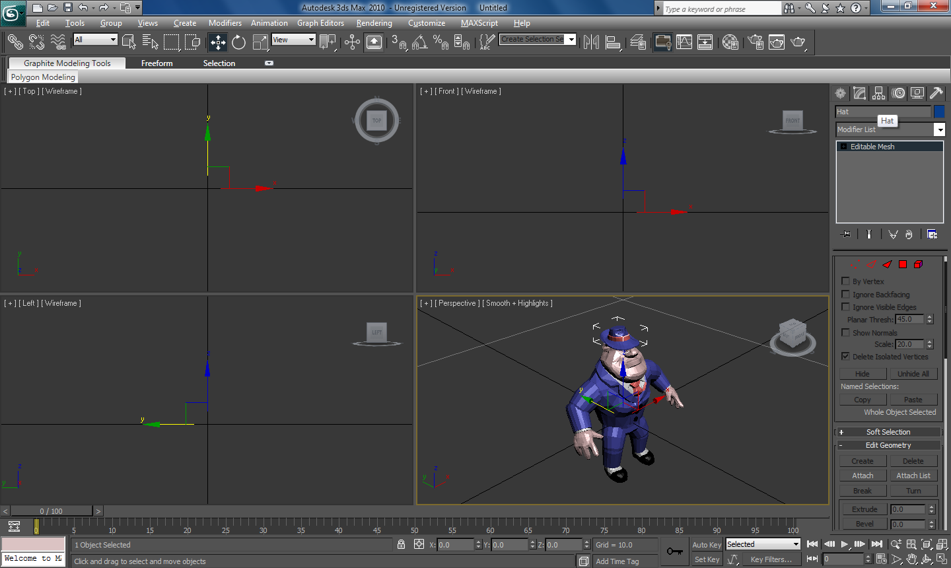

Exporting the model
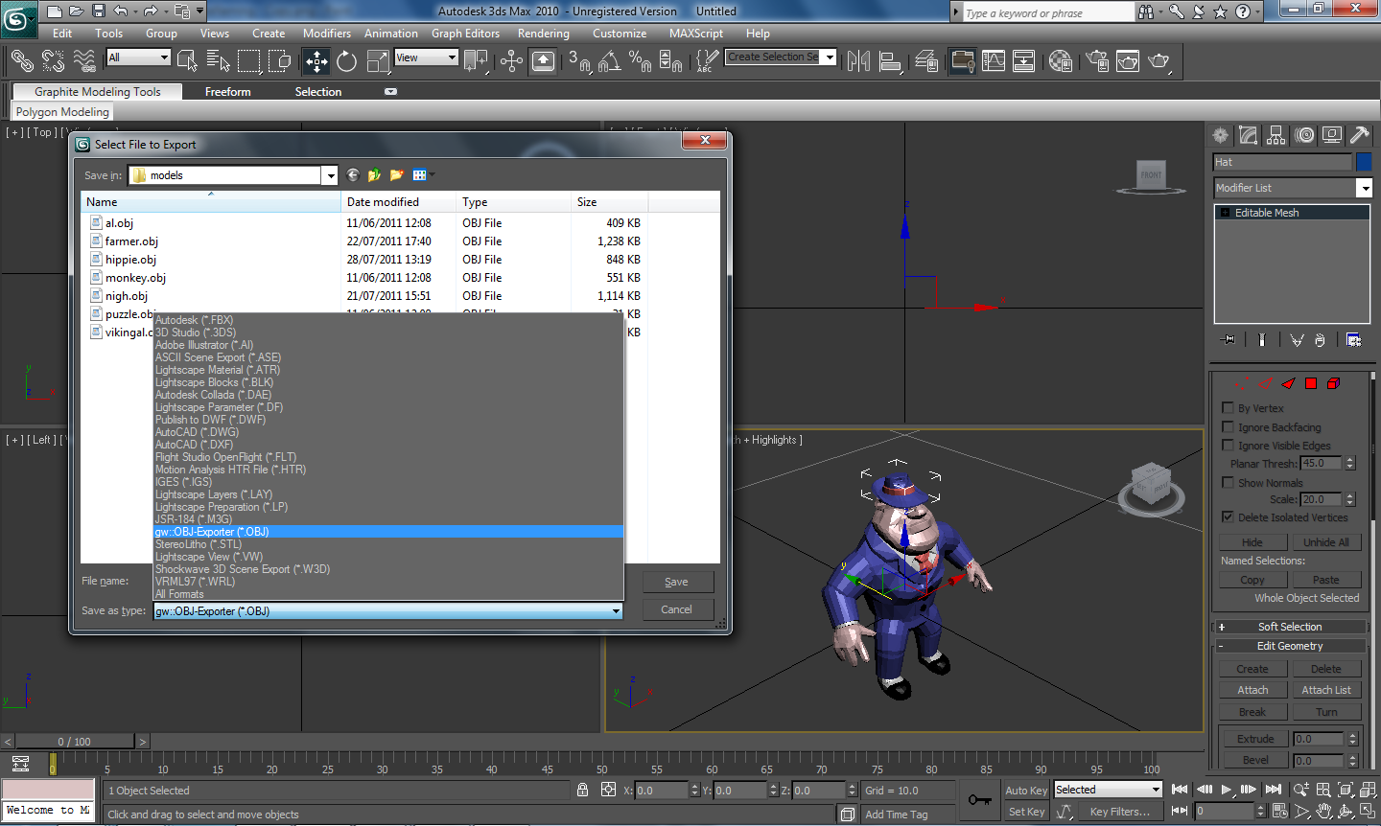
As with most applications 3D Studio Max allows for the exporting of the object (.obj) file format, when exporting please ensure you choose this format and to 'export all' of the model.
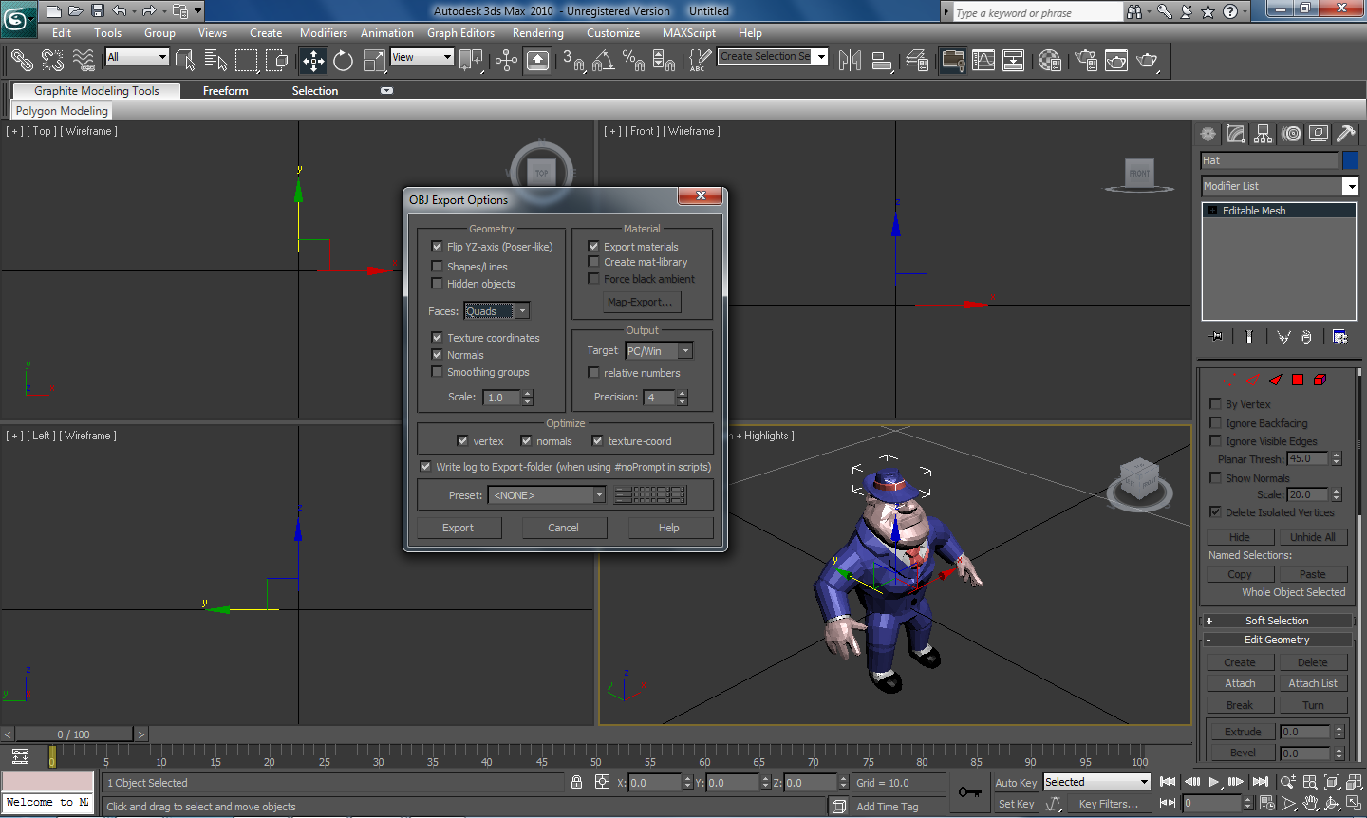
Once you have been presented with the object file format properties menu, you must ensure you export the materials, include the normals and also the texture coordinates.

Maya
Maya is a a large application, used more within industry and is a good application to use to export object models for use within wavefront animation studio.

Naming the parts
Ensuring that the parts you wish to animate are relevantly named is important, this allows for easy selection of model parts within the animation studio. This can be done using the 'attribute editor'. This is located in the 'general' tab and is normally located on the right.
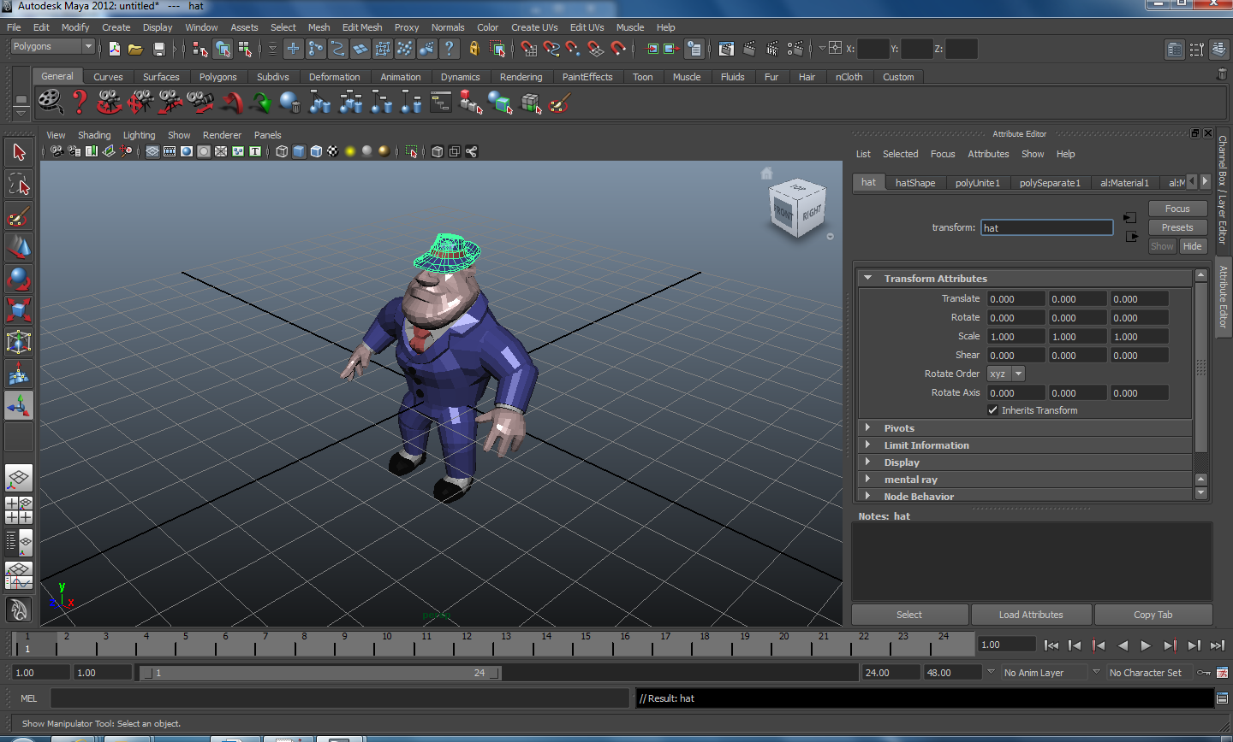

Enabling Object Exporter
Unfortunately the obj exporter is not installed as standard with maya, so here are the steps to include and install it, this must be done prior to being able to export object (.obj) files.
At first you must go to the Window menu at the top of Maya, within the Settings/Preferences menu there is Plug-in Manager selection, once you have chosen this option you will be presented with a menu.
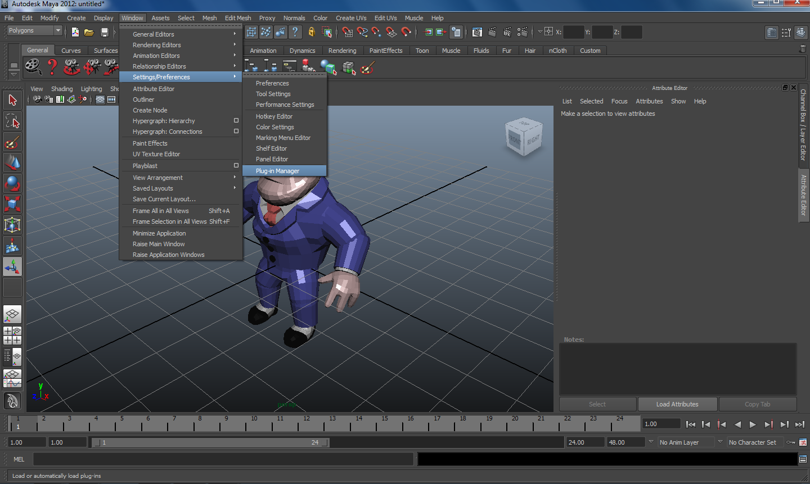
After you have been presented with the Plug-in Manager menu, you will be able to locate objExport.mll, this has a loaded option next to it, if it is not already enabled then you must enable it by ensuring the loaded tickbox is checked.
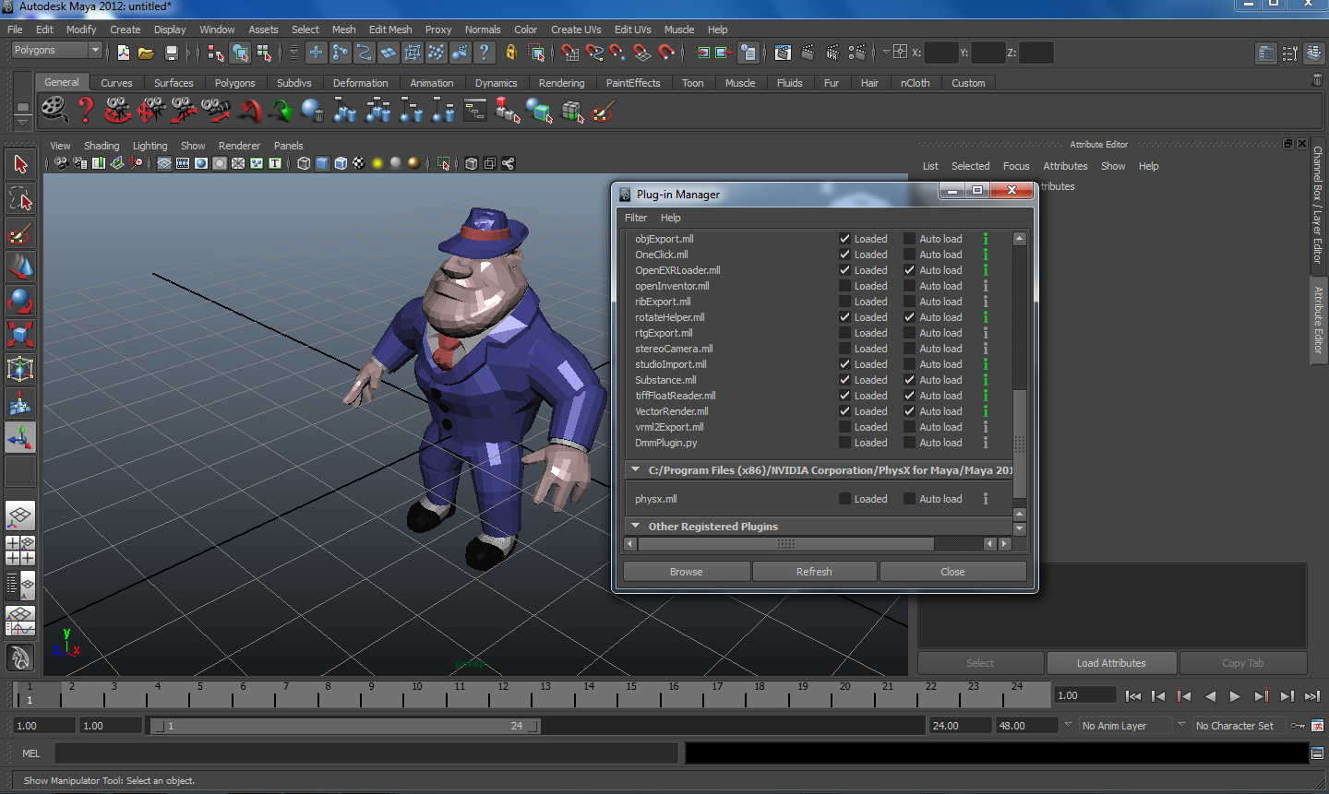

Exporting the model
Once you have enabled the object exporter plug in you will then be able to export your model in the object file format. Make sure when you are exporting that you choose the 'export all' option and not just selected.
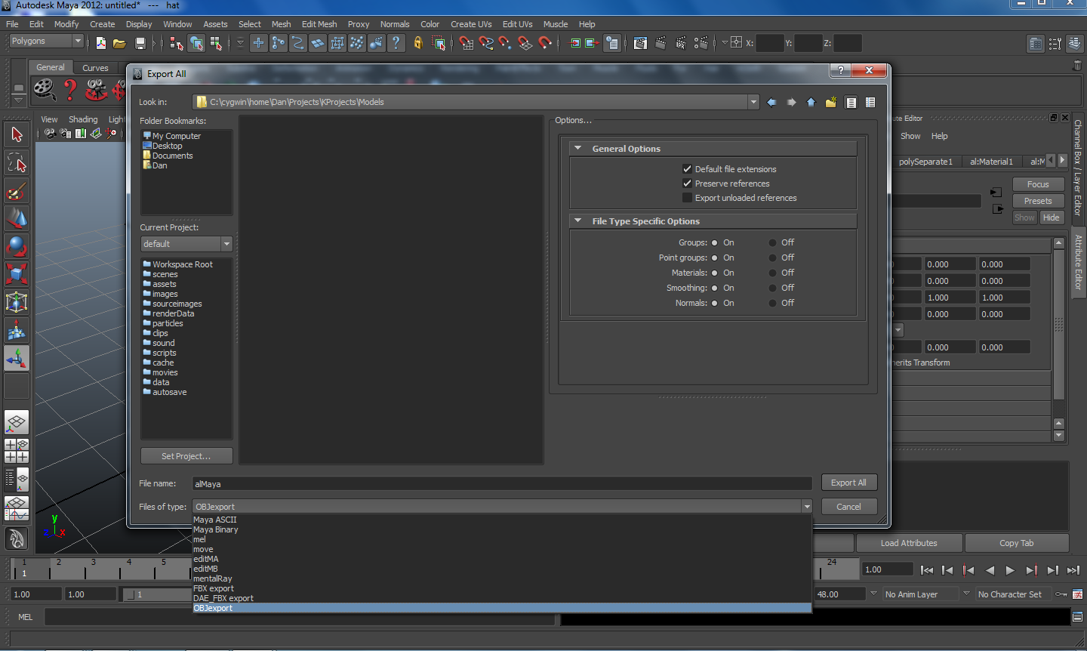

Once you have chosen to export all, you will be presented with the 'Export All' window, within this window, located at the bottom is 'Files of type', you should now be able to choose OBJexport as one of the export options.
All of the 'File Type Specific Options' should be set to on and in the 'General Options' the default file extensions should be checked alongside preserve references.

Import a Model
At present any size of models may be loaded in, however only models in the object format (.obj) may be loaded in to Wavefront Animation Studio, this can be achieved by navigating through the File/Open menu, upon which you shall be presented with a open file navigation dialogue box, this is then used to open the object model of choice. The only file format that will be visible for choice is .obj.
Note: The .mtl file must be located in the same directory as the .obj

Naming an Animation
When an animation is created it must be given a unique name, this name is then used within the developers code for running the individual animation.
Note: The naming of the animation is different to the naming of the animation file and is held internally within the file itself.

Saving an Animation
To save an animation file you must use the 'save' or 'save as' items located within the 'Animation' menu item. If 'save as' is chosen then you shall be presented with a navigation box, this will allow you to navigate to a location of your choosing. The navigation box has a dialogue box located at the bottom, this allows you to save the animation file with a name of your choosing and will always save the file with the .anm file extention.
Note: Any attempt to save the animation file prior to using the 'save as' item will be presented with the 'save as' navigation box.

Animating a model
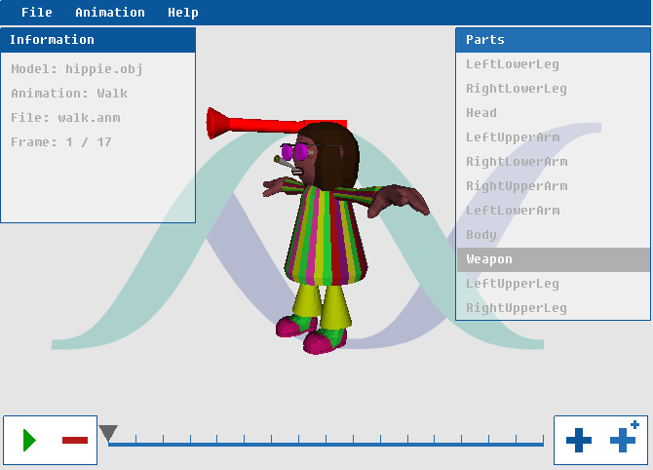

Parts
To create a meaningful animation compilation, it is advised that object models used in WAStudio be made up of separate parts. Each of these parts of a model can be used to create an animation sequence. The more available parts there are in the model the more inventive the animation sequences can be.

Animating Parts
Animating the parts is made as simple as possible using the interface controls, for more detailed information on how to manipulate the parts and create a compilation please see the 'Animation Interface Controls' page.
To allow smoother quicker animation the user can use the interpolation button or the 'plus plus' button detailed in the 'Animation Interface Controls' page. This allows the user to be able to create a middle frame between the currently selected frame and the next frame in the sequence, if the last frame is currently selected then the selected frame is duplicated and is pointless.

Animation Re-use
When beginning to animate a model, it is good to consider if the animation compilation is going to be used with multiple models. If this is the case then the parts that shall be used to animate must correspond to the same parts in all models by giving them the same name. Otherwise the animation sequences will appear incorrectly.

Menu Items

File Menu
Open
Opens file dialogue navigation to select a model to begin animating.
Close
Closes the current model.

Animation Menu
Attach
Allows an animation file to be loaded and attached to the currently loaded model.
Detach
Removes the animation compilation from the model completely, allowing the compilation to be started from the beginning.
Rename
Allows the name of the animation compilation to be altered.
Save As
Allows the current animation compilation to be saved with more specifics.
Save
Saves the current animation compilation.

Help Menu
About
Displays product information.

Bottom Menu
 | Plays the animation compilation from the start, continously.
 | Pauses the currently playing animation compilation, only visible whilst compilation is being played.
 | Removes currently selected animation block.
 | Creates a new animation frame identical to selected frame and moves to it.
 | Creates an interpolation animation frame between currently selected animation frame and next animation frame (halfway created animation frame).
Time line Bar :- Displays all of the animation frames and allows them to be cycled through individually.

Parts Box
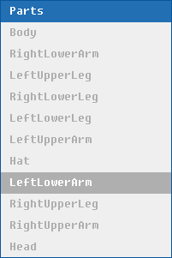
Displays the named objects of the model, these can be selected individually for animating.

Information Box
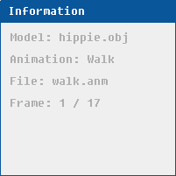
Contains Model name, Animation name, File name and includes how many current frames are in the compilation.

Controls

Keyboard Interface Controls
 | R + Z + Middle Mouse Button rotates the selected object on Z axis, this is achieved by moving the mouse in a left or right motion.
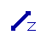 | Z + Middle Mouse Button moves the selected object on Z axis, this is achieved by moving the mouse in an upward or downward motion.
 | R + Middle Mouse Button rotates the selected object on the X axis, this is achieved by moving the mouse in a left or right motion.
 | Middle Mouse Button moves selected object on X axis, this is achieved by moving the mouse in an upward or downward motion.
 | Middle Mouse Button moves selected object on Y axis, this is achieved by moving the mouse in a left or right motion.

Mouse Interface Controls
Right Mouse Button | Rotates the model in the direction of the mouse.
Scroll Wheel | Zooms in or out of the model.

Minimum System Requirements
The hardware requirements of the software is entirely dependent on the complexity of the model you intend to animate. Below is the specification of the hardware we have used to test the product.
Operating System | Processor | Memory | Graphics
Windows XP or Newer | 1.8 Ghz Processor or Higher | 512MB RAM | Intel GMA 950 or Higher
Linux | 1 Ghz Processor or Higher | 256MB RAM | Intel GMA 915 or Higher

