AAON Unit Design Software

The program allows a design engineer to create an air conditioning or a heat pump unit and calculate all required engineering parameters. Refer to the following step by step instructions.

Examples with symmetrical configurations with mirror image relation ship in its components.

1) A system that consists of a) two identical compressors b) two identical condenser coils
c) intertwined evaporator with same number of feeds or near same number of feeds.

2) A system that consists of a) two identical compressors b) two identical condenser coils
c) intertwined evaporator with same number of feeds or near same number of feeds.
d) face split reheat coil coupled with each condenser coil.

3) A system that consists of a) two identical compressors b) face split condenser with
Even number of splits c) intertwined evaporator with same number of feeds or near same number of feeds.

4) A system that consists of a) two identical compressors b) face split evaporator with even splits c) intertwined condenser with same number of feeds or near same number of feeds.

Examples with unsymmetrical configurations without a mirror image relationship.

1) A system that consists of a) two different compressors b) two identical condenser coils
c) intertwined evaporator with same number of feeds or near same number of feeds.

2) A system that consists of a) two compressors b) two identical condenser coils
c) intertwined evaporator with same number of feeds or near same number of feeds.
d) reheat coil coupled with only one condenser coil.

1) To add new Evaporator coil:

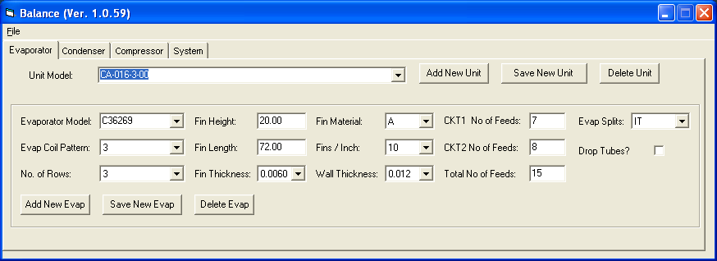

An evaporator model may already exist in the data base. If this is true select the evaporator from the drop down list.

If evaporator does not exist, click “Add New Evap” button.

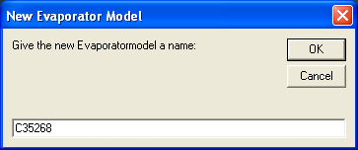

Enter the new evaporator model name in popup message box and click “OK”.

New evaporator model name will appear in drop down list and other data fields will be cleared or appear with defaults.

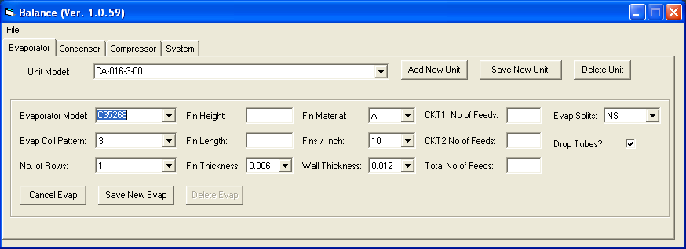

Complete all data fields by selecting appropriate values and entering data for new coil.

- Evaporator circuiting selection:

IT = Intertwined
For an intertwined coil complete circuit 1 number of feeds field and circuit 2 number of feeds field. Total number of feeds must equal sum of circuit 1 and 2 number of feeds.

FS = Face Split
Program assumes circuit 1 number of feeds and circuit 2 number of feeds are equal for a face split coil.

NS = Non Split
For non-split coil, enter the total number of feeds in either circuit. This number must be entered into the total number of feeds box too. Enter zero for the remaining circuit feeds.

During run time, program will check whether the total number of feeds entered allow for an even pass coil. If not, user is alerted as to the possibilities of selecting an even pass coil. If you chose to make a coil with drop tubes, please check the “Drop Tubes?” box. You could choose a number for total feeds which makes an even pass coil by dropping few tubes. Program will allow up to 10% of drop tubes. For 7 mm coils please enter an integral multiple of 0.827 as fin height. For other coil patterns enter an integral multiple of corresponding transverse tube distance in AAON coil pattern.

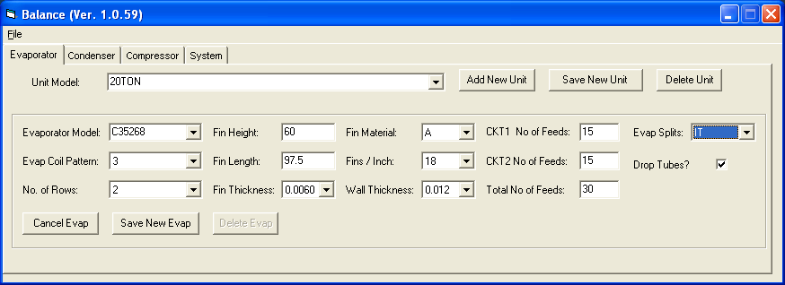

Once you are done completing all data, please click “Save New Evap” button to save new evaporator model into the database file.

2) To add new condenser coil:

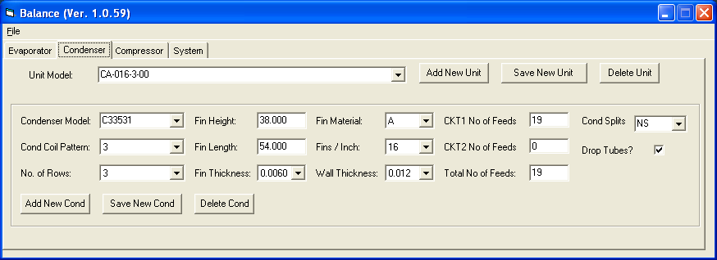

A condenser model may already exist in the data base. If this is true select the condenser from the drop down list.

Select condenser tab. Steps are identical to add new evaporator model. If condenser does not exist, click “Add New Cond” button. Enter the new condenser model name in popup message box and click “OK”. New condenser model name will appear in drop down list and other data fields will be cleared or appear with defaults. Complete all data fields by selecting appropriate values and entering data for new coil.

- Condenser circuiting selection:

IT = Intertwined
For an intertwined coil complete circuit 1 number of feeds field and circuit 2 number of feeds field. Total number of feeds must equal sum of circuit 1 and 2 number of feeds.

FS = Face Split
Program assumes circuit 1 number feeds and circuit 2 number of feeds are equal for a face split coil.

NS = Non Split
For non-split coil, enter the total number of feeds in either circuit. This number must be entered into the total number of feeds box too. Enter zero for the remaining circuit feeds.

During run time, program will check whether the total number of feeds entered allow for an even pass coil. If not, user is alerted as to the possibilities of selecting an even pass coil. Please refer to the evaporator circuiting section for drop tubes and fin height selection instructions.

Once you are done completing all data, please click “Save New Cond” button to save new condenser model into the database file.

3) To select appropriate compressor:

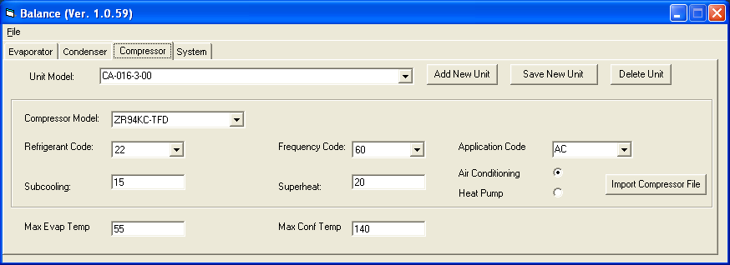

Select compressor tab. Select the compressor model, frequency, refrigerant and the correct application code. Copeland defines their application codes as follows:

AC - Capacity at 100%
AH - Half of even tandem
A6 - 66% of tandem
A5 - 50% of tandem
AL - Larger of the uneven tandem
AS - Smaller of the uneven tandem

(Current version of the program is set for 55% for AL and 45% for AS case. Please contact Nimal Rajasinghe, if you have a different unit with “AL” and “AS” compressors)

Do not change the sub-cool and super-heat defaults values at this stage. (For these two quantities change in input can be made once the complete unit model has been saved)
Note: All air conditioning scroll compressors are already included in the data base. If you desire to add a medium temperature, high temperature or any other variant follow these steps:

a) Run CpCalc program provided by Copeland. Save the compressor coefficients file to a desired directory in you computer. Click “Import Compressor File” in compressor tab page. File selection window will pop up. Move to the appropriate directory and click on the coefficient file generated by the CpCalc program.

4) To add a new unit:

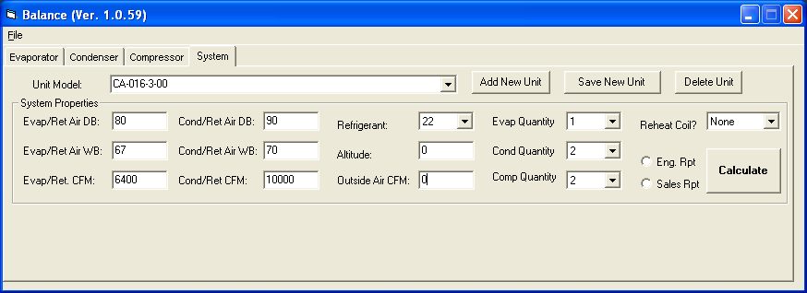

Unit model may already exist in the data base. If this is true select the unit model from the drop down list.

If unit model does not exists in the data base, you must add and save a new unit model before doing any calculations with the coils and compressor(s) you saved or selected above.

Select system tab. Click “Add New Unit” button. Complete the message box with the unit model name. We strongly recommend using AAON configuration for the unit model. Since AAON unit configuration is common to many departments with AAON Inc. Remember Unit model name is what links all other components and system data together in the data base file.

Click “OK” button in the message box. System data fields are now ready to accept your data. Defaults can be change to preferred data. Complete the system data including design conditions, evaporator quantity, condenser quantity, compressor quantity etc.

Please select “None” at reheat field if reheat option is not offered with this unit

Click “Save New Unit” button. Now your new set of coils and selected compressor(s) are all linked to the unit model you created.

The “Calculate” button will generate a computed output.

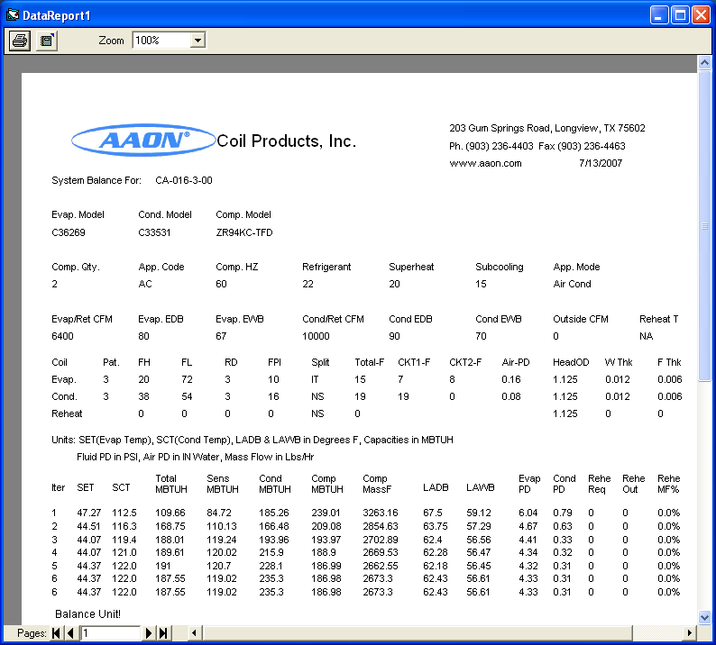

For a system with a reheat coil, select the appropriate configuration of reheat from the drop down list. There are three selections of reheat configurations in the list. These correspond to three different piping arrangements AAON Inc., has designed.
1) Vapor Parallel 2) Vapor Series 3) Liquid

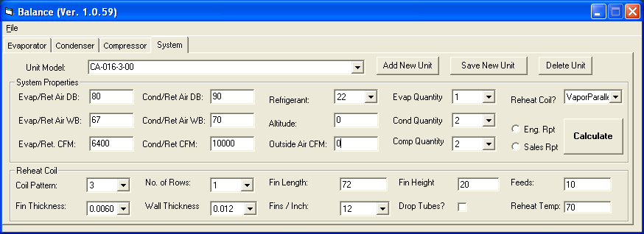

Select the desired reheat configuration. Reheat coil data input frame will be visible in the system tab. Complete all data fields to achieve the desired output (reheated temperature).

Click “Save New Unit” button to save this unit model. Now your new set of coils, selected compressor(s) are all linked to the unit model you created. Reheat coil data will also be saved along with other unit data.

Click “Calculate” button to obtain a computed out put for a system with a reheat coil.

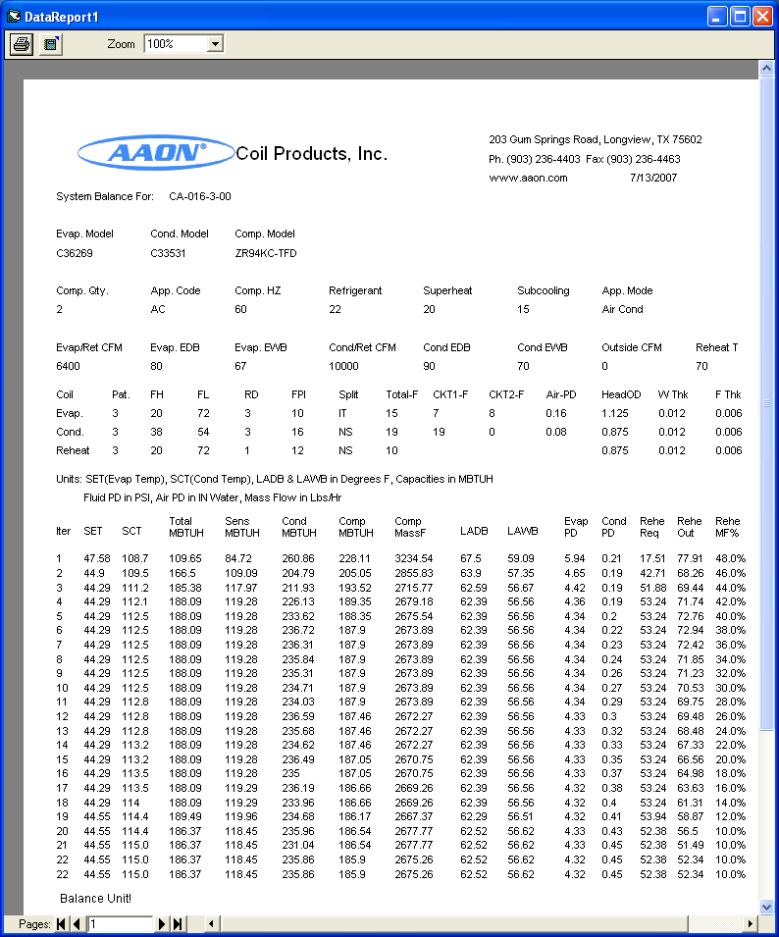

At given instance the selected unit will link the compressor, coils and the system data you saved with unit model. Changes to any data fields are possible, in-order to make engineering design decisions. Unit model will be linked to evaporator model name, condenser model name, compressor model name, Comp frequency, refrigerant, and comp application code.

Note: After saving the unit model you can change any data field of your choice (superheat and sub-cool settings etc). Please read following section to learn how to make these changes permanent or temporary.

5) Changing data fields after saving a unit:

There are four database tables associated with the program. They are evaporator, condenser, compressor and unit.

You can accomplish a permanent change to the database by clicking “Save” button in corresponding tab. You can also accomplish the same by following steps.

- Change your data
- Select a different model in corresponding table.
- Before computation, select the original model in corresponding table that has been updated with new data.

For example changes sub-cool and superheat can be accomplished by selecting different unit model in the drop down list after changing the data field. To change the fin thickness of the evaporator change the fin thickness and select a different evaporator model from the drop down list. These changes will be saved to the corresponding data base table.
If you select a different model in any given tab to accomplish changes to data fields you must select the original model before computing the desired output.

To keep changes in temporary state, do not select a different model in corresponding data table. You can calculate a different output results for a temporary data changes.

6) Computation for a single compressor unit:

- Select an existing “NS” evaporator or save a new “NS” evaporator
- Select an existing “NS” condenser or save a new “NS” condenser
- Select appropriate compressor, frequency, refrigerant and the application code.
- Select an existing unit model or save a new unit model after completing the system data.
(Select 1 in each of the fields, evaporator quantity, condenser quantity and compressor quantity)
- Click calculate button.

7) Computation for a dual unit with one intertwined evaporator, two “NS” condensers and two compressors:

- Select an existing “IT” evaporator or save a new “IT” evaporator
- Select an existing “NS” condenser or save a new “NS” condenser
- Select appropriate compressor, frequency, refrigerant and the application code.
- Select an existing unit model or save a new unit model after completing the system data.
(Select 2 in each of the field’s condenser quantity and compressor quantity. Select 1 in evaporator quantity field.)
- Click calculate button.

To evaluate part load capacity of above, simply select 1 in compressor quantity drop down list and calculate.

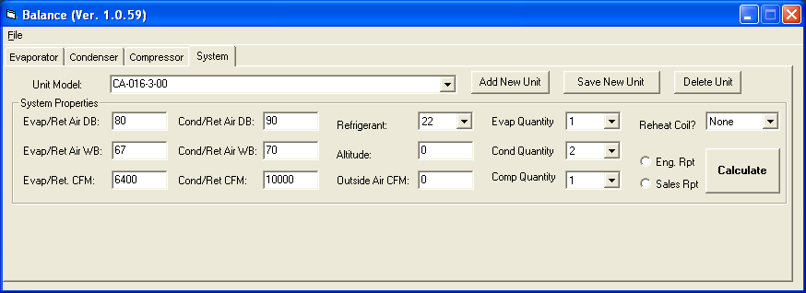

8) Computation for a dual unit with one intertwined evaporator, one intertwined condenser and two compressors:

- Select an existing “IT” evaporator or save a new “IT” evaporator
- Select an existing “IT” condenser or save a new “IT” condenser
- Select appropriate compressor, frequency, refrigerant and the application code.
- Select an existing unit model or save a new unit model after completing the system data.
(Select 1 in each of the field’s condenser quantity and evaporator quantity. Select 2 in compressor quantity field.)
- Click calculate button.

To evaluate part load capacity of above, simply select 1 in compressor quantity drop down list and calculate.

9) Computation for a dual unit with one intertwined evaporator, two “NS” condensers and two tandem compressors:

- Select an existing “IT” evaporator or save a new “IT” evaporator
- Select an existing “NS” condenser or save a new “NS” condenser
- Select appropriate tandem compressor, frequency, refrigerant and the application code.
- Select an existing unit model or save a new unit model after completing the system data.
(Select 2 in each of the field’s condenser quantity and compressor quantity. Select 1 in evaporator quantity field.)
- Click calculate button.

To evaluate 50% part load capacity of above, simply select “AH” in compressor application code drop down list and calculate. To evaluate 25% part load capacity of above select “AH” in compressor application code drop down list and select 1 in compressor quantity drop down list and calculate.

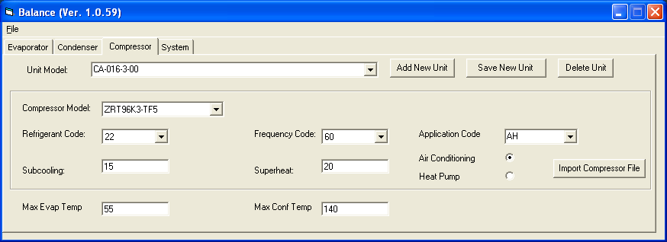

10) Computation for a dual unit with one intertwined evaporator, one intertwined condensers and two tandem compressors:

- Select an existing “IT” evaporator or save a new “IT” evaporator
- Select an existing “IT” condenser or save a new “IT” condenser
- Select appropriate tandem compressor, frequency, refrigerant and the application code.
- Select an existing unit model or save a new unit model after completing the system data.
(Select 1 in each of the field’s condenser quantity and evaporator quantity. Select 2 in compressor quantity field.)
- Click calculate button.

To evaluate 50% part load capacity of above, simply select “AH” in compressor application code drop down list and calculate. To evaluate 25% part load capacity of above select “AH” in compressor application code drop down list and select 1 in compressor quantity drop down list and calculate.

11) To create a heat pump from an existing air conditioning unit:

Select the air conditioning unit from the unit model drop down and simply click on heat pump option button in compressor tab page. The extension “HeatPump” will be added to the unit name. All above mentioned computational methods can be repeated with the heat pump unit.

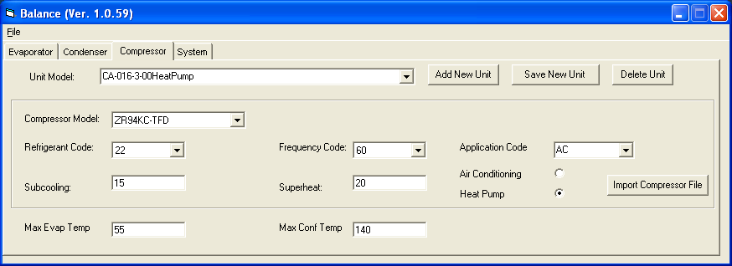

Heat pump defaults value are selected in accordance with ARI 210/240, 47 F DB/
43 F WB.

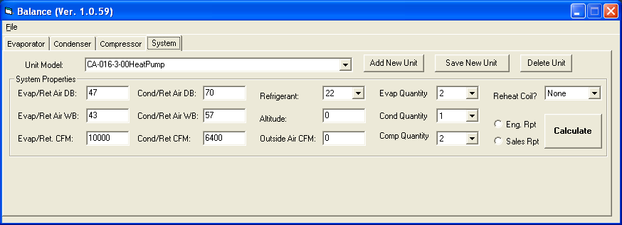

You can create a heat pump unit and have the program generate corresponding air conditioning unit by clicking on air conditioning option button in compressor tab page.
When you are creating a heat pump add the extension “HeatPump” to the end of the unit model name.

For an Air Conditioning unit:
Evaporator Entering CFM = Return CFM + Outside CFM

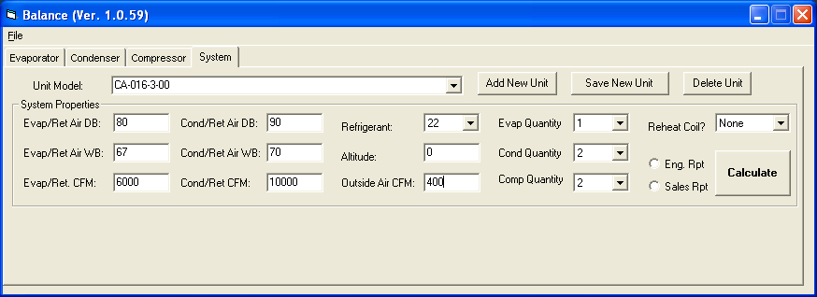

For a Heat Pump Unit:
Condenser Entering CFM = Return CFM + Outside CFM

Program will calculate mixed air CFM and dry/wet bulb condition.

12) In the event your unit does not balance:

First examine the difference between the evaporator capacity and compressor capacity

Next examine the difference between the condenser heat rejection and evaporator capacity. Heat rejection must be less than 1.33 X evaporator capacity.

Changing coil parameters (rows, fins/inch etc) and CFM needs to be considered.

In the event your unit with reheat does not balance; In addition to two of the above,

Please examine the difference between required reheat capacity and the actual reheat output. Reheat coil configuration must be changed to get them within 4% of each other.

Piping diagrams for vapor parallel and vapor series reheat configurations are included in this help file.

Reheat piping diagram for vapor parallel:

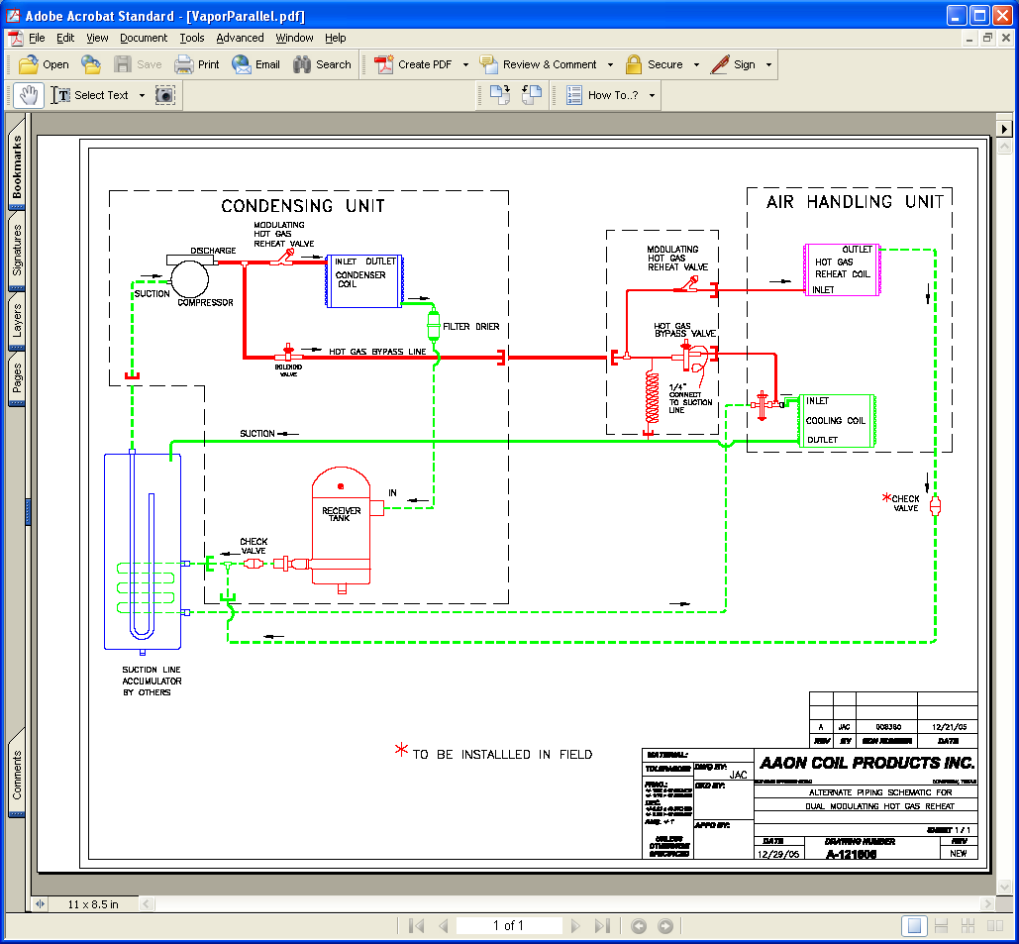

Reheat piping diagram for vapor series:

