**INTRODUCTION**

In today’s world, the need of medical attention is very much needed due to current living lifestyle follow by the peoples especially in the cities. Thus, this causes the increase in the number of hospitals. Based on the statistics, in Malaysia the number of private hospitals is far more higher, almost double to the available public hospitals [1].

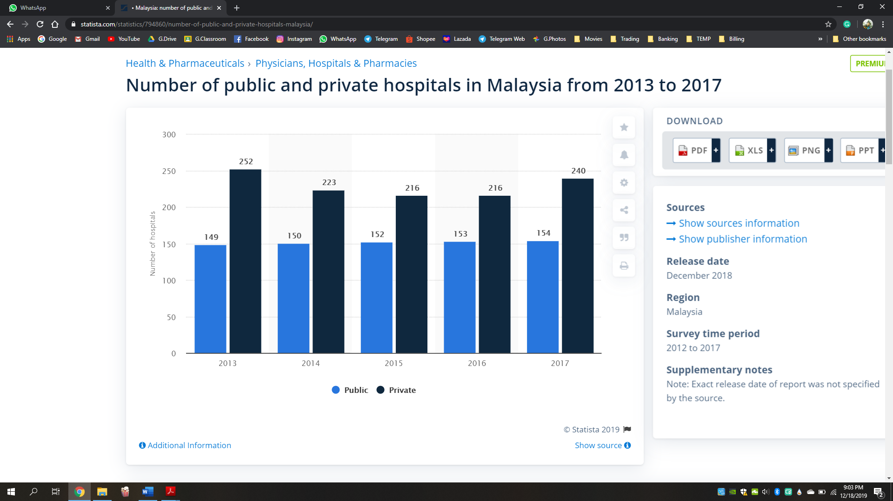

Figure 1: Number of public and private hospitals in Malaysia from 2013 to 2017

Furthermore, the cost of the private hospitals is fairly higher than the public hospital. Based on a survey conducted in 2018, for the most basic consultation fee is from RM 30 to RM 250 at the private hospitals where the consultation fee is only RM 1 at the public hospitals [2]. This cost difference is mainly cause by the care and attentions that are given to the patients. The public hospital couldn’t afford this sort of services due at the lowest cost charged to the patient. Patients for who want to get better care or who are affordable preferers the private hospital for the attentions given for the high cost. On the other hand, the patients who can’t afford the cost of the private hospitals has no choice to go for the public hospitals even though these hospitals can’t afford personal assistance for their critical level patients. In traditional way, these hospitals have to hire more medical personnel’s in order to cope with the population. As the ratio of the medical personnel to the population is continuously increasing based the DEPARTMENT OF STATISTICS MALAYSIA. This causes the inability to provide assistance and care by the staff for all day long to their patients. In addition to that, it is even more difficult to monitor any problems faced by the patients when they are asleep.

To overcome this problem this paper proposes the system which will be capable of monitoring the heart pulse, body thermal and facial expression and sending this information to respective person in charge if any abnormal activities takes place. This system is constructed using multiple technologies, such as the Raspberry Pi, Electrocardiogram (ECG), thermal sensors, facial recognition technology and cloud-based computing.

Raspberry Pi is a credit card sized single board computer weighs only 50g. It uses power rating of 5V, 700mA and cost effective than an actual computer. The board comes in different models A, B and a more advanced version B+. The B+ model has 512 MB RAM, runs on ARMII processor and has an operating frequency around 700MHz. Many Operating systems like Raspbian, Pidora, and Raspbmc can be installed using a SD card. Different peripherals like mouse, keyboard, Wi-Fi adapter can be connected using its four USB2.0 ports to make it a full-size computer. Also, the board consists of an Ethernet port to connect to network, GPIO pins to interface and control switches, sensors, LEDs and other devices. All kinds of monitors like projectors, LCD screens, TVs can be connected using HDMI port. Some additional features include the audio jack and the camera connector to interface camera. These numerous features enable the users to use Raspberry pi in wide range of applications.

The electrocardiogram (ECG or EKG) is the register of heart's electrical activity. Heart muscles contract by electrical stimulation, known as activation or excitation. These muscles are electrically charged at rest and get contracted by depolarizing the charge. ECG [3]is the graph of these electrical signals. It gives the information about heart rate and rhythm, and the mass or volume of the chambers of heart.

A temperature sensor is a device, usually an RTD (resistance temperature detector) or a thermocouple, that collects the data about temperature from a particular source and converts the data into understandable form for a device or an observer. Temperature sensors are used in many applications like HV and AC system environmental controls, food processing units, medical devices, chemical handling and automotive under the hood monitoring and controlling systems, etc.

The most common type of temperature sensor is a thermometer, which is used to measure temperature of solids, liquids and gases. It is also a common type of temperature sensor mostly used for non-scientific purposes because it is not so accurate.

The rest of the paper is structured as follows. Section II deals with the system design. Section III discusses the implementation of the program and Section IV presents the results. Finally, Section V explains the conclusion.

**LITERATURE REVIEW**

**An IoT Based Patient Monitoring System Using Raspberry Pi.**

To develop a system that can collect the patient’s health status for medical needs. Patients body temperature, body movements, respiration and heart rate are measured using respective sensors. Unable to process and display the collected data using web-based clouds.

**Personal Heart Monitoring and Rehabilitation System using Smart Phones**

The main objective is to investigate and develop a portable application whereby a heart patient is monitored using one or more (wireless) sensors. Personalize the monitoring and we have mechanisms in place to locate the user in case of emergency. We detect life threatening arrhythmias and give the patient general information about their health when they are not in a dangerous situation. Includes rehabilitation applications that can be personalized for the patients and monitor their progress. Needs a person in charge to monitor the system on the clinical side.

**Healthcare based on IoT using Raspberry Pi**

The basic aim of system design is to monitor different ECG machines automatically, updating the database of website continuously and alerting the doctors by a message, if the health parameters are not in range of normal values. This system is designed to continuously monitor the Electrocardiogram (ECG) and other vital parameters. Only uses one sensor to determine a person health condition

**SYSTEM ARCHITECTURE**

The functionality of the developed PMS is shown in Figure 2. The system comprises of 3 layers: hardware layer, cloud layer and software layer. The hardware layer encompasses the sensor node which are collecting health data and transmitting to the cloud for analytics. The sensor node consists of an ECG sensor, a Pi camera and a Raspberry Pi (RPi). The ECG sensor readings are sent to the cloud via RPi. The RPi uses a convolutional neural network model to perform facial emotional analysis to identify the emotional quality (EQ) score. Both the ECG data and the EQ score are sent to the cloud layer.

At cloud layer, the data is stored, analyzed and processed with heavy computational algorithms. These analytics results are then stored in the local database for future references. When abnormalities such a high heartbeat rate or low EQ score are detected, a notification alerting for immediate action is sent to the software layer. The software layer is a graphical user interface which displays all the data in textual or graphical format. This acts as the interface for the medical staff to monitor the patients continuously.



Cloud Layer

Software Layer

Data sent from the hardware layer are analyzed to present the data in graphical format and also to calculate the EQ score

Hardware Layer

Images of patient are captured at an interval to evaluate the EQ score continuously. The interval depends on the patient’s EQ score

The interface is used to alert the medical staff in case of emergency. Medical experts are also continuously updated regarding patient’s health

ECG data are measured using ECG sensors attached to the patient’s body. These readings are then sent to the cloud via RPi

**Figure 2: Patient Monitoring System Architecture**

# **REFERENCES**

|  |  |
| --- | --- |
| [1] | S. R. Department, "Number of public and private hospitals in Malaysia 2013-2017," Statista Research Department, , 5 July 2019. [Online]. Available: https://www.statista.com/statistics/794860/number-of-public-and-private-hospitals-malaysia/. |
| [2] | T. R. Team, "Government and Private Hospitals in Malaysia: How Much Do They Really Cost?," RinggitPlus, 24 May 2018. [Online]. Available: https://ringgitplus.com/en/blog/Insurance/Government-and-Private-Hospitals-in-Malaysia-How-Much-Do-They-Really-Cost.html. |
| [3] | H. Rate. [Online]. Available: http://www.practicalclinicalskills.com. |