Lab manual – VPC-Peering

Topics
- VPC-Peering - Diagram
- Configure EC2 instance with public IP in the N.Virginia
- Configure EC2 instance with only private IP in the Canada
- Configure VPC Peering
- Update Routing table of N.Virginia
- Update Routing Table of Oregon
- Check the Connectivity Between EC2 instance in both the Regions.

- VPC-Peering - Diagram
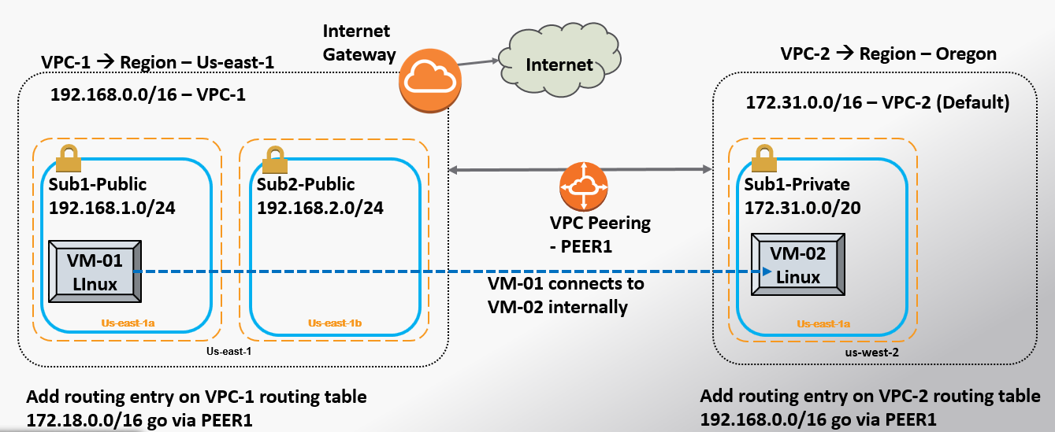

- Configure EC2 instance with public IP in the N.Virginia
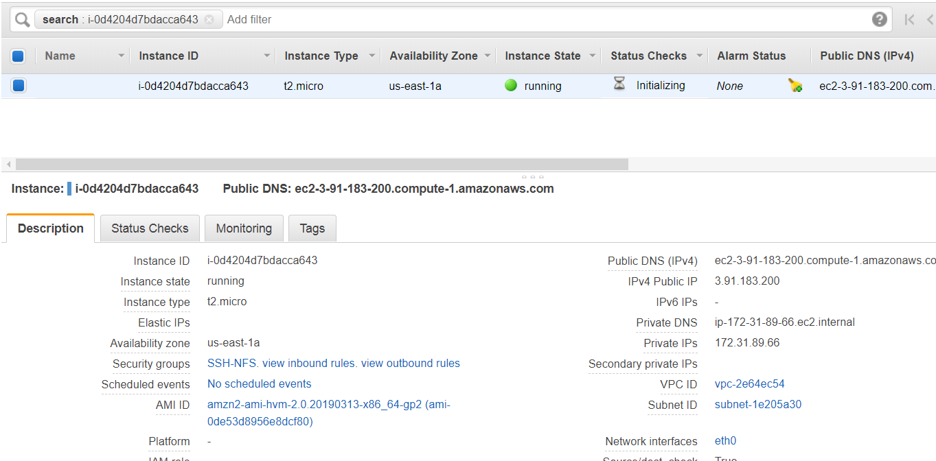

- Configure EC2 instance with only private IP in the Canada
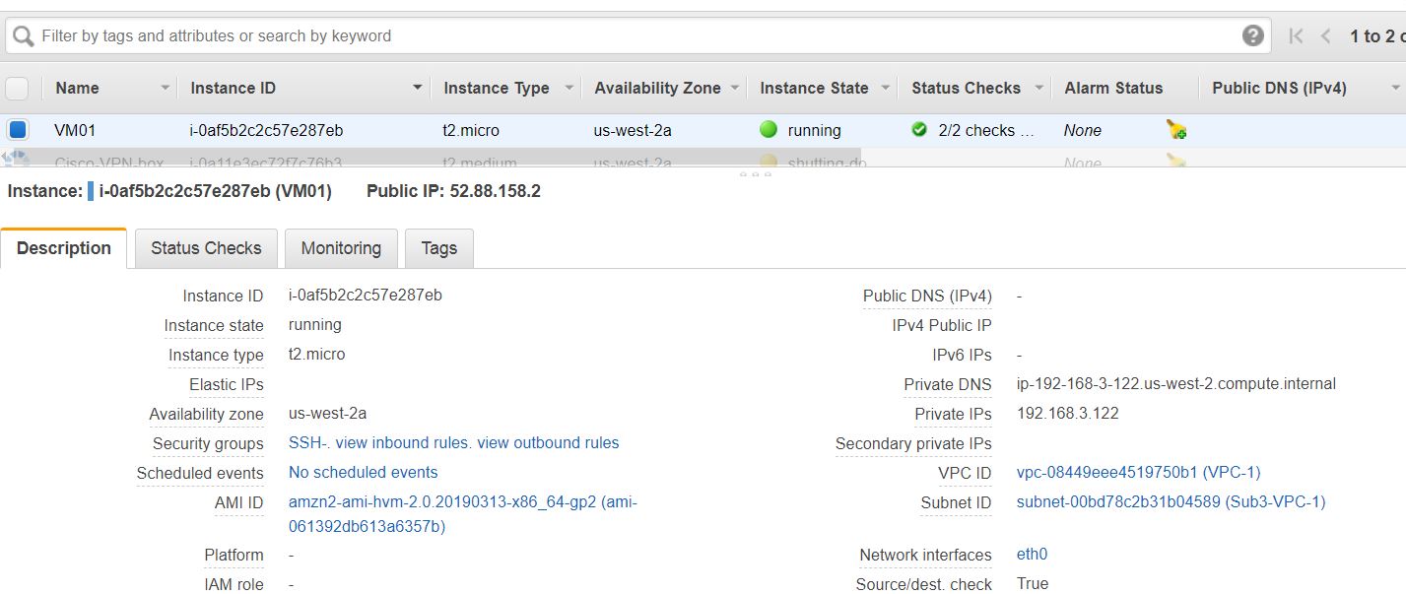
This has only “Private IP”.

- Configure VPC-Peering
  - Click on the “Peering” under the VPC option.
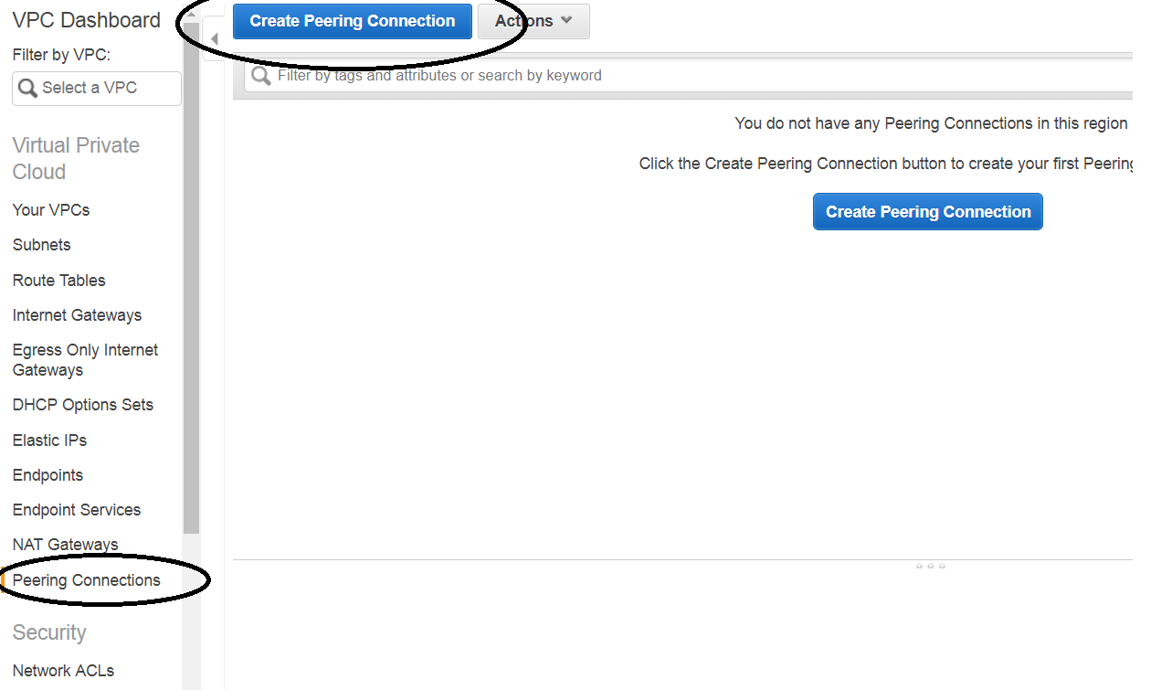
  - Configure the VPC details of both side.
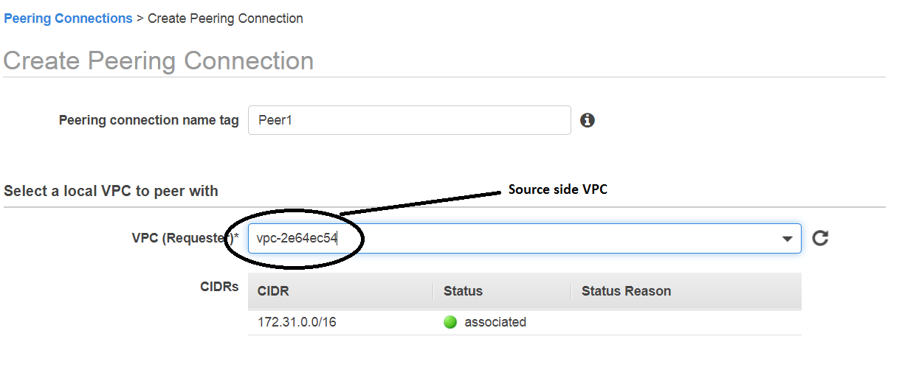
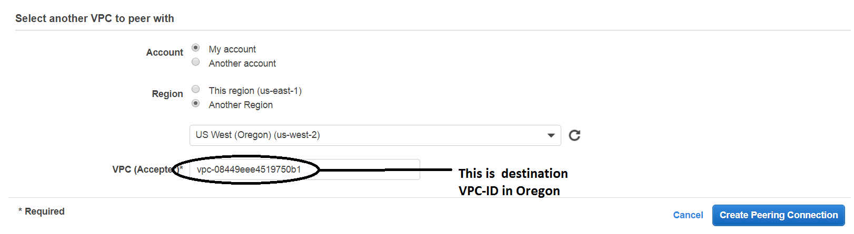

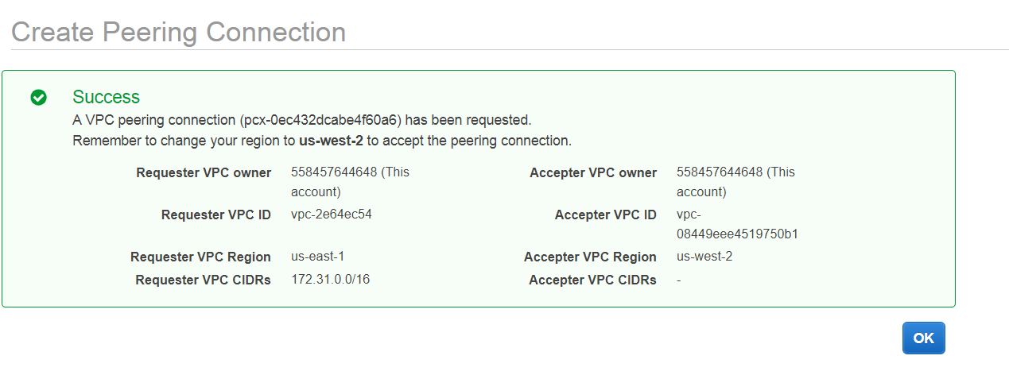
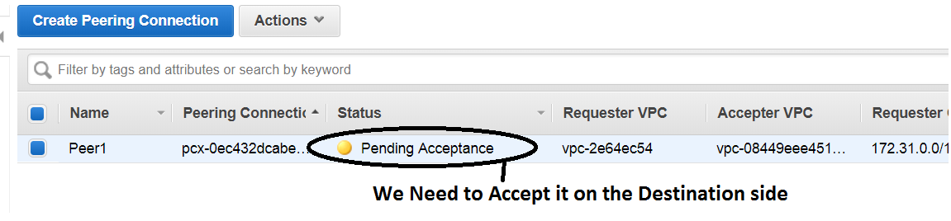

  - Accept it on the “Oregon Side”.
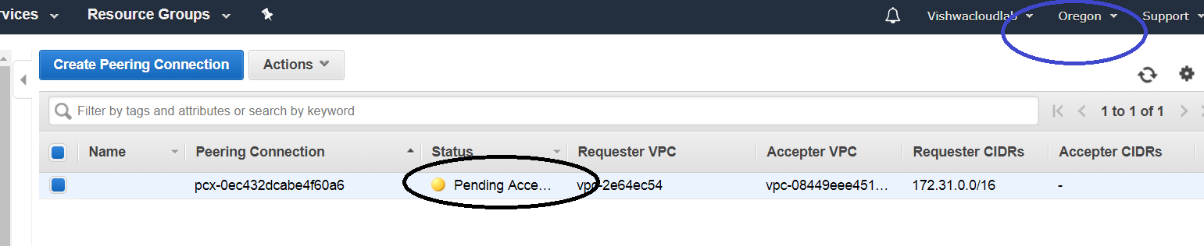
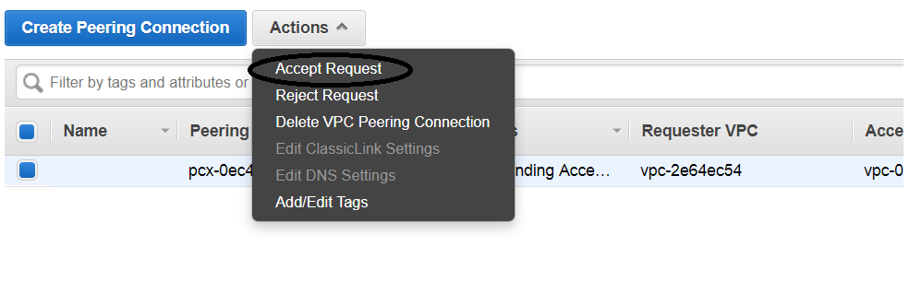

  - Output of both side VPC peering
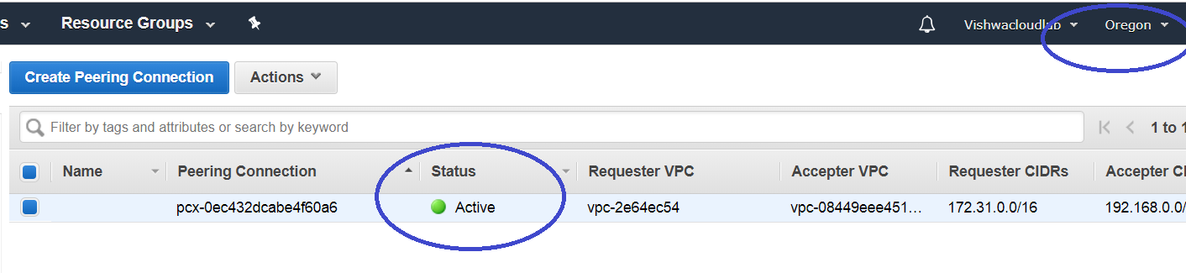
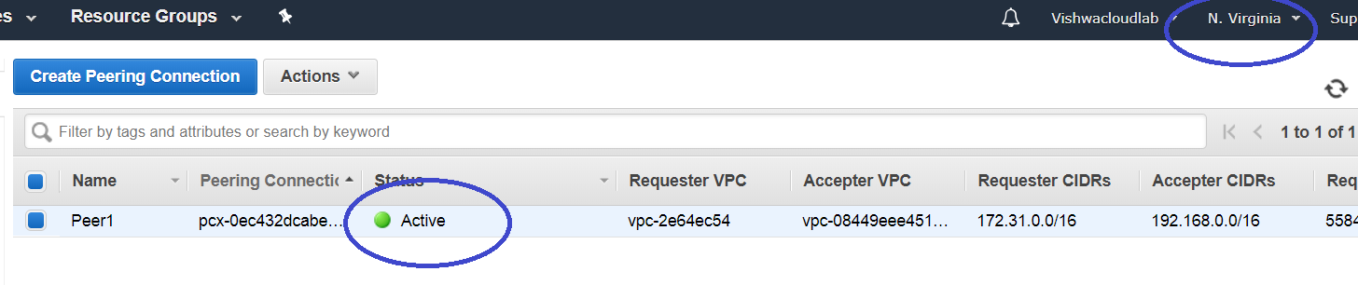

- Update Routing table of N.Virginia
Update the route Table with the Oregon VPC CIDR in the Destination.
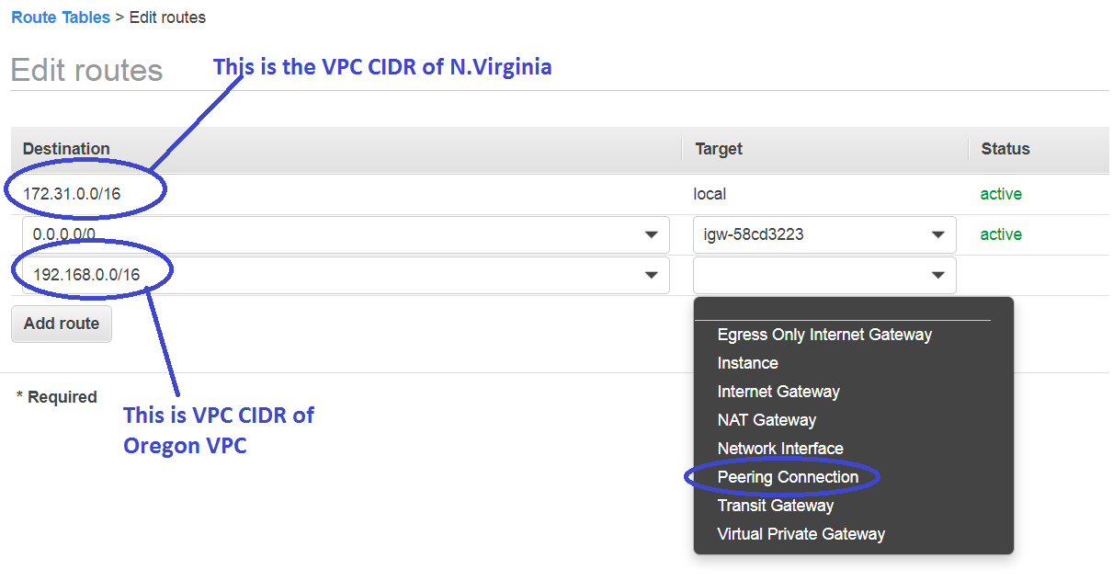
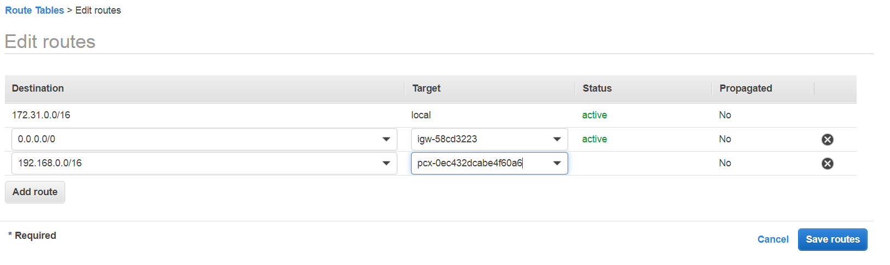
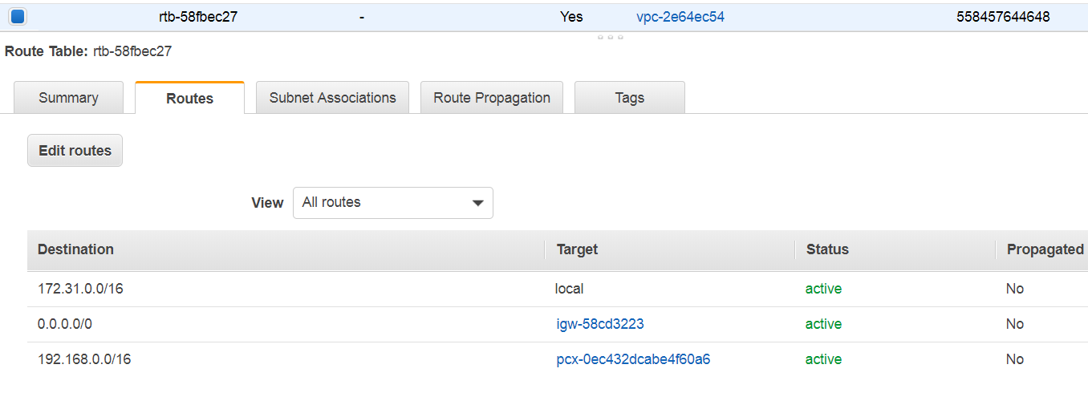

- Update Routing table of Oregon

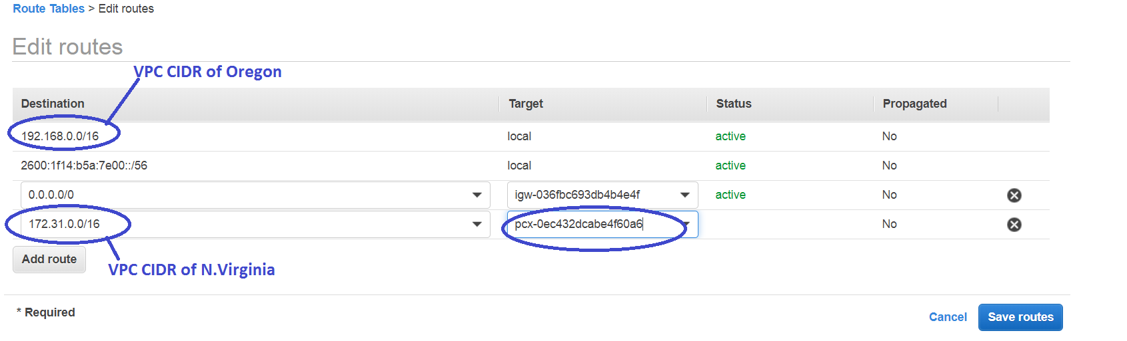
Input the CIDR of the N.Virginia VPC and select the Peering connection ID that was just created in the above.

- Check the Connectivity Between EC2 instance in both the Regions.
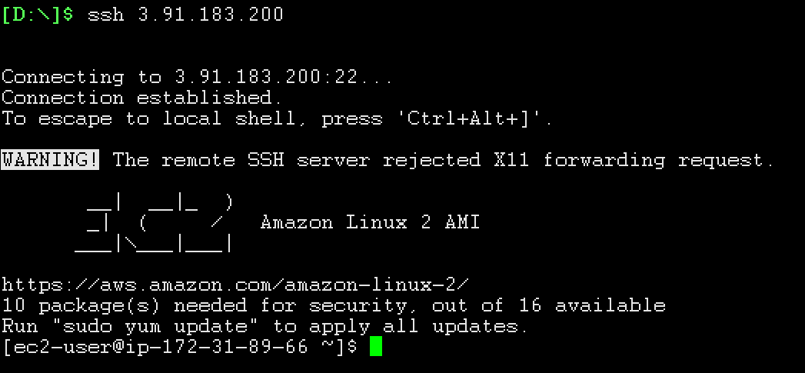
Login to the EC2 in the N.Virginia,
Source IP 172.31.89.66
Destination IP 192.168.3.122
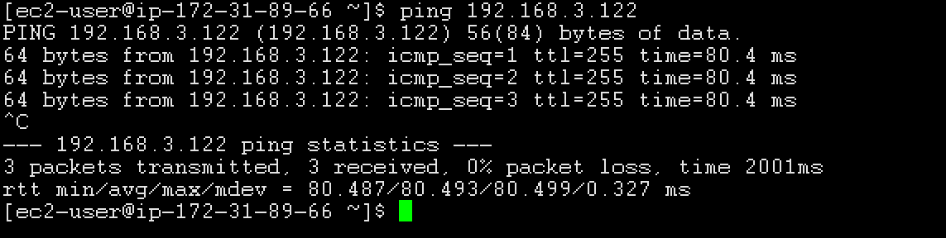
We, are able to ping the destination.
Which means, VPC PEERING IS WORKING FINE.

