Lab manual – S3 – Simple Storage Service

Steps
- Create log bucket
- Create data bucket
- Upload the File

- Create log bucket
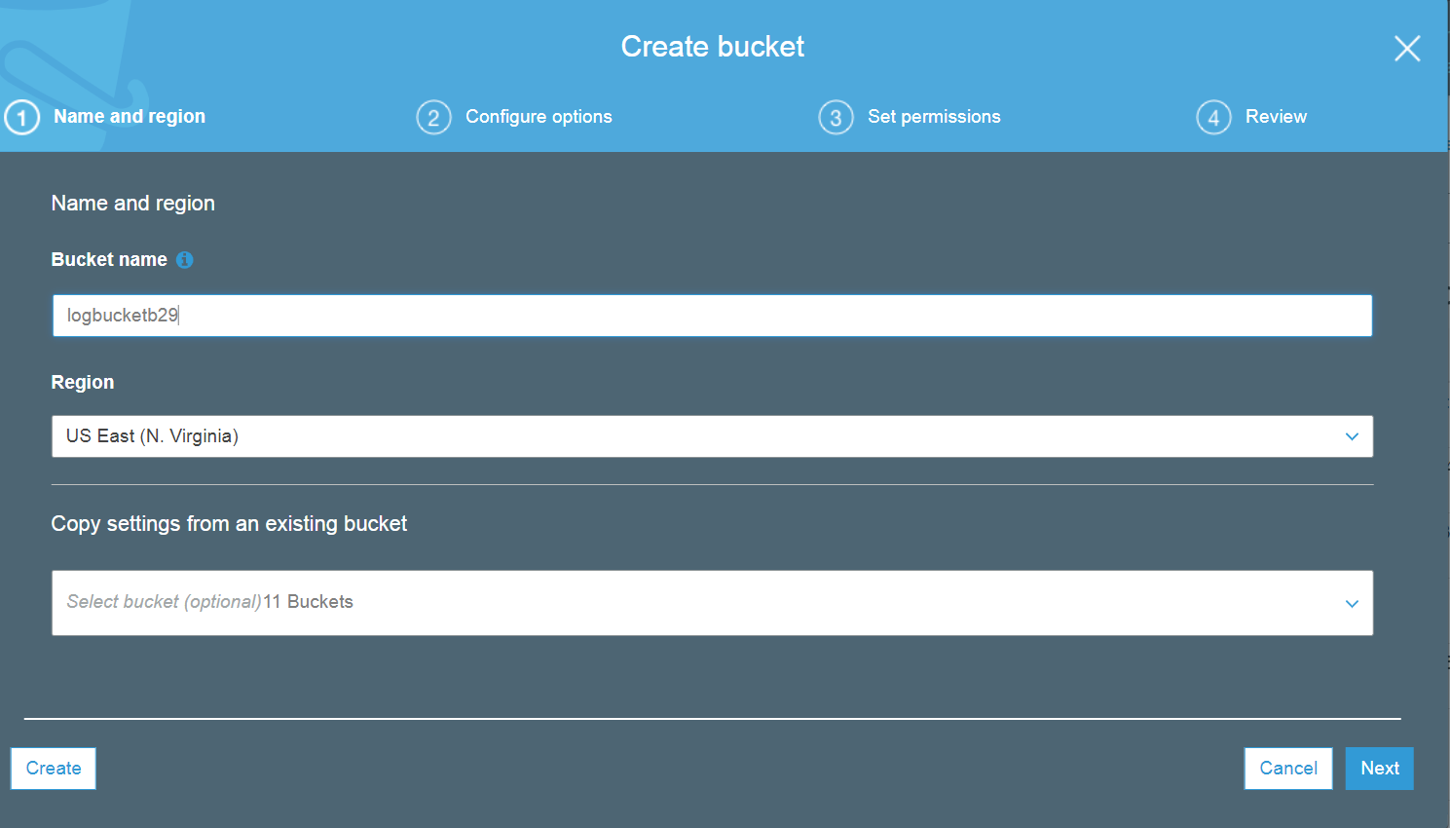
Click "NEXT".
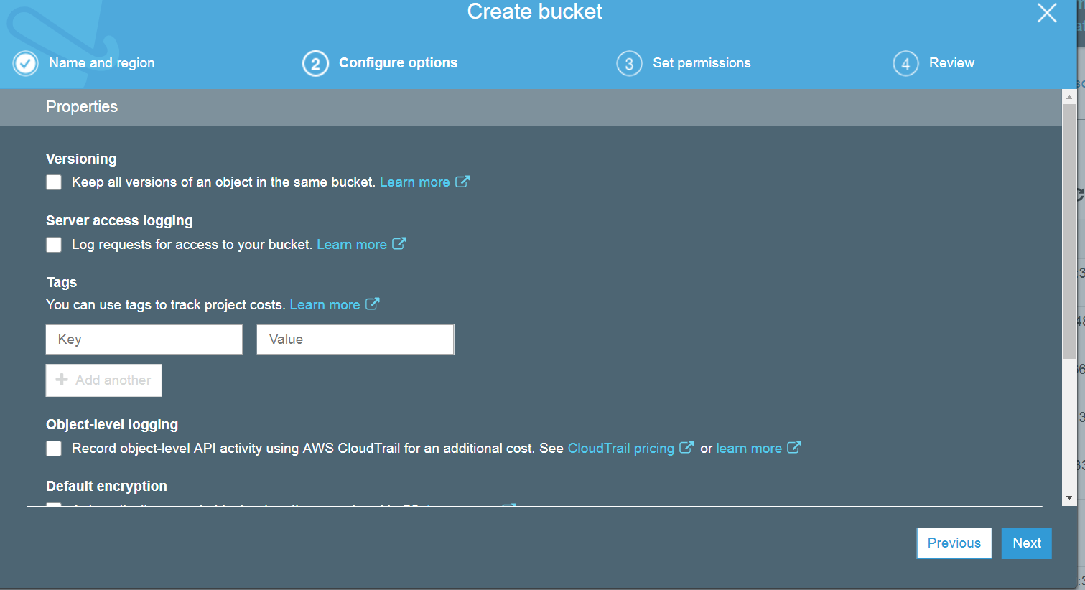
Click "NEXT"
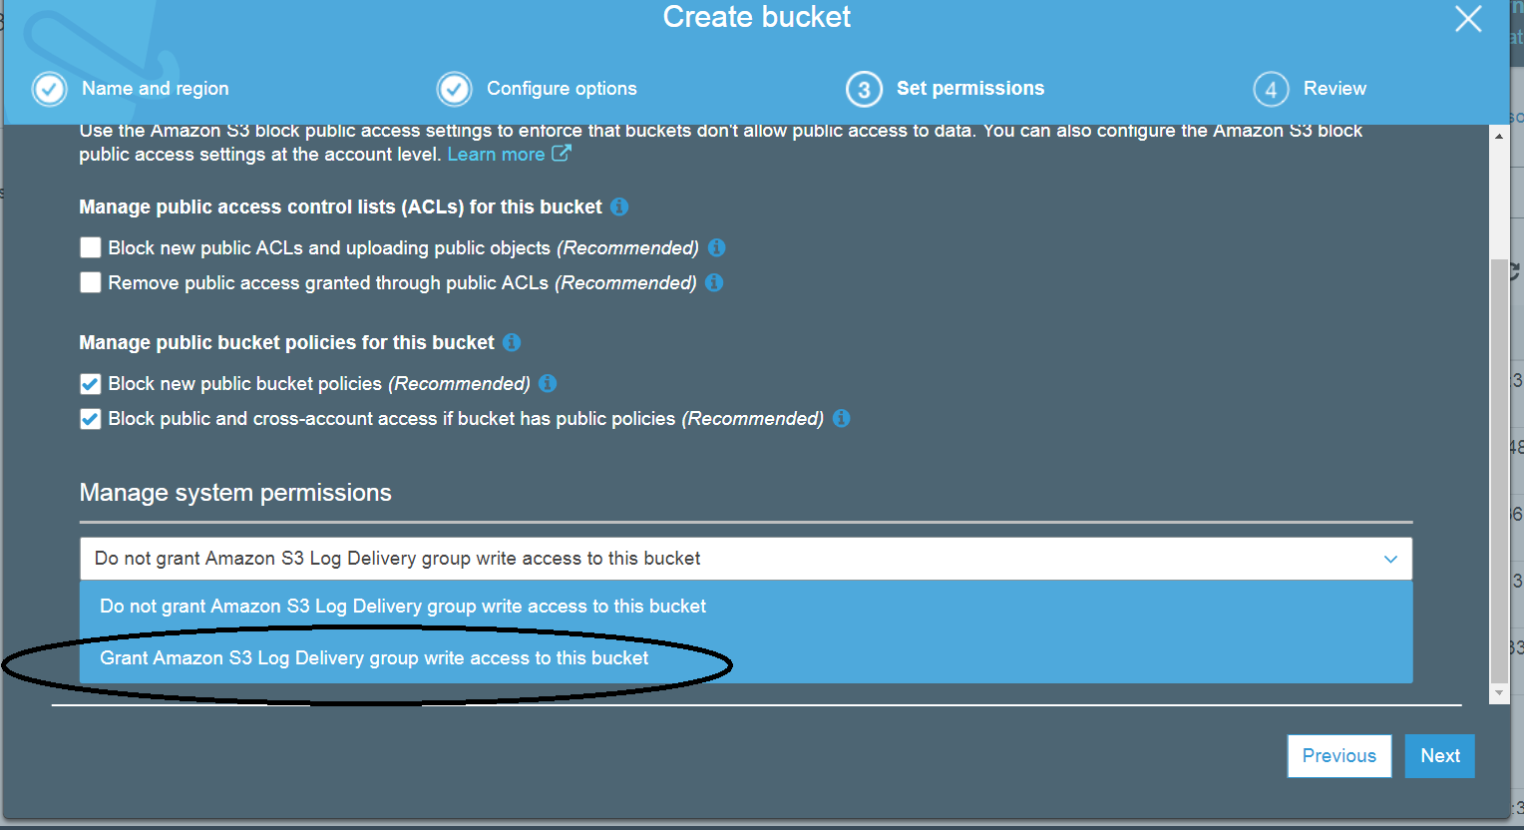
Select "Grant Amazon S3 log" for this bucket.
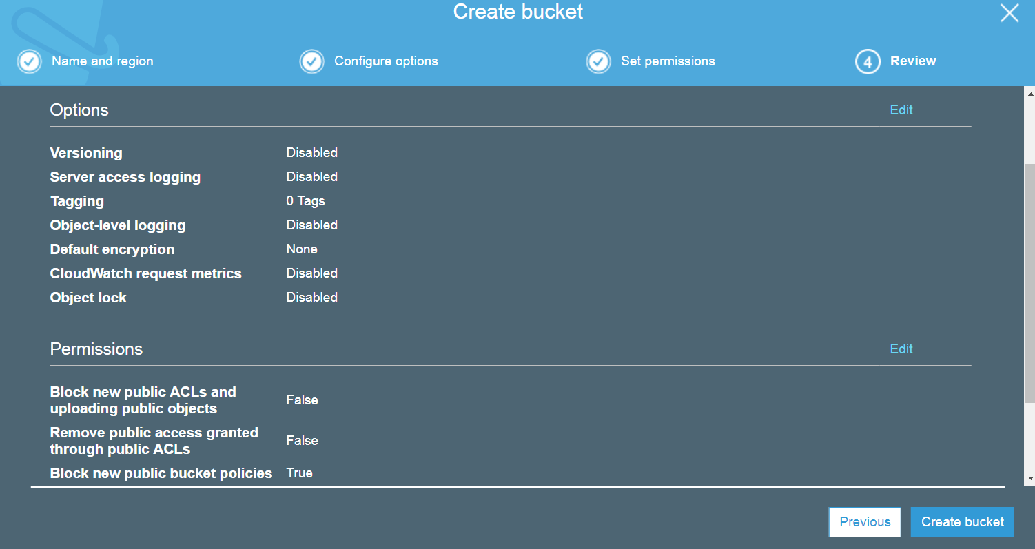
Click on 'create Bucket.

- Create data bucket

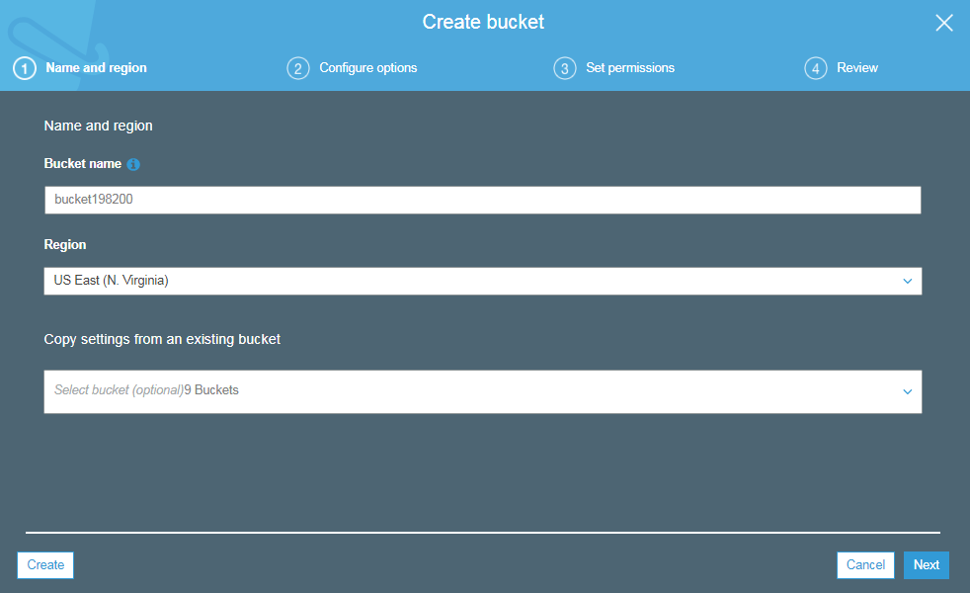
Note:- The Data Bucket and Log Bucket should be in the same Region
Click “NEXT”
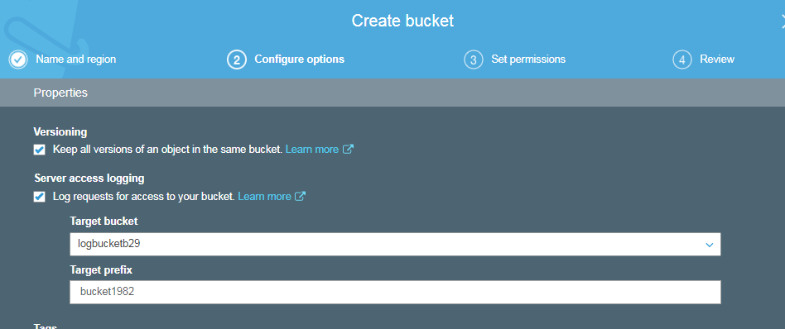
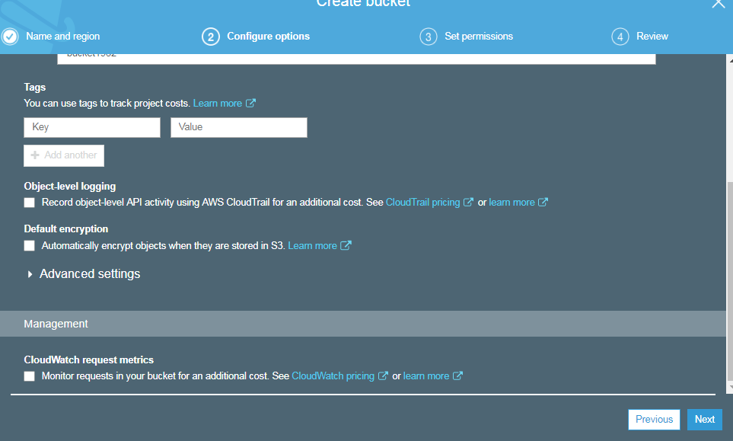
Click “NEXT”
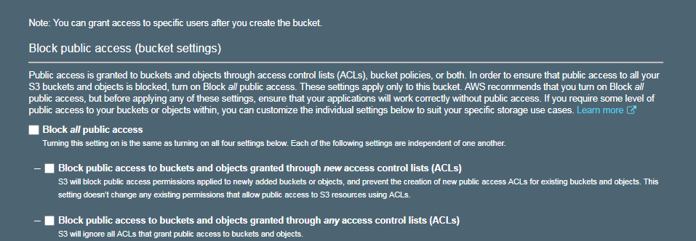
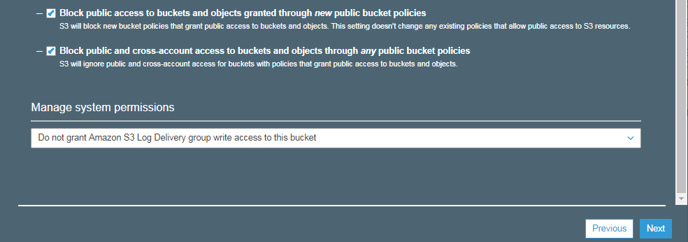
Click “NEXT”
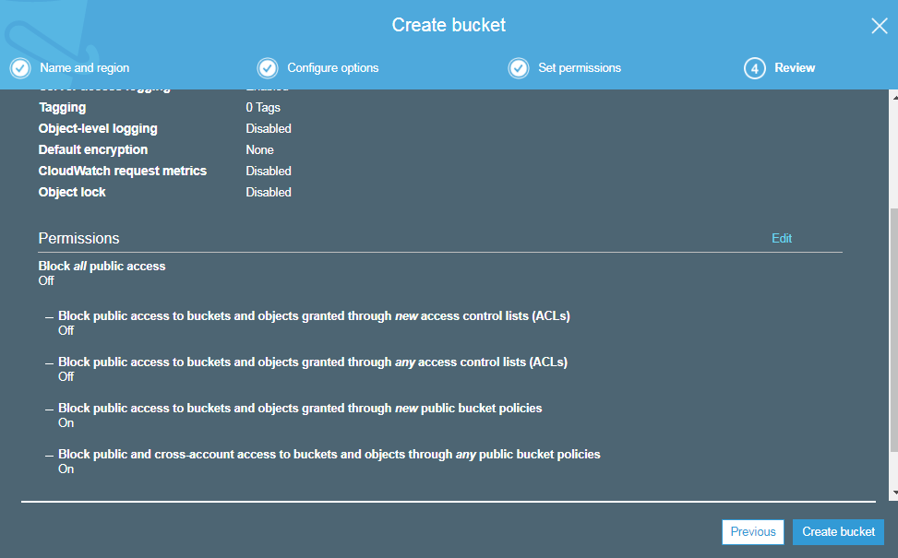
Click “Create bucket”

Output:
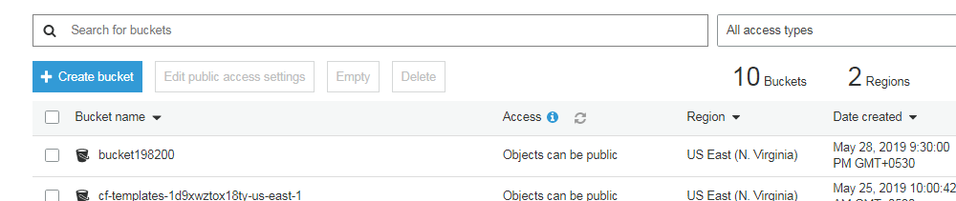

- Upload the File
Click on the Bucket name
You should be able to see the below screen
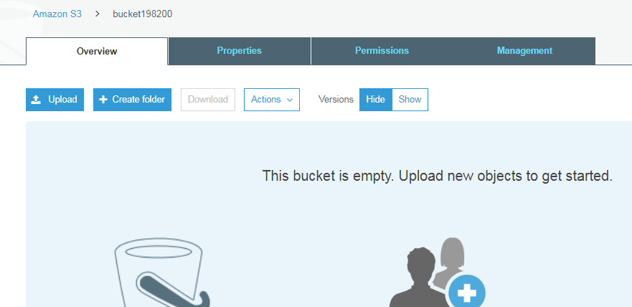

Click “upload”

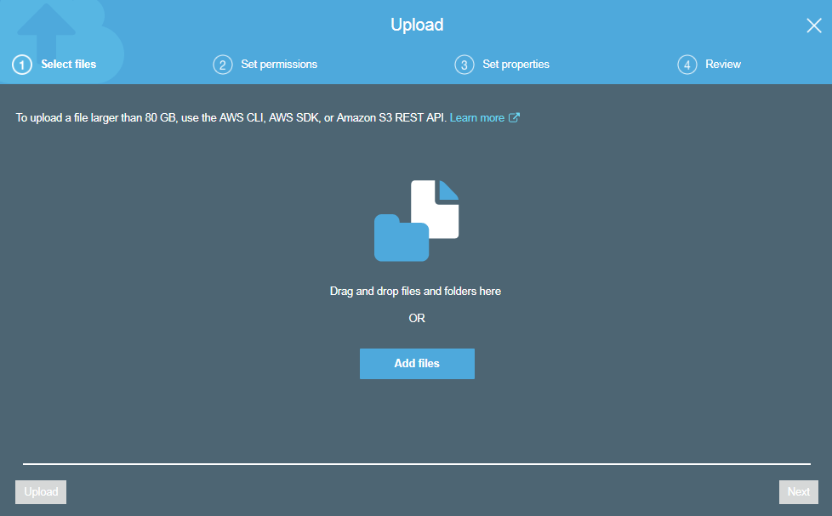

Click on “Add Files”
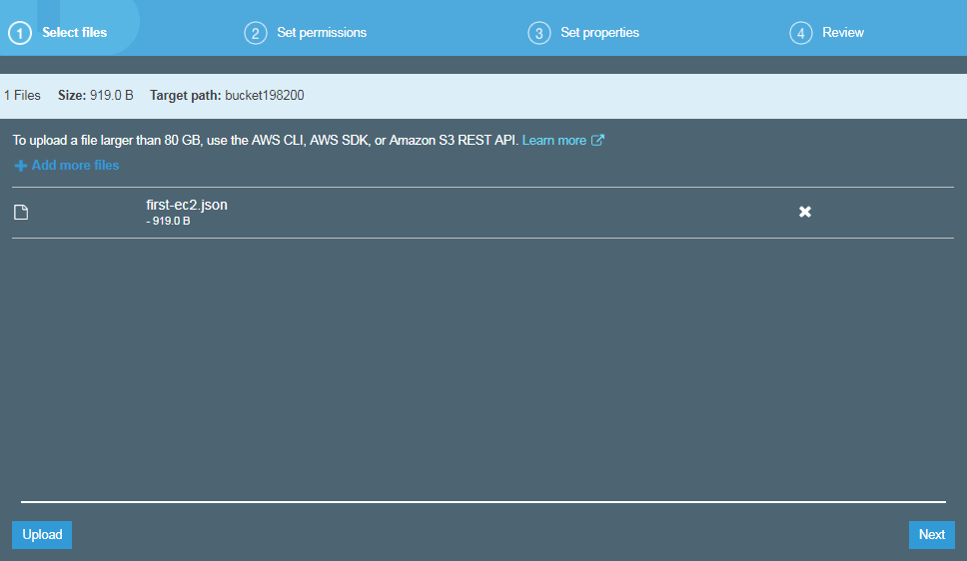
Click on “NEXT”
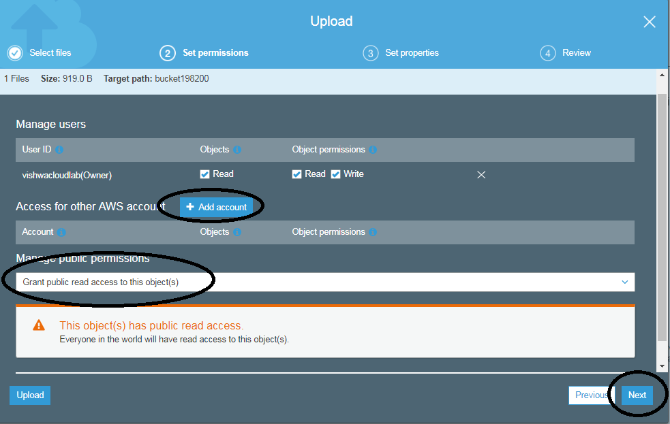

Select “Grant public read access to this object”

Then Click “NEXT”
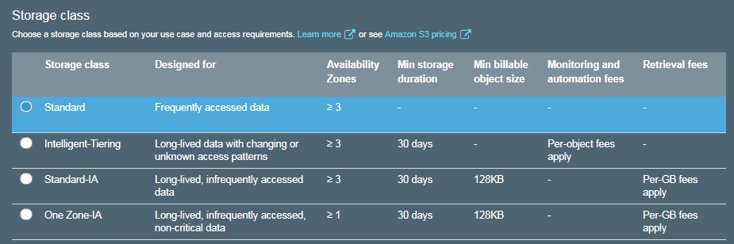

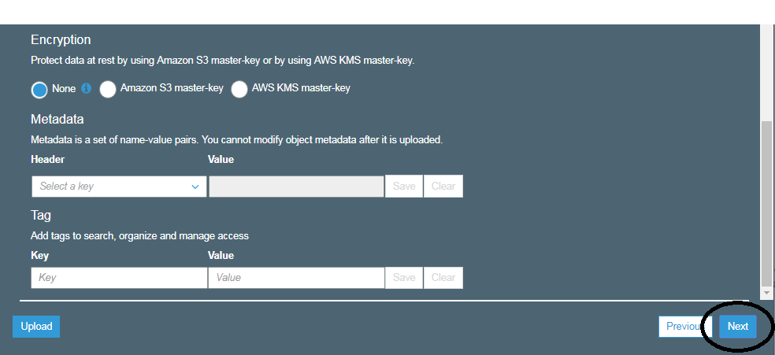

Note:-- If required we can enable “Encryption” on file/object level

Click on “NEXT”
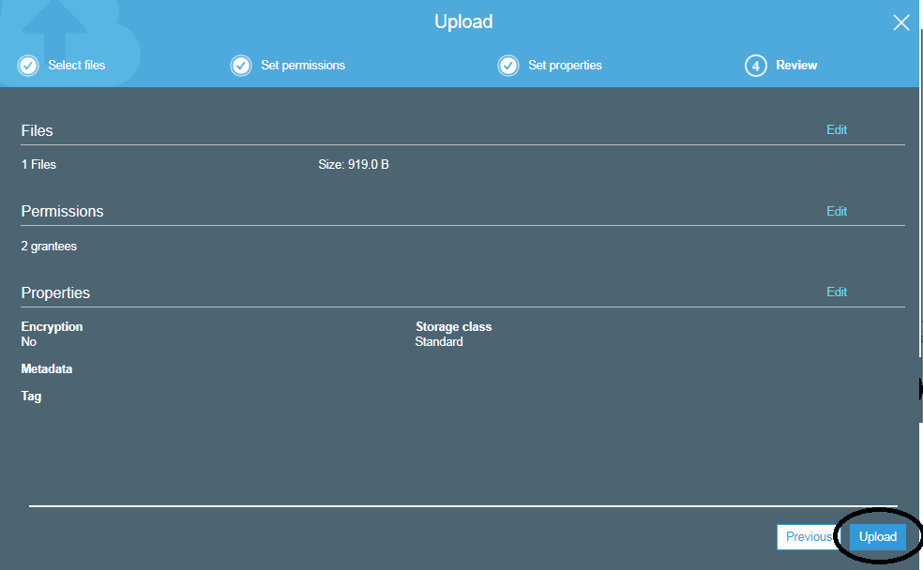
Click on “UPLOAD”
OUTPUT:

