Disease Trend Analysis
Insight Summary Report
Prepared by Dasun Dhananjaya | Data Science Intern | Gamage Recruiters (Pvt) Ltd

1. Overview
This report analyzes disease patterns across patient demographics (age, gender, season, and location) using a dataset of 6,000 patient records collected from January 2024 to December 2025 across 10 locations in Sri Lanka.
Dataset Summary
6,000 patient records | 8 disease categories | 10 locations | 2-year period (2024-2025)

2. Disease Trends by Season
Sri Lanka experiences four monsoon-based seasons. The heatmap below shows how disease case counts vary across these seasons.
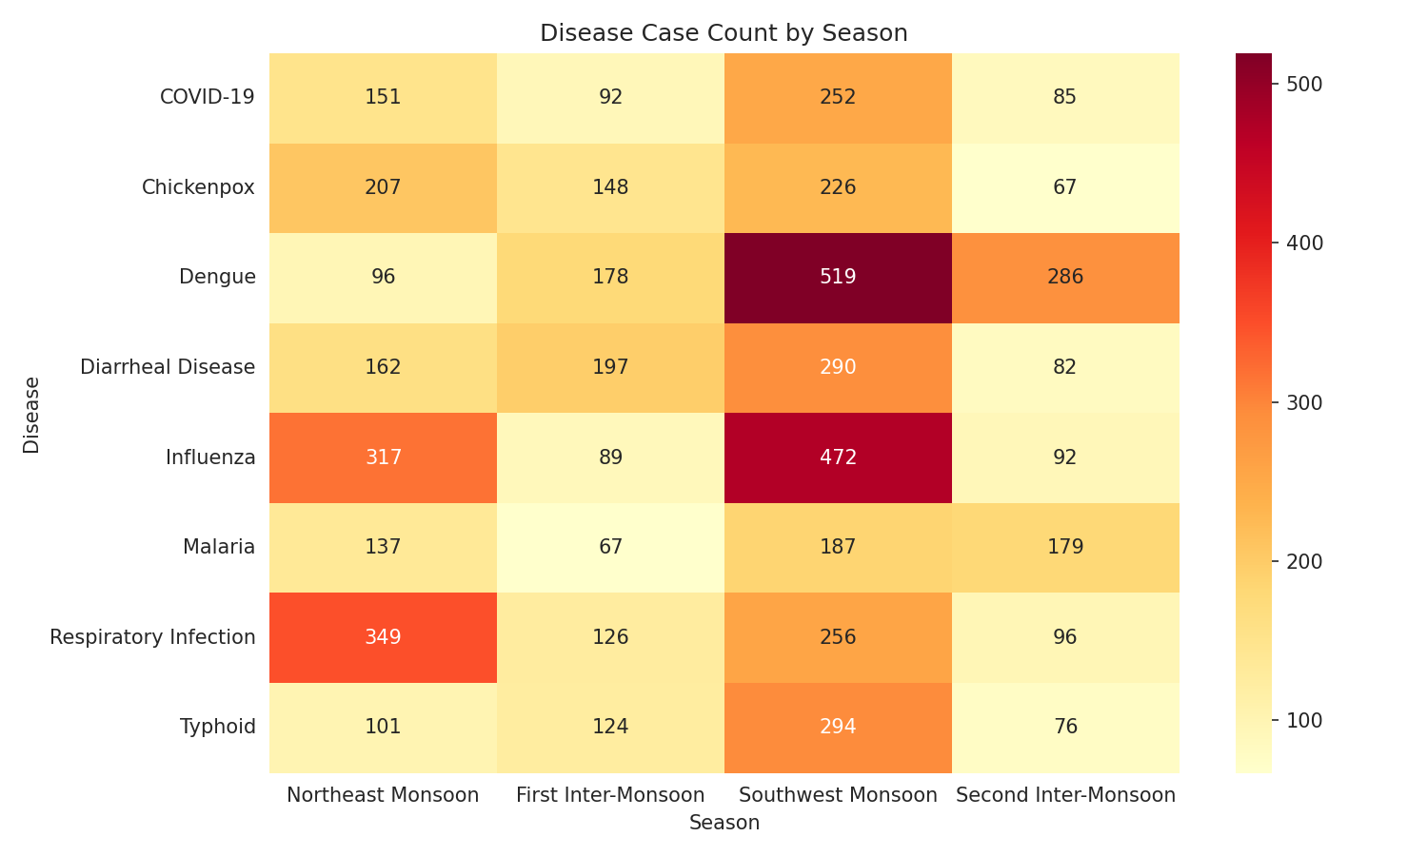
Key Insight
Dengue cases peak during the First and Second Inter-Monsoon periods (Apr-Jun, Oct-Nov), which are the rainiest months. Respiratory infections and Influenza rise during the Northeast Monsoon (Dec-Feb).
The line chart below tracks monthly case counts for each disease, showing the seasonal rise and fall more clearly.
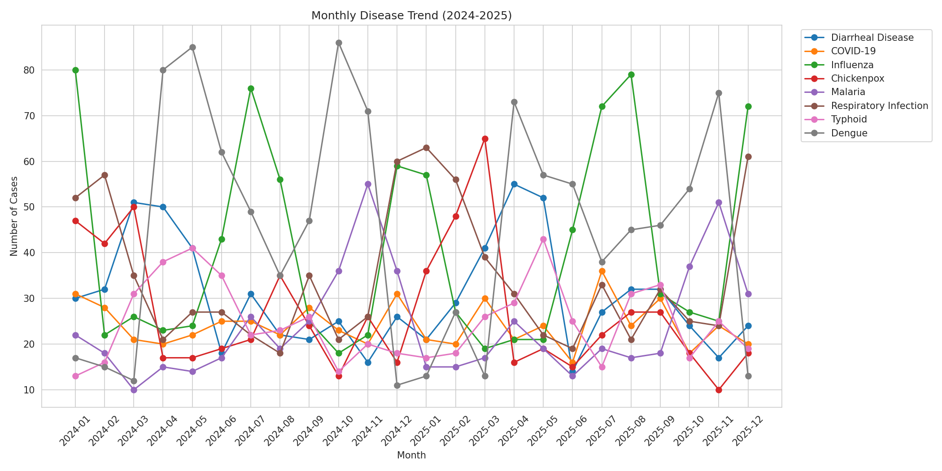
Total case volume by season:
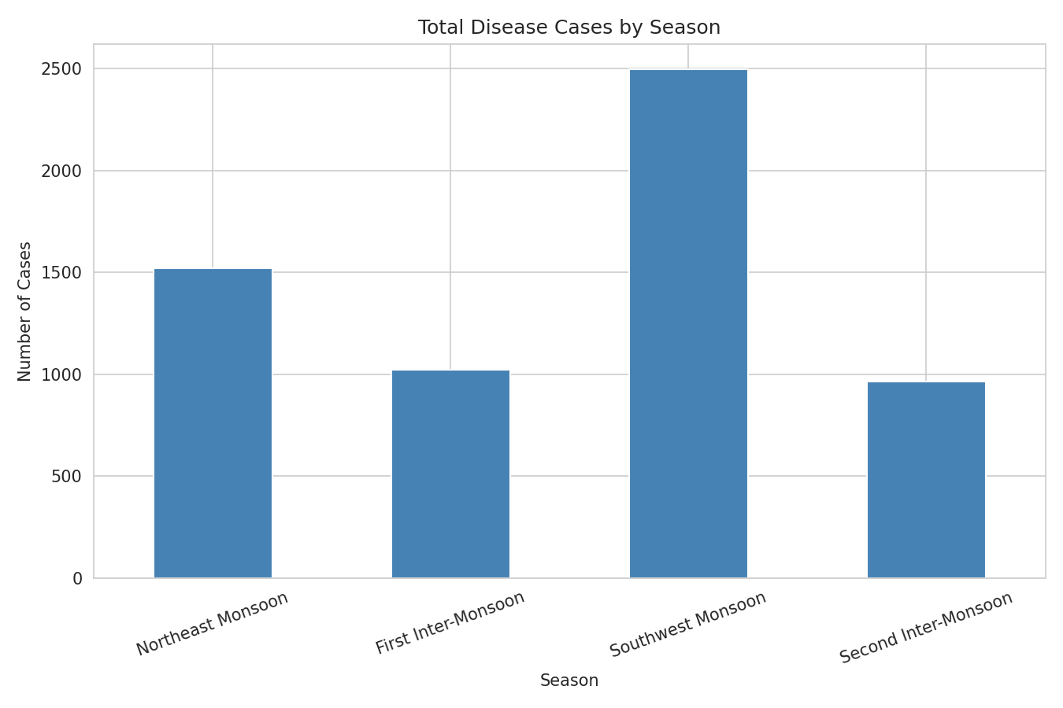

3. Disease Distribution by Location
Case counts vary significantly by location, reflecting differences in population density, climate, and water/sanitation conditions.
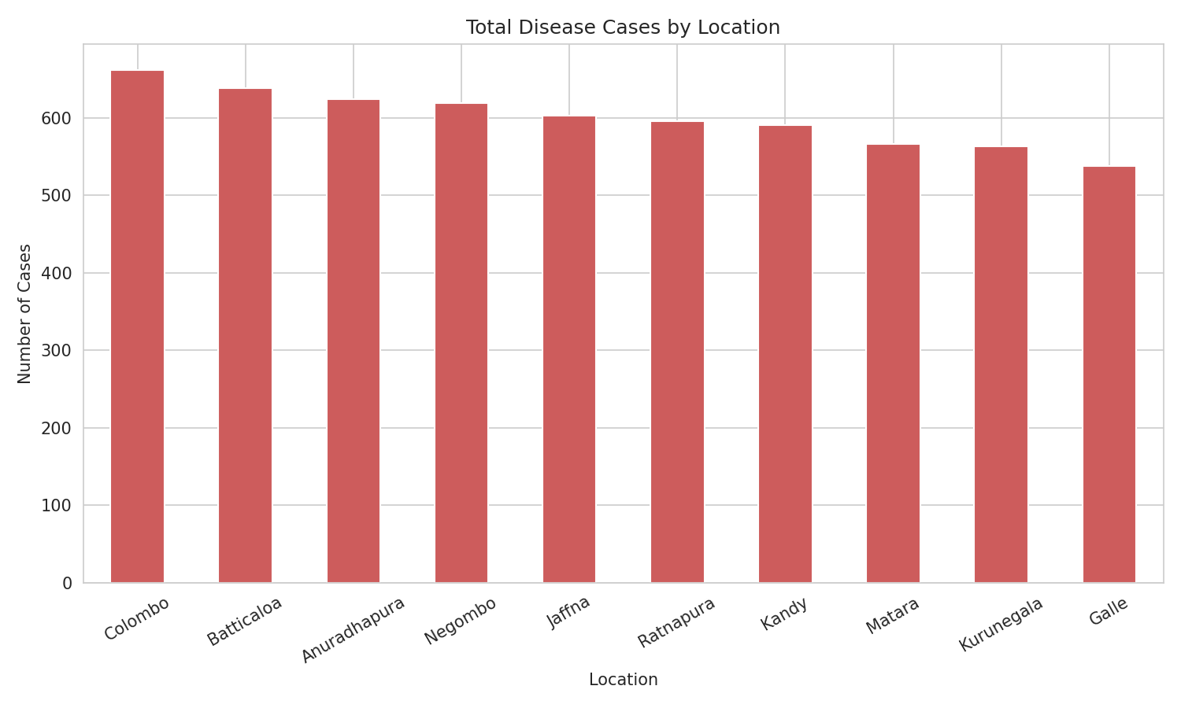
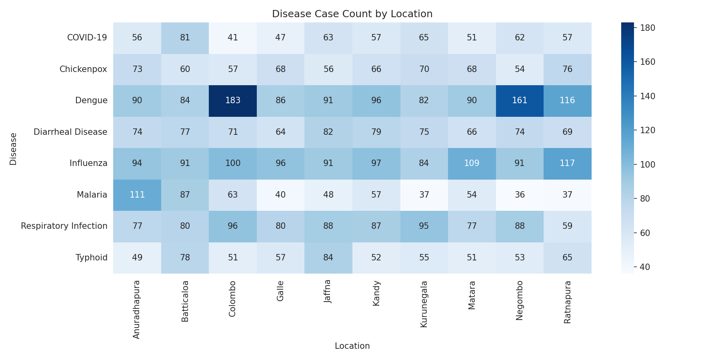
Key Insight
Colombo and Negombo show the highest Dengue case counts, consistent with dense urban mosquito breeding conditions. Anuradhapura and Batticaloa show higher Malaria counts, matching known dry-zone malaria risk areas.

4. Demographic Breakdown
Age group and gender comparisons add extra context for healthcare planning.
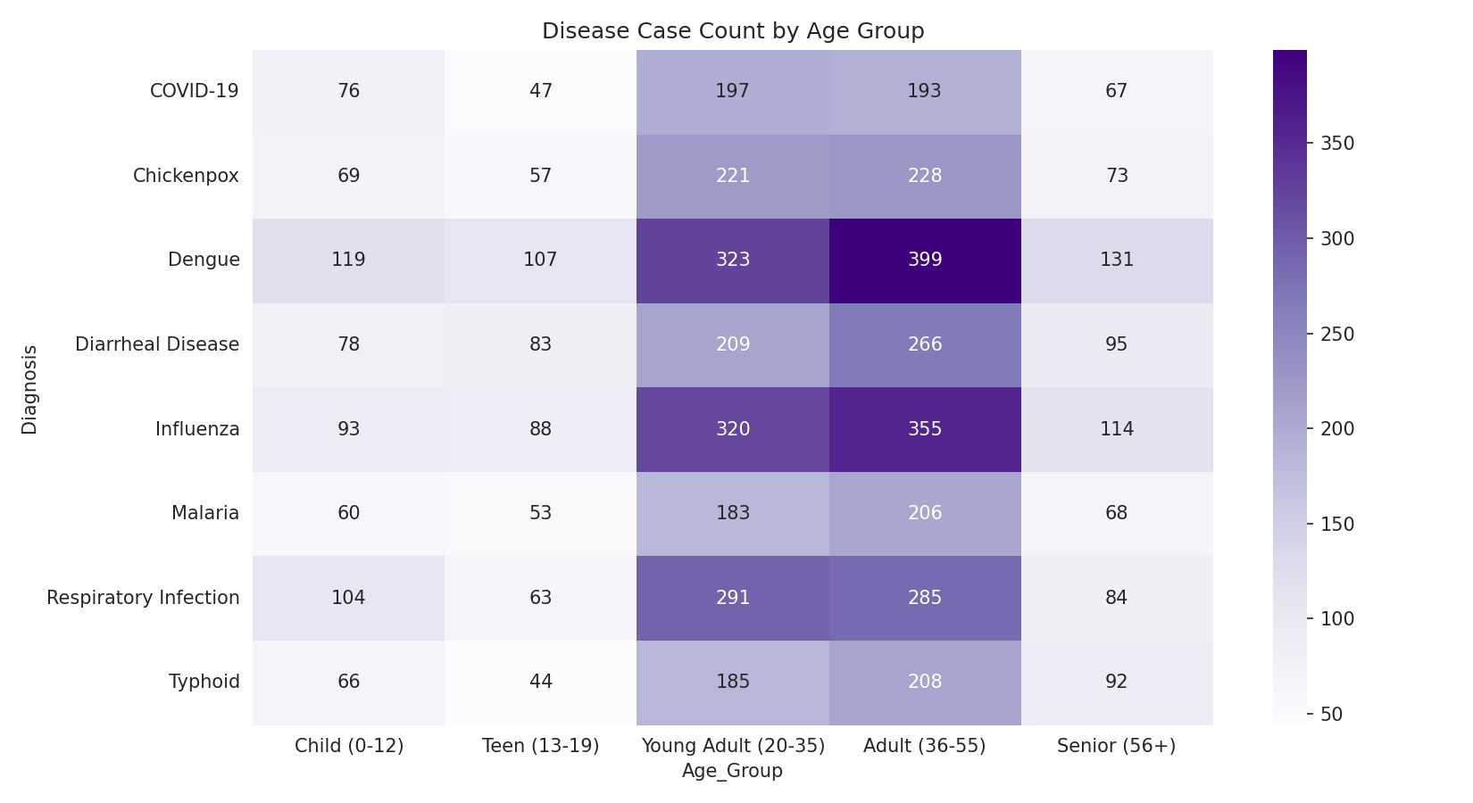
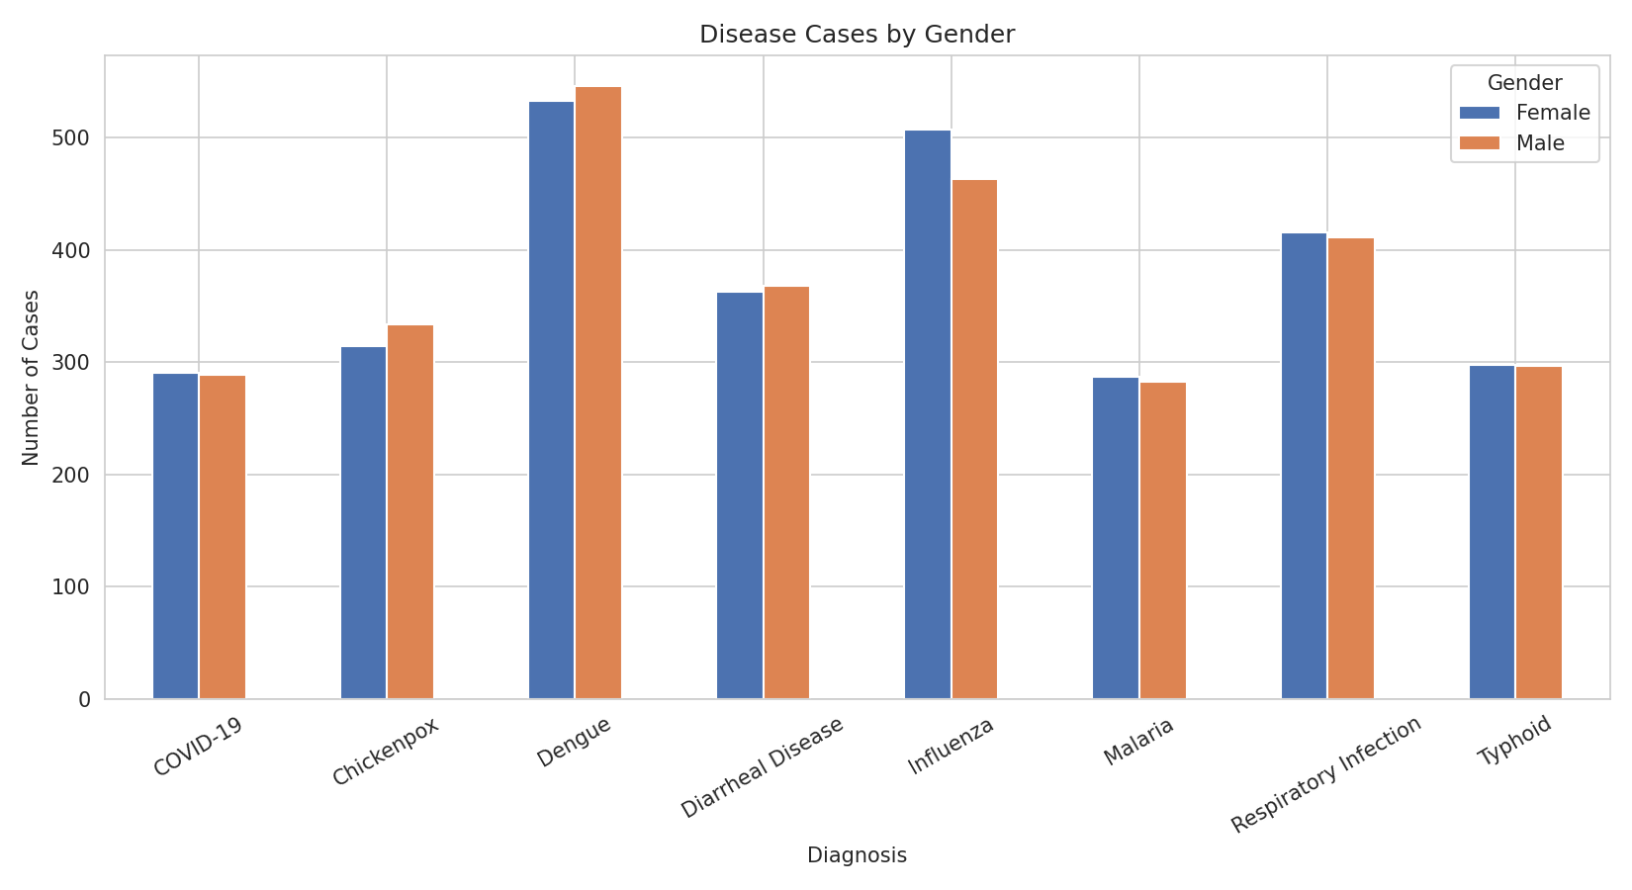
Key Insight
Children (0-12) show higher Chickenpox rates. Case counts are fairly balanced between male and female patients across most disease categories.

5. Summary of Key Insights
# | Insight | Supports
1 | Dengue peaks in Apr-Jun and Oct-Nov (rainy inter-monsoon months) | Vector control planning timing
2 | Respiratory Infection & Influenza rise in Dec-Feb (Northeast Monsoon) | Winter-season hospital resource planning
3 | Diarrheal Disease increases in Mar-May (hot, dry period) | Water quality / sanitation programs
4 | Colombo & Negombo have highest Dengue case counts | Urban mosquito control priority areas
5 | Anuradhapura & Batticaloa show higher Malaria counts | Dry-zone malaria surveillance
6 | Children (0-12) show higher Chickenpox rates | School-based vaccination / awareness
7 | Gender distribution is broadly balanced across diseases | No major gender-targeted intervention needed

6. Recommendations for Dashboard
- Include a season filter so healthcare planners can view disease patterns for any monsoon period.
- Add a location map view to highlight high-risk districts for each disease.
- Use the interactive Plotly charts (monthly trend, location breakdown) as live dashboard components.
- Track case counts monthly against previous year to detect early outbreaks.

Deliverables
- EDA Notebook: Disease_Trend_Analysis_EDA.ipynb
- Disease Trend Visualizations: charts/ folder (PNG charts + interactive HTML)
- Insight Summary Report: this document

