Models Developed

- Logistic Regression
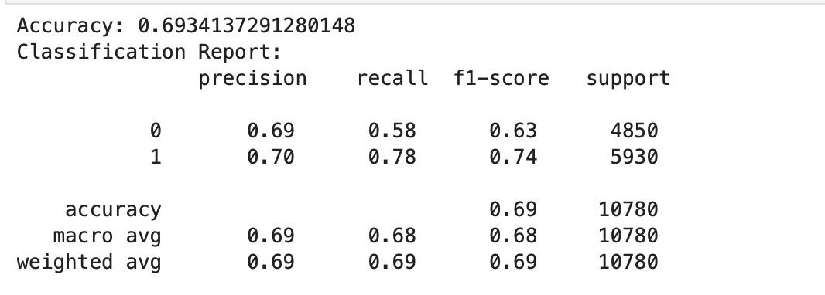

- Decision Tree
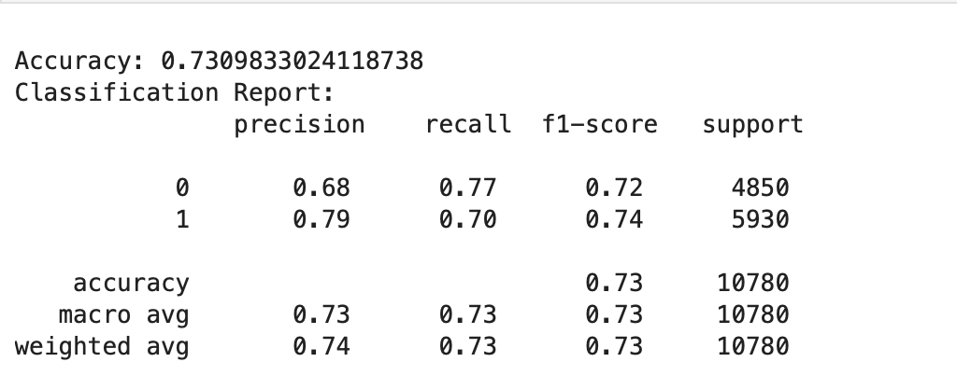

- Random Forest – Selected Model
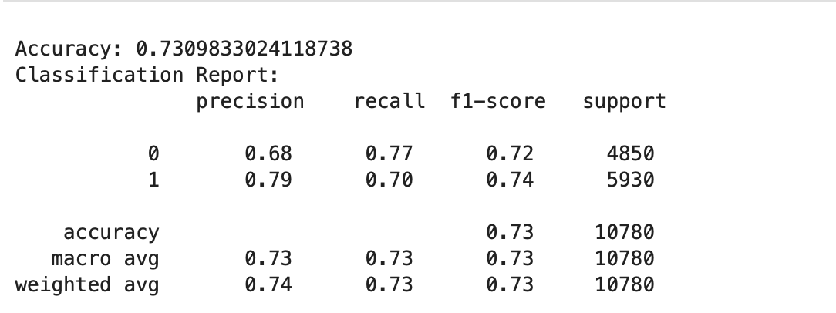
- SVM
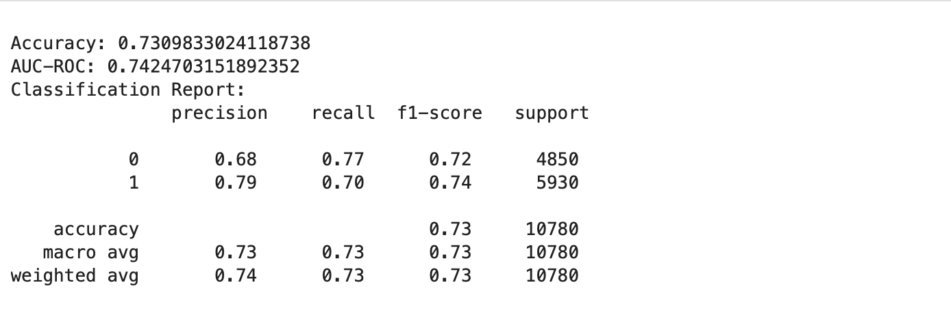

- K-Means Clustering

- PCA + MLP
