

Darshan University

A Project Report on

**“Bank Management System”**

Under the subject

**Software Engineering (2301CS405)**

B. Tech, Semester – IV

Computer Science & Engineering Department

Submitted By

Student Name:Nimavat Mansi Dilipbhai Enrollment No.:23010101177

Academic Year (2024-2025)

|  |  |
| --- | --- |
| Internal Guide  Prof. R. B. Gondaliya  Darshan University | Dean-DIET  Dr. Gopi Sanghani  Darshan University |

**Computer Science & Engineering**

**Department**

**Darshan University**

**DECLARATION**

We hereby declare that the SRS, submitted along with the **Software Engineering** **(2301CS405)** for entitled **“Bank Management System”** submitted in partial fulfilment for the Semester-4 of **Bachelor Technology (B. Tech)** in **Computer Science and Engineering (CSE)** Departmentto Darshan University, Rajkot, is a record of the work carried out at **Darshan University, Rajkot** under the supervision of R. B. Gondaliya and that no part of any of report has been directly copied from any students’ reports, without providing due reference.

Nimavat Mansi Dilipbhai

(Student name)

Student’s Signature

Date: _22/12/2024_________

**Computer Science & Engineering**

**Department**

**Darshan University**

**CERTIFICATE**

This is to certify that the SRS on **“Bank Management System” has** been satisfactorily prepared by **Nimavat Mansi Dilipbhai** (**23010101177**) under my guidance in the fulfillment of the course **Software Engineering (2301CS405)** work during the academic year 2024-2025.

Internal Guide Dean-DIET

Prof. R. B. Gondaliya Dr. Gopi Sanghani

Darshan University Darshan University

**ACKNOWLEDGEMENT**

I wish to express my sincere gratitude to my project guide Prof. R. B. Gondaliyaand all the faculty members for helping me through my project by giving me the necessary suggestions and advices along with their valuable co- ordination in completing this work.

I also thank my parents, friends and all the members of the family for their precious support and encouragement which they had provided in completion of my work. In addition to that, I would also like to mention the Darshan University personals who gave me the permission to use and experience the valuable resources required for the project from the University premises.

Thus, in conclusion to the above said, I once again thank the faculties and members of **Darshan University** for their valuable support in completion of the project.

Thanking You

**Nimavat Mansi Dilipbhai**

**ABSTRACT**

Bank management system is a system which aims in developing a computerized system to maintain all daily problem related money. This system will act as a tool to transfer traditional Banking into digital Banking. This project has many features which are generally not available in general Banking system like facility of user login, UPI Payment, Money transfer on one click etc. It also has a facility of admin login through which the admin can monitor the whole system. This system will be designed with the basic features such as Manager can add/view/update/delete Clerk and Account details in it. It has also a facility where customer after logging in their accounts can see Transaction History and Current Balance and Loans and also they can request the Manager to get details of Various Loan and insurance policy. The Manager after logging into his account i.e. admin account can generate various reports such as Branch report , issue report, Clerk report and Money report.

Main purpose of this system is to reduce human efforts as much as possible.

**Table of Contents**

List of Figures ....................................................................................................................................................... I

List of Tables ....................................................................................................................................................... II

1 Introduction 1

1.1 Product perspective 1

1.2 Product features 1

1.2.1 There are three different users who will be using this product: 1

1.3 Functional Requirement 1

1.3.1 Manger 1

1.3.2 Member 1

1.3.3 Admin 1

1.4 Non-Functional Requirement 2

1.4.1 Security 2

1.4.2 Data integrity 2

1.4.3 Performance 2

1.4.4 Maintainability 2

2 Design and Implementation Constraints 3

2.1 Use case diagram 3

2.2 Activity diagram and Swimlane diagram 4

2.3 Sequence diagram 8

2.4 State diagram 9

2.5 Class diagram 10

2.6 Data flow diagram 11

2.6.1 Context diagram (level-0) 11

2.6.2 DFD Level-1 11

2.6.3 DFD Level-2 12

3 External interface requirement (Screens) 13

3.1 Screen-1: Registration Form 13

3.2 Screen-2: Login Form 14

3.3 Screen-3: Add borrower book 15

4 Database design 16

4.1 List of Tables 16

5 Stories and Scenario 17

5.1 Story-1: Add New Book in Library Catalogue 17

5.1.1 Scenario# S1.1 17

5.1.2 Scenario# S1.2 17

5.1.3 Scenario# S1.3 17

5.2 Story-2: Search Book 18

5.3 Story-3: Manage due date for borrowed book 18

5.4 Story-4: Renew book 18

5.5 Story-5: Generate a report on book usage and availability 18

6 Test cases 19

7 References 23

**List of Figures**

Figure 2-1 Use case diagram for Bank management system ............................................................................. 3

Figure 2-2 Activity Diagram for ATM .................................................................................................................. 4

Figure 2-3 Activity diagram for Paying salary .................................................................................................... 5

Figure 2-4 Swimlane diagram for ATM ............................................................................................................... 6

Figure 2-5 Sequence diagram for Book Issue ..................................................................................................... 8

Figure 2-6 State diagram of Book ....................................................................................................................... 9

Figure 2-7 State diagram for Librarian .............................................................................................................. 9

Figure 2-8 Class diagram for Library management system .............................................................................. 10

Figure 2-9 Context diagram for Library management system ......................................................................... 11

Figure 2-10 DFD level-1 for Library management system ................................................................................ 11

Figure 2-11 DFD level-2 for Issue book ............................................................................................................ 12

Figure 3-1 Screen-1: Registration Form ........................................................................................................... 13

Figure 3-2 Screen-2: Login Form ...................................................................................................................... 14

Figure 3-3 Screen-3: Add borrower book ......................................................................................................... 15

**I**

**List of Tables**

Table 3.1-1 Screen element of Registration form ............................................................................................ 13

Table 3.2-1 Screen element of Login form ....................................................................................................... 14

Table 3.3-1 Screen element of Add borrower book ......................................................................................... 15

Table 4.1-1 Table: Book .................................................................................................................................... 16

Table 4.1-2 Table: Borrower ............................................................................................................................. 16

Table 4.1-3 Table: Staff ..................................................................................................................................... 16

Table 4.1-4 Table: Student ............................................................................................................................... 16

**II**

# Introduction

## Product perspective

This project is basically updating the manual Banking system into an internet-based application so that the users can know the details of their account, current Balance etc. It is a multi-user system that efficiently manages all fundamental banking operations such as Account Management, Transaction Processing, Loan Management, and Customer Service. It can effectively handle all the basic requirements of a small-scale banking institution.

## Product features

### There are three different users who will be using this product:

* Bank Manager who will be acting as the administrator.
* Customer who will be accessing the Banking.
* Visitor who will request to open a new account or inquire about services.

## Functional Requirement

### Manger

* Link Addhar
* Accept New Applications
* Assign/Remove Clerk
* Current Balance in ATM
* Allow Online Transaction
* Check Current Schemes
* Allow Online Transation
* View Bills
* Exchanging Money

### Member

* Login
* Deposit
* Check Balance
* Net Banking
* Money Transfer
* Generate UPI
* Generate ATM PIN
* Check Loan

### Admin

* Send OTP
* Upload Details of Loan
* Branch
* Transaction Report
* Pay Salary
* Generate Account Report
* Generate transaction message

## Non-Functional Requirement

### Security

### Data integrity

### Performance

### Maintainability

# Design and Implementation Constraints

## Use case diagram

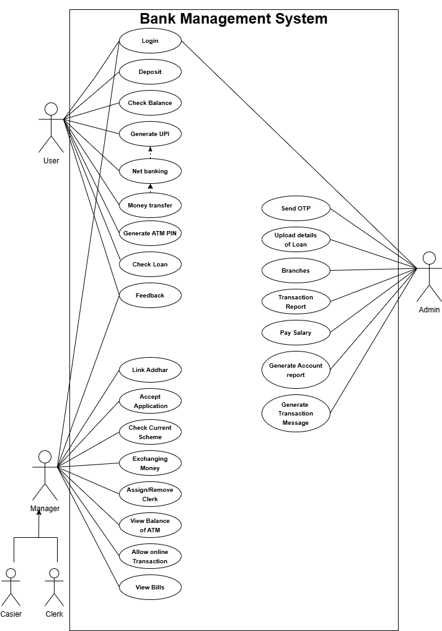

*Figure 2-1 Use case diagram for Bank management system*

## Activity diagram and Swimlane diagram

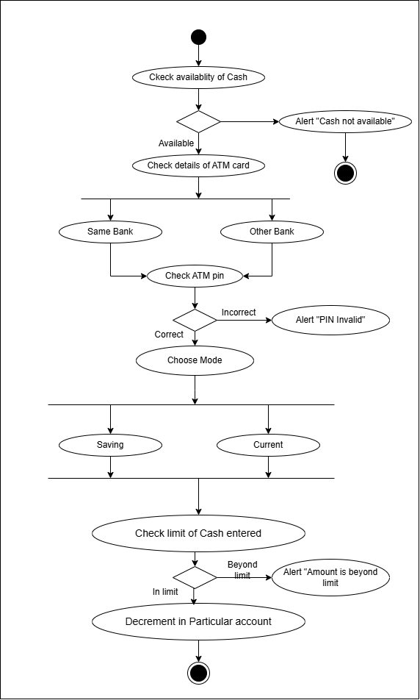

*Figure 2-2 Activity Diagram for ATM*

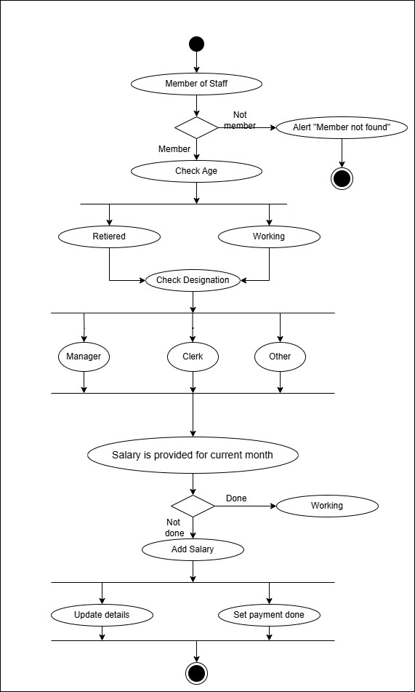

*Figure 2-3 Activity diagram for Paying salary*

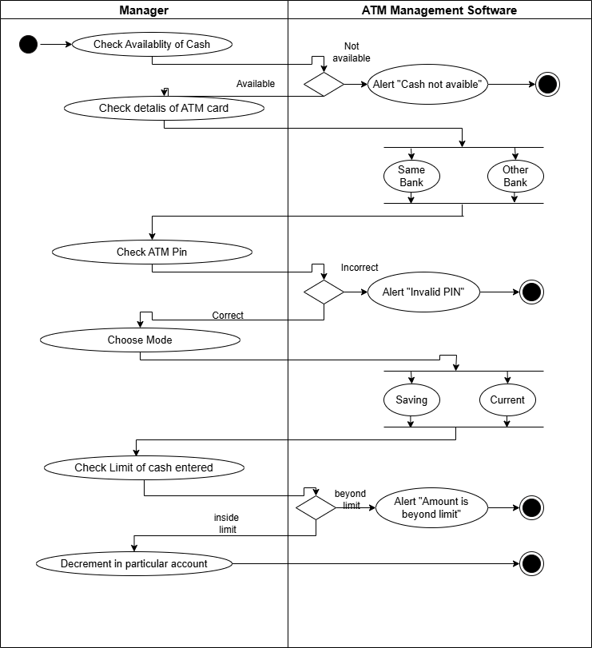

*Figure 2-4 Swimlane diagram for ATM*

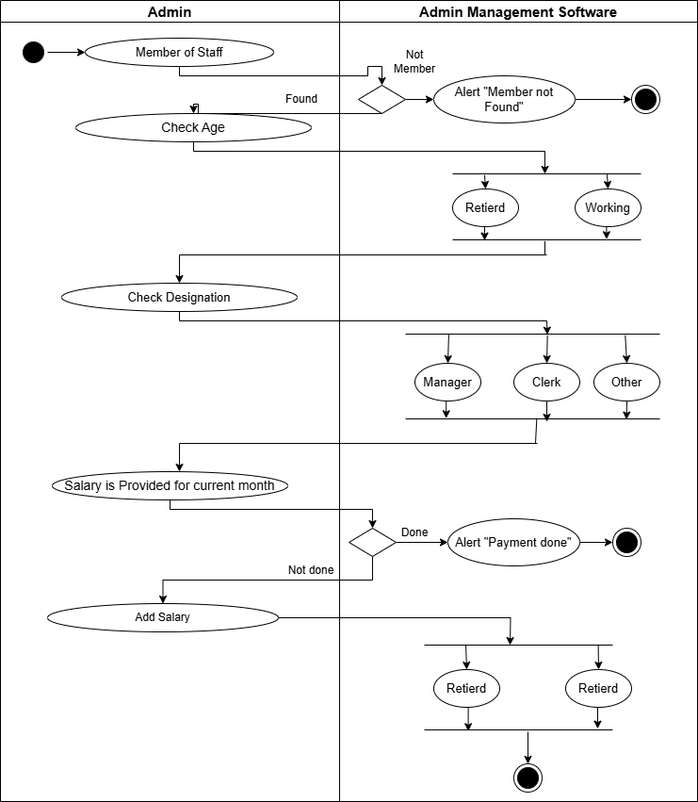

*Figure 2-5 Swimlane diagram for paying salary*

## Sequence diagram

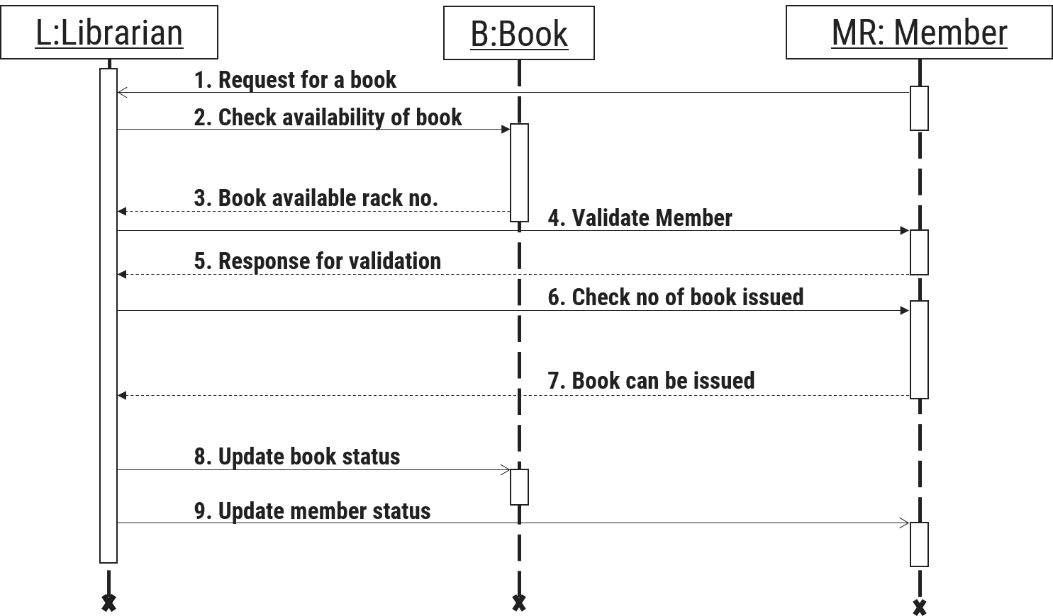

*Figure 2-5 Sequence diagram for Book Issue*

## State diagram

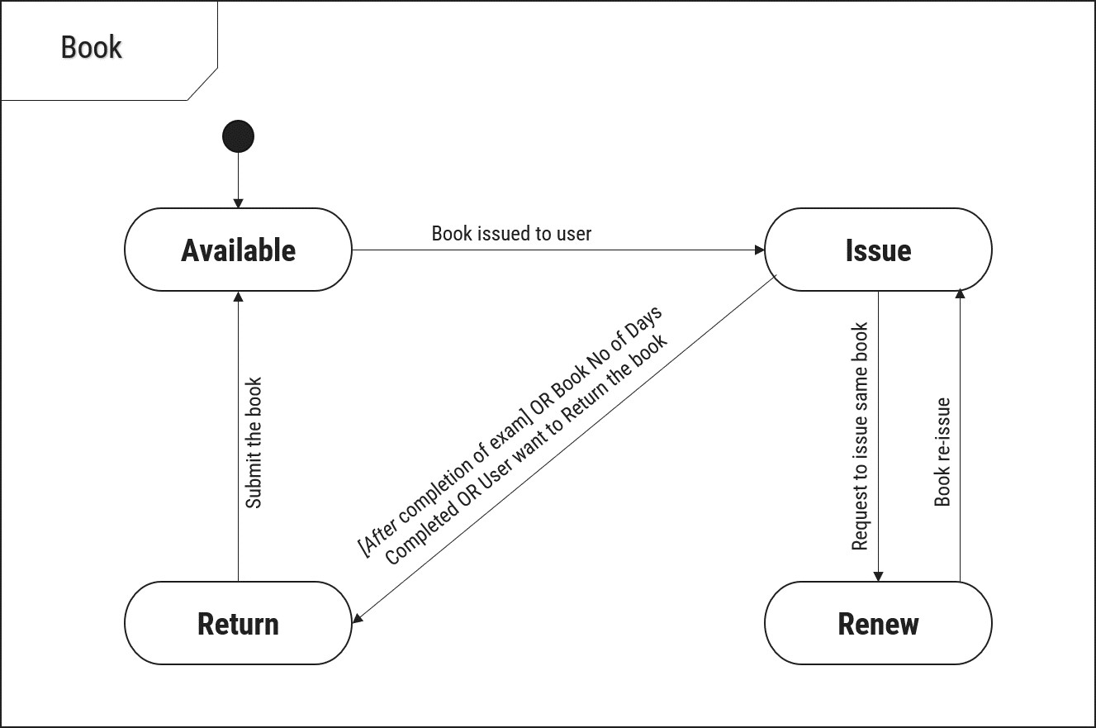

*Figure 2-6 State diagram of Book*

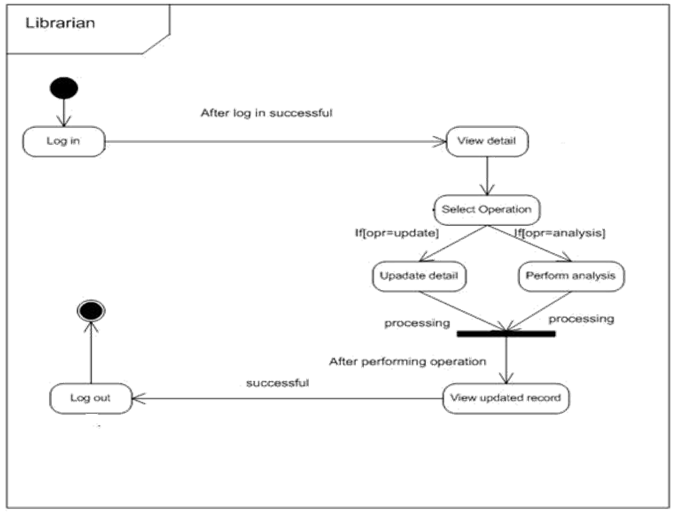

*Figure 2-7 State diagram for Librarian*

## Class diagram

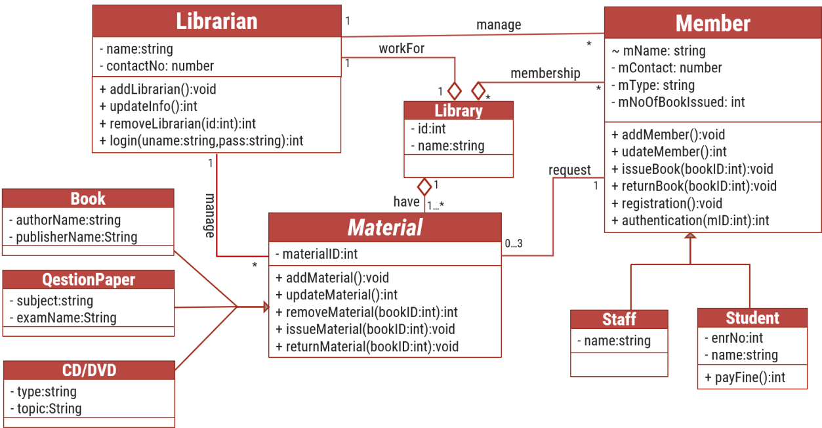

*Figure 2-8 Class diagram for Library management system*

## Data flow diagram

### Context diagram (level-0)

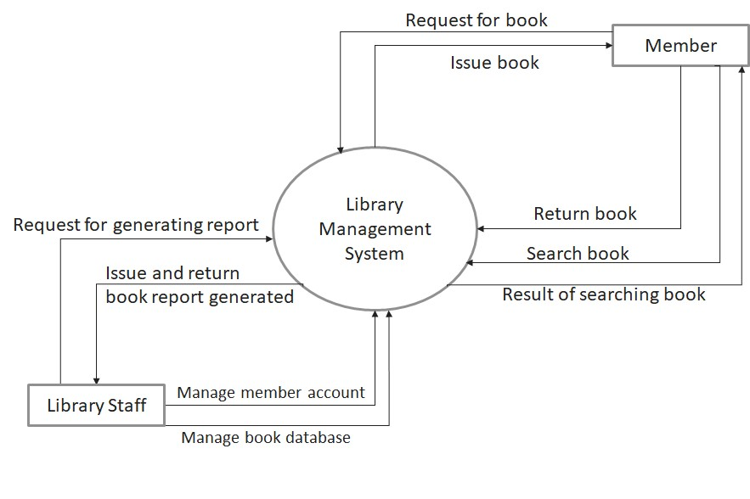

*Figure 2-9 Context diagram for Library management system*

### DFD Level-1

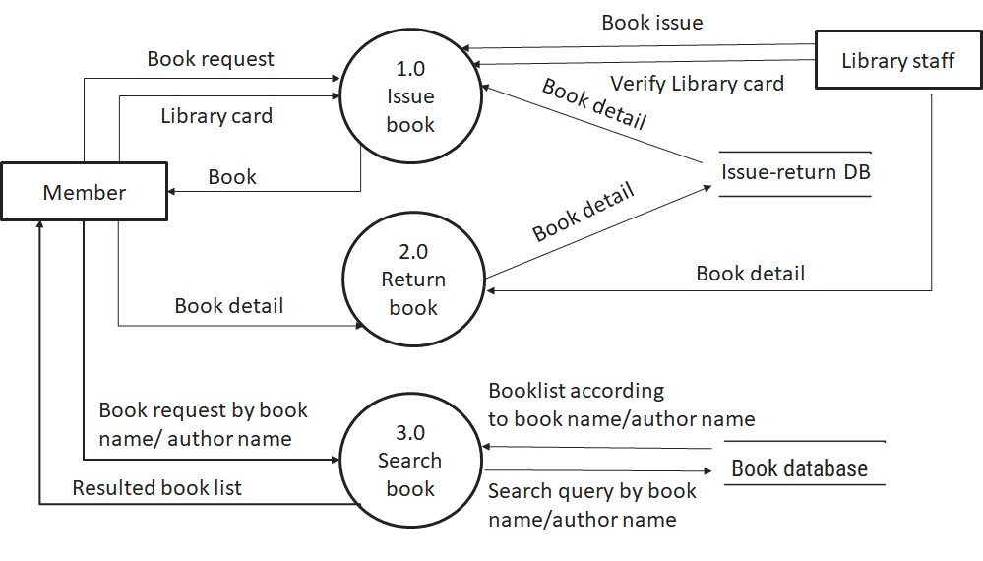

*Figure 2-10 DFD level-1 for Library management system*

### DFD Level-2

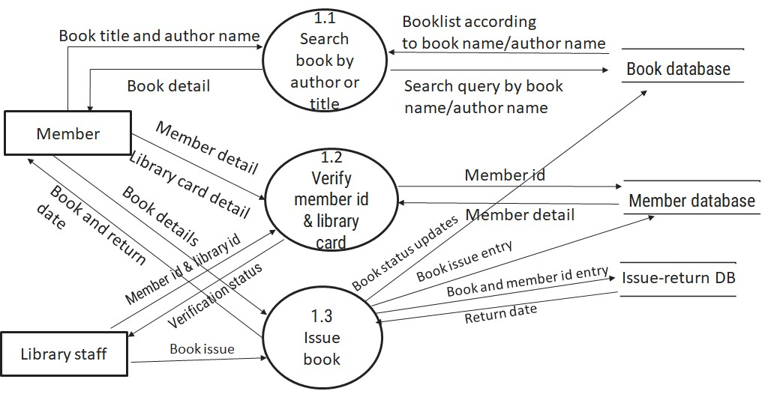

*Figure 2-11 DFD level-2 for Issue book*

# External interface requirement (Screens)

## Screen-1: Registration Form

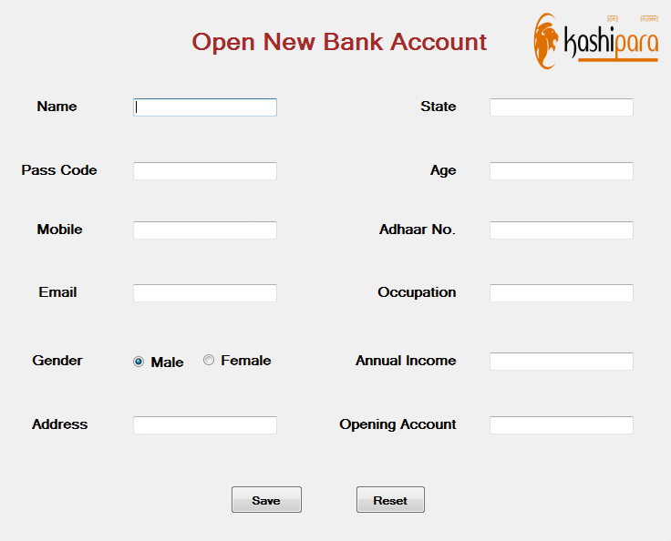

*Figure 3-1 Screen-1: Registration Form*

**Purpose:** This form will allow the target end-users to register in the system. To register , the following information will be encoded in the system.

*Table 3.1-1 Screen element of Registration form*

|  |  |  |  |  |  |
| --- | --- | --- | --- | --- | --- |
| **Sr.** | **Screen Element** | **Input Type** | **O/M** | **1/N** | **Description** |
| **1** | Name | Textbox | M | 1 | Name field should be editable and accept the Name. |
| **2** | Pass Code | Textbox | M | 1 | It comprises a sequence of numbers that a user must enter correctly to gain access. |
| **3** | Moblie | Number | M | 1 | Moblie field should be editable and accept the Mobile and display as cross |
| **4** | Email | Textbox | M | 1 | Email field should be editable and accept the Email. |
| **5** | Gender | Radio | M | 1 | Choice should be one only |
| **6** | Address | Textbox | O | 1 | Address field should be editable and accept the Address. |
| **7** | State | Textbox | M | 1 | State field should be editable and accept the State. |
| **8** | Age | Number | M | 1 | Age field should be editable and accept the Age above 18. |
| **9** | Adhaar No. | Number | M | 1 | Adhaar number field should be editable and accept the Number. |
| **10** | Occupation | Textbox | O | N | Occupation field should be editable and accept the Occupation. |
| **11** | Annual Income | Number | M | 1 | Annual Income field should be editable and accept the Annual Income. |
| **12** | Opening Account | Textbox | O | N | Opening Account field should be editable and accept the Opening Account. |

## Screen-2: Login Form

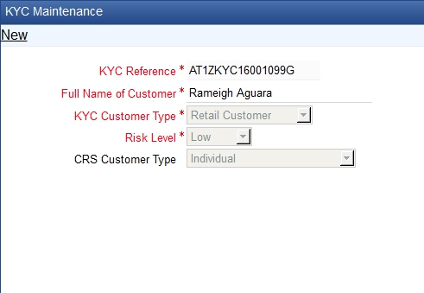

*Figure 3-2 Screen-2: Login Form*

**Purpose:** This form will be used by the system’s users to access records and features of the system. The users will input the correct combination of their username and password to be able to login to the system.

*Table 3.2-1 Screen element of Login form*

|  |  |  |  |  |  |
| --- | --- | --- | --- | --- | --- |
| **Sr.** | **Screen Element** | **Input Type** | **O/M** | **1/N** | **Description** |
| **1** | Username | Textbox | M | 1 | Username field should be editable and accept the Username. |
| **2** | Password | Password | M | 1 | Password field should be editable and accept the password and display as star or dot. |
| **3** | Remember Me | Checkbox | M | 1 | Saving login credentials through remember me checkbox |
| **4** | I forgot my  password | Link | ------ | ------ | Link for navigate to Forgot password page for allows users to recover password. |
| **5** | Register a new membership | Link | ------ | ------ | Link for navigate to membership registration. |
| **6** | Sign in | Button | ------ | ------ | Login button navigates to another page even if valid login credentials. |

## Screen-3: Add borrower book

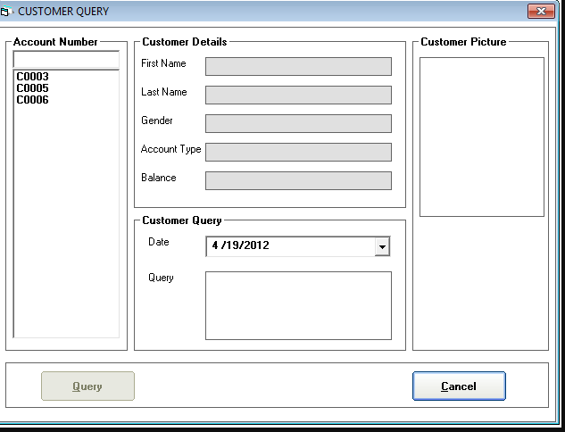

*Figure 3-3 Screen-3: Add borrower book*

**Purpose:** This module will allow the system administrator to add, edit, update or delete borrowers of book. The admin can add borrower information and manage it.

*Table 3.3-1 Screen element of Add borrower book*

|  |  |  |  |  |  |
| --- | --- | --- | --- | --- | --- |
| **Sr.** | **Screen Element** | **Input Type** | **O/M** | **1/N** | **Description** |
| **1** | Borrower ID | Textbox | M | 1 | Borrower ID field should be editable and fill autogenerated Borrower ID. |
| **2** | Student ID | Textbox | M | 1 | Student ID field should be editable and accept Student barcode id. |
| **3** | First Name | Textbox | M | 1 | First Name field should be editable and accept only string as a borrower first name. |
| **4** | Middle Name | Textbox | O | 1 | Middle Name field should be editable and accept only string as a borrower middle name. |
| **5** | Last Name | Textbox | M | 1 | Last Name field should be editable and accept only string as a borrower last name. |
| **6** | Contact | Textbox | M | 1 | Contact field should be editable and accept only 10-digit mobile number. |
| **7** | Grade Id | Textbox | O | 1 | Auto fetch detail from the database if proper student id is entered. |
| **8** | Submit | Button | ----- | ----- | Submit is a button for store the entered data into database. |
| **9** | Cancel | Button | ----- | ----- | Cancel is a button for close add borrower dialog. |

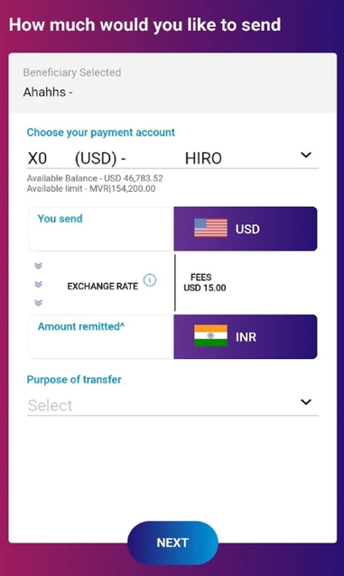

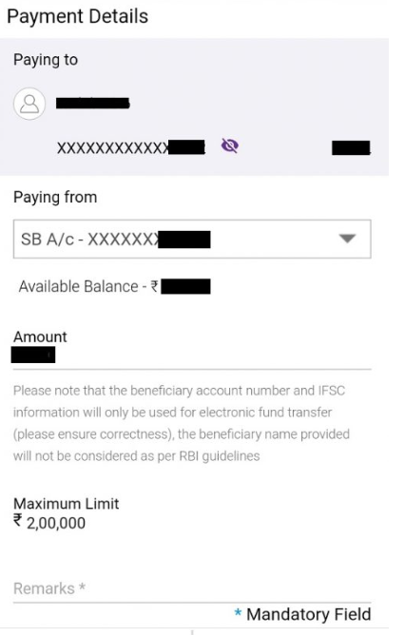

# Database design

## List of Tables

* Book
* Borrower
* Student
* Staff

#### *Table 4.1-1 Table: Book*

|  |  |  |  |  |
| --- | --- | --- | --- | --- |
| **Column** | **Data Type** | **Null** | **Keys & Constrains** | **Default Value & Description** |
| **BookID** | int | NN | PK (Auto Increment) |  |
| **BookName** | varchar(100) | NN |  |  |
| **ISBN** | varchar(100) | AN |  |  |
| **Publication_year** | int | AN |  |  |
| **Language** | varchar(50) | AN |  |  |

#### *Table 4.1-2 Table: Borrower*

|  |  |  |  |  |
| --- | --- | --- | --- | --- |
| **Column** | **Data Type** | **Null** | **Keys & Constrains** | **Default Value &**  **Description** |
| **BorrowerID** | int | NN | PK (Auto Increment) |  |
| **BookID** | varchar(100) | NN | FK | Reference of Book Table |
| **BorrowedFromDate** | DateTime | AN |  |  |
| **BorrowedToDate** | DateTime | AN |  |  |
| **ActualReturnDate** | DateTime | AN |  |  |
| **IssuedBy** | int | NN | FK | Reference of Student and  Staff Table |

#### *Table 4.1-3 Table: Staff*

|  |  |  |  |  |
| --- | --- | --- | --- | --- |
| **Column** | **Data Type** | **Null** | **Keys & Constrains** | **Default Value & Description** |
| **StaffID** | int | NN | PK (Auto Increment) |  |
| **StaffName** | varchar(100) | AN |  |  |
| **IsAdmin** | Boolean | AN |  |  |
| **Designation** | varchar(100) | AN |  |  |

#### *Table 4.1-4 Table: Student*

|  |  |  |  |  |
| --- | --- | --- | --- | --- |
| **Column** | **Data Type** | **Null** | **Keys & Constrains** | **Default Value & Description** |
| **StudentID** | int | NN | PK (Auto Increment) |  |
| **StudentName** | varchar(100) | AN |  |  |
| **Gender** | varchar(100) | AN |  |  |
| **DOB** | DateTime | AN |  |  |
| **Department** | varchar(100) | AN |  |  |
| **Contact** | number(10,0) | AN |  |  |

# Stories and Scenario

## Story-1: Add New Book in Library Catalogue

|  |  |  |
| --- | --- | --- |
| *Story #* ***S1*** | **:** | **As a** Librarian,  **I want to** add a new book in library catalogue  **So that** everyone can easily find and borrow it. |
| **Priority** | **:** | High |
| **Estimate** | **:** | XL |
| **Reason** | **:** | The addition of a new book to the library catalogue is crucial for ensuring that the library's collection is up-to-date and accessible to everyone. |

### Scenario# S1.1

|  |  |  |
| --- | --- | --- |
| *Scenario#* ***S1.1*** | **:** | Adding a New Book with Valid Information |
| **Prerequisite** | **:** | Librarian is logged in to the Library management system. |
| **Acceptance**  **Criteria** | **:** | **Given:**  The Librarian is navigated to the library catalog management page. Valid book information, including title, author, ISBN, and other relevant details is added.  **When:**  The librarian selects the "Add New Book" option  And The librarian enters valid book details  The librarian clicks the "Save" button to add the book to the catalog.    **Then t**he system successfully adds the book to the catalog and the librarian receives a confirmation message with the book's identification number. |

### Scenario# S1.2

|  |  |  |
| --- | --- | --- |
| *Scenario#* ***S1.2*** | **:** | Adding a New Book with Invalid Information. |
| **Prerequisite** | **:** | The librarian is logged into the library management system. |
| **Acceptance**  **Criteria** | **:** | **Given:** The librarian is on the library catalogue management page  **When:** The librarian selects the "Add New Book" option and the librarian enters an incomplete or incorrect book details and librarian clicks the "Save" button to add the book to the catalogue.  **Then t**he system displays error messages for the incorrect or missing information and the book is not added to the catalogue. |

### Scenario# S1.3

|  |  |  |
| --- | --- | --- |
| *Scenario#* ***S1.3*** | **:** | Attempting to Add a Duplicate Book |
| **Prerequisite** | **:** | The librarian is logged into the library management system and the librarian is on the library catalogue management page |
| **Acceptance**  **Criteria** | **:** | **Given**: The book information, including title, author, ISBN, and other relevant details, is available and the book with the same ISBN is already in the catalogue.  **When**: User Clicks on “Add book” button. Enter a number of copies with |
|  | | the same book detail mentioned in the field.  **Then**: Generate unique book id, barcode and spine label for various book of same title. |

## Story-2: Search Book

|  |  |  |
| --- | --- | --- |
| *Story #* ***S2*** | : | **As a** Librarian or member,  **I want to** search for books by title, author, or keyword,  **So that** I can quickly find books that match my interests. |
| **Priority** | **:** | High |
| **Estimate** | **:** | M |
| **Reason** | **:** | Implementing a search functionality is essential for enhancing the user experience, as it allows librarian and member to efficiently discover and access the library's resources. |

## Story-3: Manage due date for borrowed book

|  |  |  |
| --- | --- | --- |
| *Story #* ***S3*** | **:** | **As** Librarian,  **I want** to manage due dates for borrowed books  **So that** I can ensure that books are returned on time and avoid overdue fines. |
| **Priority** | **:** | High |
| **Estimate** | **:** | M |
| **Reason** | **:** | Proper due date management is crucial for maintaining the library's collection and ensuring that books are available for all members. |

## Story-4: Renew book

|  |  |  |
| --- | --- | --- |
| *Story #* ***S3*** | **:** | **As** Librarian,  **I want** to renew a book that I have borrowed  **So that** I can extend my borrowing period if needed. |
| **Priority** | **:** | Medium |
| **Estimate** | **:** | M |
| **Reason** | **:** | Book renewal functionality is a convenience feature for librarian, allowing them to keep a book for an extended period if no one else has requested it. |

## Story-5: Generate a report on book usage and availability

|  |  |  |
| --- | --- | --- |
| *Story #* ***S3*** | **:** | **As** Librarian,  **I want** to generate reports on library usage and book availability **So that** I can make informed decisions about library’s books. |
| **Priority** | **:** | Medium |
| **Estimate** | **:** | L |
| **Reason** | **:** | Reporting functionality helps librarians track the usage of library resources and make data-driven decisions to improve services and collections. |

# Test cases

|  |  |  |  |
| --- | --- | --- | --- |
| **Project Name:** | **EMI Calculator** | **Test Designed by:** | **P. U. Jadeja** |
| **Module Name:** | **Login** | **Test Designed date:** | 01-10-2023 |
| **Release Version:** | **1.0** | **Test Executed by:** | **R. B. Gondaliya** |
|  |  | **Test Execution date:** | 15-01-2023 |

|  |  |  |  |  |
| --- | --- | --- | --- | --- |
| **Pre-condition**: **Web application should be accessible** | | | |  |
| **Test Case ID** | **Test Title** | **Test Type** | **Description** | **Test Case ID** |
| **TC_001** | Login to web application with  valid credential | Functional | Login to Library management system web application through valid credential | TC_001 |
| **TC_002** | Login to web application with  invalid credential | Functional | Login to Library management system web application through invalid credential | TC_002 |
| **TC_003** | Varify login page elements | GUI | varify that all elements are availabe on login page | TC_003 |

|  |  |
| --- | --- |
| Test Case Title | Login to web application with valid credential |
| Test Type | Functional |
| Test Priority | High |
| Pre-condition | Web application should be accessible |

|  |  |  |  |  |  |  |  |
| --- | --- | --- | --- | --- | --- | --- | --- |
| Test Step | Test Case Description | Expected Result | Actual Result | Status | Comment | Data | BUG ID |
| 1 | Access Web application URL | The site  launched properly | Site launched successfully | Pass |  | [https://accounts. google.com/Ser viceLogin](https://accounts.google.com/ServiceLogin) |  |
| 2 | Enter valid Username  in  username  field | Username  field should be editable and accept the  Username | Username input accepted | Pass |  | Username: Rbgondaliya@ gmail.com |  |
| 3 | Enter valid Password in Password  field | Password field should be editable and accept the password and display as star or dot | Password input displayed in dot and  accepted | pass |  | Password: rbgondaliya |  |
| 4 | Enter valid captcha  code in  captch field | Captch field should editable and accept captcha and captcha is case sensitive | Captcha input accepted | Pass | Step require d when human  action validati on perfor | get captcha from image which is near by captcha  field |  |
|  |  |  |  |  | m |  |  |
| 5 | Click on  login button | User should login into site and navigated to dashboard | User navigated to dashboard and  username should br display in top of the right side. | pass |  |  |  |

|  |  |
| --- | --- |
| Test Case Title | Login to web application with invalid credential |
| Test Type | Functional |
| Test Priority | Medium |
| Pre-condition | Web application should be accessible |

|  |  |  |  |  |  |  |  |
| --- | --- | --- | --- | --- | --- | --- | --- |
| Test Step | Test Case Description | Expected Result | Actual Result | Status | Comment | Data | Bug ID |
| 1 | Verify that User is not able to  Login with  invalid  Username and  invalid  Password | Should be display an error message enter wrong username  or password | Display an error of wrong username and password | Pass |  |  |  |
| 2 | Verify that User is not able to  Login with Valid Username and  invalid  Password | Should be display an error message enter wrong password | Display an error of wrong password | Pass |  |  |  |
| 3 | Verify that User is not | Should be display an error | Display an error  Username | Pass |  |  |  |
|  | able to  Login with  invalid  Username and Valid Password | message User not found | not found |  |  |  |  |
| 4 | Verify that User is not able to  Login with  blank  Username  or  Password | Set required field validation  message  for  Username and Password | Display an error of wrong username and password | Fail | Not performa  a validation  function  fix it |  | Bug_002 |

|  |  |
| --- | --- |
| Test Case Title | Varify login page elements |
| Test Type | GUI |
| Test Priority | Medium |
| Pre-condition | Web application should be accessible |

|  |  |  |  |  |  |  |  |
| --- | --- | --- | --- | --- | --- | --- | --- |
| Test Step | Test Case  Description | Expected Result | Actual Result | Status | Comment | Data | Bug  ID |
| 1 | Launch application with the  given url | The site launched properly | Site launched successfully | Pass |  | [https://accounts.google .com/ServiceLogin](https://accounts.google.com/ServiceLogin) |  |
| 2 | Verify that the login screen contains elements  such as  Username,  Password,  Sign in  button,  Remember password check box, Forgot password link, and | All listed control displayed properly  on the  page | Login page loaded successfully | Pass |  |  |  |

|  |  |  |  |  |  |  |  |
| --- | --- | --- | --- | --- | --- | --- | --- |
|  | Create an account link. |  |  |  |  |  |  |
| 3 | Verify that cursor is focused on  “Username ” text box on the  page load | Cursor is focused in Username textbox | Cursor  focus in Username textbox | Pass |  |  |  |
| 4 | Verify that tab functionali  ty is  working properly or not | When tab pressed cursor  move in  next control | Cursor  moving in  next control | Pass |  |  |  |
| 5 | Verify that all the fields such as  Username, Password has a valid  placeholde  r | All text  fields have proper placehold er | All text fields have proper placeholder | Pass |  |  |  |
| 6 | Verify that the labels float  upward when the text field is in focus or filled (In case of  floating label) | When field is focused or filled, label display on top of the  filled | When field is focus or filled, label display on top of the  filled | Pass | step  required when  fields with floating label |  |  |
| 7 | verify that forgot  password  link  working properly | when click on  forgot password load forgot passworg | forgot password  link not  working | Fail |  |  |  |
|  |  | page |  |  |  |  |  |

# References

* http://www.w3schools.com/html/html_intro.asp
* https://www.w3schools.com/php/default.asp
* https://www.javatpoint.com/uml