**1. Homepage**

* Hero banner: a **clean photo of golden fields / soybean meal / chickpeas in burlap bags**.
* Overlay punch line:  
  *“Pure. Organic. Traceable. Indian Agricultural Excellence for US Supply Chains.”*
* Call-to-Action (CTA): **“Request a Quote” / “Download Product Specs.”**

We can add list of products under Download product Specs.

Organic Soyabean Meal

Organic Soya Lecithin

Organic Sunflower Lecithin

Organic Glycerine

Organic Soyabean

Organic Barley

Organic Wheat

Organic Cracked Corn

Organic Castor Oil

Organic Flaxseed

**2. About Us / Why India?**

* Highlight **India’s strengths**: centuries-old farming, large-scale production, global certifications, competitive pricing.
* Add **logos of certifications**: USDA Organic, Non-GMO, FSSAI, ISO, HACCP. (Add pictures of all certifications from vandana organic website)

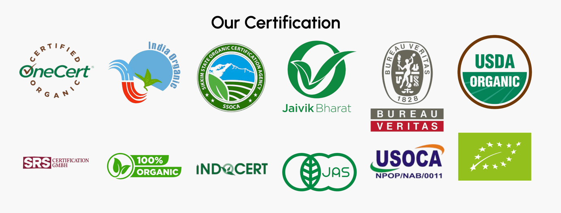

* Emphasize **sustainability + traceability** with a short story: *“From smallholder farms in India to verified export supply chains.”* (add pictures of an Indian farmer and a manufacturing industry in US and add line…From…..Supply chain on the side)

**3. Products Page**

* Each product with:
  + Image (soybean meal flakes, chickpeas, etc.)
  + Key specs: protein %, moisture %, purity level.
  + Certifications (Organic / Non-GMO / Kosher).
  + Downloadable **COA (Certificate of Analysis)** sample.
* Example line:  
  *“Soy Lecithin – Non-GMO, food-grade, viscosity-controlled, ready for pharma & food industries.”*

Add information about two products with two blocks in one row, and list all other products with their name and a link to download specs.

**Traceability & Quality Assurance**

* Infographic showing the **journey**:  
  *Farm → Collection → Processing → Testing → Export → US Delivery.* (add some pictures to show this)
* Highlight: **“Batch-wise COA & traceability codes available.”**
* Mention labs/testing partners, if any. (Mention about lab testing partners as mentioned on the certification section above.

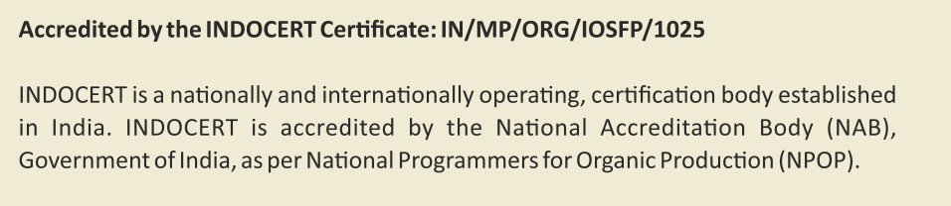

**Sustainability & Organic Focus**

* Short section: *“Empowering Indian farmers while meeting global sustainability goals.”*
* Showcase **green packaging, low-carbon logistics, and fair trade initiatives**.

Sample Websites-

https://vandanaorganic.com/b2b

<https://www.instagram.com/officialvandanaorganic/>

<https://www.linkedin.com/company/vandana-organic-trade/?originalSubdomain=in>

<https://www.facebook.com/VandanaOrganicTrade/>