ce**N**tralized, s**E**rvice orien**T**ed, sel**F** adaptive, app**LIC**ation for movie **S**treaming - **NETFLICS**

Software Engineering for Autonomous Systems/Service Oriented Software Engineering

Valentina Cecchini – 255596

Stefano Valentini – 254825

demo video:

*\*full resolution images can be found along with this document*

**OVERVIEW**

The aim of this project is to build a video streaming application project based on web services, with particular focus on self-adaptivity.

The system exploits the interactions between services and to achieve a great level of availability while avoiding waste of resources through the implementation of a load-balancing mechanism that is able to “turn off” certain components of the system when not needed and to wake them back up in case of an high volume of incoming requests is detected.

**E-R MODEL**

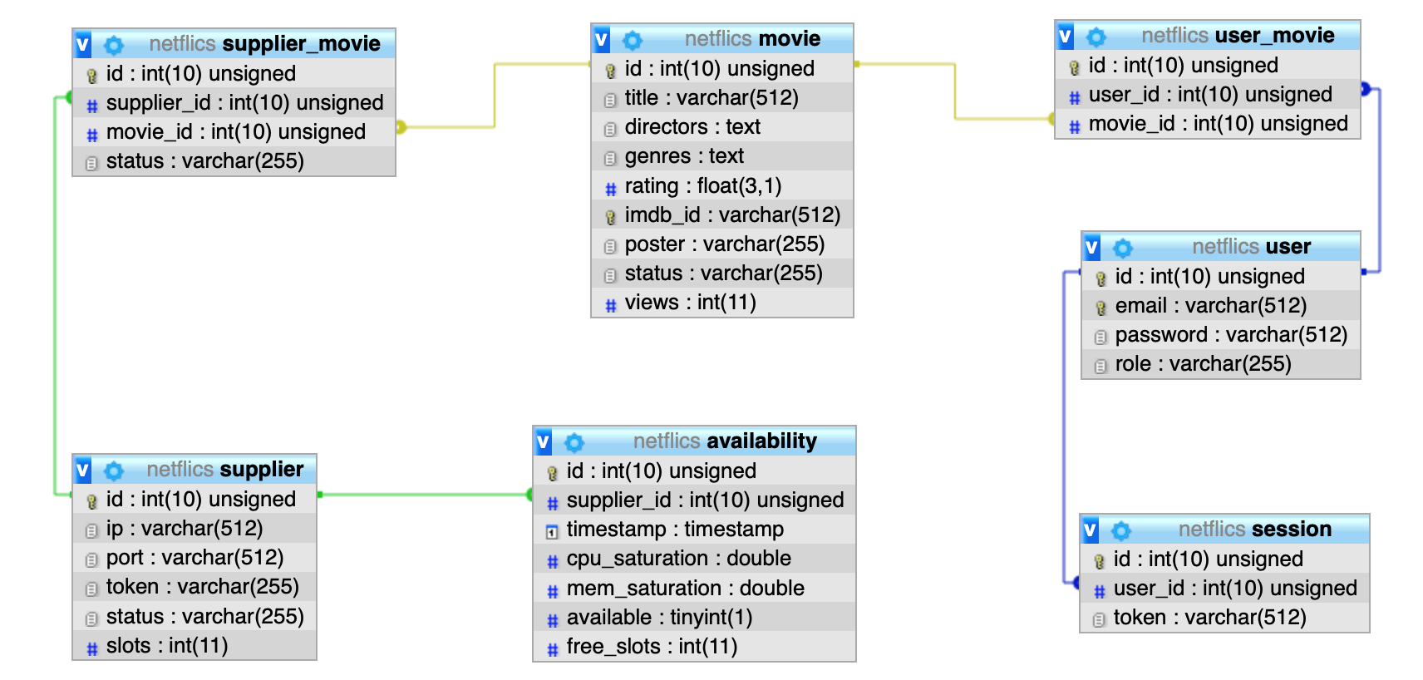

The database underlying the system is organized in the following way:

There are three principal entities: *user*, *movie* and *supplier*; for the user we are interested

in saving the e-mail and password and in distinguishing among them by the role that can be "ADMIN" or "USER".

For each *user* we want to record each log in through the table *session* and the set of movies that he has watcher through the table *user_movie*.

For *supplier* entity, we want to keep the data about where each single supplier can be found, a way to recognize it, it’s status and how many slots (i.e., how much client connections it can hold) it has.

For reach *supplier* we desire to store the availability, its resource consumption and its number of free slots, at any given time.

For the *movie* entity we want save all the metadata and the number of times that the movie is seen.

We also need to record which *supplier* has a certain film and which one has not: to do it, the entity *supplier_movie* holds this kind of information.

**SYSTEM’S ARCHITECTURE**

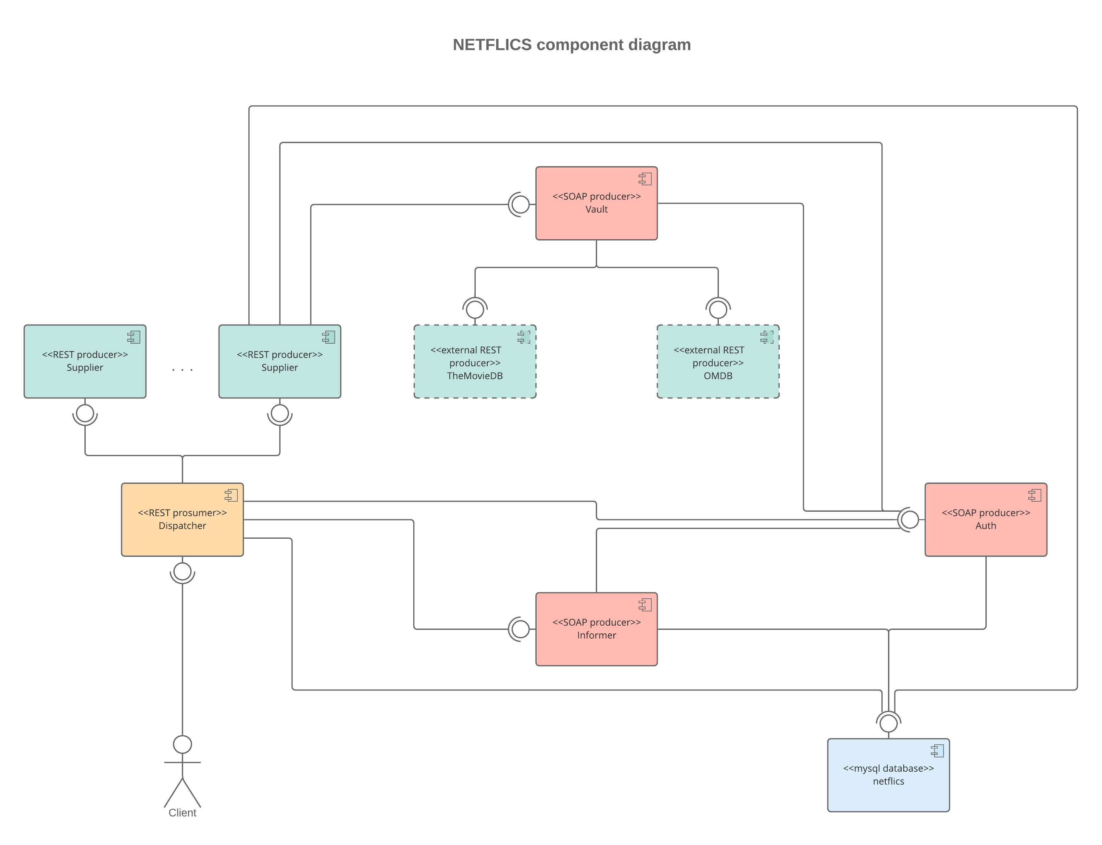

**SOAP** services:

* **Auth**: is the service that is responsible for checking the user’s credentials to allow it to log in/out and access the system’s functionalities, endpoints**:**
  + **logIn(email, password) -> {result, role, token}**

checks the user’s credentials and performs the log in action, returning the role and a new token for the user to use

* + **logOut(token) -> {result}**

deletes the session associated to the sent token

* + **checkToken(token) -> {result, role}**

checks the token and returns the role of the user

* **Vault**: is the service that is responsible for keeping all the movie files on disk and to send them to the suppliers that request them**:**
  + **getMovie(imdb_id, token) -> {movie, result}**

returns the movie data associated to the imdb_id, if the user is authorized

* + **addMovie(imdb_id, movie, token) -> {result}**

saves to disk the movie data that it has received, retrieves the metadata of the movie from TheMovieDB and OMDB and stores them into the db.

* **Informer:** is the service that is responsible for retrieving information from the database to be used for the render of the webclient gui (such as the list of the most viewed movies, etc.).

**REST** services

* **Supplier**:is the service that is responsible for retrieving the movie data from the *Vault* service and make it available for the Dispatcher; endpoints:
  + **GET /{token}/movie/{id}**

returns the requested movie data as a StreamingOutput

* + **GET /{token}/availability**

returns the current system resource occupation

* + **POST /{token}/movie/{id}**

commands this supplier to fetch the movie data from the Vault service

* + **POST /{token}/wakeup**

commands this supplier to wake up

* + **POST /{token}/sleep**

commands this supplier to go to sleep

* **Dispatcher**: is the only component of the system that communicates with the client(s), it’s main task is the one that consist on permitting the client to stream the movie by requesting it from the “best” supplier (the mechanism by which this is accomplished is detailed in the “Load Balancing” section of this document; endpoints:
  + **PUT /{token}/movie/{imdbId}**

forwards the received movie data to the Vault.addMovie service to store it (reserved to admins)

* + **POST /{token}/logout**

calls Auth.logOut

* + **GET /movie/mostviewed**

returns the data that is retrieved by the Informer.mostViewed service

* + **GET /movie/bestones**

returns the data that is retrieved by the Informer.bestOnes service

* + **GET /{token}/movie/lastviewed**

returns the data that is retrieved by the Informer.lastViewed service

* + **GET /{token}/movie/stream/{imdbId}**

main functionality of this component, finds the “best” supplier and forwards to the client the StreamingOutput that is returned by it.

**LOAD BALANCING**

The load balancing procedure is based on the **MAPE-K** cycle; it is implemented in this system by the *LoadBalancer* class in the *Dispatcher* service and it starts any time the Dispatcher receives a stream request by a client.

**MONITOR**: the *Dispatcher* retrieves from the database the list of the sleeping suppliers (and puts them into the *sleepingSuppliers* list) and the suppliers that are awake; then the Dispatcher sends an availability request to all the awake suppliers (in parallel), if any; so to retrieve the availabilities (in this case the free slots) of the suppliers.

When the availability data is returned the system decides whether a given supplier is considered as “free” or not by looking at the number of its free slots, so to build the *freeSuppliers* list.

**ANALYZE**: the *Dispatcher* retrieves the list of all the suppliers that currently have the requested movie data, then it divides them in two groups: the suppliers that are “free” and currently **have** the movie data and the suppliers that are “free” and currently **do not have** the movie data, so to fill the *freeSupplierHavingMovie* and *freeSuppliersNotHavingMovie* lists.

**PLAN**: this phase consists of filling certain lists that will be later processed by the execute phase, based on the results of previous phases.

If the list *freeSuppliers* has more than 0 entries then it means that there are free suppliers, so check whether there are free suppliers having the movie by looking at the size of the *freeSuppliersHavingMovie* list, if so, chose the one that has the highest amount of free slots, lets call this supplier *chosenOne*; if, instead, there list is empty, but the *freeSupplier* one is not it must mean that the *freeSuppliersNotHavingMovie* is not empty: in this case chose the best one in terms of free slots and add it to the *supplierToFetch* list (meaning that it will be commanded to retrieve the movie data from the *Vault* service).

Now, we are still in the case in which the *freeSuppliers* list is not empty, in this case there may be some supplier that is idle, i.e., the number of its free slots is equal to the number of its total slots, if so, add it to the *suppliersToSleep* list, paying attention to exclude the *chosenOne* and all the *suppliersToFetch* from this list.

While, if the *freeSuppliers* list is empty we do not perform any of the previously described actions and we check, instead, if there are some sleeping suppliers, by looking at the size of the *sleepingSuppliers* list: if so, we chose some random sleeping supplier(s) and we put it(them) into the *suppliersToWake* list, we also put them into the *suppliersToFetch* list, since after having been woken up, they will not have any movie data available.

Finally, if there no *freeSuppliers* and there are no *sleepingSuppliers* it means that the only choice we have is to call directly the *Vault* service to stream back its data to the user, notice that this is an extreme situation that should not happen.

**EXECUTE**: this phase consists on sending the respective commands on the right suppliers, by looking at the previously filled lists.

For each element of a given list the appropriate request is performed, e.g., a

POST /{token}/sleep is sent to each member of the *suppliersToSleep* list.

Now, if the *chosenOne* has been previously identified, a stream from that supplier to the client is opened, otherwise the stream will be opened from the *Vault.*

If, in the plan phase, neither the *chosenOne* has been identified, neither it has been decided to stream from the *Vault* (i.e., we are waiting for some supplier to wake up and fetch the movie) the procedure is restarted after a fixed amount of time, for at most *X* times.

**TESTS**

To test the application a *testclient* java application has been developed: this application sends a certain number of requestst to the GET /{token}/movie/stream/{imdbId} endpoint, one each *X* second(s); for each test the number of requests to perform is 10, every 2 seconds.

Since the machine in which the services are deployed is able to handle the stream requests in milliseconds, an artificial delay of *10* seconds and *15* seconds has been added on the *supplier* request and *vault* request respectively.

Suppliers with a number of free slots *<= 2* are considered *not free*.

**TEST 1**

* supplier 1: *AWAKE*
* supplier 2: *AWAKE*
* supplier 3: *AWAKE*

|  |  |  |  |  |  |
| --- | --- | --- | --- | --- | --- |
| REQUEST # | START TIME | ACCEPT TIME | END TIME | TTA | TTC |
| 0 | 14:35:08,568 | 14:35:10,087 | 14:35:20,108 | 0:00:01,519 | 0:00:10,021 |
| 1 | 14:35:10,507 | 14:35:10,742 | 14:35:20,750 | 0:00:00,235 | 0:00:10,008 |
| 2 | 14:35:12,509 | 14:35:12,687 | 14:35:22,694 | 0:00:00,178 | 0:00:10,007 |
| 3 | 14:35:14,510 | 14:35:16,820 | 14:35:27,826 | 0:00:02,310 | 0:00:11,006 |
| 4 | 14:35:16,511 | 14:35:16,756 | 14:35:27,761 | 0:00:00,245 | 0:00:11,005 |
| 5 | 14:35:18,516 | 14:35:18,698 | 14:35:29,702 | 0:00:00,182 | 0:00:11,004 |
| 6 | 14:35:20,520 | 14:35:20,710 | 14:35:30,717 | 0:00:00,190 | 0:00:10,007 |
| 7 | 14:35:22,525 | 14:35:22,723 | 14:35:32,730 | 0:00:00,198 | 0:00:10,007 |
| 8 | 14:35:24,528 | 14:35:24,713 | 14:35:34,718 | 0:00:00,185 | 0:00:10,005 |
| 9 | 14:35:26,531 | 14:35:28,945 | 14:35:38,954 | 0:00:02,414 | 0:00:10,009 |
| 10 | 14:35:28,534 | 14:35:28,949 | 14:35:38,955 | 0:00:00,415 | 0:00:10,006 |

Average **TTA** (Time To Accept): **0.734s**

Average **TTC** (Time To Complete)**: 10.280s**

**SUPPLIER 1** (serves requests 0, 1, 2, 6 ,7 ,8):

|  |  |  |
| --- | --- | --- |
| TIME | FREE SLOTS | STATUS |
| 14:35:09,733 | 5 | AWAKE |
| 14:35:10,087 | 4 | AWAKE |
| 14:35:10,742 | 3 | AWAKE |
| 14:35:12,687 | 2 | AWAKE |
| 14:35:20,089 | 3 | AWAKE |
| 14:35:20,710 | 2 | AWAKE |
| 14:35:20,747 | 3 | AWAKE |
| 14:35:22,692 | 4 | AWAKE |
| 14:35:22,723 | 3 | AWAKE |
| 14:35:24,713 | 2 | AWAKE |
| 14:35:30,714 | 3 | AWAKE |
| 14:35:32,727 | 4 | AWAKE |
| 14:35:34,710 | 5 | AWAKE |

Average free slots: **3**

**SUPPLIER 2** (serves requests 3, 4, 5, 9, 10):

|  |  |  |
| --- | --- | --- |
| TIME | FREE SLOTS | STATUS |
| 14:35:09,724 | 5 | AWAKE |
| 14:35:10,033 | 5 | SLEEP |
| 14:35:14,709 | 5 | AWAKE |
| 14:35:17,756 | 4 | AWAKE |
| 14:35:16,821 | 3 | AWAKE |
| 14:35:18,698 | 2 | AWAKE |
| 14:35:26,760 | 3 | AWAKE |
| 14:35:26,825 | 4 | AWAKE |
| 14:35:28,700 | 5 | AWAKE |
| 14:35:28,945 | 4 | AWAKE |
| 14:35:28,949 | 3 | AWAKE |
| 14:35:38,951 | 4 | AWAKE |
| 14:35:38,952 | 5 | AWAKE |

Average free slots: **4**

**SUPPLIER 3** (serves no requests)

|  |  |  |
| --- | --- | --- |
| TIME | FREE SLOTS | STATUS |
| 14:35:09,728 | 5 | AWAKE |
| 14:35:10,031 | 5 | SLEEP |
| 14:35:26,778 | 5 | AWAKE |
| 14:35:28,963 | 5 | SLEEP |

Average free slots: **5**

**TEST 2**

* supplier 1: *SLEEP*
* supplier 2: *SLEEP*
* supplier 3: *SLEEP*

|  |  |  |  |  |  |
| --- | --- | --- | --- | --- | --- |
| ID | START TIME | ACCEPT TIME | END TIME | TTA | TTC |
| 0 | 14:28:53,460 | 14:29:02,408 | 14:29:12,443 | 0:00:08,948 | 0:00:10,035 |
| 1 | 14:28:55,401 | 14:29:02,405 | 14:29:12,443 | 0:00:07,004 | 0:00:10,038 |
| 2 | 14:28:57,404 | 14:29:02,378 | 14:29:12,443 | 0:00:04,974 | 0:00:10,065 |
| 3 | 14:28:59,410 | 14:29:04,767 | 14:29:14,779 | 0:00:05,357 | 0:00:10,012 |
| 4 | 14:29:01,430 | 14:29:02,408 | 14:29:12,443 | 0:00:00,978 | 0:00:10,035 |
| 5 | 14:29:03,419 | 14:29:05,915 | 14:29:15,921 | 0:00:02,496 | 0:00:10,006 |
| 6 | 14:29:05,424 | 14:29:05,656 | 14:29:15,661 | 0:00:00,232 | 0:00:10,005 |
| 7 | 14:29:07,428 | 14:29:10,963 | 14:29:20,968 | 0:00:03,535 | 0:00:10,005 |
| 8 | 14:29:09,454 | 14:29:10,945 | 14:29:20,963 | 0:00:01,491 | 0:00:10,018 |
| 9 | 14:29:11,441 | 14:29:11,629 | 14:29:21,686 | 0:00:00,188 | 0:00:10,057 |
| 10 | 14:29:13,441 | 14:29:13,711 | 14:29:23,718 | 0:00:00,270 | 0:00:10,007 |

Average **TTA** (Time To Accept): **3.225s**

Average **TTC** (Time To Complete)**: 10.026s**

**SUPPLIER 1** (server requests 0, 1, 2, 4, 10)

|  |  |  |
| --- | --- | --- |
| TIME | FREE SLOTS | STATUS |
| 14:28:56,381 | 5 | SLEEP |
| 14:28:57,211 | 5 | AWAKE |
| 14:29:02,378 | 4 | AWAKE |
| 14:29:02,405 | 3 | AWAKE |
| 14:29:02,408 | 2 | AWAKE |
| 14:29:02,408 | 1 | AWAKE |
| 14:29:12,400 | 2 | AWAKE |
| 14:29:12,408 | 3 | AWAKE |
| 14:29:12,414 | 4 | AWAKE |
| 14:29:12,414 | 5 | AWAKE |
| 14:29:13,711 | 4 | AWAKE |
| 14:29:23,715 | 5 | AWAKE |

Average free slots: **4**

**SUPPLIER 2** (server requests 3, 5, 6)

|  |  |  |
| --- | --- | --- |
| TIME | FREE SLOTS | STATUS |
| 14:28:56,379 | 5 | SLEEP |
| 14:28:57,252 | 5 | AWAKE |
| 14:29:02,239 | 5 | SLEEP |
| 14:29:02,528 | 5 | AWAKE |
| 14:29:04,767 | 4 | AWAKE |
| 14:29:05,656 | 3 | AWAKE |
| 14:29:05,915 | 2 | AWAKE |
| 14:29:14,774 | 3 | AWAKE |
| 14:29:15,658 | 4 | AWAKE |
| 14:29:15,919 | 5 | AWAKE |

Average free slots: **4**

**SUPPLIER 3** (server requests 7, 8, 9)

|  |  |  |
| --- | --- | --- |
| TIME | FREE SLOTS | STATUS |
| 14:29:07,958 | 5 | SLEEP |
| 14:29:08,784 | 5 | AWAKE |
| 14:29:10,945 | 4 | AWAKE |
| 14:29:10,963 | 3 | AWAKE |
| 14:29:11,677 | 2 | AWAKE |
| 14:29:20,961 | 3 | AWAKE |
| 14:29:20,965 | 4 | AWAKE |
| 14:29:21,680 | 5 | AWAKE |

Average free slots: **4**

**TEST 3**

* supplier 1: *AWAKE*
* supplier 2: *OFFLINE*
* supplier 3: *OFFLINE*

|  |  |  |  |  |  |
| --- | --- | --- | --- | --- | --- |
| ID | START TIME | ACCEPT TIME | END TIME | TTA | TTC |
| 0 | 14:47:17,602 | 14:47:20,535 | 14:47:30,567 | 0:00:02,933 | 0:00:10,032 |
| 1 | 14:47:19,549 | 14:47:20,535 | 14:47:30,567 | 0:00:00,986 | 0:00:10,032 |
| 2 | 14:47:21,554 | 14:47:21,736 | 14:47:31,744 | 0:00:00,182 | 0:00:10,008 |
| 3 | 14:47:23,556 | 14:47:23,682 | 14:47:39,742 | 0:00:00,126 | 0:00:16,060 |
| 4 | 14:47:25,561 | 14:47:25,685 | 14:47:41,034 | 0:00:00,124 | 0:00:15,349 |
| 5 | 14:47:27,567 | 14:47:27,678 | 14:47:43,263 | 0:00:00,111 | 0:00:15,585 |
| 6 | 14:47:29,570 | 14:47:29,833 | 14:47:45,132 | 0:00:00,263 | 0:00:15,299 |
| 7 | 14:47:31,574 | 14:47:31,725 | 14:47:41,733 | 0:00:00,151 | 0:00:10,008 |
| 8 | 14:47:33,580 | 14:47:33,728 | 14:47:43,733 | 0:00:00,148 | 0:00:10,005 |
| 9 | 14:47:35,585 | 14:47:35,785 | 14:47:45,789 | 0:00:00,200 | 0:00:10,004 |
| 10 | 14:47:37,588 | 14:47:37,688 | 14:47:52,972 | 0:00:00,100 | 0:00:15,284 |

Average **TTA** (Time To Accept): **0.484s**

Average **TTC** (Time To Complete)**: 12.515s**

**SUPPLIER 1** (serves requests 0, 1, 2, 7, 8, 9; the other requests have been sent to the *Vault)*

|  |  |  |
| --- | --- | --- |
| TIME | FREE SLOTS | STATUS |
| 14:47:19,987 | 5 | AWAKE |
| 14:47:20,535 | 4 | AWAKE |
| 14:47:20,535 | 3 | AWAKE |
| 14:47:21,736 | 2 | AWAKE |
| 14:47:30,537 | 3 | AWAKE |
| 14:47:30,537 | 4 | AWAKE |
| 14:47:31,725 | 3 | AWAKE |
| 14:47:31,742 | 4 | AWAKE |
| 14:47:33,728 | 3 | AWAKE |
| 14:47:35,785 | 2 | AWAKE |
| 14:47:41,730 | 3 | AWAKE |
| 14:47:43,730 | 4 | AWAKE |
| 14:47:45,787 | 5 | AWAKE |

Average free slots: **3**