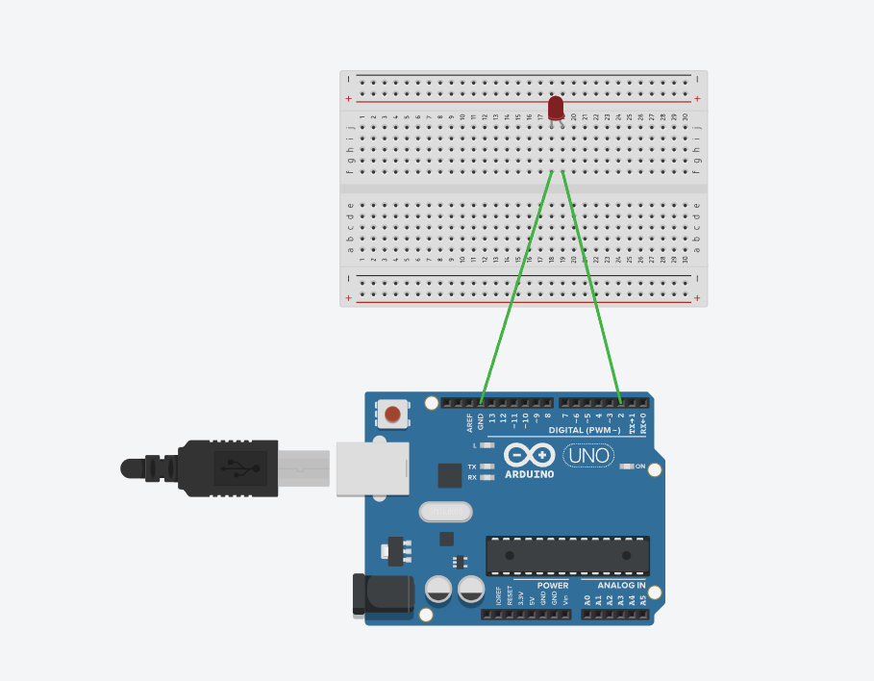

void setup(){

pinMode(2,OUTPUT);

}

void loop(){

digitalWrite(2,HIGH);

delay(1000);

digitalWrite(2,LOW);

delay(1000);}