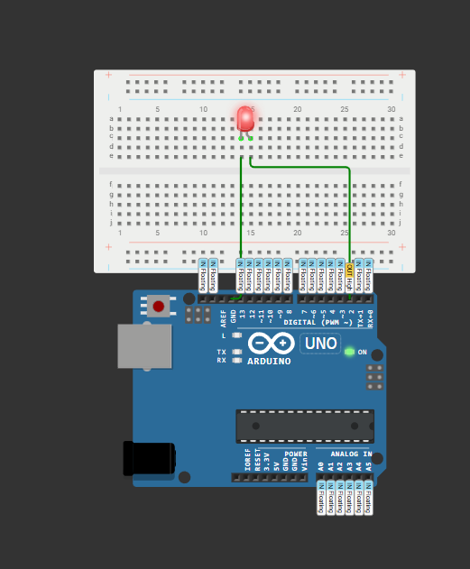01.

void setup(){

  pinMode(2,OUTPUT);

}

void loop(){

  digitalWrite(2, HIGH);

  delay(1000);

  digitalWrite(2, LOW);

  delay(1000);

}