Cloud Service Models :

What is Iaas (Infrastructure as service) ?

Infrastructure as a service (IaaS) is a type of cloud computing service that offers essential compute, storage and networking resources on demand, on a pay-as-you-go basis.
- IaaS solution helps you to reduce maintenance of on-premises data centres, save money on hardware costs.
- IaaS solutions give you the flexibility to scale your IT resources up and down with demand.
- They also help you quickly provides new applications and increase the reliability of your underlying infrastructure.
Each resource is offered as a separate service component and you only pay for a particular resource for as long as you need it.
A cloud computing service provider like AWS manages the infrastructure, while you purchase, install, configure and manage your own software—including operating systems, middleware and applications.
IaaS is made up of a collection of physical and virtualized resources that provide consumers with the basic building blocks needed to run applications and workloads in the cloud.

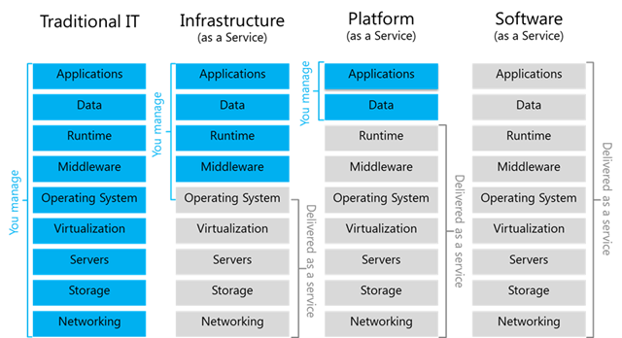
https://azure.microsoft.com/en-in/resources/cloud-computing-dictionary/what-is-iaas/#overview

What is PaaS (Platform as a service) ?

Platform as a service (PaaS) is a complete development and deployment environment in the cloud, with resources that enable you to deliver everything from simple cloud-based apps to sophisticated, cloud-enabled enterprise applications. You purchase the resources you need from a cloud service provider on a pay-as-you-go basis and access them over a secure Internet connection.
Like IaaS, PaaS includes infrastructure—servers, storage and networking—but also middleware, development tools, business intelligence (BI) services, database management systems and more. PaaS is designed to support the complete web application lifecycle: building, testing, deploying, managing and updating.
PaaS allows you to avoid the expense and complexity of buying and managing software licenses, the underlying application infrastructure and middleware, container orchestrators such as Kubernetes or the development tools and other resources. You manage the applications and services you develop and the cloud service provider typically manages everything else.

https://www.javatpoint.com/platform-as-a-service
Platform as a Service (PaaS) provides a runtime environment. It allows programmers to easily create, test, run, and deploy web applications. You can purchase these applications from a cloud service provider on a pay-as-per use basis and access them using the Internet connection. In PaaS, back end scalability is managed by the cloud service provider, so end- users do not need to worry about managing the infrastructure.
PaaS includes infrastructure (servers, storage, and networking) and platform (middleware, development tools, database management systems, business intelligence, and more) to support the web application life cycle.
Example: Google App Engine, Force.com, Joyent, Azure, Heroku
PaaS providers provide the Programming languages, Application frameworks, Databases, and Other tools:

What is SaaS (Softeware as a service) ?

Software as a service (SaaS) allows users to connect to and use cloud-based apps over the Internet. Common examples are email, calendaring and office tools (such as Microsoft Office 365).
SaaS provides a complete software solution which you purchase on a pay-as-you-go basis from a cloud service provider.You rent the use of an app for your organisation and your users connect to it over the Internet, usually with a web browser. All of the underlying infrastructure, middleware, app software and app data are located in the service provider’s data center.
The service provider manages the hardware and software and with the appropriate service agreement, will ensure the availability and the security of the app and your data as well.
SaaS allows your organisation to get quickly up and running with an app at minimal upfront cost.

There are the following services provided by SaaS providers -
Business Services - SaaS Provider provides various business services to start-up the business. The SaaS business services include ERP (Enterprise Resource Planning), CRM (Customer Relationship Management), billing, and sales.
Document Management - SaaS document management is a software application offered by a third party (SaaS providers) to create, manage, and track electronic documents.
Example: Slack, Samepage, Box, and Zoho Forms.
Social Networks - As we all know, social networking sites are used by the general public, so social networking service providers use SaaS for their convenience and handle the general public's information.
Mail Services - To handle the unpredictable number of users and load on e-mail services, many e-mail providers offering their services using SaaS.

What is serverless computing?

https://azure.microsoft.com/en-in/resources/cloud-computing-dictionary/what-is-serverless-computing/

Serverless computing enables developers to build applications faster by eliminating the need for them to manage infrastructure. With serverless applications, the cloud service provider automatically provisions, scales and manages the infrastructure required to run the code.
In understanding the definition of serverless computing, it is important to note that servers are still running the code.
The serverless name comes from the fact that the tasks associated with infrastructure provisioning and management are invisible to the developer.
This approach enables developers to increase their focus on the business logic and deliver more value to the core of the business. Serverless computing helps teams increase their productivity and bring products to market faster and it allows organisations to better optimise resources and stay focused on innovation.

Cloud Deployment Models:

Private cloud. The cloud infrastructure is provisioned for exclusive use by a single organization comprising multiple consumers (e.g., business units). It may be owned, managed, and operated by the organization, a third party, or some combination of them, and it may exist on or off premises.

Community cloud. The cloud infrastructure is provisioned for exclusive use by a specific community of consumers from organizations that have shared concerns (e.g., mission, security requirements, policy, and compliance considerations). It may be owned, managed, and operated by one or more of the organizations in the community, a third party, or some combination of them, and it may exist on or off premises.

Public cloud. The cloud infrastructure is provisioned for open use by the general public. It may be
owned, managed, and operated by a business, academic, or government organization, or some combination of them. It exists on the premises of the cloud provider.

Hybrid cloud. The cloud infrastructure is a composition of two or more distinct cloud infrastructures (private, community, or public) that remain unique entities, but are bound together by standardized or proprietary technology that enables data and application portability (e.g., cloud bursting for load balancing between clouds).

