Project Profile

[1] Project Profile
Project Name: PlacementCell
Type of Application: Web based application
Project Description: The Placement Cell Management System is an online platform that connects students, recruiters, and the university placement cell in one system. It replaces manual placement processes with a structured digital solution where students can create profiles, upload resumes, view company announcements, and apply for jobs.
The system also allows the placement cell to manage student information and company recruitment activities efficiently.

Team Size: 2
Id: 24MSIT068 –Rahul Panchal
Id : 24MSIT130 – Nimesh Prajapati
Front End: Angular , CSS
Back End: Java , Spring Boot
Database : Postgres SQL
Tools : Intellij Idea,Visual studio code, Git & Github , Supabase

Introduction to tools

[2] Introduction to Tools :
Front End Tool:
Angular
Angular is a TypeScript-based front-end framework used for building dynamic web applications.
It helps developers create structured, scalable, and component-based user interfaces, especially for single-page applications (SPAs).
CSS
CSS is a style sheet language used to design and control the appearance of web pages.
It allows developers to apply colors, layouts, fonts, spacing, and responsive designs to make websites visually attractive and user-friendly.

Back End Tool:
Java
Java is a high-level, object-oriented programming language used to build secure and scalable applications.
It is widely used for developing web applications, enterprise systems, and backend services.
Spring Boot
Spring boot is a Java-based framework used to build stand-alone and production-ready applications quickly. It simplifies Spring application development by providing auto-configuration, embedded servers, and minimal configuration. In this project, Spring Boot is used to develop the backend APIs, handle business logic, and manage database interactions efficiently.

System Study

[3] System Study:
3.1 Existing System:
The current campus recruitment process in many universities is mostly manual and unorganized. The placement cell usually shares company details and application forms with students through email or messaging platforms. Students must repeatedly fill separate forms for every company, making the process inefficient and difficult to manage.
Limitations of the Existing System:
• Repeated form submission: Students must fill a new form for each company opportunity.
• Manual management: Placement staff manually collect and organize student applications.
• Lack of centralized platform: There is no single system for students and placement administrators to manage recruitment activities.
• No proper tracking: Difficult to track placed and unplaced students.
• Communication delays: Important information about companies or interviews may not reach
all students on time.
• Data management issues: Managing student records manually can lead to errors and inefficiency.
3.2 Proposed System :
The proposed Placement Cell Management System aims to overcome these issues by providing a centralized and automated web-based platform for managing campus recruitment activities. The system allows students to create profiles, upload resumes, and apply to companies, while the placement cell can manage job postings and student applications efficiently.

Key Features of the Proposed System:
- Centralized Platform: All placement activities are managed through a single system.
- Student Profiles: Students can create and update their profiles and upload resumes.
- Company Job Posting: Placement cell or recruiters can post job opportunities.
- Online Applications: Students can apply to companies directly through the platform.
- Application Management: Placement cell can monitor and manage student applications.
- Student Tracking: Easy tracking of placed and unplaced students.
- Secure Data Storage: All student and company data is stored safely in a database.

3.3 Scope of the Proposed System
The scope of the Placement Cell Management System is to simplify and digitize the campus recruitment process within universities.
- Provides a centralized system for managing campus placements.
- Allows students to create a profile once and apply to multiple companies.
- Enables placement administrators to manage student records and job postings efficiently.
- Helps track placement statistics such as placed and unplaced students.
- Improves communication between students and the placement cell.
- The system can be extended with future features such as interview scheduling and analytics.
3.4 Aims and Objectives

Aim
The aim of the Placement Cell Management System is to develop a centralized and efficient platform that simplifies the campus recruitment process by connecting students and placement administrators in a structured digital environment.
Objectives
- To provide a centralized platform for managing campus placements.
- To simplify the application process for students.
- To allow students to create profiles and apply to companies easily.
- To help placement cell administrators manage recruitment activities efficiently.
- To maintain accurate records of placed and unplaced students.
- To ensure secure storage and management of student and company data.
- To make the placement process faster, organized, and paperless.
3.5 Feasibility Study
A feasibility study evaluates whether the proposed system is practical, achievable, and beneficial for the organization. It helps determine whether the system can be successfully implemented using available resources.
3.6 Operational Feasibility
Operational feasibility determines how effectively the system will operate in the real environment of the university placement process.

Key Points:
- The system provides a simple and user-friendly interface for students and placement administrators.
- Students can easily create profiles, upload resumes, and apply to companies.
- Placement cell administrators can manage student records and job postings efficiently.
- The system reduces manual work and improves communication between students and the placement cell.
- Being web-based, it can be accessed anytime and from anywhere.
3.7 Technical Feasibility
Technical feasibility analyzes whether the required technologies and resources are available to develop and maintain the system.

Key Points:
- The system will be developed using Angular for the frontend and Spring Boot for the backend.
- A secure database system will be used for storing student and company data.
- The technologies used are reliable, scalable, and widely supported.
- Secure authentication and data management features will be implemented.
- The system can be expanded in the future with additional features such as analytics and reporting.

3.8 Economical Feasibility
Economic feasibility evaluates whether the project is financially viable and beneficial.

Key Points:
- The system uses open-source technologies, reducing development costs.
- Minimal infrastructure and hosting costs are required.
- It reduces manual paperwork and administrative effort.
- Saves time for both students and placement administrators.
- Improves overall efficiency of the campus recruitment process.

System Analysis

[4]. System Analysis
4.1 Requirements Specification
The Requirements Specification defines the features, functionalities, and constraints of the Placement Cell Management System. It ensures that the system meets the needs of students and placement administrators while providing an efficient and organized platform for managing campus recruitment activities.
Functional Requirements
Functional requirements describe what the system should do — the core features and behaviors expected from the application.
- User Registration and Login
- The system should allow Students and Admin to register and log in securely.
- Authentication should verify user credentials before granting access.
- Passwords should be stored securely in the database.

2. Student Functions
- Students can create and update their profiles with personal details, academic information, and skills.
- Students can upload their resumes to their profiles.
- Students can view available company job opportunities posted by the placement cell.
- Students can apply for jobs directly through the system.
- Students can track the status of their applications.

3. Placement Cell (Admin) Functions
- Admin can manage student accounts and profiles.
- Admin can add and manage company job postings.
- Admin can view and manage applications submitted by students.
- Admin can track placed and unplaced students.
- Admin can update or remove job postings when necessary.

4. Job Posting Management
- The placement cell can add company details and job opportunities.
- Each job posting includes company name, job role, eligibility criteria, and application deadline.
- Students can view job details before applying.

5. Notifications and Updates
- The system can provide updates or notifications regarding new job postings.
- Students can view important placement-related announcements through the system.

6. Search and Filtering
- The system allows students to search and filter job opportunities based on company name or job role.
- Job listings should be displayed in an organized and easy-to-navigate format.

7. Data Management
- All student and placement data will be stored in a secure database.
- The system should allow administrators to manage, update, and retrieve student and job data easily.
- Data backup and recovery options can be implemented for security.
Non-Functional Requirements
Non-functional requirements define the system quality, performance, and operational standards of the Placement Cell Management System.

Type | Description
Performance | The system should support multiple students accessing job listings and applying simultaneously without delays.
Security | Student data, login credentials, and resumes must be securely stored and protected from unauthorized access.
Usability | The interface should be simple, user-friendly, and easy to navigate for students and placement administrators.
Reliability | The system should operate consistently and recover quickly from minor errors or failures.
Scalability | The system should allow future enhancements such as interview scheduling, analytics, or additional modules.
Maintainability | The code structure should be modular and well-documented so developers can easily maintain and update it.
Availability | The platform should be accessible online at any time for students and placement cell administrators.
Portability | The application should work on common web browsers such as Chrome, Edge, and Firefox across different operating systems.

System Modules :
The Placement Cell Management System consists of two main modules that ensure smooth management of campus recruitment activities.

1. Student Module
This module allows students to register, manage their profiles, and apply for campus placement opportunities.
Key Features:
- Register and log in to the system.
- Create and update personal and academic profiles.
- Upload resumes and other required documents.
- View available company job opportunities.
- Apply for jobs directly through the platform.
- Track application status and placement updates.

Placement Cell (Admin) Module
This module allows the placement cell administrators to manage student data and campus recruitment activities.
Key Features:
- Manage student registrations and profiles.
- Add and manage company job postings.
- View and manage student applications.
- Track placed and unplaced students.
- Update or remove job postings when necessary.
- Monitor overall placement statistics.

4.2 Use Case Diagram :

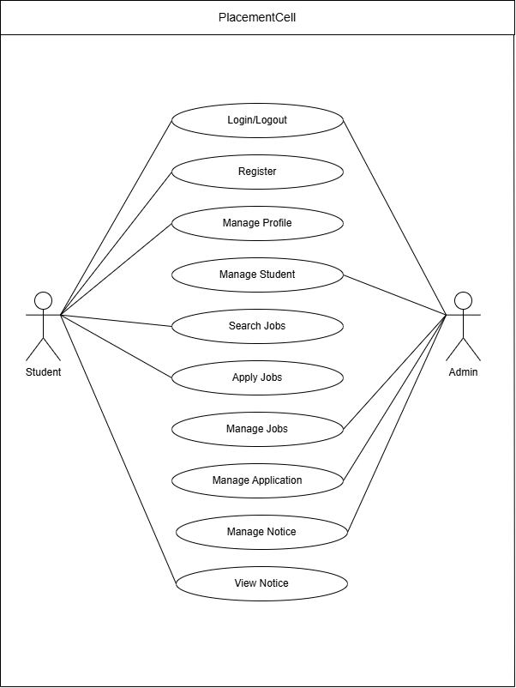

4.3 Context (0) level DFD :-

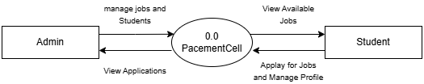

4.4 1st level DFD :- Student

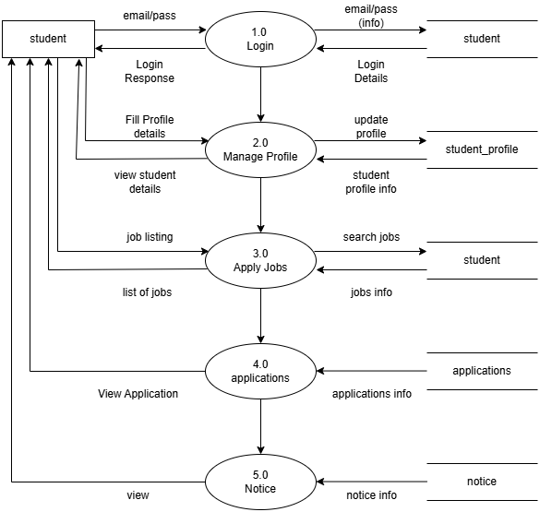

4.5 1st level DFD :- Admin

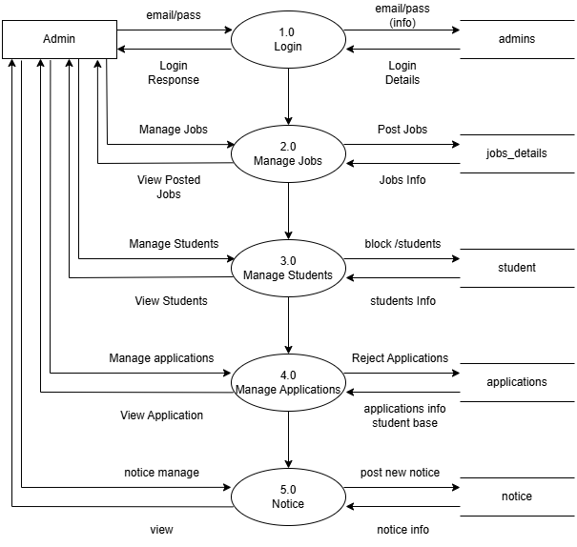

Class Diagram :-

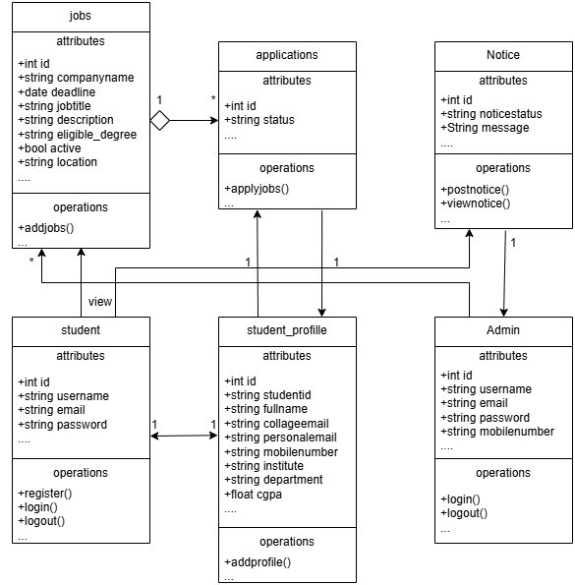

No | Field Name | Data type | Constraint | Description
1 | adminid | int | primary key | Id
2 | name | varchar | not null | store admin name
3 | email | varchar | not null | store admin email
4 | password | varchar | not null | store admin password
5 | mobile | varchar | null | store admin mobile
6 | active | boolean | not null | admin status

