Cell Counter System Project

**System Project Management Plan**

**Version: SPMP v1.0**

**Prepared by**

**Group #2**

**NIMESHKUMAR ITALIYA**

**-**

**JAY DESAI**

**August 27th, 2019**

**Preface**



In this report, the correct way to get team members has made plans. These reports and team members, supervisor checks. This report covers a summary including purpose, summary, objectives, constraints, schedule, budget summary. Moreover, this report contains managerial process like estimation, staffing resource allocation, quality control and risk management plans.

**Version History**

|  |  |  |  |  |
| --- | --- | --- | --- | --- |
| Version | Status | Date | Responsible | Version Definition |
| 1 | Draft | 27.09.2019 | Nimesh and Jay | SPMP 1.0 |

**List of Figures**



Figure 1 System Requirements List……………….………………………………………….21

Figure 2 System Requirements Chart……………………………………...………………….21

Figure 3 System Design List………………………………………………………………….22

Figure 4 System Design Chart………………………………………………………………..22

Figure 5 Coding, Testing, Integration, Feedback List………………………………………..23

Figure 6 Coding, Testing, Integration, Feedback List………………………………………..23

**List of Tables**



Table 1. Project Deliverables…………………………………………………………………………...06

Table 2. Internal structure………………………………………………………………………………08

Table 3. Project Responsibilities…………………………………………………………………….....08

Table 4. Product Function I/O Summary………………………………………………………………09

Table 5. Function Point Metrics………………………………………………………………………..09

Table 6. Complex Adjustment Values………………………………………………………………….10

Table 7. Project work activity………………………………………………………………………......13

Table 8. Resource allocation for Work Activity………………………………………………………..13

Table 9. Resource Allocation for customer Meeting……………………………………………………13

Table 10. Resource Allocation for preparing SPMP………………………………………………........14

Table 11. Resource Allocation for preparing SRS……………………………………………………...14

Table 12. Resource Allocation for preparing SDD……………………………………………………..14

Table 13. Resource Allocation for preparing STD……………………………………………………..14

Table 14. Resource Allocation for Coding……………………………………………………………..15

Table 15. Resource Allocation for preparing Testing………………………………………………….15

Table 16. Resource Allocation for preparing User Manual……………………………………………15

Table 17. Resource Allocation for Deployment……………………………………………………….15

Table 18. Schedule and Budget Allocation for Customer Meeting……………………………………15

Table 19. Schedule and Budget Allocation for Preparing SPMP………………………………….......16

Table 20. Schedule and Budget Allocation for Preparing SRS………………………………………..16

Table 21. Schedule and Budget Allocation for Preparing SDD……………………………………….16

Table 22. Schedule and Budget Allocation for Preparing STD……………………………………….17

Table 23. Quality Control Plan………………………………………………………………………..17

Table 24. Probability of Risks…………………………………………………………………….......18

Table 25. Ratio of Probability…………………………………………………………………………18

Table 26. Product Time Schedule……………………………………………………………………..19

Table 27 Validation & Verification Plan………………………………………………………………20

**Table of Contents**

**PREFACE……………………………………………………………………………………………….02**

**LIST OFFIGURES……………………………………………………………………………………..03**

**LIST OF TABLES……………………………………………………………………………………...03**

**TABLE OF CONTENTS………………………………………………………………………………04**

**1 - OVERVIEW……………………………………………………………………………………….05**

* 1. **Project Summary…………………………………………………………………………..05**
     1. **Purpose, Scope and Objective………………………………………………..05**
     2. **Assumptions and Constraints………………………………………………..05**
     3. **Project Deliverables…………………………………………………………..05**
     4. **Schedule and Budget Summary……………………………………………...07**
  2. **Evolution of the SPMP…………………………………………………………………….07**

1. **- REFRENCE MATERIALS………………………………………………………………………07**
2. **- DEFINATIONS, ACRONYMS and ABBREVIATIONS………………………………………07**
3. **- PROJECT ORGANIZATION…………………………………………………………………...07**
   1. **External Interfaces………………………………………………………………………...07**
   2. **Internal Interfaces…………………………………………………………………………08**
   3. **Project Responsibilities……………………………………………………………………08**
4. **- MANAGERIAL PROCESS PLANS…………………………………………………………….08**
   1. **Start-up Plan……………………………………………………………………………….08**
      1. **Estimation Plan……………………………………………………………….08**
      2. **Resource Acquisition Plan…………………………………………………...11**
      3. **Project Staff Training Plan………………………………………………….11**
   2. **Work Plan………………………………………………………………………………….12**
      1. **Work Activities……………………………………………………………….12**
      2. **Schedule Allocations………………………………………………………….13**
      3. **Resource Allocation…………………………………………………………..13**
      4. **Budget Allocation……………………………………………………………..15**
   3. **Control Plan………………………………………………………………………………..16**
      1. **Requirements Control Plan………………………………………………….16**
      2. **Schedule Control Plan………………………………………………………..16**
      3. **Quality Control Plan…………………………………………………………16**
      4. **Reporting Plan………………………………………………………………..17**
   4. **Risk Management Plan……………………………………………………………………17**
      1. **Description of Risks…………………………………………………………..17**
5. **- TECHNICAL PROGRESS PLANS…………………………………………………………….19**
   1. **Process Model……………………………………………………………………………..19**
   2. **Methods, Tools and Techniques…………………………………………………………19**
   3. **Infrastructure Plan……………………………………………………………………….19**
   4. **Product Acceptance Plan…………………………………………………………………19**
6. **- SUPPORTING PROCESS PLANS……………………………………………………………..20**
   1. **Configuration Management Plan………………………………………………………...20**
   2. **Quality Assurance Plan…………………………………………………………………...20**
   3. **Documentation Plan………………………………………………………………………20**
   4. **Development Plan………………………………………………………………………….20**
   5. **Review Plan………………………………………………………………………………...20**
7. **- APPENDICES……………………………………………………………………………………21**
   1. **Appendix 1 – Grant chart…………………………………………………...…………….21**

1. **Overview**
   1. **Project Summary**
      1. **Purpose, Scope, and Objectives**

**1.1.1.1 Purpose:**

The purpose behind opting this idea is to have knowledge about cross domain first and then it is something like that type of problem that never often understood by people so saving time for all including students, faculties and researchers and many more who are included in counting cells from microscopic image manually with higher percent of accuracy. We decide to give an automated tool in which only image needed to upload and then automatically algorithm works and count and give back to user.

**1.1.1.2 Scope:**

The Software Requirements Specification captures all the requirements in a single document. The *Cell Counter System* that is to be developed provides quickly, accurately and less time-consuming counter which will help them to give focus on another main task.

**1.1.1.3 Objectives:**

Our objectives are ;

* + TO INCREASE EFFICIENCY
  + TO SAVE TIME OF STUDENTS,RESEARCHERS
  + TO DETERMINE SPORE LOAD
  + TO FIGURE OUT VALIDITY OF FERTILIZERS
  + TO MAINTAIN SPORE LOAD
  + TO DETECT NON-VIABLE CELL
  + TO DETERMINE EFFICIENCY OF DRUGS
  + TO CHECK UNDERLYING CONDITIONS

**1.1.2. Assumptions and Constraints**

**1.1.2.1 Assumptions:**

We assumed that the following points exist:

* The users have sufficient knowledge of domain.
* Images gave to software must be in better resolution.
* Reference images must be selected wisely to count cell accurately.
* Maybe 4K images resolution may not supported by system.

**1.1.2.2 Constraints:**

Our project constraints are:

* Density of the other courses in the university
* Lack of experience of the members of the project.
* Be limited to the project calendar.
* Not to find enough time.
* In case of higher resolution image, it may take little bit higher to process on it.
* In manual mode, if user by mistakenly opt reference image that is not suitable then it is user fault.
* Image must be of good quality so that software accuracy should not be compromised.
* Database should be maintained in case of automatic mode opt by user to detect cell.

**1.1.3. Project Deliverables**

|  |  |  |
| --- | --- | --- |
| **Work Product** | **Description** | **Delivery Date** |
| Problem Statement | Define the problem (submitted) | 09.07.2019 |
| Initial Plan | Define the technical and managerial processes (submitted) | 10.07.2019 |
| Reviewed Initial Plan | Revised Document (Submitted) | 10.07.2019 |
| SPMP Document | Software Project Management Plans is used to define the scope, purpose and objectives of the project, to specify roles and responsibilities of team members, the customer company if it exists. Many plans are considered in order to define the assumptions and constraints of the project. It defines which process model is chosen for the project life cycle. It is used to document agreed deliverables and their dates. | 15.07.2019 |
| Reviewed SPMP Document | Revised Version | 15.07.2019 |
| SRS Document | Software Requirements Specification is used to describe the behavior of the software of the system to be developed. It documents the functional and nonfunctional requirements of the system. It includes a set of use cases which describes the user-system interactions. | 03.08.2019 |
| Reviewed SRS Document | Revised Version | 05.08.2019 |
| SDD Document | Software Design Description is  used for complete description of  design of the software of the  system to be developed. It  documents all the information  about the design.  It specifies the form of the  document used to specify system  architecture and application  design in a software related  project. | 01.9.2019 , 07.09.2019 , 13.09.2019 , 19.09.2019 |
| Reviewed SDD Document | Revised Version | 22.09.2019 |
| STD Document | Software Test Documentation is used to describe plans for testing the software with verification and validation plans. | 03.09.2019 , 09.09.2019 , 15.09.2019 , 21.09.2019 |
| Reviewed STD Document | Revised version | 24.09.2019 |
| Final Versions of Documents | All documents are given with last versions | 30.09.2019 |
| Project Contest |  | 30.09.2019 |
| Presentation | At the end of semester presentations will be done which reflects the work we done during project development |  |
|  |  |  |

**Table 1 : Project Deliverable**

There will be four major deliverables in the project which are SPMP, SRS, SDD, and STD.

All these documents will be prepared according to the IEEE standards.

These deliverables can be downloaded from our website. Each and every updates of those deliverables will be announced from the website as well.

**1.1.4. Schedule and Budget Summary**

We estimate schedule allocation in section 5.2.4 combining with budget allocation.

**1.2.** **Evolution of the SPMP**

After this report, students and advisors with the new additions are possible.

1. **Reference Materials**

* IEEE Std 1058-1998, IEEE Standard for Software Project Management Plans
* Pressman, Roger S., *Software Engineering*, 4th edition, McGraw-Hill, 1997
* Rajib Mall, Fundamentals of Software Engineering 5th edition, 1997

1. **Definitions, Acronyms, and Abbreviations**

**SPMP:** Software Project Management Plan

**SRS:** Software Requirements Specification

**V&V:** Verification and Validation

**HW:** Hardware

**SW:** Software

**LOC:** Line of Code

**KLOC:** Kilo Line of Code

**IEEE:** Institute of Electrical and Electronical Engineers

**COCOMO:** Constructive Cost Model

**IDE:** Integrated Development Environment

**RAM:** Read Only Memory

**SDD:** Software Design Description

**STD:** Software Test Documentation

**WBS:** Work Breakdown Structure

**PC:** Personal Computer

1. **Project Organization**

**4.1.** **External Interfaces**

This project is a basic level project. Therefore, project will be controlled by supervisor and quality group in each step. Supervisor will determine mistakes on project before implementation. After Cell Counter team correct mistakes, documents are delivered as a new version.

**4.2 Internal Structure**

|  |  |
| --- | --- |
| **Phases** | **Responsibilities** |
| Project Management | Project Manager |
| Software Requirement | Business Analytics |
| Software Design | Designer |
| Coding | Coder |
| Testing & Maintenance | Tester |
| Customer Feedback | Business Analytics |

**Table 2 : Internal Structure**

**4.3 Project Responsibilities**

|  |  |  |
| --- | --- | --- |
| **Member Name** | **Responsibilities** | **E-mail** |
| Nimesh Italiya | Project Manager, Coder | [17ce036@charusat.edu.in](mailto:17ce036@charusat.edu.in) |
| Jay Desai | Business Analytics, Designer | [17ce025@charusat.edu.in](mailto:17ce025@charusat.edu.in) |
| Isha Kimsuriya | Designer | [17ce045@charusat.edu.in](mailto:17ce045@charusat.edu.in) |
| Shubham Patel | Designer | [17ce026@charusat.edu.in](mailto:17ce026@charusat.edu.in) |
| Aayush Gajjar | Coder | [17ce030@charusat.edu.in](mailto:17ce030@charusat.edu.in) |
| Kapil Kapuriya | Tester | [17ce041@charusat.edu.in](mailto:17ce041@charusat.edu.in) |

**Table 3 : Project Responsibilities**

1. **Managerial Process Plans**

**5.1 Start-up Plan**

This section contains our project’s estimation plan, staffing plan, resource acquisition plan, and training plan. In the following subsections, all these plans will exist with their explanations in the details.

**5.1.1.** **Estimation Plan**

The beginning of a project, it is difficult to predict. This report is the first design of SPMP, we cannot expect an adequate data. Using the following function points, we will predict our estimation plan

|  |  |  |
| --- | --- | --- |
| **Inputs** | **Outputs** | **Inquiries** |
| * Load image on which user wants to work. * Zoom in or Zoom out image. * Select operation on image. * Select particular area on which user wants to count cell. * select some sample cell image. * Train model button by using dataset. * Select accuracy and speed of a model. * stop training of a model. * Save model button. * Discard model button. * Test model button. * Load model button. | * Error Message (if user load Wrong image file.) * Load image Show by after Press Load Button * Zoom in image by after Press Zoom in Button * Zoom out image by after Press Zoom out Button * Perform the appropriate operation on image as per-user selection. * Create data set by selecting some sample cell image. * Train model button by using dataset. * Show accuracy of a model. * Show count on screen. * Highlight cell on image. * Show loaded model on screen. | * About * help * User will look, system has saved model for Delete or Load some model * User will do Search model |

**Table 4 : Product Function I/O Summary**

Number of inputs: 12

Number of outputs: 11

Number of inquiries: 4

Number of files: 10

Number of external interface: 8 ( Python 3.6, anaconda, tensorflow, keras, opencv, pyqt5, matploatlib, numpy, sqlite Database, OS)

|  |  |  |  |
| --- | --- | --- | --- |
| **Measurement Parameter** | **Count ( C)** | **Weighting Factor(W)** | **W*C** |
| Inputs | 12 | 3 | 36 |
| Outputs | 11 | 4 | 44 |
| Inquiries | 4 | 3 | 12 |
| Files | 10 | 7 | 70 |
| External Interfaces | 10 | 5 | 50 |
| **TOTAL** |  |  | 212 |

**Table 5 : Function Point Matrices**

|  |  |  |  |
| --- | --- | --- | --- |
| **#** | **Influence Factors** | **Weight**  **(Fi)** | **Comments** |
| 1 | Does the system require reliable backup and recovery? | 3 | Some data base backup and recovery are provided. |
| 2 | Are data communications required? | 3 | Not direct data communication required. |
| 3 | Are there distributed processing functions? | 5 | All modules are isolated from each other. |
| 4 | Is performance critical? | 5 | Creating or executing machine learning model is critical. |
| 5 | Will the system run in an existing, heavily utilized operational environment? | 5 | Not directly related but will run in the same memory space with other operational programs. |
| 6 | Does the system require on-line entry? | 0 | All input and output are offline. |
| 7 | Does the on-line data entry require the input transaction to be built over multiple screens or operations? | 0 |  |
| 8 | Are the master files updated on-line? | 0 | Image files updated offline |
| 9 | Are the inputs, outputs, files or inquiries complex? | 4 | Only input, output are complex, others are middle |
| 10 | Is the internal processing complex? | 5 | Machine learning algo and flexibility make the system complex |
| 11 | Is the code designed to be reusable? | 4 | The code can be adopted to other systems |
| 12 | Are conversion and installation included in the design? | 4 |  |
| 13 | Is the system designed for multiple installations in different organizations? | 5 | There is need to installation in different organization |
| 14 | Is the application designed to facilitate change and ease of use by the user? | 4 | Design and interfaces make the system flexible |
|  | **ΣFi** | **44** |  |

**Table 6 : Complex Adjustment Values**

CAF = [0.65+0.01*sum(Fi)]

CAF = [0.65+0.01* 44]

CAF = 1.09

UFP = 212

Function Point = UFP * CAF

Function Point = 212 * 1.09

Function Point = 231.08

**COCOMO**

**LOC=**FP*Language factor

We use Python. These programs average Language factor is 31. When we put it to the equation we get:

LOC=231.08 * 31 = 7163

KLOC=12131/1000=7.163

By using cocomo equations, we found the following results;

E=ab(KLOC)bb (Effort)

D=cb (E)db (Duration)

Our Project is organic so we use ab=2.4, bb=1.05, cb=2.5, db=0.38

E=2.4*(7.163)1.05 = 18.96 person-month

D=2.5*(18.96)0.38= 7.64 months

E/D ratio gives the recommended number of people. For Our Project it is:

E/D=18.96/7.64=2.49 ≈ 3 as our group consist of six people we fulfil necessary human resources.

**5.1.2.** **Resource Acquisition Plan**

Our entire Project, we will use team members computers. The worst computer has following hardware: Intel i5 7th generation with 8 GB RAM of speed 2.5 GHz contains 1 TB HDD without Graphic card.

In addition to these HW requirements also the following SW requirements should be satisfied:

* Python 3.6.x
* Libraries like Anaconda, TensorFlow etc

**5.1.3.** **Project Staff Training Plan**

Cell counter team members will learn that don’t know topics and develop them. They will continuously search about this project. When they meet, they transfer knowledge from member to another. The team members don’t have enough knowledge and experience in Python, PyCharm, Machine learning. Thus, they will gain knowledge about these programs.

**5.2.** **Work Plan**

**5.2.1. Work Activities**

In the following table you can see the work activities of the Our Project:

|  |  |
| --- | --- |
| **1** | **CUSTOMER MEETING** |
| 1.1 | Contact with Customer |
| 1.2 | Problem Description |
| 1.3 | Requirements Gathering |
| **2** | **PREPARING SPMP** |
| 2.1 | Work Products & Activities Description |
| 2.2 | Product Size Estimation |
| 2.3 | Process Model |
| 2.4 | Resource Allocation |
| 2.5 | Schedule Allocation |
| 2.6 | Risk Management Plan |
| 2.7 | Technical Process Plan |
| 2.8 | Supporting Process Plan |
| 2.9 | Documentation |
| 2.10 | Review of SPMP |
| 2.11 | Revised SPMP |
| 2.12 | Approval of SPMP |
| **3** | **PREPARING SRS** |
| 3.1 | Contact with Customer |
| 3.2 | Formal Identification of User Group |
| 3.3 | Product Functions |
| 3.4 | Functional Requirements |
| 3.5 | Non-Functional Requirements |
| 3.6 | Documentation |
| 3.7 | Review of SRS |
| 3.8 | Revised SRS |
| 3.9 | Approval of SRS |
| **4** | **PREPARING SDD** |
| 4.1 | SDD Basic Concepts |
| 4.2 | Database Design |
| 4.3 | Interface Design |
| 4.4 | Algorithm Design |
| 4.5 | Documentation |
| 4.6 | Review of SDD |
| 4.7 | Revised SDD |
| 4.8 | Approval of SDD |
| **5** | **PREPARING STD** |
| 5.1 | V & V Management |
| 5.2 | V & V Acquisition |
| 5.3 | V & V Supply |
| 5.4 | V & V Development |
| 5.5 | V & V Operation |
| 5.6 | V & V Maintenance |
| 5.7 | Documentation |
| 5.8 | Review of STD |
| 5.9 | Revised STD |
| 5.10 | Approval of STD |
| **6** | **CODING** |
| 6.1 | Define Model |
| 6.2 | Train Model |
| **7** | **TESTING** |
| 7.1 | Count test |
| 7.2 | Efficiency test |
| **8** | **User Manual** |
| 8.1 | Spore/RBC/WBC/Platelet/Bacteria Manual |
| 8.2 | Other Mode Manual |
| **9** | **DEPLOYMENT** |
| 9.1 | Approval of Product |

**Table 7 : Project Work Activity**

**5.2.2. Schedule Allocation**

We estimate schedule allocation in section 5.2.4 combining with budget allocation.

**5.2.3.** **Resource Allocation**

Tables related to resource allocation are stated below:

|  |  |  |  |
| --- | --- | --- | --- |
| **WORK** | **REQUIRED SKILL** | **BASED ON** |  |
| **ACTIVITY** |  |
|  |  |  |
|  |  |  |  |
| Customer Meeting | Human Relations | Face to face, WhatsApp |  |
|  |  |
|  |  |  |
|  |  |  |  |
| Preparing SPMP | Knowledge of IEEE Std and Estimation Techniques, Planning | IEEE Std. 1058- |  |
| And Coordination | 1998 |  |
|  |  |
|  |  |  |  |
| Preparing SRS | SW Engineering | IEEE Std. 830- |  |
| 1998 |  |
|  |  |  |
|  |  |  |  |
| Preparing SDD | SW Engineering | IEEE Std. 1058- |  |
| 1998 |  |
|  |  |  |
|  |  |  |  |
| Preparing STD | SW Engineering | IEEE Std. 1016- |  |
| 1998 |  |
|  |  |  |
|  |  |  |  |
| Coding | Knowledge of Python and Machine Learning | IEEE Standards |  |
|  |  |  |  |
| Testing | Knowledge Of Control Engineering and Testing Techniques | IEEE Standards |  |
|  |  |  |  |
| User Manual | Knowledge of User Manual Standard | IEEE Std. 1063- |  |
| 1987 |  |
|  |  |  |
|  |  |  |  |
| Deployment | Knowledge of Review Techniques | IS 502 Standards |  |
|  |  |  |  |

**Table 8 : Resource allocation for Work Activity**



**CUSTOMER MEETING**

|  |  |  |  |  |
| --- | --- | --- | --- | --- |
| **WBS** | **WORK PACKAGES** | **SW TOOLS** | **HUMAN RESOURCES** | **HW RESOURCES** |
|  |  |  |  |  |
| 1.1 | Contact with customer | - | Team | - |
|  |  |  |  |  |
| 1.2 | Problem Description | - | Team | - |
|  |  |  |  |  |
|  |  |  |  |  |
| 1.3 | Requirements Gathering | - | Team | - |
|  |  |  |  |  |
|  |  |  |  |  |

**Table 9 : Resource Allocation for customer Meeting**

|  |  |  |  |  |
| --- | --- | --- | --- | --- |
| **PREPARING SPMP** | | | | |
| **WBS** | **Work Packages** | **SW Tools** | **Human Resources** | **HW Resources** |
| 2.1 | Work Products & Activities Decomposition | MS Project | Team | PC |
| 2.2 | Product Size Estimation | System Star | Team | PC |
| 2.3 | Process Model | - | Team | - |
| 2.4 | Resource Allocation | - | Team | - |
| 2.5 | Schedule Allocation | MS Project | Team | PC |
| 2.6 | Risk Management plan | - | Team | - |
| 2.7 | Technical Process Plan | Python 3.6.x with ML | Team | PC |
| 2.8 | Supporting Process Plan | Python 3.6.x with OpenCV | Team | PC |
| 2.9 | Documentation | MS Office | Team | PC |
| 2.10 | Review of SPMP | - | Supervisor & Customer | - |
| 2.11 | Revised SPMP | MS Office | Team | PC |
| 2.12 | Approval of SPMP | - | Supervisor | - |

**Table 10 : Resource Allocation for Preparing SPMP**

|  |  |  |  |  |
| --- | --- | --- | --- | --- |
| **PREPARING SRS** | | | | |
| **WBS** | **Work Packages** | **SW Tools** | **Human Resources** | **HW Resources** |
| 3.1 | Contact with Customer | - | Team | - |
| 3.2 | Formal Identification of User Group | - | Team | - |
| 3.3 | Product Functions | MS Office | Team | PC |
| 3.4 | Behavioral Requirements Specifications | MS office | Team | PC |
| 3.5 | Non-Behavioral Requirements | MS Office | Team | PC |
| 3.6 | Documentation | MS Office | Team | PC |
| 3.7 | Review of SRS | - | Supervisor & Customer | - |
| 3.8 | Revised SRS | MS Office | Team | PC |
| 3.9 | Approval of SRS | - | Supervisor & Customer | - |

**Table 11 : Resource Allocation for preparing SRS**

|  |  |  |  |  |
| --- | --- | --- | --- | --- |
| **PREPARING SDD** | | | | |
| **WBS** | **Work Progress** | **SW Tools** | **Human Resources** | **HW Resources** |
| 4.1 | SDD Basic Concepts | - | Team | PC |
| 4.2 | Database Design | Visio , SQLite | Team | PC |
| 4.3 | Interface Design | Visio , PyQT5 | Team | PC |
| 4.4 | Algorithms Design | PyCharm | Team | PC |
| 4.5 | Documentation | MS Office | Team | PC |
| 4.6 | Review of SDD | - | Supervisor & Customer | - |
| 4.7 | Revised SDD | MS Office | Team | PC |
| 4.8 | Approval of SDD | - | Supervisor & Customer | - |

**Table 12 : Resource Allocation for preparing SDD**

|  |  |  |  |  |
| --- | --- | --- | --- | --- |
| **PREPARING STD** | | | | |
| **WBS** | **Work Progress** | **SW Tools** | **Human Resources** | **HW Resources** |
| 5.1 | V & V Management | MS Office | Team | PC |
| 5.2 | V & V Acquisition | MS Office | Team | PC |
| 5.3 | V & V Supply | MS Office | Team | PC |
| 5.4 | V & V Development | MS Office | Team | PC |
| 5.5 | V & V Operation | MS Office | Team | PC |
| 5.6 | V & V Maintenance | MS Office | Team | PC |
| 5.7 | Documentation | MS Office | Team | PC |
| 5.8 | Review of STD | - | Supervisor & Customer | - |
| 5.9 | Revised STD | MS Office | Team | PC |
| 5.10 | Approval of STD | - | Supervisor & Customer | PC |

**Table 13 : Resource Allocation for preparing STD**

|  |  |  |  |  |
| --- | --- | --- | --- | --- |
| **CODING** | | | | |
| **WBS** | **Work Packages** | **SW Tools** | **Human resources** | **HW Resources** |
| 6.1 | Define Model | PyCharm | Team | PC |
| 6.2 | Train Model | PyCharm | Team | PC |

**Table 14 : Resource Allocation for Coding**

|  |  |  |  |  |
| --- | --- | --- | --- | --- |
| **TESTING** | | | | |
| **WBS** | **Work Packages** | **SW Tools** | **Human resources** | **HW Resources** |
| 7.1 | Count Test | Cell Counter | Team | PC |
| 7.2 | Efficiency Test | Cell Counter | Team | PC |

**Table 15 : Resource Allocation for preparing Testing**

|  |  |  |  |  |
| --- | --- | --- | --- | --- |
| **USER MANUAL** | | | | |
| **WBS** | **Work Packages** | **SW Tools** | **Human resources** | **HW Resources** |
| 8.1 | Spore/RBC/WBC/Platelet/Bacteria Manual | MS Office | Team | PC |
| 8.2 | Other Model Manual | MS Office | Team | PC |

**Table 16 : Resource Allocation for preparing User Manual**

|  |  |  |  |  |
| --- | --- | --- | --- | --- |
| **DEPLOYMENT** | | | | |
| **WBS** | **Work Packages** | **SW Tools** | **Human resources** | **HW Resources** |
| 9.1 | Approval of Product | - | Team | PC |

**Table 17 : Resource Allocation for Deployment**

**5.2.4. Schedule Allocation**

Whatever work activities mentioned in above tables are now converted and timing periods as follow:

**Customer Meeting**

|  |  |  |  |  |  |
| --- | --- | --- | --- | --- | --- |
| **WBS** | **Work Packages** | **Start Date (D.M.Y)** | **End Date (D.M.Y)** | **Work Hour** | **People Assigned** |
| 1.1 | Contact with customer | 10.07.2019 | 10.07.2019 | 2 | Jay, Isha, Nimesh |
| 1.2 | Problem Description | 11.07.2019 | 15.07.2019 | 2 | Team |
| 1.3 | Requirements Gathering | 11.07.2019 | 15.07.2019 | 3 | Team |

**Table 18 : Schedule Allocation for Customer meeting**

**Preparing SPMP**

|  |  |  |  |  |  |
| --- | --- | --- | --- | --- | --- |
| **WBS** | **Word Packages** | **Start Date**  **( D.M.Y )** | **End Date**  **( D.M.Y )** | **Work Hour** | **People Assigned** |
| 2.1 | Work Products & Activities Decomposition | 28.07.2019 | 31.07.2019 | 2 | Isha, Shubham |
| 2.2 | Product Size Estimation | 25.07.2019 | 25.07.2019 | 3 | Nimesh |
| 2.3 | Process Model | 26.07.2019 | 26.07.2019 | 1 | Jay |
| 2.4 | Resource Allocation | 27.07.2019 | 27.07.2019 | 2 | Nimesh |
| 2.5 | Schedule Allocation | 27.07.2019 | 27.07.2019 | 1 | Team |
| 2.6 | Risk Management Plan | 27.07.2019 | 27.07.2019 | 1 | Nimesh |
| 2.7 | Technical Process Plans | 28.07.2019 | 28.07.2019 | 1 | Nimesh, Aayush |
| 2.8 | Supporting Process Plans | 28.07.2019 | 28.07.2019 | 1 | Nimesh, Aayush |
| 2.9 | Documentation | 29.07.2019 | 29.07.2019 | 4 | Jay |
| 2.10 | Review of SPMP | - | - | - | Supervisor |
| 2.11 | Revised SPMP | - | - | - | - |
| 2.12 | Approval of SPMP | - | - | - | Supervisor |

**Table 19 : Schedule Allocation for Preparing SPMP**

**Preparing SRS**

|  |  |  |  |  |  |
| --- | --- | --- | --- | --- | --- |
| **WBS** | **Word Packages** | **Start Date**  **( D.M.Y )** | **End Date**  **( D.M.Y )** | **Work Hour** | **People Assigned** |
| 3.1 | Contact with Customer | 10.07.2019 | 10.07.2019 | 2 | Jay, Isha, Nimesh |
| 3.2 | Formal Identification of User Group | 18.07.2019 | 18.07.2019 | 2 | Jay, Isha |
| 3.3 | Product Functions | 16.07.2019 | 16.07.2019 | 2 | Jay, Nimesh |
| 3.4 | Behavioral Requirements Specification | 16.07.2019 | 16.07.2019 | 3 | Jay, Nimesh |
| 3.5 | Non-Behavioral Requirements Specification | 16.07.2019 | 16.07.2019 | 2 | Aayush, Shubham |
| 3.6 | Documentation | 23.07.2019 | 23.07.2019 | 4 | Jay |
| 3.7 | Review of SRS | 3.08.2019 | 3.08.2019 | - | Customer |
| 3.8 | Revised SRS | - | - | - | - |
| 3.9 | Approval of SRS | 4.08.2019 | 4.08.2019 | - | Supervisor |

**Table 20 : Schedule Allocation for Preparing SRS**

**Preparing SDD**

|  |  |  |  |  |  |
| --- | --- | --- | --- | --- | --- |
| **WBS** | **Work Packages** | **Start Date**  **( D.M.Y )** | **End Date**  **( D.M.Y )** | **Work Hour** | **People Assigned** |
| 4.1 | SDD Basic Concepts | 5.08.2019 | 5.08.2019 | 4 | Jay, Nimesh |
| 4.2 | Database Design | 8.08.2019 | 8.08.2019 | 2 | Jay, Nimesh |
| 4.3 | Interface Design | 23.08.2019 | 29.08.2019 | 21 | Isha, Shubham |
| 4.4 | Algorithms Design | 23.08.2019 | 29.08.2019 | 28 | Nimesh, Aayush |
| 4.5 | Documentation | 30.08.2019 | 30.08.2019 | 5 | Jay |
| 4.6 | Review of SDD | - | - | - | - |
| 4.7 | Revised SDD | - | - | - | - |
| 4.8 | Approval of SDD | - | - | - | - |



**Table 21 : Schedule Allocation for Preparing SDD**

**Preparing STD**

|  |  |  |  |  |  |
| --- | --- | --- | --- | --- | --- |
| **WBS** | **Work Packages** | **Start Date**  **( D.M.Y )** | **End Date**  **( D.M.Y )** | **Work Hour** | **People Assigned** |
| 5.1 | V&V Management | 24.08.2019 | 24.08.2019 | 4 | Jay |
| 5.2 | V&V Acquisition | 26.08.2019 | 26.08.2019 | 2 | Jay |
| 5.3 | V&V Supply | 27.08.2019 | 27.08.2019 | 2 | Kapil |
| 5.4 | V&V Development | 28.08.2019 | 28.08.2019 | 3 | Jay |
| 5.5 | V&V Operation | 28.08.2019 | 28.08.2019 | 4 | Kapil |
| 5.6 | V&V Maintenance | 30.08.2019 | 30.08.2019 | 3 | Kapil |
| 5.7 | Documentation | 1.09.2019 | 1.09.2019 | 5 | Jay |
| 5.8 | Review of STD | - | - | - | - |
| 5.9 | Revised STD | - | - | - | - |
| 5.10 | Approval of STD | - | - | - | - |

**Table 22 : Schedule Allocation for Preparing STD**

**5.3.** **Control Plan**

**5.3.1. Requirements Control Plan**

Changes are to be made in the requirements, after the completion of the SPMP step. Team members have a meeting for revision. Document will be examined for the major/minor revision. Resource allocation, Schedule allocation and estimation plan will be reconsidered and updated. Budget is not important due to this project is a senior Project. Document will be updated as a new version of all projects.

**5.3.2.** **Schedule Control Plan**

The Project consists of certain time interval. Project group members constantly conversation in messenger, meeting one or two days in a week, and they effort to finish the Project. The results of the meeting between team members will be discussed with supervisor and keep on regular basis

**5.3.3. Quality Control Plan**

|  |  |  |  |
| --- | --- | --- | --- |
| **Work Products & Items** | **Suitable to Standards** | **Needs Revisions** | **Explanations** |
| SRS |  | YES | Need Modifications |
| SRS Review | YES |  | Under reviewing |
| SRS Approval | YES |  | Approved by Supervisor & Customer |
| SDD |  | YES | Need Modifications |
| SDD Review | YES |  | Under Reviewing |
| SDD Approval | YES |  | Approved by Supervisor & Customer |
| STD | YES |  | No major changes |
| STD Review | YES |  | Under Reviewing |
| STD Approval | YES |  | Approved by Supervisor & Customer |
| Project Plan | YES | YES | Some effective changes are there |
| Project Plan Review | YES |  | Under Reviewing |
| Project Plan Approval | YES | YES | Some plans are approved but in some case we have to look again |
| Design |  |  |  |
| Design Review |  |  |  |
| Design Approval |  |  |  |
| Coding |  |  |  |
| Testing |  |  |  |
| Implementation |  |  |  |
| Project Review |  |  |  |
| Project Approval |  |  |  |

**Table 23 : Quality Control Plan**



**5.3.4. Reporting Plan**

Each of versions of all the documents and updates and status reports will be sent and discussed with the supervisor and upon approval the approved document will be circulated to the other members of the committee. The report on the status of the project will be sent to the members and interview about mistakes or lacks of reports.

**5.4.** **Risk Management Plan**

|  |  |  |  |
| --- | --- | --- | --- |
| RISKS | PROBABILITY | IMPACT  1(low) – 5(high) | REFERNCES |
| Quality of product documentation and coding are not suitable | 20% | 3 | 5.4.1.1 |
| Disagree between team members | 10% | 2 | 5.4.1.2 |
| Unavailability of team members | 15% | 2 | 5.4.1.3 |
| Timing Problem | 25% | 2 | 5.4.1.4 |
| Health problem | 10% | 1 | 5.4.1.5 |
| Mistake in coding | 20% | 4 | 5.4.1.6 |
| System may be not work | 5% | 4 | 5.4.1.7 |

**Table 24 : Probability of Risks**

|  |  |
| --- | --- |
| Probability | Uncertainty Statement |
| > % 80 | Almost certainly |
| %80 - %61 | Probable, probably |
| %60 – %41 | Doubtable |
| %40 – %21 | Unlikely |
| < % 20 | Highly unlikely |

**Table 25 : Ratio of Probability**

**5.4.1. Description of Risks**

**5.4.1.1. Quality of product documentation and coding are not suitable**

Cell Counter team prepares the project planning, software documentation and coding with less experience. Thus, The Cell Counter Team must, try to prepare every documents of project in high priority and control all steps of documentation.

**5.4.1.2. Disagree Between Team Members**

The Cell Counter Team must behave respectfully and be careful not disagree with each other. If the Cell Counter Team has this problem, they must solve the problem between team members in early time and prevention disagreement things before the conflict.

**5.4.1.3. Unavailability of Team Members**

The Cell Counter Team must use all common free time to work on project. Before the Cell Counter Team start does project, they have to adjust date before starting the project. If the Cell Counter Team has a problem about meeting, Team must use all communication (phone, WhatsApp, e-mail …) , and may be prevent problem of time.

**5.4.1.4. Timing Problem**

The Cell Counter Team must split the project and prepare the working program in weekly and check each team members program every week and control how project is run.

**5.4.1.5. Health Problem**

The Cell Counter Team must take care of their health. If team have health problem, they must do work overtime or adjust new part-time members and work another team member to instead of ill team member.

**5.4.1.6. Mistake in Coding**

If the Cell Counter Team does not want any mistake in coding, Team must do control the coding and test every week or control and test small part and back up codes every week.

**5.4.1.7. System may be not Work**

The Cell Counter Team must do not notice the mistake in design or coding. If Team does not want any problem, they must do control the design again and again and contact with instructor when coding and designing.

1. **Technical Process Plans**

**6.1.** **Process Model**

We in our project, we used Iterative Process Model. The initialization of the project started in July 2019 and at the end of July 2019, a prototype of the project will be developed. And finally, at the end of September 2019, our project will be finished. The schedule plan for the project table will be given in the following table, table 24.

|  |  |  |  |
| --- | --- | --- | --- |
| **Activity** | **Start Date** | **End Date** | **Time**  **(Date/man)** |
| Defining PS | 8/07/2019 | 8/07/2019 | 4 |
| Initial Planning | 10/07/2019 | 14/07/2019 | 20 |
| Reviewing IP | 15/07/2019 | 15/07/2019 | 4 |
| SPMP Documenting | 16/07/2019 | 20/07/2019 | 11 |
| Reviewing SPMP | 20/07/2019 | 20/07/2019 | 2 |
| SRS Documenting | 21/07/2019 | 23/07/2019 | 6 |
| SDD Documenting | 5/08/2019 | 23/08/2019 | 57 |
| Coding and Testing | 30/08/2019 | 26/09/2019 | 112 |
| Total Elapsed Time | 8/07/2019 | 30/09/2019 | 216 (Date/man) |

**Table 26 : Product Time Schedule**

**6.2.** **Methods, Tools, and Techniques**

Tools and techniques used to realize these working and to develop final product are shown below:

**SW TOOLS:** Python 3.6.x, MS Office, MS Project

**HW TOOLS:** PC and Peripherals

**PERSONAL SKILLS:** Communication skills, Python, SW Engineering Processes, Reviewand Testing Techniques, User Manual, Planning and Coordination.

**6.3.** **Infrastructure Plan**

This software, internet connection, hardware and operating system are available from other sources and from the internet is provided by team members. Each team member has one PC with the operating system of Windows 10. Group members identify themselves as areas of project work as a group and as individuals we project focuses. These places mostly individual’s house or hostel and the group assigned to particular work sat with another at library, during SE and SGP lab.

**6.4.** **Product Acceptance Plan**

Customer wants a review process will be reviewed and problems will be solved. By the consultant and the client is missing a delivery point is checked to determine. Then cover the missing points, a new version is created and delivered to the customer is presented. This process shall continue until the customer and supervisor satisfaction is achieved. In this way, the customer really needs to improve the basic product warranties may be the result. If there are problems to be solved, and the product will deliver the necessary points will change.

**7. Supporting Process Plans**

**7.1.** **Configuration Management Plan**

This part is very important for future changes for our project. When our project supervisor or customers comes a request for project change, we will quickly review our previous report and we will change our report like desired format. As the regeneration of the report, the report names will also change. Such as;

First Deliverable: Deliverable Name V1.0, like SPMP V1.0

Major Change for Deliverable: Deliverable Name V2.0, like SPMP V2.0

Minor Change for Deliverable: Deliverable Name V1.1, like SPMP V1.1

**7.2.** **Quality Assurance Plan**

**Quality Assurance Plan:**

All project reports must be made according to the IEEE a standard format and should be submitted according to this format. Customer meetings are very important, that’s why these meetings should be well organized. Project members must follow project Schedule very carefully and projects should be delivered in a time.

**Verification and Validation Plan:**

|  |  |
| --- | --- |
| Verification Plan | Validation Plan |
| The process of determining to make the right product | Products are made to ensure that the correct process |
| Made full order to produce for needs of customers | About producing the right product |
| All project’s delivered time and every step made according to accuracy of the SW. | Made full order to produce for needs of customers |

**Table 27 : Verification & Validation Plan**

**7.3.** **Documentation Plan**

***All documents will be made according to IEEE standards.*** For these IEEE templates ***considers for*** SPMP, SRS, SDD, and STD. Each deliverable document will be reviewed by thesupervisor.

**7.4.** **Deployment Plan**

After our project is finish, our project resembles a desktop application. Thus, every people use our project. But, if people use GPS program, their computers or laptops must take signals from satellite.

**7.5.** **Review Plan**

After each phase of Project which are SPMP, SRS, SDD, STD are completed, are reviewed.

There are two types of review:

* First review is done by Cell Counter team after the completion of deliverable.
* Second review is done by supervisor. Supervisor controls verification of the deliverable and to cover requirements of the product.

1. **Appendices**

**8.1.Appendix 1 – Grant chart**

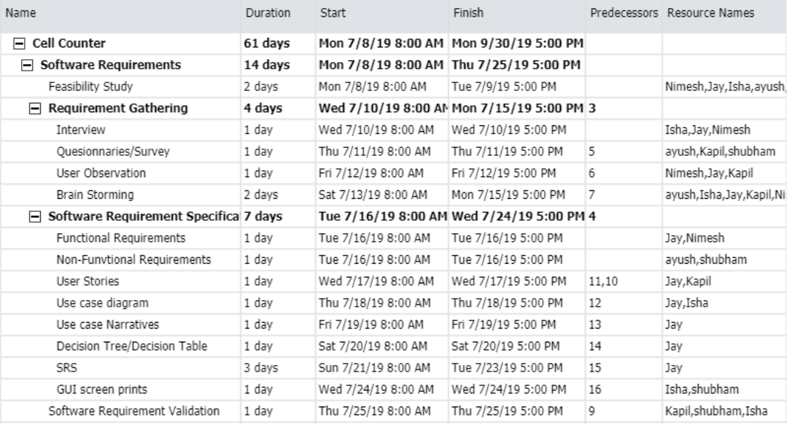

**Figure 1 : Software Requirements List**

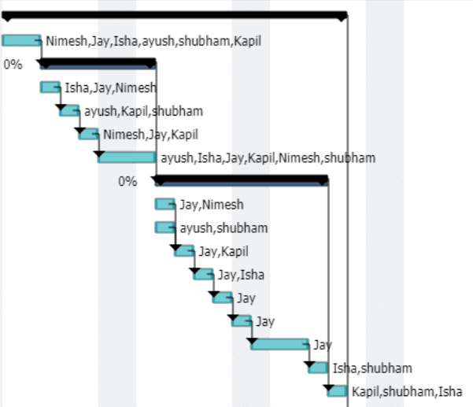

**Figure 2 : Software Requirements Chart**

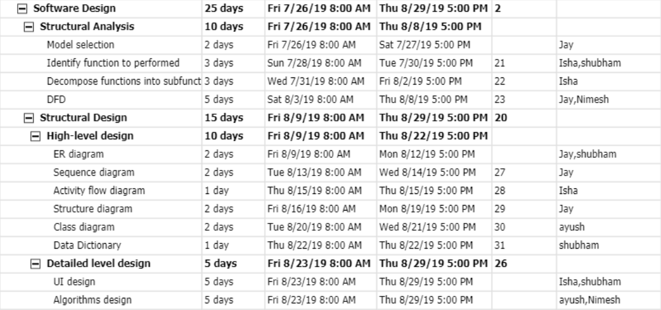

**Figure 3 : Software Design List**

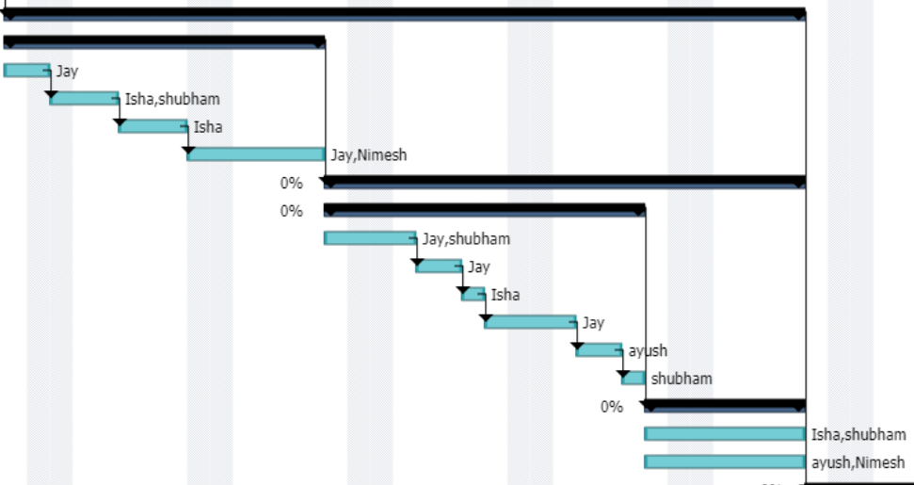

**Figure 4 : Software Design Chart**

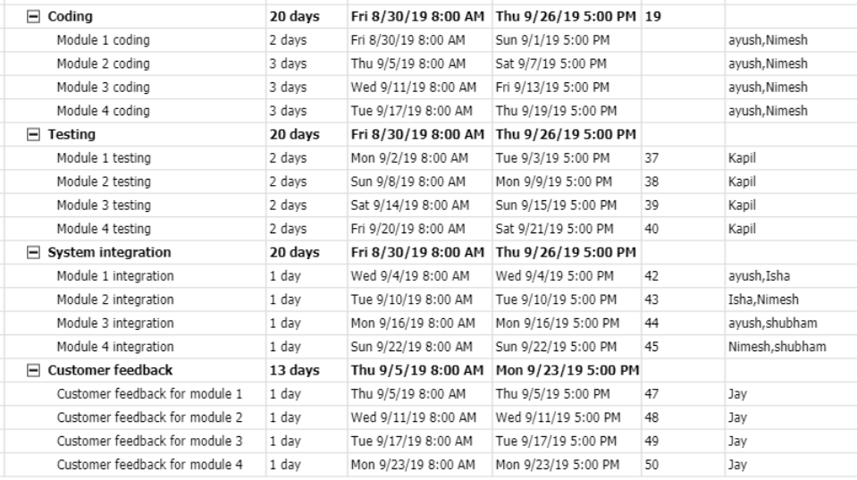

**Figure 5 : Coding, Testing, Integration and Feedback List**

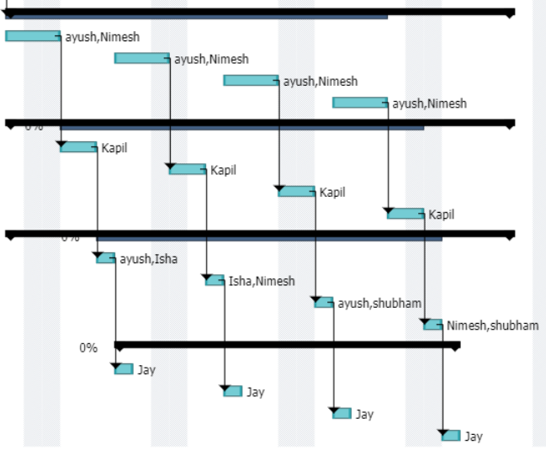

**Figure 6 : Coding, Testing, Integration and Feedback Chart**