Cell Counter System
Software Requirements Specification

Version 1.0

Table of Contents
1. Introduction 4
1.1 Purpose 4
1.2 Scope 4
1.3 Refrences 5

2. Overall Description 5
3. Specific Requirements 7
3.1 Function Requirement 7
3.1.1 Counting Spores 7
3.1.2 Counting Blood Cells 7
3.1.3 Counting Bacterial Fungus 7
3.1.4 Determine type of Cell 8
3.2 Usability 8
3.3 Reliability 8
3.3.1 Availability 8
3.3.2 Accuracy 8
3.3.3 Access Reliability 8
3.4 Operating Environment 8
3.5 Design Constraints 9
3.5.1 Software Language Used 9
3.5.2 Development Tools 9
3.6 Licensing Requirements 9
3.7 Legal, Copyright, and Other Notices 9
3.8 Applicable Standards 9
4. External Interface Requirements 9
4.1 User Interfaces 9
4.2 Hardware Interfaces 9
4.3 Software Interfaces 9
5. Non-Functional Requirements 9
5.1 Perfromance Requirements 9
5.2 Security Requirements 10
5.3 Safety Requirements 10
5.4 Software Quality Requirements 10

6. Supporting Information 10
- 6.1 Use Case Diagram 10
- 6.2 Use Case Stories 11
- 6.3 Use Case Narratives 12
- 6.4 Activity Flow Diagram 15
- 6.5 Data Flow Diagram 16

7. Provisional Information 19
- 7.1 Provisional GUI 19
- 7.2 Provisional Database 20
7.2.1 Data Dictionary 20
7.2.2 Database Structure 21
7.2.3 Database Design 22

Online Library System

Introduction

Many students, faculties and researchers whomsoever working on microscopical images like Spore, RBC, WBC etc., they have a tedious task to took photo from hemocytometer and then count how many cells are there. In this technique manual error plays a crucial role and if counting is not that much of accurate which will increase as number as counter will use for further derivations, equations and then it will make vast difference so accuracy matters a lot and also timing for counting took much effort from person and also time consuming.

We have decided to design and develop something which will fruitful for them and also reduce their wastage of time during counting. We provide a software from where they can easily find out counter without much effort as only image needed to be upload and software count it automatically and save time and also increase efficiency of counting.

Purpose

The purpose behind opting this idea is to have knowledge about cross domain first and then it is something like that type of problem that never often understood by people so saving time for all including students, faculties and researchers and many more who are included in counting cells from microscopic image manually with higher percent of accuracy. We decide to give an automated tool in which only image needed to upload and then automatically algorithm works and count and give back to user.

Scope

The Software Requirements Specification captures all the requirements in a single document. The Cell Counter System that is to be developed provides quickly, accurately and less time-consuming counter which will help them to give focus on another main task. The Cell Counter System is supposed to have the following scopes:

- Software only provides counter.
- Analysis of input is not determined by software.
- Result depends on dataset either created by user or having data on machine.
- Variations in this field is in large amount so exact detection not every time possible.

References
The SRS document uses the following documents as references:
1.4.1 WBC/RBC cell counting:
https://www.ncbi.nlm.nih.gov/pmc/articles/PMC3996871/
1.4.2 Morphology concepts for WBC/RBC: https://pdfs.semanticscholar.org/2a19/b73303d23555e17e45a6c609ff9893e441c7.pdf

Overall Description

- Product Perspective

Cell Counter System is used to deliver for those who are strongly or we can say daily interact with cells and lot of time spend on counting it but if that time will be saved then imagine how useful it will that researches can focus on more their research aspect as automated tool is count it on behalf of them with less time and major accuracy.
The following diagram explains you that a cell image in which counter is needed, it will be helpful for following fields which are facing manual counting issues:


Teacher
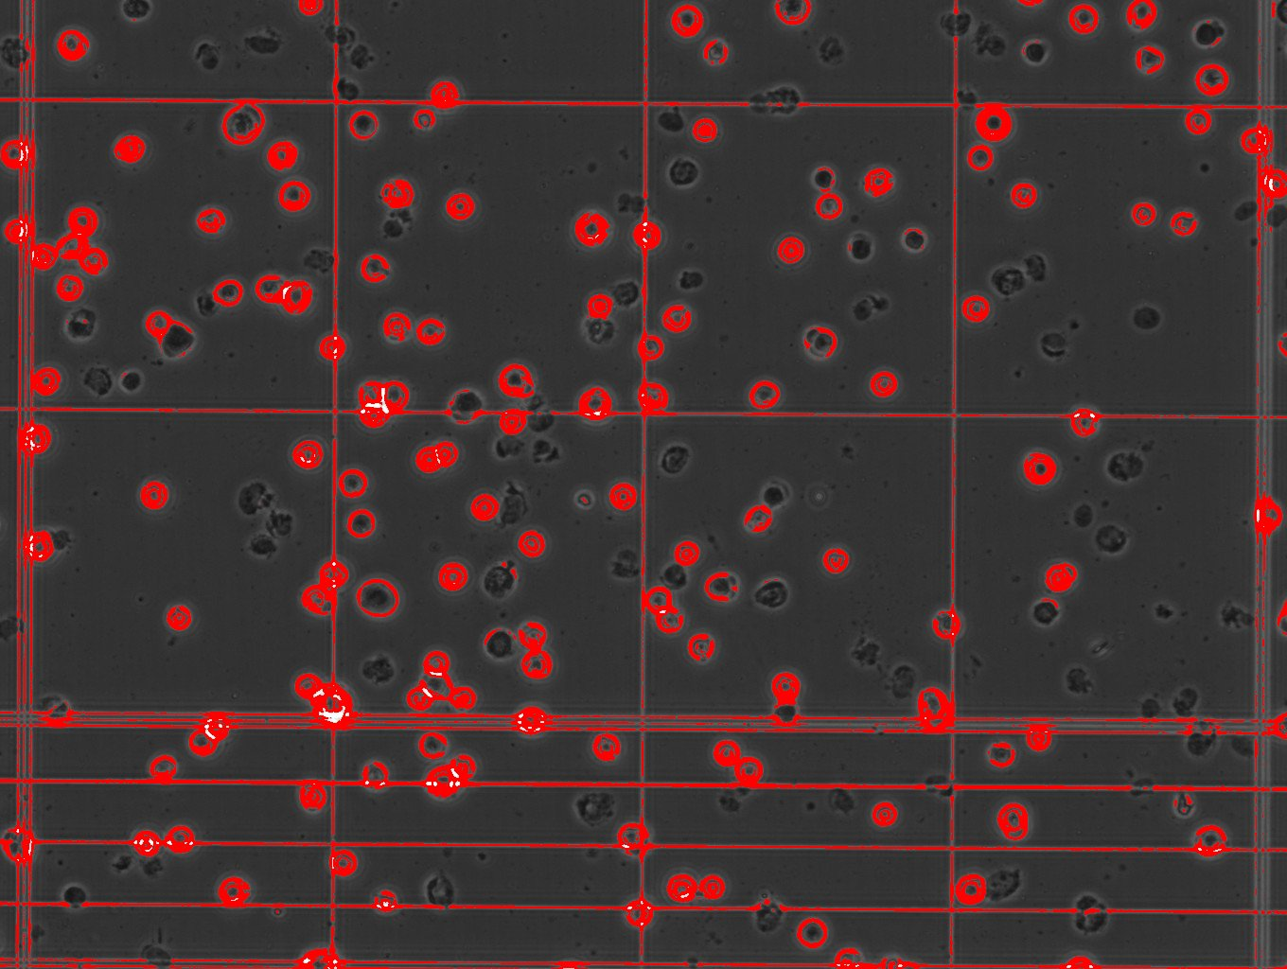
Researchers
Agriculture Industries
Student
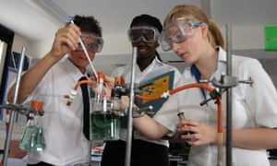

Overview of cell counter system

- Product Functions

Cell Counter System have functionalities quite similar as we discuss earlier in above content but focus on more deeply about counting cell automatically how improves a from where it is fruitful:

- Counting of cells will give you result of drug applied on any creature whether it is harmful or not.
- Batches are in agricultural industries need to maintain spore count in kgs and set as live spores give you date till product is useful for clients.
- It is cost efficient as it is totally free of cost which will useful for students, researchers, teachers and agriculture field.
- Main functionality of software is that how to count cell is totally depend on user that which image give input as reference image for cell consideration for that particular picture.
- Automatic mode is also there from where if user not want to select reference image then it is going for this mode.
- It will help into maintain particular spore amount in product so that per unit how many spores need to import is already define so better utilization of resources done.
- By detecting viable and non-viable cells, whether plant have anti-cancer or any other diseases properties can be classified.

- User characteristics

The users who are interact with this system directly are must be aware about biology field and this software is also made for microbiological field, biochemistry field and biotech field students, researchers and faculties. So, person who is aware about this field, easily can use it as our software is user-friendly and imagine in case user is not of this field then still, he/she can easily adopt this software as each and every functionality with examples are provided in help section.

- Constraints

- In case of higher resolution image, it may take little bit higher to process on it.
- In manual mode, if user by mistakenly opt reference image that is not suitable then it is user fault.
- Image must be of good quality so that software accuracy should not be compromised.
- Database should be maintained in case of automatic mode opt by user to detect cell.
- The users need some basic knowledge about field so that he/she can easily adopt it.

- Assumptions and dependencies

- The users have sufficient knowledge of domain.
- Images gave to software must be in better resolution.
- Reference images must be selected wisely to count cell accurately.

Specific Requirements
This section describes in detail all the functional requirements.

Functionality

Counting Spores

Determine shape of Spore

Not consider dye which is not sustain properly

Spore may be count for particular region wise or from whole image

Detect Spore based on size of it given by user

Reference image mode should be count spore only based on selected spore within image

Display Count

3.1.2 Counting Blood Cells

Detect all blood cells

Differentiate RBC, WBC, Platelets

Differentiate WBC Cells

Separate Counter for each category

Blood cell may be count for particular region wise or from whole image

Reference image mode should be count blood cells only based on selected cell within image

Display Count

3.1.3 Counting Bacterial Fungus

Detect Bacterial fungus

Detect colony of bacteria

Differentiate colonies from image

Display Count

3.1.4 Determine type of cell

Differentiate Viable and Non-viable cell

Differentiate Live and Dead cell

Separate Counter for each an individual type

Display Count

Usability
- The system shall allow the users to use all functionalities ae per their perception.
- Since all users are familiar with the domain because others are not use it so no need to have any additional knowledge.
- The system is user friendly and self-explanatory.

Reliability
The software has to be very reliable in case of accuracy that matters a lot during computation of counting.

Availability
The software is available 100% free for some specific user at initial stage and is used 24 hrs a day and 365 days a year. The software shall be operational 24 hours a day and 7 days a week.

Accuracy
The accuracy of the system is must and most efficient as compare to speed so it will maintain accuracy nearly above 90% every time.

Access Reliability
The software shall provide 100% access reliability.

Operating Environment
Operating environment for the cell counting system is as listed below:
- Operating system: Windows, Linux
- 4 GB graphics card for better performance

Design Constraints

Software Language Used
The languages that shall be used for coding the Cell Counter System is Python. It is little bit tough to do project in python as far as image processing concept is taken into account.

Development Tools
We use PyQt designer tool for GUI and then use PyCharm having python library version 3.6.7 to demonstrate our whole project. There is no more tutorial available on PyQt designer so it is somewhat difficult to understand it’s working.

Licensing Requirements
The usage is restricted to only Laboratories of PDPIAS and RPCP students and faculties who gave inspiration and basic knowledge us from where we are able to develop this software.

Legal, Copyright, and Other Notices
Cell Counter System is a trademark of Dr. Anoop Markande, Dr. Kiran Patel and Mr. Mrugendra Rehvar and cannot be used without their consent.

Applicable Standards
The ISO/IEC 6592 guidelines for the documentation of computer-based application systems will be followed.

External Interface Requirements

4.1 User Interfaces
- Front-end Software: Designer file of PyQt
- Back-end Software: SQLite Studio Database

4.2 Hardware Interfaces

4 GB Graphic card for better performance

4.3 Software Interfaces
- Language: Python
- Coding Tool: PyCharm
- GUI tool: PyQt
- Database: SQLite Studio
- Libraries: TensorFlow, Keras, NumPy, matplotlib, Anaconda

Non-Functional Requirements

Performance Requirements
- The graphical user interface shall have a consistent look and feel.
- The load time for user interface screen must be less than 3-4 seconds.
- Processing of image must not be taking too longer time that user exit from software.
- Detecting cells or spore should be done within 1 minute.

Security Requirements
- Database having all existing model dataset so only insert or read operation should be performed rather than deleting or dropping table causes inefficiency of model

Safety Requirements
- If there is extensive damage to a wide portion of the database due to catastrophic failure, such as a disk crash, the recovery method restores a past copy of the database that was backed up to archival storage (typically tape) and reconstructs a more current state by reapplying or redoing the operations of committed transactions from the backed up log, up to the time of failure.

Software Quality requirement
- The System must give accurate result compare to manual effort.
- Specify the factors required to establish the required reliability of the software system at time of delivery.

Supporting Information

Use case diagram:

Below diagram narrate us how actually our software process as per actor give input and which kind of functionality added so that various options are available to them and then can use it effectively.

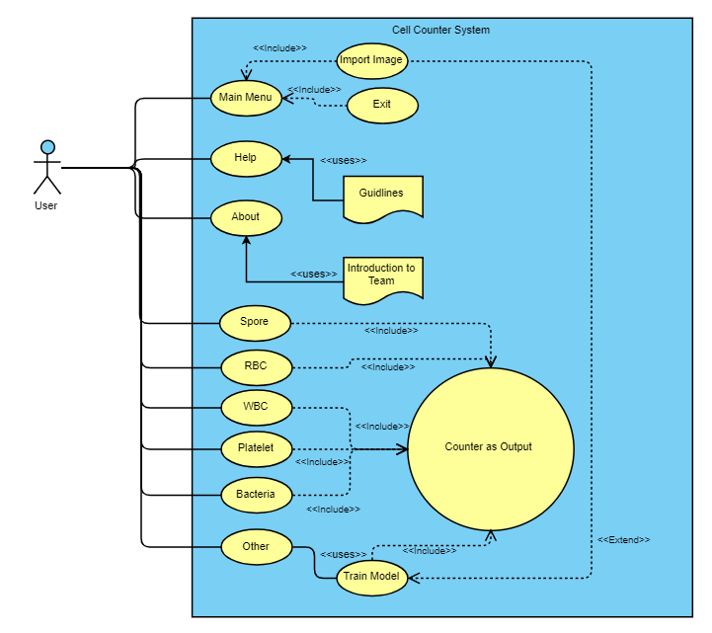

Use Case Stories:

- Dhara Patel
-currently pursuing M.Sc. in biochemistry facing issue of counting spores manually.
-Since last 2 years the major problem that she is facing was counting spores from one picture minimum 3 times to getting mean value of it but for one picture it takes a lot of time and also takes much attention. At the end of the day after counting it for several images she gets tired badly.

- Dr. Kiran Patel
-faculty member in PDPIAS institute
-He is currently researching on spore analysis and for that he should have to look for several images and counting spores for each image which is very tedious task and also having chance of errors. It is very time consuming as far as research concern. As a researcher he should have to focus more on researching rather than counting the spores which is a basic requirement.

- Mansi Rathod
-currently pursuing B. Pharm.
-She is working with RBC cell meaning is that she study characteristics of RBC, life cycle of RBC cells, development of RBC cells in particular conditions so in all these stuffs she requires to have record of RBC cell after particular time interval so she count RBC cells so many times so she also facing difficulty of if she made mistake then experimental result goes wrong.

- Hetaswi Patel
-currently pursuing B. Pharm.
-She is facing issue of differentiation in WBC cells and then also count for individual type. Actually 4 types of WBC cells are there, so she failed so many times to count WBC cell for each type as she looks for several images in a day so she is not able to complete her work effectively.

- Payal Parmar
-currently pursuing B. Pharm.
- Platelet count is very essential for fine health, in order to this She has so many pictures from faculty side to count them and gave to faculty as she is helping her faculty who is part of research in this field, but it is take too long time duration that she cannot give time to another topics.

- Dr. Anoop Markande
-faculty member in PDPIAS institute.
- He is currently researching on bacterial analysis and for that he should have to look for several images and counting bacterial colonies for each image which is very tedious task and also having chance of errors. It is very time consuming as far as research concern. As a researcher he should have to focus more on researching rather than counting the bacterial colonies which is a basic requirement.

Use Case Narrative:

- Spore Counting
Overview → In this after importing image, users are able to get count of spores from image with the help of existing dataset of machine.
Precondition → User must be having knowledge that on clicking spore button software only able to detect spore, nothing else type of category and also it will check based on existing models of spores, image quality must be good for detect.
Basic Flow → After clicking on count button, detection algorithm works based on previous model of spore and current dataset for spores and then give you result.
Alternate Flow → There is also possibility that user import image having no spores based on current dataset of software in that condition whenever count less than 20 user will get warning message then go on other section where he/she are able to develop own model on basis of that this thing from image should be consider as spore
Use case connect with it → Dhara Patel and Dr. Kiran Patel are actors who are connected with this use case.
- RBC Counting
Overview → In this after importing image, users are able to get count of RBC from image with the help of existing dataset of machine.
Precondition → User must be having knowledge that on clicking RBC button software only able to detect RBC cells, nothing else type of category and also it will check based on existing models of RBC cells along with good quality pictures.
Basic Flow → After clicking on count button, detection algorithm works based on previous model of RBC cells and current dataset for RBC and then give you result.
Alternate Flow → There is also possibility that user import image having no RBC cells based on current dataset of software in that condition whenever count less than 20 user will get warning message then go on other section where he/she are able to develop own model on basis of that this thing from image should be consider as RBC cell and rest are ignored.
Use case connect with it → Mansi Rathod is actor who have concerned with this use case.
- WBC Counting
Overview → In this after importing image, users are able to get count of WBC cells and also got differentiation of WBC cells from image with the help of existing dataset of machine.
Precondition → User must be having knowledge that on clicking WBC button software only able to detect WBC cells, nothing else type of category and also it will check based on existing models of WBC cells and also differentiate it only it matched with more than 90% from dataset of types of WBC cells, high quality images required for better accuracy.
Basic Flow → After clicking on count button, detection and differentiation algorithm works based on previous model of WBC cells and current dataset for WBC cells and then give you result.
Alternate Flow → There is also possibility that user import image having no WBC cells and not able to detect types of it based on current dataset of software in that condition whenever count less than 10 user will get warning message then go on other section where he/she are able to develop own model on basis of that this thing from image should be consider as WBC cell and which type it took in consideration by machine.
Use case connect with it → Hetaswi Patel is that actor who is joined with this use case.
- Platelet Counting
Overview → In this after importing image, users are able to get count of platelet from image with the help of existing dataset of machine.
Precondition → User must be having knowledge that on clicking platelet button software only able to detect platelets, nothing else type of category and also it will check based on existing models of spores, apart from it images must be in good resolution.
Basic Flow → After clicking on count button, detection algorithm works based on previous model of platelets and current dataset for platelets and then give you result.
Alternate Flow → There is also possibility that user import image having no platelets based on current dataset of software in that condition whenever count less than 5 user will get warning message then go on other section where he/she are able to develop own model on basis of that this thing from image should be consider as platelet.
Use case connect with it → Payal Parmar is actor who are connected with this use case.
- Bacteria Counting
Overview → In this after importing image, users are able to get count of bacteria colonies and detect shape of colonies from image with the help of existing dataset of machine.
Precondition → User must be having knowledge that on clicking bacteria button software only able to detect bacteria colonies and shape, nothing else type of category and also it will check based on existing models of bacteria colonies, high resolution image is mandatory for better result.
Basic Flow → After clicking on count button, detection algorithm works based on previous model of bacteria colonies and current dataset for bacteria colonies and then give you result.
Alternate Flow → There is also possibility that user import image having no bacteria colonies based on current dataset of software in that condition whenever count less than some particular number, user will get warning message then go on other section where he/she are able to develop own model on basis of that this thing from image should be consider as bacteria colony
Use case connect with it → Dr. Anoop Markande is actor who directly affected with this use case.
- Other
Overview → In this after importing image, users need to train a model for getting count for particular thing that passes as lesson during learning time.
Precondition → User must be having knowledge that whatever he/she is going to select as reference must be relative to image.
Basic Flow → User select references for counting a particular from image not only imported image but on clicking change image for more data values for that thing and after that he/she need to mention whether he/she required to get better result or take less time based on input model will be trained and it reflects on main homepage and then click on count button give you result as per your inputs.
Alternate Flow → There is chance that misconception about selecting reference then accuracy of software goes down which is not mistake of software and user will not satisfy with output so carefully this phase must be completed for better accuracy from user side by choosing reference image clearly.
Use case connect with it → All users who are not want to get result based on precious model or existing dataset of software, they are attached with this use case.

Activity Flow Diagram:

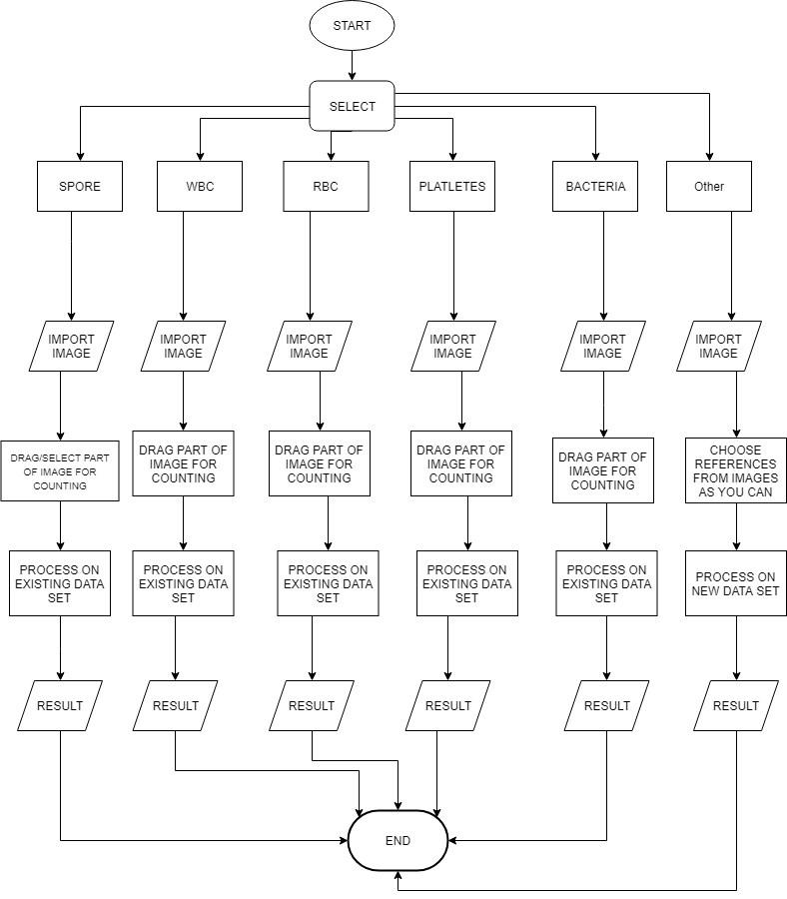

Data Flow Diagram:

Level 0:

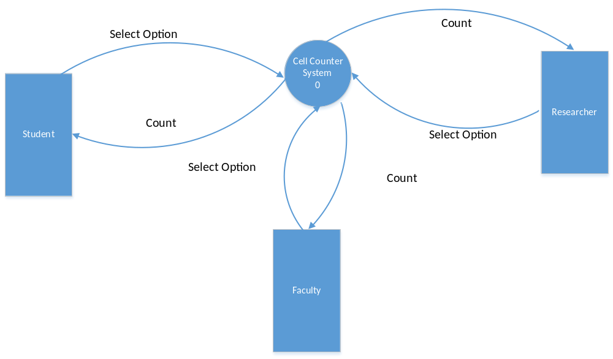

Level 1:
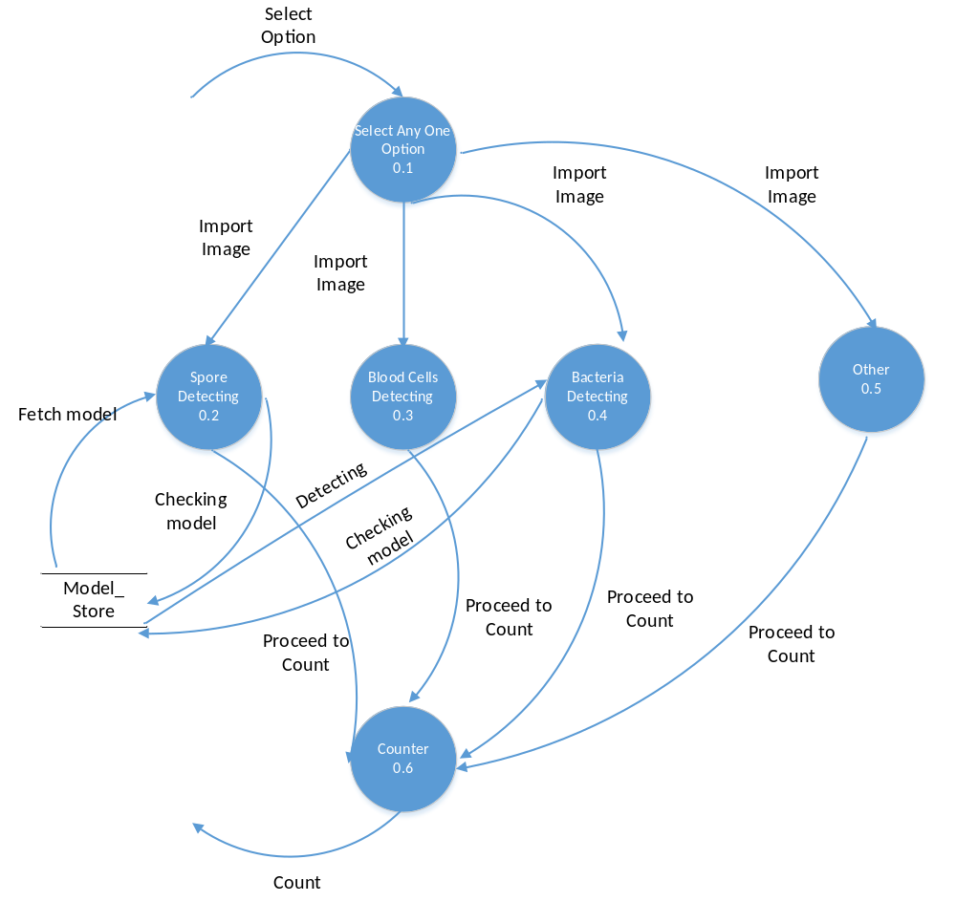

Level 2:

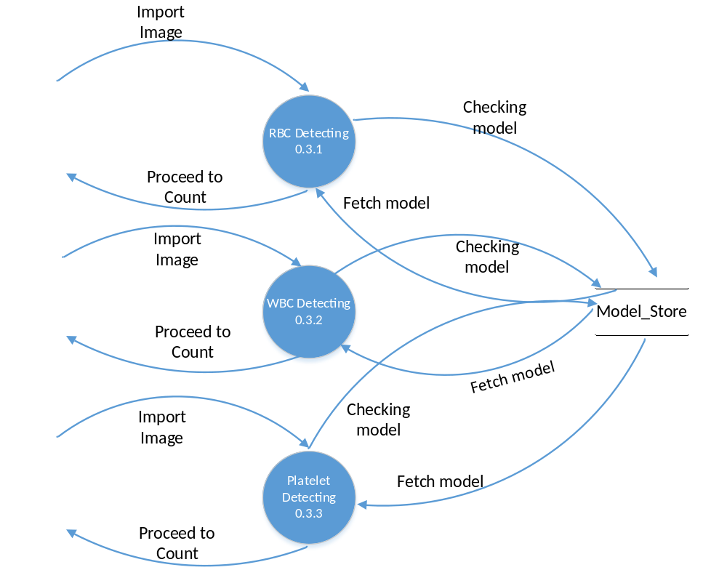
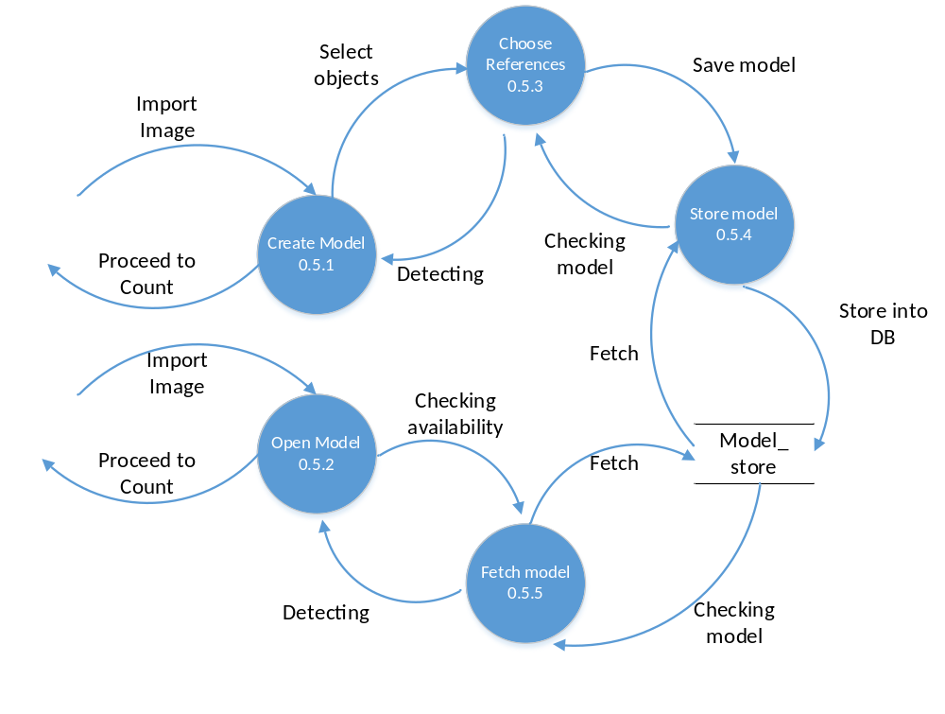

Provisional Information

Provisional GUI

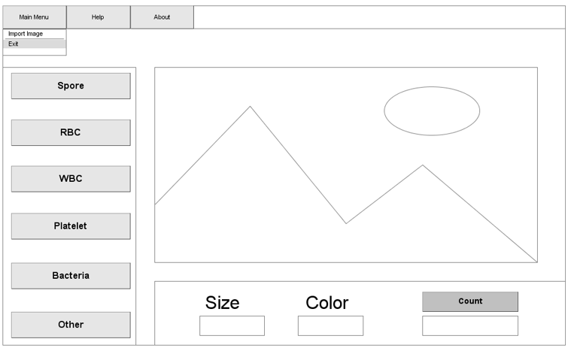

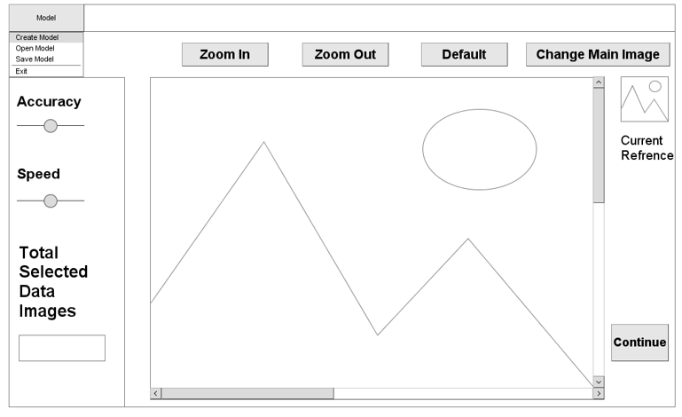
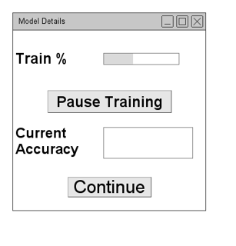

Provisonal Database

- 7.2.1 Data Dictionary

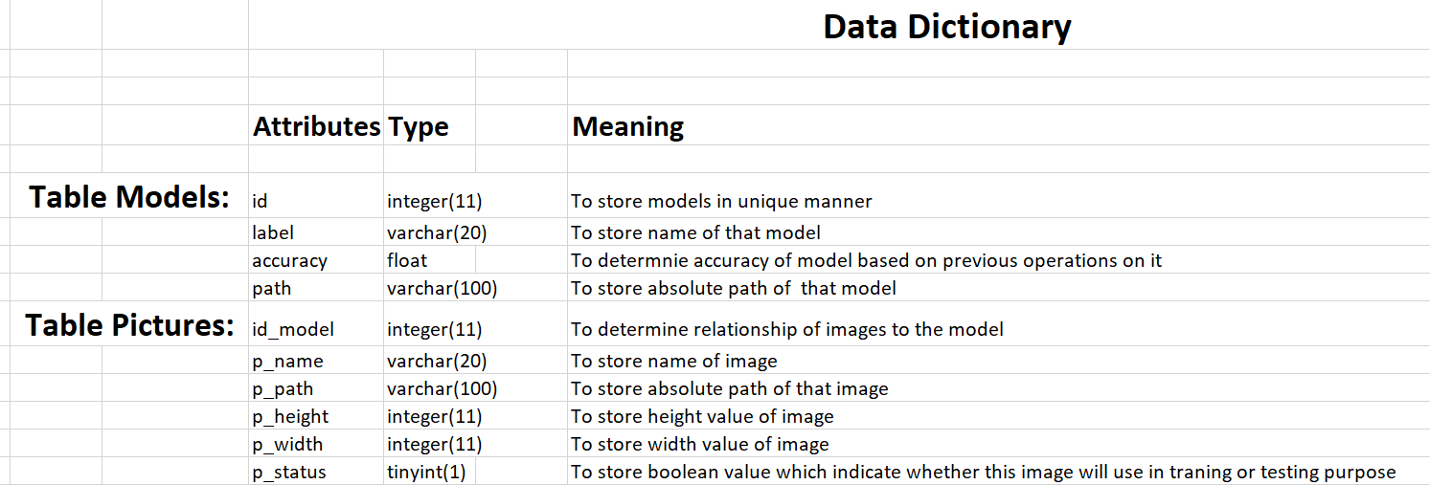

- 7.2.2 Database Structure

Table Models:
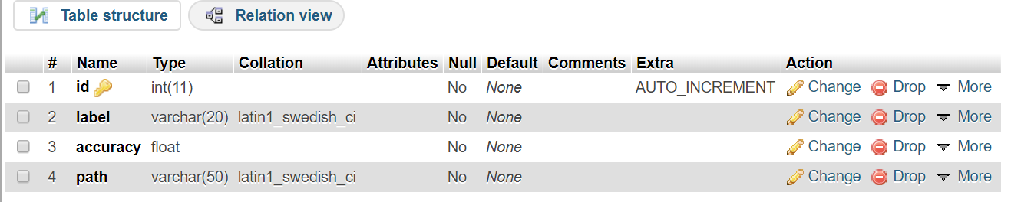

Table Pictures:
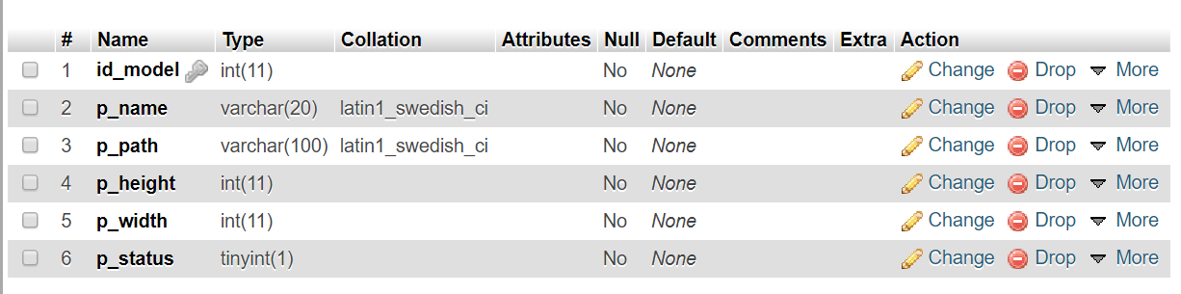

- 7.2.3 Database Design

