# 2. Analysis

## 2.1 Introduction

Analysis is the process of collecting and gathering information and its operation for the betterment of the system. Analysis is the 1st process of software development process. If the analysis is in the good way then better software is developed. Analysis is done for fulfilling the requirement of the customer or the developer. If analysis is not done then we are unable to get the software that we imagine or we are willing.   
  
Analysis of requirements is an iterative procedure that starts with a brainstorming meeting and continues through the course of development. ***(FRANCIS, 2014)***

Requirement analysis is also done with the group discussion, interviews, focus groups, etc. Requirement analysis contain all the tasks that are need for the stakeholders. High quality of requirements are documented, actionable, measureable and traceable.

As I am going to develop the website so I hardly need the analysis for the betterment and development of my website.

**SWOT analysis for my project:**

I have choose this type of analysis for my project because it helps me to find out the strength and weakness of my project. This analysis also helps me to create an opportunities in the future, and also give me an idea about the threat that may arise in the future.

For checking the strength, we must deal with the questions that what benefits this project gives to user? And also why it is better than any other software? If we get this answer than we will know our strength.

For the weakness, we must look after the things that we must avoid so that in future the project will not be weaken. Also we must be able to look after the factors that we must look after to improve our project.

And to find out the opportunities from the SWOT is by looking after the strength and finding out what opportunities that a project can give in the future.

And the threats are find out through help of SWOT by the obstacles that we are facing in the current context. Also thinking about the competitors.

So, by the help of SWOT analysis, I can clearly avoid the future issue and can complete my project with ease.

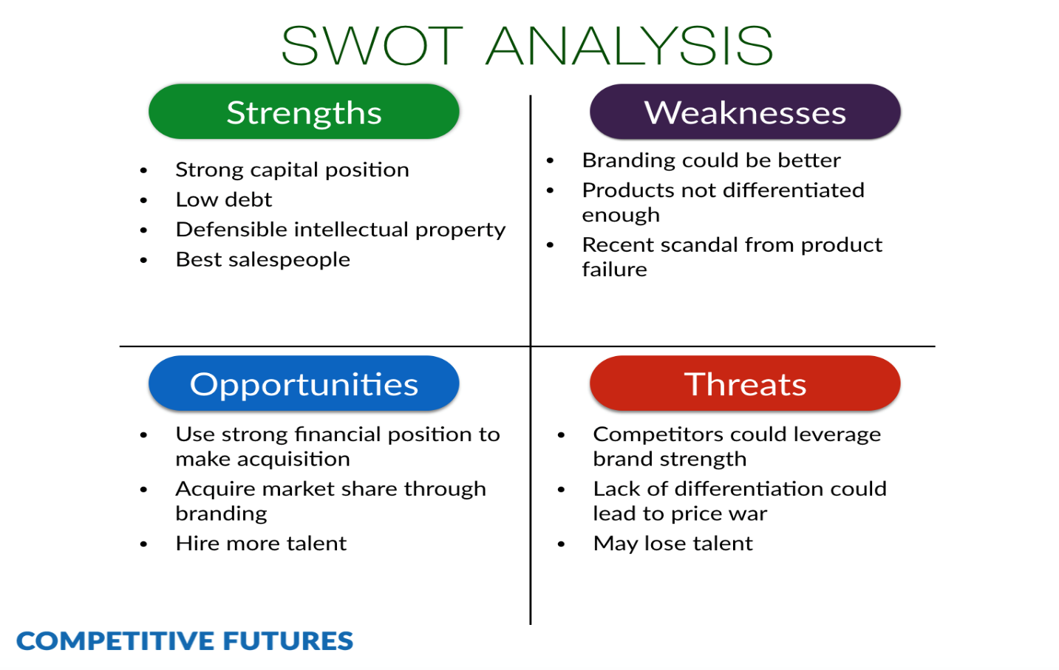

Fig: SWOT analysis

## 2.2 Feasibility Study

Feasibility study is an analysis that notices all the significant factors that are used to develop the software. In this feasibility study, it includes the economical study, technical study, legal study and many more. Developers use the feasibility study to develop the software with ease.

Similarly for my perspective, I must also look after the feasibility study to see the problems that may arises in the future and to tackle with them. Also with the help of this my software will be developed in such a way that it lasts longer.

For my project I must study the feasibility of my software. To do that here are some of the types:

1. Economic feasibility:

In this type of feasibility we must look after our fund or budget. If the software can be developed with the budget we have then it is economic feasible.

For My project, I don't need the budget to develop the software because it is a academic project and I won't need to travel anywhere to get the information. So my budget will not be used.

1. Technical feasibility:

This feasibility study will help us to know that whether or software and hardware are feasible to develop our software or not.

For my project, I don't think that hardware and software should be advanced, so technical terms are fulfilled for my project.

1. Legal Feasibility:

In this feasibility study we see that our projects meets the legal and the ethical procedure or not. If its meets than our feasibility study is complete.

For my project, legal feasibility is stable and good. Because as my project is based on the web application which is for the readers so there is not illegal to develop.

1. Schedule feasibility:

In this feasibility test we look after the time which we take to develop the project.

For my project, time is very much enough to complete my project. So I think schedule feasibility is also passed.

1. Operational feasibility:

In this feasibility test, we look after the user interaction. Whether our project is interact able to the users who uses it or not.

So as my project is simple to use than I think it is also operational feasible.

## 2.3 Requirement analysis

In this type of analysis we look after the functional and non functional analysis. In the functional requirement, we take one of the function from our project and analyze it. Similarly for non-functional requirement we do it same.

**Functional Requirement:** It is the procedure which helps us to know what a system do.

Functional requirements of my project are:

|  |  |  |  |  |  |
| --- | --- | --- | --- | --- | --- |
| **Functional ID** | **Functions in my project** | **Data** | **Rational** | **Dependency** | **Remarks** |
| F01 | Registration | Name and Address | Different names of the users | F01 | Add new readers |
| F02 | Login | Email and Password | Gives security to the readers or users | F01 | Help to order the books |
| F03 | Reset Password | Email | Password can be changed | F02 | New password is made for securing the profile. |
| F04 | Post notice of new coming books | Book name. | For the readers | F02 | Upcoming books are listed |
| F05 | Update Book | Post book details | For the Readers | F02 | Readers can easily see the book details that is updated |
| F06 | Admin Login | Admin details  ( Email and Password) | Admin | F06 | Open the dashboard of the admin |
| F07 | Update admin login (Profile) | Update the admin details | Admin | F06 | Details of the admin will be Updated |
| F08 | Asking Questions related books | Details | Readers to the admin | F02 | Readers can interact with the admin related book |
| F09 | Answer the Questions | Question Details | Admin to readers | F02 | Admin will answer the asked question |

Table: Functional Requirements

**Non Functional Requirements:**

Non functional requirements are those requirements which is not directly related but indirectly related to the project. It includes the quality attributes of the project.

Non-Functional requirements are of two categories. I.e. Execution and Evolution qualities. Execution is the observable during the run time while Evolution is the static structure of the system.

Table of non-functional requirements of my project are:

|  |  |  |  |  |  |
| --- | --- | --- | --- | --- | --- |
| **Non-Functional Id** | **Functions** | **Data** | **Rational** | **Dependency** | **Remarks** |
| N01 | Responsive | - | Support Different types of Resolutions | - | Fit in different screen sizes. |
| N02 | Usability | - | User friendly | - | User friendly |
| N03 | Reliable | - | Is trusted | - | People can easily trust the website |
| N04 | Robust | - | Supports many platforms | - | Should work with different platforms |
| N05 | Multi-Browser support | - | Tested in many browsers | - | Runs in different browser |
| N06 | Scalability | - | To be able to handle workloads | - | It will handle the data flow easily |

Table: Non-Functional Requirements

**MoSCoW Prioritization:**

MoSCoW prioritization is the technique for helping to understand and to manage the priority. ***(moscow-prioritisation, 2019)***

MoSCoW Prioritization for the Functional Requirements are:

|  |  |  |
| --- | --- | --- |
| **ID** | **Functionalities** | **Priority** |
| F01 | Registration | Must have |
| F02 | Login | Must have |
| F03 | Reset Password | Must have |
| F04 | Post Notice of Upcoming book | should have |
| F05 | Update Books | Should have |
| F06 | Asking Questions related books | Would have |
| F07 | Answer the Questions related books | Would have |
| F08 | Admin Login | Must have |
| F09 | Admin Profile Update | Should have |

Table:MoSCoW Prioritization for the Functional Requirements

MoSCoW Prioritization for the Non-Functional Requirements are:

|  |  |  |
| --- | --- | --- |
| **ID** | **Functionalities** | **Priority** |
| N01 | Responsive | Must have |
| N02 | Usability | Must have |
| N03 | Reliable | Should have |
| N04 | Robust | Must have |
| N05 | Multi-Browser support | Must have |
| N06 | Scalability | Won't have |

Table:MoSCoW Prioritization for the Non-Functional Requirements

## 2.4 Use Case Diagram

Use case diagram is the diagrammatic representation of the interaction between the elements of the system. It looks like flow chart but gives the proper idea about the system. It speaks about which actor is doing what.

As looking at my project, there are 2 actors. One the customer own selves and second one is admin who handle the website.

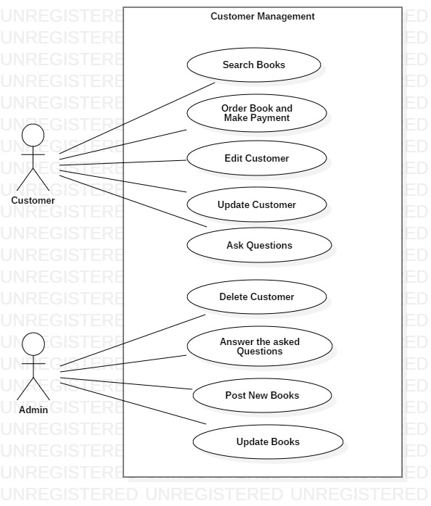

Fig: Use Case Diagram

## 2.4 NLA with Initial Class diagram

**Introduction:**

For my college project I have decided to develop a web application which help the people to buy or order a novels from online. My website also contains some of the various features. As my website is based on the online book management system but the book available is only of literature. Different categories of the books are available.

My website helps user or the readers to search the book according to their interest. My website helps the use to comment or give review about the books in the online forum. The review and comments written by users/readers is answered by the admin. Also my website contains the registration system in which user can register and can be easily connected to the website. In the review or the comment section or review section user can delete, update and insert their review. Also the User details which they have entered while registering themselves can be easily edit, delete and update.

Here are my candidate class list:

By looking at the above scenario I have divided into the nouns and verbs. Where nouns indicate the class and verbs indicate the methods.

Nouns:

1. College
2. Novels
3. Books
4. Categories
5. Readers
6. Users
7. Review
8. Comment
9. Register
10. Admin
11. Order

Verbs:

1. Buy
2. Search
3. Add, edit and delete the review
4. Add, edit and delete the user details
5. Admin replying the reviews and comments

Here are My Final Classes for initial class diagram:

1. Book
2. Categories
3. User
4. Review
5. Order

Proper Reason about I selected these classes for my initial class diagram are:

|  |  |
| --- | --- |
| **Book** | I select this as class because users order the books of different categories from the website. Also in between the novels and the books, I select it because it seems more standard. |
| **Categories** | I select this as class because it indicates the types of books. |
| **User** | Without the user, engagement in the website will not be possible. And I select the User rather than the readers because user indicate all the peoples involved in the website. |
| **Review** | I selected review because here are the views of the users' related books. Also I select it rather than comments because it seems more advanced and is standard word. |
| **Order** | I select the order because user will buy the books from the website by online. And selecting it rather than the buy is due to the word weight. |
| **Register** | I select this because the people who registers will be added to the database and can order the books. |

Here is my Initial Class diagram:

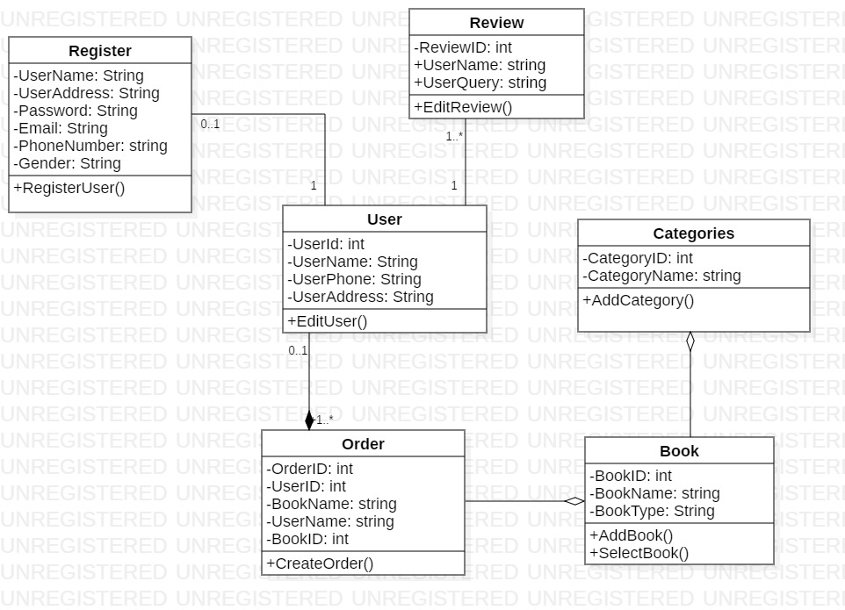

Fig: Initial Class Diagram

# **Conclusion:**

After the analysis, I can conclude that the project will be made with ease and will maintain the standard. Project will be easy to use by all type of users. And also project will be sustain for a long time as I have mentioned all the functionality that project will have for the future.