**Testing**

Testing is define as the activity to check whether the expected result is matched with the actual result or not ***(software-testing-introduction-importance, 2019).*** Software testing generally helps to find out the errors of the program.

There are many types of testing. Some of them are:

1. Alpha testing
2. Regression testing
3. Acceptance testing
4. Back-end testing
5. Beta testing
6. Black box testing
7. White box testing
8. Unit testing
9. Boundary value testing
10. Component testing

But for my project I will only use the 2 type of testing, I.e. Black box and Unit testing.

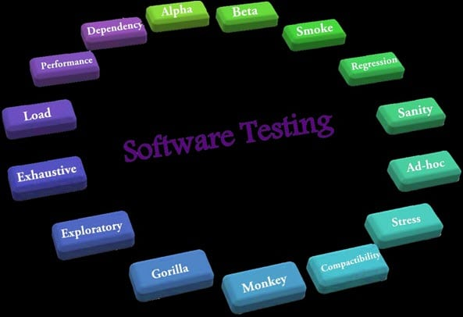

Fig 1: Types of testing

1. **Black Box testing:**

That type of testing in which the internal processing isn't seen but only the input and output is called black box testing. This type of testing is also called the behavioral and eye-to-eye testing.

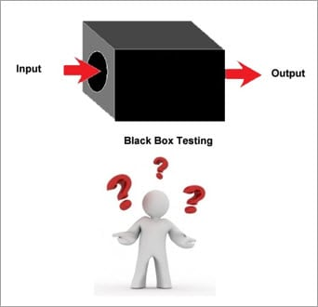

Fig 2: Black Box testing

1. **Unit Testing:**

That type of testing in which the individual material or the components are tested is called as Unit testing. This type of testing is done to know whether the each unit of the project is performed as it is designed or not. It is generally performed by the white box testing.

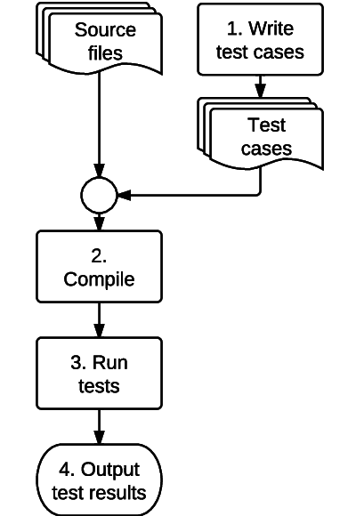

Fig 3: Unit Testing