"DOORS"
a local, centralized system
for controlling and managing
a set of automatic doors

a prescriptive design document

1. Summary

The "Doors" system aims to elegantly fulfill a set of requirements common to most apartment buildings and many other facilities: management and monitoring of multiple physical entry-points (Door units), and serving of common intercom features to an arbitrary number of clients (Intercom units), all coordinated through a central (Hub) unit.
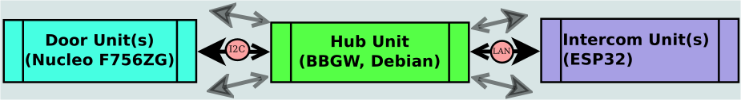
Short version: one hub interfaces between multiple doors and multiple intercoms.

2. The Door Unit

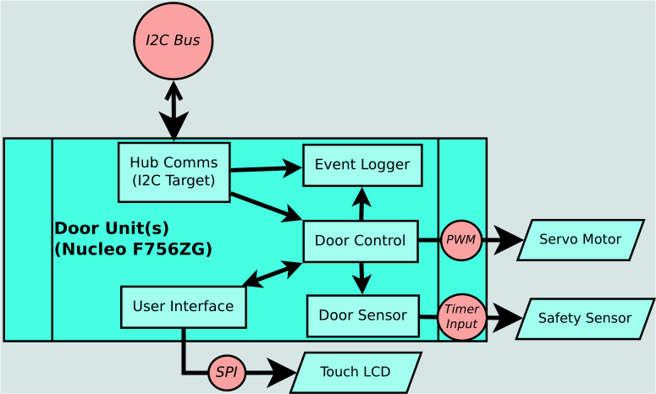
The Door Unit consists of:
- an STM32 Nucleo-F756ZG board;
- a servo-motor, controlling an automatic door;
- an additional power supply unit for the servo;
- a safety sensor, to detect blockage and avoid accidents;
- a touch display for passcode entry & "bell" functions;
- a small QVGA camera, mainly for Intercom functions.

Each Door shares an I2C bus with the Hub and all other Door units, and participates in the bus passively as an I2C Target.

Internally, the Door is a FreeRTOS based system, consisting of the following tasks:
- User Interface, operating the touch display and processing its inputs;
- Hub Comms, handling inputs from the Hub over the I2C bus;
- Door Sensor, continuously reading inputs from the safety sensor into a circular buffer;
- Door Controller, operating the physical door while considering input from all above tasks;
- Camera, snaps still frames in certain situations(e.g. apartment bell rung).

The Door’s I2C Target module exposes four registers:
- Event Count, which holds the number of outgoing messages and is routinely polled by the Hub.
- Event Queue, read by the Hub to fetch the latest outgoing message.
- Hub Command, where the Hub writes commands for the Door to execute.
- Data, read by the Hub relatively infrequently and only after the Door reports that data is ready.
This would be for an unusually large packet, such as a photo from the Door camera.
3. The Intercom Unit

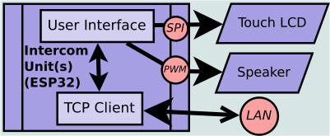
The Intercom Unit consists of:
- an ESP32 WROOM-32 board;
- a touch display for door information & control;
- a speaker for the "bell" function.

Each Intercom unit is connected to a local network, and functions as a client, interacting with the singular Hub unit’s server process to facilitate indirect communications with the Door layer.
Internally, the Intercom is a simple FreeRTOS based system, with its two primary tasks being operating the user interface and communicating with the Hub.

The most common use of the Intercom would be informing the user of a "bell" request from one of the Door units, while supplying additional information - a photo taken at the time of the request. The user may then use the Intercom unit to respond by ordering the Door to open.

4. The Hub Unit

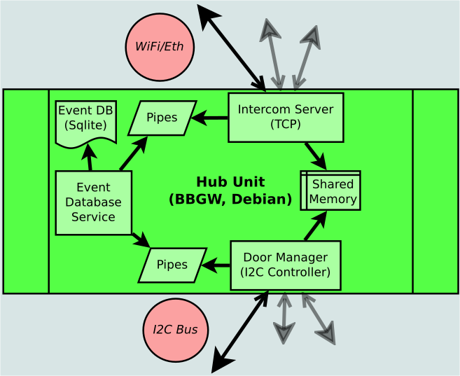
The Hub Unit consists of a single Beaglebone Green board.

The board is physically connected to an I2C bus it shares with all Door units, and functions as the one and only I2C Controller of this bus. Some additional hardware, not covered here, is likely necessary for this bus to function over application-useful distances.

The Hub is also connected to a local network, where it functions as a server with all local Intercom units as its clients.

Internally, the Hub is a Debian Linux system continuously running multiple processes:
- Door Manager, handling I2C communication with the Door units;
- Intercom Server, handling socket communication with the Intercom units;
- Event Database Service, wrapping a local Sqlite database for access by other processes.

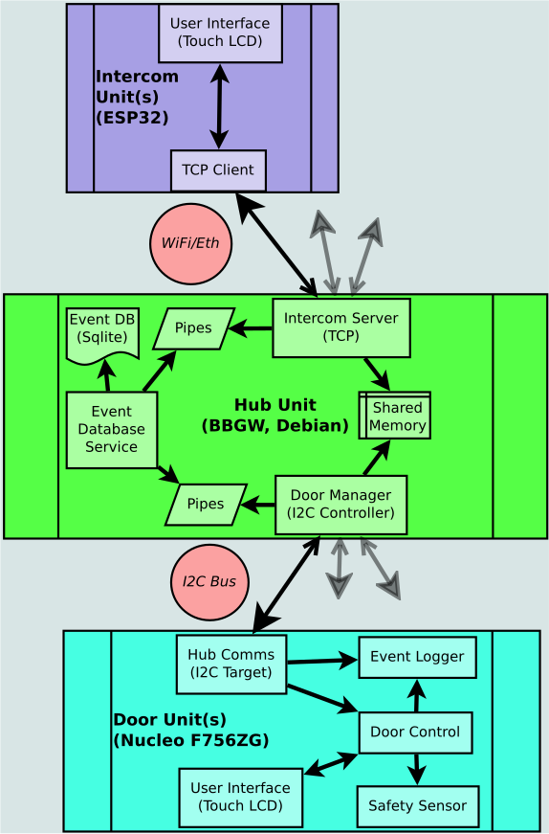
5. Overview

