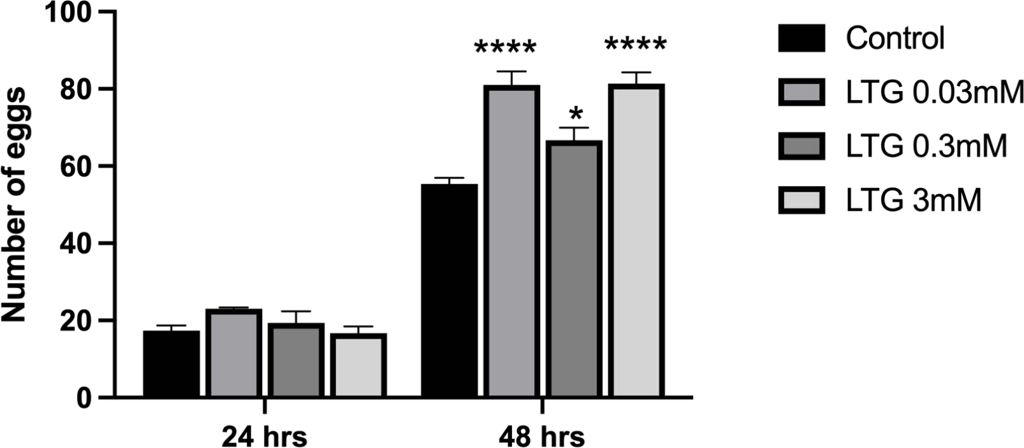
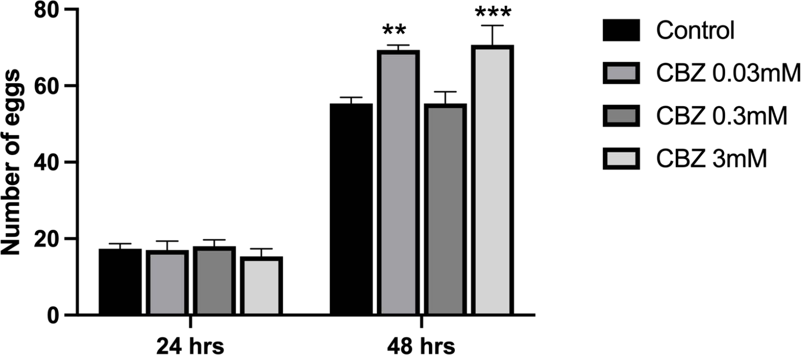
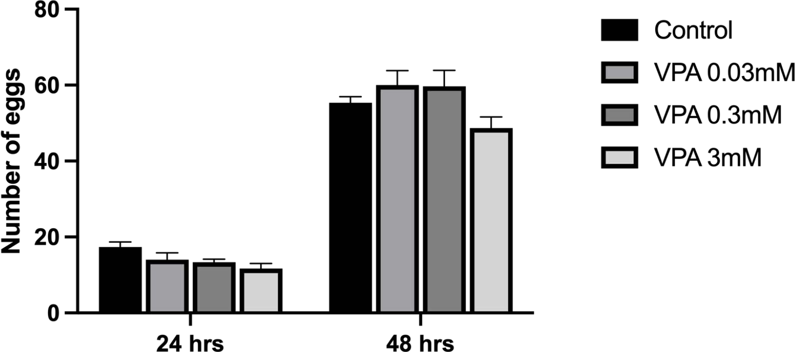
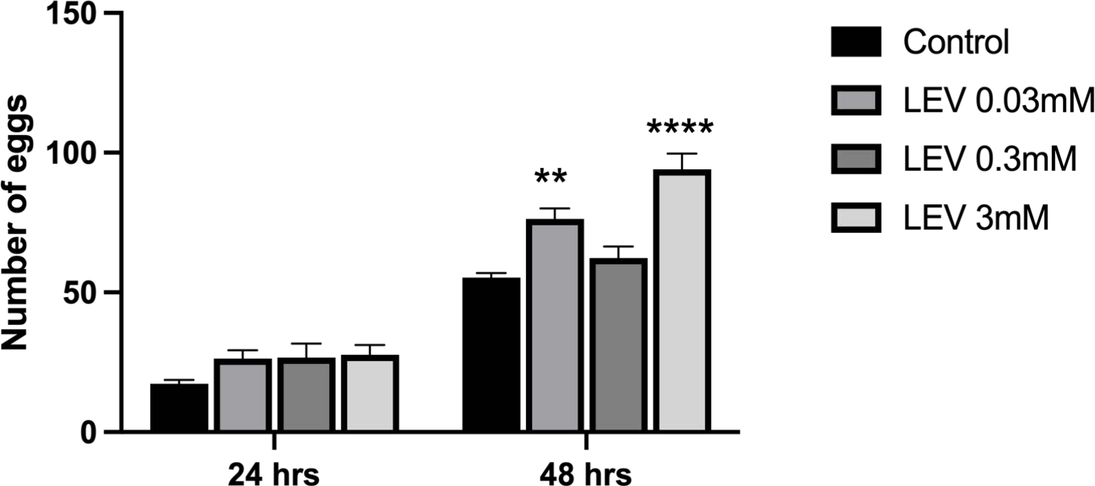
B
A
C
D
Figure 1A–D
Effect of LTG, CBZ, VPA, and LEV on Egg Count in Canton-S Strain Drosophila melanogaster (F1 generation) at 24 and 48 hr
Bars represent Mean ± SEM (n = 20). p < .05, **p < .01, ***p < .001, ****p < .0001 vs. Natural control.
Analysis by two-way ANOVA, followed by Tukey's multiple post hoc comparison test

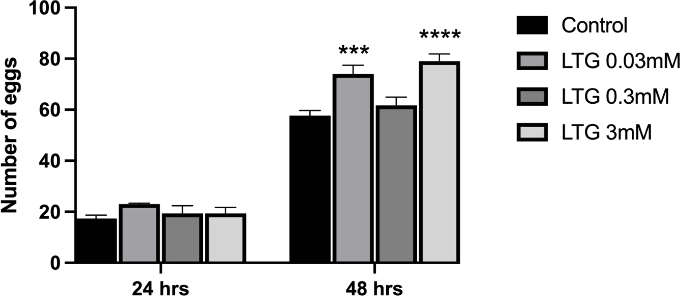
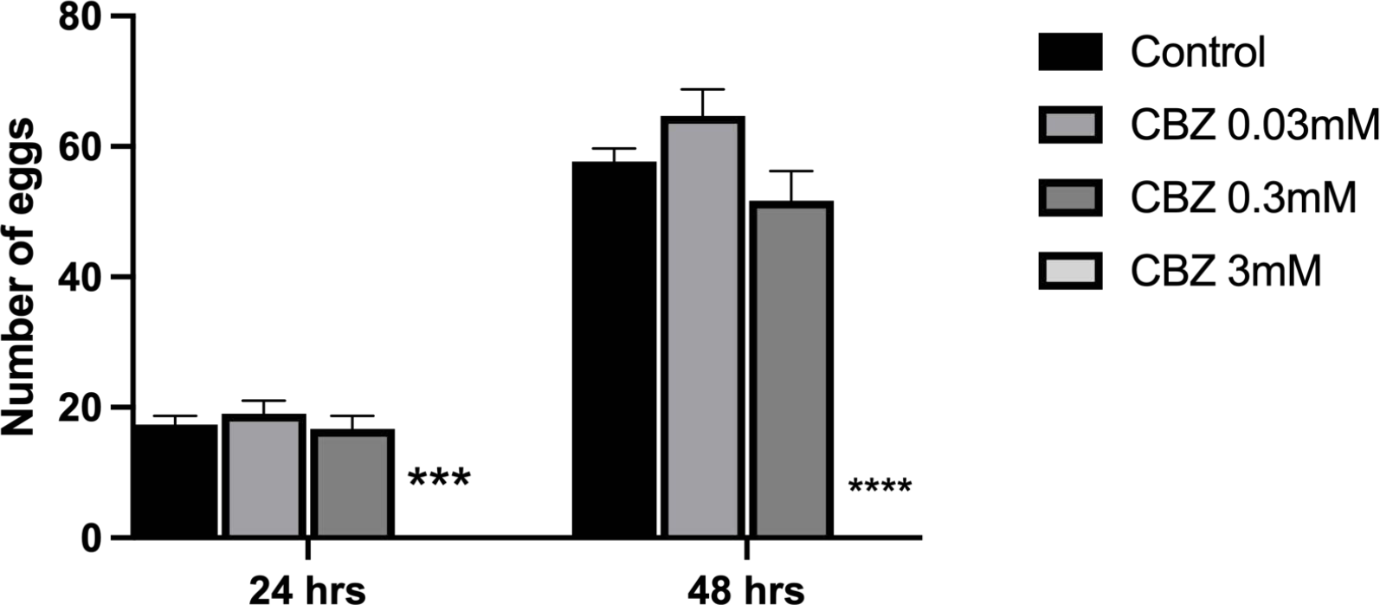
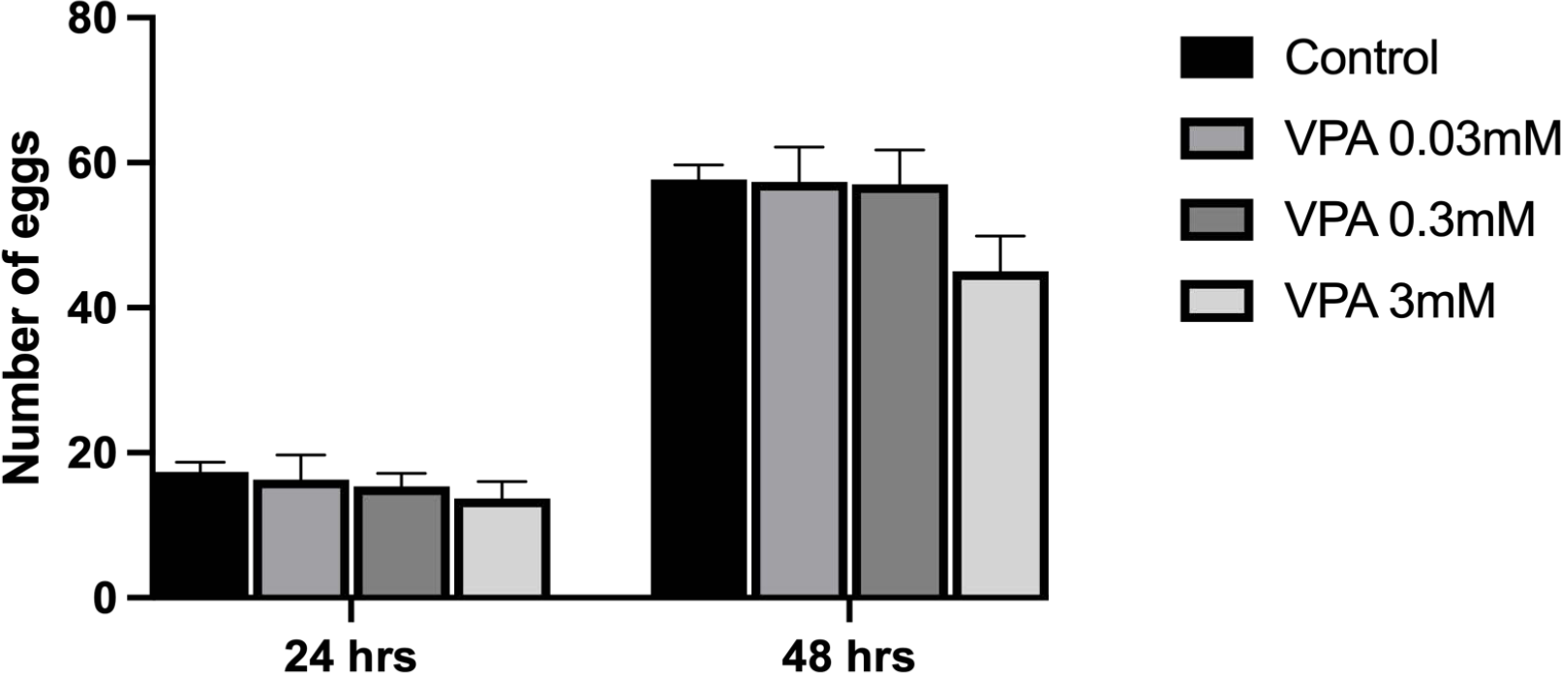
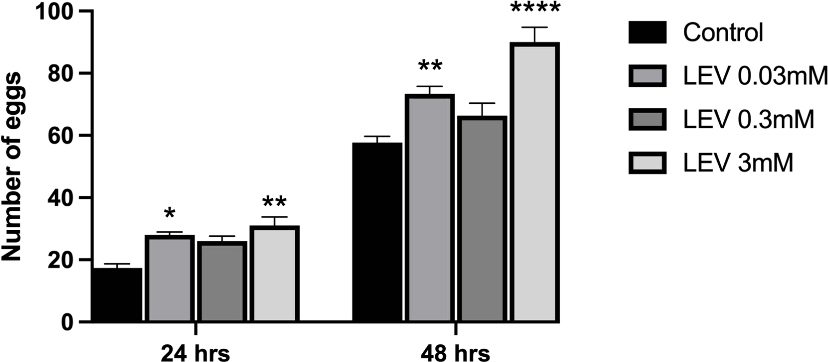
A
B
D
C
Figure 2A–D
Effect of LTG, CBZ, VPA, and LEV on Egg Count in Canton-S Strain Drosophila melanogaster (F2 generation) at 24 and 48 hr.
Bars represent Mean ± SEM (n = 20). p < .05, **p < .01, ***p < .001, ****p < .0001 vs. Natural control.
Analysis by two-way ANOVA, followed by Tukey's multiple post hoc comparison test

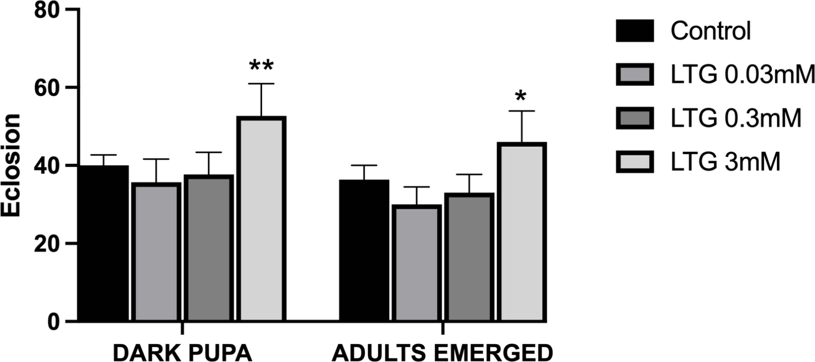
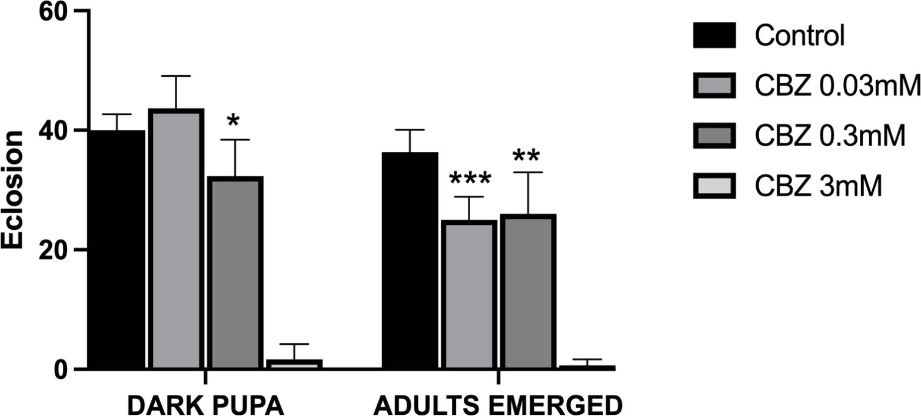
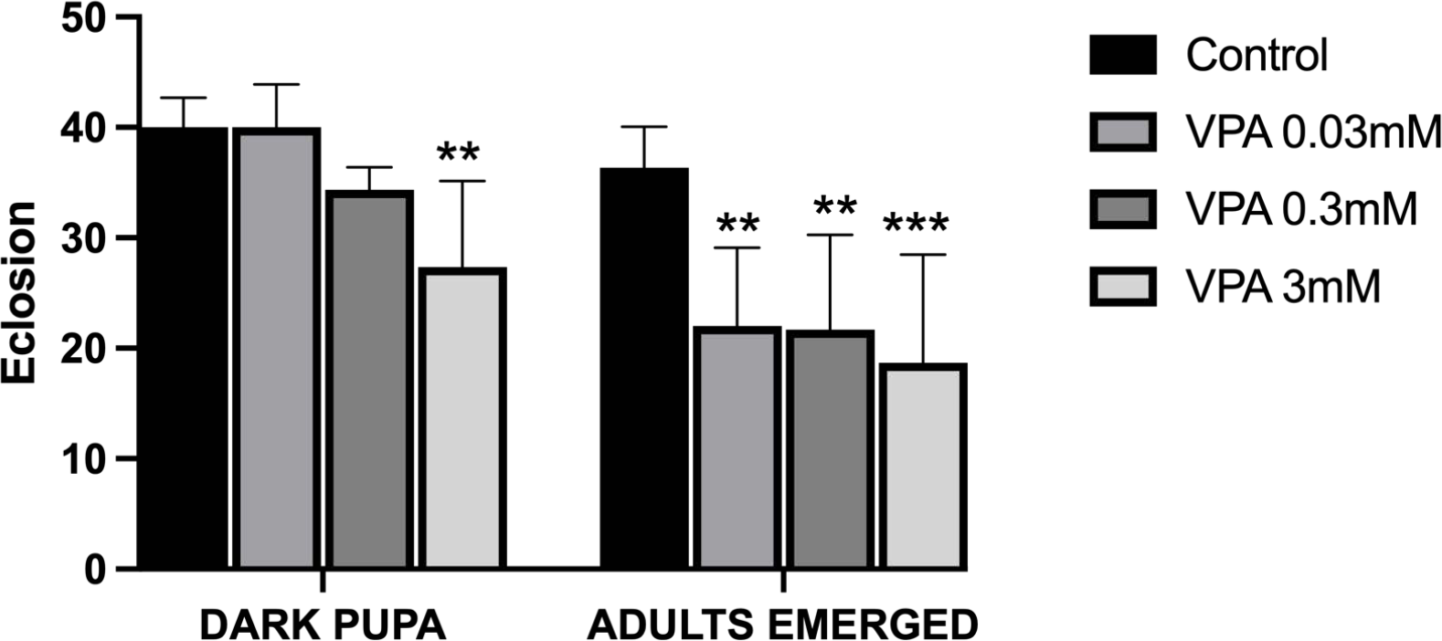
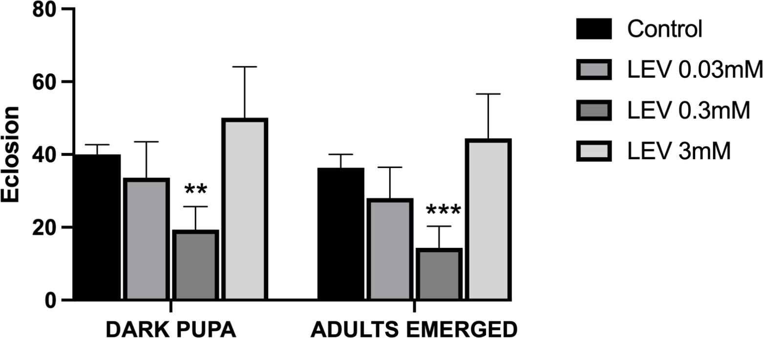
B
A
C
D
Figure 3A-D
Effect of LTG, CBZ, VPA, and LEV on Adult Eclosion in Canton-S Strain Drosophila melanogaster (F1 generation).
Bars represent Mean ± SEM (n = 20). p < .05, **p < .01, ***p < .001, ****p < .0001 vs. Natural control. Analysis by two-way ANOVA, followed by Tukey's multiple post hoc comparison test

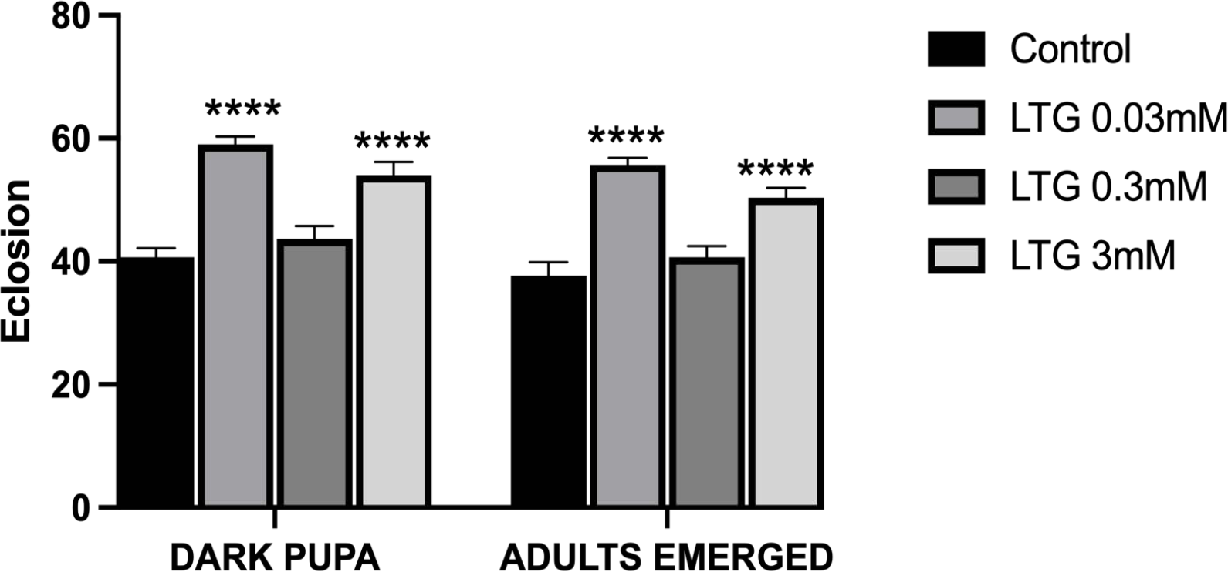
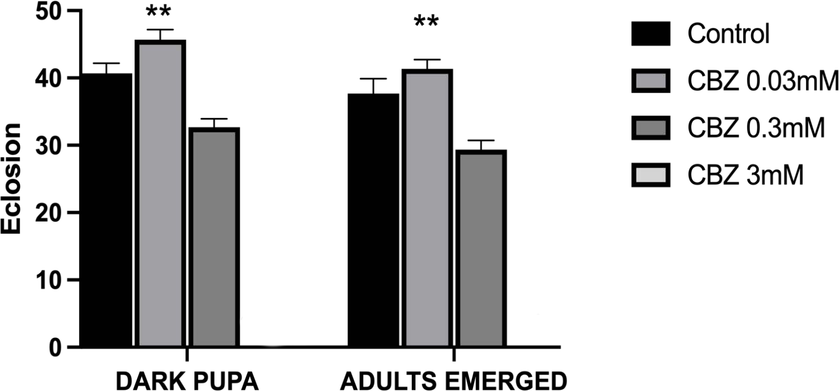
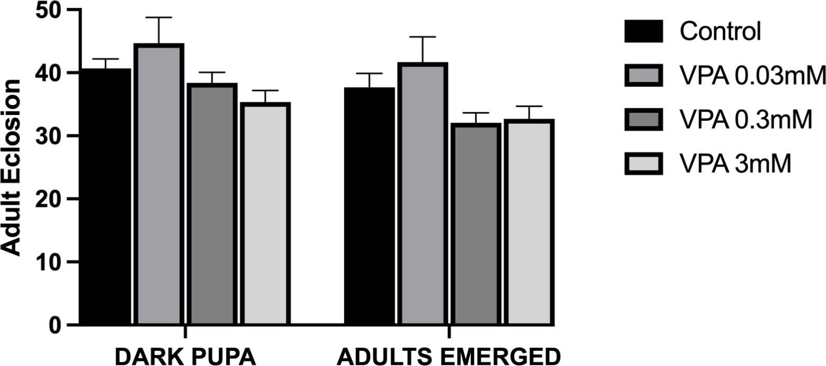
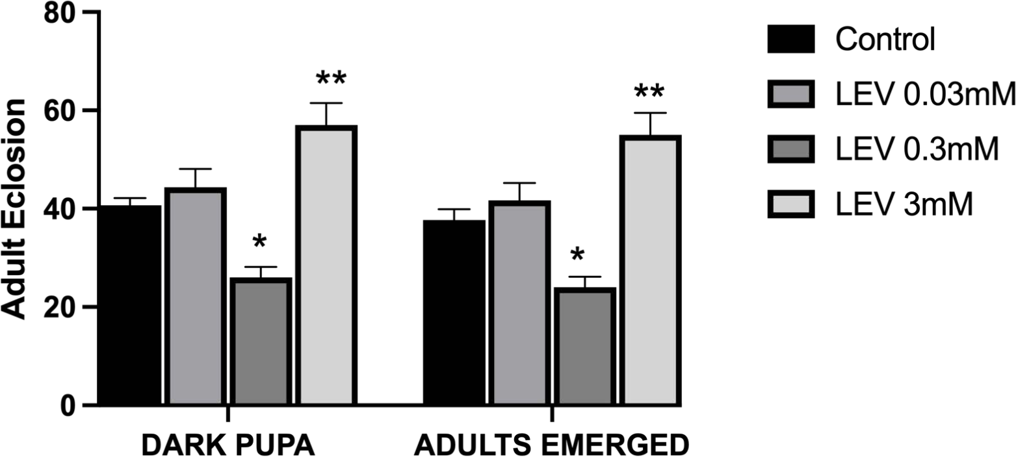
B
A
C
D
Figure 4A-D
Effect of LTG, CBZ, VPA, and LEV on Adult Eclosion in Canton-S Strain Drosophila melanogaster (F2 generation).
Bars represent Mean ± SEM (n = 20). p < .05, **p < .01, ****p < .0001 vs. Natural control. Analysis by two-way ANOVA, followed by Tukey's multiple post hoc comparison test

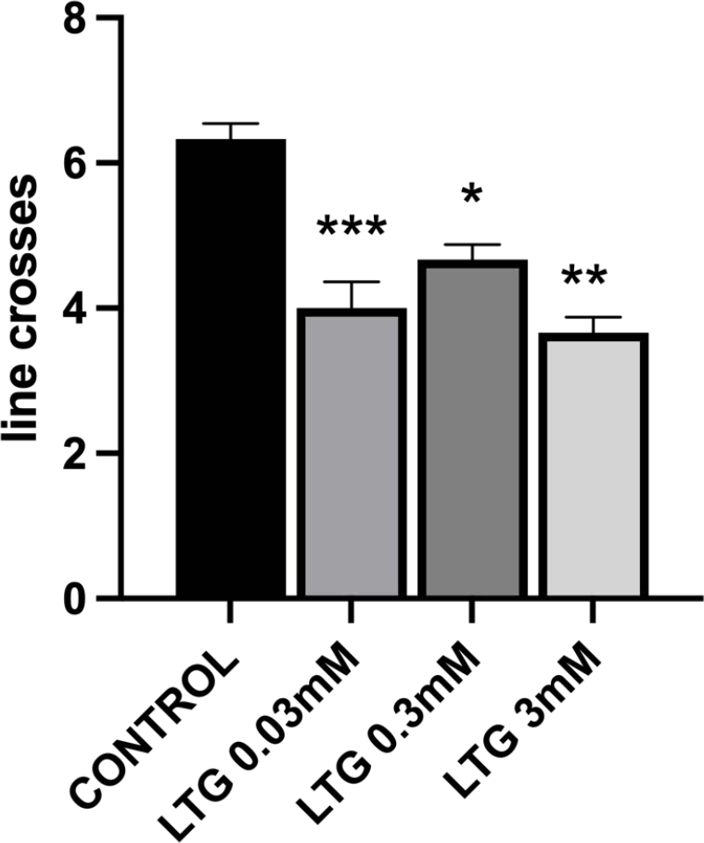
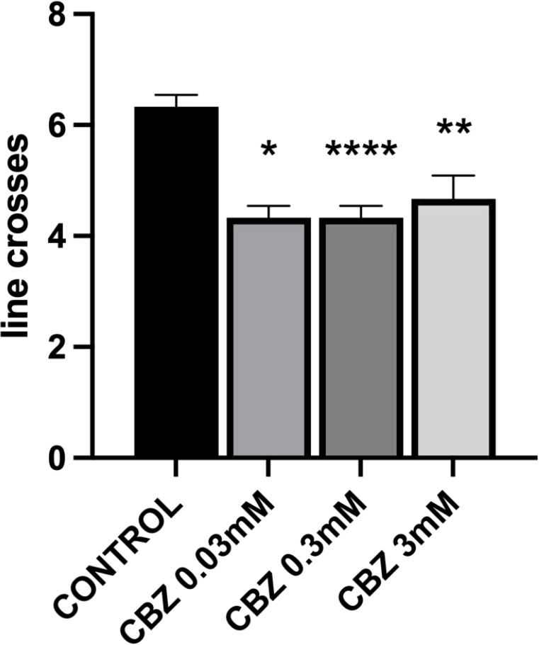
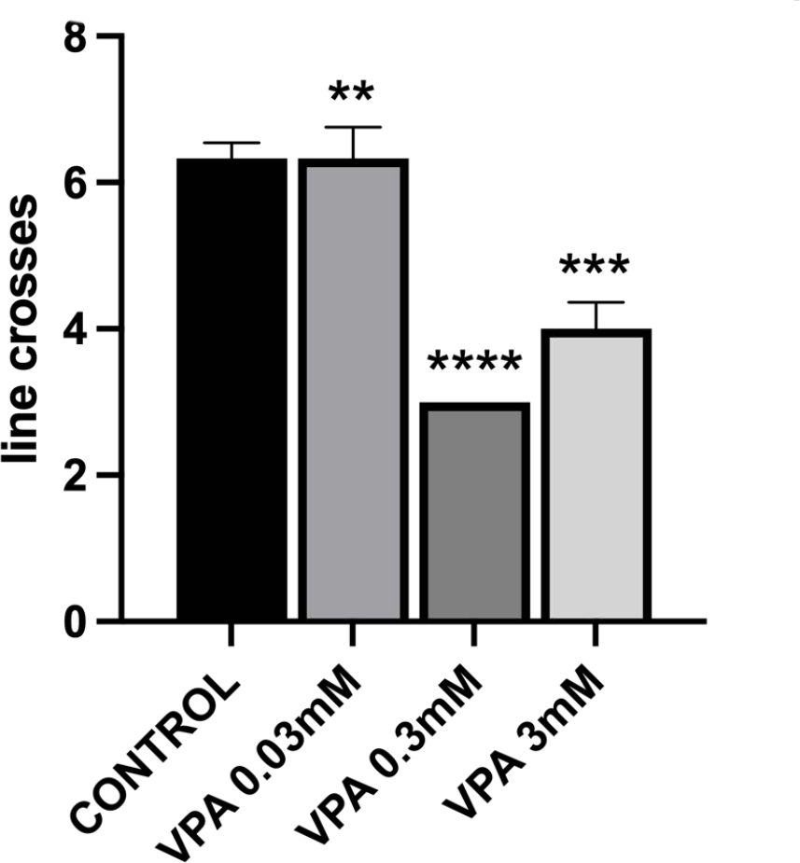
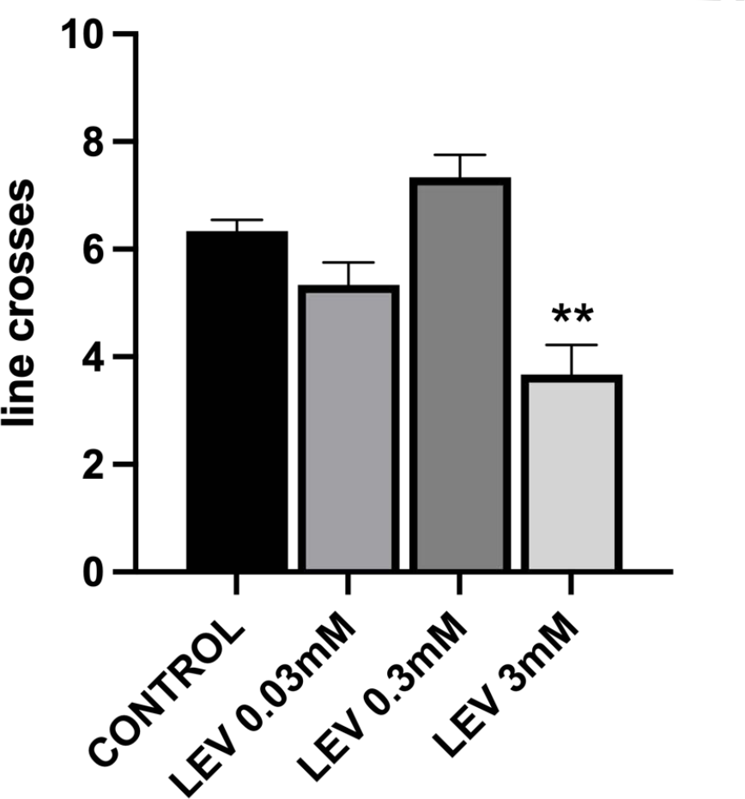
B
A
C
D
Figure 5A-D
Effect of LTG, CBZ, VPA, and LEV on Larva Motility (Line Crosses) in Canton-S Strain Drosophila melanogaster (F1 Generation).. Bars represent Mean ± SEM (n = 20). p < .05, **p < .01, ***p < .001, ****p < .0001 vs. Natural control.
Analysis by one-way ANOVA, followed by Tukey's multiple post hoc comparison test

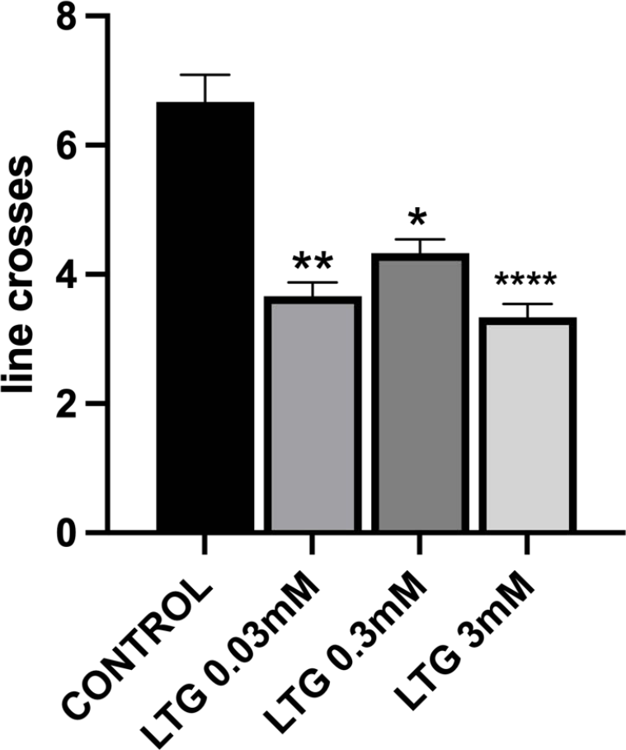
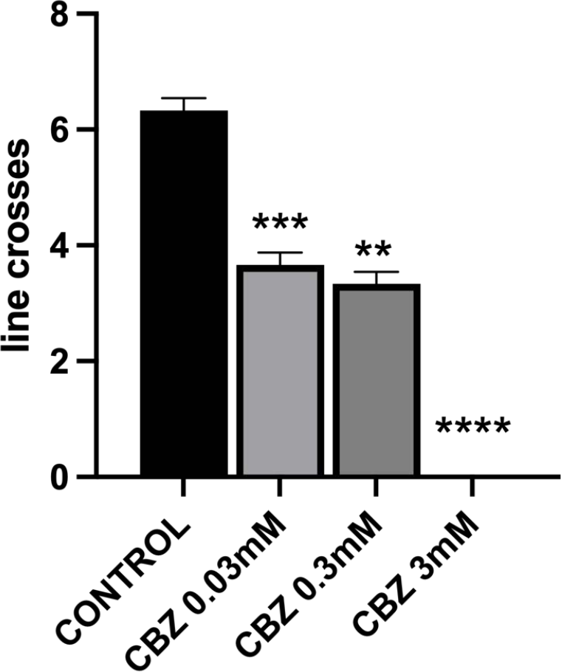
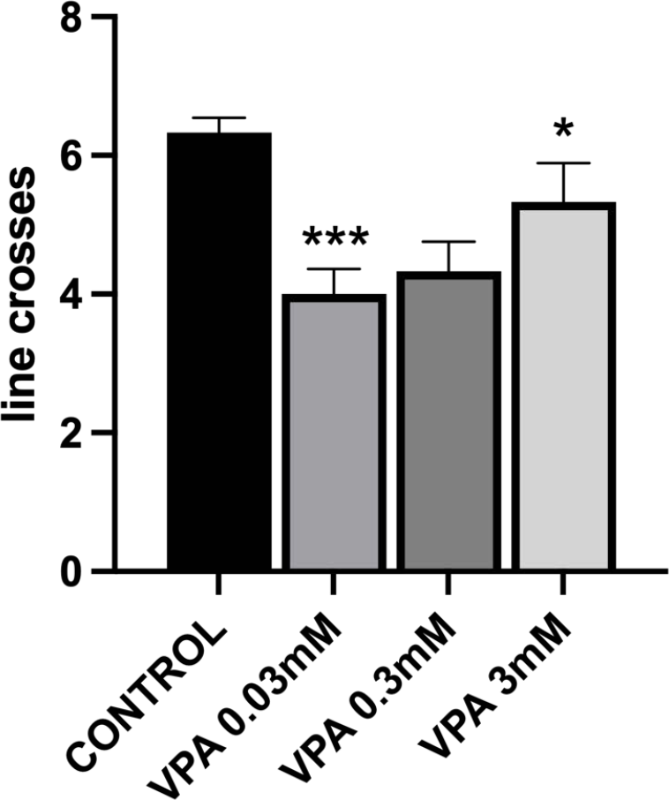
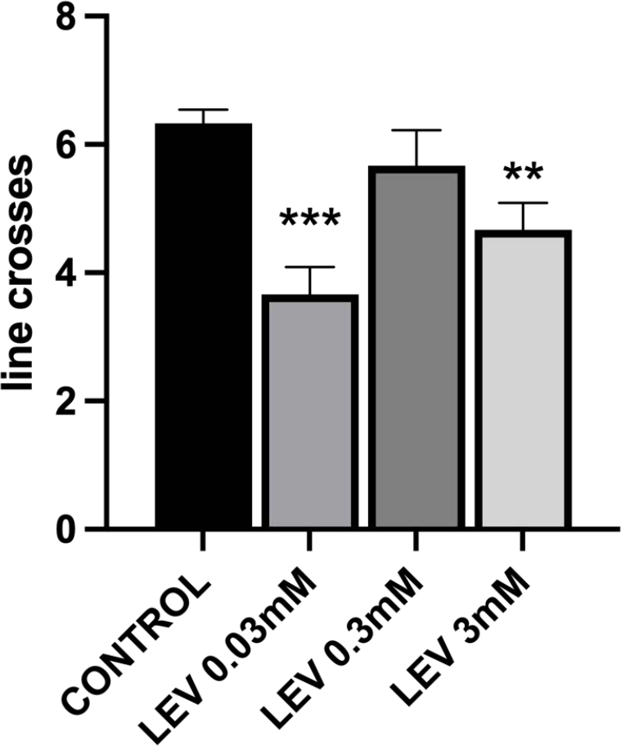
A
B
C
D
Figure 6A-D
Effect of LTG, CBZ, VPA, and LEV on Larva Motility (Line Crosses) in Canton-S Strain Drosophila melanogaster (F1 Generation).
Bars represent Mean ± SEM (n = 20). p < .05, **p < .01, ***p < .001, ****p < .0001 vs. Natural control. Analysis by one-way ANOVA, followed by Tukey's multiple post hoc comparison test

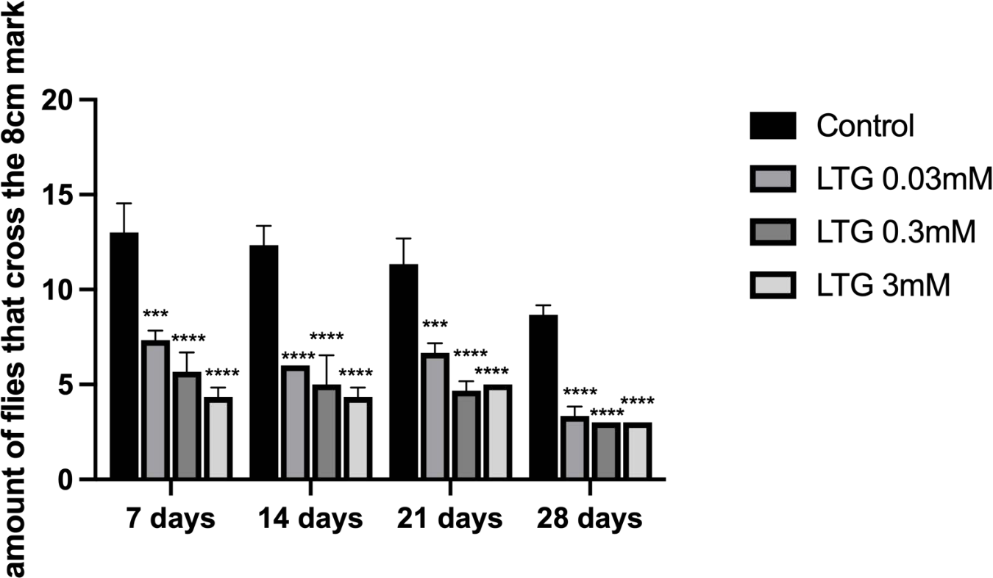
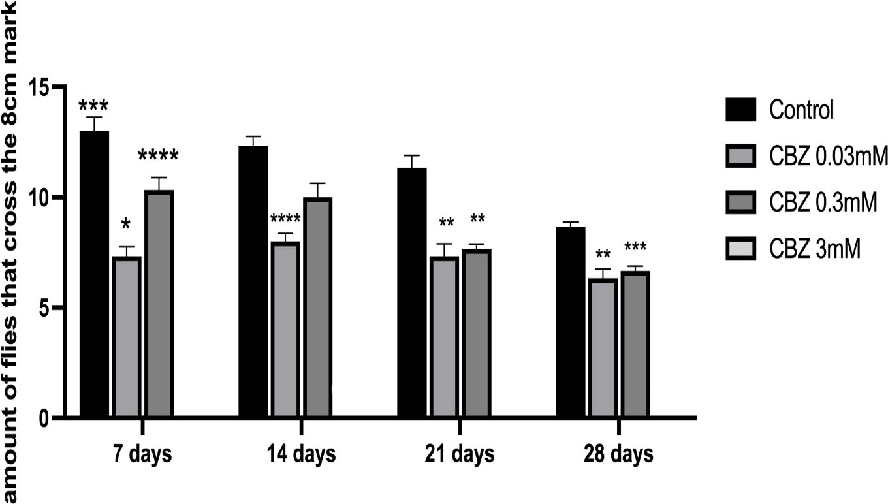
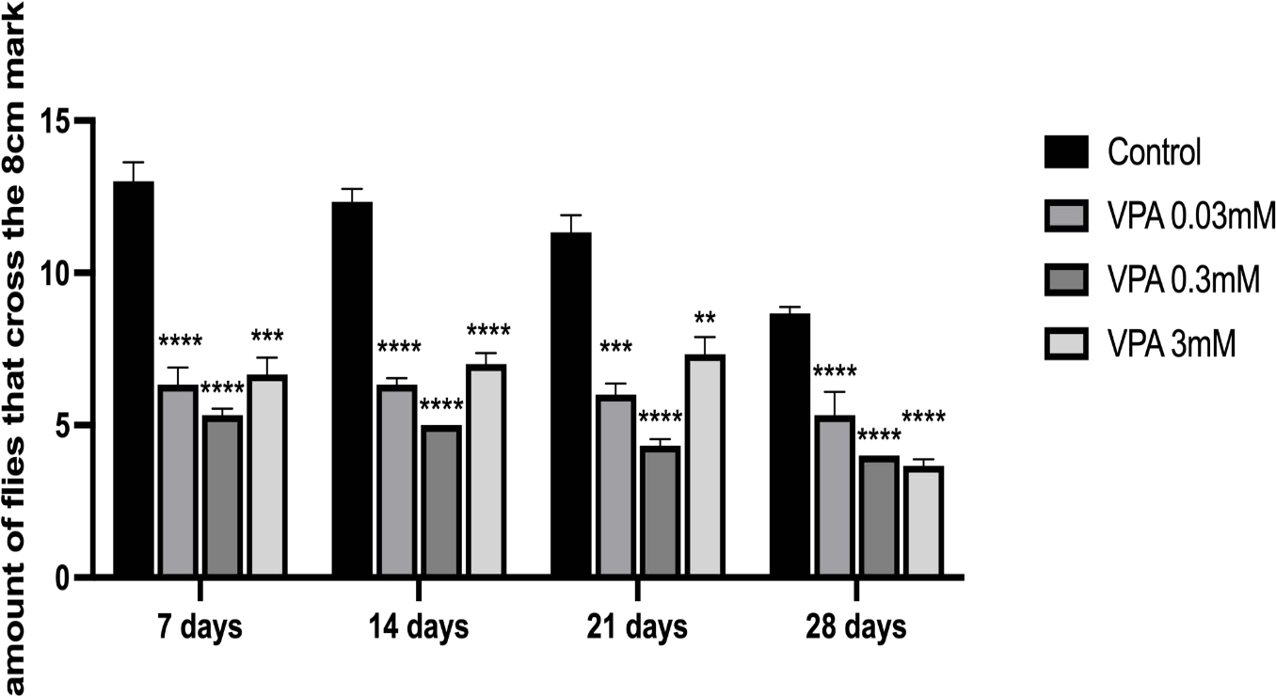
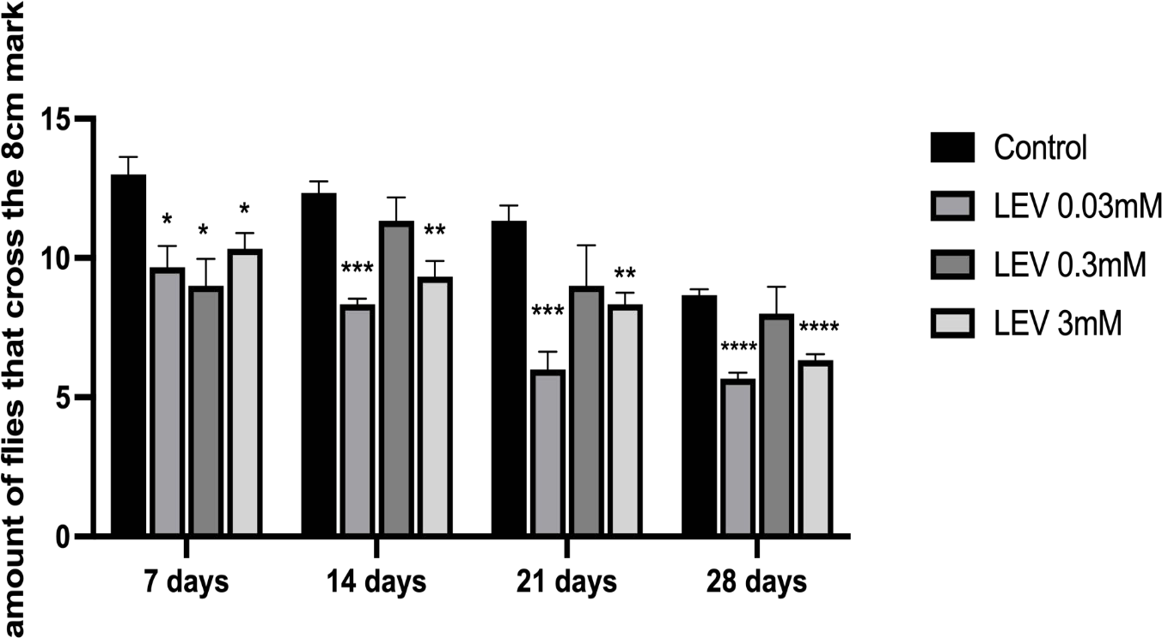
A
B
C
D
Figure 7A-D
Effect of LTG, CBZ, VPA, and LEV on Adult Negative Geotaxis (Climbing Ability) in Canton-S Strain Drosophila melanogaster(F1 Generation).
Bars represent Mean ± SEM (n = 20). p < .05, **p < .01, ***p < .001, ****p < .0001 vs. Natural control. Analysis by two-way ANOVA, followed by Tukey's multiple post hoc comparison test

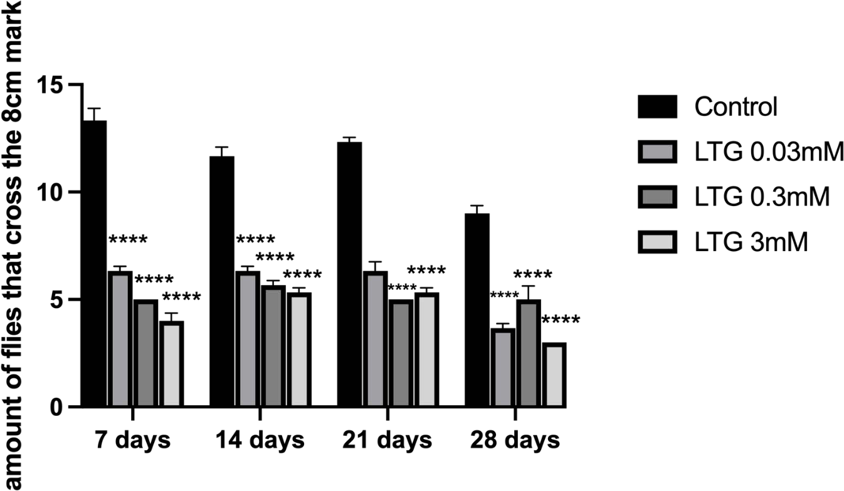
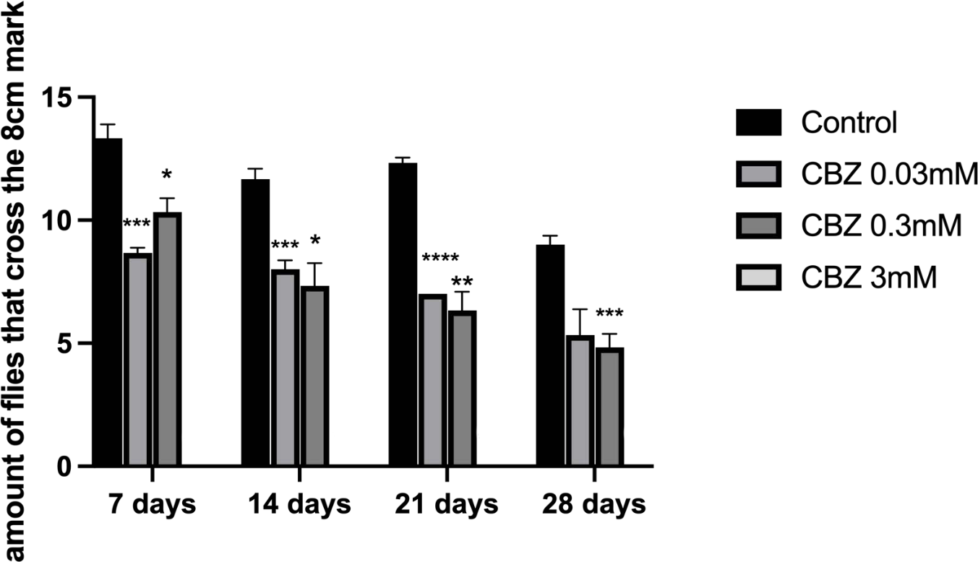
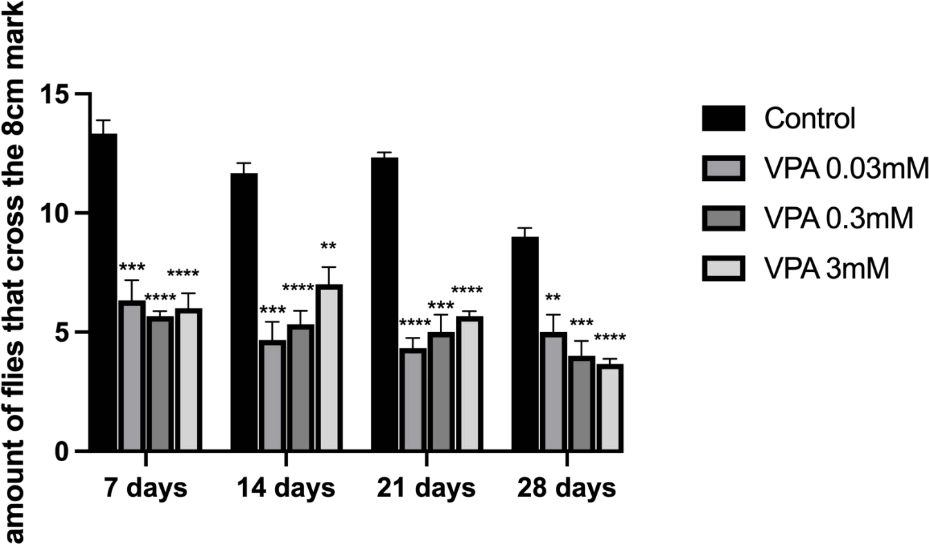
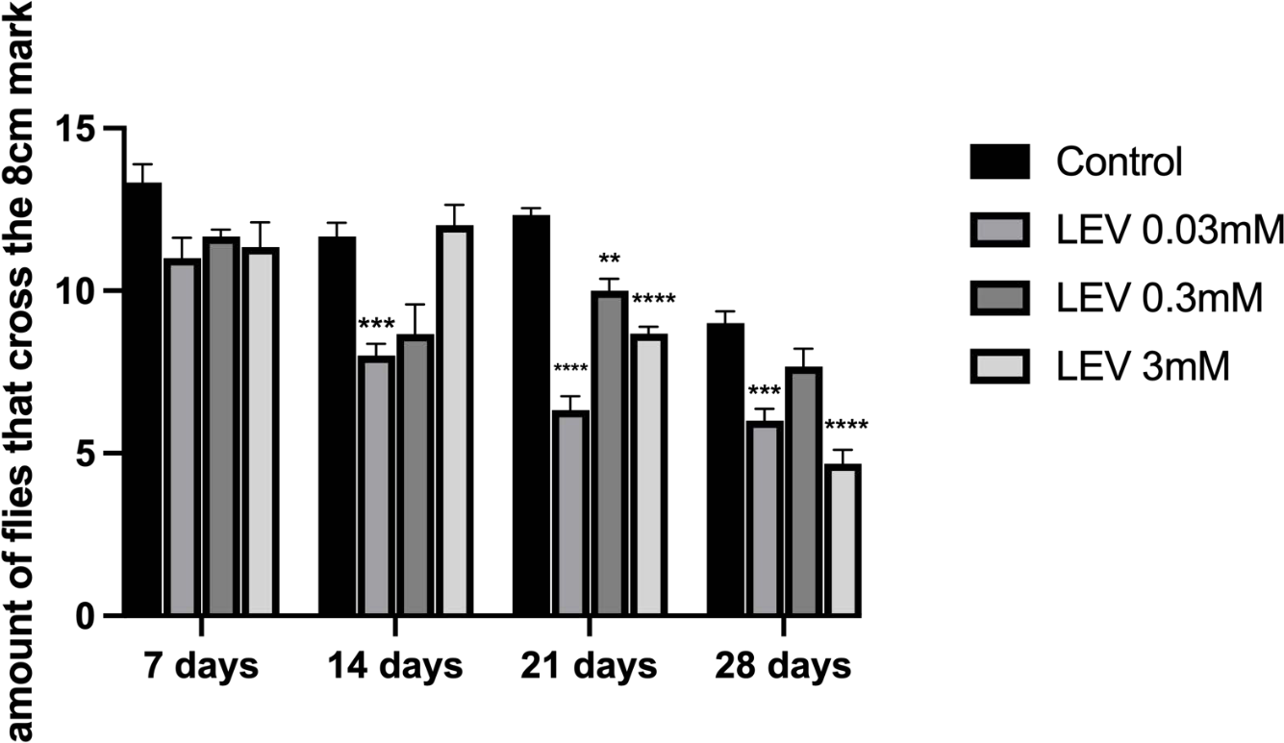
B
A
D
C
Figure 8A-D
Effect of LTG, CBZ, VPA, and LEV on Adult Negative Geotaxis (Climbing Ability) in Canton-S Strain Drosophila melanogaster (F2 Generation). Bars represent Mean ± SEM (n = 20). p < .05, **p < .01, ***p < .001, ****p < .0001 vs. Natural control.
Analysis by two-way ANOVA, followed by Tukey's multiple post hoc comparison test

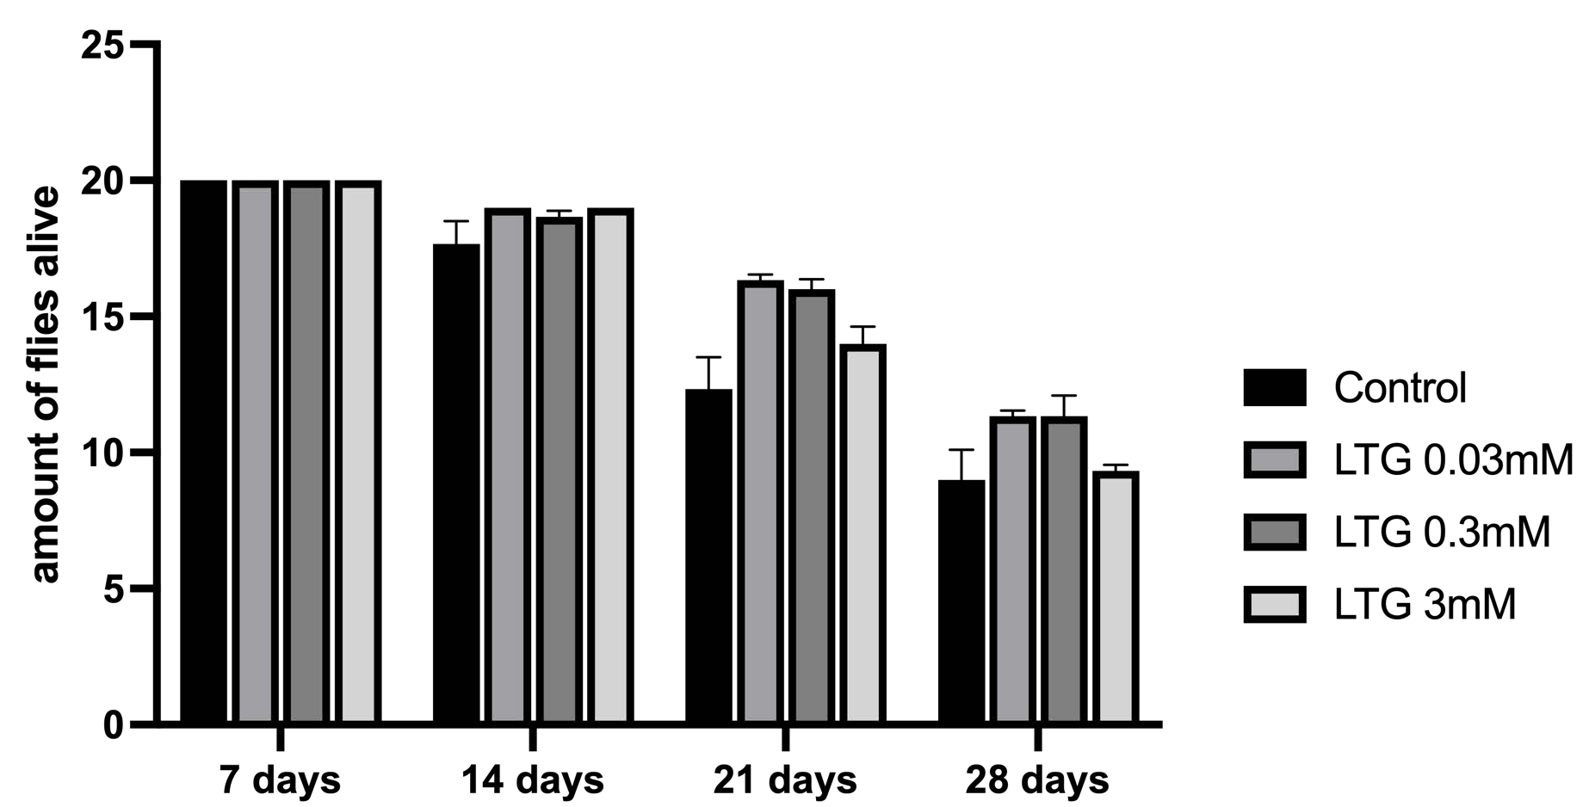
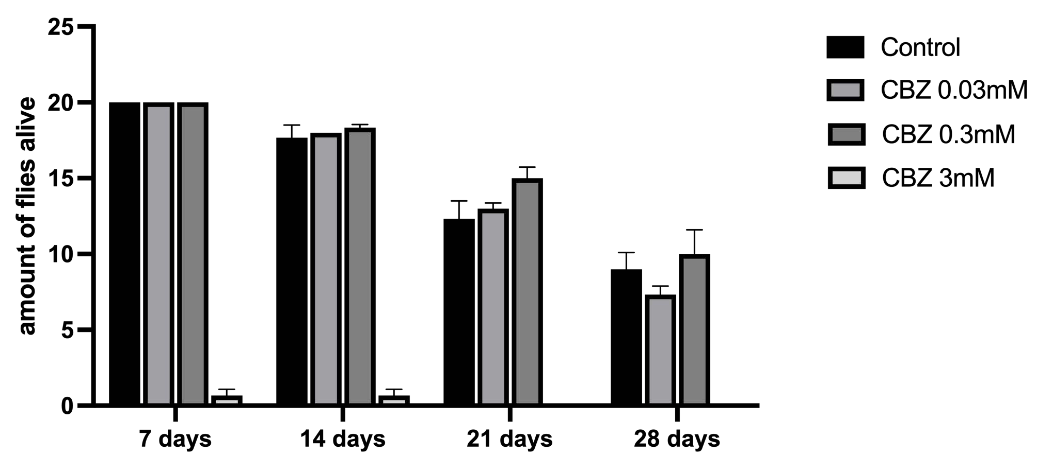
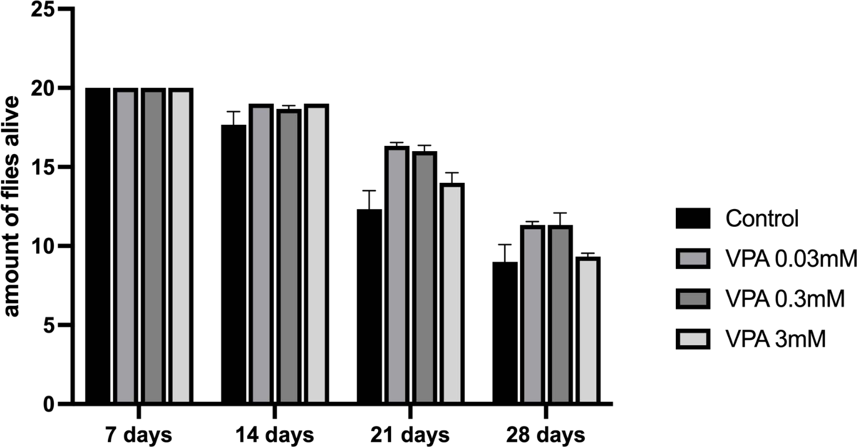
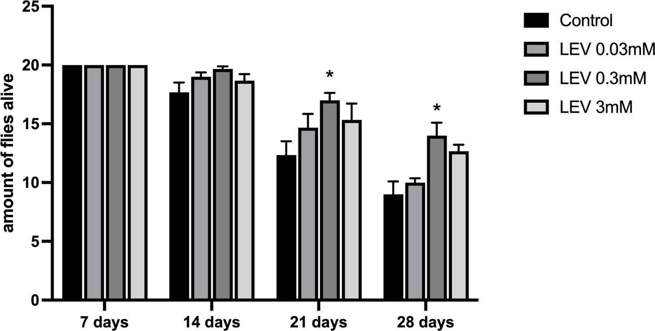
A
B
C
D
Figure 9A-D
Effect of LTG, CBZ, VPA, and LEV on Longevity in Canton-S Strain Drosophila melanogaster (F1 Generation).
Bars represent Mean ± SEM (n = 20). p < .05, **p < .01, ***p < .001, ****p < .0001 vs. Natural control. Analysis by two-way ANOVA, followed by Tukey's multiple post hoc comparison test

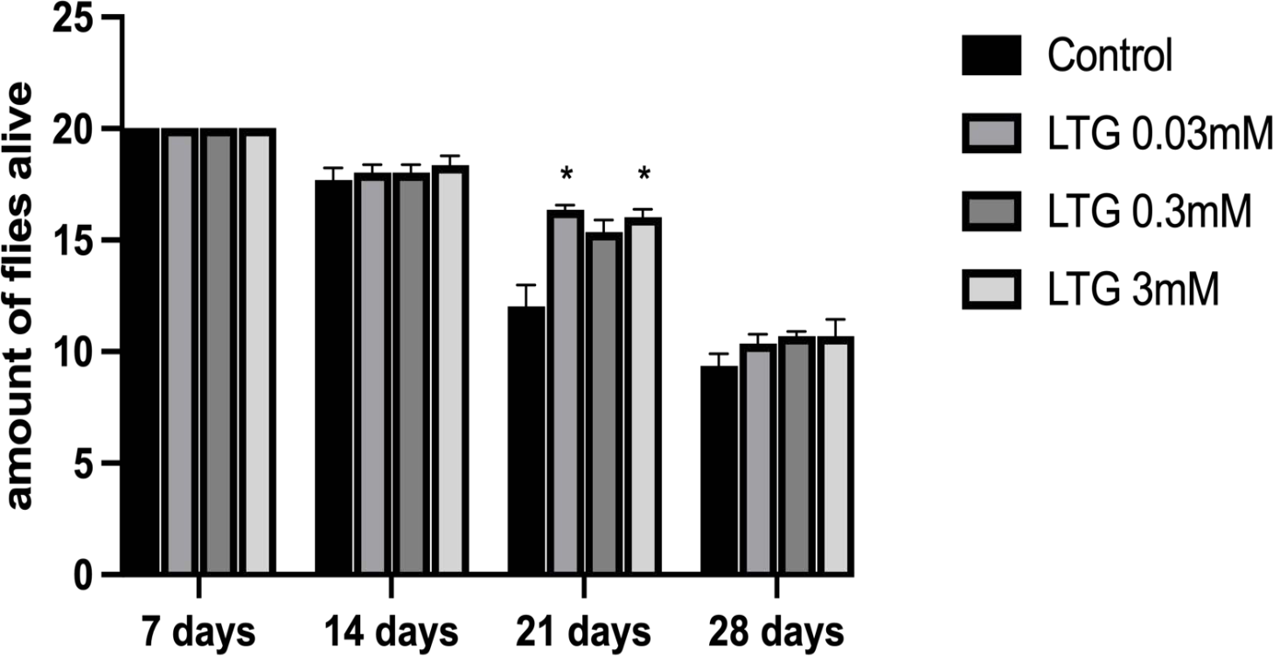
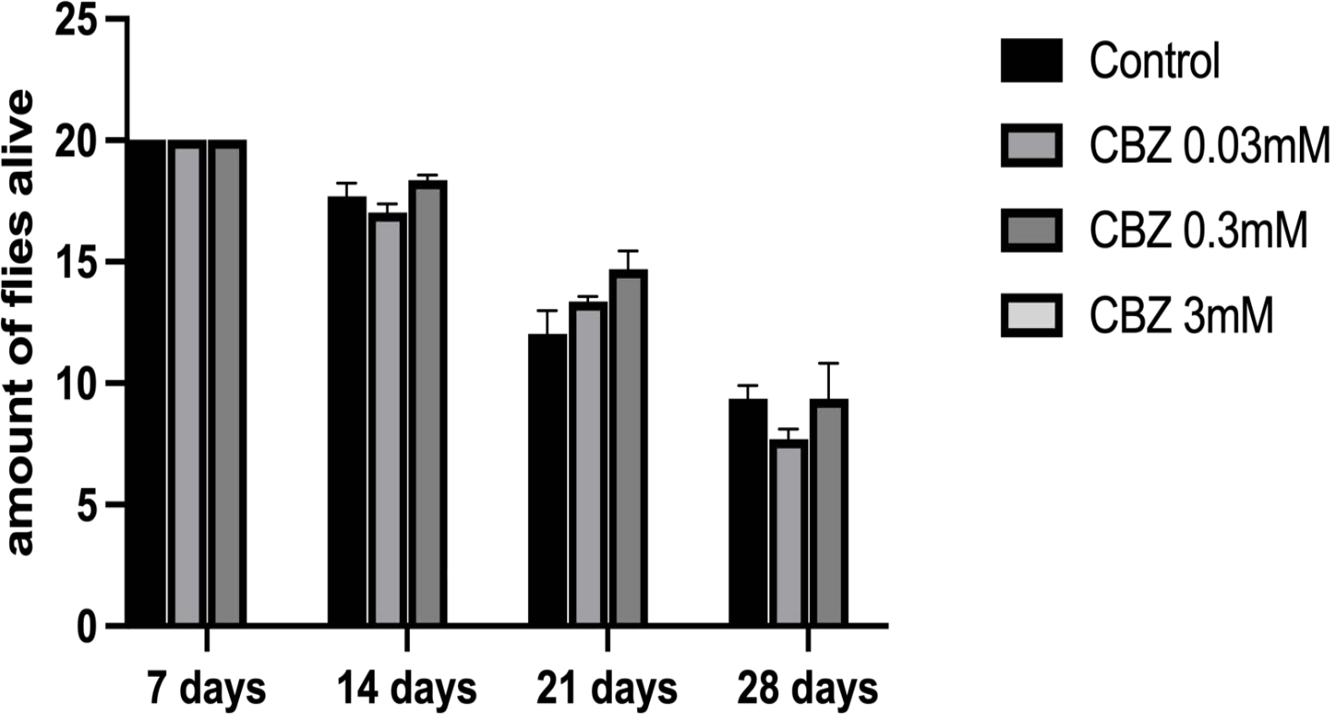
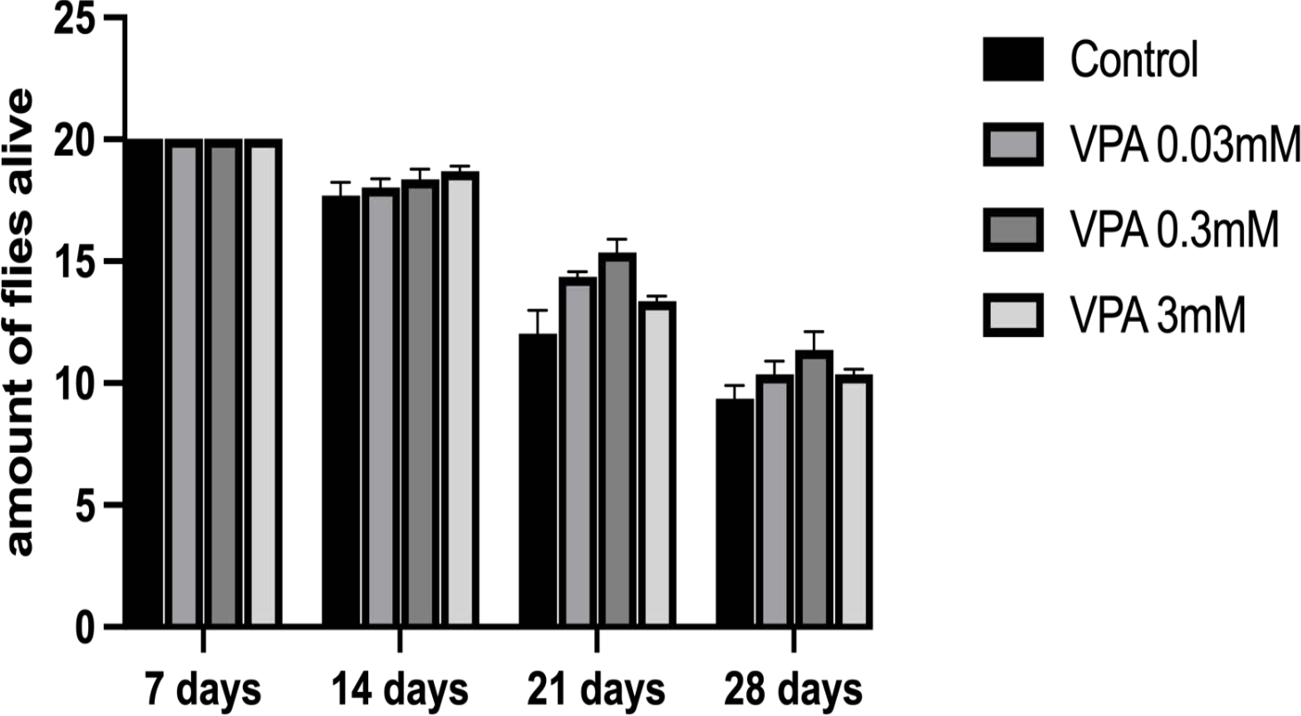
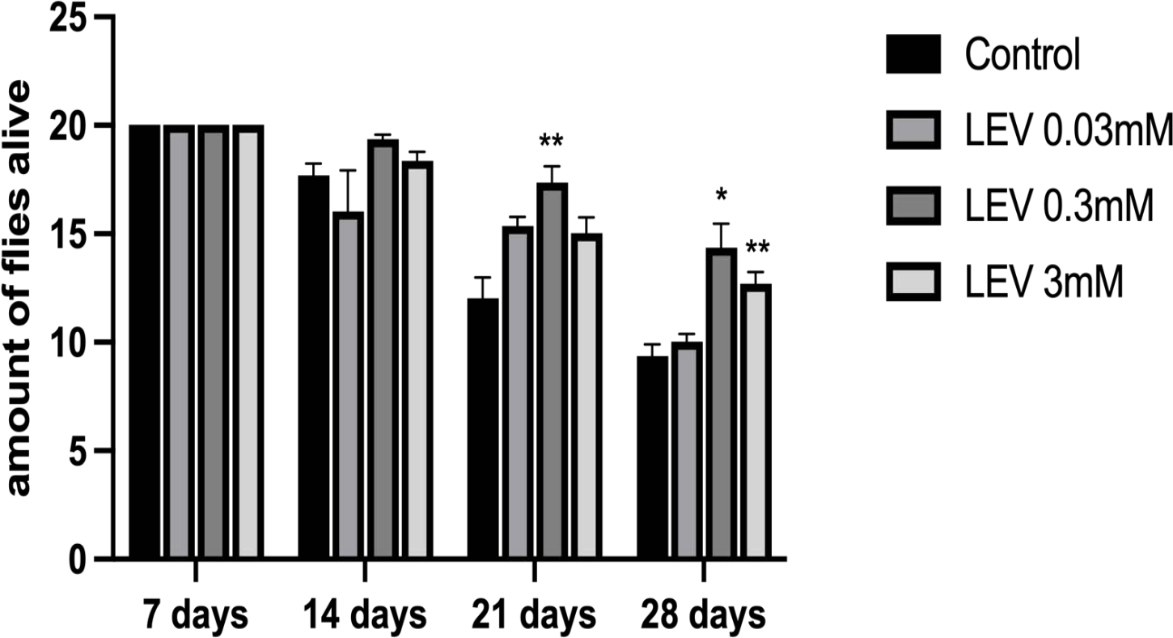
B
A
C
D
Figure 10A-D
Effect of LTG, CBZ, VPA, and LEV on Longevity in Canton-S Strain Drosophila melanogaster (F2 Generation).
Bars represent Mean ± SEM (n = 20). p < .05, **p < .01, ***p < .001, ****p < .0001 vs. Natural control. Analysis by two-way ANOVA, followed by Tukey's multiple post hoc comparison test

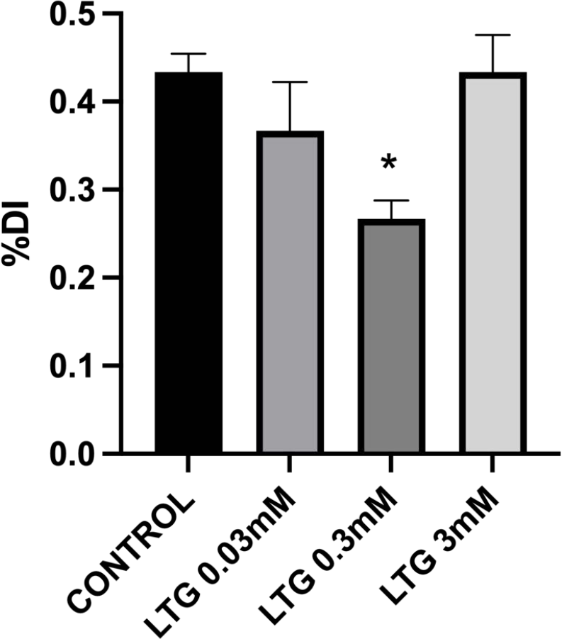
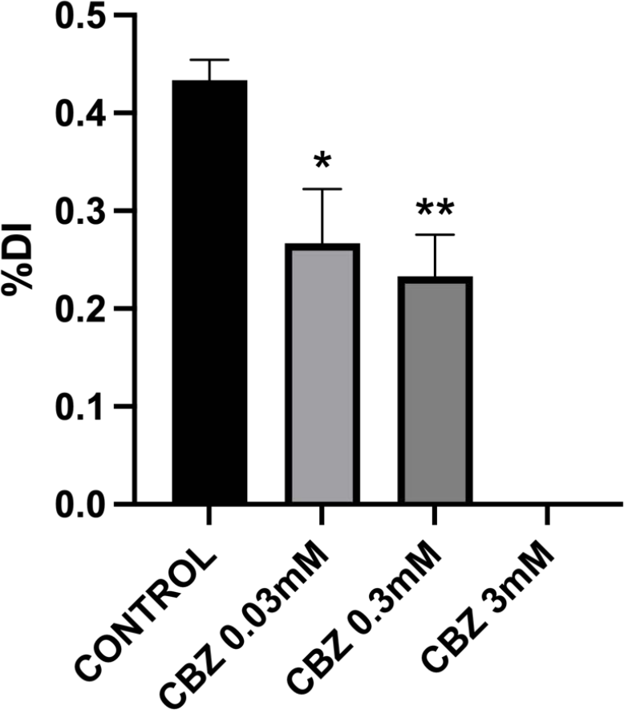
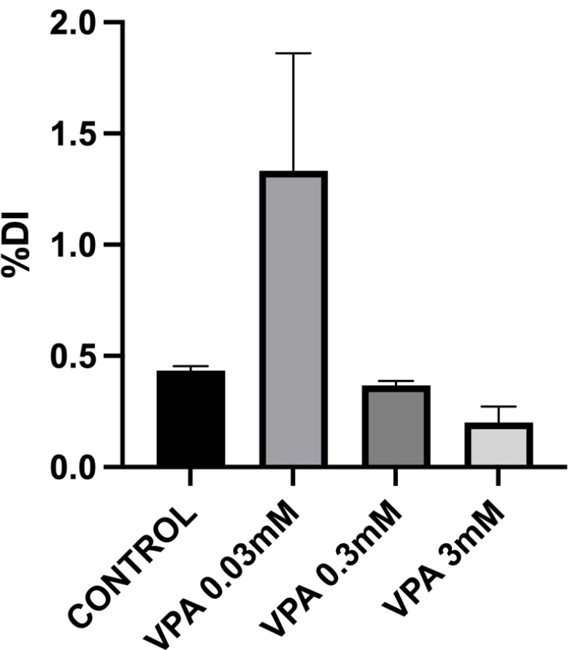
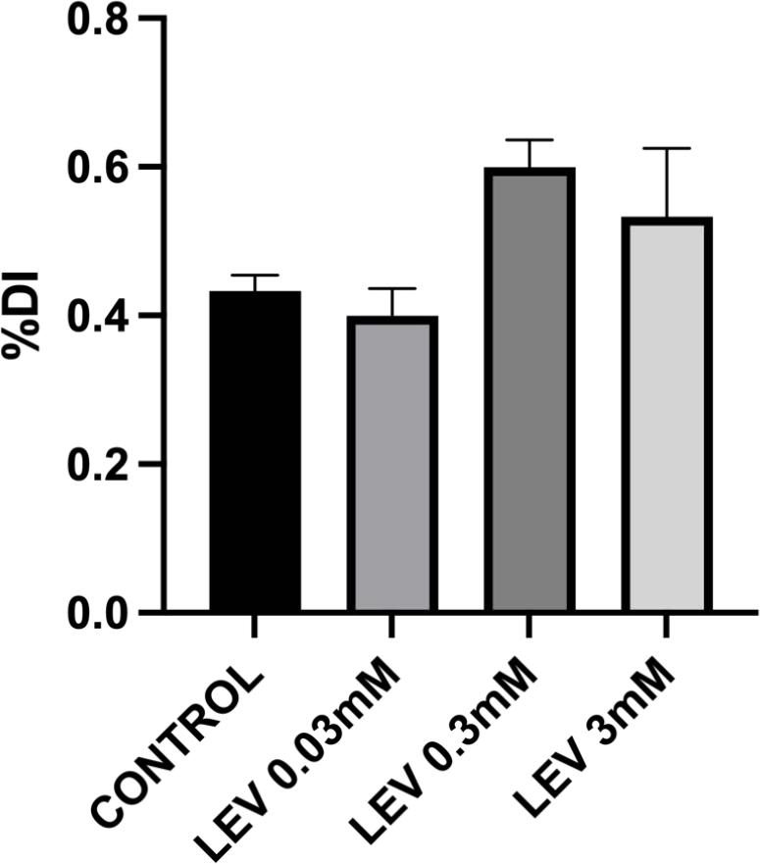
A
B
C
D
Figure 11A-D
Effect of LTG, CBZ, VPA, and LEV on Memory (Discrimination Index) in Canton-S Strain Drosophila melanogaster (F1 Generation).
Bars represent Mean ± SEM (n = 20). p < .05, **p < .01, ***p < .001, ****p < .0001 vs. Natural control. Analysis by one-way ANOVA, followed by Tukey's multiple post hoc comparison test

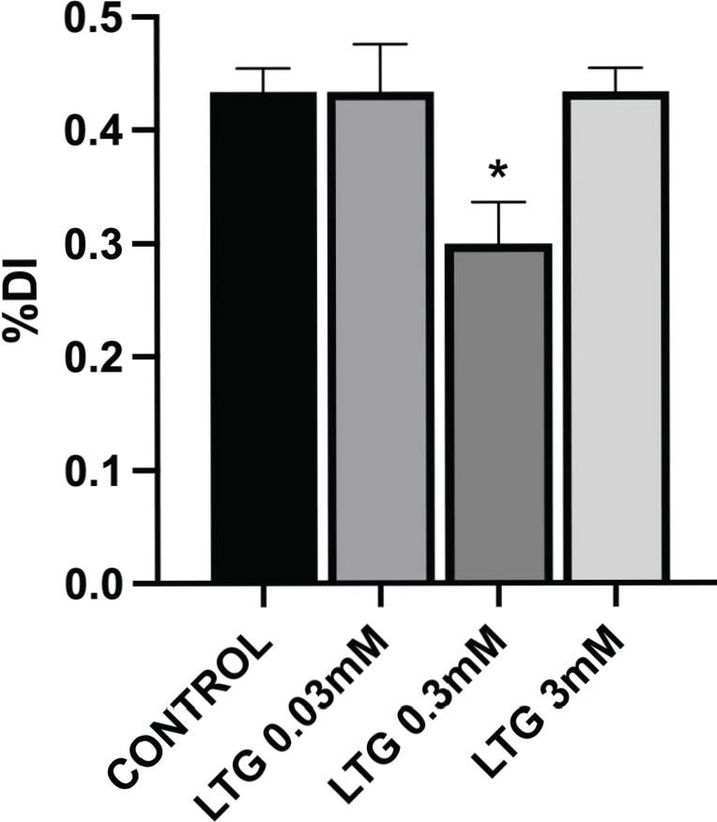
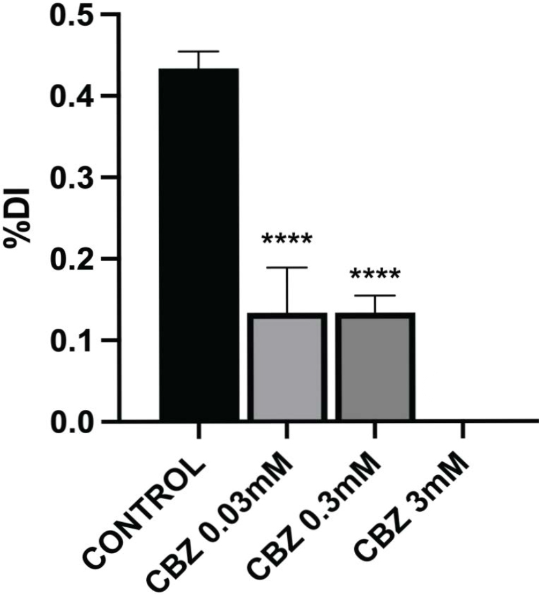
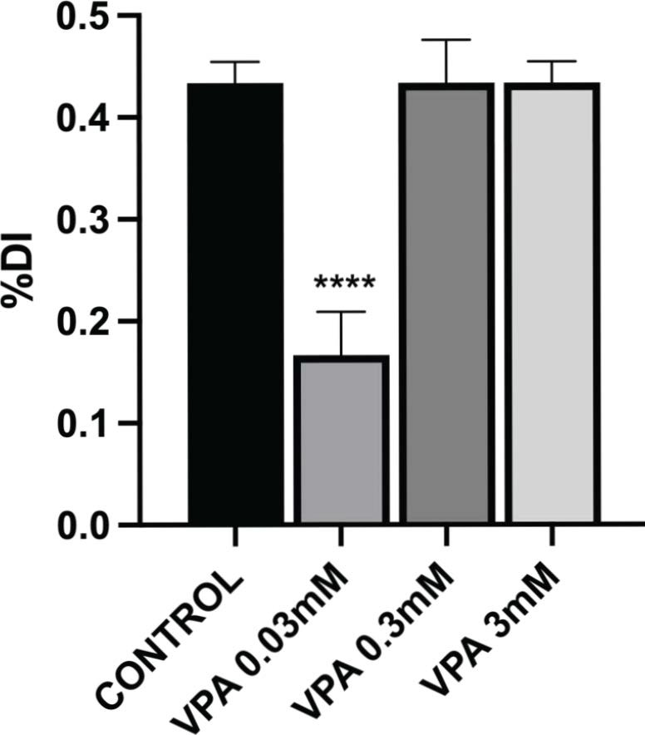
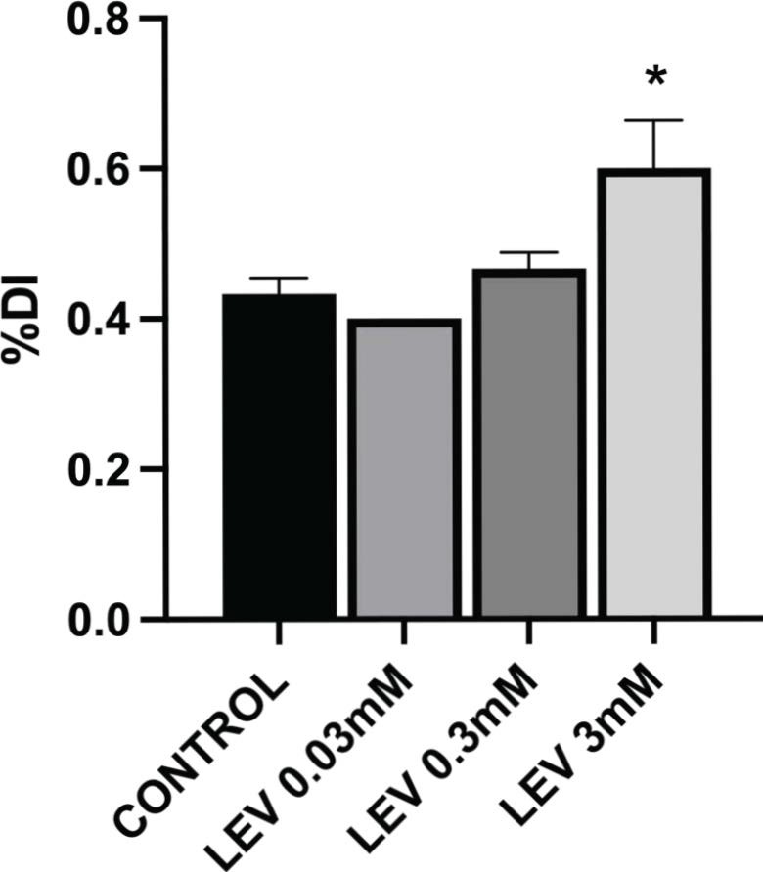
E
F
C
D
Figure 12A-D
Effect of LTG, CBZ, VPA, and LEV on Memory (Discrimination Index) in Canton-S Strain Drosophila melanogaster (F2 Generation).
Bars represent Mean ± SEM (n = 20). p < .05, **p < .01, ***p < .001, ****p < .0001 vs. Natural control. Analysis by one-way ANOVA, followed by Tukey's multiple post hoc comparison test

