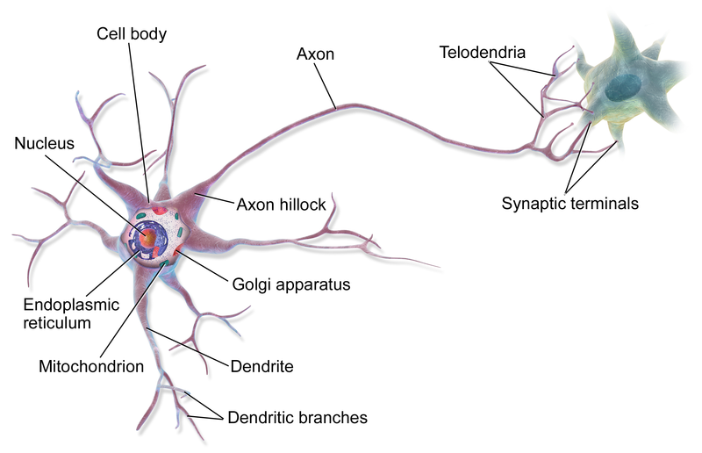

A **neuron**, **neurone**,[[1]](https://en.wikipedia.org/wiki/Neuron#cite_note-1) or **nerve cell** is an [excitable](https://en.wikipedia.org/wiki/Membrane_potential#Cell_excitability) [cell](https://en.wikipedia.org/wiki/Cell_(biology)) that fires electric signals called [action potentials](https://en.wikipedia.org/wiki/Action_potentials) across a [neural network](https://en.wikipedia.org/wiki/Neural_network_(biology)) in the [nervous system](https://en.wikipedia.org/wiki/Nervous_system). Neurons communicate with other cells via [synapses](https://en.wikipedia.org/wiki/Synapse), which are specialized connections that commonly use minute amounts of chemical [neurotransmitters](https://en.wikipedia.org/wiki/Neurotransmitter) to pass the electric signal from the presynaptic neuron to the target cell through the synaptic gap.

Neurons are the main components of [nervous tissue](https://en.wikipedia.org/wiki/Nervous_tissue) in all [animals](https://en.wikipedia.org/wiki/Animalia) except [sponges](https://en.wikipedia.org/wiki/Sponge) and [placozoans](https://en.wikipedia.org/wiki/Placozoans). [Plants](https://en.wikipedia.org/wiki/Plant) and [fungi](https://en.wikipedia.org/wiki/Fungi) do not have nerve cells. Molecular evidence suggests that the ability to generate electric signals first appeared in evolution some 700 to 800 million years ago, during the [Tonian](https://en.wikipedia.org/wiki/Tonian" \o "Tonian) period. Predecessors of neurons were the [peptidergic](https://en.wikipedia.org/wiki/Peptidergic" \o "Peptidergic) secretory cells. They eventually gained new gene modules which enabled cells to create post-synaptic scaffolds and ion channels that generate fast electrical signals. The ability to generate electric signals was a key innovation in the evolution of the nervous system.[[2]](https://en.wikipedia.org/wiki/Neuron#cite_note-2)

Neurons are typically classified into three types based on their function. [Sensory neurons](https://en.wikipedia.org/wiki/Sensory_neuron) respond to [stimuli](https://en.wikipedia.org/wiki/Stimulus_(physiology)) such as touch, sound, or light that affect the cells of the [sensory organs](https://en.wikipedia.org/wiki/Sense), and they send signals to the [spinal cord](https://en.wikipedia.org/wiki/Spinal_cord) or [brain](https://en.wikipedia.org/wiki/Brain). [Motor neurons](https://en.wikipedia.org/wiki/Motor_neuron) receive signals from the brain and spinal cord to control everything from [muscle contractions](https://en.wikipedia.org/wiki/Muscle_contraction)[[3]](https://en.wikipedia.org/wiki/Neuron#cite_note-3) to [glandular output](https://en.wikipedia.org/wiki/Gland). [Interneurons](https://en.wikipedia.org/wiki/Interneuron) connect neurons to other neurons within the same region of the brain or spinal cord. When multiple neurons are functionally connected together, they form what is called a [neural circuit](https://en.wikipedia.org/wiki/Neural_circuit).

A neuron contains all the structures of other cells such as a [nucleus](https://en.wikipedia.org/wiki/Cell_nucleus), [mitochondria](https://en.wikipedia.org/wiki/Mitochondria), and [Golgi bodies](https://en.wikipedia.org/wiki/Golgi_bodies) but has additional unique structures such as an [axon](https://en.wikipedia.org/wiki/Axon), and [dendrites](https://en.wikipedia.org/wiki/Dendrite).[[4]](https://en.wikipedia.org/wiki/Neuron#cite_note-Betts-4) The soma is a compact structure, and the axon and dendrites are filaments extruding from the soma. Dendrites typically branch profusely and extend a few hundred micrometers from the soma. The axon leaves the soma at a swelling called the [axon hillock](https://en.wikipedia.org/wiki/Axon_hillock) and travels for as far as 1 meter in humans or more in other species. It branches but usually maintains a constant diameter. At the farthest tip of the axon's branches are [axon terminals](https://en.wikipedia.org/wiki/Axon_terminals), where the neuron can transmit a signal across the [synapse](https://en.wikipedia.org/wiki/Synapse) to another cell. Neurons may lack dendrites or have no axon. The term [neurite](https://en.wikipedia.org/wiki/Neurite) is used to describe either a dendrite or an axon, particularly when the cell is [undifferentiated](https://en.wikipedia.org/wiki/Cellular_differentiation).

Most neurons receive signals via the dendrites and soma and send out signals down the axon. At the majority of synapses, signals cross from the axon of one neuron to a dendrite of another. However, synapses can connect an axon to another axon or a dendrite to another dendrite. The signaling process is partly electrical and partly chemical. Neurons are electrically excitable, due to maintenance of [voltage](https://en.wikipedia.org/wiki/Voltage) gradients across their [membranes](https://en.wikipedia.org/wiki/Cell_membrane). If the voltage changes by a large enough amount over a short interval, the neuron generates an [all-or-nothing](https://en.wikipedia.org/wiki/All-or-none_law) [electrochemical](https://en.wikipedia.org/wiki/Electrochemical) pulse called an [action potential](https://en.wikipedia.org/wiki/Action_potential). This potential travels rapidly along the axon and activates synaptic connections as it reaches them. Synaptic signals may be [excitatory](https://en.wikipedia.org/wiki/Excitatory_postsynaptic_potential) or [inhibitory](https://en.wikipedia.org/wiki/Inhibitory_postsynaptic_potential), increasing or reducing the net voltage that reaches the soma.

In most cases, neurons are generated by [neural stem cells](https://en.wikipedia.org/wiki/Neural_stem_cell) during brain development and childhood. [Neurogenesis](https://en.wikipedia.org/wiki/Neurogenesis) largely ceases during adulthood in most areas of the brain.