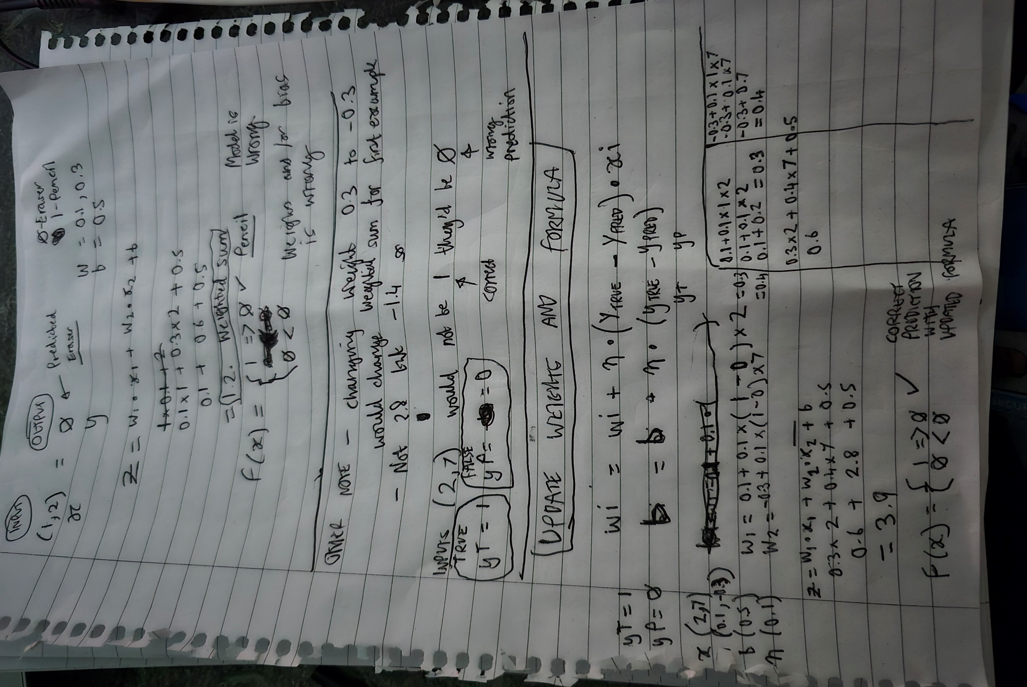

***Update - In the last section title UPDATE WEIGHTS AND FORMULA there is an error.***

***The bias value b is still using the original value of 0.5 and hasn’t had the new formula applied. So therefore the calculation as a whole is wrong.***

*Calculate weight and bias*

weight = wi + n * (yT - yP) * xi

bias = b + n * (yT – yP)

*So…*

w1 = 0.1 + 0.1 * (1 – 0) * 2 = 0.3

w2 = -0.3 + 0.1 * (1 – 0) * 7 = 0.4

b = 0.5 + 0.1 * (1 – 0) = 0.6

*Then apply new weights and bias to training the model*

Z = w1 * x1 + w2 * x2 + b

Z = 0.3 * 2 + 0.4 * 7 + 0.6

Z = 0.6 + 2.8 + 0.6

Z = 4

F(x) = 1 => 0 or 0 < 0

**F(4) = 1**