In machine learning, the perceptron (or McCulloch–Pitts neuron) is an algorithm for supervised learning of binary classifiers. A binary classifier is a function which can decide whether or not an input, represented by a vector of numbers, belongs to some specific class.^{[1]} It is a type of linear classifier, i.e. a classification algorithm that makes its predictions based on a linear predictor function combining a set of weights with the feature vector.

History
[edit]
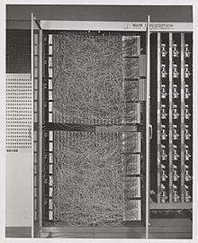Mark I Perceptron machine, the first implementation of the perceptron algorithm. It was connected to a camera with 20×20 cadmium sulfide photocells to make a 400-pixel image. The main visible feature is the sensory-to-association plugboard, which sets different combinations of input features. To the right are arrays of potentiometers that implemented the adaptive weights.^{[2]: 213}
See also: History of artificial intelligence § Perceptrons
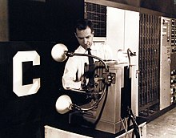The Mark 1 Perceptron, being adjusted by Charles Wightman (Mark I Perceptron project engineer).^{[3]} Sensory units at left, association units in center, and control panel and response units at far right. The sensory-to-association plugboard is behind the closed panel to the right of the operator. The letter "C" on the front panel is a display of the current state of the sensory input.^{[4]}
The perceptron was invented in 1943 by Warren McCulloch and Walter Pitts.^{[5]} The first hardware implementation was Mark I Perceptron machine built in 1957 at the Cornell Aeronautical Laboratory by Frank Rosenblatt,^{[6]} funded by the Information Systems Branch of the United States Office of Naval Research and the Rome Air Development Center. It was first publicly demonstrated on 23 June 1960.^{[7]} The machine was "part of a previously secret four-year NPIC [the US' National Photographic Interpretation Center] effort from 1963 through 1966 to develop this algorithm into a useful tool for photo-interpreters".^{[8]}
Rosenblatt described the details of the perceptron in a 1958 paper.^{[9]} His organization of a perceptron is constructed of three kinds of cells ("units"): AI, AII, R, which stand for "projection", "association" and "response".
Rosenblatt's project was funded under Contract Nonr-401(40) "Cognitive Systems Research Program", which lasted from 1959 to 1970,^{[10]} and Contract Nonr-2381(00) "Project PARA" ("PARA" means "Perceiving and Recognition Automata"), which lasted from 1957^{[6]} to 1963.^{[11]}
