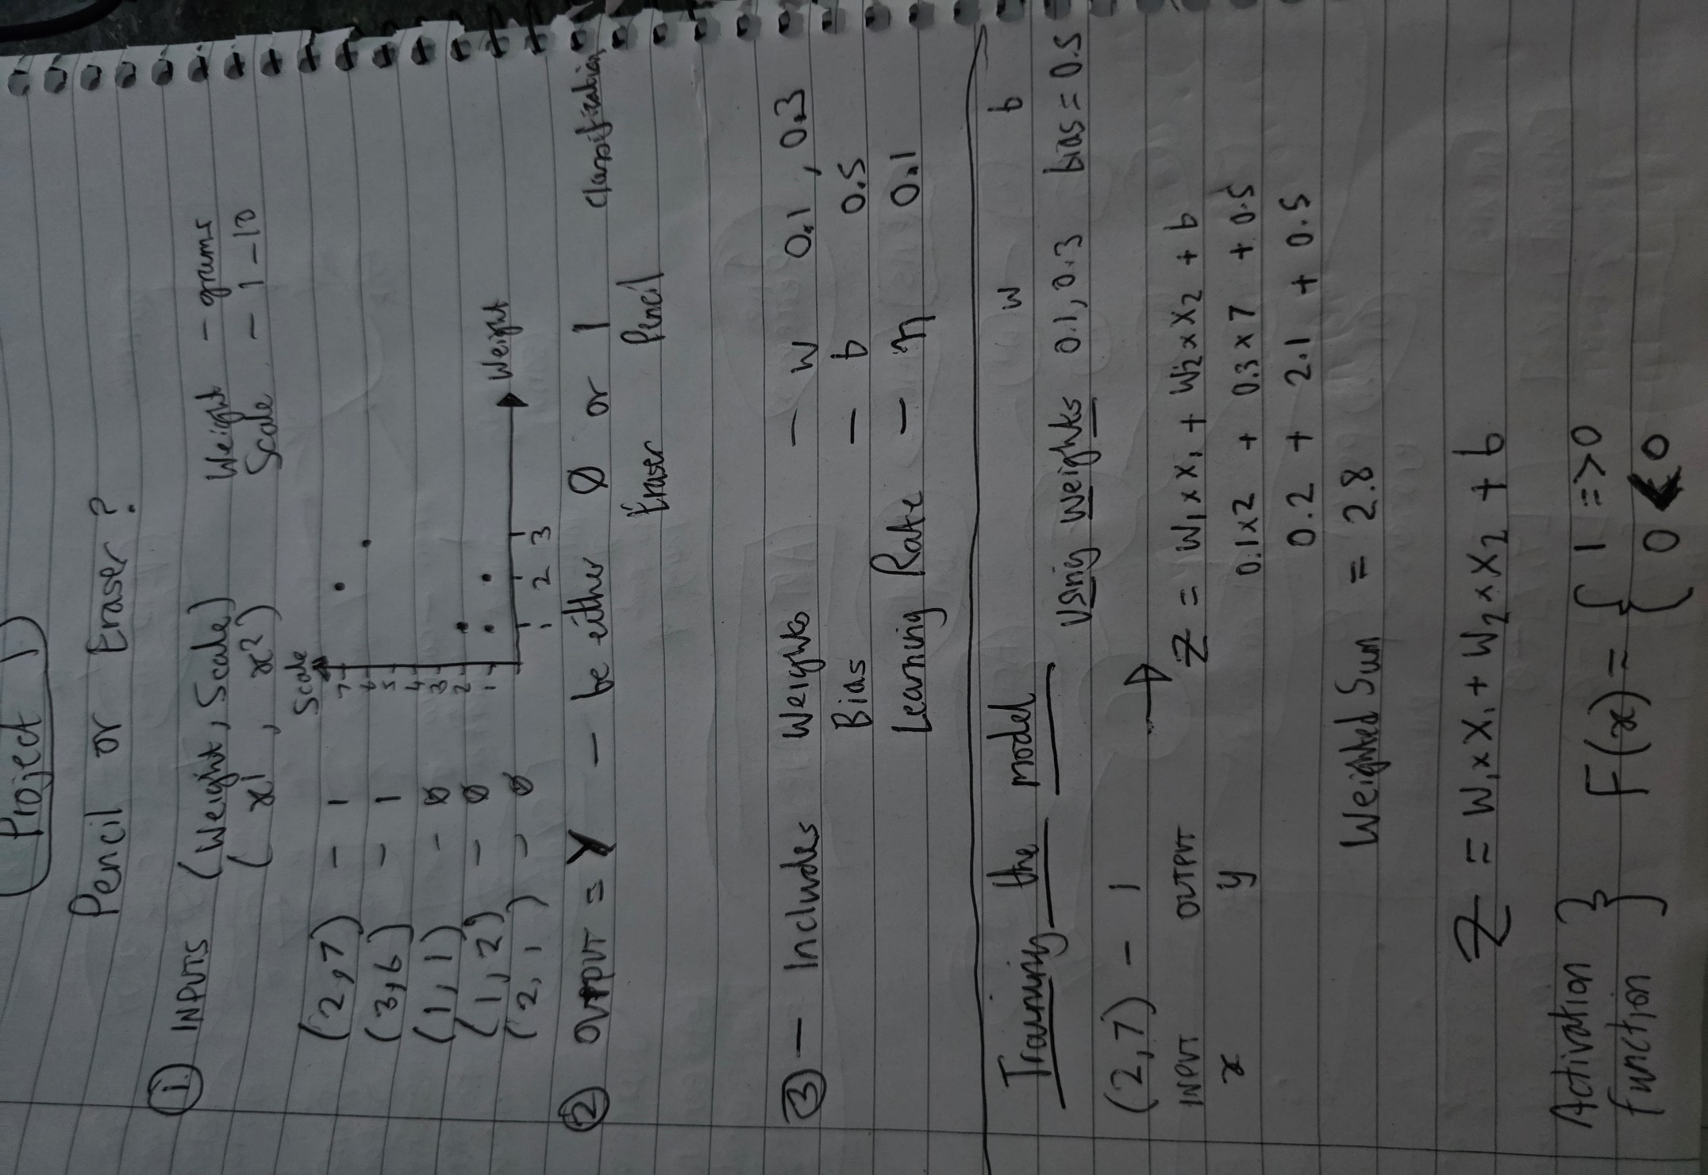
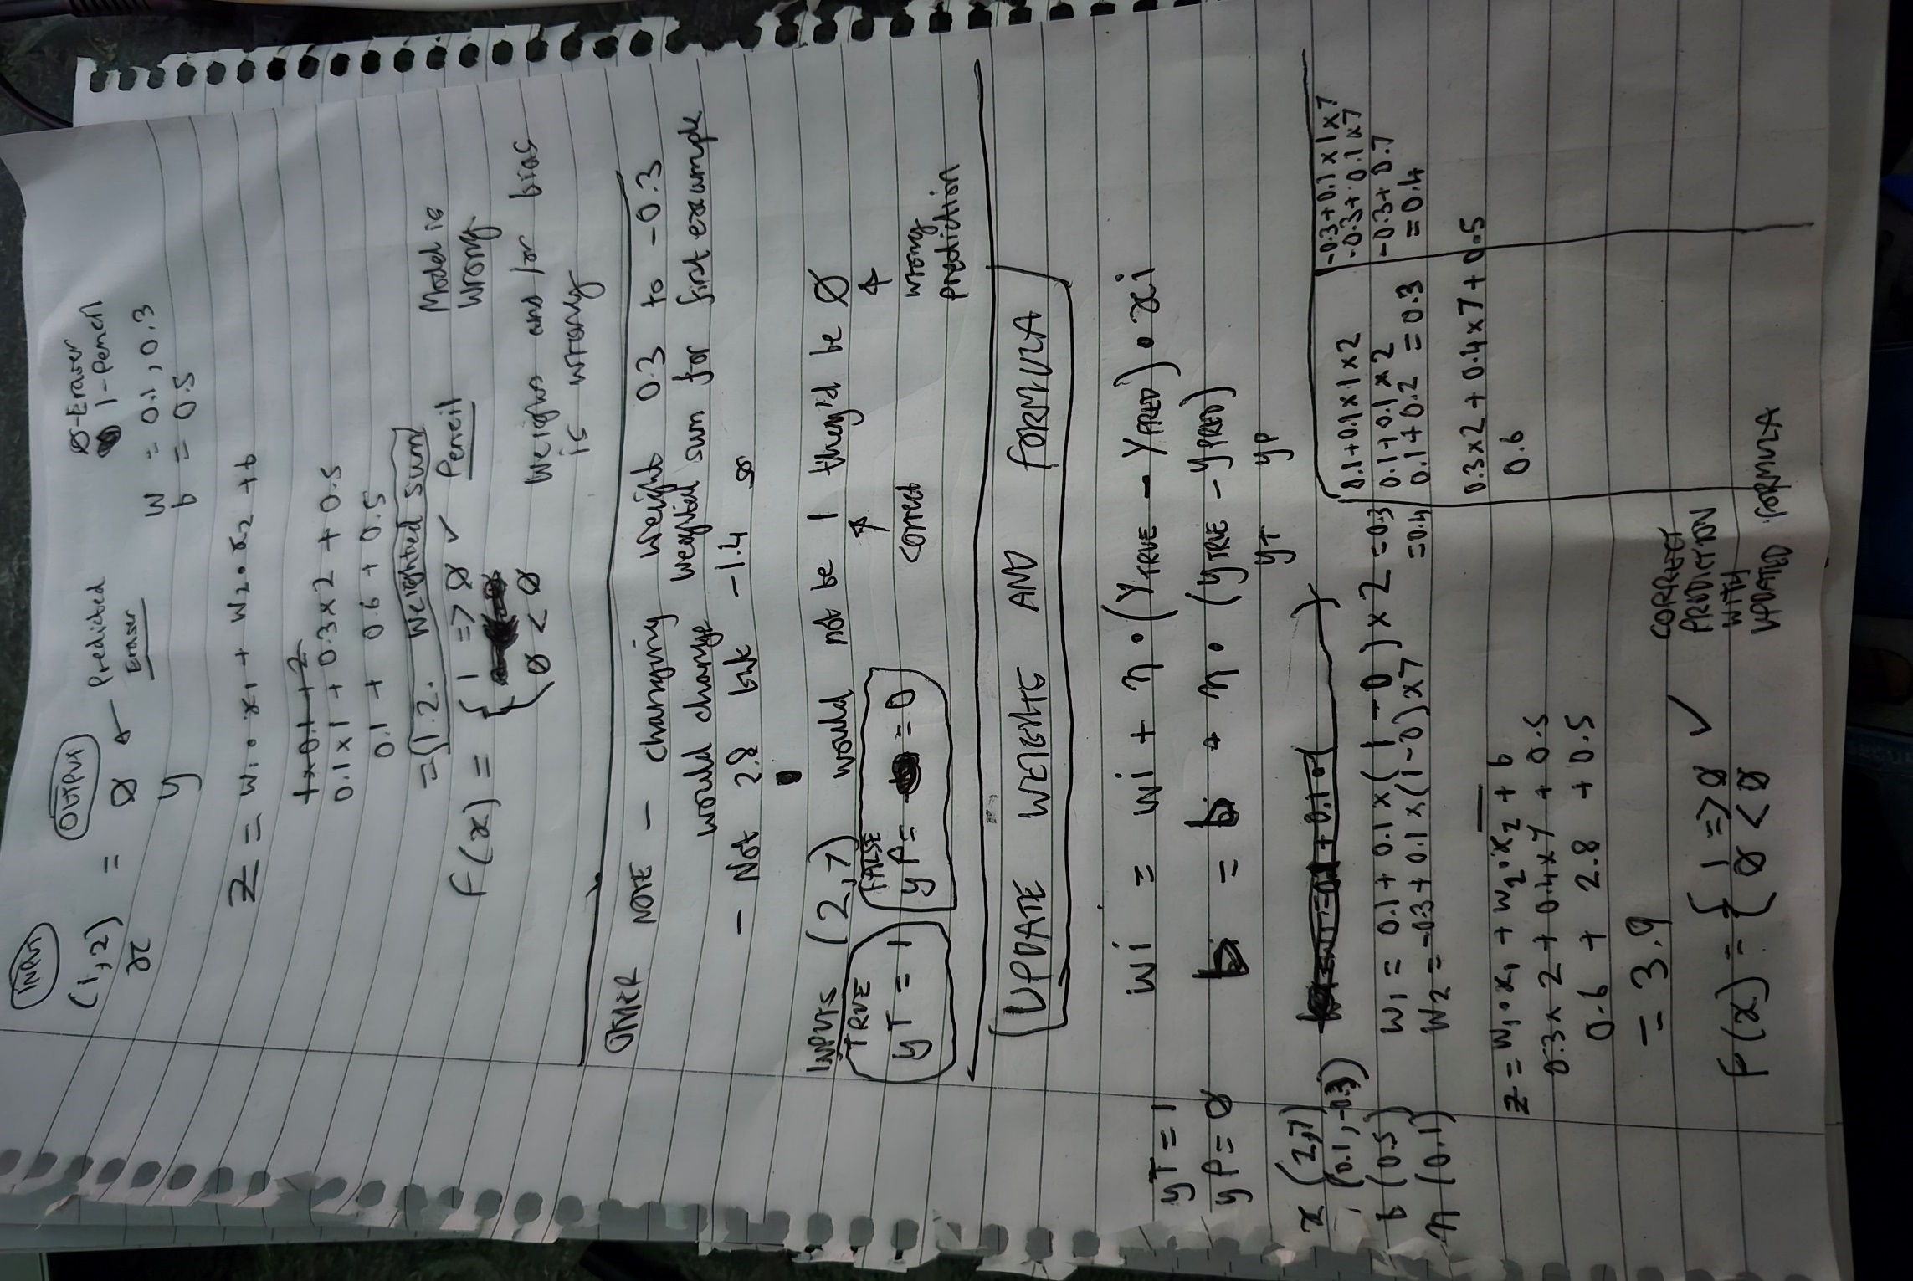
Update - In the last section title UPDATE WEIGHTS AND FORMULA there is an error.
The bias value b is still using the original value of 0.5 and hasn’t had the new formula applied. So therefore the calculation as a whole is wrong.

Calculate weight and bias

weight = wi + n * (yT - yP) * xi
bias = b + n * (yT – yP)

So…

w1 = 0.1 + 0.1 * (1 – 0) * 2 = 0.3
w2 = -0.3 + 0.1 * (1 – 0) * 7 = 0.4

b = 0.5 + 0.1 * (1 – 0) = 0.6

Then apply new weights and bias to training the model

Z = w1 * x1 + w2 * x2 + b
Z = 0.3 * 2 + 0.4 * 7 + 0.6
Z = 0.6 + 2.8 + 0.6
Z = 4

F(x) = 1 => 0 || 0 < 0
F(4) = 1

Put into Code

Using weights [0.1, -0.3] and bias [0.5] for all inputs…

const trainInputs = [
[2, 7],
[3, 6],
[1, 1],
[1, 2],
[2, 1],
]

const trainLabels = [1, 1, 0, 0, 0]

class Perceptron {
constructor(learningRate = 0.1) {
this.weights = [0.1, -0.3] // unmodified weights
this.bias = 0.5 // unmodified bias
this.learningRate = learningRate
}
train(trainData) {
for (let i = 0; i < trainData.length; i++) {
let sum = this.bias
let inputs = trainData[i]
for (let j = 0; j < inputs.length; j++) {
sum += inputs[j] * this.weights[j]
}
console.log(sum)
}
}
}

const perceptron = new Perceptron()
perceptron.train(trainInputs)

Outputs

-1.4000000000000001
-0.9999999999999998
0.3
0
0.39999999999999997

Using weights [0.1, 0.3] and bias [0.5] for all inputs…

const trainInputs = [
[2, 7],
[3, 6],
[1, 1],
[1, 2],
[2, 1],
]

const trainLabels = [1, 1, 0, 0, 0]

class Perceptron {
constructor(learningRate = 0.1) {
this.weights = [0.1, 0.3] // unmodified weights
this.bias = 0.5 // unmodified bias
this.learningRate = learningRate
}
train(trainData) {
for (let i = 0; i < trainData.length; i++) {
let sum = this.bias
let inputs = trainData[i]
for (let j = 0; j < inputs.length; j++) {
sum += inputs[j] * this.weights[j]
}
console.log(sum)
}
}
}

const perceptron = new Perceptron()
perceptron.train(trainInputs)

Outputs

2.8
2.5999999999999996
0.8999999999999999
1.2
1

Using modified formula - weights [0.3, 0.4] and bias [0.6] for all inputs…

const trainLabels = [1, 1, 0, 0, 0]

class Perceptron {
constructor(learningRate = 0.1) {
this.weights = [0.3, 0.4] // modified weights
this.bias = 0.6 // modified bias
this.learningRate = learningRate
}
train(trainData) {
for (let i = 0; i < trainData.length; i++) {
let sum = this.bias
let inputs = trainData[i]
for (let j = 0; j < inputs.length; j++) {
sum += inputs[j] * this.weights[j]
}
console.log(sum)
}
}
}

const perceptron = new Perceptron()
perceptron.train(trainInputs)

Outputs – modified formula

4
3.9000000000000004
1.2999999999999998
1.7
1.6

Note – the last three were predicted to be less than 0 – They are not. So the model needs to be modified again.

