Team 9 : MILESTONE 2 REPORT
Model chosen:
- Model A: Data-Efficient ViT (DeiT-Tiny)
  - Architecture: deit_tiny_patch16_224
  - Trained Model Filename:
    - Our dataset: deit_tiny_patch16_224_best_our.pth
    - Pooled dataset: deit_tiny_patch16_224_best_our.pth
- Model B: Standard Vision Transformer (ViT-Tiny)
  - Architecture: vit_tiny_patch16_224
  - Trained Model Filename:
    - Our dataset: vit_tiny_patch16_224_best_pooled.pth
    - Pooled dataset: vit_tiny_patch16_224_best_pooled.pth
Rationale behind these 2 models: These are small enough to fine tune on limited GPU and data resources
Fine tuning done:
- Replaced the classifier head (final layer) to output 10 classes (that we have chosen for our dataset) instead of 1000 ImageNet classes
- Allowed all transformer layers to update during training

For our dataset:
Training and Validation curves

Model A:
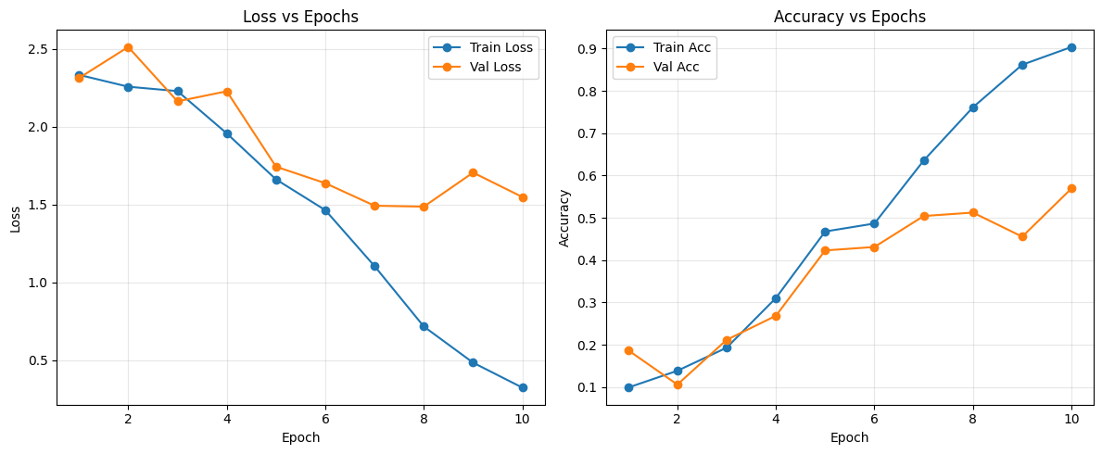
- It learns useful class features, as shown by dropping losses and rising accuracies
- The widening train-val gap implies moderate overfitting – expected with small datasets and full fine–tuning of all transformers
- Flattening after epoch 7 – 8 indicates model reached it’s learning limits
- Model is learning meaningful patterns but begins to slightly overfit after mid-training
Model B:
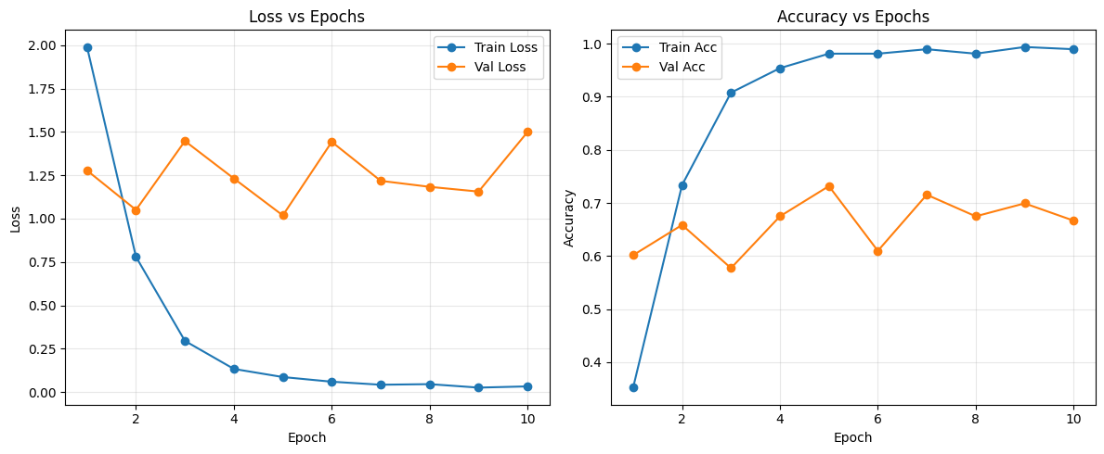
- It tunes much faster
- The training validation gap shows overfitting likely because all transformer layers were unfrozen and dataset is small
Model A vs Model B (F1 score)
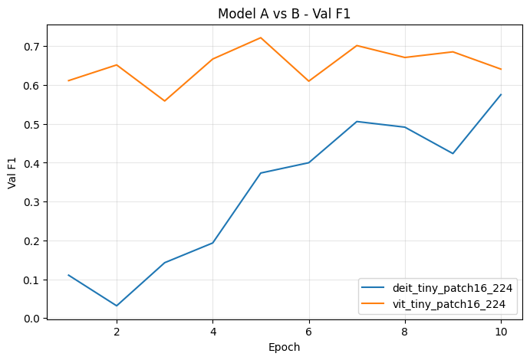
- As model B consistently achieves higher F1 than Model A, it adapts faster and maintains better generalization to validation data
- Model B curve is relatively stable and it indicates good convergence and less overfitting
Per class F1:
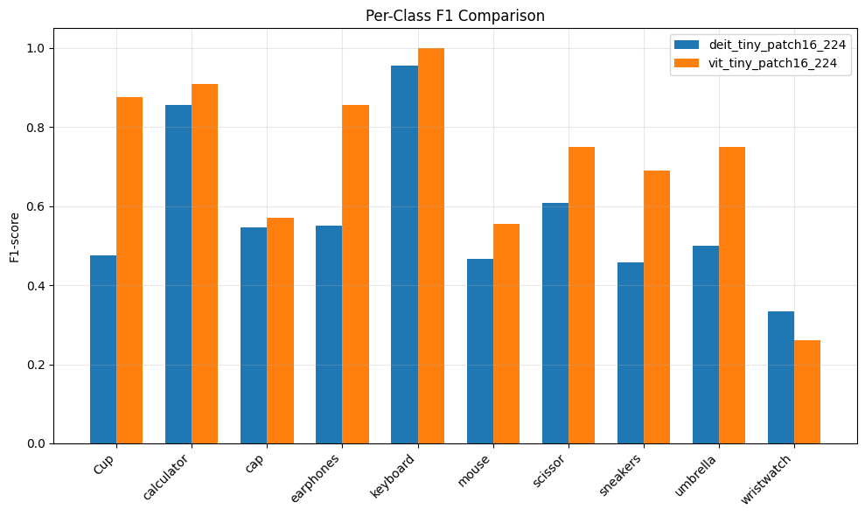
- Higher F1 for particular class implies that the model predicts that class well
Confusion matrix for Model A
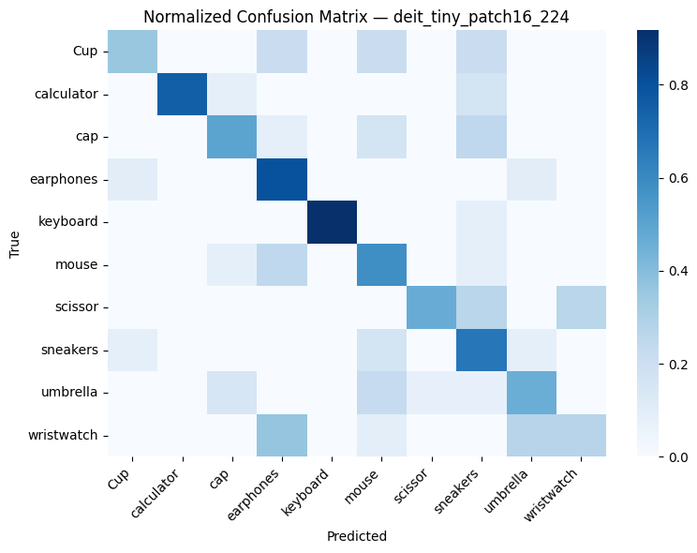

Confusion matrix for Model B
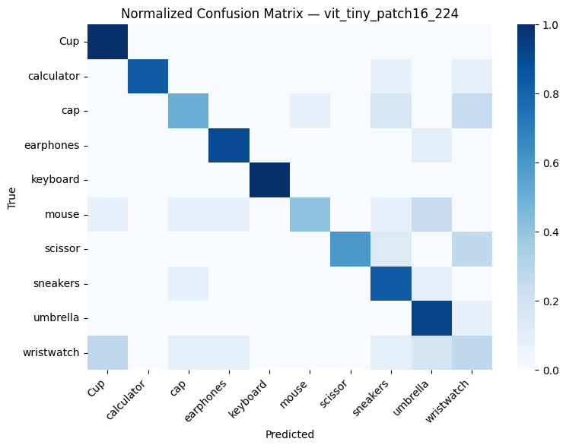

Improvement from model A to Model B on class prediction
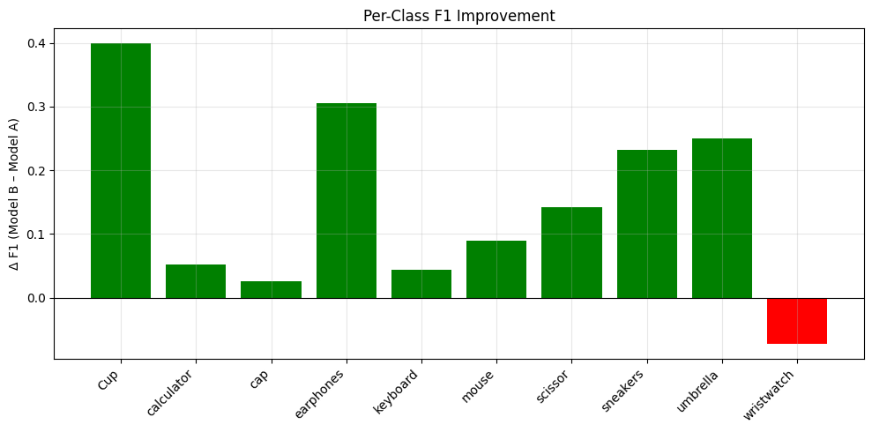

For Pooled Dataset:
Training and Validation curves
Model A
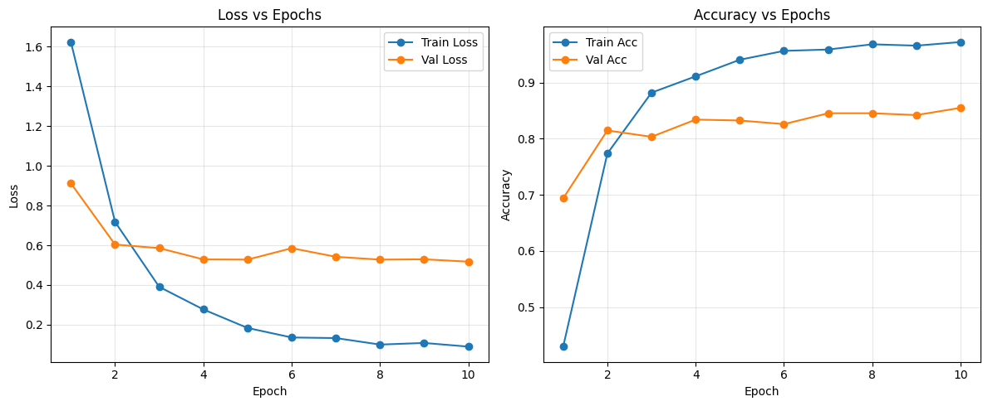
- It learns effectively and within few epochs
- Consistent train-val gap indicates model fits well without memorization
- Validation accuracy of around 0.8 indicates strong generalization

Model B
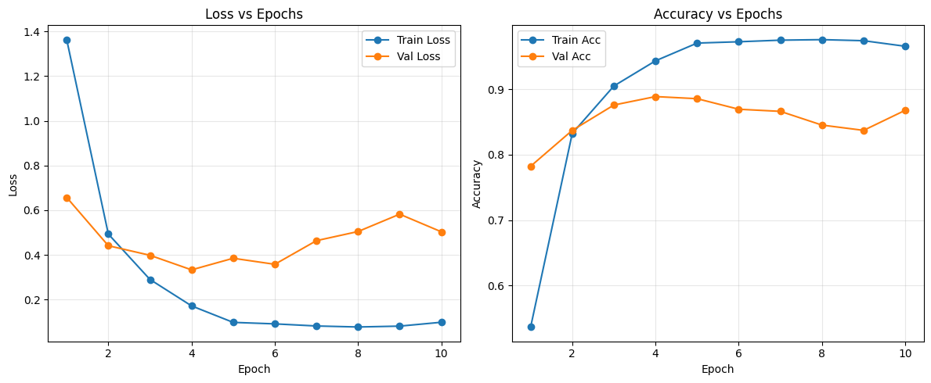
- Validation loss decreases initially but rises after, this suggests mild overfitting in later epochs
- Early stopping (around 6 epochs) might give better model
- Validation accuracy is around 88 to 90%
- It converges faster than model A

Model A vs Model B (F1 value)
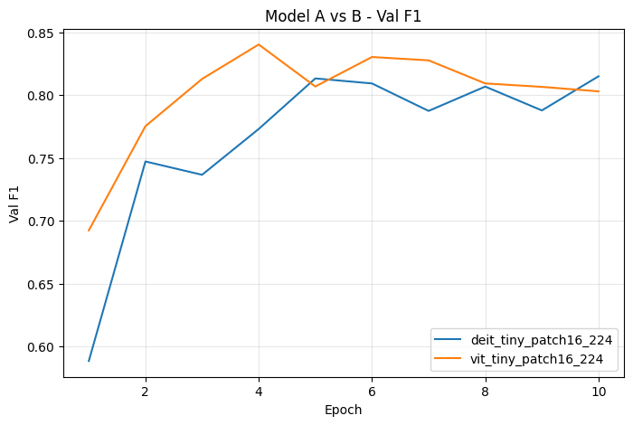
- Both models generalize well enough
- Model B converges faster than Model A
- Overall Model B performs slightly better
Per class F1 score
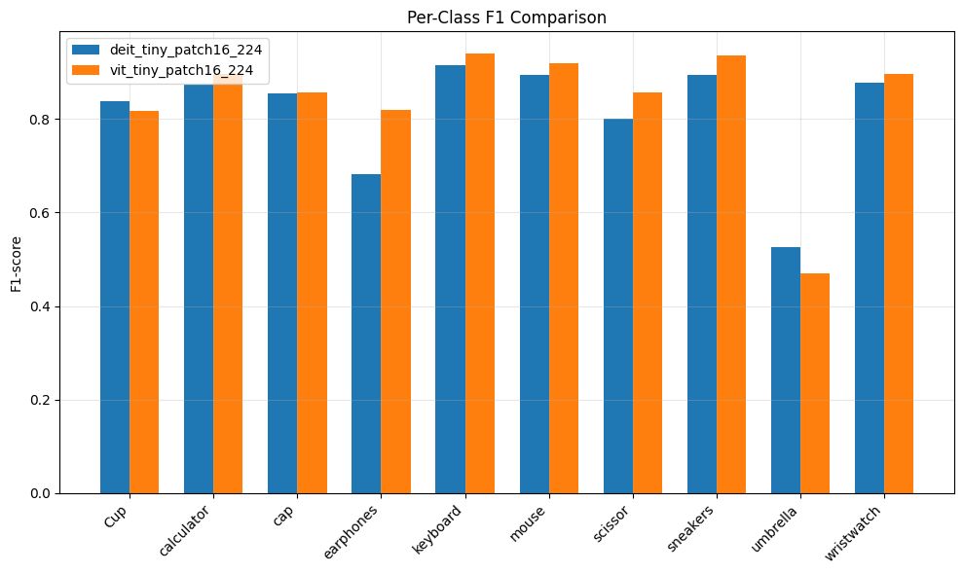
- Model B shows superior generalization across varied object types
- Model A performs better in rare class i.e umbrella
Confusion matrix for Model A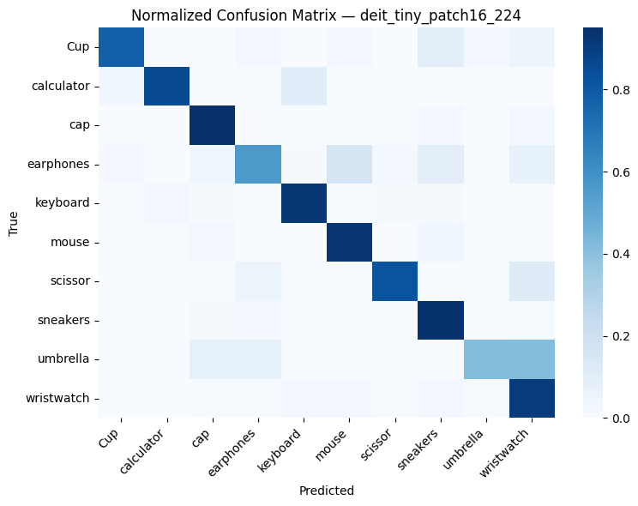
Confusion matrix for Model B
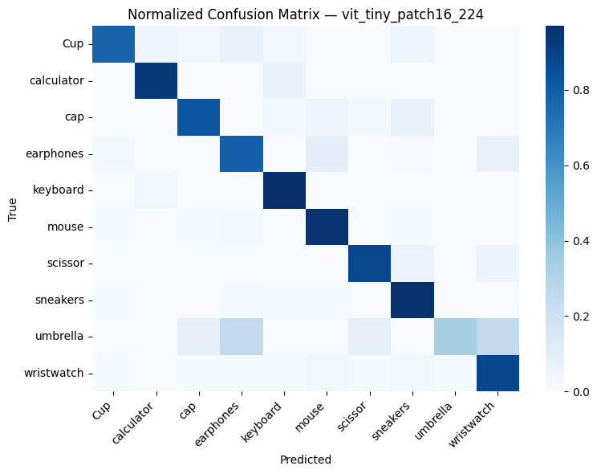

Improvement from Model A to Model B
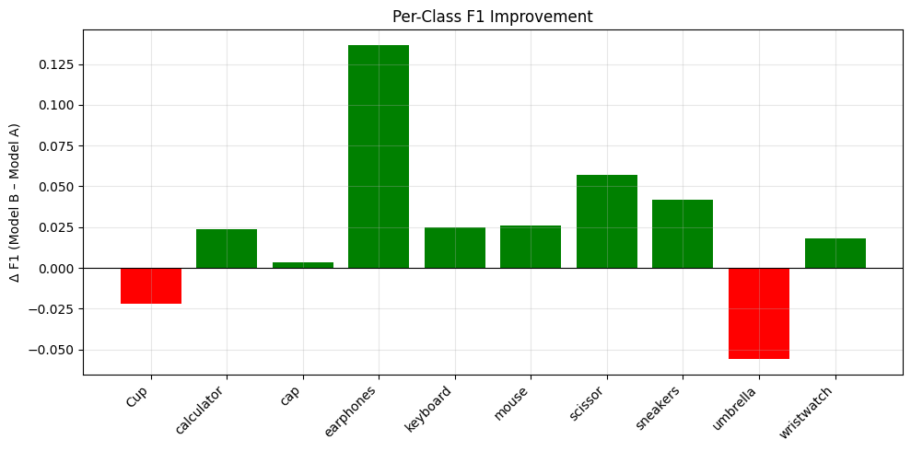

Insights from ‘Our Dataset’ vs ‘Pooled Dataset:
- On larger dataset, both model’s performance is almost similar
- Model A gets trained better on Pooled dataset as it was larger
- Pooled dataset has slight F1 gain
- Pooled dataset sees better generalization
- Pooled dataset per class stability is more balanced
- Model B has advantages in both datasets
Visual examples using Model B trained on ‘Our Dataset’ and image retrieval from ‘Pooled dataset’
For more refer notebook, vit_tiny_inference.ipynb
Misclassifications:
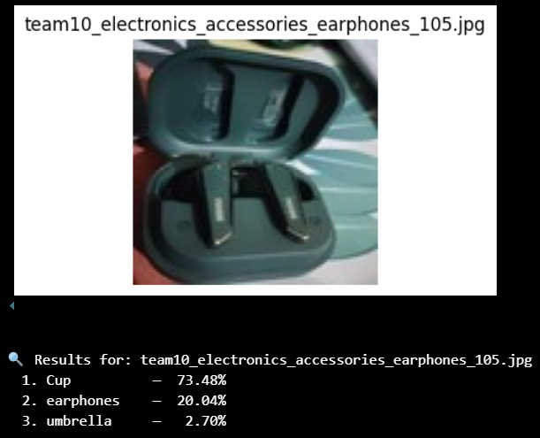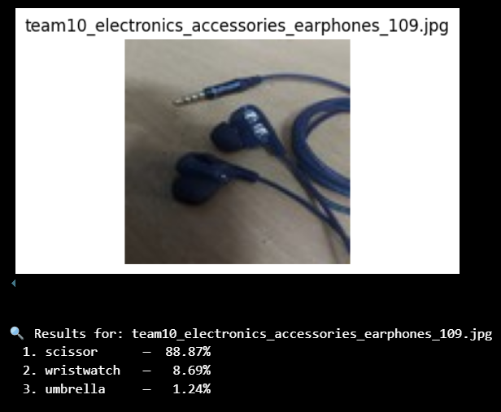
Maybe because the outline looks like cup Maybe due to cross shape

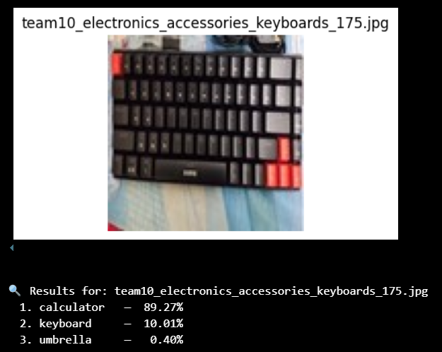
Maybe due to distortion in image

Image retrieval for class ‘wristwatch’
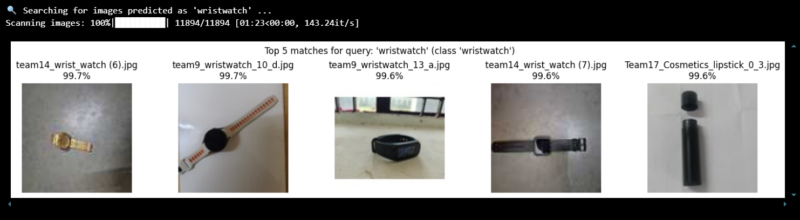
Notice the cosmetic lipistick also comes in top 5 maybe due to shape similarity
Visual examples using Model A trained on ‘Our Dataset’ and image retrieval from ‘Pooled dataset’
For more refer notebook, deit_tiny_inference.ipynb
Misclassifications:
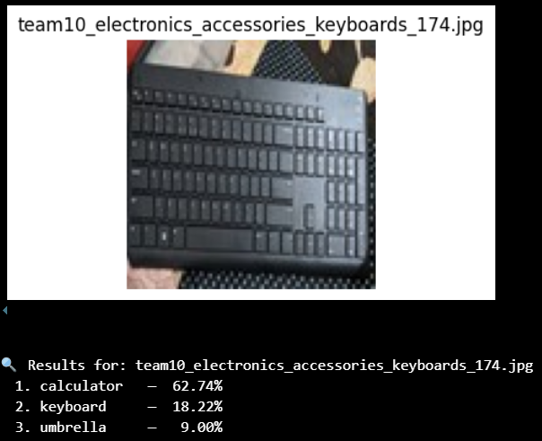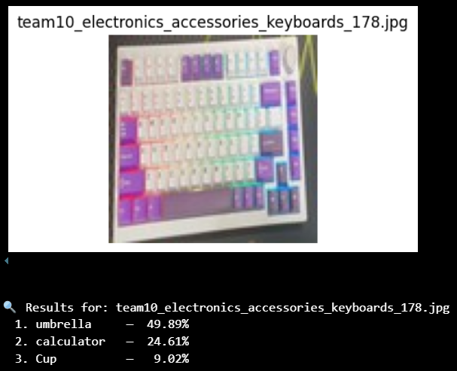
Maybe due to distorted images Maybe due to distorted and colorful image

Though, it classifies correctly the images which Model B does not as shown below
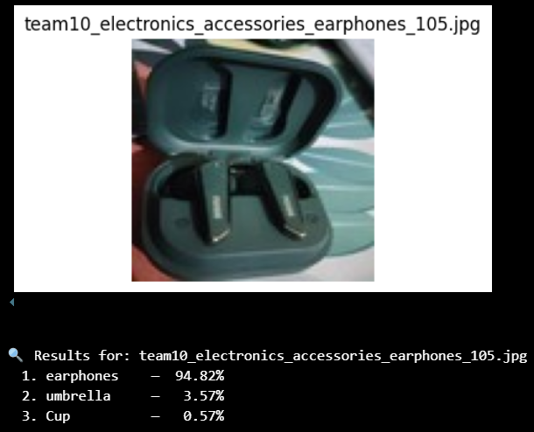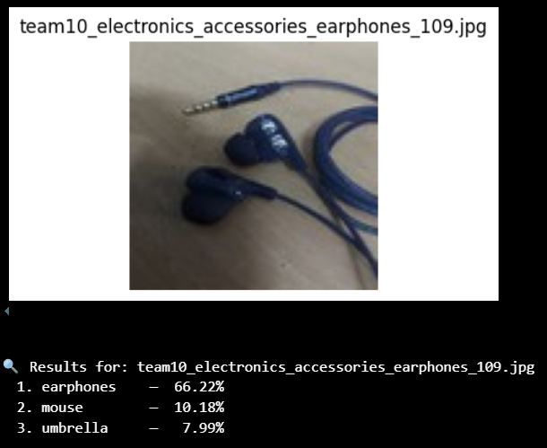
Image retrieval for class ‘wristwatch’
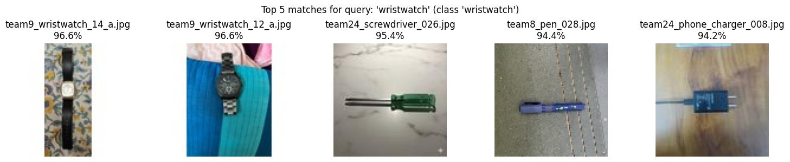
As apprehended, Model A does not gets trained properly for some classes in same number of epochs

