**Numbers in JavaScript**

* Two ways to declare a number in JavaScript  
  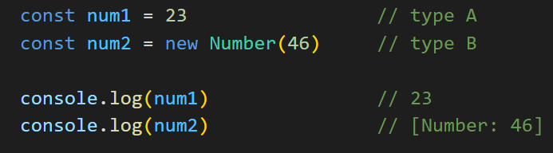
* typeB returns a number object and type A returns primitive number
* typeB has some methods already attached to it (ex-toString) while typeA has no methods attached.
* However, all methods that type B has access to can be applied to type A too (JavaScript does that behind the scenes)
* Overall, no major difference b/w the two and we can use anyone.

**Number Method – toString()**

* converts a number to a string
* returns a string
* Number.toString()  
  A screen shot of a computer

  Description automatically generated

**Number Method – toFixed()**

* used to limit decimal digits of a number
* returns a number
* Number.toFixed(limit)  
  A screen shot of a computer

  Description automatically generated

**Number Method – toLocaleString()**

* used to convert numbers into more "readable" format as per locale country defined ( adds commas as per lakhs or millions etc)
* returns a string
* Number.toLocaleString(locale)
* locale examples – Indian (en-IN), USA (en-US) etc  
  A screenshot of a computer program

  Description automatically generated

**Math function**:

* Math.round - round off to closest whole number
* Math.ceil - round off to higher whole number
* Math.floor - round off to lower whole number
* Math.ceil - round off to higher whole number
* Math.random - every time returns a random number b/w [0,1]  
    
  A black background with text and numbers

  Description automatically generated