PRISM — Proactive Recommendation & Insight System for Metrics
Tool Overview · Changes Made · Hardcoded Inventory
World Wide Technology · Jersey Mike's Data Platform
AT A GLANCE
- PRISM watches every store's key numbers and, the moment fresh data lands, flags what's wrong, explains why, and recommends a fix — no one has to open a report.
- Core principle: the data decides everything factual (what's wrong, the numbers, the severity, the recommendation); the AI is optional and only rephrases or elaborates.
- Two halves: a chat tab (ask questions in plain English) and the proactive agent (auto-scans and alerts).
- Watches 4 metrics: Same-Store Sales, Customer Satisfaction (OSAT), EBITDA margin, Food Safety.
METRICS — a dictionary with one entry per weekly metric the agent watches. Today that's exactly three: SSS_Pct, OSAT_Pct, EBITDA_Pct. Each entry carries that metric's own settings — which target column to use, the drop threshold, the target buffer, the trailing window, the label, etc.
FSA_CONFIG — the equivalent single config block for food safety (handled separately because it's event-based).
- Finds systemic patterns a dashboard can't — e.g. “5 stores under one consultant, all slipping together”.
- Status: runs on realistic dummy data today; built to switch to live Microsoft Fabric by changing one file.
1 · What the tool is
- “Jersey Mike's Data Assistant” — a Streamlit app with two halves: a chat assistant (plain English → SQL → answer) and PRISM, the proactive agent.
- PRISM reads the numbers the moment they land → decides what needs attention → explains the likely cause → recommends an action → routes it to the responsible person.
- Guiding principle (now fully realized): the deterministic core decides everything factual; the LLM only rephrases/elaborates already-decided facts.
2 · How the tool works right now
The agent pipeline (one function, run_analysis)

- Reading and anaylsing the data from the pipeline(gold layer)
- Detect — per store, per metric, two tests: a sudden drop vs the store's own recent average, and below target. Food safety is event-based (latest audit + a hard floor of 80).
- Enrich — attach location and the responsible chain (Owner, FBC, Area Director, Regional VP).
- Correlate — group anomalies by FBC / Area Director / Region / multi-metric store to surface systemic patterns; keep the top 6.
- Diagnose — set the cause, recommendation and severity (see below).
- Compose — build the alert message (composed, not sent).
How cause & recommendation are produced — Data vs AI
- By data (default, no AI call):
  - Cause is computed from sub-metrics: OSAT → lowest guest sub-score; SSS → traffic vs ticket vs comp; FSA → the audit's finding; EBITDA → sales- vs cost-driven.
  - Recommendation = a lookup in a curated PLAYBOOK (a fix-it reference sheet: “if the problem is X, do Y”).
  - Severity = a fixed rule (food-safety floor breach = Critical, etc.).
  - Same input → same output every run. Auditable, and free (no API).
- By AI (optional, per card):
  - Runs only when you flip a card to “AI.” It cannot change the diagnosis or invent numbers.
  - It adds value: a plain-language explanation for the field role, connects the store's other issues into one story, and expands the fix into 2–3 concrete steps.
  - If it fails or the card is left on Data, the data version stands.
Under the hood
- All data goes through one function (execute_query) with a read-only guard — no accidental writes; this is also the single swap-point for live Fabric.
- The database is loaded once and reused (fast).
- Every run is saved: history, recurrence (“times seen”), open/resolved status, and thumbs-up / thumbs-down feedback with an all-time “% useful” stat.
3 · Changes made this engagement
- Correctness: fixed the persona bug that had silently disabled half the detection (OSAT & EBITDA were producing zero alerts); the DB now loads once (~56× fewer rebuilds); real computed “latest week” instead of a hardcoded date.
- Detection / UX: each alert shows the size of the miss (e.g. “-27%”, “-4.0 pts”); food-safety breaches get their own “Below safety floor” label.
- Hybrid reasoning (the big one): new diagnose.py makes cause, recommendation & severity fully deterministic; the AI no longer decides anything.
- AI as optional narrator: a per-card Data/AI switch (on alert and pattern cards) that adds explanation + steps without touching the diagnosis.
- Persistence & security: new alert_store.py (history, recurrence, status, feedback); a read-only SQL guard.
- Housekeeping: repaired file corruption; updated the project memory.
- New files: diagnose.py, alert_store.py.
4 · What's hardcoded (and whether it matters)
Legend: Keep = fine for a project-specific tool · → Config = move to one config file so it can be tuned without code changes · Curate = needs ops sign-off.
- 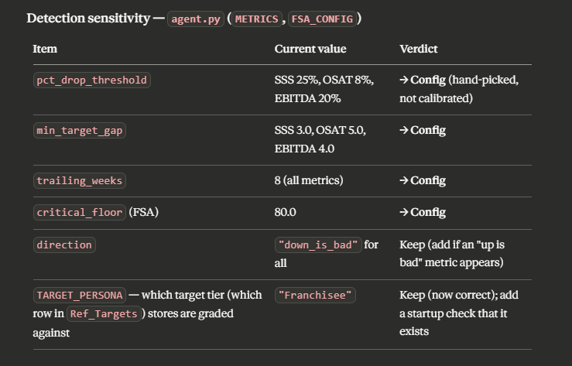
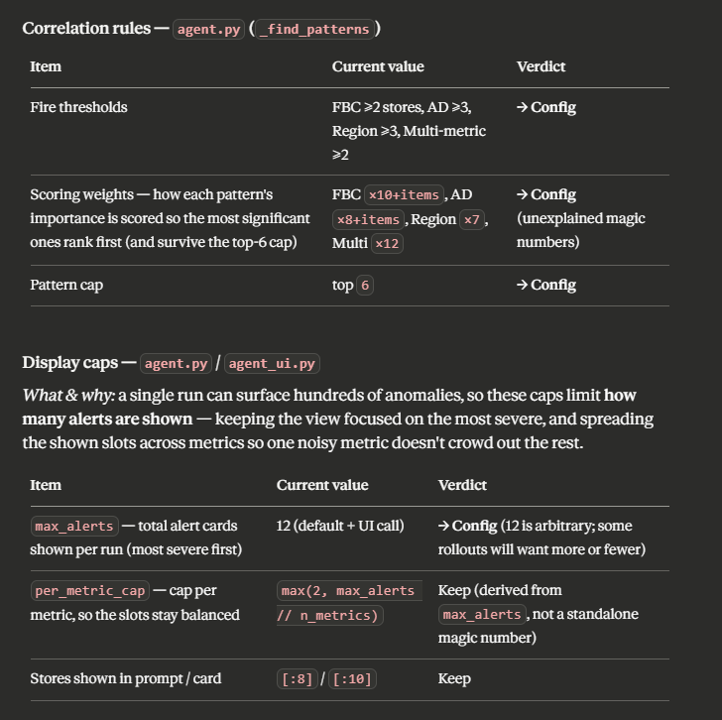

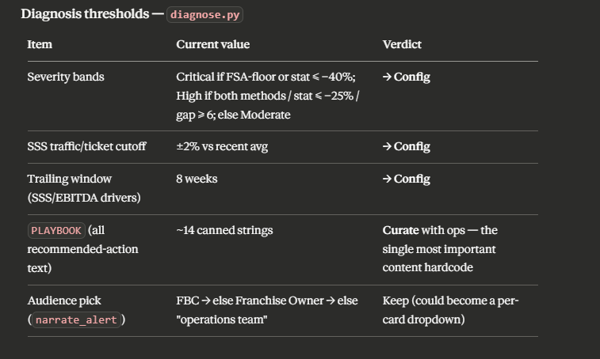
- PLAYBOOK recommendation text (~14 entries): the one content hardcode that needs real ops input before client use.
- 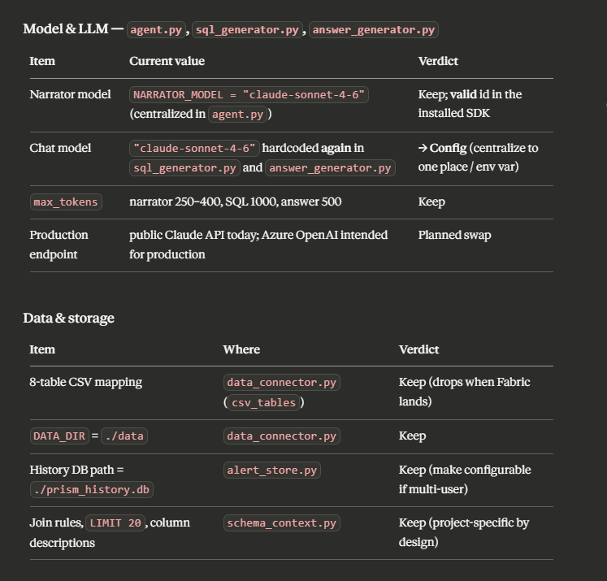Brand colors, the 4-metric set, join rules, CSV/table list: Keep (project-specific by design).
- Bottom line: most content hardcoding is fine; the tuning knobs should move into one config.yaml, and the PLAYBOOK needs ops sign-off.
5 · Still open (not yet done)
- Escape HTML in the cards (XSS risk once live data flows).
- Remove the shipped debug scripts and the committed Windows venv.
- Add automated tests / README / CI.
- Fix the enrichment date-sort (parse to a real date, like detection does).
- Bigger bets: real pipeline trigger, real email/Teams dispatch, Fabric + Azure OpenAI cutover.

Can PRISM auto-discover like the chatbot? Partly — but not the part that matters. The chatbot can auto-discover because a human supplies the intent every time (you ask the question; the LLM writes SQL against whatever schema exists). PRISM has no human at detection time — it runs by itself and has to decide what to watch and how. Reading the schema (table/column names) is the easy part and yes, we could reuse the same trick. But for each metric PRISM also needs things the schema can't tell it:
- Which columns are even metrics vs IDs/dates/names (StoreID, FiscalWeekKey, FBC_Name are columns too).
- Direction — is down bad or up bad? (sales down = bad; complaint rate up = bad.)
- Threshold / target — what counts as "meaningfully off" (25% for sales vs 8% for OSAT). That's a business call.
- How to explain the cause — the sub-metric decomposition and the playbook are metric-specific.
If you auto-watched every numeric column with no direction/threshold, you'd get noise — everything that moved, flagged, with no real severity or cause.
The clean answer is the middle ground: make the metric list config-driven instead of hardcoded, and add auto-assist on top. Concretely — keep a small config (or a Ref_-style table in Gold) listing the watched columns + their direction/threshold/target, so adding a metric is a row, not code. Then optionally borrow the chatbot's schema scan to suggest candidates: "these new numeric Gold columns aren't being watched — want to add them?" A human sets direction/threshold once. You could even offer a shallow "generic watch" mode that trends any numeric column against its own history (statistical only, no target, no tailored cause) as a catch-all — but the good alerts will always come from the configured set.

What if the schema changes or new tables comes in gold layer:
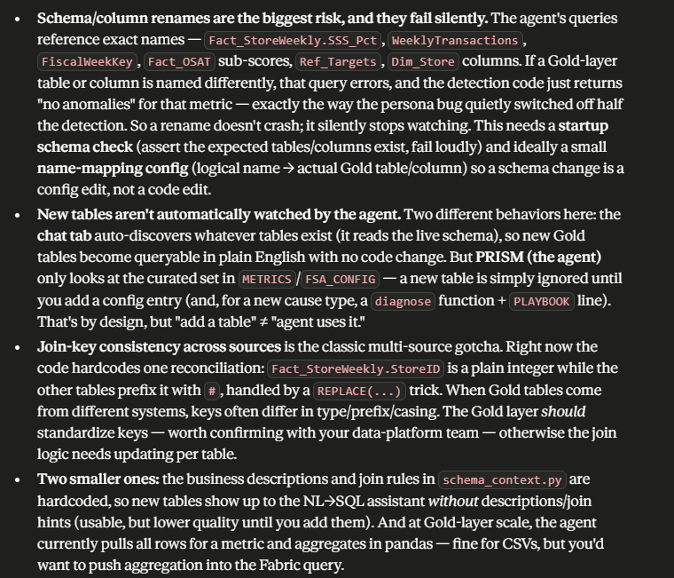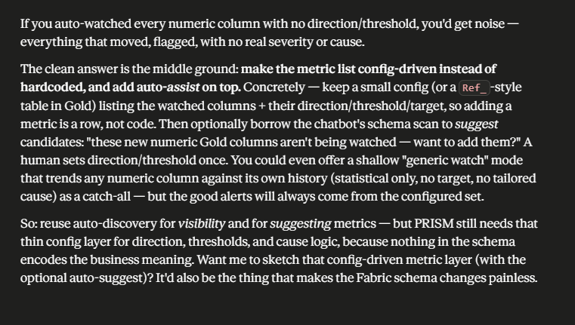

Steps to connect to fabric
