

PRISM Redesign
Agentic Diagnosis + Insights Table
Technical & Functional Redesign — Handoff
Jersey Mike's Data Platform · World Wide Technology
8 July 2026
Build status — complete. All five build steps are implemented and tested end-to-end against the labelled test dataset. The app runs today via the Streamlit trigger; the live LLM path activates once a callable reasoning model is set.

Make a new world happen

Contents
Executive summary 3
1. Why we are changing it 3
2. Locked decisions 4
3. Architecture — gather → reason → ground 4
4. The insights table & CSV mirror 5
5. File-by-file changes 6
6. Build status 7
7. Guardrails we are committing to 7
8. How this maps to the Fabric cutover 8
9. How to run (today) 8
10. What changed in this build 8

Executive summary
PRISM is the proactive half of Jersey Mike's Data Assistant: it scans every store when fresh data lands, flags what's wrong, explains why, recommends an action, and routes it to the responsible person. This redesign addresses two limitations of the current build — its output was trapped in a separate app, and its diagnosis was a growing if/else ladder that reasoned about one metric at a time.
The new design does two things. First, it turns the diagnosis into a store-level, LLM-reasoned step that reads all of a store's flagged metrics together and explains how they connect — while a deterministic guard validates every number and falls back to the old logic if anything fails. Second, it turns PRISM's output into a table a dashboard can read, so the answer lives where users already work instead of in a second app.
Core principle. Detection stays deterministic and every fact the system emits is checked against the real data. The model reasons and correlates; it never decides whether something is an anomaly, and it can never invent a number or downgrade a hard-rule severity.

1. Why we are changing it
The output is trapped in a separate app. The only “push” was an email that is composed but never sent, and to see anomalies, causes and actions a user had to open a second Streamlit app — which a store owner living in the Balanced Scorecard dashboard will not do.
The diagnosis reasons one metric at a time. The old diagnose.py inspects each metric in isolation and reads a pre-written recommendation. It cannot express that one metric is causing another (sales down → margin down), and every new situation needs a new hardcoded branch.
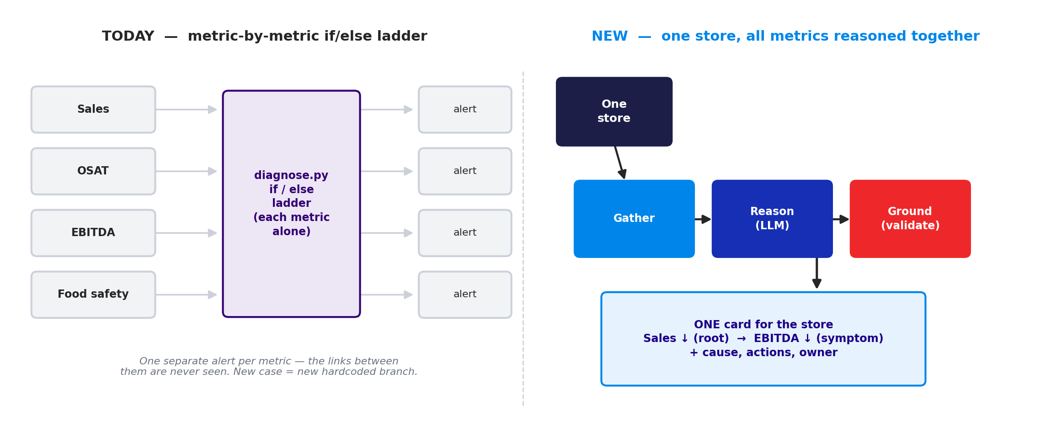
Figure 1 — From a per-metric if/else ladder (today) to one store diagnosed as a single connected story (new).

2. Locked decisions
Decision | Choice | Notes
Diagnosis engine | AI-primary, deterministic fallback | The LLM produces the diagnosis; diagnose.py runs only when the AI fails or its numbers don't validate.
Detection | Unchanged, deterministic | Statistical + target + food-safety floor stay exactly as they are. The AI never decides whether something is an anomaly.
Storage | Both — SQLite is memory, CSV is its mirror | SQLite insights table is the system of record (upsert, recurrence). The CSV is rebuilt from it each run for the dashboard.
Trigger | Streamlit button stays | No pipeline access yet. run_analysis() stays trigger-agnostic, so a Fabric step can call it later with no code change.
Presentation | One card per store | All of a store's flagged metrics are diagnosed together as one connected story.

3. Architecture — gather → reason → ground
The new diagnosis path replaces the role of diagnose.py (which becomes the fallback) with three explicit steps, grouped by store. Detection and the org-level pattern pass are unchanged and still run first.
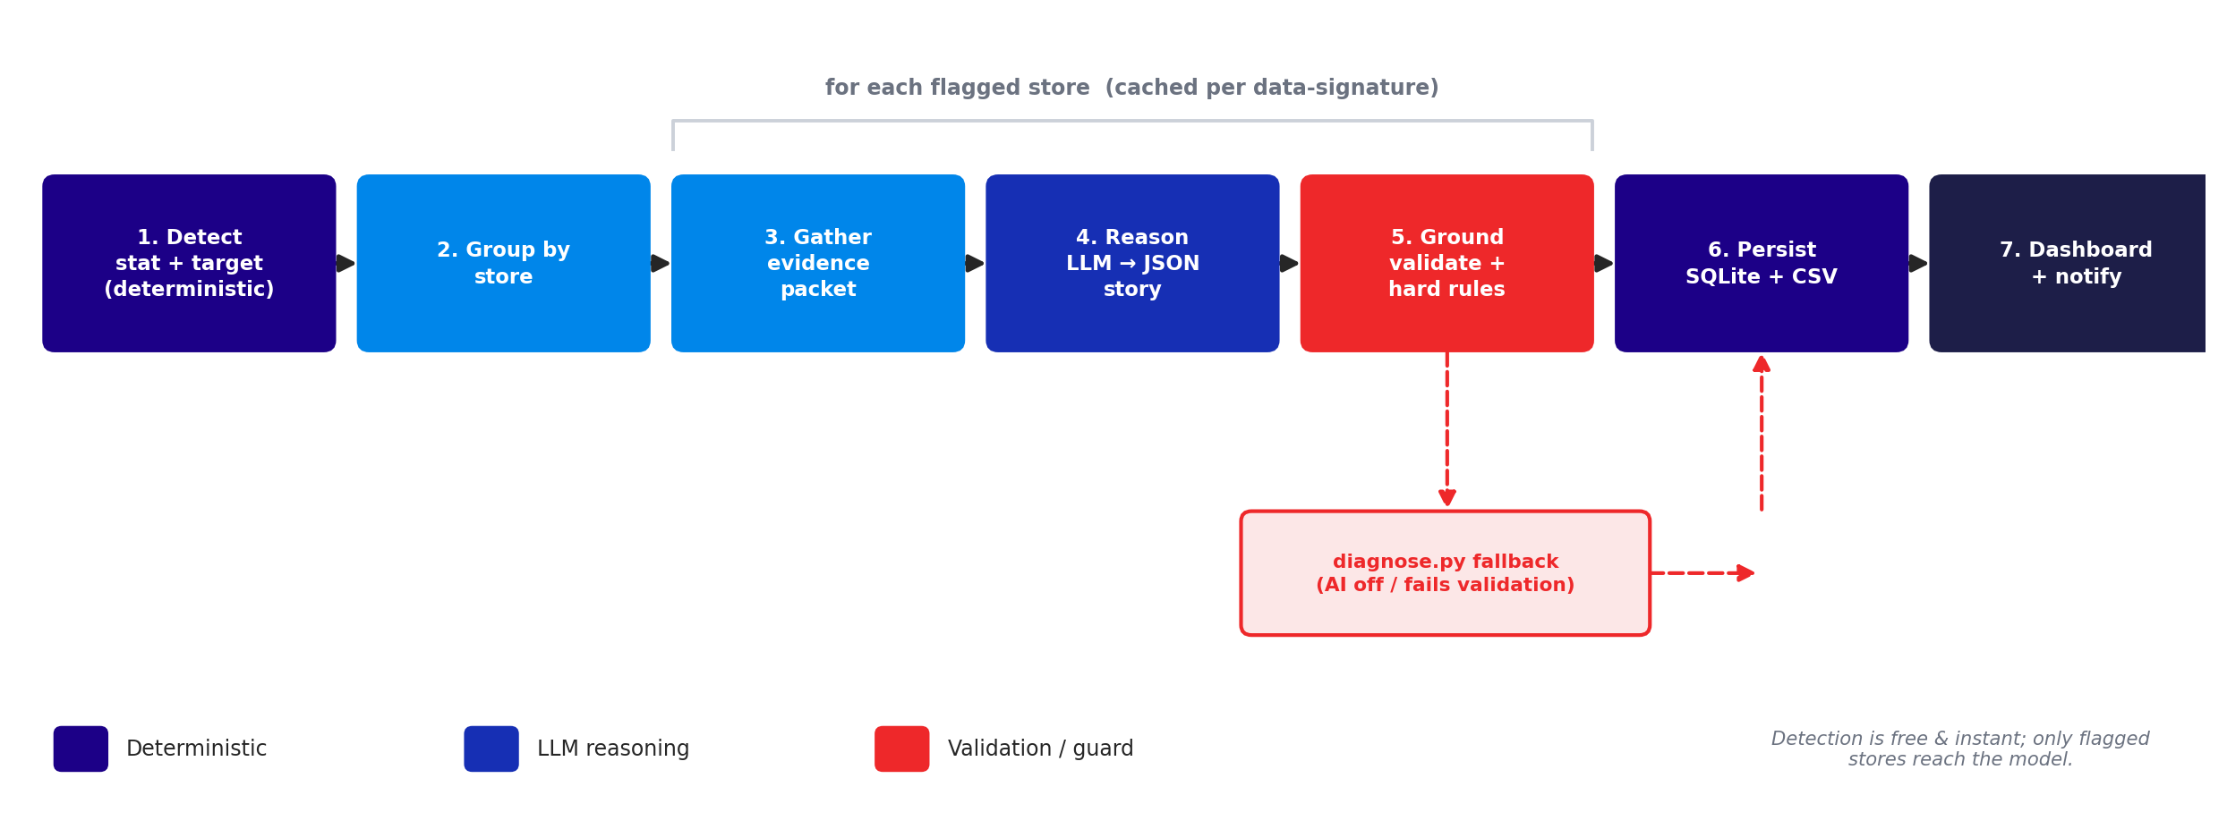
Figure 2 — The pipeline. Detection is deterministic and free; only flagged stores reach the model; the guard validates every number and falls back to diagnose.py when needed.

Gather (evidence.py)
For each flagged store, assemble one evidence packet: the flagged metrics with their numbers, the supporting sub-metrics (transactions, ticket, the OSAT sub-scores, the food-safety finding, and more — discovered dynamically), the last ~12 weeks of trends, peer/cohort context, recurrence from history, and a deterministic lead/lag hint for whether one metric's decline precedes another's. Adding a new metric later means adding a field here, not a new branch.

Reason (reason.py)
The model receives one store's packet and returns a single structured diagnosis as JSON: a headline, the root-cause metric, a causal chain (each metric tagged root / contributing / symptom), a store-level severity, and 2–4 concrete actions. v1 (built now) is one call with the whole packet; v2 (later) gives the model read-only tools it can call to investigate before concluding.

Ground (ground.py)
After the model answers, PRISM validates that every number it cited appears in the evidence, rejects invented metrics, and enforces hard rules — a food-safety floor breach is Critical regardless, and the model may raise severity but never lower it below the deterministic rule. On any failure or outage it discards the AI output and uses diagnose.py. This is the step that lets operations trust “do X.”

4. The insights table & CSV mirror
PRISM's output becomes a table, not just a screen. The SQLite insights table is the memory (one row per store, upserted so recurring issues bump a “times seen” count). A flat CSV mirror is rebuilt from it each run so it always reflects current state — ongoing issues stay, resolved ones drop off, re-runs never duplicate. Power BI imports that CSV directly today; later the same shape is written to a Fabric Gold table with no logic change.
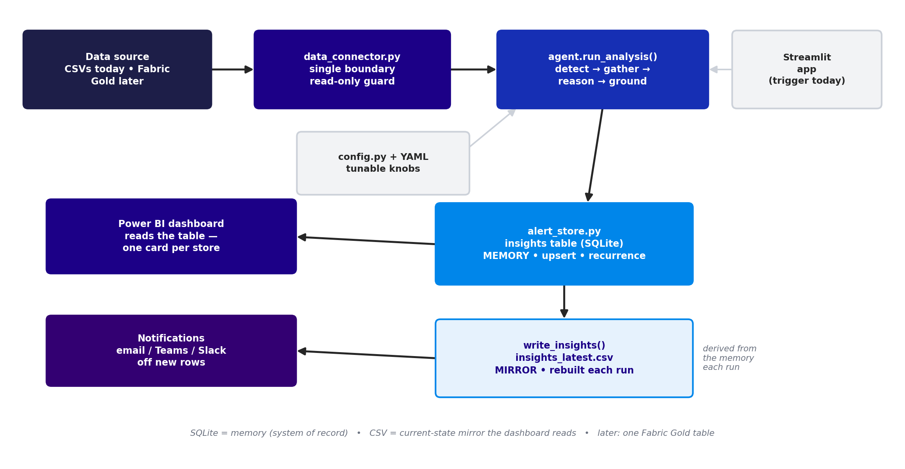
Figure 3 — Data flow. One boundary (data_connector) in, SQLite memory + CSV mirror out, consumed by the dashboard and notifications.

5. File-by-file changes
File | Change
evidence.py | NEW — builds the per-store evidence packet (column-aware); deterministic lead/lag helper.
reason.py | NEW — LLM → structured JSON store diagnosis (v1 no tools). Fails soft to a fallback.
ground.py | NEW — validates AI numbers against the packet, enforces hard rules, falls back to diagnose.py.
agent.py | Group anomalies by store; per store run gather→reason→ground with caching; keep detection & patterns; run_analysis() now returns {patterns, stores, alerts}.
diagnose.py | Unchanged in behaviour — demoted to the deterministic fallback. Stops growing.
alert_store.py | New insights table (upsert, recurrence, status, feedback) + save/get/persist helpers.
data_connector.py | New write_insights() CSV mirror. The read-only query guard is untouched.
agent_ui.py | One card per store (AI/Data badge, evidence, story, actions, owners); insights-table view + CSV download; per-store feedback.
config.py / prism_config.yaml | New reasoning_model, reasoning block, and insights_export block — all with safe defaults.

6. Build status
Each step was built and tested against the labelled test dataset (7 flagged stores with correct severities, 6 patterns, recurrence, and the CSV mirror all verified).
- evidence.py — per-store evidence packet. Done + tested.
- reason.py v1 + ground.py — validated JSON diagnosis, severity hard-rules, fallback. Done + tested.
- Rewire agent.py — group-by-store with caching, behind a reasoning switch. Done + tested.
- Insights table + CSV mirror — upsert / recurrence verified. Done + tested.
- agent_ui.py — one card per store + insights view + CSV download. Done + tested.
- Optional next — v2 tool-calling in reason.py; an eval harness over the labelled dataset.

7. Guardrails we are committing to
- Cost & latency. Only stores that detected an anomaly reach the AI; one call per store, not per metric; results cached per data-signature. Detection stays free.
- Determinism. Low temperature, structured output, the validation layer and caching make a given week's result stable and repeatable.
- Trust. Every emitted number is validated against the data; hard rules can't be overridden; failures fall back to the deterministic path.
- In-tenant. In production the reasoning call moves to Azure OpenAI so client data stays in the Microsoft tenant.
- Evaluation. The labelled test dataset becomes the eval set that scores the model's diagnosis as the system evolves.

8. How this maps to the Fabric cutover
- data_connector stays the single boundary — reads repoint to the Fabric SQL endpoint; write_insights repoints to an upsert/MERGE into a Gold insights table.
- run_analysis() stays trigger-agnostic — the Streamlit button is replaced by a Gold-layer pipeline step or scheduler with no code change.
- The reasoning LLM swaps from Anthropic to Azure OpenAI behind reason.py.
- The dashboard reads the Gold insights table; Data Activator / Power Automate sends the email/Teams/Slack notification off new rows.

9. How to run (today)
- Install dependencies: pip install -r requirements.txt.
- Ensure .env has ANTHROPIC_API_KEY, and set a callable reasoning_model in prism_config.yaml (or repoint reason.py at Azure OpenAI). If the id can't be called, PRISM still runs — every card shows source: fallback (deterministic, still correct).
- Run: streamlit run app.py → open the Proactive Agent tab → Simulate Pipeline Run.
- You get the systemic patterns, then one card per store (severity, an AI-vs-Data badge, the flagged metrics with numbers, the store-vs-peers line, the connected root→downstream story, actions, and owners), plus per-store feedback.
- An Insights table panel shows the persisted insights with a Download CSV button; each run rewrites insights_latest.csv for Power BI to import.
- Tune without code in prism_config.yaml: reasoning.enabled, max_store_cards, insights_export, detection thresholds, and the playbook.

10. What changed in this build

New files
- evidence.py, reason.py, ground.py, and a sample insights_latest.csv.

Changed files
- agent.py, agent_ui.py, alert_store.py, data_connector.py, config.py + prism_config.yaml.

Unchanged on purpose
- Detection, the org-level correlation pass, and diagnose.py — now the deterministic fallback rather than the primary brain.

Make a new world happen
wwt.com

