PRISM
Technical Documentation
Proactive Recommendation & Insight System for Metrics
Jersey Mike's · built by WWT · architecture, code, data flow, and file reference

Contents
1. What PRISM is
2. How PRISM works
3. The agent (agent_loop.py + tools.py)
4. Technical stack
5. Data boundary & persistence
6. File reference — what each file holds
7. How the code moves, file to file
8. Guardrails and keeping the agent honest
9. Running PRISM

1. What PRISM is
PRISM — Proactive Recommendation & Insight System for Metrics — is the proactive half of Jersey Mike's data assistant, built by WWT. Every week it reads the balanced-scorecard metrics for every store, finds the few that are genuinely off, has an AI agent work out why and what to do about it, links related stores into systemic patterns, and routes each issue to the right owner — before anyone goes looking.
It exists to solve an attention problem. A dashboard shows what moved, but with a few hundred stores and a dozen metrics each, that is thousands of data points a week and no way for a person to look at the right thing at the right time. PRISM does that triage automatically and hands back a short, plain-language conclusion with one recommended action.
The guiding principle is a deterministic pipeline with exactly one AI step. Deciding which stores are off, validating numbers, correlating patterns, and routing are all fixed code. Only the per-store diagnosis — the explanation of the cause — is done by the AI agent, and even that must prove every claim against real data. This is the v2 design; it runs behind the reasoning.use_tools switch, with the older single-narration path (reason.py) kept as a fallback.
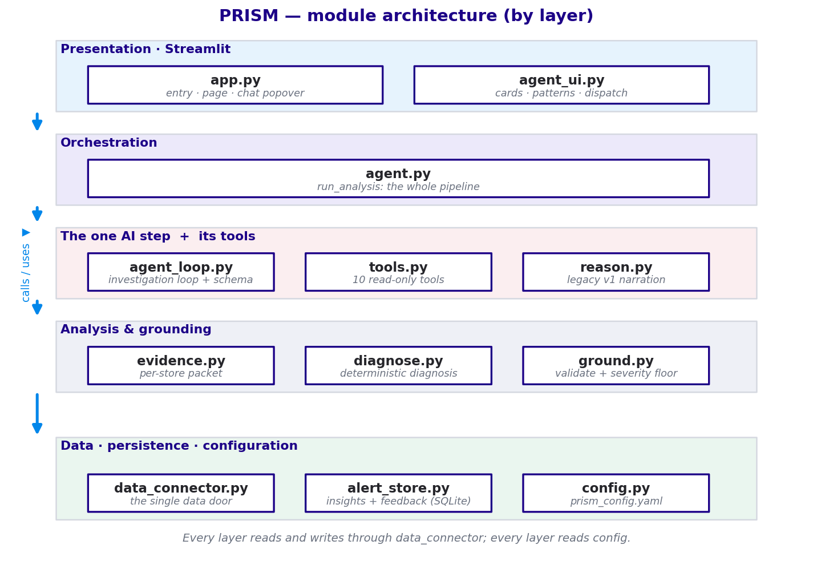
Figure 1 — PRISM modules organised by layer.

2. How PRISM works
A weekly run is orchestrated end to end by agent.run_analysis(). The stages below are deterministic except stage 4 (the AI diagnosis).
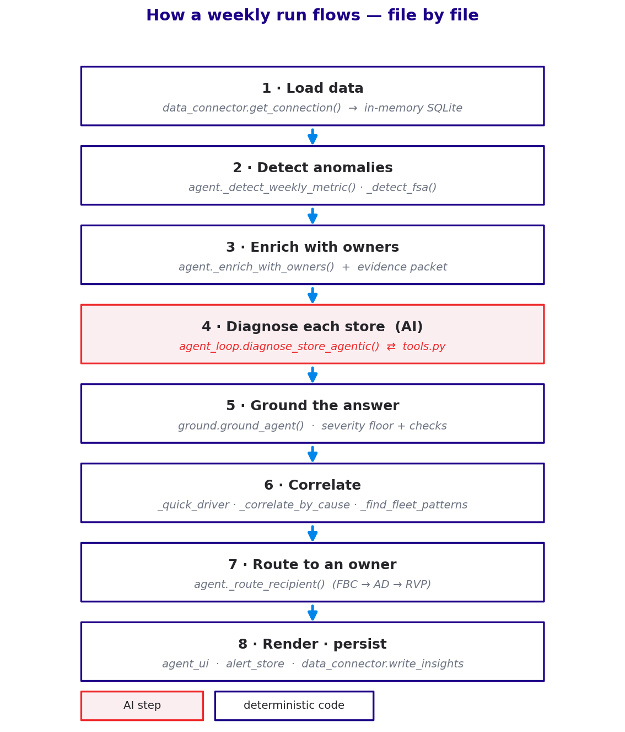
Figure 2 — the weekly run, stage by stage, with the file and function behind each.

2.1 Detection — which stores are off
agent._detect_weekly_metric() compares each store's latest value against its own trailing baseline; rate metrics (SSS, OSAT, EBITDA) are compared in points, not ratios, with per-metric severity bands calibrated from real volatility. agent._detect_fsa() handles food-safety audits separately, flagging only a genuine breach of the safety floor (not a store merely under an aspirational target). This step is pure rules, so the trigger behaves identically every week.

2.2 Enrichment
agent._enrich_with_owners() attaches each flagged store's org context (franchise owner, FBC, Area Director, Regional VP, region), and evidence.py builds the per-store evidence packet — the numbers the card and the agent will use.

2.3 Diagnosis — the one AI step
For each flagged store, agent._diagnose_stores() calls agent_loop.diagnose_store_agentic(), which runs the investigation loop described in section 3. Diagnoses run in parallel across the top-ranked stores via a ThreadPoolExecutor, and results are cached on a store signature so unchanged stores aren't re-diagnosed.

2.4 Grounding
ground.ground_agent() enforces a deterministic severity floor — the AI may raise severity but never lower a hard rule (a food-safety breach is always Critical) — and reconciles the primary issue with any secondary issues. The legacy path additionally validates every cited number against the evidence packet and falls back to diagnose.py if too much is unverifiable, so no store is ever dropped.

2.5 Correlation
Correlation is deterministic. agent._quick_driver() tags every flagged store with a rule-based cause; the agent's richer driver overrides it on diagnosed stores. agent._correlate_by_cause() groups stores that share a driver under one FBC and only calls it systemic if the cohort clears count, share, and lift thresholds; agent._find_fleet_patterns() flags a driver that is broad across regions and FBCs as a company-wide pattern for leadership.

2.6 Routing, render, persist
agent._route_recipient() resolves the tier the agent proposed (suggested_route) to a real person and escalates up the FBC → Area Director → Regional VP chain if a tier is unassigned. agent_ui.py renders the store and pattern cards and the dispatch bar; alert_store.py upserts the insights (and keeps human feedback separate); data_connector.write_insights() mirrors the current insights to a CSV the dashboard reads.

3. The agent (agent_loop.py + tools.py)
Persona. The model is cast as a seasoned Jersey Mike's field analyst with one narrow job: given a flagged store, find the cause and the action. Instructions (the system prompt) hold the rules: tools return measurements not verdicts; never assert what you haven't checked; use only numbers a tool returned; give one primary action; state honest confidence; separate problems go in secondary_issues; food safety is its own issue.
The loop. The agent decides a question, calls a tool, reads the measurement, and decides again — up to a budget of 8 tool calls. It exits by producing a store_diagnosis: either naturally (enough evidence) or via a single forced final call when the budget is hit (lower confidence, open items noted). If it errors, PRISM falls back to the deterministic diagnosis — so the loop can never run forever and never returns nothing.
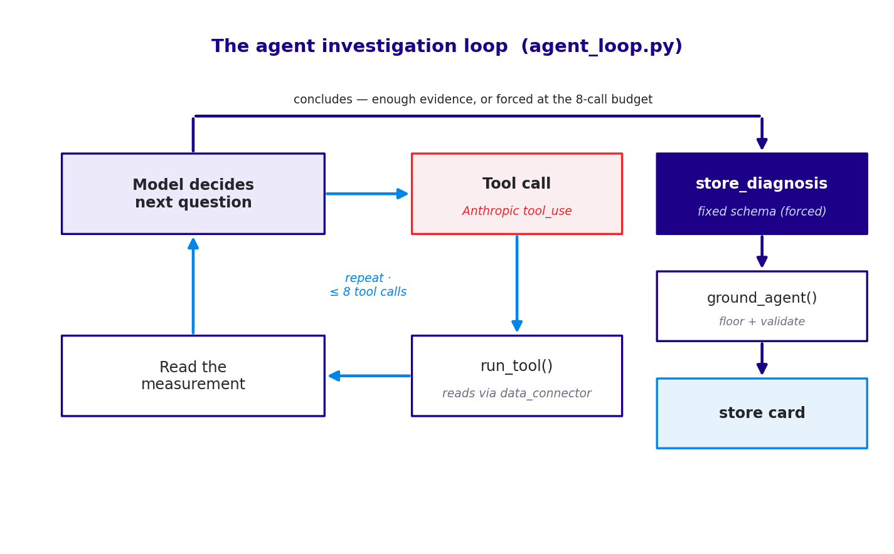
Figure 3 — the investigation loop and its exit path.

3.1 The tools
All ten tools are read-only and fall into two kinds: analysis doors that return a computed measurement, and raw-data doors that return underlying rows. Each carries a description the model uses to pick the right one.
Tool | Type | What it returns
decompose_sss | analysis | Splits a sales move into traffic vs ticket (order size).
compare_to_peers | analysis | This store vs its FBC cohort — gap and rank.
metric_trend | analysis | A metric over time — sharp drop vs slow slide.
osat_breakdown | analysis | Guest sub-drivers (food, service, cleanliness, value); weakest.
channel_mix | analysis | OLO / third-party / loyalty mix.
margin_decomp | analysis | EBITDA move vs the sales move.
ops_check | analysis | Operational signals (OpEx, order accuracy).
fsa_history | analysis | Recent food-safety audits and the latest finding.
get_store_weeks | raw data | The store's recent weekly rows.
list_columns | raw data | Available columns, so the agent can orient.

3.2 Why the output has a fixed schema
The agent's final answer is not free text — it must fill the store_diagnosis schema (severity, confidence, scope, driver, headline, primary_metric, root_cause, causal_chain, recommended_action, secondary_issues, suggested_route, cited_values, and more) via a forced tool call. The model is non-deterministic, so PRISM pins down the structure even though it can't pin down the content. The schema is the contract that lets deterministic code act on the answer: grounding floors severity and verifies cited_values, correlation groups on driver, routing resolves suggested_route, and the UI renders headline and recommended_action.

4. Technical stack

4.1 Libraries
PRISM has a deliberately small dependency set (requirements.txt), plus a few Python standard-library modules doing heavy lifting.
Library | Used for
streamlit 1.58 | The whole web UI — the proactive panel and the “Ask PRISM” chat popover (app.py, agent_ui.py).
anthropic 0.109 | Claude API client — the agentic diagnosis (forced tool-use) and the chat answers.
pandas 3.0 | All tabular data — loading CSVs, query results, the insights mirror.
python-dotenv 1.2 | Loads ANTHROPIC_API_KEY (and config) from .env.
pyyaml 6.0 | Reads prism_config.yaml into config.py.
pip-system-certs | Uses the OS certificate store (corporate TLS).
sqlite3 (stdlib) | The in-memory warehouse and the prism_history.db insights store.
concurrent.futures (stdlib) | ThreadPoolExecutor runs store diagnoses in parallel.

4.2 Data model
data_connector.py loads eight CSVs from data/ into the in-memory SQLite database: the facts Fact_StoreWeekly, Fact_OSAT, Fact_FSAScore; the dimensions Dim_Store, Dim_FranchiseOwner, Dim_Region, Dim_Date; and Ref_Targets (the per-persona goals stores are graded against). In production these tables are served from the Microsoft Fabric Gold layer instead — the code above the connector is unchanged.

4.3 Configuration
Everything tunable lives in prism_config.yaml, read once by config.py: the per-metric severity bands and is_rate flags, the food-safety floor, the correlation thresholds (count / share / lift and the fleet-wide spread), reasoning.use_tools and max_tool_calls, the model names, and the recommended-action playbook. A missing or broken file falls back to built-in defaults so PRISM keeps running.

5. Data boundary & persistence
All data access goes through one module, data_connector.py — the single door. Reads run through execute_query(), which is protected by a read-only guard: only a single SELECT/WITH statement may run, so a bad generated query can never mutate data. Writes go through the explicit write_insights() path (never generated SQL). alert_store.py owns the durable state — an insights table that is upserted each run (auto-resolving recovered stores) and a separate insight_actions table for human feedback that a re-run never clobbers.
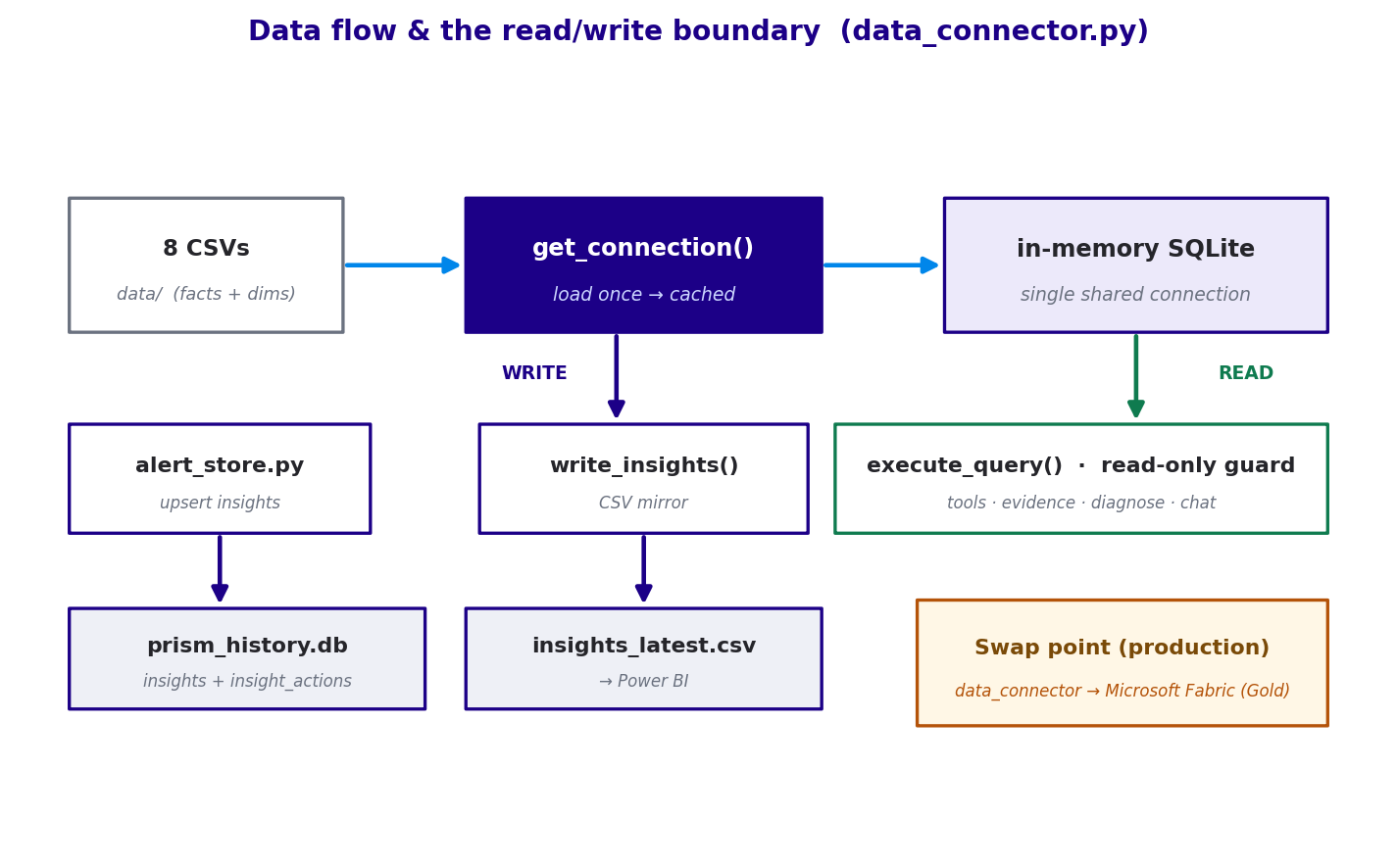
Figure 4 — reads, writes, and the single production swap point.

6. File reference — what each file holds
The codebase is ~5,100 lines of Python across the modules below, grouped by role.
File | Layer | What it holds
app.py | Presentation | Streamlit entry — page config, branding, loads data, renders the panel, and the “Ask PRISM” chat popover.
agent_ui.py | Presentation | Renders the store cards, pattern cards, and dispatch bar; the “run” action; card message + routing display.
agent.py | Orchestration | The pipeline — detection, enrichment, _diagnose_stores, correlation, _route_recipient, narration, and run_analysis.
agent_loop.py | AI step | The investigation loop, the system prompt, and the store_diagnosis schema; the forced-conclusion exit.
tools.py | AI step | The 10 read-only tools, their schemas/descriptions, and run_tool(); the cheap _quick_driver helpers.
reason.py | AI step | Legacy v1 single-narration diagnosis, used when reasoning.use_tools is off.
evidence.py | Analysis | Builds the per-store evidence packet and groups anomalies by store.
diagnose.py | Analysis | Deterministic per-metric diagnosis and severity — the safe fallback.
ground.py | Grounding | ground() full validation + ground_agent() severity floor; falls back to diagnose.py.
data_connector.py | Data | The single data door — get_connection, execute_query (read-only guard), write_insights.
alert_store.py | Persistence | SQLite insights + insight_actions; upsert, resolve, and read helpers.
config.py | Config | Loads prism_config.yaml and exposes METRICS, CORRELATION, REASONING, PLAYBOOK, models.
chat_assistant.py | Chat | Routes “Ask PRISM” between data-query mode and alerts mode; conversation memory.
sql_generator.py | Chat | Natural language → SQL, using the schema context.
answer_generator.py | Chat | Turns SQL results into a plain-language answer.
schema_context.py / schema_scan.py | Chat / shared | Describe and scan the DB schema for the chat and the UI.
debug_*.py | Dev | Small standalone diagnostics (targets, OSAT, persona, weekly, checks).

7. How the code moves, file to file

7.1 The proactive run
app.py starts Streamlit, loads the shared connection from data_connector, and calls render_agent_panel() in agent_ui.py. When a run is triggered, the UI calls agent.run_analysis(), which drives the whole pipeline:
- agent detects anomalies (_detect_weekly_metric, _detect_fsa) reading through data_connector, then enriches them with owners and builds packets via evidence.py.
- For each flagged store, agent._diagnose_stores() calls agent_loop.diagnose_store_agentic(), which loops with the model and executes tools.run_tool() — every tool reads through data_connector.
- The diagnosis is validated by ground.ground_agent() (which can fall back to diagnose.py).
- agent then correlates (_quick_driver, _correlate_by_cause, _find_fleet_patterns) and routes (_route_recipient).
- Results flow back to agent_ui.py to render, to alert_store.py to persist, and to data_connector.write_insights() to mirror for the dashboard. Throughout, every module reads its settings from config.py.

7.2 The “Ask PRISM” chat
The floating chat in app.py calls chat_assistant.ask(), which routes to one of two modes. A data question goes sql_generator (NL → SQL, using schema_context) → data_connector.execute_query → answer_generator (results → prose). An alerts question is answered from the persisted insights via alert_store.get_insights(), phrased by the model. This is the human-in-the-loop surface where a generated query is allowed — always behind the read-only guard.

8. Guardrails and keeping the agent honest
PRISM's trust model is that freedom scales with oversight. On the unattended weekly path the agent is bounded to verified read-only tools and its every claim is validated; open SQL is only allowed in the human-reviewed chat. Detection is deterministic, tools return measurements not verdicts, grounding floors severity and checks cited numbers, and there is always a safe deterministic fallback.
When the agent still gets one wrong despite having the tools, the fix is a loop, not a one-off: reproduce the case (input + tool trace + correct answer) → diagnose why from the trace → fix the class (a firmer prompt rule, a better tool description, a deterministic checker in ground_agent, or moving the check into code) → lock it with a regression test → score on an eval set → feed new cases from the thumbs-down feedback in insight_actions. The strongest lever is a deterministic checker, because it catches the error without trusting the model to be careful.

9. Running PRISM
From the project folder, with the virtual environment active, launch the Streamlit app:
.\venv\Scripts\python.exe -m streamlit run app.py
An ANTHROPIC_API_KEY in .env is required for the AI diagnosis and chat; without it, detection and the deterministic fallback still run. Configuration is read once at import, so a change to prism_config.yaml needs a full app restart to take effect.

