
PRISM
Complete Technical Reference
Proactive Recommendation & Insight System for Metrics
Jersey Mike's Data Platform · World Wide Technology
10 July 2026
Read this, not the code. This document is a self-contained walkthrough of the whole system — what PRISM is, how it is built, its architecture, every processing step, the data model, and a description of every file and what its code does. Reading it end to end should give a thorough understanding without opening a single source file.

Make a new world happen

Contents
1. What PRISM is 3
2. The problem it solves 3
3. How it is built — stack & core principles 4
4. System architecture 4
5. Module map — how the files fit together 5
6. The data model 6
7. Detection — how anomalies are found 6
8. Correlation — systemic patterns 7
9. Diagnosis — gather -> reason -> ground 8
10. The deterministic fallback 9
11. Persistence, auto-resolve & write-back 10
12. The Ask PRISM chat assistant 10
13. Configuration — every knob 11
14. Security & safety 11
15. Performance 12
16. File-by-file reference 12
17. How to run it 17
18. The Power BI / Fabric cutover 18
19. Testing & the labelled dataset 18
20. Limitations & roadmap 18
Appendix — glossary 18

1. What PRISM is
PRISM (Proactive Recommendation & Insight System for Metrics) is the proactive half of Jersey Mike's Data Assistant. A normal BI stack reports numbers and waits for a person to notice a problem. PRISM reads the numbers automatically the moment fresh data lands and turns them into routed, explained, actionable alerts — before anyone opens a report.
For every store it: flags what is wrong, explains why, recommends an action, and resolves the person responsible. Its real differentiator over a dashboard is correlation: it connects anomalies across stores, metrics, and the management hierarchy into one systemic insight — for example "five stores under one field consultant are all slipping together" — instead of leaving a human to assemble that from separate charts.
It watches four metrics — Same-Store Sales, Customer Satisfaction (OSAT), EBITDA margin, and Food Safety — and ships with a chat assistant ("Ask PRISM") for natural-language questions over the same data.

2. The problem it solves
Without PRISM | With PRISM
Someone must open a dashboard and scan it to notice a problem. | The moment data lands, problems are detected automatically.
Each metric is a separate chart per store; a human assembles the pattern. | Anomalies are correlated across stores, metrics and the org hierarchy.
"Sales are down" — but is it traffic or ticket? A person must dig. | The cause is decomposed from the data (traffic-led vs ticket-led, etc.).
No standard "what to do next." | Each alert carries a recommended action from a curated playbook.
Nobody is explicitly told. | Each alert resolves the owner / FBC / area director / regional VP.

The net effect: issues surface earlier, with a likely cause and a recommended fix, aimed at the person who can act — with no human in the loop at detection time.

3. How it is built — stack & core principles

Technology
Component | Choice | Why
Language | Python 3.10+ | The whole analytics core is Python.
UI | Streamlit | Pure-Python UI; fast to build. Interim surface; Power BI is the production dashboard.
Data (now) | in-memory SQLite + pandas | Zero-setup stand-in for the Fabric endpoint.
LLM (optional) | Anthropic Claude | Structured tool-use for reasoning; Azure OpenAI in production (in-tenant).
Config | YAML (pyyaml) | Ops-editable knobs, no code change.
Persistence | SQLite file + CSV | Local memory + a dashboard-ready mirror.

Three principles that define the design
1. Deterministic core, optional AI. Detection is always deterministic (statistics + thresholds). The LLM reasons about cause and connection, but every number it emits is validated against the real data, it can never lower a hard-rule severity, and on any failure the system falls back to a deterministic diagnosis. The model can never invent an anomaly.

2. One data boundary. Every read and write goes through data_connector.py. Today it loads CSVs into in-memory SQLite; in production that one module is repointed at Microsoft Fabric and nothing downstream changes.

3. UI is a thin, replaceable shell. The logic returns plain data (dictionaries, tables, a CSV). Only two files know Streamlit exists. The same output feeds Streamlit today, a Power BI dashboard tomorrow, and notifications — the brain is UI-agnostic.

4. System architecture
Top to bottom, PRISM is five layers: a single data boundary, a deterministic detection + correlation core, a hybrid diagnosis step (AI with a deterministic guard and fallback), a persistence layer that is both memory and a dashboard feed, and a thin UI. Configuration sits to the side, feeding tunable knobs into every layer.
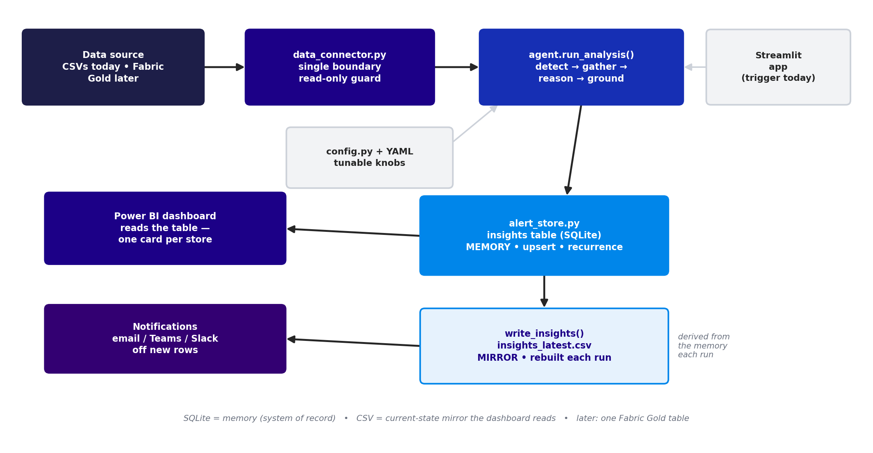
Figure 1 — System architecture and data flow: one boundary in, SQLite memory + CSV mirror out, consumed by the dashboard and notifications.

5. Module map — how the files fit together
The codebase is organised in clean layers. The UI files are the only ones that import Streamlit; the pipeline calls the four step-modules; everything that touches data goes through the single boundary; and configuration is externalised to YAML.
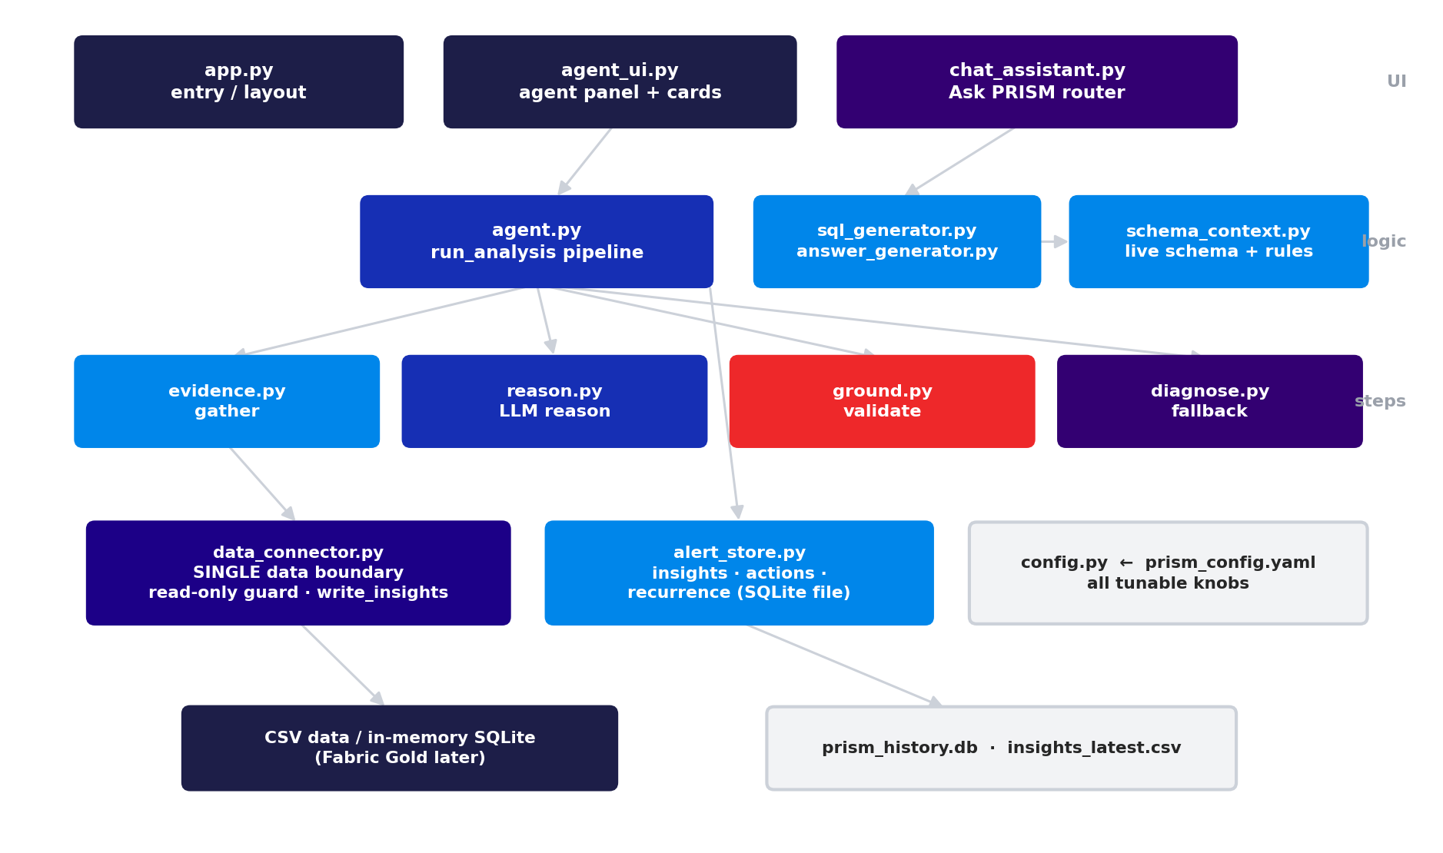
Figure 2 — Module dependency map. UI -> logic -> pipeline steps -> boundary / storage / config -> data at rest.

6. The data model
PRISM reads eight source tables (CSV today, a Fabric Gold model later) and writes its own output tables into a local SQLite file. One quirk runs through the joins: Fact_StoreWeekly.StoreID is a plain integer while the other tables prefix it with '#', so joins reconcile both sides with REPLACE(). Targets are keyed by persona tier (the Franchisee tier is used for grading).
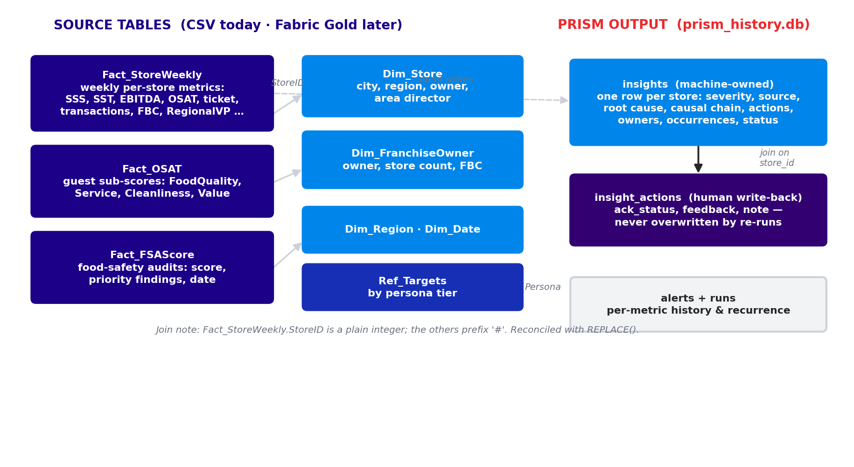
Figure 3 — Source tables (facts, dimensions, targets) and the PRISM output tables (insights, insight_actions, alerts/runs).

7. Detection — how anomalies are found
Detection is fully deterministic and runs for every store on every watched metric. Each weekly metric is tested two independent ways; an anomaly is recorded if either fires, and the methods that fired are stored so the UI can label them.
- Method 1 — Statistical. The latest week is compared to the store's own trailing average over the previous 8 weeks. If the percentage drop exceeds the metric's threshold, it flags. Catches a sudden decline even if still near target.
- Method 2 — Threshold. The latest value is compared to the target minus a per-metric buffer, so a store only a hair below target does not flood the list. Catches chronic underperformance a trend check misses.
- Food safety is modelled differently. FSA scores are discrete audit events, not weekly rows, so a trailing average is meaningless. PRISM keeps each store's most recent audit and flags it if it is below target or below a hard floor of 80 (any audit under 80 is automatically Critical).
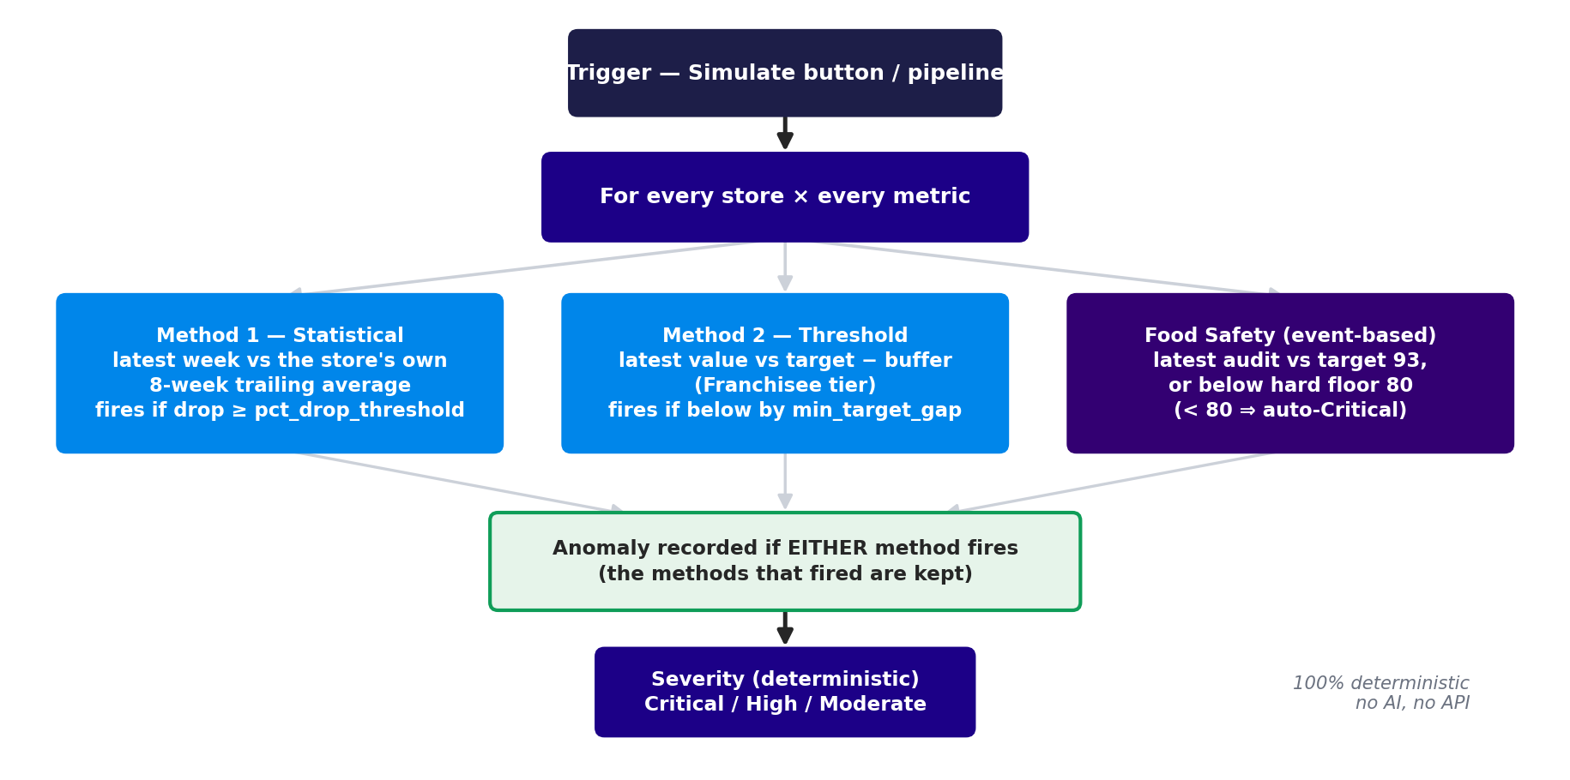
Figure 4 — Detection. Two independent methods per weekly metric plus event-based food safety; deterministic severity; no AI.
Engineering note. PRISM avoids SQL window functions (the bundled SQLite predates them) — it pulls raw rows with portable SQL and computes the latest week and trailing average in pandas, which also keeps the SQL engine-portable for the Fabric move. FiscalWeekKey is a DD-MM-YYYY string, so it is parsed to a real date before sorting.

8. Correlation — systemic patterns
After enrichment attaches each anomaly's location and full responsible chain, PRISM groups the full anomaly set four ways, scores each group so the most significant sort to the top, and caps the list. This is the differentiator a single-metric dashboard cannot reproduce.
Pattern | Groups by | Fires when | Meaning
FBC | Field consultant | 2+ stores | One consultant's stores are slipping together
Area Director | Area director | 3+ stores | A whole territory shows a cluster
Region | Region + metric | 3+ stores | A geographic problem on one metric
Multi-Metric Store | Single store | 2+ metrics | One store failing on several fronts at once

Crucially, patterns are computed on the full anomaly set before any display trim — so a systemic pattern is never hidden just because its individual stores did not make the top-N card list.

9. Diagnosis — gather -> reason -> ground
This is the hybrid brain. For each flagged store, PRISM builds an evidence packet, lets the model reason across the store's metrics into one connected story, then validates that story against the data and falls back to a deterministic diagnosis if anything fails.
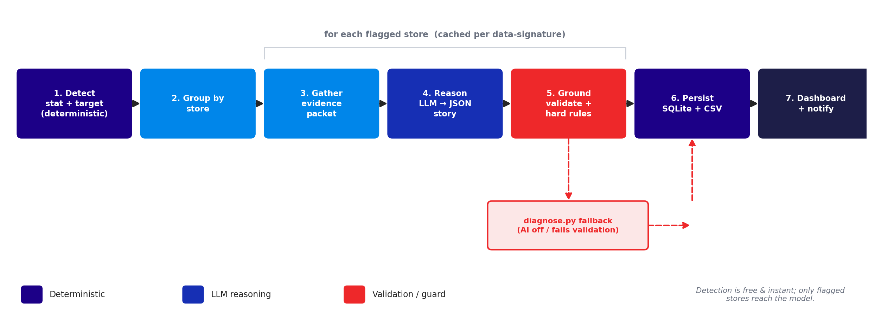
Figure 5 — The per-store pipeline. Detection is free; only flagged stores reach the model; the guard validates every number and falls back when needed.

Gather (evidence.py)
Assemble one evidence packet per store: the flagged metrics with their numbers, the supporting sub-metrics (transactions, ticket, the four OSAT sub-scores, the food-safety finding, and more — discovered dynamically), the last ~12 weeks of trends, peer/cohort context (store vs its FBC and region), recurrence from history, and a deterministic lead/lag hint for whether one metric's decline precedes another's. Adding a new metric means adding a field here, not a new branch.

Reason (reason.py)
The model receives the packet and returns a single structured diagnosis by calling a defined tool — a headline, the root-cause metric, a causal chain (each metric tagged root / contributing / symptom), a store-level severity, and 2-4 concrete actions. Forcing a tool schema means the SDK returns an already-parsed object, so long narrative strings can never break the output.

Ground (ground.py)
Every number the model cited is checked against the packet; invented metrics are rejected; food-safety floor breaches are forced to Critical; and the model may raise severity but never lower it below the deterministic rule. On any failure the AI output is discarded and diagnose.py produces the diagnosis. This is the step that lets operations trust "do X."
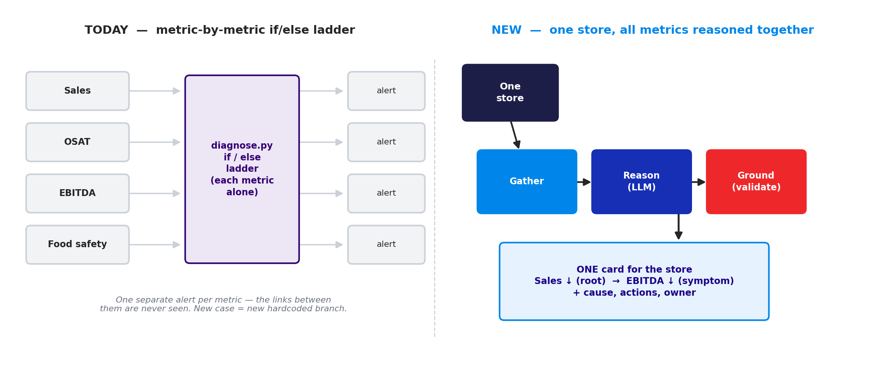
Figure 6 — Why this replaced the old design: from a per-metric if/else ladder to one store diagnosed as a single connected story.

10. The deterministic fallback
diagnose.py is the project-specific brain that runs whenever the AI is off or its output does not validate. For each metric it decomposes sub-metrics the warehouse already holds to name the proximate driver, maps that driver to a client-approved recommended action via a PLAYBOOK, and computes severity by rule:
- Same-Store Sales — compares latest transactions and average ticket to their trailing averages: fewer customers but steady spend is traffic-led; steady customers but lower spend is ticket-led; both soft; or a comp / trade-area issue if neither moved but it is still below target.
- OSAT — reads the four guest sub-scores (Food Quality, Service, Cleanliness, Value); the lowest is named the driver.
- Food safety — uses the audit's actual priority finding, or reports the score is below the 80 floor.
- EBITDA — if sales are also declining it is sales-driven; otherwise cost / labor-driven.
Because it is a lookup plus rules, it is fully reproducible and needs no API call — the trustworthy safety net beneath the AI.

11. Persistence, auto-resolve & write-back
Every run is persisted to a local SQLite file. The insights table is machine-owned (one row per store, upserted so recurring issues bump a "times seen" count). Stores that are no longer flagged are auto-resolved — they close themselves when their metrics recover, with no human action. Human input (feedback and acknowledgement) is kept in a separate insight_actions table so re-runs never overwrite it, and so a Power App or Teams flow can write there in the dashboard world.
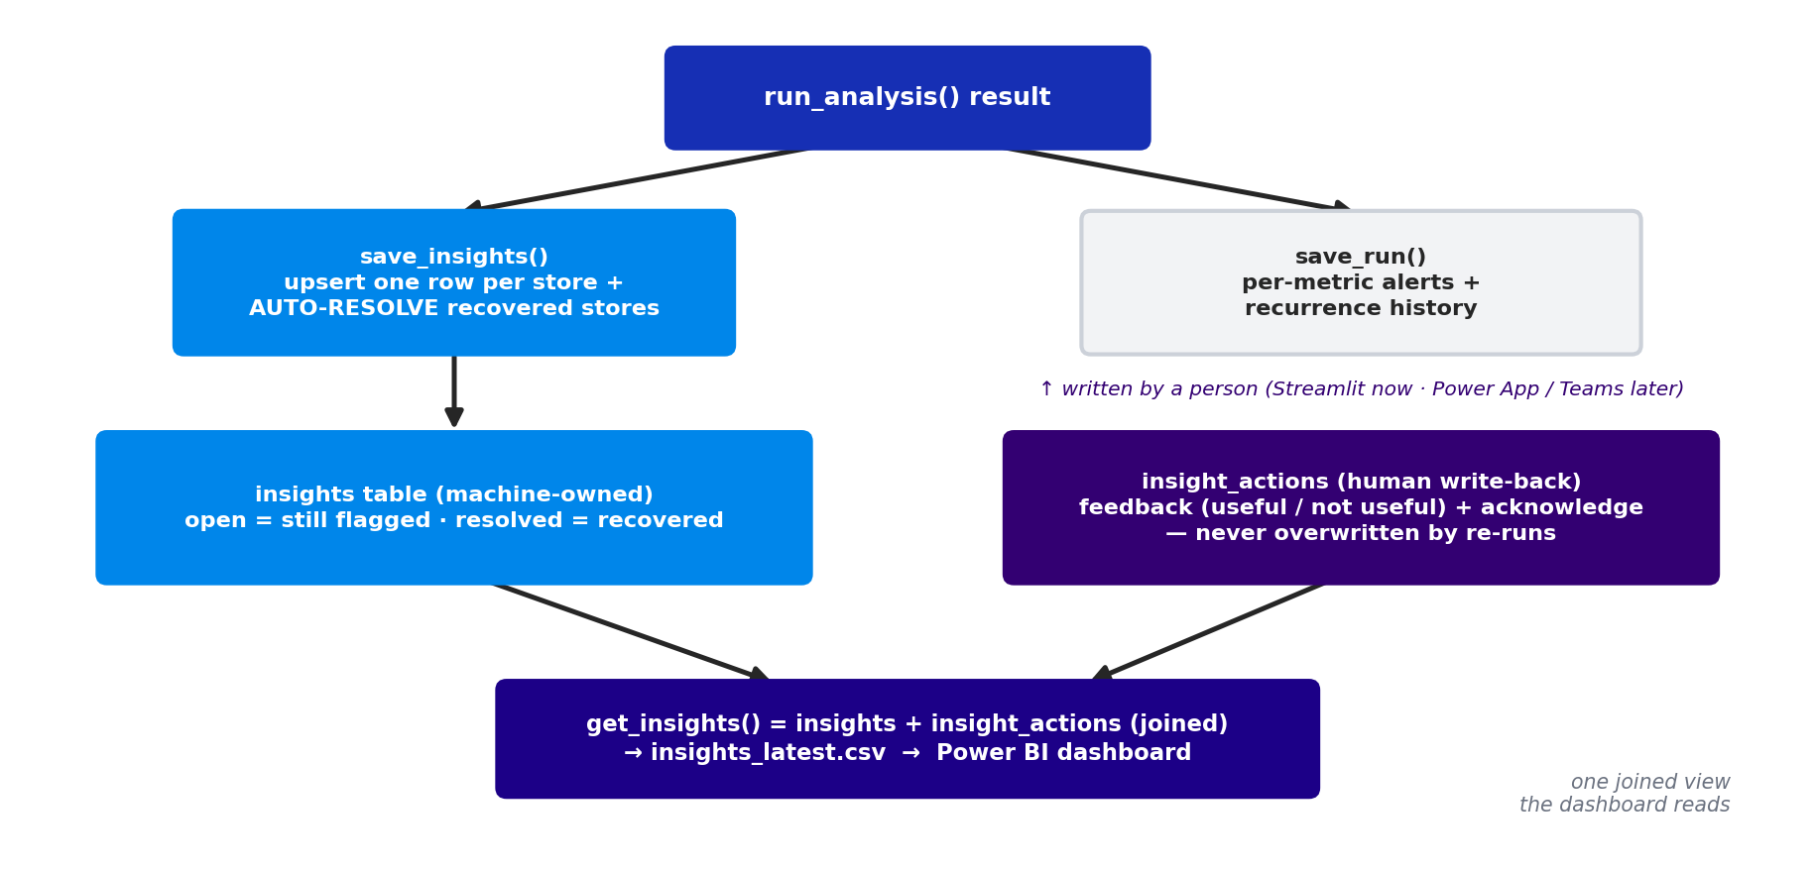
Figure 7 — Persistence & write-back. Machine owns insights (with auto-resolve); humans write insight_actions; the two are joined into the dashboard feed.
The dashboard reads get_insights(), which joins the two tables, and the same rows are exported to insights_latest.csv each run. In production this shape is written to a Fabric Gold table instead, with no change to the logic.

12. The Ask PRISM chat assistant
The chat is a small, branded floating assistant on the main page. It routes each question automatically: questions about the raw metrics go through natural-language -> SQL (with follow-up memory, so "which is second highest?" resolves against the previous turn), and questions about the alerts go to a PRISM-aware path that answers from the insights table. It can render a chart and offer a CSV download, and each store card has an "Explain" button that queues a plain-language explanation into the chat.
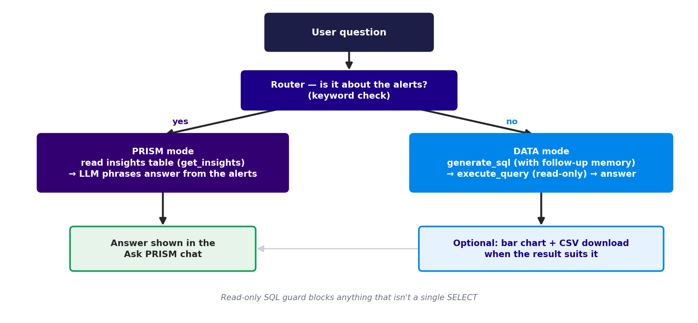
Figure 8 — The chat router: PRISM-aware answers vs data (NL -> SQL) answers, both guarded by the read-only SQL rule.

13. Configuration — every knob
All tunable settings live in prism_config.yaml, loaded by config.py. If the file or PyYAML is missing or malformed, config.py falls back to built-in defaults and prints a warning, so the app always runs. The main knob groups:
- target_persona, max_alerts — the grading tier and how many cards to show.
- model ids — reasoning_model, narrator_model, chat_model.
- metrics — the watched-metric list; each has direction, trailing window, target column, statistical threshold and target buffer. Add a metric = add a block, no code.
- fsa — food-safety label, target column and the critical floor (80).
- patterns — correlation fire-thresholds, score weights, and the pattern cap.
- severity — the deterministic severity bands (critical / high drop, high target gap).
- reasoning — enabled, max_store_cards, use_tools, cache, max_workers (parallelism).
- insights_export — whether to keep the SQLite table, write the CSV mirror, and the file paths.
- playbook — the recommended action per diagnosed driver (curate with operations).

14. Security & safety
- Read-only SQL guard. execute_query refuses anything that is not a single SELECT/WITH, blocking DROP/DELETE/stacked statements. This matters most once pointed at live Fabric.
- Resilient writes. The CSV export never crashes a run: if the file is locked (open in Excel), it writes a *_new.csv fallback and warns.
- HTML escaping. Every data- or AI-derived value rendered in the UI cards is escaped, so a store name, finding or model output containing markup cannot inject.
- Fails safe. The optional LLM calls degrade to deterministic text on any error; the agent otherwise makes no external calls.
- Honest by construction. PRISM composes but does not transmit alerts; the UI says "routed / ready to send," never "sent."
- Secrets. The API key comes from a .env file, excluded from version control alongside venv/, __pycache__/ and the history DB.

15. Performance
The realistic dataset flags many stores, so PRISM is careful about where it spends time:
- Only diagnose what is shown. Stores are ranked by severity and capped first, so the model is called only for the cards actually displayed — not for every flagged store.
- Parallel model calls. The per-store diagnoses run concurrently (a small thread pool); all database work stays single-threaded so the shared connection is never hit by many threads at once.
- Compute-once peer baselines. The peer comparison scans the weekly table once per metric and caches it, instead of once per store.
- Caching. A store's diagnosis is cached on a data signature, so re-running an unchanged week costs no model calls at all.

16. File-by-file reference
Every file that matters, what it is for, and what its code does. Files are grouped by role.

UI layer

app.py
Purpose. The Streamlit entry point — the branded main page and the floating chat.
Sets the page config (using prism_icon.png as the page icon), injects the branding CSS, and draws the PRISM header (icon + wordmark + gradient rule). load_data() builds and caches the in-memory database once. It then renders the proactive agent as the whole main page (render_agent_panel), and mounts the "Ask PRISM" popover pinned bottom-right.
Key pieces: _load_page_icon / _icon_data_uri load the icon (with an emoji fallback); the popover holds the suggested-prompt chips, the conversation history, and a submit form; on submit it calls chat_assistant.ask(), appends the exchange to session state, and reruns. Problem solved: one branded surface that combines the agent view with the chat, with the logic delegated out.

agent_ui.py
Purpose. The operator-facing UI for the proactive agent (one card per store).
render_agent_panel() is the main entry: it draws the run trigger, persists each run (save_run + persist_insights), renders the systemic pattern cards, then one card per store, plus the history and insights-table panels.
Key functions: _render_store_card (severity badge, AI/Data source badge, evidence pills, the connected causal story, actions, responsible chain, and a fallback-reason line); _render_pattern; _render_insights_table (the dashboard feed with a CSV download and the "% useful" value metric); _store_message (the composed notification); _collect_recipients; _render_history_panel; _render_schema_assist; _agent_css. Each card carries feedback, Acknowledge and Explain buttons that write to the write-back table. Every data-/AI-derived value is HTML-escaped.

Pipeline & logic

agent.py
Purpose. The PRISM pipeline — the single, trigger-agnostic entry point.
run_analysis() orchestrates the whole flow and returns {patterns, stores, alerts, flagged_store_ids}. It is deliberately trigger-agnostic — a button today, a Fabric pipeline step tomorrow, no code change.
Detection: _get_targets, get_latest_week, _detect_weekly_metric (the two methods), _detect_fsa, _detect_generic. Enrichment: _enrich_with_owners attaches location and the full responsible chain. Correlation: _find_patterns builds the four pattern types and scores them.
Diagnosis: _diagnose_stores ranks and caps stores, then runs them through gather -> reason -> ground in parallel (with caching); _diagnose_store and _finish assemble each store's card. _summarize_pattern and the narrate_* helpers are the optional LLM polish. _compose_alert_message builds the email-style notification text.

evidence.py
Purpose. Gather — builds one evidence packet per flagged store.
build_store_packet() assembles the packet; group_by_store turns the flat anomaly list into per-store groups. Helper builders: _store_context (owners/region), _weekly_trend (last ~12 weeks of every existing metric), _osat_subscores, _fsa_latest, _peer_context (store vs FBC/region cohort). It is column-aware, so a lean or rich dataset both work.
Notable: _latest_per_store caches the per-metric baseline so peers are computed once per run (reset_caches clears it); _lead_lag is a few lines of pandas that detect whether one metric's decline precedes another's — a real ripple signal that also works with the AI off; _history pulls recurrence from the SQLite store.

reason.py
Purpose. Reason — the LLM turns a packet into a structured diagnosis.
_reason_once() calls the model with a forced tool (store_diagnosis) whose schema defines the exact output, so the SDK hands back a valid object — no hand-written JSON to mis-format. reason_store_ex returns (diagnosis, error) and is thread-safe for the parallel path; reason_store is the simple wrapper.
Helpers: _extract_tool_input reads the tool call's parsed input; _first_text / _parse_json are a text fallback that tolerates fences or prose. The client is created lazily and any failure returns None (and the reason), so the caller falls back cleanly.

ground.py
Purpose. Ground — keep the AI honest, or fall back.
ground() first normalises the model output (_normalize_ai coerces root_cause / causal_chain / actions into the exact shapes downstream code expects, so an odd type can never crash the UI), then validates: _valid_metrics rejects invented metrics, _packet_numbers + _close (magnitude-tolerant) check every cited number, and severity is hardened with _worst_det_severity and _fsa_floor_breach.
_fallback() builds a deterministic store-level diagnosis from diagnose.py whenever the AI is missing or rejected. Every returned diagnosis carries source ("ai" | "fallback") and a validation record for transparency.

diagnose.py
Purpose. The deterministic fallback — cause, action and severity with no AI.
diagnose_alert() sets cause, action, severity and driver for one anomaly; diagnose_pattern does the same for a correlated pattern. _severity applies the deterministic bands. The per-metric driver functions (_diagnose_sss, _diagnose_osat, _diagnose_fsa, _diagnose_ebitda) decompose sub-metrics; a _DISPATCH maps each metric to its function; the recommended action comes from the PLAYBOOK. Fully reproducible, no API.

Chat

chat_assistant.py
Purpose. The Ask PRISM router — data questions and alert questions.
ask() routes on is_prism_question (a keyword check). answer_data runs NL -> SQL with follow-up memory (_history_pairs feeds prior turns to the SQL generator) then phrases the result; answer_prism answers from get_insights() using the LLM. chartable decides when a result is worth a bar chart; SUGGESTED_PROMPTS are the starter chips.

sql_generator.py
Purpose. Natural language to SQLite SQL (Claude).
generate_sql(question, conversation_history) builds a system prompt from the live schema (schema_context) and returns a single SELECT. It accepts recent (question, SQL) pairs so follow-up questions have context.

answer_generator.py
Purpose. Query result to a business-language answer (Claude).
generate_answer(question, sql, df) turns the result rows into a short, specific, plain-language answer, leading with the most important finding and naming stores and numbers.

schema_context.py
Purpose. The live schema + business rules for the SQL generator.
COLUMN_DESCRIPTIONS holds business meaning for known columns; STATIC_RULES holds the critical join rules (the StoreID '#'-prefix reconciliation) and SQL conventions. get_schema_context() reads the live tables, row counts and columns from SQLite and merges in the descriptions — so a newly added CSV appears automatically.

schema_scan.py
Purpose. Auto-assist for the watched-metric list.
scan_unwatched_metrics() finds numeric columns in the weekly fact that are not yet watched and are not obviously IDs/dates; suggest_yaml_block writes a ready-to-paste config block. A human still supplies the business meaning. This is the discovery half of the config-driven design.

Boundary, storage & config

data_connector.py
Purpose. The single data boundary — the Fabric swap point.
Reads: get_connection() loads the eight CSVs into one in-memory SQLite database once (a connection singleton) and reuses it; execute_query(conn, sql) runs a query but only after _is_read_only confirms it is a single SELECT/WITH. DATA_DIR selects the dataset.
Writes: write_insights() exports the current insights to insights_latest.csv (rebuilt each run) via _safe_to_csv, which never raises on a locked file. This is the one function repointed to a Fabric Gold-table upsert in production; the read-only guard on the query surface is untouched.

alert_store.py
Purpose. Persistence — memory, recurrence, and human write-back.
Tables: alerts + runs (per-metric history and recurrence), insights (machine-owned store-level output), and insight_actions (human write-back). init_db creates them.
Key functions: save_run persists per-metric alerts; save_insights upserts store insights and auto-resolves recovered stores; get_insights joins insights with insight_actions (the dashboard shape); record_insight_feedback and set_insight_action write the human overlay; persist_insights is the one call the UI makes (save + CSV export); insight_feedback_stats powers the "% useful" metric.

config.py / prism_config.yaml
Purpose. All tunable knobs, with a safe fallback to built-in defaults.
config.py loads prism_config.yaml and exposes the settings (METRICS, FSA_CONFIG, PATTERN_RULES, SEVERITY, REASONING, INSIGHTS_EXPORT, PLAYBOOK, model ids, and more). Section 13 lists the knob groups. Editing the YAML tunes PRISM without touching code; a missing or broken file falls back to defaults with a warning.

Data, assets & docs

data/ (source dataset)
Purpose. The realistic sample dataset — the eight tables PRISM loads.
Fact_StoreWeekly (~15k weekly rows), Fact_OSAT (guest sub-scores), Fact_FSAScore (audits), Dim_Store, Dim_FranchiseOwner, Dim_Region, Dim_Date, and Ref_Targets. (The folder also contains extra "Showcase"/Periods/Personas CSVs that data_connector does not load.) DATA_DIR in data_connector.py selects this set or the labelled test set.

prism_test_data/ (labelled test set)
Purpose. A 10-store x 10-week dataset with a known planted anomaly in each store.
Used to confirm detection and diagnosis are correct — each store's expected result is documented in its README, so the AI's conclusions can be scored against a known answer. The recommended next step is to turn this into an automated eval harness.

prism_history.db
Purpose. The SQLite persistence file.
Holds the alerts, runs, insights and insight_actions tables across sessions. This is PRISM's local system of record; in production it is replaced by the Fabric Gold tables.

insights_latest.csv
Purpose. The dashboard feed — the current open insights, rebuilt each run.
One row per open store with severity, source, the flagged metrics, root cause, causal chain and actions (as JSON), the responsible chain, occurrences, status, and the joined human overlay (ack_status, feedback). Power BI imports this directly today; later it is a Fabric Gold table of the same shape.

prism_icon.png · requirements.txt · debug_*.py
Purpose. Supporting files.
prism_icon.png is the app/brand icon (used as the page icon and header). requirements.txt pins the dependencies (streamlit, anthropic, pandas, python-dotenv, pyyaml). The debug_*.py scripts are small ad-hoc checks from development and are not part of the running app.

Documents/
Purpose. The human-readable documentation set.
Contains this technical reference, the redesign plan, and the earlier overview/state documents. These are handoff artifacts, separate from the code.

17. How to run it
- Install dependencies: pip install -r requirements.txt
- Ensure .env has ANTHROPIC_API_KEY, and set a callable reasoning_model in prism_config.yaml (or repoint reason.py at Azure OpenAI). If the model is not callable, PRISM still runs — every card shows source: fallback (deterministic, still correct).
- Run: streamlit run app.py -> the branded PRISM page opens; click Simulate Pipeline Run.
- You get the systemic patterns, one card per store, the insights-table panel with a CSV download, and the floating Ask PRISM chat (bottom-right).
- Tune without code in prism_config.yaml — reasoning.enabled, max_store_cards, thresholds, the playbook, and the insights export.

18. The Power BI / Fabric cutover
PRISM's output is a table, so the production dashboard does not require the Streamlit app at all. The plan, all isolated to the data boundary:
- Repoint data_connector reads from CSV/SQLite to the Fabric SQL endpoint; write_insights becomes an upsert/MERGE into a Gold insights table.
- Run run_analysis() as a scheduled Fabric notebook/pipeline step (it is already trigger-agnostic).
- Power BI reads the insights table (joined with insight_actions) and renders one card per store, with row-level security scoping each owner to their stores.
- Human actions (resolve/feedback) come from a Power App visual or Teams buttons writing to insight_actions; recovered stores auto-resolve. Notifications fire from Data Activator / Power Automate on new Critical rows.

19. Testing & the labelled dataset
prism_test_data/ plants a known anomaly in each of ten stores (sudden drops, below-target, a multi-metric store, a food-safety floor breach, a below-target audit, a statistical-only dip) plus healthy controls. Running PRISM against it confirms detection flags exactly the right stores with the right severities, the expected patterns are found, and the controls stay clean. Because each store has a documented expected result, it doubles as the answer key for an eval harness that scores the AI's diagnosis as the system evolves.

20. Limitations & roadmap
- Proximate, not ultimate, cause. The diagnosis identifies what is low and how metrics connect, not root causes outside the data (weather, staffing, competition).
- AI needs a callable model + in-tenant hosting. Set a valid reasoning_model; in production move the call to Azure OpenAI.
- Playbook wording needs operations sign-off. The recommended actions are a starting point.
- Next steps: a pytest/eval suite on the labelled data; the Fabric + Azure OpenAI cutover; a real pipeline trigger and Teams/email dispatch; a v2 "investigative" agent that calls read-only tools to test its own hypotheses.

Appendix — glossary
Term | Meaning
Anomaly | A metric reading detection flagged (statistical drop and/or below target).
Driver | The proximate sub-metric behind an anomaly (e.g. traffic vs ticket for sales).
Pattern | A correlated group of anomalies across stores / metrics / hierarchy.
Gather / Reason / Ground | Build evidence -> LLM diagnoses -> validate & fall back.
Insights table | Machine-owned output; one row per store; the dashboard feed.
insight_actions | Human write-back (feedback + acknowledge), never overwritten by re-runs.
Auto-resolve | A store closes itself when it is no longer flagged (recovered).
Data boundary | data_connector.py — the single place data is read/written; the Fabric swap point.
Fallback | The deterministic diagnosis (diagnose.py) used when the AI is off or rejected.

World Wide Technology · Make a new world happen

