PRISM
From Narrator to Analyst
The agentic redesign — what changes, why it's better, and how it works

Making the LLM the brain: giving it tools to investigate the data and prove every claim — instead of narrating a fixed packet. Consolidated from the PRISM design discussion.
Prepared for: PRISM / Jersey Mike's Data Assistant — WWT
Scope: v2 architecture — agent, tools, and how it reshapes detection, correlation, routing and alerts

Contents
Contents 2
1. The big idea in one page 3
2. Where PRISM is today 3
3. The core change: narrator → analyst 3
4. How the agent works: the investigation loop 4
Two kinds of tools 5
Deciding when it's “done” 6
A real dry run — store #8019 6
5. Why it's better — the same card, disciplined 7
6. What changes across the system 7
7. The guardrails that keep it safe 9
8. Where this sits, and the build path 9
9. Current vs agentic — at a glance 10

1. The big idea in one page
Today PRISM's AI is a narrator. Detection (rules) flags a store, code assembles a fixed packet of numbers, and the language model writes a story over it. The model never touches the data — it explains whatever it's handed, and because it has to produce a narrative, it reaches, hedges ("may…"), and occasionally distorts ("89% below").
The agentic redesign turns the AI into an analyst. Instead of one narration pass, the model runs an investigation loop: it decides what to check, calls a tool that returns a measurement, reads the result, decides what to check next, and repeats until it can explain the store — then writes a diagnosis where every claim is backed by a tool result.
The one-line difference
Current PRISM asks the model: “write a story that fits these numbers.”
Agentic PRISM asks: “prove each thing you want to claim.”
The first rewards a confident narrative; the second rewards a correct one.

Why it matters: trust (every line traceable to a check), no distortion (a 0.8-point dip is reported as 0.8 points, not “89%”), depth on demand (it can go fetch what a fixed packet wasn't given), and consistency (same store, same evidence, same answer).

2. Where PRISM is today
The current pipeline is sound and stays largely in place:
- Detection — deterministic. Rules decide which stores are genuinely off (point-drop vs the store's own trend, target gaps, the food-safety floor). No AI here, by design.
- Evidence packet. Code gathers the flagged store's numbers, a peer comparison, and a lead/lag correlation between the store's own metrics.
- The LLM narrates. It receives that packet as text and writes the root cause, the causal chain, and the recommended action.
- Guard. Every number the model cites is validated; if it fails, PRISM falls back to a deterministic diagnosis.
The limitation is the middle step. The model cannot see the data — it only sees a summary code already made. So the “analysis” is whatever was pre-computed, and the model's job is to phrase it. That's where guesswork and over-claiming creep in.
The core problem, seen in a real card
A live #8019 card said food safety “may reflect service quality issues” (it's 82 — above the 80 floor, i.e. fine), called a 0.8-point ticket dip “89% below,” and hedged two links with “may.” It reads as thorough, but a chunk of it is confident filler you can't tell apart from the facts.

3. The core change: narrator → analyst
The fix isn't a bigger packet or open database access. It's giving the model a set of safe tools and letting it choose which to run, in what order, to test its hypothesis. It still does all the thinking; the tools guarantee the numbers.
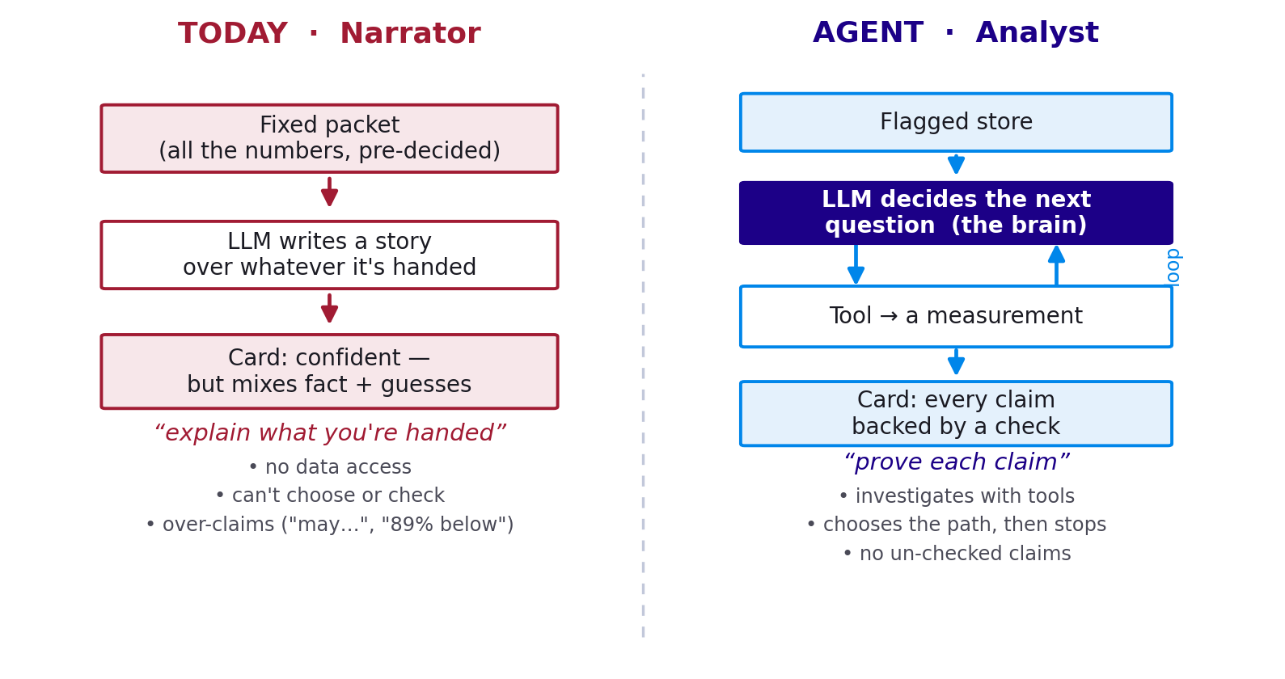
Figure 1 — The same store, two philosophies: explain what you're handed vs prove each claim.
Why premade tools ≠ a narrator
Fixing the menu of possible actions is not the same as fixing the actual actions. A doctor has a fixed set of tests but isn't “just narrating” — the skill is which tests to order, in what order, and what the results mean. With tools, PRISM's path is different for every store and driven by what each result reveals.

4. How the agent works: the investigation loop
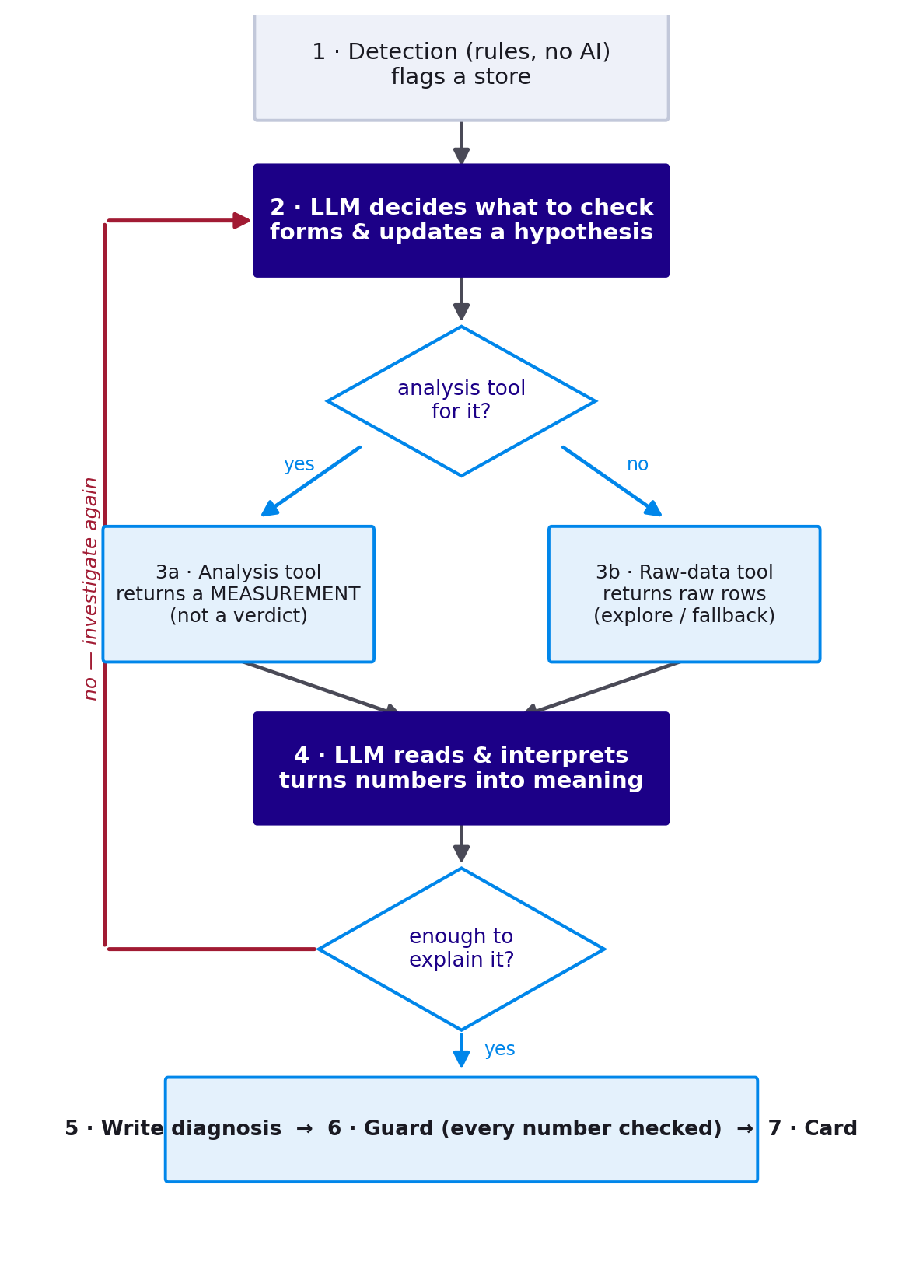
Figure 2 — The agentic loop. The model decides, a tool measures, the model interprets, and it repeats until it can explain the store.

Two kinds of tools
Tools come in two flavours, and both matter:
- Analysis doors — do a calculation and return a measurement, not a verdict (e.g. decompose_sss → “transactions +137, ticket −0.37,” not “it's a traffic problem”). This is the common path.
- Raw-data doors — hand back the actual rows so the model can look for itself (get_store_weeks, list_columns). The fallback for questions no analysis tool covers — the thing that stops the agent being boxed into pre-built KPIs.
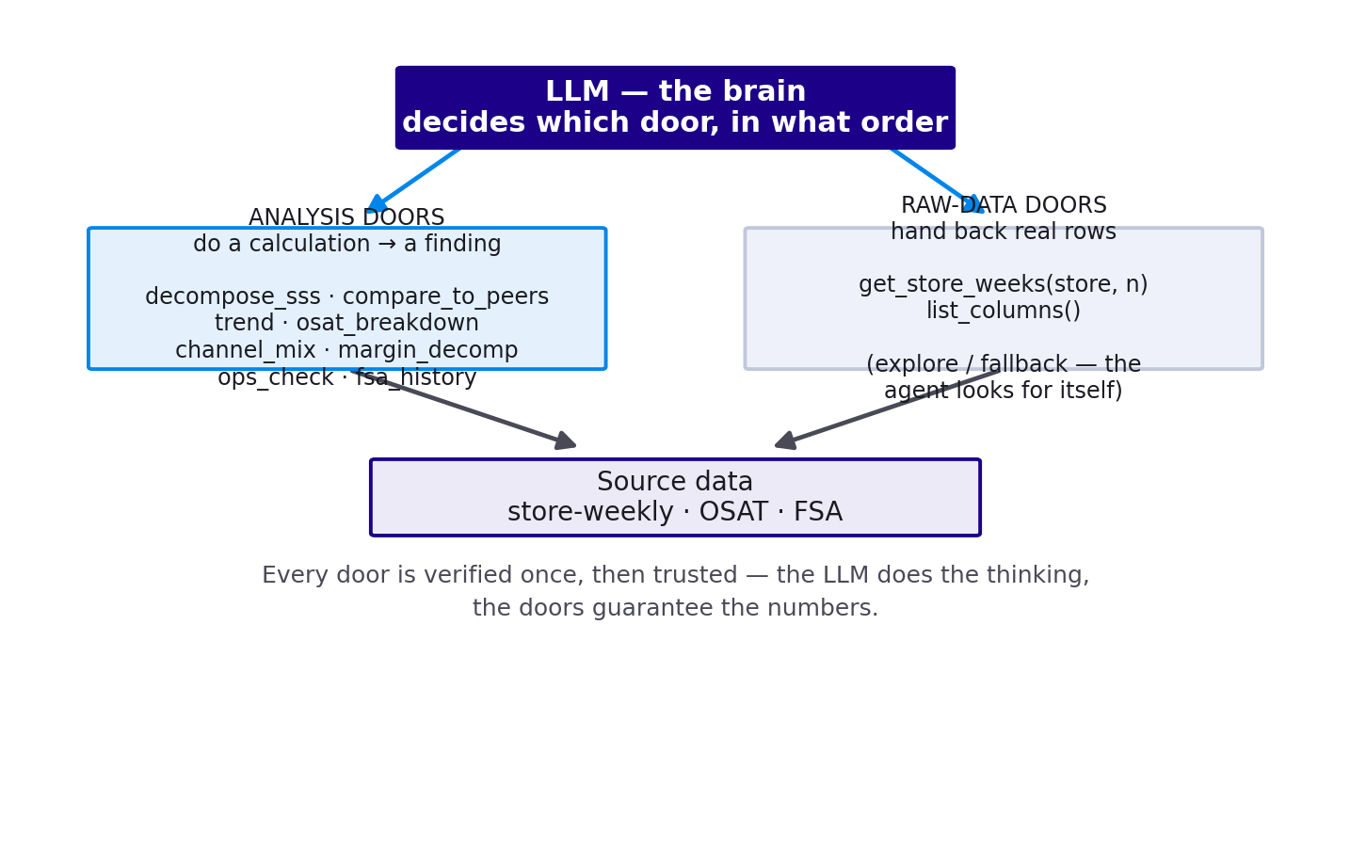
Figure 3 — The toolbox: the LLM is the brain; analysis doors and raw-data doors are its hands.
The rule that keeps the LLM a brain
Tools must return measurements, never verdicts. The moment a tool returns “the cause is X,” the thinking has moved into the tool and the LLM is a narrator again. Keep the tools dumb and factual; keep the judgement in the model.

Deciding when it's “done”
The “enough to explain it?” decision is not the model's gut alone. It proposes to stop, wrapped in structure:
- Definition of done — a complete diagnosis needs a root cause, evidence, store-vs-market settled, the obvious alternatives ruled out, and an action. The playbook's cause list is exactly what it must knock down first.
- Justified confidence — a confidence score with a reason; low confidence → another round.
- Hard caps — a max number of tool calls, and “stop if the last call didn't change the hypothesis.”
- Backstop — if it stops too thin, the guard rejects it and falls back. And “can't rule this out — no data” is a valid stop.

A real dry run — store #8019
Real numbers (FBC Marcus Webb, week of 25-05-2026). Notice the data overturns the obvious assumption:
- decompose_sss → transactions up (+137), ticket down (−0.37) → “ticket-led, not a traffic problem.”
- compare_to_peers → 8019 = 0.1, but the whole Marcus Webb cohort averages 1.4 → “partly cohort-wide, not purely store-specific.”
- trend → near 1 for months → “chronic, not a sudden collapse.”
- osat_breakdown → Service steady (4.0), Value weakest (3.8) → “not a service problem; a value/price-perception angle.”
- get_store_weeks (raw door) → confirms visits rising, ticket easing, OSAT flat.
Diagnosis: “Chronically soft sales, ticket-led not traffic; cohort-wide across Marcus Webb with 8019 at the low end; Value is the weak driver. Act at the FBC/area level (promo mix, upsell, value messaging), not a single-store service fix.”

5. Why it's better — the same card, disciplined
“More informative” isn't the goal; “reliably correct” is. Here is the current #8019 card, claim by claim, against what the agent would produce:
Claim on the card | Current PRISM (narrates) | Agentic PRISM (proves)
The drop | “89% below trailing average” — a ratio of a tiny % | “0.8 points below recent average (0.91→0.10)” — as the tool measured it
Ticket as root | “AvgTicket leads SSS by 2 wks” — real lead/lag | Kept — it came from an actual check
Store vs market | “clear laggard… not a market headwind” | Cohort avg is 1.4 (also far below 5) → “worst in a soft cohort,” won't over-claim
OSAT | “may suppress… ticket” — untested “may” | Tests it: Value (3.8) is the weak driver, reported with evidence
Food safety | “82 … may reflect service quality” (CONTRIBUTING) | Checks: 82 is above the 80 floor → not a factor → removed

Two things jump out: the agentic card has no “may” anywhere (every “may” in the current card is a spot where it's guessing), and it's shorter — but every line is load-bearing.
Confident essay vs evidence file
The current card is a confident essay. The agentic card is an evidence file — every line traces to a check. For something a franchisee acts on, you want the evidence file, even if it's less dramatic. Rich-but-partly-wrong is more dangerous than lean-but-right, because it's persuasive.

6. What changes across the system
The agent doesn't just improve the card — it reshapes several subsystems:
Area | Today | With the agent
Detection | Deterministic rules (kept). Recently recalibrated: point-drops not ratios, FSA floor-only, per-metric bands. | Unchanged — still rules-first, so “what's a problem” is never the model's call.
Metric correlation | Lead/lag correlation auto-narrated as “root cause.” | Becomes a tool the agent calls — and cross-checks against decomposition/peers before calling it a cause.
Store correlation | Counts flagged stores sharing an FBC/area/region — co-occurrence, no cause. | Correlates on shared root cause; rolls several stores into one systemic insight.
External factors | Absent (not in the data). | Raised as labelled hypotheses (“worth checking — not confirmed”), steered by the store-vs-cohort signal.
Routing | Flat: whole hierarchy attached to every card. | Cause- and level-aware: store issue → FBC; cohort issue → up a level. Contacts still resolved deterministically.
Email / Teams alerts | Severity-gated, one per insight. | Fewer, higher-confidence; rolled-up (5 stores → 1 alert); carry a decision; actionable with no nagging.

The correlation and routing changes are tightly linked — a shared cause across a cohort is exactly what turns five store alerts into one area alert, routed a level up:
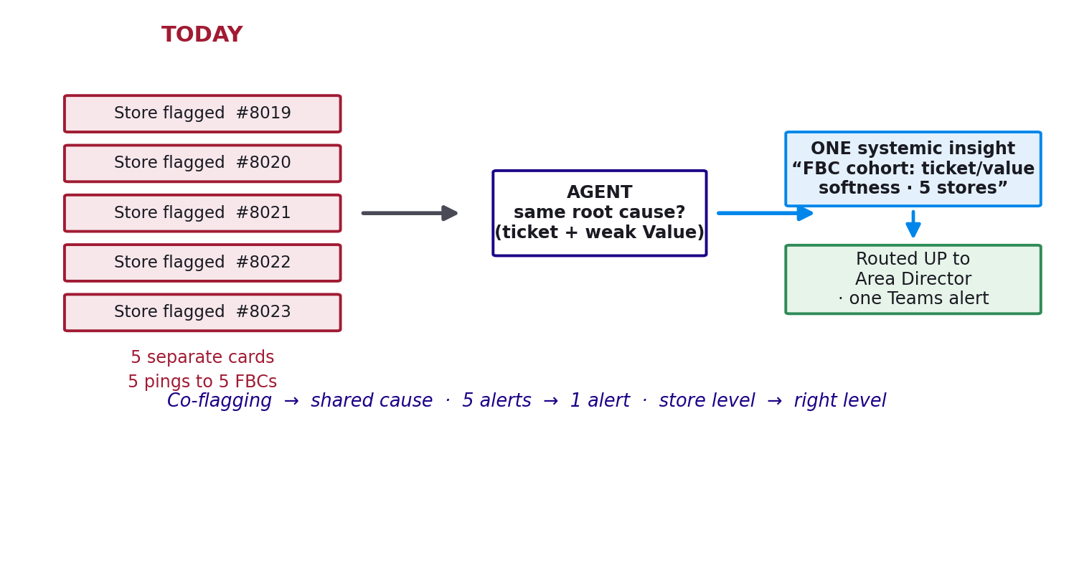
Figure 4 — From co-flagging to shared-cause: five separate store pings become one systemic insight, routed to the right level.
The connecting idea
A shared cause across a cohort is the strongest cue that an external / market factor is in play. When the agent finds five stores with the same root cause, that's when it raises market-level hypotheses; one isolated store points at local ones. Correlation tells the external-factor step where to look.

7. The guardrails that keep it safe
The agent gains freedom, but inside firm limits — the governing rule is that freedom scales with oversight:
- Tools return measurements, never verdicts — the thinking stays in the model.
- Prefer an analysis tool; drop to raw data only when none fits — most steps stay verified.
- The guard still validates every cited number and can fall back deterministically.
- The model chooses the tier and content; the deterministic layer resolves the real contacts and decides whether/when to actually send — the LLM never fires an email itself.
- Unattended path (auto-routed cards) → verified tools. Human-in-the-loop chat → open SQL is fine, because a person reviews it.

8. Where this sits, and the build path
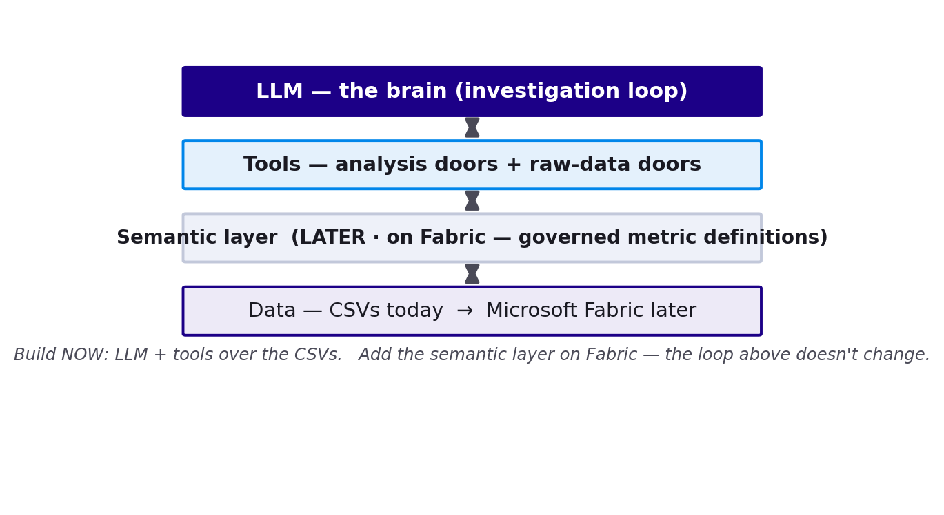
Figure 5 — The layers. Build the loop and tools now over the CSVs; the semantic layer slots in beneath the tools on Fabric.
Build NOW (prototype): the LLM + a handful of analysis tools + the raw-data door + the loop, over the current CSVs. This proves the analyst thesis — the risky, high-value part — cheaply, with no new infrastructure. Keep every metric definition in one place so the tools are swappable later.
Add LATER (Fabric): a semantic layer — the governed, business-language definitions of every metric — slots in beneath the tools. The tools stop hand-writing SQL and ask the Power BI model, so PRISM and the dashboards share one definition of truth. The agent loop above doesn't change.
Focus
LLM-as-brain is the priority; the semantic layer is what lets you scale it safely later, not what proves it works. Prove it first, cheaply; formalise the foundation once you're on Fabric and it pays off.

9. Current vs agentic — at a glance
Dimension | Current (narrator) | Agentic (analyst)
Data access | None — sees a fixed packet | Through verified tool doors (measurements + raw rows)
How claims are made | Narrates whatever's handed | Proves each claim with a tool result
Investigation path | One pass, fixed | Chosen per store; loops until confident
Distortion risk | “89% below,” phantom causes, “may…” | Point moves; no un-checked claims; no “may”
Correlation | Co-flagging by hierarchy | Shared-cause, rolled up to one insight
Routing / alerts | Flat; one alert per insight | Cause/level-aware; rolled-up, actionable
Trust | Confident essay | Evidence file — auditable, reproducible

Bottom line: the agent makes PRISM an actual analyst instead of a narrator — the deck's promise (“the data decides, every number checked”) becomes literally true, with each claim earned rather than asserted.

