PRISM
v2 — Technical Reference
The agentic Jersey Mike's data assistant — how the whole tool works

A proactive engine that flags every store's issues, has an AI agent investigate the cause with validated tools, groups them into systemic patterns, and routes each to the right owner — the data decides, the agent explains, every number is checked.
Scope: the current v2 system (reasoning.use_tools = true) — WWT / Jersey Mike's

Contents

1. What PRISM v2 is
PRISM is the proactive half of the Jersey Mike's data assistant. Every week it reads all stores' balanced-scorecard metrics, finds the ones genuinely off, and — this is the v2 change — has an AI agent investigate the cause by calling validated tools, rather than narrating a fixed summary. It then links related stores into systemic patterns and routes each issue to the responsible owner.
The shift from v1 to v2 is narrator → analyst:
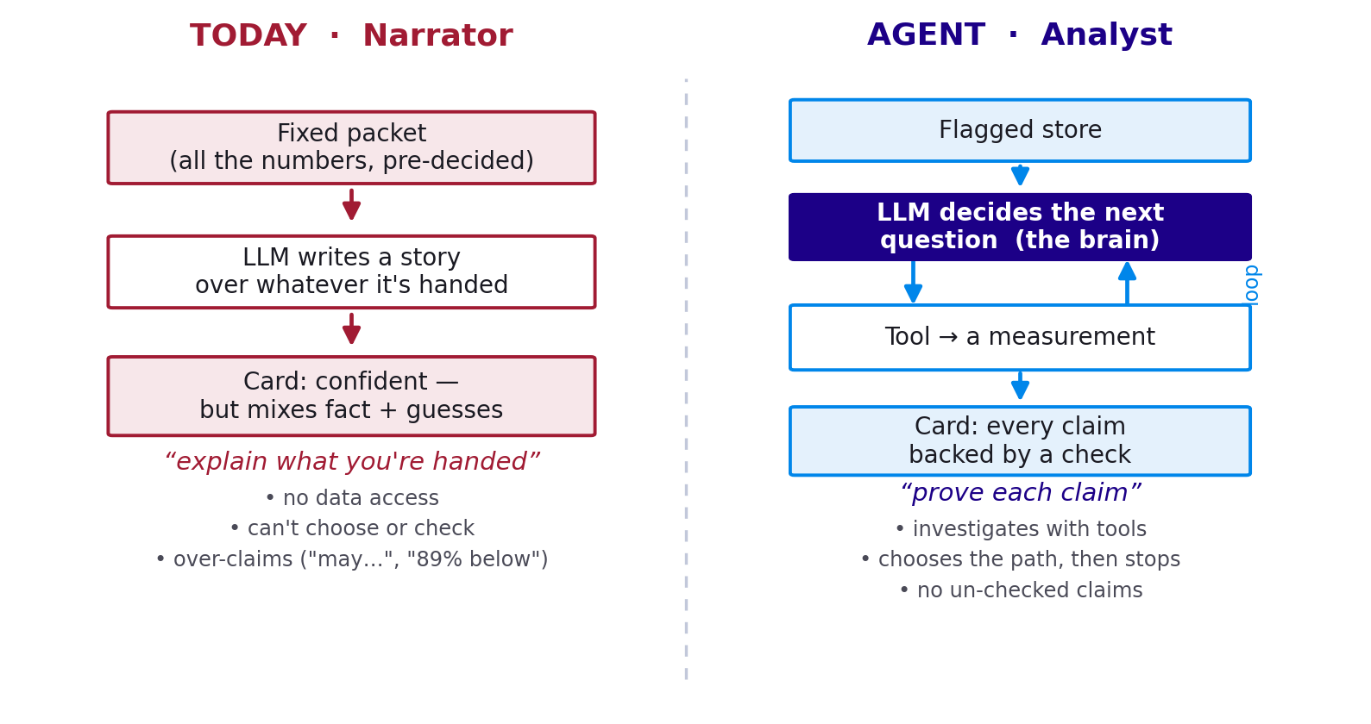
Figure 1 — v1 narrated a fixed packet; v2 investigates with tools and proves each claim.
The one-line difference
v1 asked the model “write a story that fits these numbers.” v2 asks “prove each thing you claim.”
The data still decides what's wrong; the agent explains why; every number it cites comes from a tool and is validated.

2. Architecture — the pipeline
A run is a deterministic pipeline with the agent at exactly one step. Detection, enrichment, grounding, correlation, routing and persistence are all plain code; only the store diagnosis is agentic.
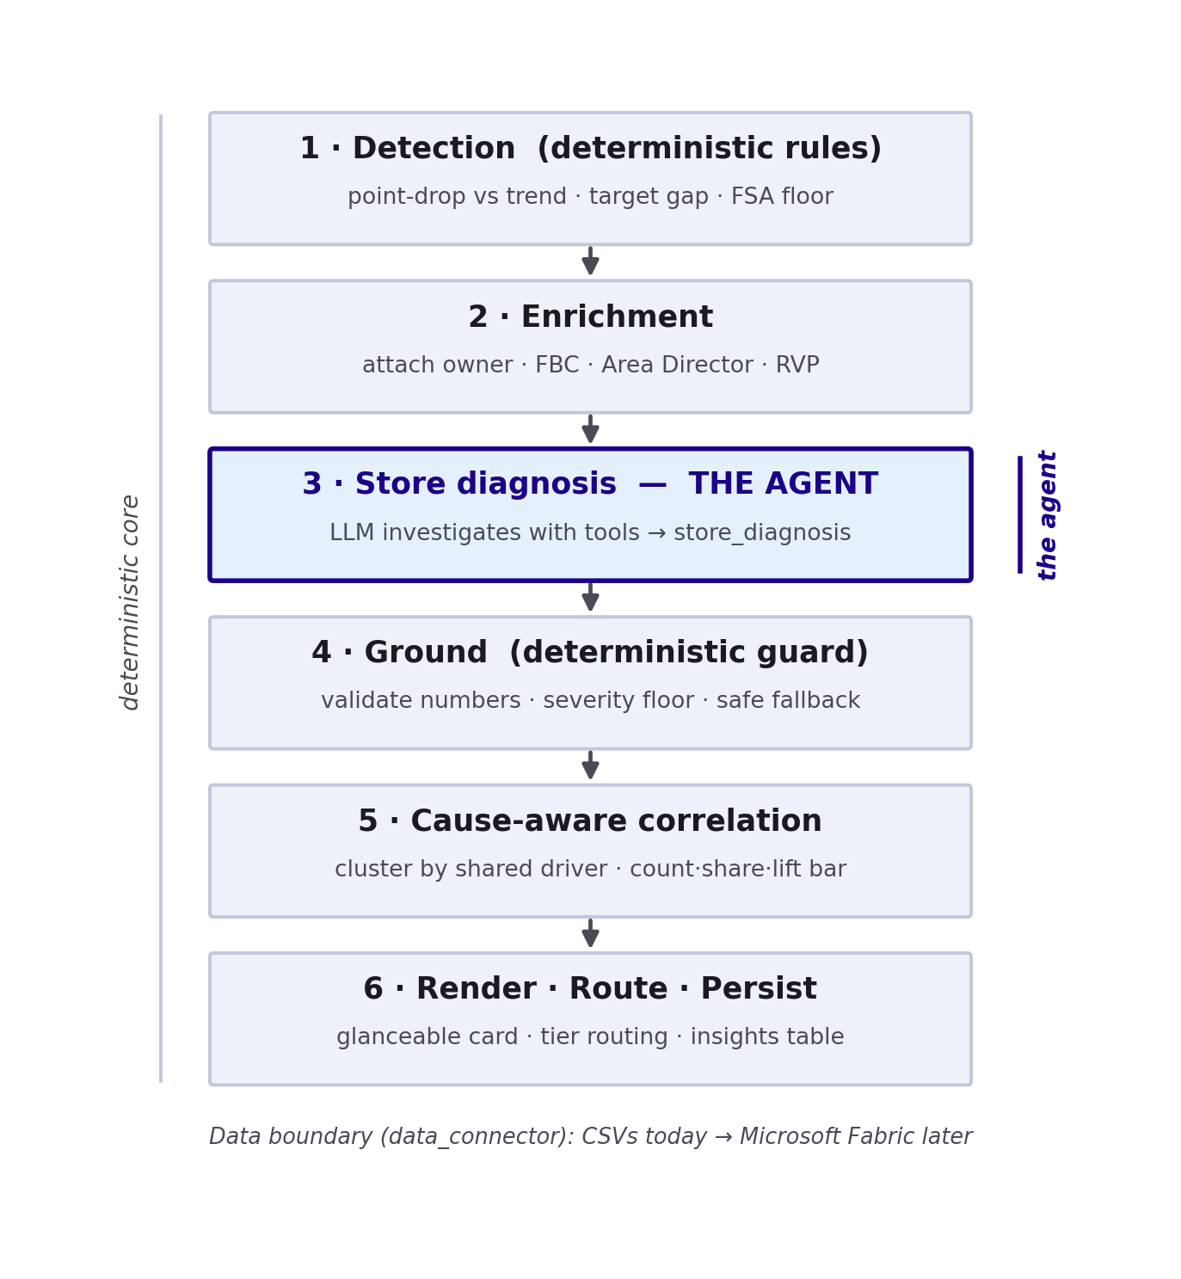
Figure 2 — The six stages. Everything is deterministic except stage 3 (the agent).
All data access goes through one module (data_connector) — the single point that repoints from local CSVs to Microsoft Fabric in production, with nothing else changing.

3. Detection — deterministic, recalibrated
Detection decides which stores are off, by rules only (never the AI), so the trust story holds. Three fixes were calibrated from the real data:
- Food safety: flag only below the 80 safety floor, not the aspirational 93 target (111 → 7 alerts).
- Percentages: rate metrics compare in POINTS (latest − trailing), never a ratio — so a 0.8-point dip reads as 0.8 points, not “89%”.
- Severity bands: per-metric point + target-gap cutoffs set from each metric's real volatility, replacing one global ratio band.
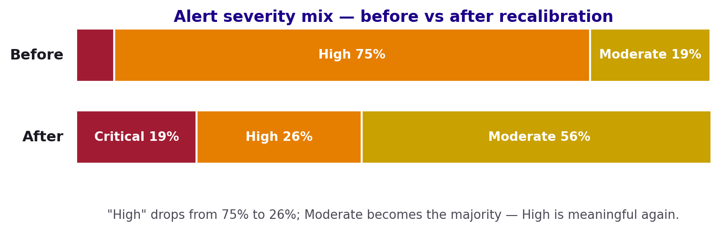
Figure 3 — Recalibration impact: “High” fell from 75% to 26% of alerts; Moderate is now the majority.

4. The agent — LLM as analyst

4.1 The investigation loop
For each flagged store the agent runs a loop: decide the next question, call a tool, read the measurement, decide again — until it can explain the store, then emit a structured store_diagnosis. A tool-call budget guarantees it concludes.
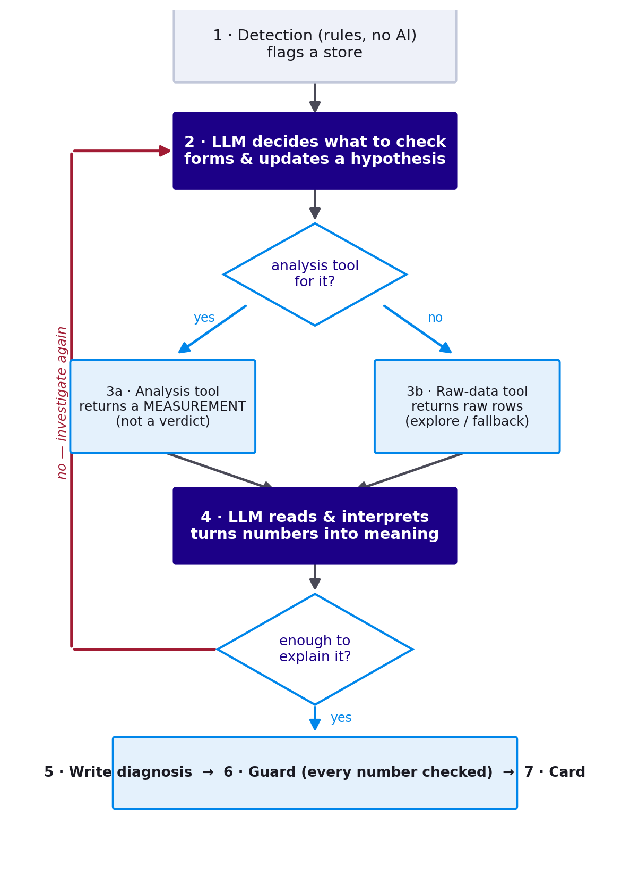
Figure 4 — The investigation loop (agent_loop.diagnose_store_agentic).

4.2 The tools
Two kinds of tools. Analysis doors return a measurement (a calculation, not a verdict); raw-data doors hand back the actual rows so the agent can look for itself. Every tool is read-only and verified once.
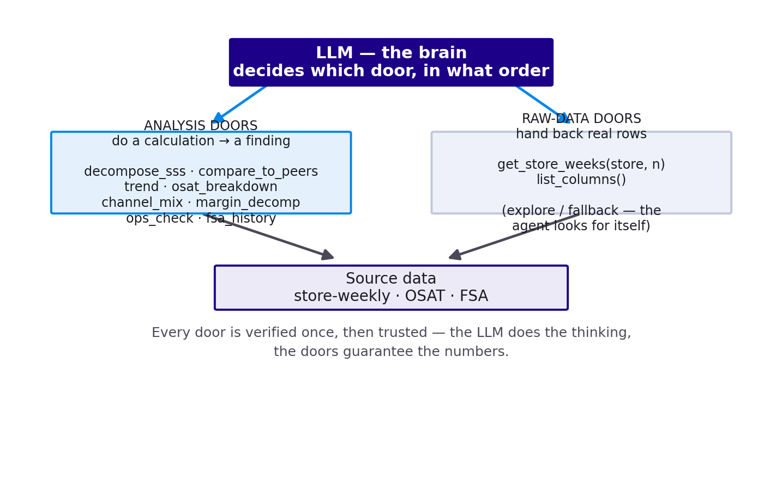
Figure 5 — The toolbox: analysis doors + raw-data doors, over the store data.

4.3 The store_diagnosis output
The agent returns one structured object (forced tool-use). Each field maps to the card:
Field | What it is
severity · confidence · scope | Critical/High/Moderate · High/Med/Low · store-specific vs cohort-wide
driver | One structured tag (traffic, ticket_value, guest_experience, food_safety, cost_margin, operations) — used to cluster stores
headline | One plain sentence with the key number
primary_metric · trend | The hero number + target, and the recent series for the sparkline
peer | This store vs its cohort average (the peer bars)
root_cause · causal_chain | The cause in plain words + how the metrics connect
recommended_action · action_context | One imperative next step + short why
also_check | External factors it could not test, labelled “not confirmed in data”
secondary_issues | Independent problems in the same store (multi-root), each with its own cause/action/route
suggested_route | The tier the agent thinks should own it (FBC / Area Director / RVP / Functional)
evidence · cited_values · unresolved | The tool trail, every cited number (for the guard), and what it couldn't test

Two rules that keep the agent honest
Tools return measurements, never verdicts — the moment a tool concludes, the thinking leaves the model. And the agent never asserts what it hasn't checked — unprovable causes go in also_check, not the root cause.

4.4 Grounding
Before a diagnosis is shown, ground.ground_agent enforces the severity floor: the worst deterministic severity across the store's anomalies (and an FSA floor breach) can raise severity but the AI can never lower a hard rule. The overall badge is the worst of the primary and any secondary issues. If the agent is unavailable, PRISM falls back to the deterministic diagnosis so no store is dropped.

5. The output card
The card is a glance: severity, one number, where it sits vs peers, one cause, one action — with the evidence tucked behind “View full breakdown.”
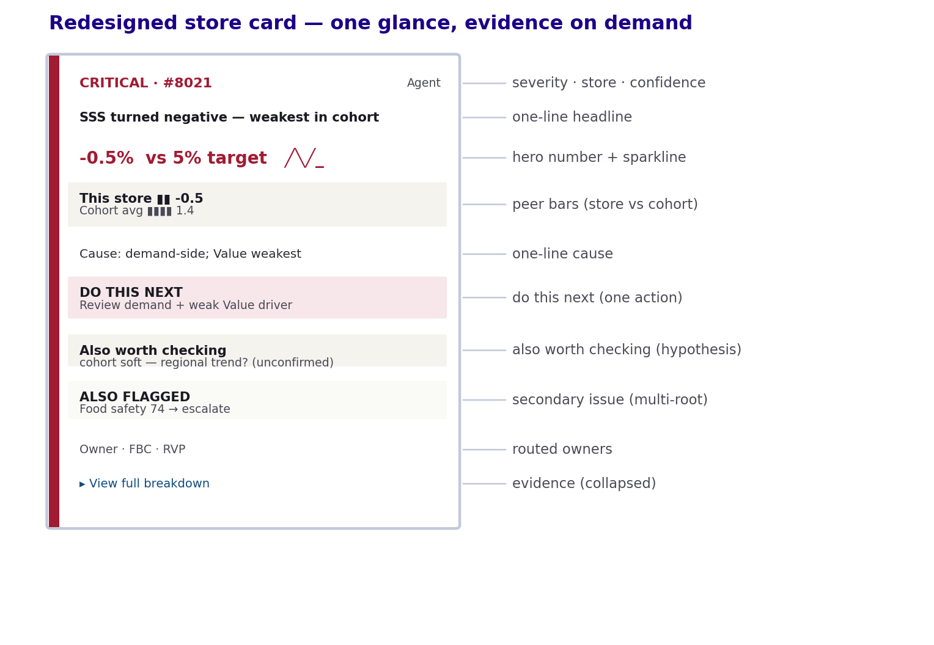
Figure 6 — Anatomy of the redesigned store card.
Multi-root: when a store has genuinely independent problems (e.g. a sales issue AND a food-safety breach), the most urgent is the primary and the rest appear as compact “Also flagged” blocks with their own action and owner — not blended into one narrative.

6. Cause-aware correlation
Every flagged store gets a cheap deterministic driver tag (the agent's richer driver overrides on the diagnosed cards), so correlation sees the whole fleet. Stores that share a driver under one FBC are clustered — turning “N stores flagged” into “N stores share ONE cause.”
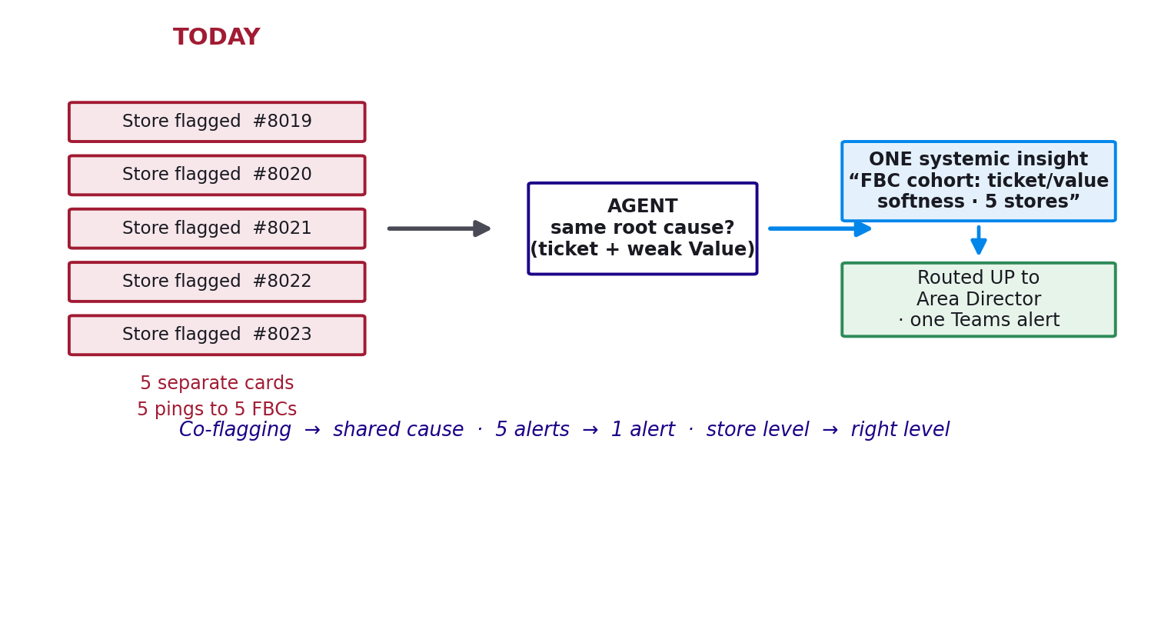
Figure 7 — From co-flagging to shared-cause: several stores roll up into one systemic insight.
But a cluster is only called systemic if it clears all three bars — so weak coincidences are dropped:
- count ≥ 3 stores,
- share ≥ 40% of that FBC's stores, and
- lift ≥ 1.8× — the driver is that many times more common here than fleet-wide.
Why the lift test matters
On the real data, “8 stores under one FBC share guest-experience” looks huge — but guest-experience is the fleet norm (53%), so it's just background and gets dropped. Meanwhile a 7-store cohort that's 2.3× the fleet's ticket-value rate is surfaced as genuinely systemic. Concrete correlation, not any correlation.

7. Routing & alerts
Alerts route by cause and level, not a fixed owner list. The agent picks the tier (suggested_route); the org table resolves the actual person; if a tier is unassigned it escalates up the chain. A store-specific issue goes to the FBC; a systemic or food-safety issue goes up (Area Director, or RVP if no Area Director exists). Secondary issues route separately — so a store's sales problem can reach the FBC while its food-safety breach reaches the Area Director. The composed message and the dispatch bar show the real recipients; the model never invents a contact.

8. Persistence & the data boundary
Diagnoses are written to an insights table (SQLite; the machine-owned record — upserted, auto-resolving when a store recovers) and mirrored to a CSV a Power BI dashboard reads. Human feedback (👍/👎/acknowledge) writes to a separate insight_actions table so re-runs never clobber it. All reads/writes pass through data_connector — the one place repointed at Microsoft Fabric in production.

9. Configuration reference
Everything below is tunable in prism_config.yaml (no code change):
Knob | What it controls
reasoning.use_tools | true = the v2 agent (tools + loop); false = the v1 single-call narrator
reasoning.max_tool_calls | Investigation budget per store before the agent must conclude (default 8)
reasoning.max_store_cards | How many stores get the agentic diagnosis per run (default 12)
metrics.* (is_rate, point/target bands) | Per-metric detection sensitivity + severity cutoffs (calibrated)
fsa.flag_below_target | false = flag food safety only below the 80 floor
correlation.min_stores / min_share / min_lift | The strict bar for a systemic cluster (3 / 40% / 1.8×)
correlation.fallback / fallback_min_stores | Looser fallback when nothing clears the bar (≥3, marked “Possible”)
insights_export.* | The SQLite table + CSV mirror the dashboard reads

10. File-by-file map
File | Role
agent.py | Orchestrator: detection, enrichment, correlation (co-flag + cause-aware), routing helper, run_analysis
agent_loop.py | The v2 investigation loop + store_diagnosis schema + system prompt
tools.py | The 10 read-only tools (analysis + raw-data doors)
ground.py | Validation + severity floor (ground / ground_agent)
diagnose.py | Deterministic per-metric diagnosis + severity (the fallback brain)
evidence.py | Per-store evidence packet: peer context, lead/lag, sub-scores
data_connector.py | The single data door (CSV today → Fabric later); read-only guard; CSV write
alert_store.py | SQLite persistence: insights + insight_actions (feedback / auto-resolve)
config.py / prism_config.yaml | All tunable knobs
app.py / agent_ui.py | The Streamlit UI: cards, patterns, dispatch, Ask PRISM (only these import Streamlit)

11. Guardrails — the trust model
- Detection is deterministic — the data decides what's a problem, never the model.
- Tools return measurements, never verdicts; the agent only uses numbers a tool returned.
- The guard validates cited numbers and enforces a severity floor the AI can't undershoot.
- The agent proposes the routing tier; the org table resolves the real person — no invented contacts.
- Freedom scales with oversight: verified tools on the unattended card path; open SQL only in the human-reviewed “Ask PRISM” chat.
- Safe fallback: if the agent is unavailable, PRISM falls back to the deterministic diagnosis.

12. Where it runs, and the path to production
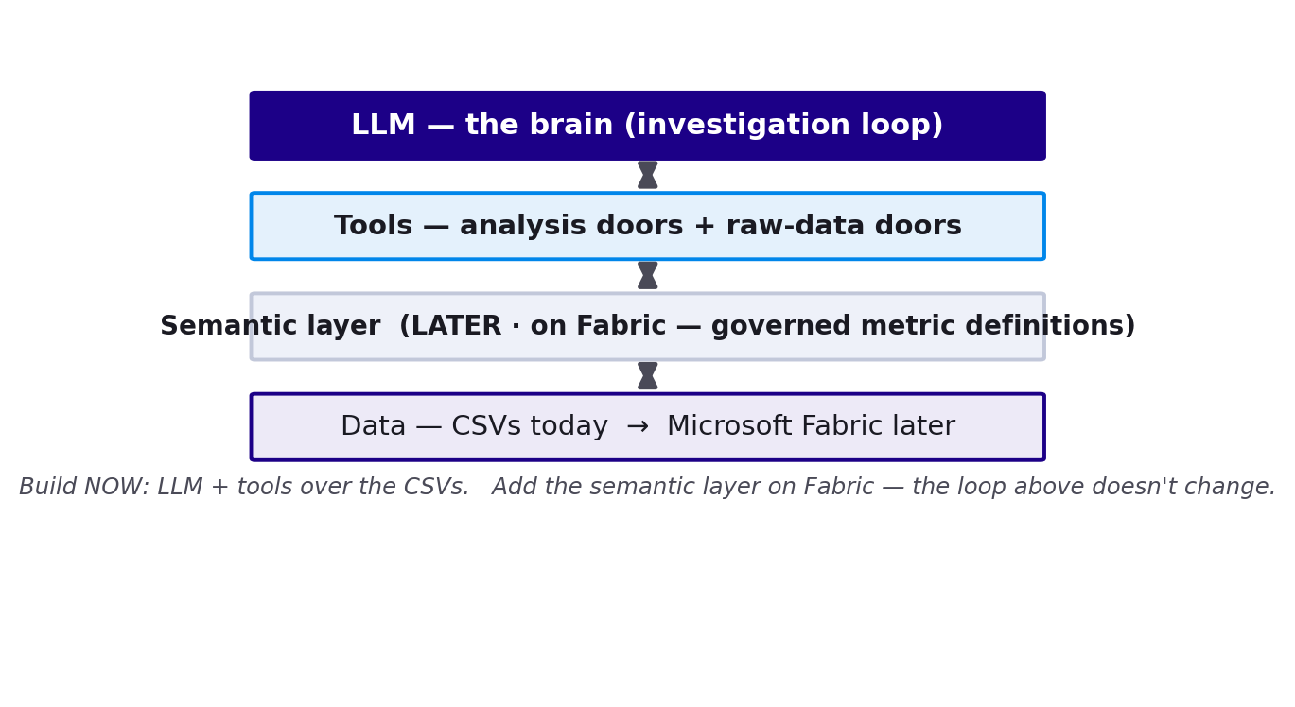
Figure 8 — The layers. Build now over CSVs; the semantic layer slots in beneath the tools on Fabric.
Today PRISM runs on local CSVs. In production, data_connector repoints at Microsoft Fabric, the reasoning model moves to Azure OpenAI in-tenant, Power BI reads the insights table (with row-level security by owner/region), and a semantic layer under the tools makes PRISM and the dashboards share one definition of truth — the agent loop above does not change.

13. v1 vs v2 — at a glance
Dimension | v1 (narrator) | v2 (agent)
Diagnosis | Narrates a fixed packet | Investigates with tools, proves each claim
Data access | None (sees a summary) | Verified tool doors (measurements + raw rows)
Card | Text-heavy paragraph | Glanceable: number, sparkline, peer bars, one action
Multiple problems | One forced narrative | Primary + independent secondary issues
Correlation | Co-flagging by hierarchy | Shared-cause clusters (count · share · lift)
Routing | Fixed owner + RVP | By cause + level; escalates; per-issue
Trust | Confident essay | Evidence file — auditable, reproducible

Bottom line: v2 makes PRISM an actual analyst — the promise “the data decides, every number checked” becomes literally true, with each claim earned rather than asserted.

