PRISM
A Plain-English Guide
What it is, the idea behind it, and how it works — written for anyone, no background needed.

Contents
1. Start here — what is PRISM?
2. The one big idea
3. How it works, step by step
4. The AI part, explained simply
5. What you actually get
6. “Ask PRISM” — the chat, explained
7. Seeing the bigger picture
8. Who gets told
9. Under the hood — the pieces
10. The technology, briefly
11. What was built (and recently fixed)
12. Glossary — every term in plain words

1. Start here — what is PRISM?
Imagine a company with a few hundred stores. Every week, numbers pour in for each one — how much it sold, how happy customers were, food-safety scores, profit. To keep track, the company builds dashboards: screens full of charts and red-and-green numbers.
Dashboards are great at one thing — showing you what happened. “This store's sales are down.” There's the red number. But they stop there. They never tell you why it happened, or what to do about it. A person still has to notice each red number, dig in, work out the cause, and decide who should fix it — across hundreds of stores and a dozen numbers each. That's thousands of little warnings a week, and no human can chase them all, so most are missed.
PRISM is software that does that chasing automatically. Once a week it looks at every store, picks out the few that are genuinely in trouble, works out the likely reason, writes it in plain English, and sends it to the right person — before anyone even goes looking. The simplest way to picture it: a tireless analyst who reviews every store, every week, and never gets tired, distracted, or runs out of time.
In one sentence
PRISM turns a mountain of weekly numbers into a short list of “here's the store that needs attention, here's why, and here's what to do about it.”

2. The one big idea
PRISM deliberately mixes two kinds of software. Most of it is ordinary, predictable code — rules that do the exact same thing every time. Only one step uses AI — the kind of technology behind ChatGPT-style tools — and its job is to explain, in human words, why a store is struggling.
Why split it this way? Because AI is wonderful at explaining things in plain language, but it can also be confidently wrong. So PRISM lets the AI do only the part it's uniquely good at — the explaining — and keeps everything else (deciding which stores are off, checking the numbers, deciding who to notify) as plain, testable code you can fully rely on. And even the AI's explanation is fact-checked before anyone sees it.
Why it matters
This is what makes PRISM trustworthy. The computer decides what is wrong (with fixed rules); the AI only explains why (and must back it up with real data). You get the AI's clarity without betting the whole system on it being right.

3. How it works, step by step
Every week, PRISM runs the same short assembly line. Each stage hands its work to the next.
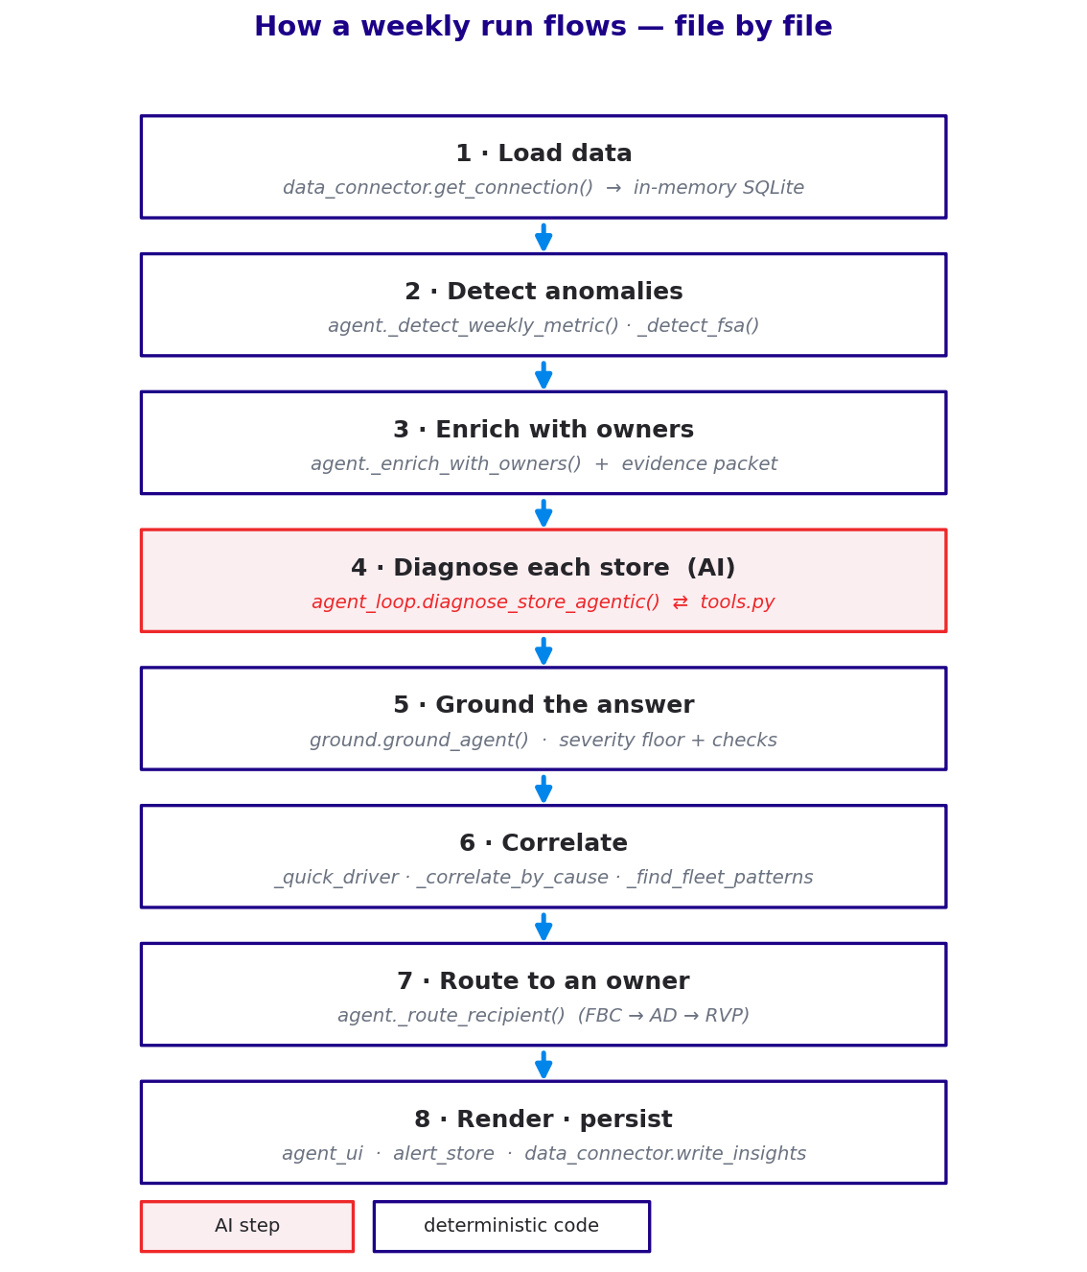
Figure 1 — the weekly assembly line, and the file that does each stage.
- Load the data — PRISM reads the week's numbers for every store.
- Detect — fixed rules pick out the stores that are genuinely off, and rank them worst-first. (This is not the AI — it's rules, so it behaves the same every week.)
- Add owner info — it attaches who is responsible for each flagged store (region, field consultant, and so on).
- Diagnose — the AI step: for each flagged store, it works out the likely cause and what to do. (Details in section 4.)
- Double-check — every number the AI used is re-checked against the real data; anything that doesn't hold up is thrown out.
- Find patterns — PRISM looks across the flagged stores to spot bigger, shared problems (section 6).
- Send + show — each issue is routed to the right person and shown as a simple card (sections 5 and 7).
Here's a single store travelling through that whole line, start to finish:
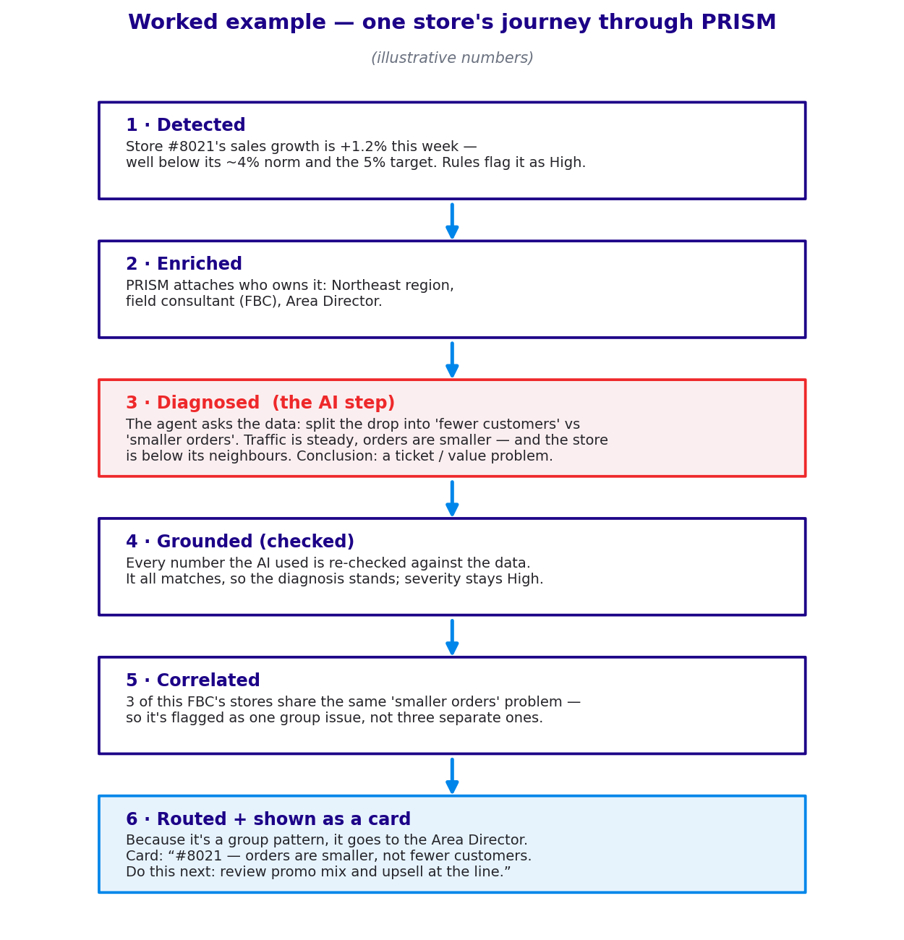
Figure 2 — a worked example (illustrative numbers).

4. The AI part, explained simply
When people hear “AI,” the fair worry is: won't it just make things up? PRISM is built so it can't. Here is how the AI actually works, in plain terms.
The AI is treated like a detective, not a storyteller. It is not handed the answer — it has to investigate. It's given a small set of tools, which you can think of as specific questions it is allowed to ask the data:
- “Split this store's sales drop into fewer customers versus smaller orders.”
- “How does this store compare to its neighbours?”
- “Is this a sudden drop, or a slow slide over months?”
The AI chooses which questions to ask, reads the answers, and asks follow-ups — up to a set limit — then writes its conclusion. Two rules keep it honest: it can only use numbers the tools give back (it cannot invent a figure), and afterwards every number it cites is re-checked against the real data. If anything doesn't match, PRISM discards the AI's answer and falls back to a simpler, safe summary. So the worst case is not a confident lie — it's a modest “here's what we can confirm.”
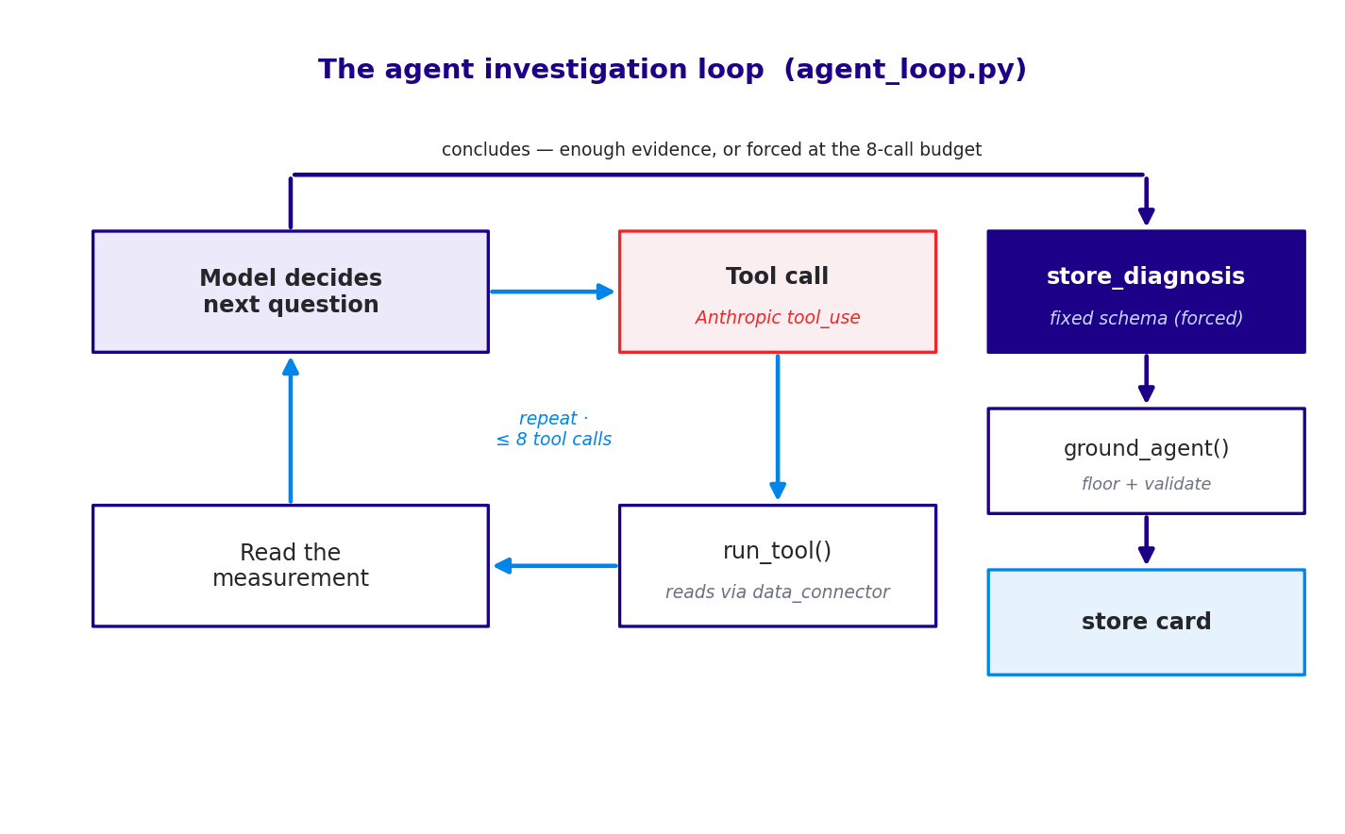
Figure 3 — the AI's investigate-then-conclude loop, and its safety exits.
Example — the AI at work
A store's sales are down. The AI first asks: fewer customers or smaller orders? The tool answers: customers are steady, orders are smaller. It then asks: how does this store compare to its neighbours? The tool answers: below them. The AI concludes: “This is a value / order-size problem, not a footfall problem,” and recommends reviewing promotions and upselling — a conclusion it can point to real numbers for.

5. What you actually get
The output is one simple card per store — a conclusion, not a pile of charts. Each card shows the store, the single number that matters (with a small trend line), how it compares to similar stores, the likely cause in a sentence, and — most importantly — the one thing to do next. It's written the way a good analyst would hand it to you across a desk.
Example card
Store #8021 — sales growth soft (+1.2% vs 5% target).
Cause: orders are getting smaller, not fewer customers coming in.
Do this next: review the promo mix and upselling at the counter.
Also worth checking: local competitor activity (not confirmed in the data).

6. “Ask PRISM” — the chat, explained
Alongside the weekly cards, PRISM has a chat box called Ask PRISM. It lets anyone get answers by typing an ordinary question, instead of clicking through screens. You can ask two very different kinds of question, and PRISM quietly works out which kind you mean.
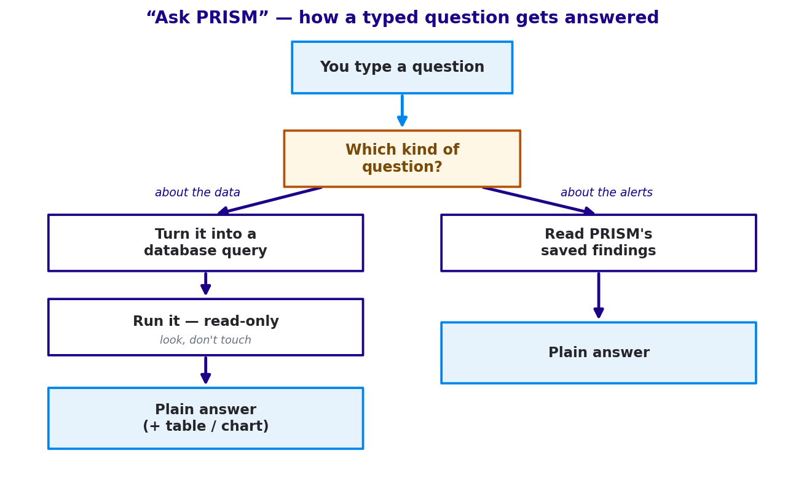
Figure 4 — the chat routes your question down one of two paths.
1. Questions about the data — the raw numbers. For example, “top 10 stores by sales” or “which stores have the lowest food-safety score?” Behind the scenes, PRISM turns your plain-English question into a database query, runs it, and turns the result back into a plain answer — usually with a small table or chart you can download.
2. Questions about PRISM's findings — its alerts. For example, “why is store 8021 flagged?”, “which stores are most serious?”, or “what did PRISM recommend for the Northeast?” For these, PRISM reads from the diagnoses it already saved and phrases the answer — no new query needed.
How does it decide which is which? A quick look at the words: if your question mentions things like flagged, alert, severity, why, or recommend, it's treated as a findings question; otherwise it's a data question. It also remembers the last few turns, so natural follow-ups like “which is the second highest?” still work.
Example — a data question
You ask: “Top 5 stores by weekly sales.”
PRISM builds a read-only query, runs it, and replies: “Here are the top 5 by sales this week: …” — with a small table you can download.
Example — a findings question
You ask: “Why is store 8021 flagged?”
PRISM answers from its saved diagnosis: “Sales growth is soft (+1.2% vs a 5% target). The cause looks like smaller orders rather than fewer customers; the suggested action is to review the promo mix and upselling.”
One safety point worth repeating: for data questions, the query PRISM builds is locked to read-only — it can look at the data but never change it. This is the one place open-ended questions are allowed, and it's always a person reading the answer and deciding what to do with it.

7. Seeing the bigger picture
PRISM doesn't only look at one store at a time. After it diagnoses the individual stores, it steps back and looks for patterns — the same problem showing up in several places at once.
- If several stores under the same manager share the same problem, PRISM groups them into one issue — so it becomes a single conversation with that manager, not five separate phone calls.
- If a problem shows up almost everywhere — across many regions and managers — PRISM calls it a company-wide issue and sends it up to leadership, because a problem that broad isn't any one store's fault.
Example — a pattern
Seven of one manager's stores all have the same “smaller orders” problem. Instead of seven separate alerts, PRISM raises one: “This manager's group has a shared value/pricing issue.” One message, one owner, one fix.

8. Who gets told
Every issue is sent to the right level of the organisation, so the right person gets the things that are theirs and nobody drowns in everyone else's:
- A single store's problem goes to that store's field consultant.
- A problem across one manager's stores goes to the area director.
- A company-wide problem goes up to operations leadership.
Importantly, PRISM drafts the alert but does not fire it off by itself — a person is always the one who decides to act. It's an advisor, not an autopilot. And it only ever reads the data; it never changes it.

9. Under the hood — the pieces
PRISM is built in layers, like floors of a building. The top floor is what people see; each floor below supports it. You never need to touch these to use PRISM, but here's the map.
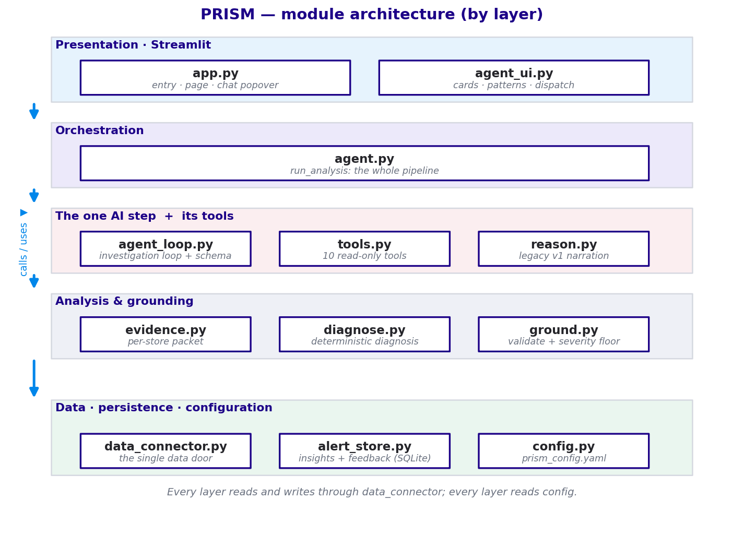
Figure 5 — the parts of PRISM, grouped by layer.
In plain terms, the main pieces are:
Piece | What it does (in plain words)
The screen | The app you look at — the cards, the patterns, and the “Ask PRISM” chat box.
The organiser | Runs the weekly assembly line from start to finish and hands work between steps.
The AI investigator | The one AI step — investigates each flagged store and writes the plain-language cause.
The toolbox | The set of specific questions the AI is allowed to ask the data.
The fact-checker | Re-checks the AI's numbers and, if needed, falls back to a safe summary.
The data door | The single place all data is read through — and later, the one place repointed at the company's main data platform.
The memory | Remembers what was flagged and any human feedback, so nothing is lost between weeks.
The settings | One file of dials (thresholds, limits) that tune PRISM without touching the code.
A note on data safety. Everything flows through one data door. Reads are locked to “look, don't touch” (the app can only read records, never change them), and the results PRISM produces are written out for a dashboard to display. Today the data lives in simple files; the door is designed so that, in future, it can point at the company's main cloud data platform with nothing else needing to change.
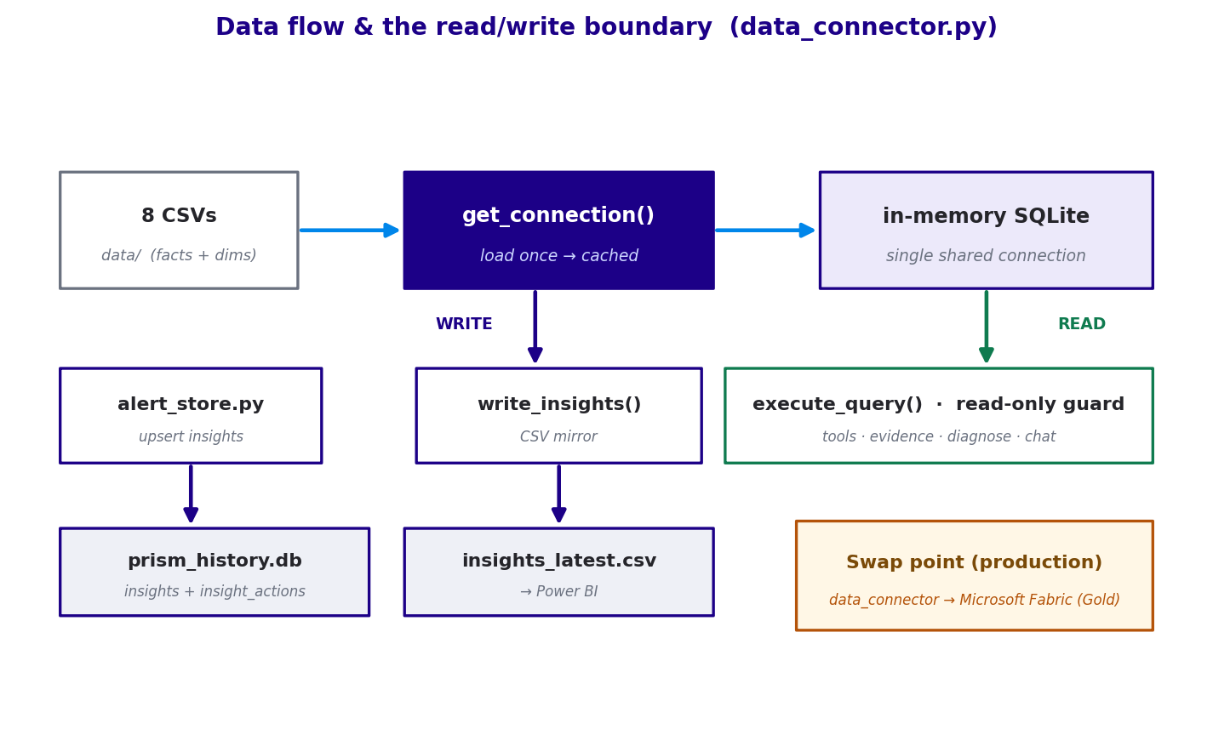
Figure 6 — how data is read and written, safely, through one door.

10. The technology, briefly
For the technically curious, PRISM is a small, standard toolkit:
- Python — the programming language everything is written in.
- Streamlit — turns the Python code into the web app you view in a browser.
- The Claude AI model (via its API) — the “brain” that does the one AI diagnosis step and powers the chat.
- pandas and SQLite — handle the tables of data and PRISM's small memory database.
- A single settings file holds all the tunable numbers, so behaviour can change without editing code.

11. What was built (and recently fixed)
The work to date, in plain terms:
- Smarter detection — the rules that flag stores were re-tuned from real data so “high priority” actually means unusual, instead of firing on most stores. Food-safety issues are treated as their own separate, always-serious case.
- The AI investigator — the diagnosis step was rebuilt so the AI investigates with tools and proves its claims, rather than just narrating numbers.
- Multiple problems per store — a store can now be flagged for more than one independent issue at once, each with its own fix.
- Pattern-finding — PRISM now links related stores into group issues, and spots company-wide problems and sends them to leadership.
- Right-person routing — each issue is now sent to the correct level (field consultant, area director, or leadership).
- A clearer card — the store card was redesigned to be glanceable: one number, one cause, one action.
- Two recent reliability fixes — the part that saves results to PRISM's memory was crashing on the AI's richer output (it expected a simpler shape). Both save paths were hardened so any result shape is stored safely — which is why results now persist correctly between runs.

12. Glossary — every term in plain words
Term | Plain meaning
Metric | A number that measures a store — e.g. sales growth, customer satisfaction, food-safety score.
Anomaly | A number that's genuinely out of the ordinary for that store — what PRISM flags.
Baseline | A store's own recent normal, used to judge whether this week is unusual.
Detection | The rules step that decides which stores are off. Not AI — fixed and predictable.
AI / GenAI model | The ChatGPT-style “brain” that writes plain-language explanations. Here, it's the Claude model.
Agent | The AI acting like a detective — asking questions (tools), reading answers, then concluding.
Tool | A specific question the AI is allowed to ask the data (e.g. “fewer customers or smaller orders?”).
Grounding | Fact-checking the AI's answer against the real data before anyone sees it.
Fallback | The safe, simple summary PRISM uses if the AI can't be trusted for a store.
Pattern | The same problem showing up across several stores — a group or company-wide issue.
Routing | Sending each issue to the right person: field consultant, area director, or leadership.
Card | The one-store summary PRISM shows: the number, the cause, and the next action.
Deterministic | Behaves the exact same way every time — the opposite of the unpredictable AI part.
That's PRISM end to end: it finds the stores that need attention, explains why in language you can trust, spots the bigger patterns, and puts the right heads-up in front of the right person — every week, without anyone having to go digging.

