Space Observation Intelligence Platform
Explore, Plan & Learn
"Discover what you can observe, plan the best time to observe it, and understand why celestial events occur."
1. Project Scope
The Space Observation Intelligence Platform is a data-driven web application that enables users to explore the night sky based on their location, date, and time. It integrates astronomical data from trusted sources, analyzes celestial information, and presents it through interactive visualizations and educational explanations.
Objectives:
- Explore: Identify visible celestial objects (planets, Moon, stars, constellations, events).
- Plan: Recommend suitable observation times and visibility info.
- Learn: Explain celestial phenomena with interactive visuals and simplified content.

2. Problem Statement
Astronomical information is scattered, technical, or focused only on visualization. Beginners struggle with questions like:
- What can I observe tonight?
- When is the best time?
- Why does the Moon change its phase?
- Why are planets visible in different positions?
This project integrates these aspects into one user-friendly platform.

3. Objectives
- Collect astronomical data from reliable sources.
- Organize and store data efficiently.
- Provide interactive exploration.
- Recommend observation windows.
- Present educational explanations.
- Build an intuitive dashboard.

4. Target Users
- Students
- Teachers
- Amateur astronomers
- Astronomy clubs
- Science enthusiasts
- Beginners

5. Functional Requirements
Explore Module
- Search by location, date, time
- Display planets, Moon phase, stars, constellations, events
Plan Module
- Recommend best observation time
- Show rise/set times, directions, observation info
Learn Module
- Explain Moon phases, eclipses, planetary visibility/colors
- Interactive animations, basic facts
Analytics Module
- Planet visibility trends
- Moon phase analysis
- Event statistics
- Interactive charts

6. Non-Functional Requirements
- User-friendly interface
- Fast response time
- Responsive design
- Reliable astronomical calculations
- Easy to extend

7. Module Specifications
Module 1 – Data Collection
- Retrieve, process, store astronomical data
- Input: APIs, astronomy libraries
- Output: Structured database
Module 2 – Explore
- Generate current night sky info
- Output: Visible planets, Moon info, events
Module 3 – Plan
- Observation recommendations
- Output: Best viewing time, visibility details, schedule
Module 4 – Learn
- Educational explanations, interactive visuals
- Output: Animations, simplified explanations, object info
Module 5 – Analytics
- Analyze datasets
- Output: Graphs, trends, dashboards
8. Technology Stack
- Programming: Python
- Database: MySQL
- Data Processing: Pandas, NumPy
- Astronomy: Skyfield, Astropy
- Frontend: Streamlit
- Visualization: Plotly, Matplotlib
- Tools: VS Code, Git, GitHub
9. Future Scope
- AI-powered astronomy assistant
- Weather integration
- Light pollution analysis
- Astrophotography recommendations
- Deep-sky object explorer
- Space mission analytics
- Mobile app

ERD:

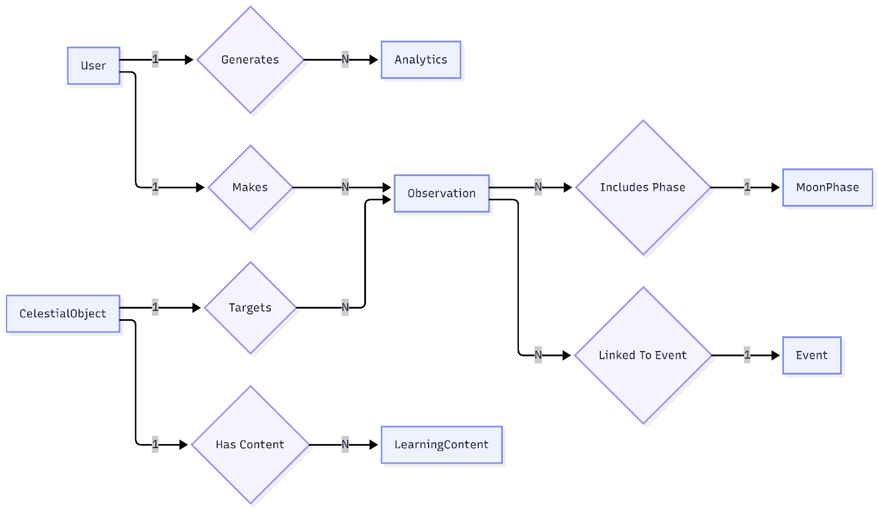

Use Case:
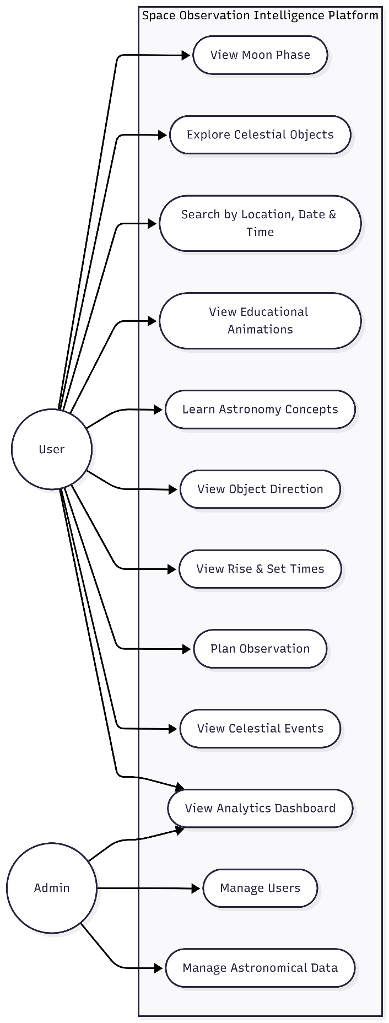

Table Structure:
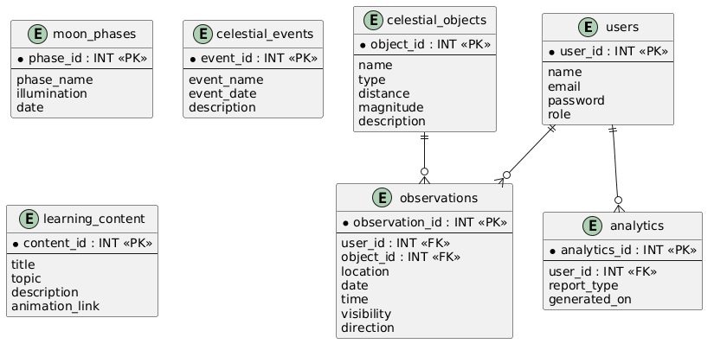
Database Schema
Entity / Table Name | Primary Key | Foreign Key(s) | Other Attributes / Columns
moon_phases | phase_id (INT) | None | phase_name, illumination, date
celestial_events | event_id (INT) | None | event_name, event_date, description
learning_content | content_id (INT) | None | title, topic, description, animation_link
celestial_objects | object_id (INT) | None | name, type, distance, magnitude, description
users | user_id (INT) | None | name, email, password, role
observations | observation_id (INT) | user_id (INT), object_id (INT) | location, date, time, visibility, direction
analytics | analytics_id (INT) | user_id (INT) | report_type, generated_on

