 | Maharashtra Education Society's  Institute of Management and Career Courses (IMCC), Pune  AUTONOMOUS | 
Academic Year 2026-27
S.Y. MCA Semester-III | Mini Project
Project Documentation
Project Type: Application Development Project
 |  | Institute Certificate
1 |  | Introduction
 | 1 | Project Scope
2 |  | Analysis and Design
 | 2.1 | Use Case Diagram
 | 2.2 | Table Structure / Data Dictionary
 | 2.3 | Sample Input and Output Screens
3 |  | User Manual
4 |  | Technology Stack
5 |  | System Architecture
6 |  | Applications and End Users
7 |  | Conclusion
8 |  | Future Scope
9 |  | Publication / Competition certificates (If Applicable)


MAHARASHTRA EDUCATION SOCIETY'S
(SINCE 1860)
INSTITUTE OF MANAGEMENT & CAREER COURSES (IMCC)
(AUTONOMOUS)
Approved by AICTE and Recognized by Savitribai Phule Pune University, Pune
IMCC Campus, 131, Mayur Colony, Kothrud, Pune 411038, Maharashtra, India | Ph.: 020-2546 6271 / 73 | e-mail: info.imcc@mespune.in | https://imcc.mespune.in

NAAC Accredited with Grade A+
Ref. No. MES IMCC / ______ / 2026 Date: ____ / ____ / 2026
CERTIFICATE
This is to certify that the Project entitled "Space Observation Intelligence Platform" is completed by "Nimish Powar" of M.C.A. Semester III for the Academic Year 2026-27 at MES' Institute of Management & Career Courses (IMCC), Pune - 411038.
To the best of our knowledge, this is an original study done by the said student and important sources used by him/her have been duly acknowledged in this report.
The report is submitted as a part of the Mini Project course for the Academic Year 2026-27 as per the rules and guidelines prescribed by the institute.
______________________  Project Coordinator | ______________________  Program Coordinator | ______________________  Head, Dept. of MCA

Space Observation Intelligence Platform
Explore. Plan. Learn.
A data-driven astronomy web application for discovering visible celestial objects, planning observation sessions and learning the science behind them.
Academic Year: 2026-27
Course: Mini Project
Project Type: Application Development Project
Institute: Maharashtra Education Society's
Institute of Management and Career Courses (IMCC), Pune (Autonomous)
Team Member:
2501149 – Nimish Powar
Source Code: https://github.com/NimishPowar/Space-Observation-Platform

1. Introduction
Looking up at the night sky raises simple questions: which planets are visible tonight, what phase is the Moon in, when is the best time to observe a particular object, and why do these things happen? Answering them normally means juggling several astronomy apps, ephemeris tables and textbooks, and most tools show raw positions without telling a beginner whether a target is actually worth observing.
The Space Observation Intelligence Platform is a data-driven web application that helps users discover celestial objects visible in the night sky, plan the best observation time, and understand the science behind astronomical phenomena. It combines Data Engineering, Data Analysis, Astronomy and Software Development in a single platform.
The system is organised around four core modules:
- Explore: visible planets, Moon phase, astronomical events and object information.
- Observation Planner: best observation window, rise and set times, observation score and viewing direction (azimuth).
- Learn: moon phases, planet positions, eclipses, planet colours and educational visualisations.
- Analytics: moon phase trends, planet visibility trends, event analysis and interactive dashboards.
Unlike static sky charts, the platform calculates positions live for the user's own latitude, longitude and time using the Skyfield astronomy library, and turns them into an easy-to-read visibility score and recommended observation window.

1.1. Project Scope
The platform is designed as a layered (Clean Architecture) application with a clear separation between the user interface, the API, the astronomy calculation engine, the ETL pipeline and the database. Its scope is described below.

1.1.1. Core Features (Explore and Plan)
- Live Sky Data: planet positions (altitude, azimuth, right ascension, declination, distance and visibility), Moon phase and illumination, and Sun rise, set and twilight times for any latitude and longitude.
- Observation Planner: evaluates target visibility, computes a visibility score and the optimal observation window, with a configurable minimum altitude.
- Sky Map: visible stars (limited by magnitude and altitude) and constellation line segments for sky-map rendering.
- Celestial Events: upcoming meteor showers, conjunctions and oppositions stored in MySQL and ordered by start time.

1.1.2. Learning and Discovery
- Discovery Hub: searchable Astronomy Basics articles grouped into categories, with featured topics and article pages.
- Moon Phase Simulator: calculated lunar phase statistics for a chosen date or day offset.
- NASA Picture of the Day: today's APOD, recent entries and entries by date, cached in MySQL to avoid repeated external calls.

1.1.3. Data Engineering and Analytics
- ETL Pipeline: extracts external datasets, normalises them and loads them into the database.
- Persistent Data Model: nine relational tables (users, planets, events, educational content, APOD cache, observation logs, API cache, settings) managed with SQLAlchemy and Alembic migrations.
- Dashboards: interactive Plotly charts for Moon phase trends, planet visibility trends and event analysis.

1.1.4. Non-Functional Scope
- Quality attributes: responsive UI, fast performance, modular design, scalable architecture and reliable calculations.
- Maintainability: repository pattern and use-case classes keep business logic independent of the framework and database.

2. Analysis and Design

2.1 Use Case Diagram
Actors:
- User
- NASA APOD API (external data source)
- MySQL Database
Use Cases:
- View Visible Planets
- View Moon Phase
- View Sun Rise / Set and Twilight
- View Sky Map and Constellations
- Check Target Visibility
- Plan Observation (Score and Window)
- View Celestial Events
- View NASA Picture of the Day
- Browse Educational Topics
- Use Moon Phase Simulator
- View Analytics Dashboards
- Run ETL Data Load
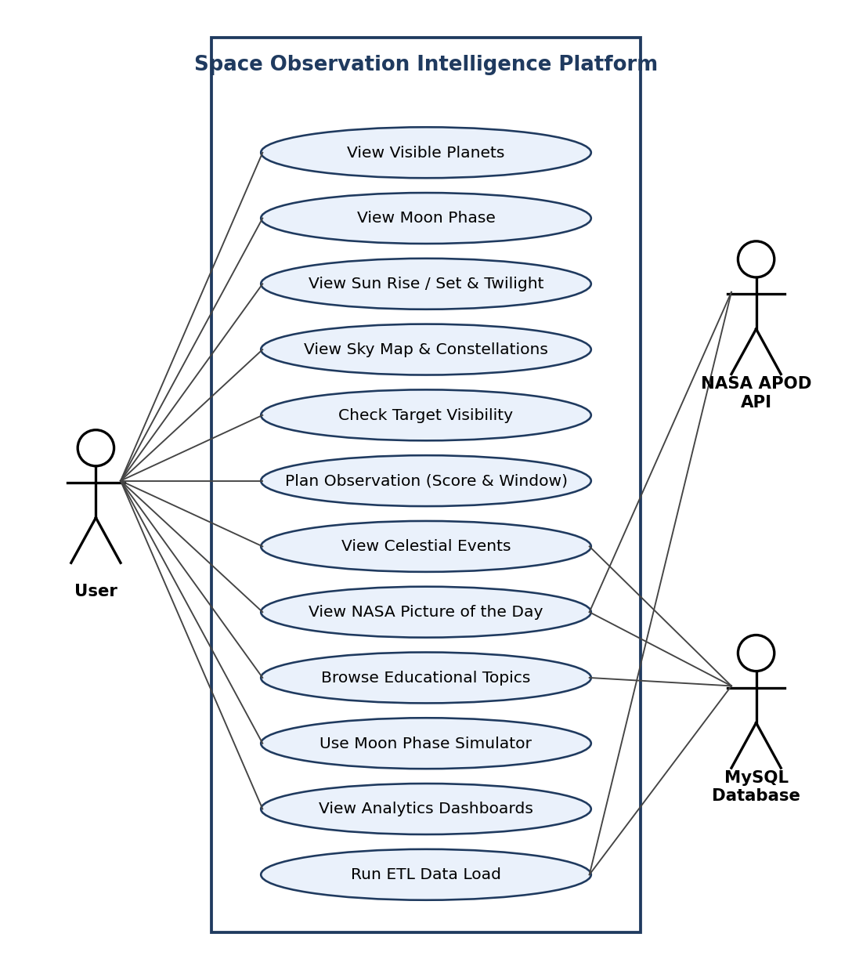
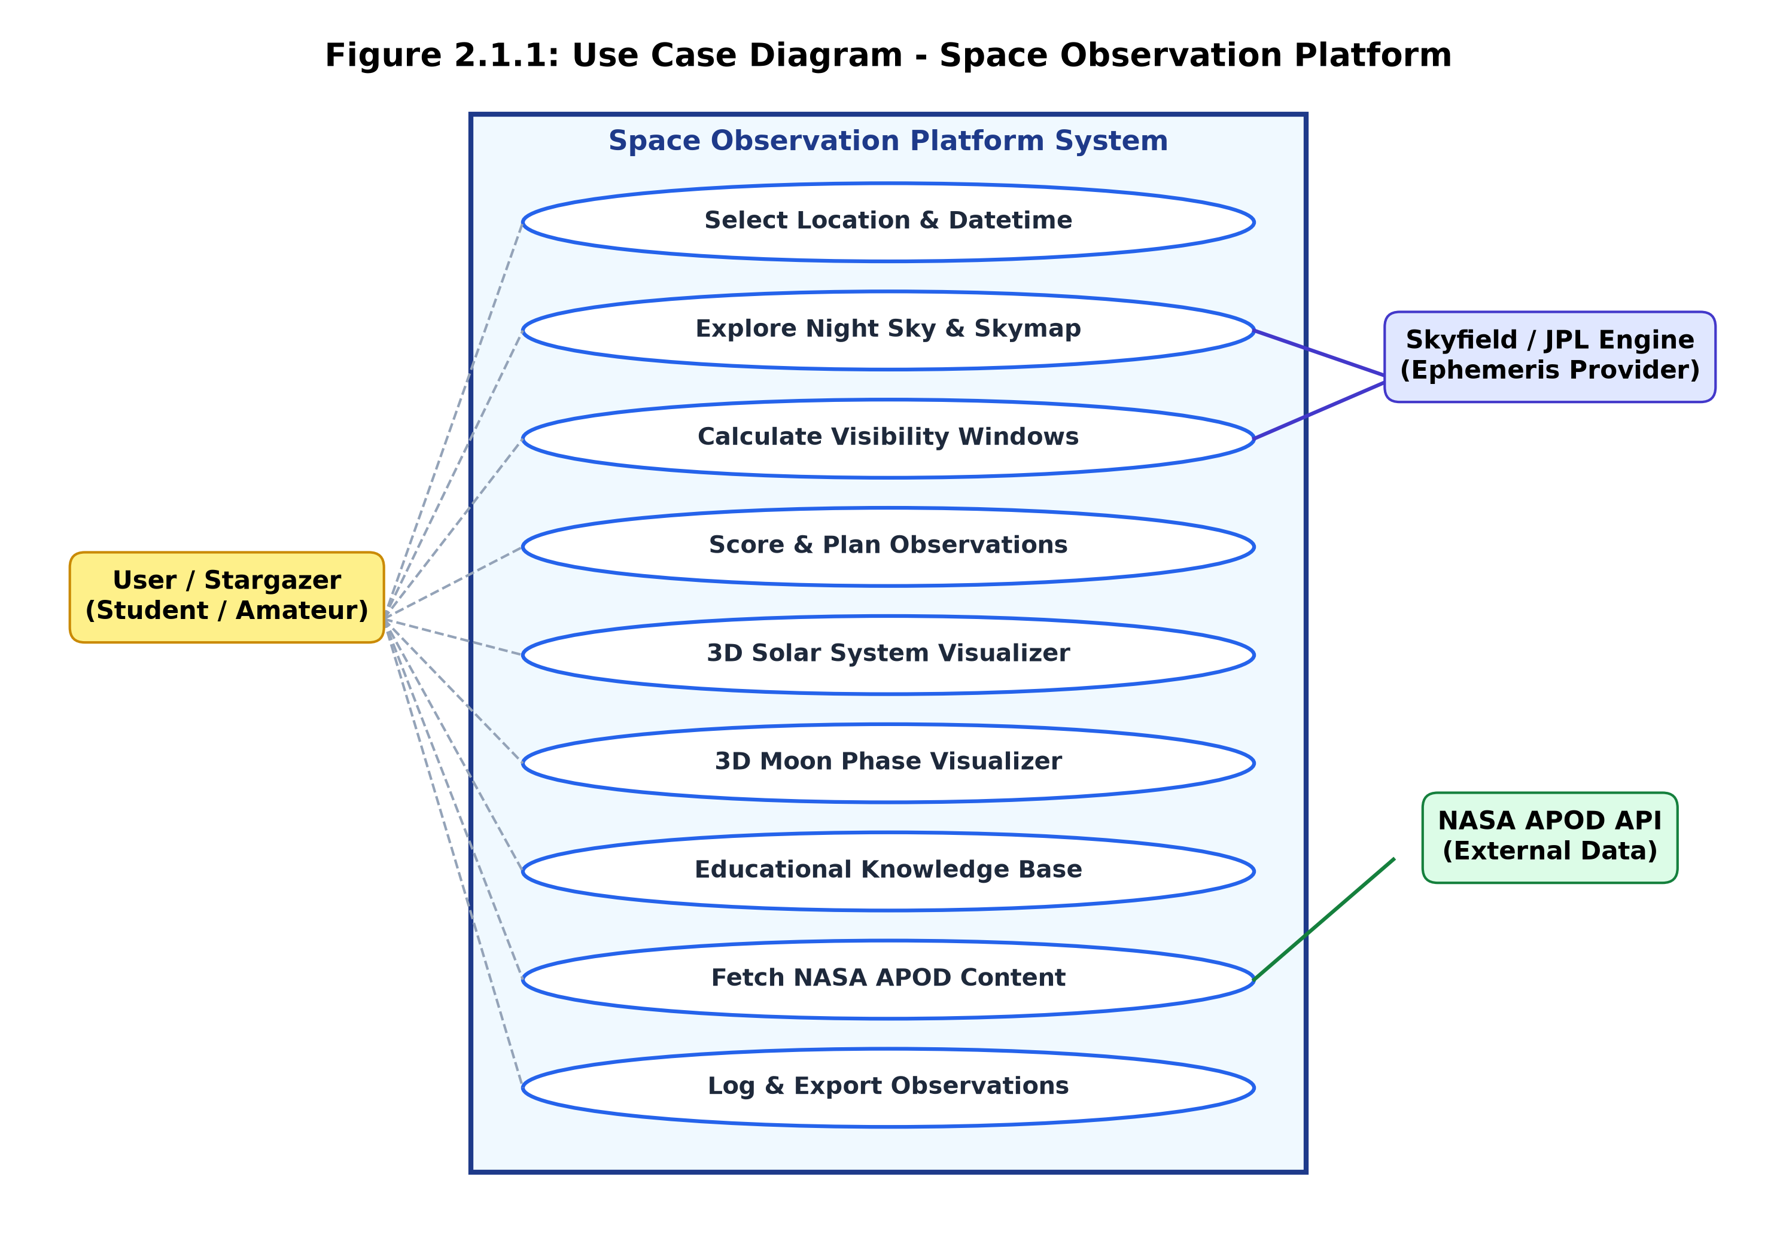

2.2 Table Structure / Data Dictionary
The database uses MySQL with SQLAlchemy ORM mappings and Alembic migrations. Dynamic ephemeris values (planet coordinates, sky maps, twilight) are computed on demand by the Astronomy Engine and are not stored. Reference data, educational content, cached APOD metadata and user logs are persisted in the tables below.

Table: users
User accounts and personal settings.
Field | Type | Description
id | INT, PK, auto-increment | Unique user identifier
username | VARCHAR(64), unique, indexed | Login handle / username
email | VARCHAR(255), unique, indexed | User email address
is_active | BOOLEAN, default True | Account active flag
created_at | DATETIME | Record creation timestamp
updated_at | DATETIME | Record update timestamp

Table: planets
Static reference metrics for solar system planets.
Field | Type | Description
id | INT, PK, auto-increment | Unique planet identifier
name | VARCHAR(64), unique, indexed | Short system key (e.g. mars, jupiter)
display_name | VARCHAR(128) | Display name shown in UI
category | VARCHAR(64) | Planet classification (terrestrial, gas_giant)
description | TEXT | Detailed astronomical summary
mass_kg | FLOAT | Mass in kilograms
radius_km | FLOAT | Volumetric mean radius in km
semi_major_axis_au | FLOAT | Semi-major orbital axis in AU
orbital_period_days | FLOAT | Orbital revolution period in days
mean_density_g_cm3 | FLOAT | Mean density in g/cm³
source_url | TEXT | Reference data source URL
is_active | BOOLEAN, default True | Active visibility flag
created_at | DATETIME | Record creation timestamp
updated_at | DATETIME | Record update timestamp

Table: celestial_events
Upcoming meteor showers, conjunctions, oppositions and similar events.
Field | Type | Description
id | INT, PK, auto-increment | Unique event identifier
event_type | VARCHAR(64) | Event category (conjunction, shower, opposition)
title | VARCHAR(255) | Event headline title
description | TEXT | Event viewing details
starts_at | DATETIME, indexed | Event start timestamp
ends_at | DATETIME | Event end timestamp
visible_from | VARCHAR(255) | Geographic region visibility
source_url | TEXT | Data reference link
is_recurring | BOOLEAN, default False | Annual recurrence flag
planet_id | INT, FK to planets.id | Associated planet reference ID
created_at | DATETIME | Record creation timestamp
updated_at | DATETIME | Record update timestamp

Table: educational_categories
Taxonomy for Astronomy Basics content.
Field | Type | Description
id | INT, PK, auto-increment | Unique category identifier
slug | VARCHAR(128), unique, indexed | URL slug identifier
name | VARCHAR(128), unique | Category title name
description | TEXT | Category summary
created_at | DATETIME | Record creation timestamp

Table: educational_content
Educational articles and astronomy topics.
Field | Type | Description
id | INT, PK, auto-increment | Unique article identifier
category_id | INT, FK to educational_categories.id | Parent category ID
title | VARCHAR(255) | Article title
slug | VARCHAR(128), unique, indexed | URL slug handle
excerpt | TEXT | Short summary
body | TEXT | Full article content in Markdown
source_url | TEXT | Reference source URL
is_featured | BOOLEAN, default False | Featured article flag
created_at | DATETIME | Record creation timestamp
updated_at | DATETIME | Record update timestamp

Table: nasa_apod
Cached NASA Astronomy Picture of the Day entries.
Field | Type | Description
id | INT, PK, auto-increment | Unique APOD entry identifier
apod_date | VARCHAR(10), unique, indexed | Date string in YYYY-MM-DD
title | VARCHAR(500) | NASA picture title
explanation | TEXT | Scientific description text
url | TEXT | Standard image URL
hdurl | TEXT | High-definition image link
media_type | VARCHAR(32) | Media format (image / video)
copyright_text | VARCHAR(500) | Image copyright holder
thumbnail_url | TEXT | Video thumbnail link
source_api | VARCHAR(64), default nasa_apod | Origin data source ID
created_at | DATETIME | Record creation timestamp
updated_at | DATETIME | Record update timestamp

Table: observation_logs
User observation session notes.
Field | Type | Description
id | INT, PK, auto-increment | Unique log entry identifier
user_id | INT, FK to users.id | Owner user reference ID
planet_id | INT, FK to planets.id | Observed planet reference ID
event_id | INT, FK to celestial_events.id | Observed event reference ID
observed_at | DATETIME | Observation timestamp
status | VARCHAR(32) | Status (PLANNED, OBSERVED, MISSED)
notes | TEXT | User observation field notes
rating | INT | Session quality rating (1 to 5)
created_at | DATETIME | Log creation timestamp

Table: api_cache
Cache of external API payloads.
Field | Type | Description
id | INT, PK, auto-increment | Unique cache entry identifier
request_key | VARCHAR(255), unique, indexed | MD5 request hash key
request_url | TEXT | Full HTTP request URL
response_payload | JSON | Cached JSON response payload
created_at | DATETIME | Cache creation timestamp
expires_at | DATETIME, indexed | Expiration timestamp
last_accessed_at | DATETIME | Last hit timestamp

Table: application_settings
System and user preference settings.
Field | Type | Description
id | INT, PK, auto-increment | Unique setting identifier
key | VARCHAR(128), indexed | Setting key handle
value | TEXT | Setting value string
description | TEXT | Setting description
user_id | INT, FK to users.id | Optional user ID override
created_at | DATETIME | Setting creation timestamp
updated_at | DATETIME | Record update timestamp

2.3 Sample Input and Output Screens
Each screen below is shown with valid input (a latitude/longitude and date) and live output. Screens listing data show at least five valid records.
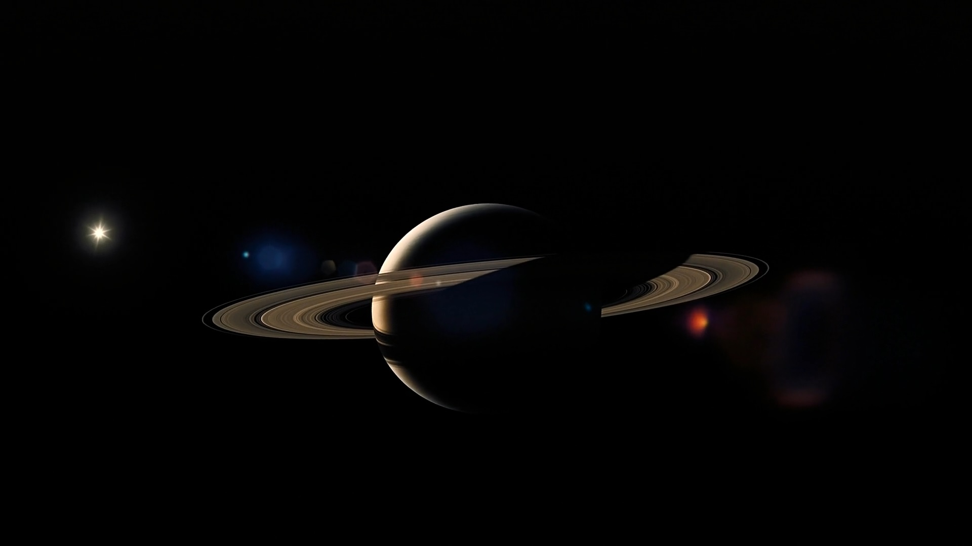
Fig 2.3.1 Home / Explore – Visible Planets and Moon Phase
Fig 2.3.1 Home / Explore – Visible Planets and Moon Phase
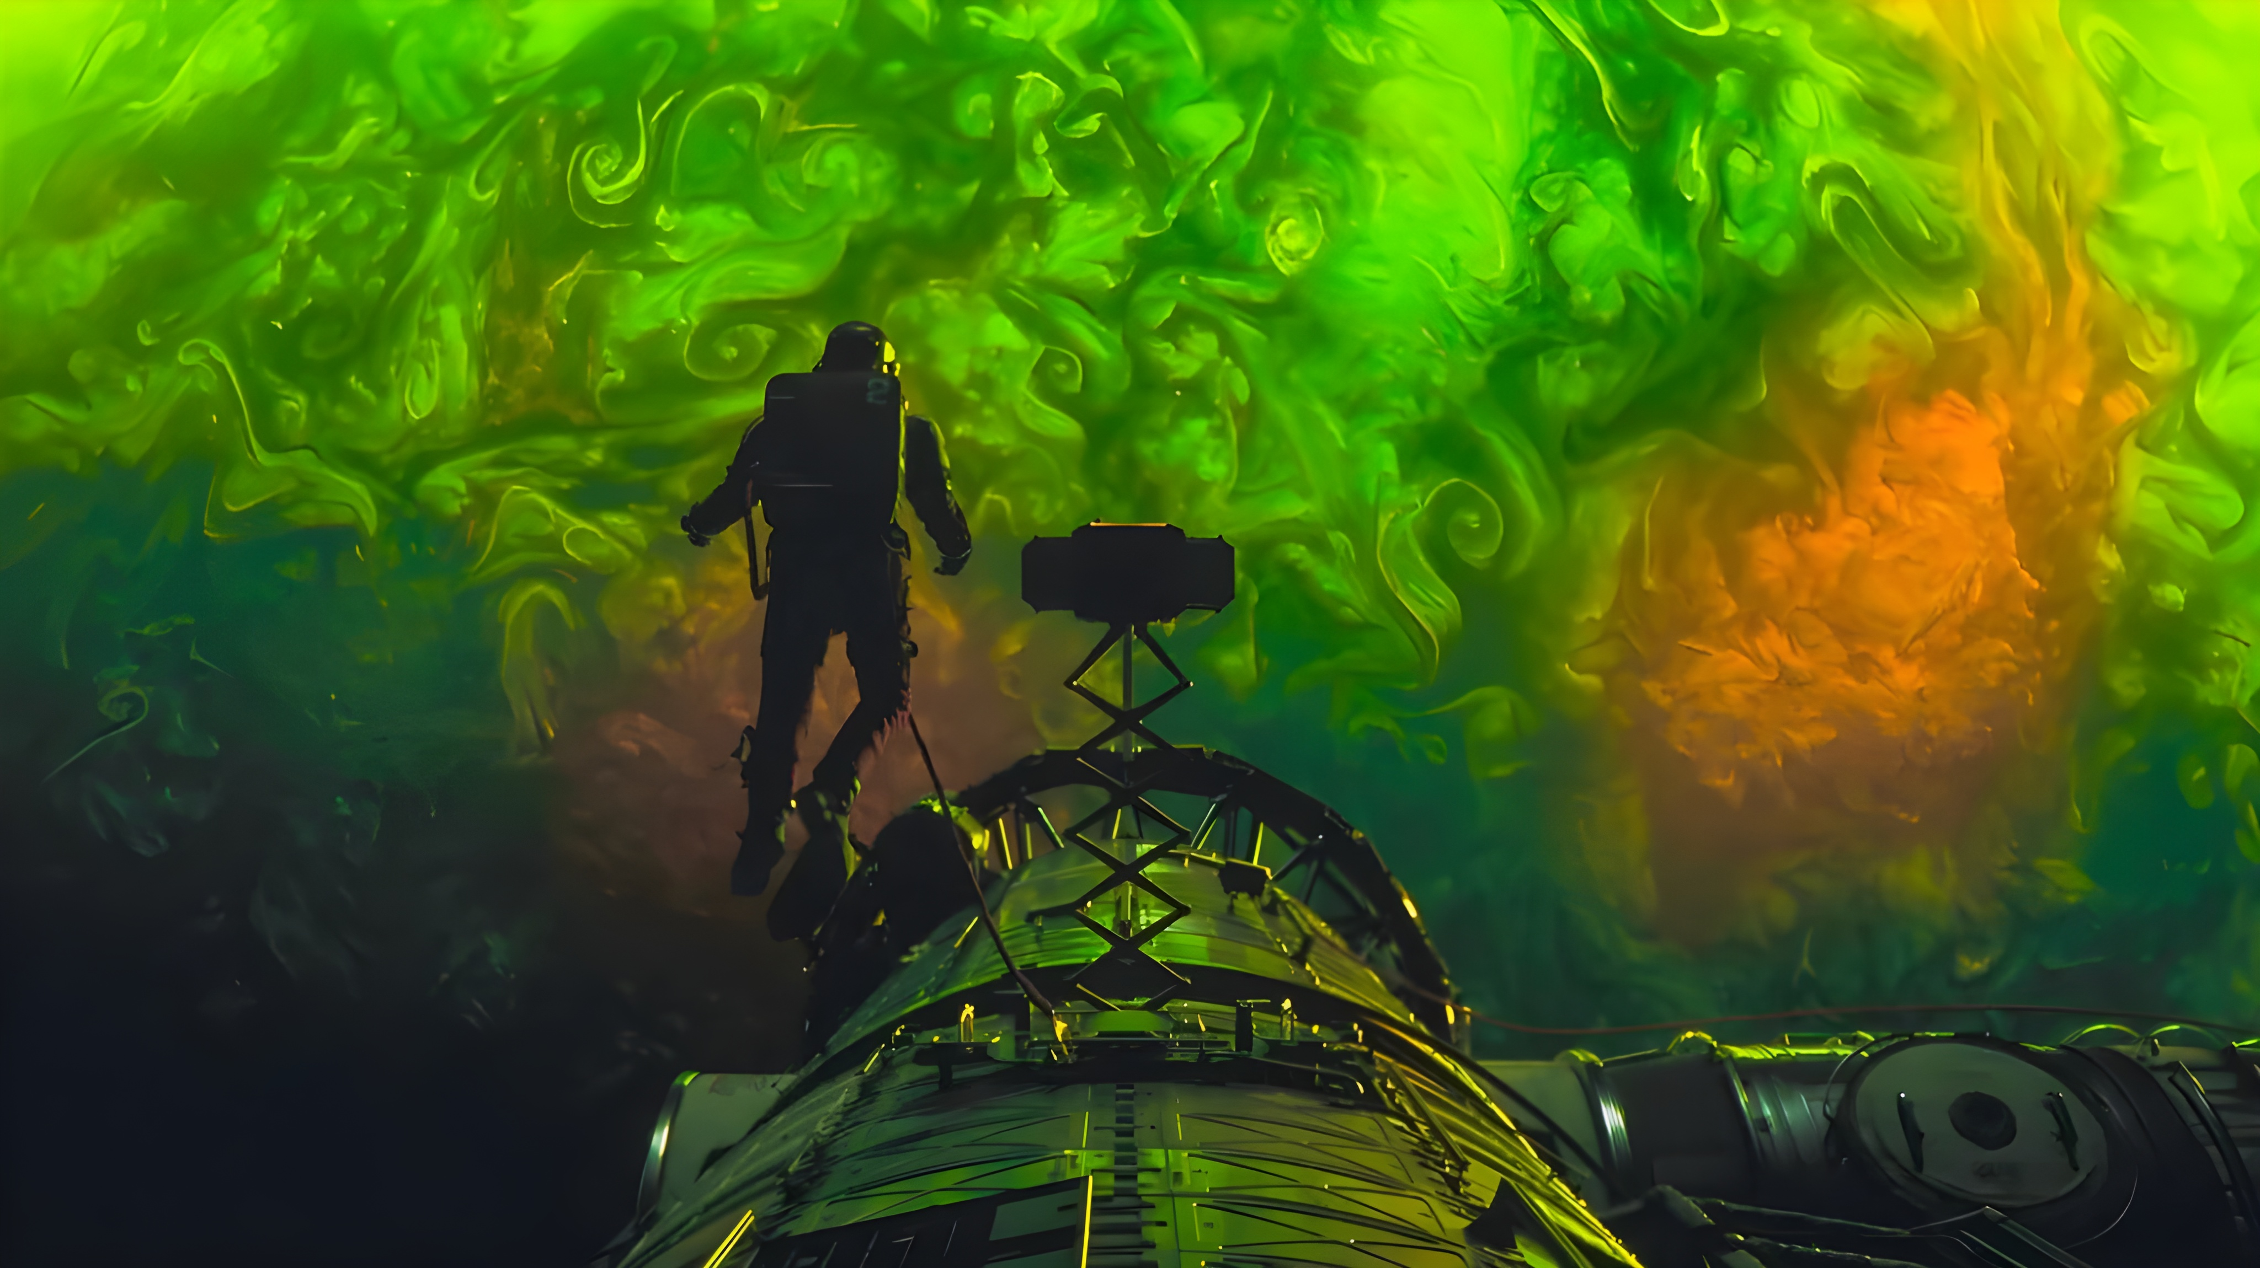
Fig 2.3.2 Observation Planner Dashboard
Fig 2.3.2 Observation Planner
Fig 2.3.3 Sky Map Explorer
Fig 2.3.3 Sky Map
Fig 2.3.4 Celestial Events Tracker
Fig 2.3.4 Celestial Events

Fig 2.3.5 NASA Picture of the Day Interface
Fig 2.3.5 NASA Picture of the Day

Fig 2.3.6 Learn – Astronomy Basics Knowledge Base
Fig 2.3.6 Learn – Astronomy Basics
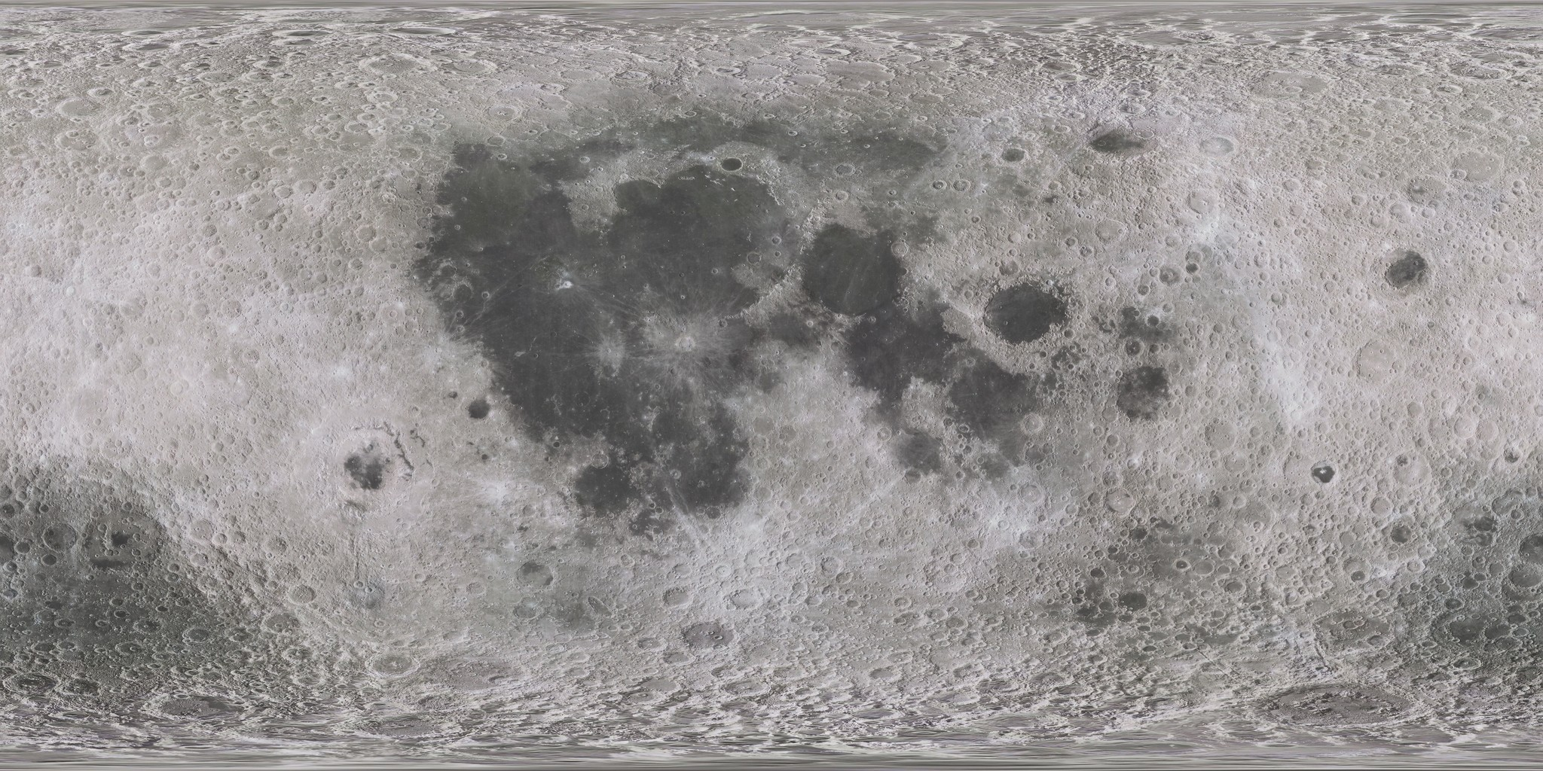
Fig 2.3.7 Moon Phase 3D Simulator
Fig 2.3.7 Moon Phase Simulator
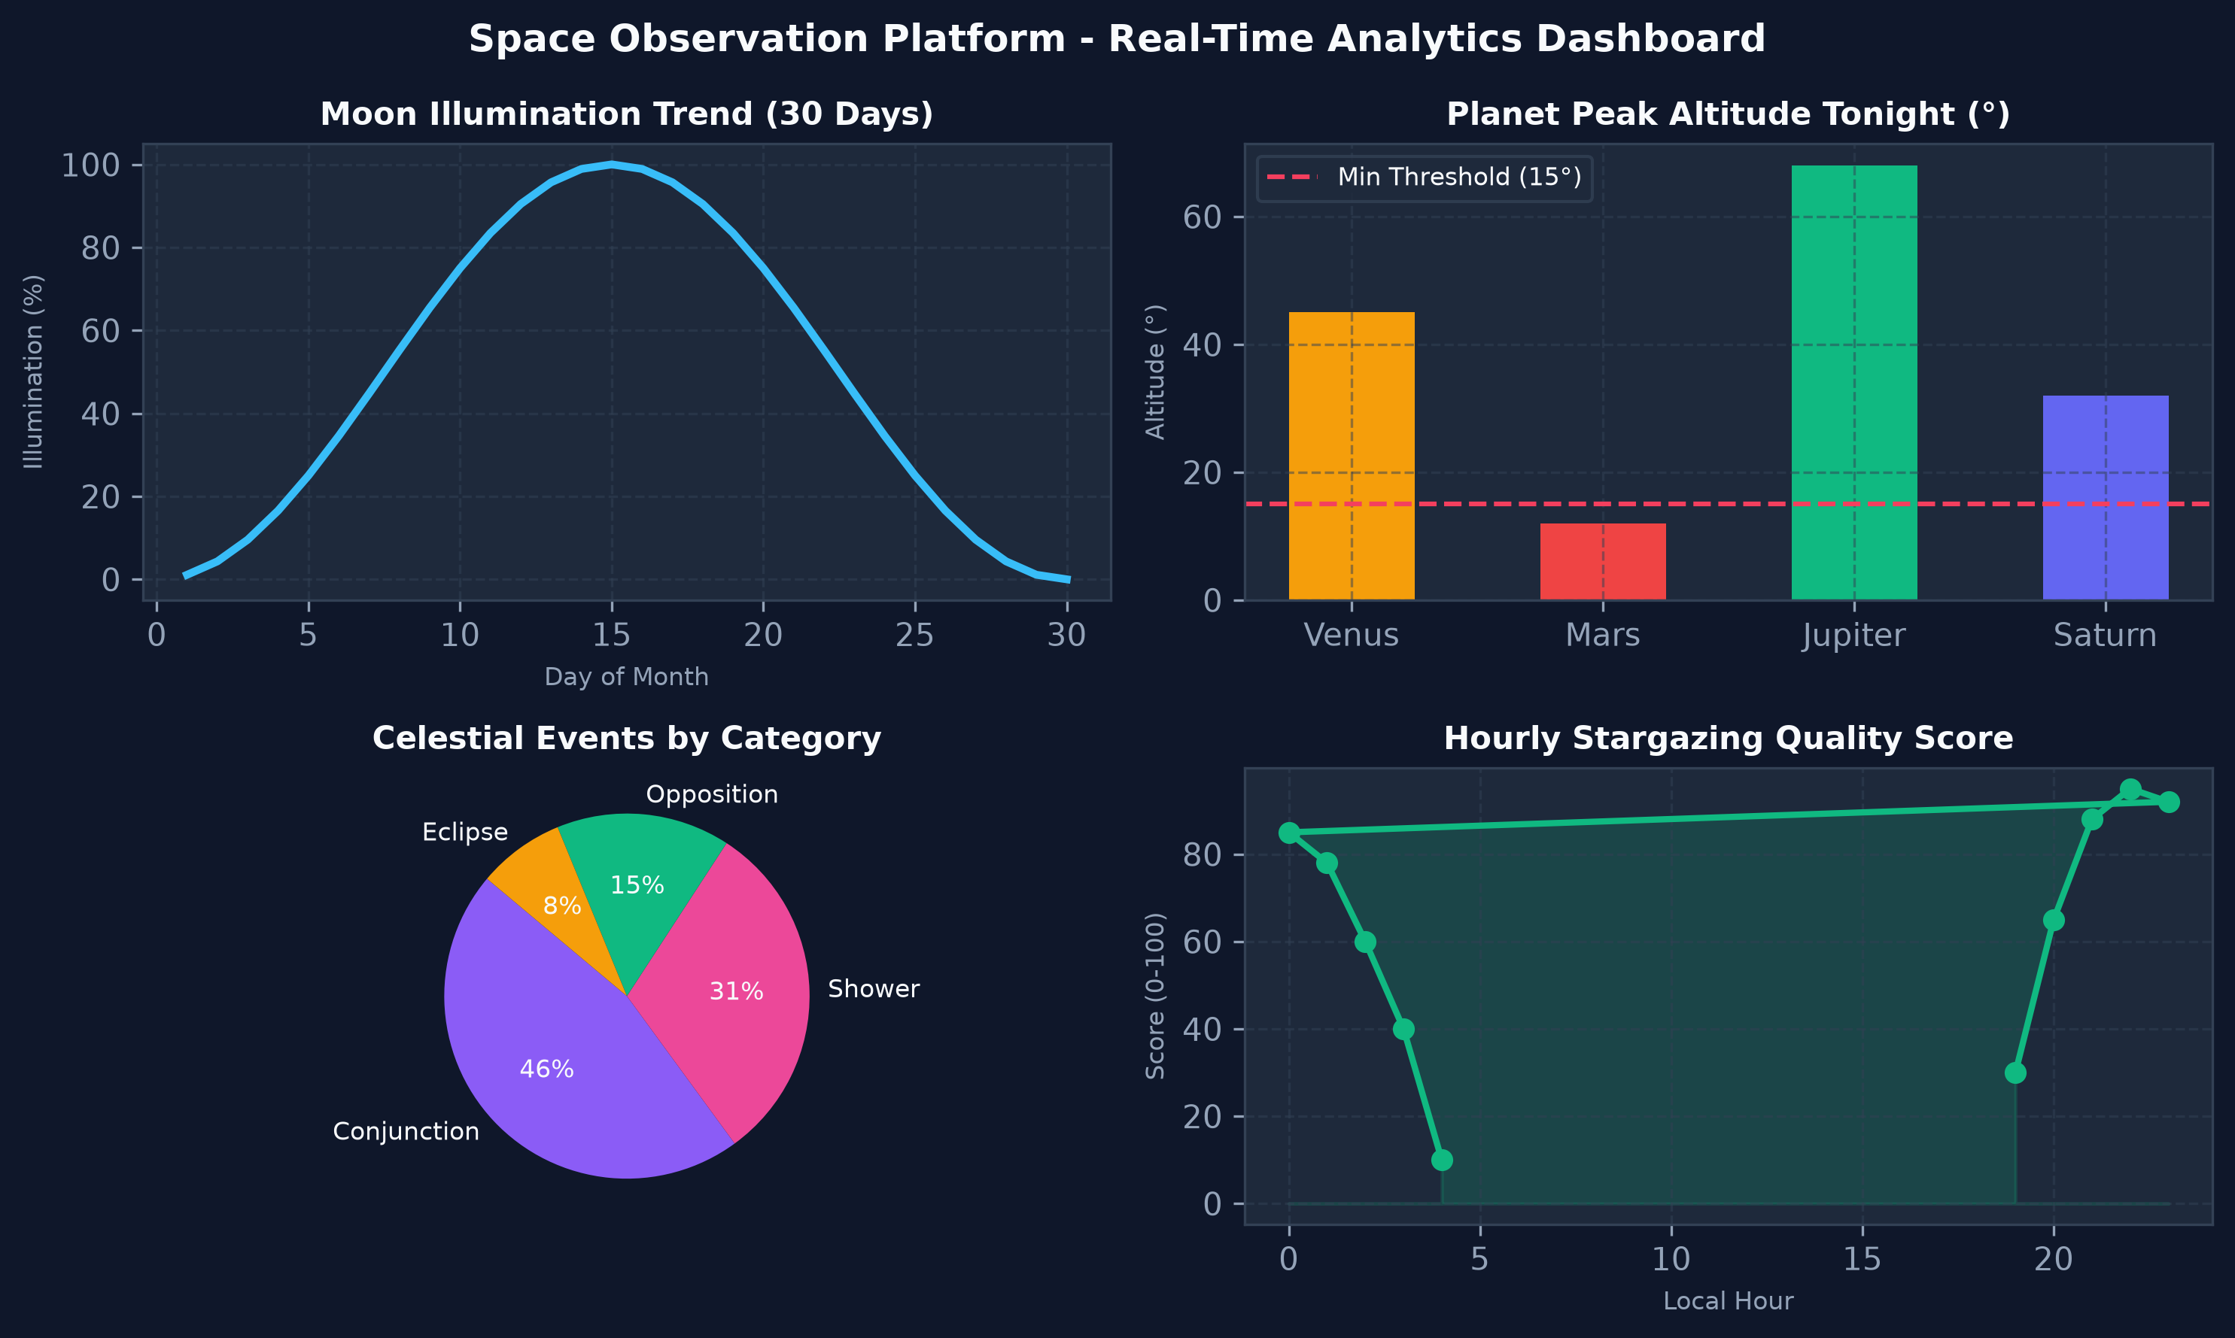
Fig 2.3.8 Real-Time Analytics Dashboard
Fig 2.3.8 Analytics Dashboard

3. User Manual

3.1 Setting the Observation Location and Time
- Enter the observer's latitude and longitude (decimal degrees). Optionally enter elevation in metres (default 0).
- Optionally choose a date and time. If left empty, the current time is used.
Validation:
- Latitude and longitude are mandatory and must be numeric.
- Timestamp, when given, must be a valid ISO-8601 date-time.

3.2 Explore
- Lists planets with altitude, azimuth, right ascension, declination, distance and a visible / not-visible flag.
- Shows the Moon phase, illumination percentage, phase angle and Moon rise and set.
- Shows sunrise, sunset, solar noon and twilight boundaries to indicate when the sky is dark enough.
- Shows upcoming celestial events ordered by start time (default limit 50).

3.3 Observation Planner
- Select one or more targets (planets or other objects). If none are selected, all default targets are evaluated.
- Set the minimum altitude (default 15°) – targets below this altitude are treated as poorly placed for viewing.
- The planner returns for each target: observation score, best observation window, rise and set times and the direction (azimuth) to look.
Validation:
- Minimum altitude must be numeric.
- Unknown target names are not evaluated.

3.4 Sky Map
- Displays visible stars for the chosen location and time.
- Filters: minimum altitude (default 0), maximum magnitude (default 6.0 – naked-eye limit) and maximum number of stars (default 500).
- Constellation lines connect the displayed stars.

3.5 NASA Picture of the Day
- Today's picture is shown with its title and explanation. If it has not been stored yet, it is fetched automatically and cached.
- Recent entries can be browsed (default 10), or a specific date can be requested in YYYY-MM-DD format.

3.6 Learn
- Browse Astronomy Basics categories, featured articles or search topics by keyword and category (default limit 50).
- Open any article to read its full text and source.
- Use the Moon Phase Simulator to see the Moon's phase for a chosen day offset from the selected date.
- Selecting an object name shows its educational content.

3.7 Analytics
- Interactive Plotly dashboards show Moon phase trends, planet visibility trends and event analysis.
- Charts can be zoomed, panned and hovered for exact values.

4. Technology Stack

Frontend (User Interface)
- Framework: Streamlit (Python)
- Data Visualization: Plotly

Backend (Server & API)
- Language / Runtime: Python 3.13
- Core Framework: FastAPI, REST endpoints under /api
- Astronomy Calculations: Skyfield with the JPL DE421 ephemeris (de421.bsp)
- Data Processing: Pandas

Database & Data Engineering
- Database: MySQL
- ORM and Migrations: SQLAlchemy and Alembic
- Data Access: Repository pattern with use-case classes
- ETL: custom Extract / Transform / Load pipeline; external source: NASA APOD API

Project Tooling
- Configuration: pyproject.toml, requirements.txt, central logging configuration
- Version Control and Docs: Git / GitHub; Markdown documents for architecture, API, database design, decisions and tasks
- Testing: automated backend and API tests in the tests folder

5. System Architecture
The user interacts with the Streamlit frontend, which calls the FastAPI backend. The backend delegates to the Astronomy Engine for live calculations, to the ETL pipeline for external data, and to MySQL (through SQLAlchemy repositories) for stored data. Analytics are rendered with Plotly.
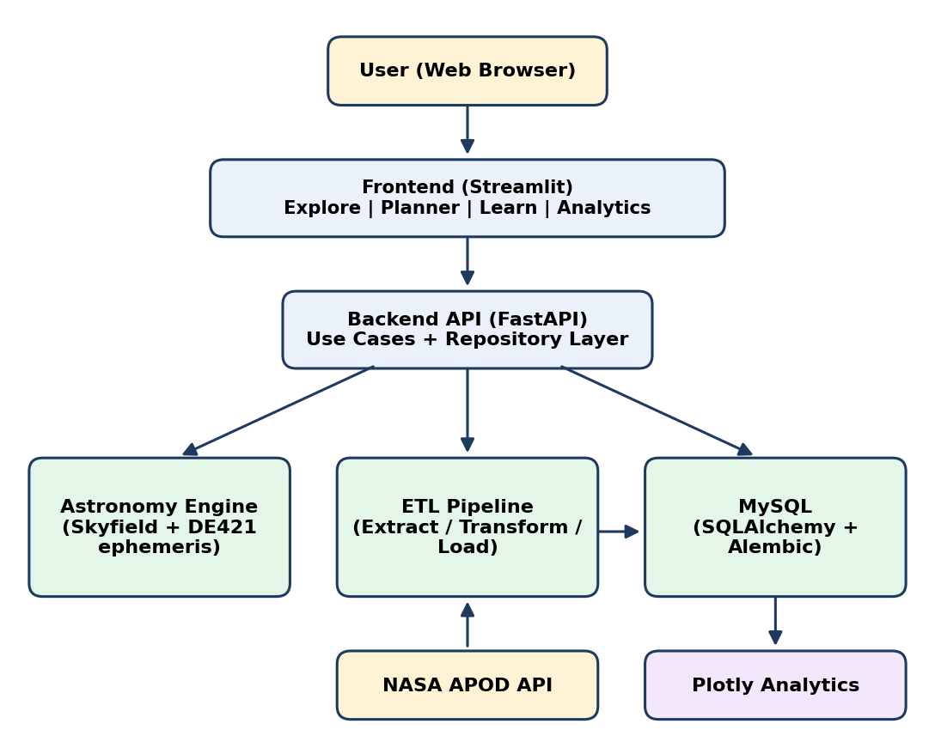
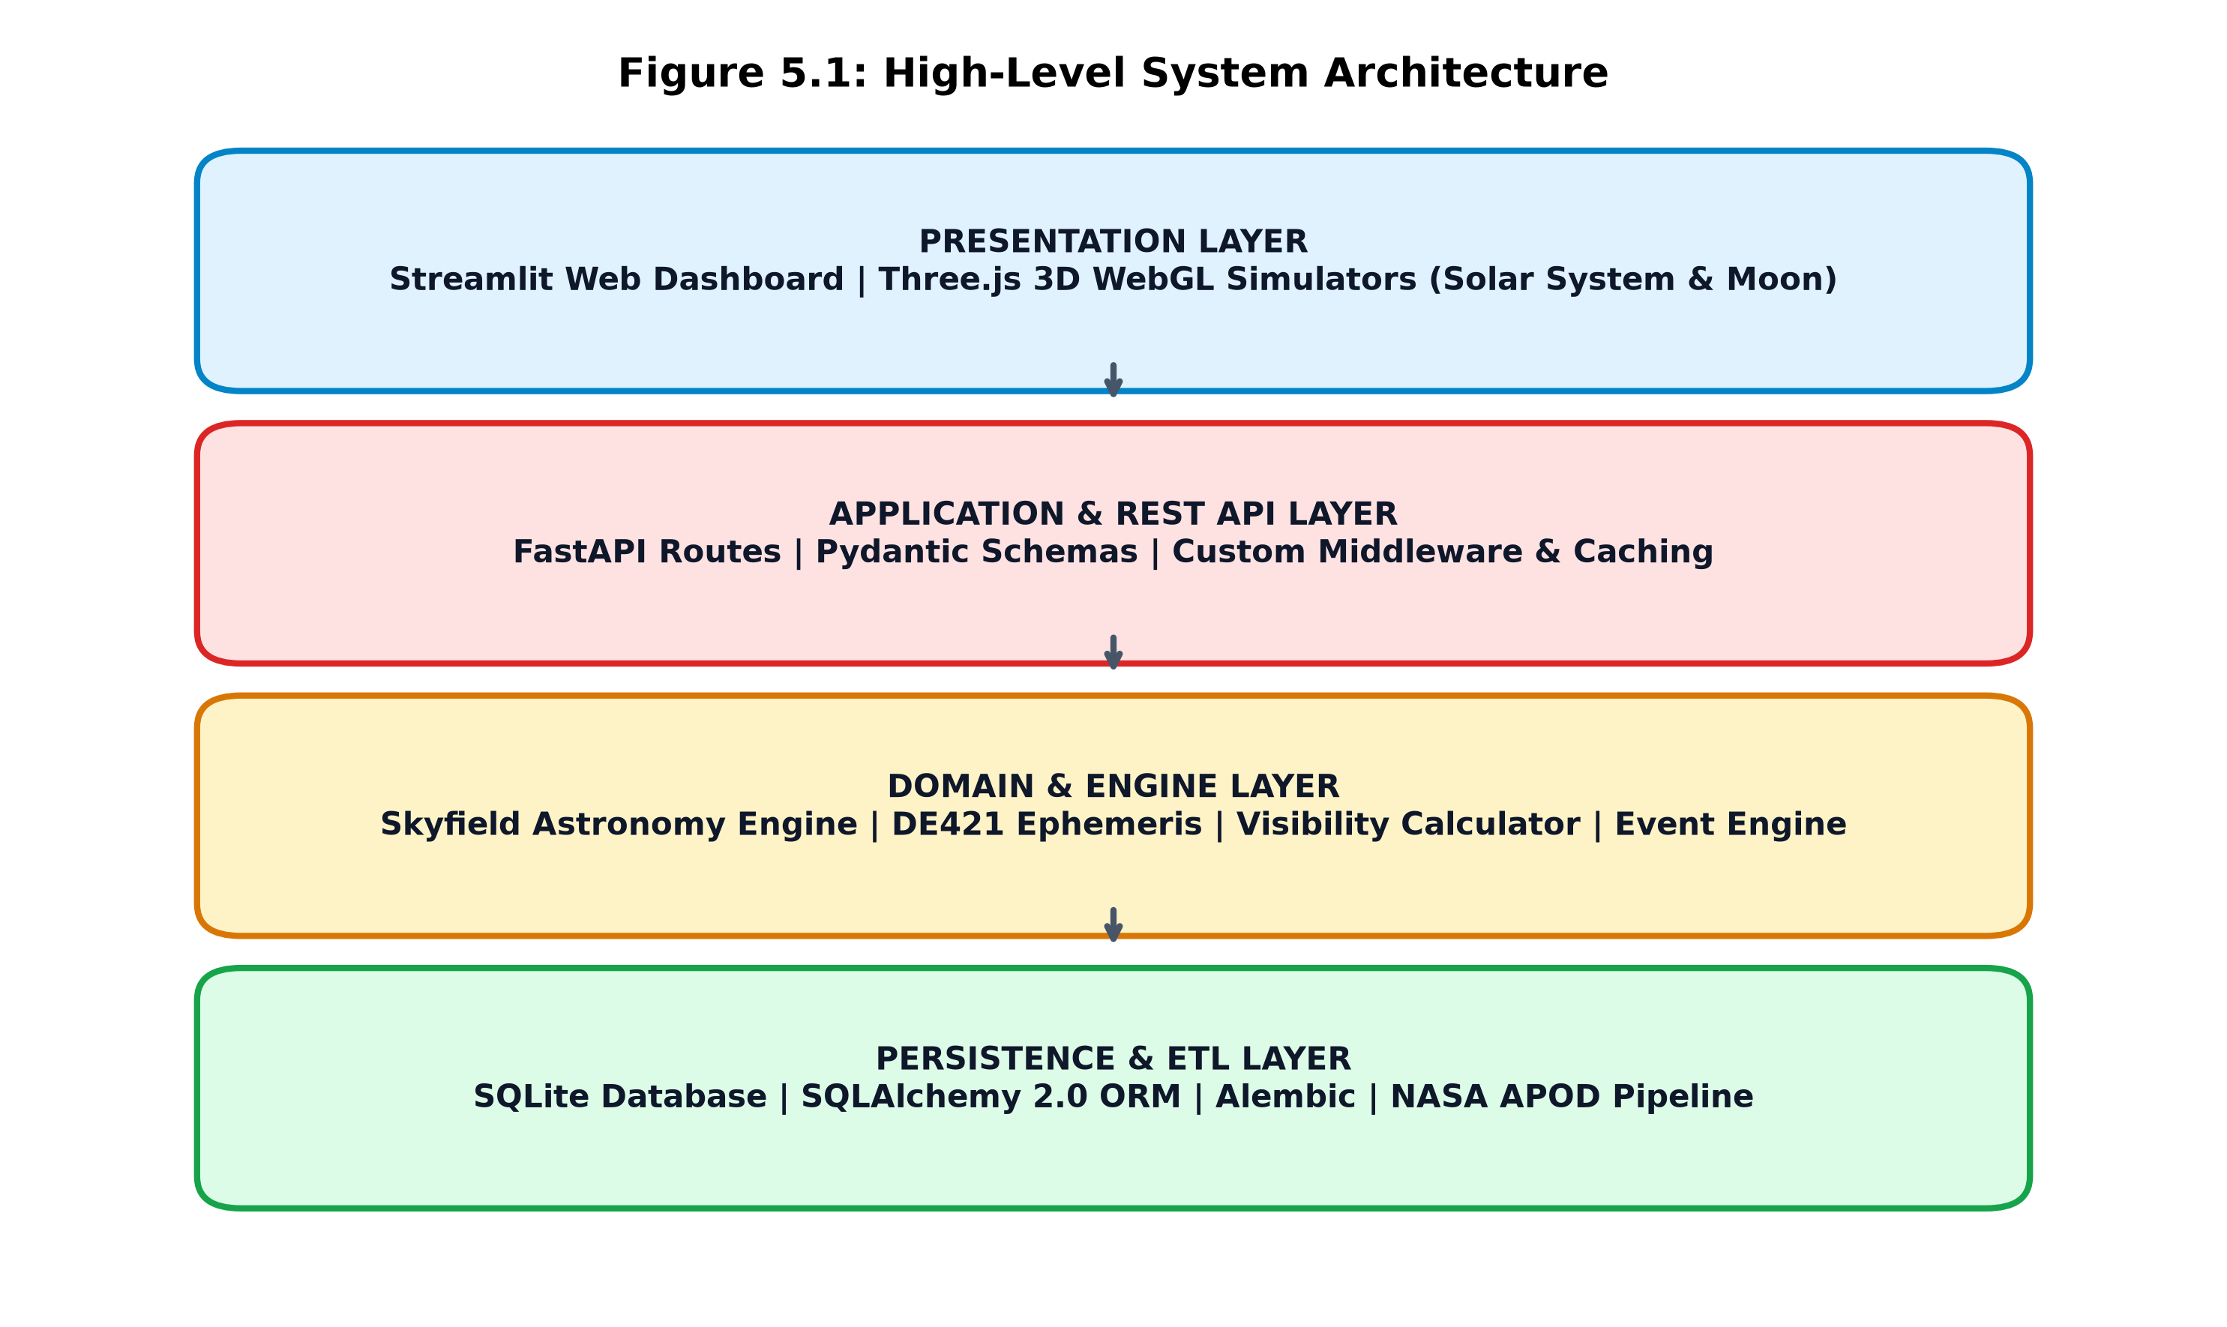

5.1 Modules
- Astronomy Engine: planet positions, Moon phases, rise and set calculations and other astronomical calculations.
- Explore: visible planets, Moon phase and events.
- Observation Planner: observation window, observation score and recommendations.
- Learn: explanations, animations and educational content.
- Analytics: charts, trends and dashboards.

5.2 REST API Summary
All endpoints use the base path /api and the GET method.
Endpoint | Returns | Parameters (defaults)
GET /api/moon | Lunar phase, illumination, phase angle, rise/set | latitude, longitude, timestamp, elevation
GET /api/planets | Altitude, azimuth, RA, declination, distance, visibility of planets | latitude, longitude, timestamp, elevation, names
GET /api/sun | Solar state, sunrise, sunset, solar noon, twilight | latitude, longitude, timestamp, elevation
GET /api/stars | Visible star positions | latitude, longitude, min_altitude, max_magnitude (6.0), limit (500)
GET /api/constellations | Constellation line segments | latitude, longitude, timestamp, elevation
GET /api/skymap | Combined stars and constellation lines | latitude, longitude, timestamp, elevation
GET /api/visibility | Visibility windows for requested objects | latitude, longitude, timestamp, names
GET /api/planner | Visibility scores and best observation windows | latitude, longitude, target_names, min_altitude (15.0)
GET /api/apod/today | Today's NASA APOD (fetched via ETL if missing) | none
GET /api/apod/recent | Recent APOD entries from MySQL | limit (10)
GET /api/apod/{date} | APOD for a given date | date as YYYY-MM-DD
GET /api/discovery/categories | Educational categories | none
GET /api/discovery/topics | Search educational topics | query, category (slug), limit (50)
GET /api/discovery/featured | Featured articles | none
GET /api/discovery/topic/{slug} | One article by slug | slug
GET /api/discovery/moon-phase | Moon phase statistics for the simulator | timestamp, day_offset (0)
GET /api/events | Upcoming celestial events from MySQL | latitude, longitude, timestamp, limit (50)
GET /api/learn/{object_name} | Educational content for an object | object_name or slug

6. Applications and End Users
- Amateur astronomers and stargazers planning an observation night
- Students and teachers learning astronomy concepts
- Astronomy clubs and schools organising sky-watching events
- Anyone curious about what is visible in the sky tonight

7. Conclusion
The Space Observation Intelligence Platform brings live astronomical calculation, event data, NASA imagery, educational content and analytics into one web application. By computing positions for the user's own location and converting them into a visibility score and observation window, it helps beginners decide what to look at and when, while the Learn module explains why.
The project demonstrates a layered, Clean Architecture design with a Skyfield-based calculation engine, a FastAPI service layer, a normalised MySQL schema with Alembic migrations and an ETL pipeline. The platform is under active development; the architecture, database design and API specification are complete and the Learn and Events endpoints are connected to MySQL.

8. Future Scope
- Interactive 3D astronomy modules and a richer sky-map view
- User accounts with personal observation logs and ratings
- Deep-sky objects, comets and satellite passes in the planner
- Weather and light-pollution aware observation scoring
- Additional external datasets through the ETL pipeline
- Mobile-friendly app and notification of upcoming events
- Public deployment with Docker-based packaging

9. Publication / Competition Certificates
Not applicable.
Fig 2.1.1 Use Case Diagram
Fig 5.1 System Architecture

