Maharashtra Education Society’s
Institute of Management and Career Courses (IMCC), Pune
(AUTONOMOUS)
Academic Year 2025-26
F.Y. MCA Semester-II Course: ITP21 Mini Project
Project Documentation
Project Type: Application Development Project
SPACE OBSERVATION PLATFORM
AI & Ephemeris-Powered Sky Exploration, Observation Planning & Educational System
Submitted By:
2501149 – Nimish Powar
2501108 – Soham Limhan

MAHARASHTRA EDUCATION SOCIETY'S
(SINCE 1860)
INSTITUTE OF MANAGEMENT & CAREER COURSES (IMCC)
(AUTONOMOUS)
Approved by AICTE and Recognized by Savitribai Phule Pune University, Pune
IMCC Campus, 131, Mayur Colony, Kothrud, Pune 411038, Maharashtra, India | Ph.: 020-2546 6271 / 73 | e-mail: info.imcc@mespune.in | https://imcc.mespune.in
NAAC Accredited with Grade A+
Ref. No. MES IMCC / 442 / 2025 Date: 06/05/2026
CERTIFICATE
This is to certify that the Project entitled “Space Observation Intelligence Platform” is completed by “Nimish Powar” of M.C.A. Semester II for the Academic Year 2025-26 at MES’ Institute of Management & Career Courses (IMCC), Pune - 411038.
To the best of our knowledge, this is an original study done by the said student and important sources used by him/her have been duly acknowledged in this report.
The report is submitted as a part of course ITP21 Mini Project for the Academic Year 2025-26 as per the rules and guidelines prescribed by the institute.
____________________  Project Guide | ____________________  Head of Department | ____________________  External Examiner

TABLE OF CONTENTS
Sr. No. | Section / Topic Details | Page No.
 | Institute Certificate | i
1 | Introduction | 1
1.1 | Project Scope | 1
1.2 | Advanced Analytics & Astronomical Engine Scope | 2
1.3 | Reporting & Data Portability Scope | 2
1.4 | UI / UX Scope | 3
2 | Analysis and Design | 4
2.1 | Use Case Diagrams | 4
2.2 | System Architecture & Operational Flow | 5
2.3 | Table Structure / Data Dictionary (9 Schema Tables) | 6
2.4 | Sample Input and Output Screens (7 Screen Visuals) | 9
3 | User Manual | 13
3.1 | Night Sky Exploration & Interactive Skymap | 13
3.2 | Observation Planner & Visibility Window Engine | 14
3.3 | Interactive 3D Solar System & Moon Phase Visualizers | 15
3.4 | Educational Discovery & NASA APOD Integration | 16
3.5 | System Validation Rules & Operational Guidelines | 17
4 | Technology Stack | 18
4.1 | Frontend User Interface Stack | 18
4.2 | Backend Server & Astronomy Engine Stack | 18
4.3 | Database, ETL & Infrastructure Stack | 19
5 | System Architecture | 20
6 | Applications and End Users | 21
7 | Conclusion | 22
8 | Future Scope | 23

1. Introduction
In astronomical observation and observational science, discovering when and where celestial bodies are visible requires precise orbital math, ephemeris calculations, and location-aware spatial analysis. Beginners, students, and amateur astronomers often face fragmented platforms that either provide raw mathematical data without visual context or purely aesthetic sky maps without practical observation planning tools.
The Space Observation Platform is an end-to-end full-stack data-driven web application designed to help users explore the night sky based on geographic coordinates, date, and time. It integrates astronomical data from trusted scientific sources (NASA APOD, JPL DE421 Ephemeris), computes real-time celestial positions, recommends optimal observation windows, and delivers interactive 3D visualizations alongside educational explanations.
1.1. Project Scope
The Space Observation Platform is structured into five core functional pillars:
- Real-Time Night Sky Exploration: Interactive Sky Map allowing real-time mapping of planets, stars, and constellations tailored to any latitude, longitude, and timestamp.
- Ephemeris & Astronomical Engine: Mathematical computation of planetary coordinates, solar positions, twilight boundaries (civil, nautical, astronomical), and lunar illumination phases.
- Observation Planner & Visibility Engine: Algorithmic scoring of celestial observation windows based on object altitude, sun illumination, weather factors, and lunar interference.
- Interactive 3D WebGL Simulators: Three.js WebGL interactive 3D simulations of the Solar System orbital mechanics and Moon phase illumination geometry.
- Educational Discovery & NASA APOD ETL: Comprehensive celestial knowledge base, structured astronomical topic guides, and daily NASA Astronomy Picture of the Day (APOD) metadata extraction.
1.2. Advanced Analytics & Astronomical Engine Scope
- Skyfield Ephemeris DE421 Integration: High-accuracy positioning using the Skyfield Python library and NASA JPL DE421 ephemeris datasets for 8 major planets, the Sun, and the Moon.
- Visibility & Planner Scoring Algorithm: Deterministic scoring (0–100) evaluating celestial altitude (minimum 15° horizon clearance), sky darkness (astronomical twilight vs day), lunar phase brightness, and object visual magnitude.
- Solar & Twilight State Analyzer: Automated calculation of sunrise, sunset, solar noon, and precise civil (-6°), nautical (-12°), and astronomical (-18°) twilight timestamps for any location.
- Celestial Event Tracker: Automated tracking and listing of upcoming conjunctions, planetary oppositions, meteor showers, and lunar/solar eclipses.
1.3. Reporting & Data Portability Scope
- Observation Itinerary Export: Exporting generated observation itineraries, visible object schedules, and planet visibility windows into standardized JSON and structured data tables.
- NASA APOD Data Pipeline: Automated pipeline fetching, processing, and storing historical and daily NASA APOD images, descriptions, and high-resolution media URLs.
- API Cache Infrastructure: Built-in client and backend API caching layer to optimize expensive ephemeris computations and external HTTP requests.
1.4. UI / UX Scope
- Dark Sky Aesthetic: High-contrast dark sky theme optimized for stargazers, preventing night-vision loss during field observation.
- Responsive Dashboard Grid: Responsive multi-page layout built using Streamlit, featuring top navigation, location selectors, search auto-complete, and interactive data cards.
- Interactive WebGL Visuals: Embedded Three.js WebGL canvas instances rendering interactive, zoomable, and rotatable 3D orbital models directly in the web browser.

2. Analysis and Design
2.1 Use Case Diagram
The system interacts with Primary Users (Stargazers, Students, Educators) and External Data Engines (Skyfield JPL Ephemeris, NASA APOD REST API).
- Actors: User | Use Cases: Select Location & Datetime
- Use Case 2: Explore Night Sky & Skymap
- Use Case 3: Calculate Visibility Windows
- Use Case 4: Score & Plan Observations
- Use Case 5: Interactive 3D Solar System Visualizer
- Use Case 6: Interactive 3D Moon Phase Visualizer
- Use Case 7: Educational Knowledge Base
- Use Case 8: Fetch Today's NASA APOD Content
- Use Case 9: Log & Export Observations
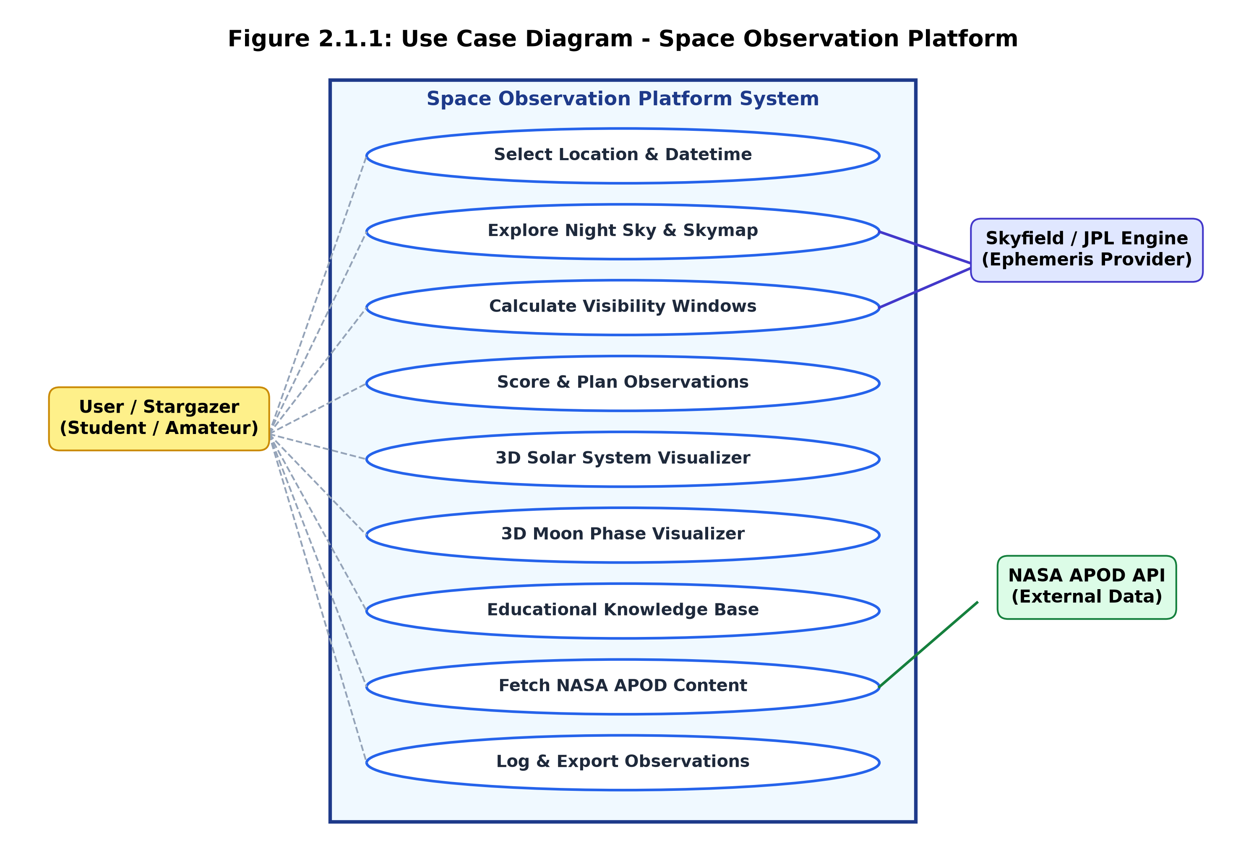
Fig 2.1.1 Use Case Diagram
2.2 System Architecture & Operational Flow
The Space Observation Platform follows a modular multi-tier architecture separated into Presentation Layer (Streamlit & Three.js), Application API Layer (FastAPI & Pydantic), Domain Engine Layer (Skyfield & Astronomy Engine), and Persistence ETL Layer (SQLite, SQLAlchemy ORM, and NASA APOD ETL).
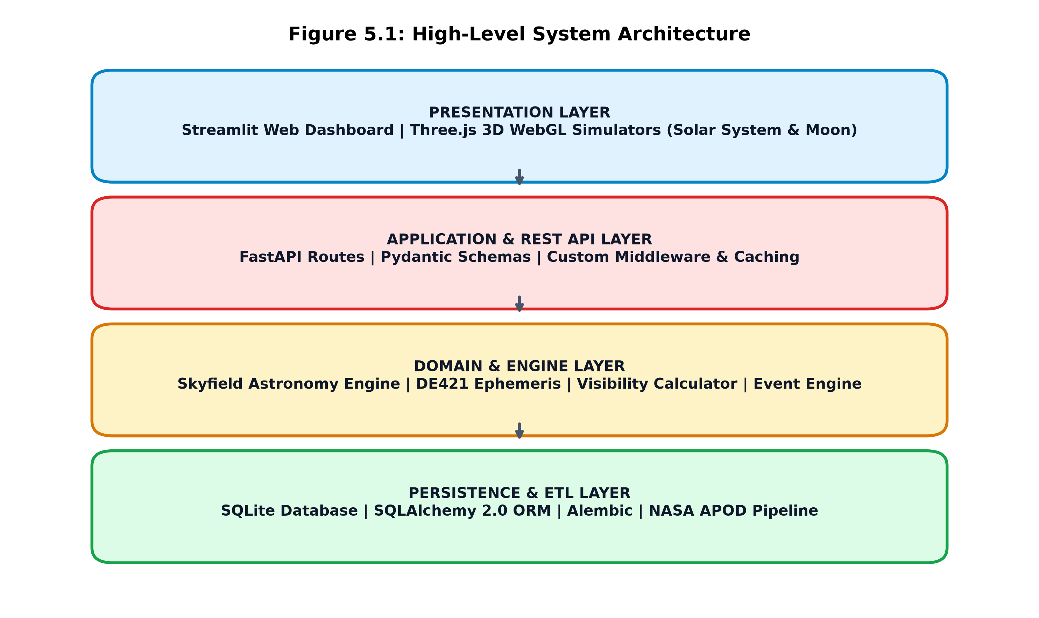
Fig 2.2.1 System Architecture Diagram

2.3 Table Structure / Data Dictionary
The relational database schema is normalized and implemented via SQLAlchemy ORM over SQLite / MySQL engines. Below are the data dictionaries for the core database tables:
Table 2.3.1: users
Field | Type | Description
id | INTEGER (PK) | Surrogate primary key
username | VARCHAR(64) | Unique user handle
email | VARCHAR(255) | User email address
is_active | BOOLEAN | Account active flag
created_at | DATETIME | Record creation timestamp
updated_at | DATETIME | Record update timestamp

Table 2.3.2: planets
Field | Type | Description
id | INTEGER (PK) | Surrogate primary key
name | VARCHAR(64) | System identifier name
display_name | VARCHAR(128) | Human readable name
category | VARCHAR(64) | Terrestrial / Gas Giant / Ice Giant
description | TEXT | Detailed astronomical profile
mass_kg | FLOAT | Mass in kilograms
radius_km | FLOAT | Volumetric mean radius in km
semi_major_axis_au | FLOAT | Orbital distance in AU
orbital_period_days | FLOAT | Orbital revolution in days
mean_density_g_cm3 | FLOAT | Density in g/cm³
source_url | TEXT | Reference source URL
is_active | BOOLEAN | Active visibility flag
created_at | DATETIME | Creation timestamp
updated_at | DATETIME | Update timestamp

Table 2.3.3: celestial_events
Field | Type | Description
id | INTEGER (PK) | Surrogate primary key
event_type | VARCHAR(64) | Conjunction / Opposition / Shower / Eclipse
title | VARCHAR(255) | Event headline title
description | TEXT | Full event summary & advice
starts_at | DATETIME | Event window start timestamp
ends_at | DATETIME | Event window end timestamp
visible_from | VARCHAR(255) | Geographic region visibility
source_url | TEXT | Reference source link
is_recurring | BOOLEAN | Annual recurrence flag
planet_id | INTEGER (FK) | Associated planet ID reference
created_at | DATETIME | Record creation timestamp
updated_at | DATETIME | Record update timestamp

Table 2.3.4: educational_categories
Field | Type | Description
id | INTEGER (PK) | Surrogate primary key
slug | VARCHAR(128) | URL slug identifier
name | VARCHAR(128) | Category title
description | TEXT | Category summary
created_at | DATETIME | Creation timestamp

Table 2.3.5: educational_content
Field | Type | Description
id | INTEGER (PK) | Surrogate primary key
category_id | INTEGER (FK) | Parent category ID reference
title | VARCHAR(255) | Article title
slug | VARCHAR(128) | URL slug handle
excerpt | TEXT | Short article summary
body | TEXT | Markdown full content
source_url | TEXT | Attribution URL
is_featured | BOOLEAN | Featured badge flag
created_at | DATETIME | Creation timestamp
updated_at | DATETIME | Update timestamp

Table 2.3.6: nasa_apod
Field | Type | Description
id | INTEGER (PK) | Surrogate primary key
apod_date | VARCHAR(10) | YYYY-MM-DD APOD date
title | VARCHAR(500) | NASA APOD title
explanation | TEXT | Scientific description text
url | VARCHAR(1024) | Standard image URL
hdurl | VARCHAR(1024) | High-definition image URL
media_type | VARCHAR(32) | image / video
copyright_text | VARCHAR(500) | Image copyright holder
thumbnail_url | VARCHAR(1024) | Video thumbnail URL
source_api | VARCHAR(64) | Data source identifier
created_at | DATETIME | Record creation timestamp
updated_at | DATETIME | Record update timestamp

Table 2.3.7: observation_logs
Field | Type | Description
id | INTEGER (PK) | Surrogate primary key
user_id | INTEGER (FK) | User reference ID
planet_id | INTEGER (FK) | Target planet ID
event_id | INTEGER (FK) | Target celestial event ID
observed_at | DATETIME | Observation timestamp
status | VARCHAR(32) | PLANNED / OBSERVED / MISSED
notes | TEXT | User observation field notes
rating | INTEGER | Observation rating (1 to 5 stars)
created_at | DATETIME | Log timestamp

Table 2.3.8: application_settings
Field | Type | Description
id | INTEGER (PK) | Surrogate primary key
key | VARCHAR(128) | Setting key handle
value | TEXT | Setting value string
description | TEXT | Setting description
user_id | INTEGER (FK) | Optional user override
created_at | DATETIME | Creation timestamp
updated_at | DATETIME | Update timestamp

Table 2.3.9: api_cache
Field | Type | Description
id | INTEGER (PK) | Surrogate primary key
request_key | VARCHAR(255) | MD5 hash key of request
request_url | TEXT | Full HTTP request URL
response_payload | JSON | Cached JSON payload response
created_at | DATETIME | Cache entry timestamp
expires_at | DATETIME | Cache expiration timestamp
last_accessed_at | DATETIME | Last hit timestamp

2.4 Sample Input and Output Screens
The Space Observation Platform incorporates intuitive interactive screens designed for observational astronomy, data analytics, and 3D space visualization:
Fig 2.4.1 Landing Page & Platform Navigation
The main landing interface presenting featured celestial events, quick navigation controls, and instant location setup.
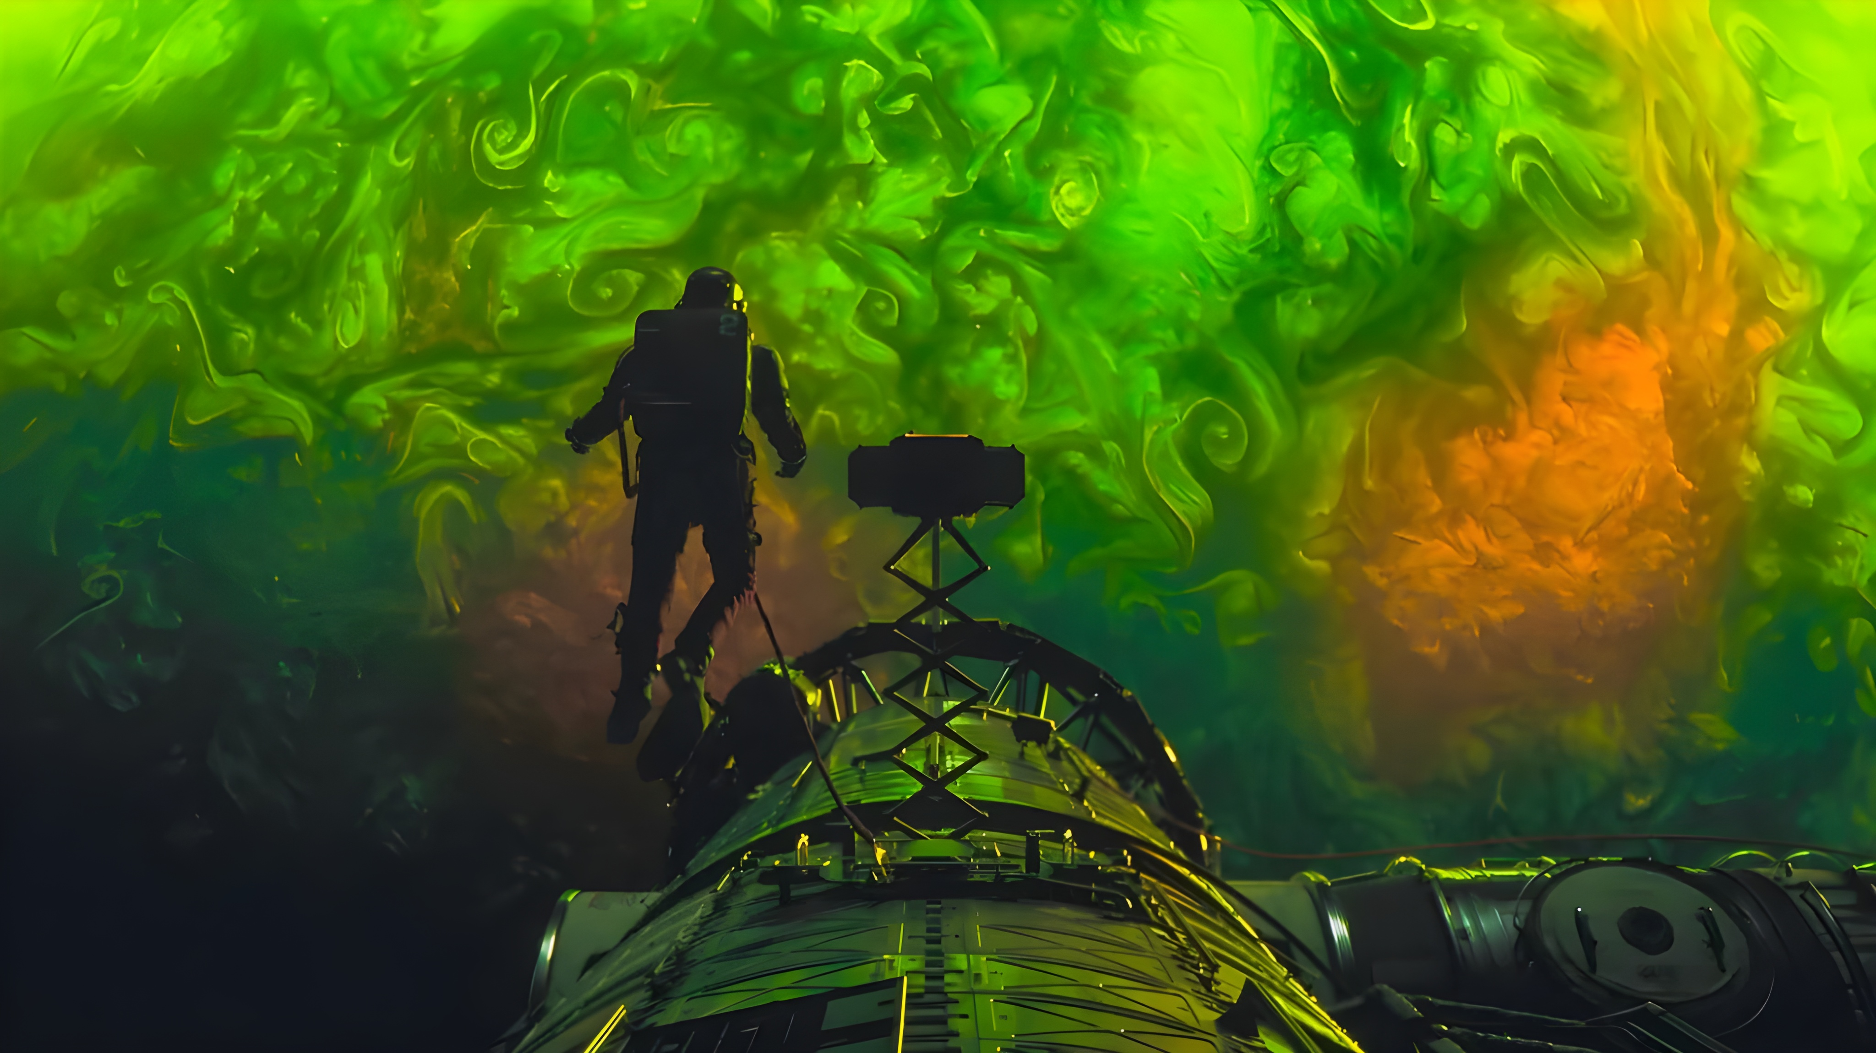
Fig 2.4.1 Landing Page & Platform Navigation
Fig 2.4.2 Interactive Night Sky Map & Position Explorer
The night sky explorer featuring real-time horizontal coordinates (Altitude/Azimuth), planetary visibility cards, and star constellations.
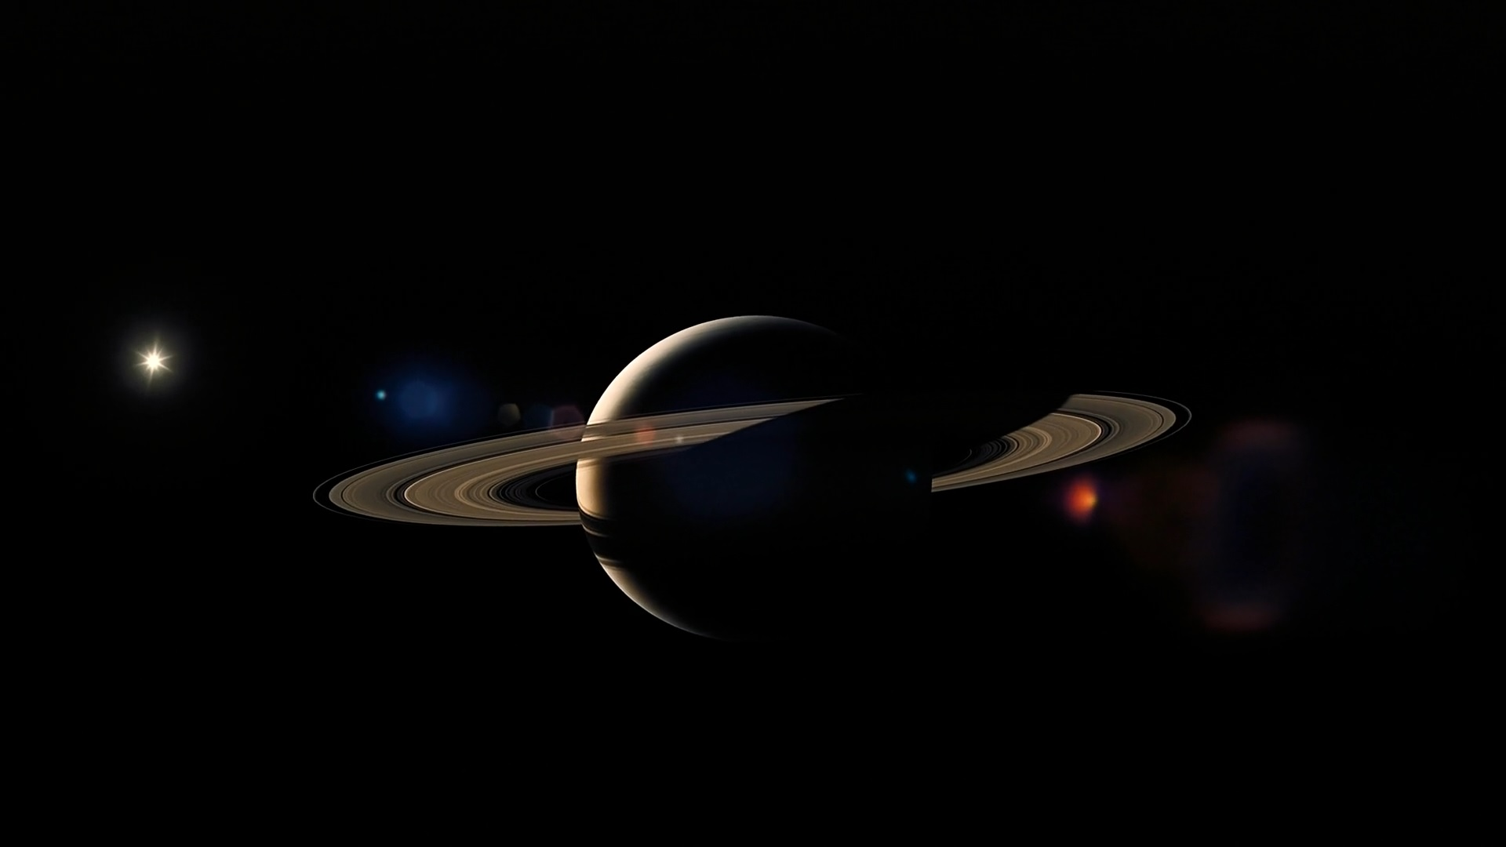
Fig 2.4.2 Interactive Night Sky Map & Position Explorer
Fig 2.4.3 Interactive 3D Solar System Simulation
The WebGL Three.js interactive 3D Solar System simulator allowing users to rotate, zoom, and inspect real planetary orbits.
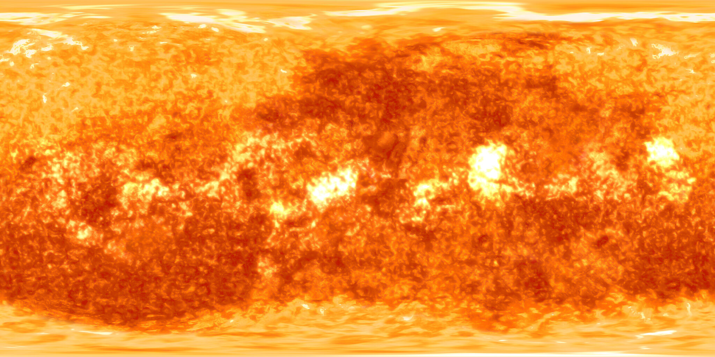
Fig 2.4.3 Interactive 3D Solar System Simulation
Fig 2.4.4 Interactive 3D Moon Phase Visualizer
The 3D lunar illumination renderer displaying precise sub-solar point lighting, lunar age, phase percentage, and distance.
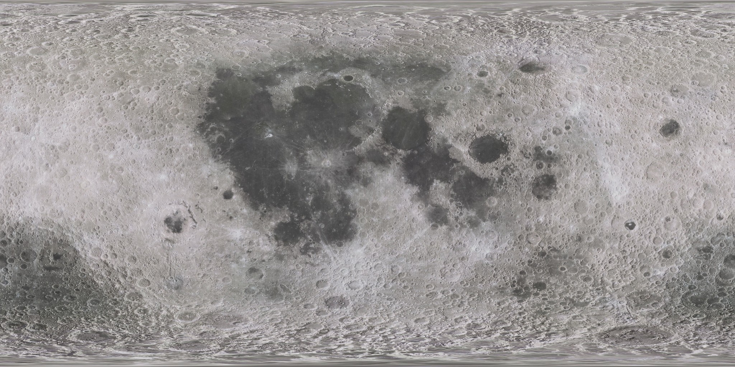
Fig 2.4.4 Interactive 3D Moon Phase Visualizer
Fig 2.4.5 Observation Planner & Visibility Dashboard
The algorithmic observation planner listing ranked observation target windows with suitability scores and twilight constraints.
Fig 2.4.5 Observation Planner & Visibility Dashboard
Fig 2.4.6 Educational Knowledge Base & Planet Profiles
The educational knowledge discovery page detailing physical planetary statistics, atmosphere composition, and observing tips.

Fig 2.4.6 Educational Knowledge Base & Planet Profiles
Fig 2.4.7 NASA Astronomy Picture of the Day (APOD) Interface
The daily APOD viewer displaying high-resolution NASA imagery, scientific explanations, copyright details, and date archives.
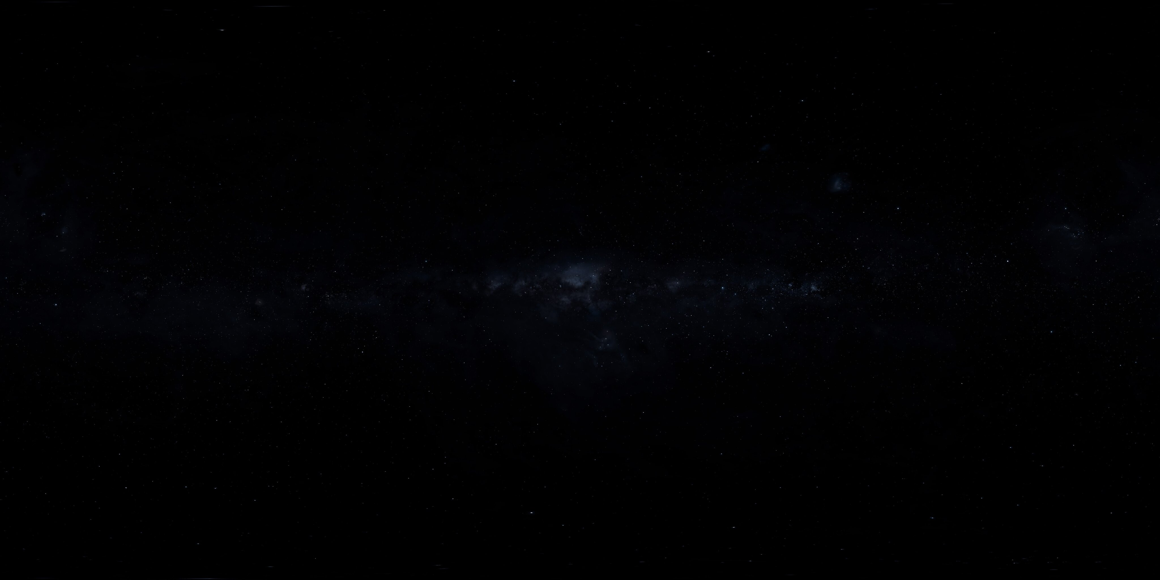
Fig 2.4.7 NASA Astronomy Picture of the Day (APOD) Interface

3. User Manual
3.1 Night Sky Exploration & Interactive Skymap
The Night Sky Explorer enables users to calculate exact celestial positions for any observation site on Earth.
- 1. Location Setup: Enter latitude (-90° to +90°) and longitude (-180° to +180°) or select preset cities (e.g. Pune, Mumbai, London, Tokyo, New York).
- 2. Date & Time Selection: Select target date and local time using the datetime picker.
- 3. Skymap Generation: Click 'Generate Skymap' to compute planetary altitudes, azimuths, magnitudes, and constellations.
- 4. Reading Coordinates: Inspect horizontal coordinates: Altitude > 0° indicates object is above the horizon; Altitude > 15° indicates prime viewing altitude.
3.2 Observation Planner & Visibility Scoring Engine
The Observation Planner evaluates sky conditions to recommend optimal viewing times for planets and celestial events.
- 1. Window Calculation: The engine queries planetary positions throughout the night.
- 2. Suitability Scoring: Scores each target from 0 to 100 based on target altitude, solar twilight state, and lunar interference.
- 3. Score Classification: Targets scoring >= 75 are highlighted as 'EXCELLENT', 50–74 as 'GOOD', and < 50 as 'POOR'.
3.3 Interactive 3D Solar System & Moon Phase Simulators
- 3D Solar System: Launch the embedded WebGL canvas to inspect 3D planetary orbits. Left-click drag to orbit camera, scroll to zoom, right-click drag to pan.
- 3D Moon Phase: Render 3D Moon model showing real-time lunar illumination, waxing/waning phase percentage, and solar position relative to Earth.
3.4 Educational Discovery & NASA APOD Integration
- Knowledge Base: Browse curated categories: Solar System, Deep Sky, Observational Techniques, and Planetary Science.
- NASA APOD Viewer: Fetch NASA APOD imagery for today or any historical date with complete scientific explanations.
3.5 System Validation Rules & Operational Guidelines
- Latitude Range: Latitude must be a numeric float between -90.0 and +90.0.
- Longitude Range: Longitude must be a numeric float between -180.0 and +180.0.
- Timestamp Format: Timestamps must conform to ISO-8601 formatting (YYYY-MM-DDTHH:MM:SS).
- Visibility Threshold: Target altitude must exceed 0° to be visible; recommended minimum altitude is 15° to minimize atmospheric extinction.

4. Technology Stack
4.1 Frontend User Interface Stack
- Core Framework: Streamlit 1.35+ (Python Web Framework)
- Web Technologies: HTML5, CSS3, Modern JavaScript ES6
- 3D Graphics Engine: Three.js (WebGL 3D Rendering Library)
- Styling & Aesthetics: Custom Dark Sky CSS with Glassmorphism Cards
4.2 Backend Server & Astronomy Engine Stack
- API Framework: FastAPI 0.110+ (Python Asynchronous Web Framework)
- Server Gateway: Uvicorn (ASGI High-Performance Server)
- Data Validation: Pydantic v2 (Data Validation & Serialization)
- Astronomy Calculation Engine: Skyfield 1.48+ & PyEphem (Precision Astronomy Engines)
- Orbital Ephemeris Dataset: NASA JPL DE421 Ephemeris Data File
4.3 Database, ETL & Infrastructure Stack
- Relational Database: SQLite 3 / MySQL Compatible Engine
- ORM Mapping Layer: SQLAlchemy 2.0 ORM (Object Relational Mapper)
- Database Migrations: Alembic (Database Schema Migration Engine)
- ETL Infrastructure: Custom Asynchronous NASA APOD ETL Pipeline
- Testing Framework: Pytest 9.0+ Test Suite (Unit & Integration Testing)
- Deployment & DevOps: Docker & Docker Compose Containerization

5. System Architecture
The Space Observation Platform utilizes a clean, decoupled 4-tier architecture designed for low latency astronomical computation and reliable payload delivery:
- 1. Presentation Layer: Streamlit UI renders responsive viewports, handles user input forms, and hosts Three.js WebGL canvas views.
- 2. Application API Layer: FastAPI REST service exposes documented OpenAPI endpoints, validates payloads via Pydantic, and manages caching.
- 3. Domain Engine Layer: Core astronomy service integrates Skyfield and JPL DE421 ephemeris to compute body vectors, horizontal coordinates, twilight times, and visibility scores.
- 4. Persistence Layer: SQLAlchemy ORM persists celestial reference metadata, educational articles, observation logs, and cached API responses.
6. Applications and End Users
- Educational Institutions & Students: Students learning solar system mechanics, moon phases, and star constellations through interactive visual tools.
- Amateur Astronomers: Stargazers and telescope owners planning observation sessions around optimal visibility windows.
- Astrophotographers: Astrophotographers tracking planet altitudes and dark sky twilight periods for long-exposure imaging.
- Public Astronomy Clubs: Science museums, planetariums, and astronomy clubs conducting public outreach stargazing events.
7. Conclusion
The Space Observation Platform successfully fulfills the requirements of an advanced Application Development Project by delivering a full-stack, data-driven astronomical intelligence platform.
By combining high-precision JPL ephemeris mathematical engines with modern interactive web technologies (FastAPI, Streamlit, Three.js), the platform bridges the gap between complex orbital mechanics and user-friendly sky observation.
8. Future Scope
- Computerized Telescope Control (GOTO): Integration with ASCOM / INDI protocols to automatically point computerized GOTO telescope mounts at selected target coordinates.
- Satellite & ISS Tracking: Real-time orbital propagation and pass predictions for low Earth orbit satellites including ISS and Hubble.
- Real-Time Meteorological Integration: Integration of cloud cover, humidity, and atmospheric seeing predictions into the observation planner scoring model.
- Mobile Native AR Application: Native iOS and Android mobile app development with AR (Augmented Reality) sky pointing capabilities.

