

Maharashtra Education Society’s
Institute of Management and Career Courses (IMCC), Pune
AUTONOMOUS

Academic Year 2025-26

F.Y. MCA Semester-II Course: ITP21 Mini Project

Project Documentation Guidelines
Project Type: Application Development Project

 |  | Institute Certificate
1 |  | Introduction
1 | 1 | Project Scope
2 |  | Analysis and Design
2 | 2.1 | Use Case Diagrams
2 | 2.2 | Table Structure/Data Dictionary
2 | 2.3 | Sample Input and Output Screens (Screens must have valid data.  All Screens must have at-least 5 valid records.)
3 |  | User Manual (All screens with proper description/purpose Details about validations related to data to be entered.)
4 |  | Publication / Competition certificates (If Applicable)



MAHARASHTRA EDUCATION SOCIETY'S
(SINCE 1860)
INSTITUTE OF MANAGEMENT & CAREER COURSES (IMCC)
(AUTONOMOUS)
Approved by AICTE and Recognized by Savitribai Phule Pune University, Pune
IMCC Campus, 131, Mayur Colony, Kothrud, Pune 411038, Maharashtra, India | Ph.: 020-2546 6271 / 73 | e-mail: info.imcc@mespune.in | https://imcc.mespune.in
NAAC Accredited with Grade A+
Ref. No. MES IMCC / 442/ 2025 Date: 06/05/2026

CERTIFICATE

This is to certify that the Project entitled “Trackify” is completed by “Nimish Powar” of M.C.A. Semester II for the Academic Year 2025-26 at MES’ Institute of Management & Career Courses (IMCC), Pune - 411038.
To the best of our knowledge, this is an original study done by the said student and important sources used by him/her have been duly acknowledged in this report.
The report is submitted as a part of course ITP21 Mini Project for the Academic Year 2025-26 as per the rules and guidelines prescribed by the institute.



Trackify

AI-Powered Personal Finance Management System
Academic Year: 2025–26
Course: ITP21 – Mini Project
Project Type: Application Development Project
Institute: Maharashtra Education Society’s
Institute of Management and Career Courses (IMCC), Pune (Autonomous)
Team Members:
2501108 – Soham Limhan
2501149 – Nimish Powar

1. Introduction

In today’s fast-paced digital world, managing personal finances effectively has become increasingly important. Many individuals struggle to track expenses, manage recurring payments, and analyze their financial habits.
Trackify is a modern full-stack personal finance management system that enables users to track income and expenses, analyze spending patterns, automate recurring payments, and receive AI-powered financial advice.
The system integrates advanced features such as:
- Bank statement PDF import
- AI-based financial advisory
- Risk score analysis
- Data visualization dashboards
- Automated recurring expense tracking
Unlike traditional finance apps, Trackify provides intelligent insights and predictive analysis, helping users make better financial decisions.

1.1. Project Scope

TrackifyV2 is a modern, full-stack personal finance management application designed to help users track their income and expenses, analyze their spending habits, and receive AI-driven financial advice. It emphasizes a premium user experience with dynamic data visualization, automated statement parsing, and local AI integration.

1.1. Core Features (Financial Tracking)
- Authentication & Security: Secure user registration, login, and password recovery using JWTs, alongside Google OAuth integration for quick sign-ins.
- Transaction Management: Manual entry of daily income and expenses categorized for granular tracking.
- Bank Statement Automation: Ability to upload PDF bank statements which the system automatically parses using regex to extract and log transactions.
- Recurring Expenses: Setup and tracking of subscription or EMI payments (e.g., setting a start date, monthly frequency, and auto-deducting them).
- Budgeting: Setting global monthly expense limits with visual warnings when nearing or exceeding the budget.

1.2. Advanced Analytics & AI
- AI Financial Advisor: An integrated chat-like interface that streams personalized financial insights, savings tips, and risk alerts generated by a local Ollama LLM based on the user's actual transaction history.
- Risk Score Analyzer: A deterministic, math-based algorithm that calculates a 0-100 financial health score by evaluating the user's savings rate and emergency fund coverage.
- Debt Payoff Calculator: A tool that uses standard amortization formulas to estimate how many months it will take to pay off a specific debt based on the principal, interest rate, and monthly payment.
- Dashboard Visualizations: Interactive charts (Bar charts for Income vs. Expense, Pie charts for Category breakdowns) built with Recharts to provide an at-a-glance view of financial health.

1.3. Reporting & Data Portability
- PDF Generation: A one-click, highly-styled, client-side PDF reporting engine that generates audit-ready financial snapshots including charts, AI insights, and transaction history.
- Data Export: Raw data exportation capabilities allowing users to download their transactions in standard CSV or formatted Excel (.xlsx) files.

1.4. UI / UX Scope
- Premium Design Aesthetics: Implementation of a glass morphism design system, smooth page transitions (via Framer Motion), dynamic gradient backgrounds, and an automated Light/Dark mode toggle.
- Responsive Layout: A fully responsive dashboard grid system designed to work seamlessly across mobile, tablet, and desktop devices.

2. Analysis and Design

2.1 Use Case Diagram

Actors:
- User
- Firebase (Database)
- Ollama AI Model

Use Cases:
- Register/Login User
- Add Transaction
- View Transactions
- Upload Bank Statement
- Analyse Expenses
- Generate Financial Insights
- Calculate Risk Score
- Manage Recurring Expenses
- Export Reports

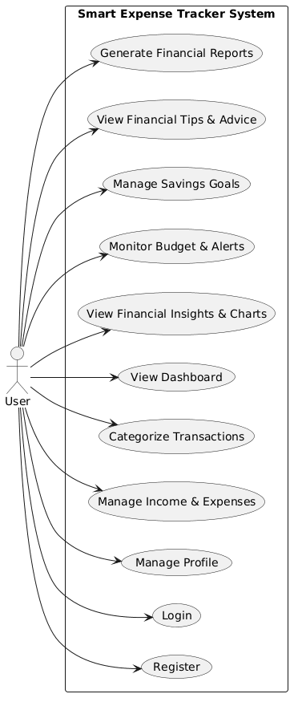

Fig 2.1.1 Use case Diagram

2.3 Table Structure / Data Dictionary

Table: Users

Field | Type | Description
email | string | User email
password | string | Hashed password
full_name | string | User name

Table: Transactions

Field | Type | Description
user_id | string | User reference
amount | float | Transaction amount
type | string | income/expense
category | string | Expense category
description | string | Details
date | timestamp | Transaction date

Table: Budgets

Field | Type | Description
user_id | string | User reference
limit_amount | float | Monthly budget

Table: Recurring Expenses

Field | Type | Description
amount | float | EMI amount
category | string | Type
day_of_month | int | Deduction date
total_months | int | Duration

2.4 Sample Input and Output Screens

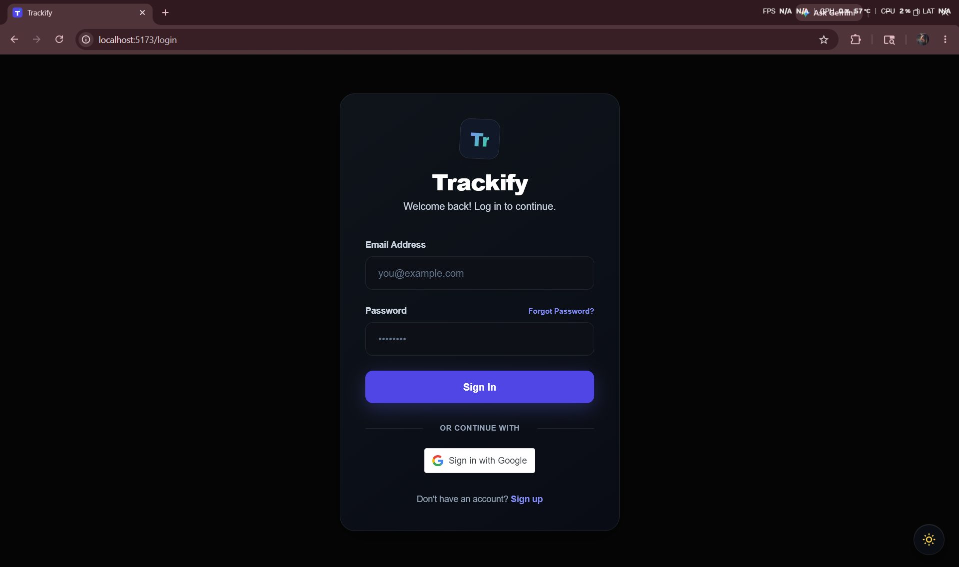
Fig 2.4.1 Login Page

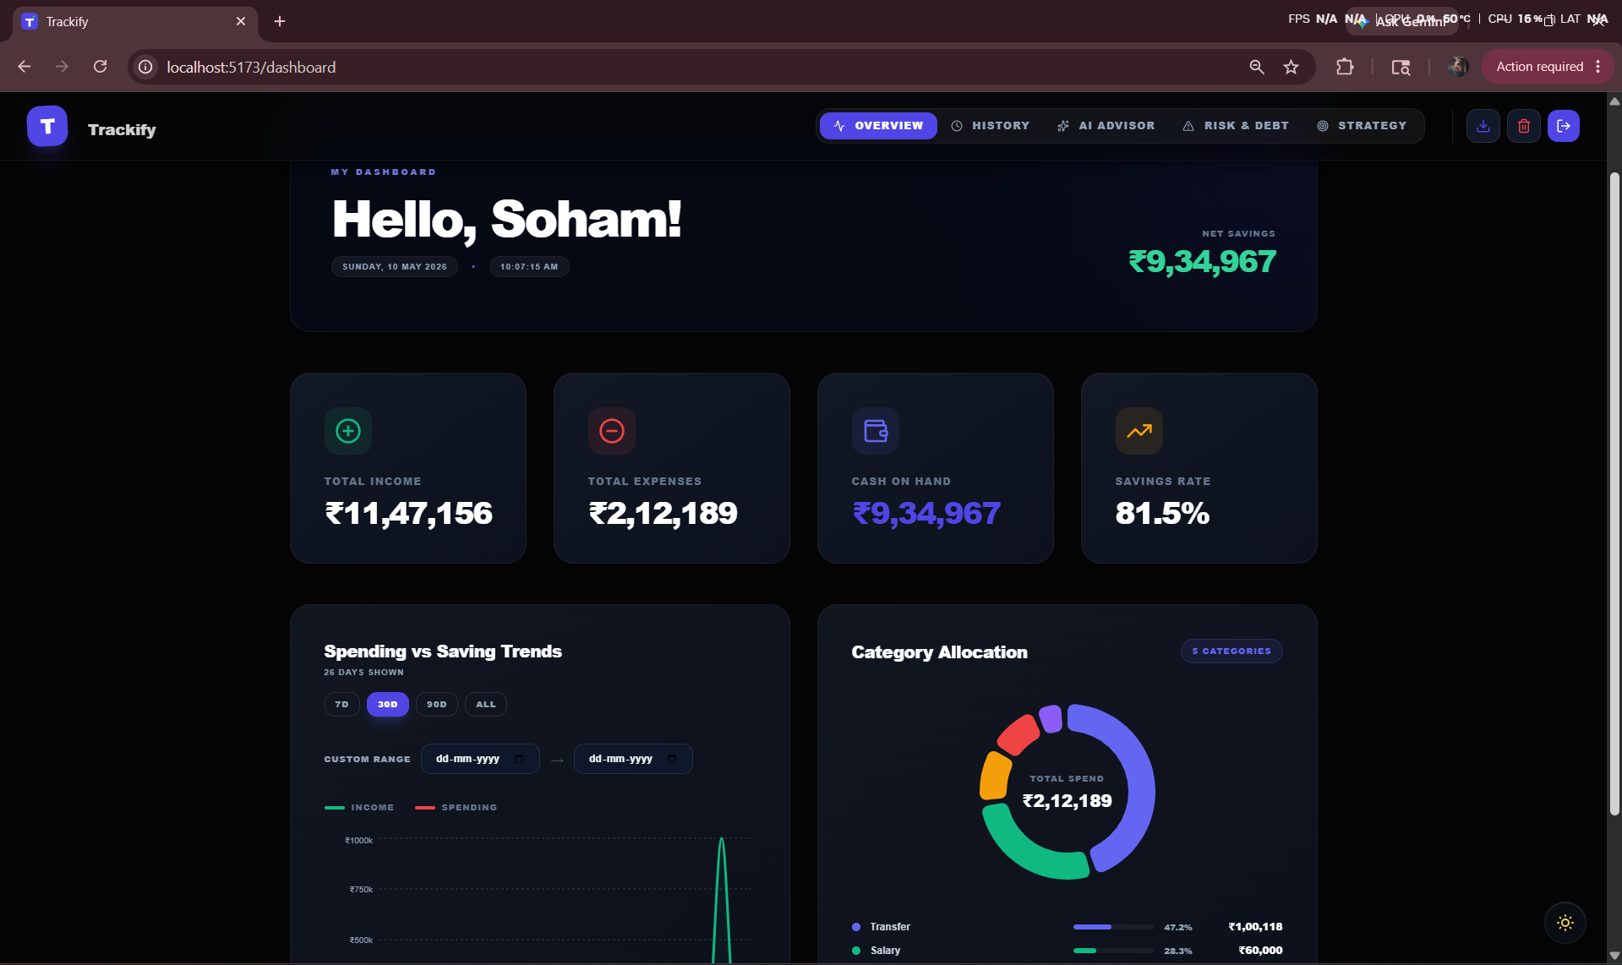
Fig 2.4.2 Dashboard

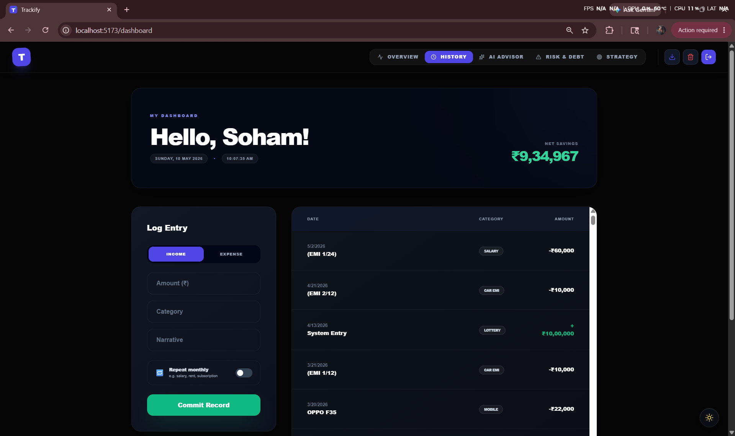
Fig 2.4.3 Add Transaction

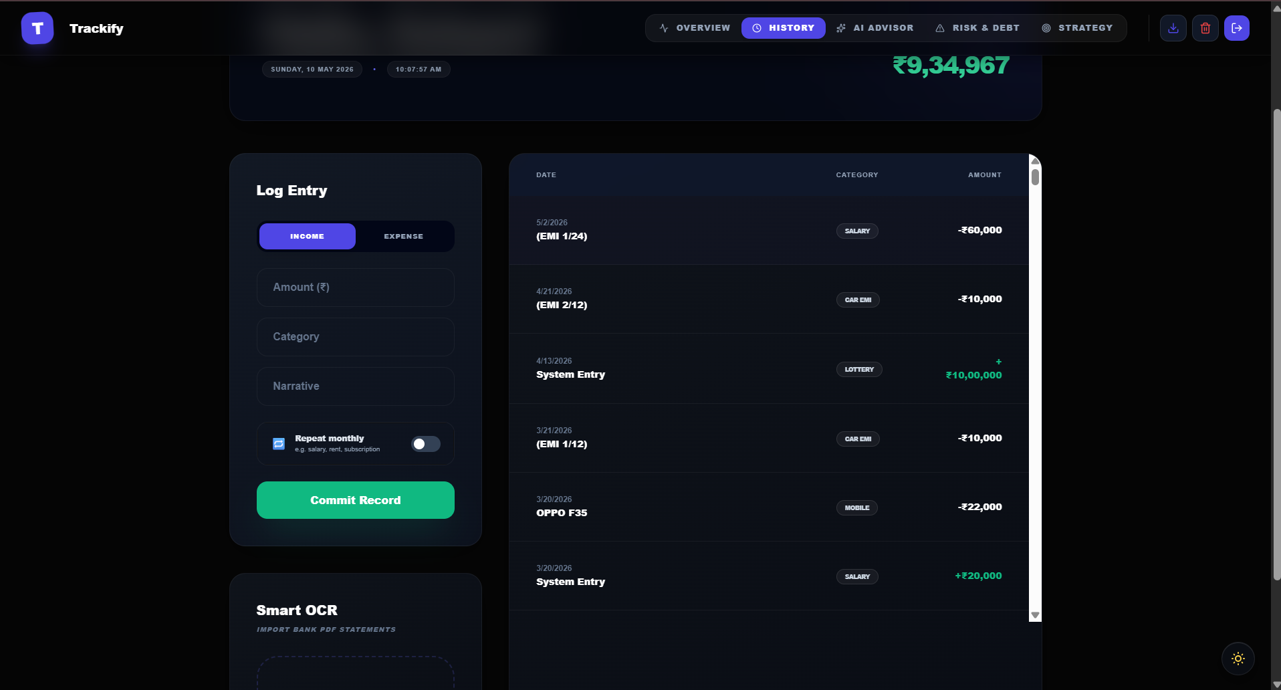
Fig 2.4.4 Transaction List

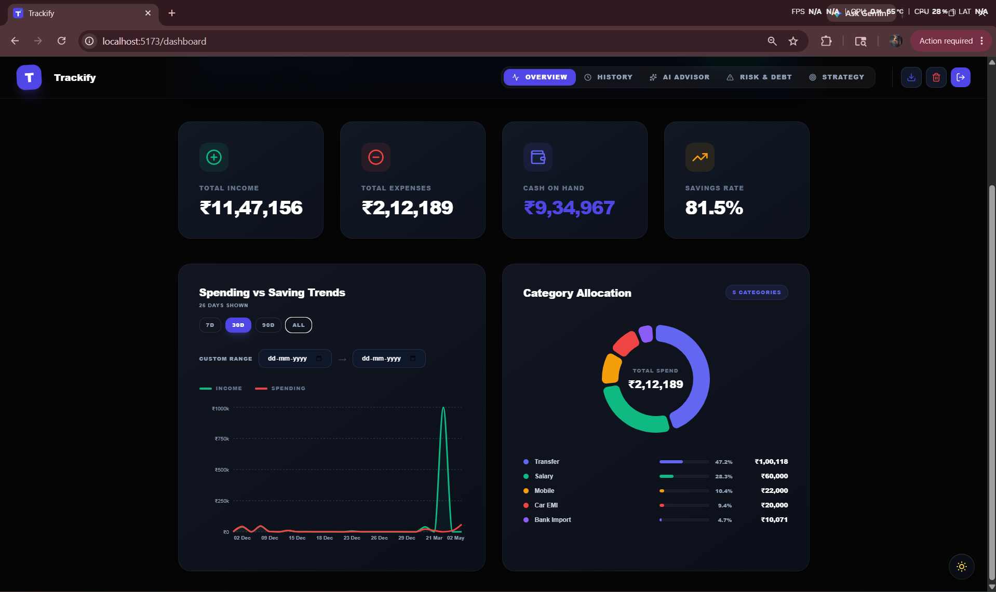
Fig 2.4.5 Analytics Dashboard
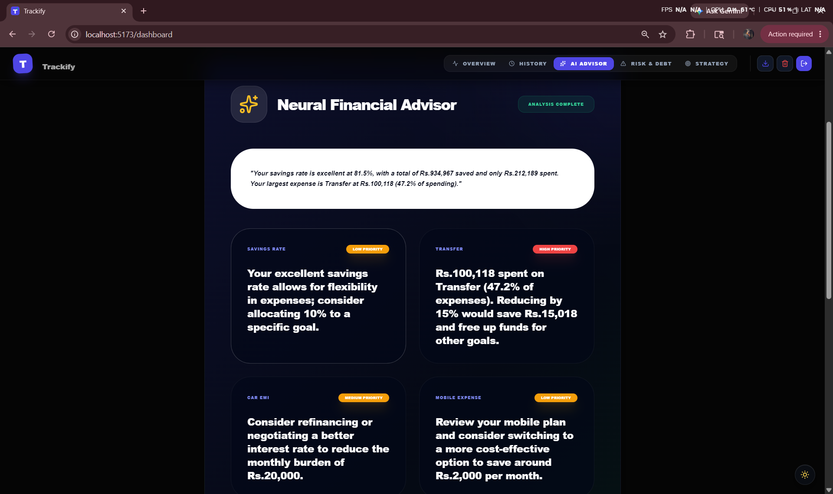
Fig 2.4.6 AI Financial Advisor
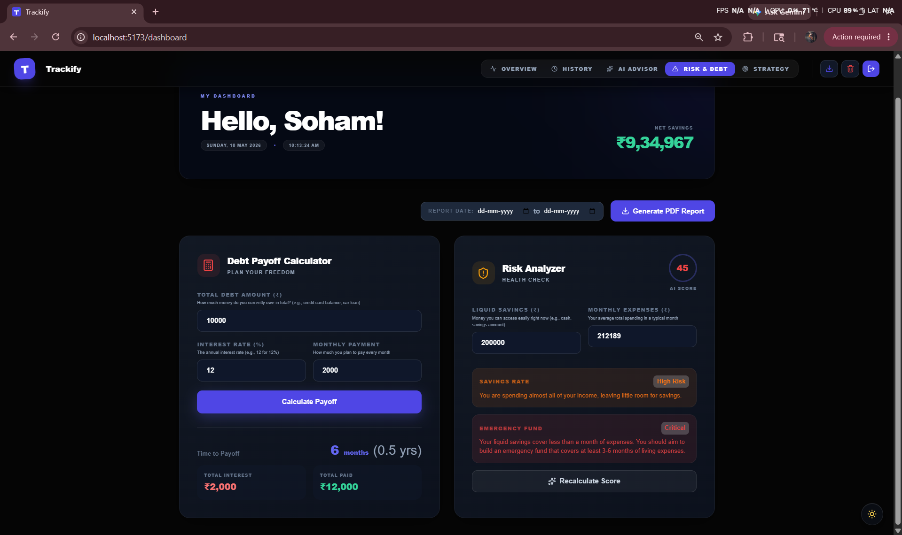
Fig 2.4.7 Risk Score Screen
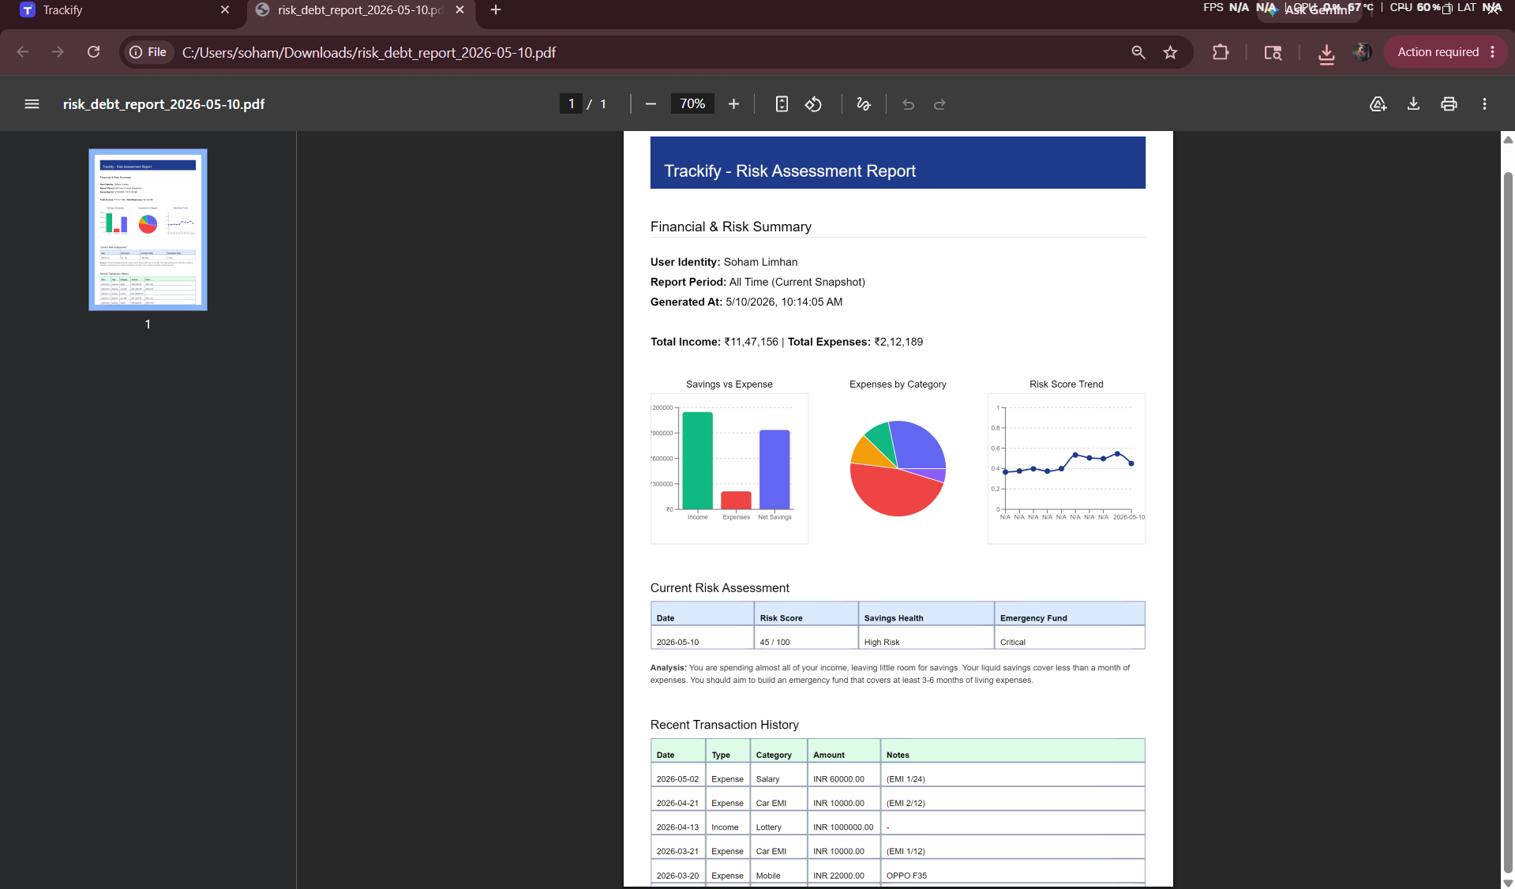
Fig 2.4.8 Export Feature

3. User Manual

3.1 User Registration & Login
- User registers using email/password or Google login
- JWT authentication is used for secure access
- One Time Password verification (Email)

3.2 Adding Transactions
- Enter amount, category, and description
- Choose income or expense
- Click “Add Transaction”
- If recurring, click on the checkbox and also the tenure.
Validation:
- Amount must be numeric
- Category cannot be empty

3.3 Upload Bank Statement
- Upload PDF file (Only Saraswat bank)
- System parses transactions automatically

3.4 Dashboard Usage
- Displays:
  - Total income
  - Total expenses
  - Savings rate
  - Savings
- Graphs show spending trends
- Category wise transactions

3.5 AI Financial Advisor
- User asks queries like:
“Can I afford a new phone?”
- AI provides:
  - Summary
  - Insights
  - Tips
- Note: AI PERFORMANCE CAN DEPEND ON SYSTEM.

3.6 Risk & Debt Analyzer
The Local Risk Score Logic
The new logic calculates a 100-point score composed of two 50-point metrics:
1. Savings Rate Score (Max 50 points)
Calculates what percentage of your total income is saved. Target: 20% (0.20) savings rate yields a full 50 points.
- If >= 20%: "Healthy"
- If >= 10%: "Moderate"
- If > 0%: "High Risk"
- If <= 0%: "Critical"
2. Emergency Fund Score (Max 50 points)
Calculates how many months of expenses your liquid savings cover. Target: 6 months of coverage yields a full 50 points.
- If >= 6 months: "Healthy"
- If >= 3 months: "Moderate"
- If >= 1 month: "High Risk"
- If < 1 month: "Critical"
3. Formula
Total Score = Savings Rate Score + Emergency Fund Score
Final Output
The two scores are added together (up to 100) and returned with contextual text explanations matching exactly the JSON format the frontend expects.

- Shows:
  - Savings ratio
  - Expense patterns
  - Risk alerts

3.7 Export Reports
- Download data as:
  - CSV
  - PDF

4. Technology Stack

Frontend (User Interface)
- Core Framework: React 19
- Build Tool: Vite
- Routing: React Router DOM
- Styling: Tailwind CSS (with PostCSS and Autoprefixer)
- Icons: Lucide React & Heroicons
- Data Visualization: Recharts
- Animations & Graphics: Framer Motion, Three.js, and CountUp
- Authentication: Google OAuth (@react-oauth/google) & JWT Decode
- Export & Reporting: jsPDF, jsPDF-AutoTable, and html2canvas (for PDF generation)

Backend (Server & API)
- Core Framework: FastAPI (Python)
- Server: Uvicorn
- Data Validation: Pydantic & Pydantic-Settings
- Authentication & Security: Passlib (bcrypt), python-jose (cryptography), and Google Auth
- Database Integration: Firebase Admin (Firestore) and SQLite (configured via Docker volumes)
- File Processing (Uploads & Exports): PyPDF2 (for parsing statements), Pandas, Openpyxl (for Excel exports), and python-multipart
- External Requests: HTTPX (used for asynchronous AI/Ollama API calls)

Infrastructure & Deployment
- Containerization: Docker & Docker Compose (orchestrating separate frontend and backend services)
- Environment Management: python-dotenv for backend secrets and Vite's native env handling for the frontend.

5. SYSTEM ARCHITECTURE

Frontend (React)
↓
Nginx Server
↓
FastAPI Backend
↓
Firestore Database + Ollama AI
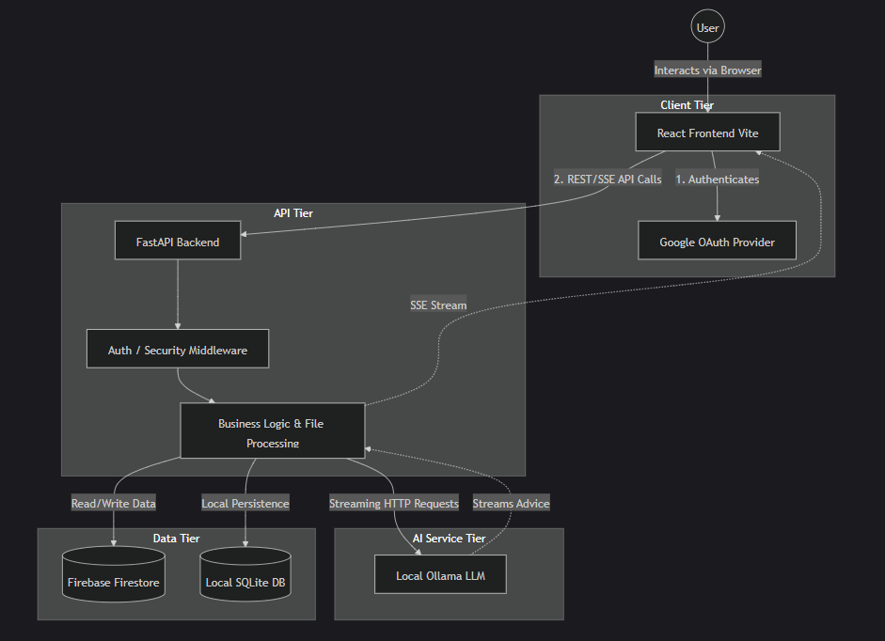

6. Applications and End Users

- Individuals managing personal finance
- Students tracking expenses
- Professionals planning budgets
- Financial advisors (basic insights)

7. Conclusion

Trackify V2 successfully provides a comprehensive personal finance solution by combining modern web technologies with AI capabilities.
The system not only tracks expenses but also provides intelligent insights, making it more powerful than traditional expense trackers.
It fulfils all objectives of an application development project and demonstrates strong full-stack development skills.

8. Future Scope

- Mobile application (Android/iOS)
- Multi-user family finance tracking
- Integration with real bank APIs
- Advanced ML-based predictions
- Investment tracking module
- Email notification system

