# **CREATIVITY IS THINKING UP NEW THINGS. INNOVATION IS DOING NEW THINGS.**

**BACKGROUND:**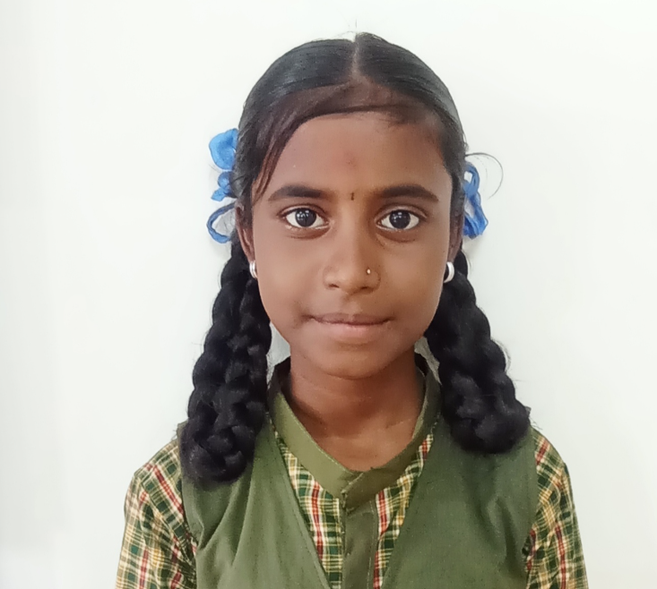

Laxmi Vagavode, a 7th-grade student at GHPS Model No.16 Hosur, is a curious and active learner. With a keen interest in science, she enjoys playing basketball, Kabbadi, and reading books. Laxmi comes from a humble background; her father is a laborer, and her mother is a homemaker. She also has an older sister who is focused on her studies.

## **INNOVATION DISTINGUISHES BETWEEN A LEADER AND A FOLLOWER**

Laxmi's journey into the world of innovation began with her first experience at the Agastya Foundation's Innovation Hub. Reflecting on this experience, she describes it as "enlightening, incredible, and amazing." The Innovation Hub provided her with access to tools like microcontrollers and sensors, which she had never encountered before. Through various activities, she engaged deeply in projects that challenged her creativity and problem-solving skills.

One of the standout projects she worked on was a solar-powered water purifier. Laxmi and her team were inspired by the scarcity of clean water in their community, a problem that affected their daily lives. "We wanted to create something that could make a real difference," Laxmi recalls. They researched existing water purification methods and adapted them to fit the local needs. The Innovation Hub provided them with the necessary resources and guided them through the brainstorming and creation process. "At first, we struggled with the technical aspects, but the instructors at Agastya were patient and explained everything clearly. It felt like a puzzle that we were solving piece by piece." (4G1)

Another project Laxmi worked on was a sustainable garden irrigation system. This project was particularly meaningful to her because it combined her love for the environment with practical innovation. The system used sensors to monitor soil moisture levels and automatically water the plants as needed. "We used simple materials like recycled plastic bottles, and it was amazing to see how something so basic could be transformed into a tool that conserves water and supports plant growth," Laxmi explains. The hands-on experience at the Innovation Hub was crucial in helping her understand the importance of sustainability and how technology can be leveraged to address environmental issues. (4E)

Laxmi's participation in these projects has significantly enhanced her ability to think creatively and approach problems from different angles. She notes, "Before joining the Innovation Hub, I used to think there was only one way to solve a problem. But now, I know there are many ways, and sometimes the most innovative solution is the simplest one." (3B)

**ASPIRATION:**

Laxmi aspires to become a scientist specializing in environmental sustainability. Her experiences at the Agastya Foundation have been instrumental in shaping this ambition. The hands-on activities and exposure to innovative technologies have given her the confidence and skills needed to pursue her dream. "Agastya has shown me that science is not just about learning from books but about creating solutions that can change the world," she says with determination. (5E)