The 5 Most Powerful Candlestick Patterns

Candlestick charts are a technical tool that pack data for multiple time frames into single price bars. This makes them more useful than traditional open-high, low-close bars (OHLC) or simple lines that connect the dots of closing prices. Candlesticks build patterns that predict price direction once completed. Proper color coding adds depth to this colorful technical tool, which dates back to 18th century Japanese rice traders.

Steve Nison brought candlestick patterns to the Western world in his popular 1991 book, "Japanese Candlestick Charting Techniques." Many traders can now identify dozens of these formations, which have colorful names like bearish dark cloud cover, evening star and three black crows. In addition, single bar patterns including the doji and hammer have been incorporated into dozens of long- and short-side trading strategies.

Candlestick Pattern Reliability
Not all candlestick patterns work equally well. Their huge popularity has lowered reliability because they've been deconstructed by hedge funds and their algorithms. These well-funded players rely on lightning-speed execution to trade against retail investors and traditional fund managers who execute technical analysis strategies found in popular texts. In other words, hedge fund managers use software to trap participants looking for high-odds bullish or bearish outcomes. However, reliable patterns continue to appear, allowing for short- and long-term profit opportunities.
Here are five candlestick patterns that perform exceptionally well as precursors of price direction and momentum. Each works within the context of surrounding price bars in predicting higher or lower prices. They are also time sensitive in two ways. First, they only work within the limitations of the chart being reviewed, whether intraday, daily, weekly or monthly. Second, their potency decreases rapidly three to five bars after the pattern has completed.

Top 5 Candlestick Patterns
This analysis relies on the work of Thomas Bulkowski, who built performance rankings for candlestick patterns in his 2008 book, "Encyclopedia of Candlestick Charts." He offers statistics for two kinds of expected pattern outcomes: reversal and continuation. Candlestick reversal patterns predict a change in price direction, while continuation patterns predict an extension in the current price direction.
In the following examples, the hollow white candlestick denotes a closing print higher than the opening print, while the black candlestick denotes a closing print lower than the opening print.

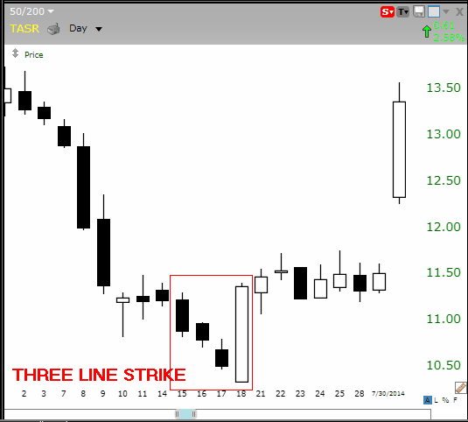
Three Line Strike

The bullish three line strike reversal pattern carves out three black candles within a downtrend. Each bar posts a lower low and closes near the intrabar low. The fourth bar opens even lower but reverses in a wide-range outside bar that closes above the high of the first candle in the series. The opening print also marks the low of the fourth bar. According to Bulkowski, this reversal predicts higher prices with an 84% accuracy rate.
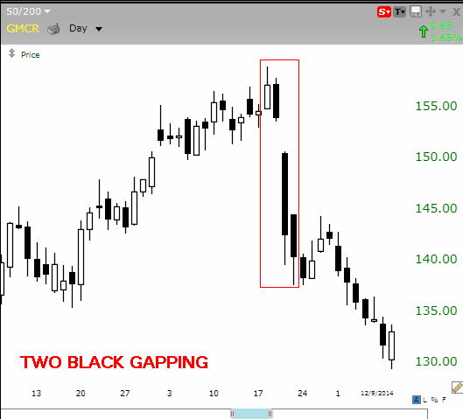
Two Black Gapping

The bearish two black gapping continuation pattern appears after a notable top in an uptrend, with a gap down that yields two black bars posting lower lows. This pattern predicts that the decline will continue to even lower lows, perhaps triggering a broader-scale downtrend. According to Bulkowski, this pattern predicts lower prices with a 68% accuracy rate.

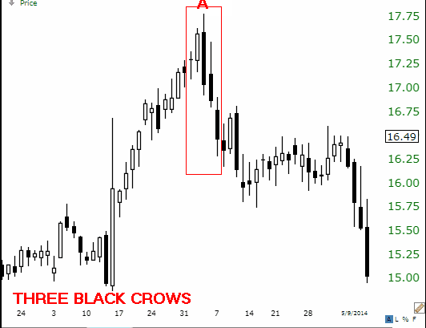
Three Black Crows

The bearish three black crows reversal pattern starts at or near the high of an uptrend, with three black bars posting lower lows that close near intrabar lows. This pattern predicts that the decline will continue to even lower lows, perhaps triggering a broader-scale downtrend. The most bearish version starts at a new high (point A on the chart) because it traps buyers entering momentum plays. According to Bulkowski, this pattern predicts lower prices with a 78% accuracy rate.

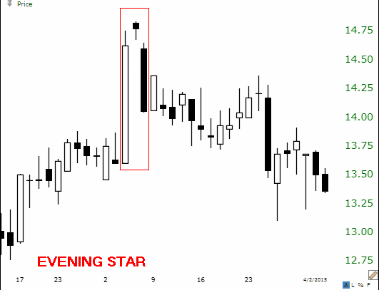
Evening Star

The bearish evening star reversal pattern starts with a tall white bar that carries an uptrend to a new high. The market gaps higher on the next bar, but fresh buyers fail to appear, yielding a narrow range candlestick. A gap down on the third bar completes the pattern, which predicts that the decline will continue to even lower lows, perhaps triggering a broader-scale downtrend. According to Bulkowski, this pattern predicts lower prices with a 72% accuracy rate.

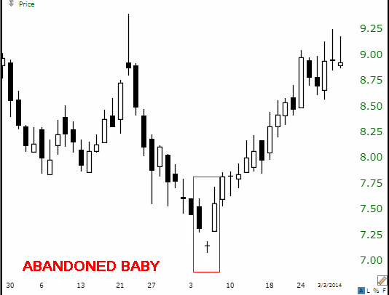
The Abandoned Baby

The bullish abandoned baby reversal pattern appears at the low of a downtrend, after a series of black candles print lower lows. The market gaps lower on the next bar, but fresh sellers fail to appear, yielding a narrow range doji candlestick with opening and closing prints at the same price. A bullish gap on the third bar completes the pattern, which predicts that the recovery will continue to even higher highs, perhaps triggering a broader-scale uptrend. According to Bulkowski, this pattern predicts higher prices with a 70% accuracy rate.

The Bottom Line

Candlestick patterns capture the attention of market players, but many reversal and continuation signals emitted by these patterns don't work reliably in the modern electronic environment. Fortunately, statistics by Thomas Bulkowski show unusual accuracy for a narrow selection of these patterns, offering traders actionable buy and sell signals.
Putting the insights gained from looking at candlestick patterns to use and investing in an asset based on them would require a brokerage account. To save some research time, Investopedia has put together a list of the best online brokers so you can find the right broker for your investment needs.

