A Business Application for Commercial Cleaning Company

Technical Design Document
By Documentation Team
TABLE OF CONTENTS
1 Introduction 1
1.1 Purpose 1
1.2 Scope 2
2 System Overview 3
2.1 System Characteristics 3
2.2 System Architecture Diagrams 4
2.3 Infrastructure services 9
2.4 Aws Infrastructure Overview 10
2.5 System Requirements 11
3 Architecture Overview 14
3.1 Components 14
3.2 API & Integrations 17
3.3 Technologies Used 20
4 Conclusion: 22

Introduction

The Commercial Cleaning Company Application is modern business software which was designed to make a highlighted cutting-edge technology. It has been carefully developed at the true purpose of rewriting and changing how commercial cleaning companies are managed. Through the demands of both supervisors and on-the-ground cleaning workers, this software streamlines much that is crucial to the maintenance industry. From instant communication between supervisors and personnel, to monitoring break times spent away from work sites for both employees on location or in vehicles an route back to base, staff allocation efficiency of such functions as real-time task management tracking; GPS employee locator logging time cars have left locations; automatic verification of completion tasks performed by service subcontracted teams (especially useful when there are many concurrent users Submit the bill The software provides cleaning staff with user-friendly channels for communication, notification of assigned tasks, route tracking via GPS technology, scheduling and clock in or out. This allows them to quickly report that work is complete, visit the site of their assignment, and receive cleaning tasks for a given day and set about performing those duties. This application has potential to bring greater profitability and productivity to a cleaning services firm. This is because it makes management more efficient, raises customer satisfaction levels and promotes openness by giving prompt updates. The Commercial Cleaning Company Application has been an important step in streamlining modern commercial cleaning operations.

Purpose
The main purpose of this application is to enable a cleaning company, acting as a commercial partner, to run its operations more effectively and efficiently on an everyday basis. With the software's unified platform, it is easier to manage activities, supervise staff and follow progress at any time. Finally, these benefits mean better resource allocation, a happy clientele and higher output and profitability.

Scope

The project is extremely multifaceted and goes well beyond work assignment and management. It also includes productivity logging, time control (by the hour), staff rosters, business vehicle operations information (through global positioning system). For administrators and supervisors more interested in labour control, tools that enable direct communication, distribution of labour tasks, vehicle information flows or staff whereabouts and recordable efficiency levels can be helpful. The cleaners, on the other hand, are equipped with access to the daily schedules, clocking in and out facilities, GPS-based route monitoring systems, reporting of break times, update news regarding assignments and a channel for communication. It is a special application for this kind of business in order to provide managers with an efficient way of managing and organizing cleaning operations and service people, as well as providing cleaners themselves with a method to manage their jobs effectively. By this one can verify that the proposed software adheres to common industry standards and meets all of the needs of a commercial cleaning company. With operating efficiency and customer service as the centrepiece, the Commercial Cleaning Company Analysis seeks to be a cleanup aid. This is done for example by putting emphasis on user-friendliness, security, flexible expansion (scalability), and moduli (divisibility).

System Overview

A feature-rich software package designed to increase a cleaning company's operational effectiveness is called the Commercial Cleaning Company Application. Its primary focus areas are task management, employee supervision, and real-time tracking of cleaning activities. The system's task-scheduling, GPS tracking, break monitoring and phone communication capabilities cover the needs of administrators (supervisors) as well as of cleaners.

System Characteristics

Let's now explore the essential features that characterize the system:

Modularity: The system is designed in such a way that new features or changes can be made with relative ease. It consists of several standalone modules-user administrations, scheduling, work checking on the spot and web tracking through GPS positioning function as well as break time monitoring.

Scalability: As the firm expands, design can accommodate more and more people, actions and data volumes. Scalable storage solutions have been installed for growing user bases and higher volumes of data during peak business hours.

Reliability: High reliability is an important condition to maintain constancy over business hours. Such strategies as regular backups and data archives help speed recovery from unanticipated system failures, preserving valuable information.

Security: It's the system 's top priority, and they have security measures to keep confidential client or employee data safe. Stringent user authentication procedures, encryption standards of the highest caliber and adherence to data protection requirements provide a safe working environment.

Performance: For real-time data processing, the program itself should run as fast and efficiently as possible. Time monitoring, GPS tracking and data management through efficient use of APIs ensure a fast-flowing user experience.

Usability: An interface that requires little training and is easy to use, of this UX design goes usability. Updates that consider customer comments make for better usability and user satisfaction in general.

Compatibility: The system is designed to be compatible with Android platforms. It also supports many different devices (including the latest models). One very important element is stable performance on numerous networks and devices.

Maintainability: The maintainability design of the system enables easy version management and frequent updates. Rapid update deployment reduces downtime, and comprehensive document makes problem-solving easier, while change management smoother.

Integration: Such basic functions as data management and GPS tracking are provided by the application through simple interaction with various APIs. The communication interfaces accommodate in-app, real-time interactions.

Data management: The system relies on a powerful database to store and retrieve data, with high regard placed toward the integrity and reliability of all user information. Older, less-accessed data are archived by various methods to ensure reliable performance.

Notification System: With a fully developed notification system, administrators and cleaning staff receive timely information. Alerts can include announcements, task assignments, work completion notices and rest time.

Task Documentation: Users can quickly and simply document work completed with the system. For more in-depth reporting, they can also include additional notes and pictures. After a task is finished, administrators receive notifications that include all the information needed to ensure accountability and transparency.

system architecture diagrams

This system has various architecture diagrams for the functionalities which are added in this section.

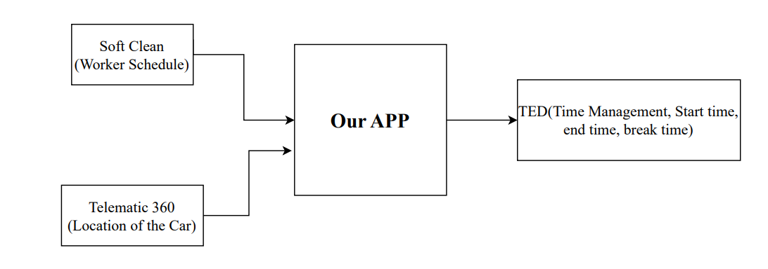

Fig 2.1: Basic structure and Design of over system

Based on the simulation in our project, soft clean Telmatic 360 is called API2 or service provider. Ted as API1 worker reports for time management will be stored on Ted helper services, which is again a simulation to serve our actual project. So, based on our project requirements,. The simulation of this app is illustrated below:

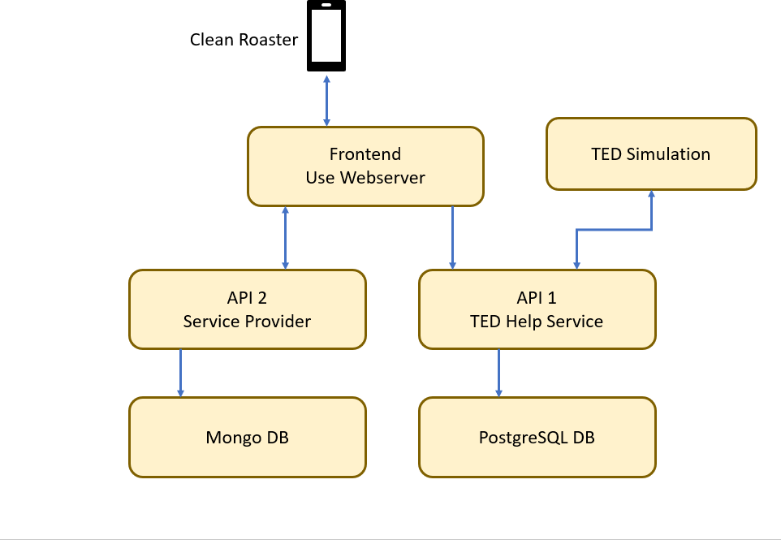

Fig 2.2: Simulation of the application

TED (TIME OPERATIONS) API1

In this project, API part is divided into two part. Where API 1 is responsible for time operation. The following task are handle by API 1:

Dedicated component managing time-related operations.

Receives processed data from Our App.

Time Operations Module.

Manages start/end times of jobs and breaks.

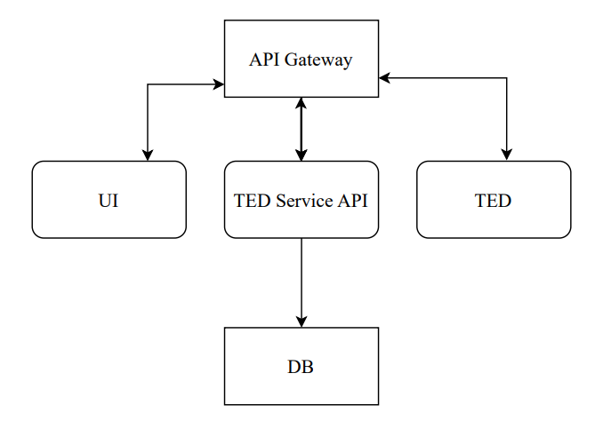

Fig 2.2: Architecture of API 1

SERVICE PROVIDER API2

API part 2 handled the services for the smooth transition of data.
- User Service
- Manage users information.
- Allows you to create a new user, login with email and password.
- Provides authorization token needed to access other endpoints.
- Scheduling Service:
- Manages worker schedules, assignments, and shifts.
- Gets data from SoftClean API(simulation api2)
- Stores and retrieves schedule data from the database.
- GPS Tracking Service:
- Tracks real-time location data of vehicles.
- Gets data from Telematics 360 (simulation api2).
- Communicates with vehicle GPS devices or mobile apps.

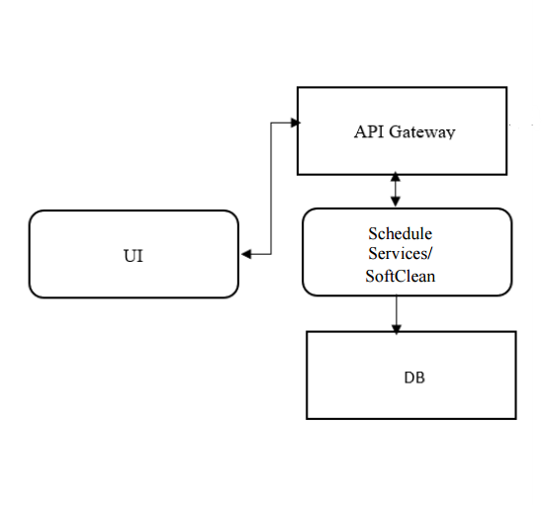

Fig 2.3: Architecture of API 2

The following picture depicts the internal operation of the whole system:

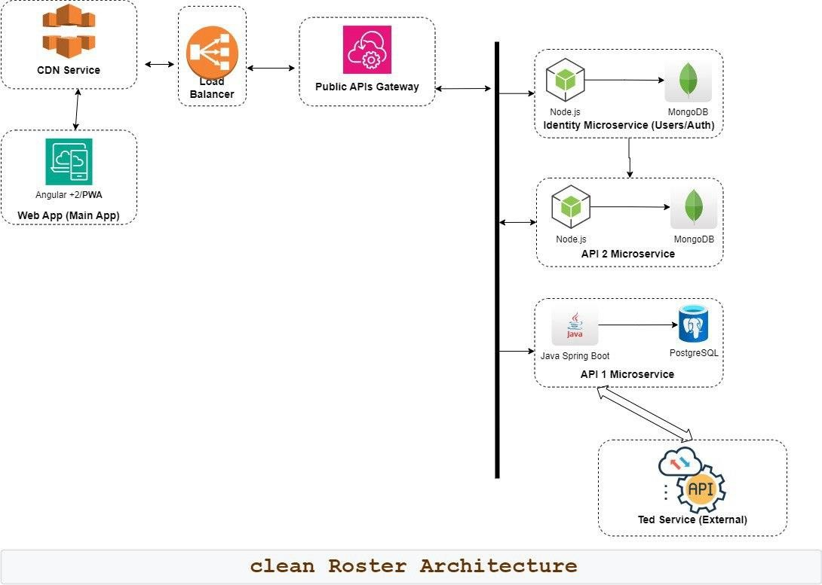

Fig 2.4: General work flow of development

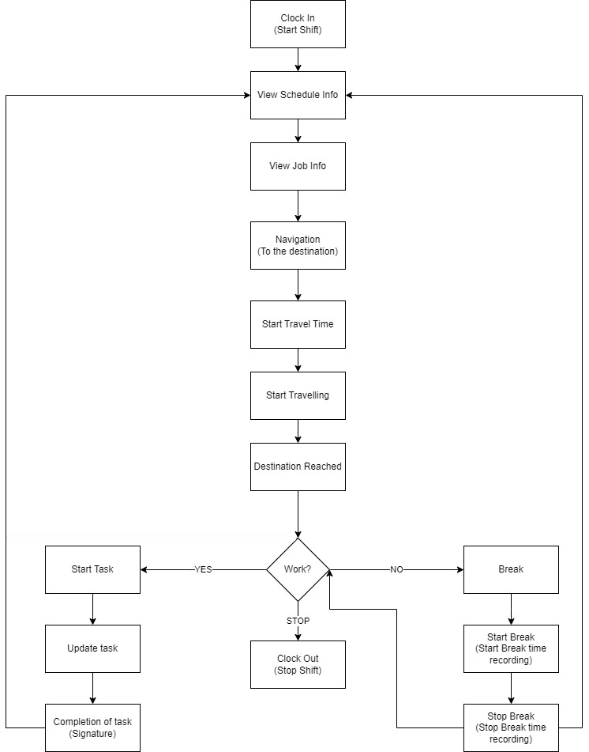

Fig 2.4: General work flow of the App

Infrastructure services
Infrastructure Services Deployment Plan:
- Source Code Repository:
- Service: GitLab Repository
- Description: The source code for the application will be stored in a GitLab repository, providing version control and collaboration features.

- Infrastructure as Code (IaC) with Terraform:
- Service: Terraform Scripts
- Description: Write Terraform scripts defining AWS resources: VPC, subnets, security groups, RDS for PostgreSQL, Fargate clusters, API Gateway, etc. Store Terraform scripts in a GitLab repository for version control. Utilize S3 to store the state file, ensuring a consistent and shareable state across the team. Create separate environments in AWS (e.g., dev, staging) Implement GitLab CI/CD pipelines with Terraform CLI for automatic deployment.

- Backend Deployment with AWS Fargate:
- Service: AWS Fargate
- Description: Containerize the application using Docker for portability and consistency. Create ECS task definitions for Fargate with necessary configurations. Utilize Terraform for Fargate task and cluster deployment. Implement auto-scaling for Fargate tasks using spot instances for cost efficiency.

- Frontend Deployment with AWS S3:
- Service: AWS S3, CloudFront (CDN)
- Description: Host the frontend as static content in an S3 bucket for scalable and reliable storage. Utilize CloudFront as a Content Delivery Network (CDN) for enhanced performance and low-latency content delivery.

- Database Deployment with RDS for PostgreSQL:
- Service: AWS RDS for PostgreSQL
- Description: Provision and configure PostgreSQL database for the application. Utilize Terraform for RDS instance provisioning with required configurations. Implement database backups and retention policies using AWS RDS features for data durability.

- API Gateway Integration:
- Service: AWS API Gateway
- Description: Configure API Gateway to handle incoming requests and route them to the appropriate Fargate tasks. Set up API Gateway stages for different deployment environments (e.g., dev, staging) for efficient environment management.

- Logging and Monitoring:
- Service: AWS CloudWatch Logs
- Description: Implement a logging strategy using AWS CloudWatch Logs for centralized log management. Configure Docker container definition within the Fargate task to use the awslogs logging driver for seamless integration.

- Rollout Schedule:
- Description: Roll out changes to the development environment first for initial testing and debugging. After successful testing in the dev environment, proceed to roll out changes to the testing environment for broader testing and validation.

2.4 Aws Infrastructure Overview
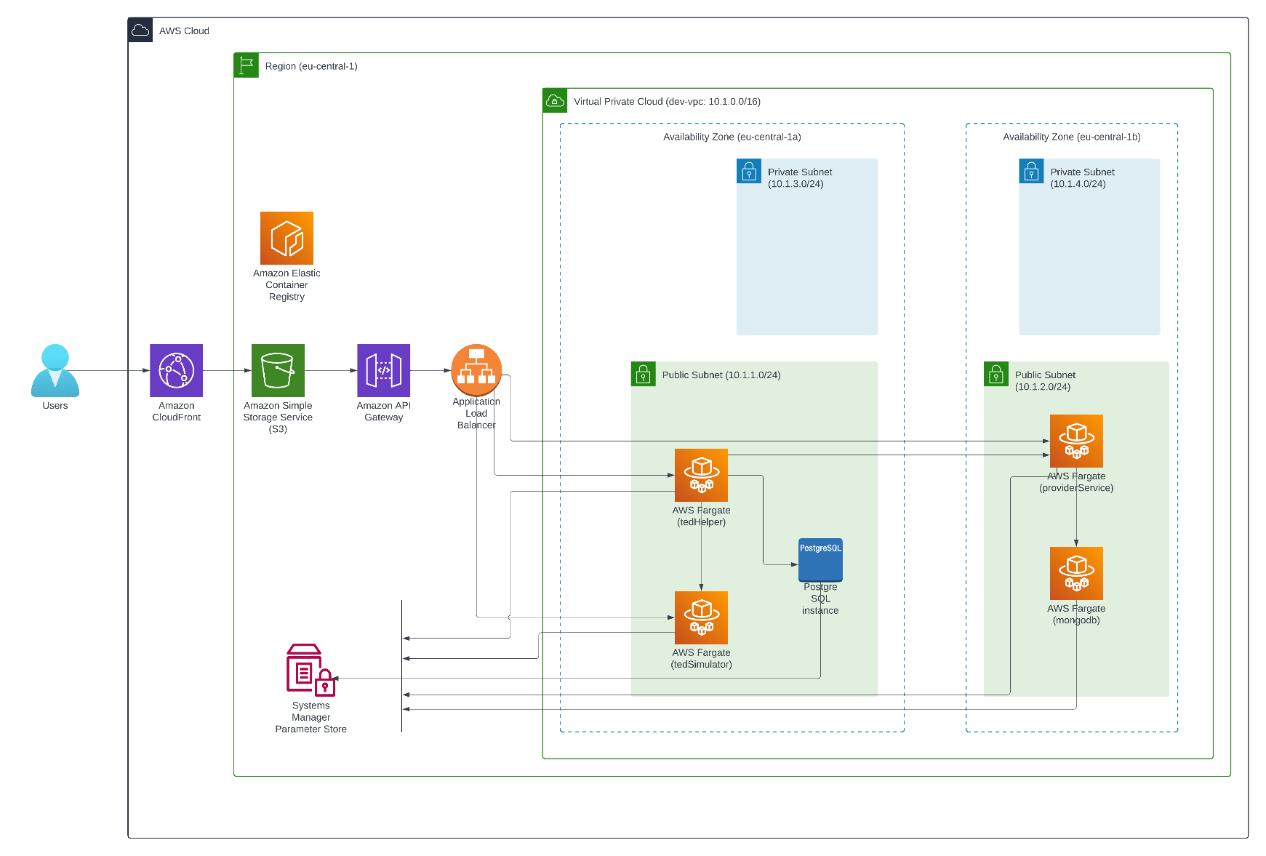

Fig: 2.5: Connection Between AWS component

2.5 System Requirements

Functional Requirements:
For Admin (Supervisor)
- User Management: Admins should be able to add, alter, and cancel user accounts for window cleaners.

- Scheduling: Admins should be able to create and oversee daily cleaning schedules for window cleaning workers (several staff can work in the same location), guaranteeing that they work from 9:00 AM to 2:30 PM.

- GPS Tracking: The app should be able to retrieve the GPS location of the automobile so that the admin always knows where the car is. Workers will be given a GPS-enabled corporate phone, which will aid in tracking them when they are not in the car.

- Work Verification: Admin should receive messages or reports indicating that window cleaning professionals have arrived and are actively working throughout the allocated hours.

- Break Time Monitoring: To ensure compliance with set break policies, the system should track and record the break periods of window cleaning workers.

- Travel Time Tracking: Admins should have access to reports and a database on trip times to and from cleaning sites, which will help them create more effective routes.

Communication with Workers: A communication module should enable admins to connect with window cleaners and vice versa, allowing for real-time updates or guidance.

For Cleaning Staff
- Access to Schedule: The app should allow window cleaners to view their daily schedules, including locations, inventory required, and assigned jobs.

- Clock-In and Clock-Out Timings: Workers should be able to clock in at 9:00 a.m. and out at 2:30 p.m. to mark the start and end of their workday.

- GPS Enabled Cars: To enable reliable route tracking during work hours, the app should interact with the GPS system in the workers' automobiles.

- Break Time Logging: By using this app, the staff/workers should be able to add their preferable break time of a fixed amount of time.

- Task Updates: The app should allow workers to update task statuses such as project completion (which would involve a signature from the consumer to complete the job), giving administrators real-time updates.

- Login & Sign up feature:
- User Account Creation: Users should be able to sign up by providing necessary information such as full name, email address, and password. The system must validate the email for uniqueness and format.
- Password Management: The system must include capabilities for password recovery, reset, and encryption to secure user accounts.
- User Authentication: Upon login, users must authenticate with their email and password. The system should also support session management to keep users logged in.
- Account Settings: Users must be able to update their account information, including password changes and email updates.

Non Functional Requirements

Security: The design of the system must incorporate security measures that align with the nature of the data stored in the database. Adherence to relevant data protection regulations to ensure the privacy and security of client and employee data. Implementing strong encryption protocols for data transmission and storage. Robust user authentication and authorization systems to control access to sensitive data and features.

- Capacity: The storage should be sufficient to handle real-time data processing, including task management, logistics data, staff information, and client details. Also implementing data archiving strategies for older, less frequently accessed data to optimize performance and storage efficiency.

- Compatibility: The system will be working efficiently on Android platforms, and should be compatible with recent versions and a range of devices with varying specifications. Adequate processing power and RAM for smooth operation on mobile devices and desktops, considering the application's data processing and real-time tracking features.

- Reliability: Analyze how frequently and intensively the application will be used by different user groups, and establish the expected uptime for the application, considering it may be used throughout the day. Also Back-ups will be made regularly to prevent data loss and quick recovery mechanisms in case of system failures.

- Scalability: The system shall be designed in a way that support large number of concurrent users in peak business hours. The capacity to scale storage as the company expands, accommodating more data from increased clients and staff.

- Maintainability: The system should enable regular updates into the main branch for early issue detection, ensure quick deployment of updates to minimize downtime, and use efficient version control and thorough documentation for change management.

- Usability: The user interface should be straightforward, allowing end-users to navigate and use the software with minimal training, and regularly update the software based on user feedback to improve usability.

.

Architecture Overview

Components
Architecture Components Overview:

- TED Service API (Technology Design):
- Description: TED Service API acts as a lightweight, scalable microservice responsible for updating travel time, break time, and work time data on TED asynchronously. It is a crucial component for maintaining accurate and timely information related to employee activities. The User Service efficiently manages user information, facilitating the creation of new users, and enables secure login through email and password, issuing essential authorization tokens for subsequent endpoint access. The Scheduling Service adeptly oversees worker schedules, assignments, and shifts, seamlessly integrating data from the SoftClean API and ensuring efficient storage and retrieval of schedule data from the database. Simultaneously, the GPS Tracking Service excels in monitoring real-time vehicle locations, interfacing with Telematics 360 and establishing communication with vehicle GPS devices or mobile apps. The underlying Database serves as a robust and scalable storage solution, proficiently housing critical information related to schedules, worker details, and vehicle tracking data.
- Key Components:
- API Endpoints (POST: /api/v1/create-travel-time, POST: /api/v1/create-break-time, POST: /api/v1/create-work-time).
- Data Model (DB Table: captureRequestResponse) Authentication/Authorization (Mutual TLS, App ID verification)
- /Users(api/v1/users/register, api/v1/users/login)
- /Schedules(api/v1/schedules)
- /VehicleLocation(/vehicle/{vehicleID}/location)

- Solution Overview:
- Description: The overall solution involves creating a scalable and maintainable microservice (TED Service API) to handle the asynchronous updating of travel time, break time, and work time data on TED. The UI captures relevant data and sends it to TED Service API, which, in turn, updates the data on TED.
- Key Components:
- UI
- TED Service API
- TED (Endpoint: API Gateway, DB)
- Data Flow (Request and Response)

- Technology Stack:
- Description: The technology stack defines the tools and frameworks used in the development of TED Service API.
- Key Components:
- Java 17(Coding Language)
- Spring Boot (Framework)
- PostgreSQL (Database)
- Maven (Build Tool)
- Tomcat (Application Server)
- Docker (Container)
- AWS API Gateway

- Client/End User Overview & Requirements:
- Description: The client (UI) and end-users (Cleaning Staff and Admins) interact with TED API endpoints to update time-related data. The Request/Response contract is essential for communication.
- Key Components:
- TED API Endpoints
- Request/Response Contract

- Build & Configuration Details:
- Description: The application is built using Maven, and the infrastructure is managed through Terraform scripts stored in a GitLab repository. The deployment plan outlines the steps for backend, frontend, database, API Gateway, and logging/monitoring configurations.
- Key Components:
- Maven (Build)
- GitLab Repository (Source Code)
- Terraform (IaC)
- AWS Resources (VPC, subnets, RDS, Fargate, API Gateway)
- Docker (Containerization)

- Data Flow and Structures:
- Description: Data flows through the application, with user input from workers and admins triggering processes related to time tracking, GPS tracking, and work scheduling. External APIs like TED, Telematic360, and SoftClean are integrated to enhance functionality.
- Key Components:
- User Input (Worker, Admin)
- External API Integration (TED, Telematic360, SoftClean)
- Data Processing Workflow
- Database Schemas (Scheduling, GPS Tracking)

- Security Architecture Overview:
- Description: The security architecture ensures the confidentiality and integrity of data. It includes measures like data encryption, authentication, authorization, mobile app security, and security for time and productivity tracking, geo-tracking, and vehicle tracking.
- Key Components:
- Data Encrytion (TLS, HTTPS)
- Authentication/Authorization (JWT, RBAC)
- Mobile App Security
- Time and Productivity Tracking Security
- Geo-Tracking and Vehicle Security

- Incident Response Plan:
- Description: The incident response plan defines steps to be taken in case of a security incident, including incident identification, containment, eradication, recovery, and lessons learned.
- Key Components:
- Incident Response Procedures
- Contact Details
- Communication and Escalation Procedures

- Testing:
- Test Plan: Document outlining the testing approach and overall framework.
- Test Cases: Functional test cases for validating the application's functionality.
- Jira: Bug-tracking tool for logging and tracking defects.
- Excel: Initially used for writing and managing test cases.

- Security Policies and Procedures:
- Description: Security policies and procedures ensure adherence to secure coding practices, user account management, password policies, and access controls.
- Key Components:
- Security Policies Documents
- Secure Coding Guidelines
- User Account Management Procedures

- Regular Security Audits:
- Description: Regular security audits, including vulnerability assessments and penetration testing, help identify and address security vulnerabilities.
- Key Components:
- Security Audit Schedule
- Vulnerability Assessment Reports
- Penetration Testing Results

- Dependencies on Other Teams:
- Description: Collaboration with other teams, including Development, Infrastructure, and Operations, is critical to ensure a holistic approach to security.
- Key Components:
- Collaboration with Development Team
- Collaboration with Infrastructure Team
- Collaboration with Operations Team

- Deliverables:
- Description: The deliverables include comprehensive documents outlining security policies, incident response plans, training materials, and regular security audit reports.
- Key Components:
- Security Policies Document
- Incident Response Plan Document
- Security Training Materials
- Security Audit Reports
- Post-Audit Review Documentation

This architecture components overview provides a structured view of the TED Service API project, highlighting key elements across technology, security, incident response, and collaboration with other teams.

API & Integrations

The TED Service API facilitates asynchronous data updates for travel time, break time, and work time on TED. This API follows a microservices architecture, ensuring scalability and maintainability.
Endpoints:

The API provides the following endpoints for data updates:
- POST /api/v1/create-travel-time: Endpoint for updating travel time data.
- POST api/v1/create-break-time: Endpoint for updating break time data.
- POST api/v1/create-work-time: Endpoint for updating work time data.
- /Users
- POST api/v1/users/register
- Registers new user
- POST api/v1/users/login
-Logs in user.
- Returns authorization token
- /Schedules
- GET api/v1/schedules
- Gets user specific schedules
- POST api/v1/schedules
- Creates user schedule
-PATCH /api/v1/schedule/:scheduleID
-Update Schedule
-DELETE /api/v1/schedule/:scheduleID
-Delete Schedule
- /VehicleLocation
-POST /api/v1/vehicleLocation`
- Create vehicle location
- PATCH /api/v1/vehicleLocation/{vehicleID}
- Update vehicle location
-GET /api/v1/vehicleLocation/{vehicleID}
- Get Location by ID
- Tags Overview
- POST /api/v1/tags
- Create a new tag
-GET /api/v1/tags
- Retrieves logs
- PATCH /api/v1/tags/:tagsID
- Update logs
-POST /api/v1/vehicleLocation`
- Create vehicle location
- PATCH /api/v1/vehicleLocation/{vehicleID}
- Update vehicle location
-GET /api/v1/vehicleLocation/{vehicleID}
- Get Location by ID
- POST /api/v1/tags
- Create a new tag
-GET /api/v1/tags
- Retrieves logs
- PATCH /api/v1/tags/:tagsID
- Update logs
- Activities Overview
- POST /api/v1/activity
-Create an activity
- GET /api/v1/activity
- Retrieves all activities
-PATCH /api/v1/activity/:activityID
-Updates an existing activity entry
- Overview of Projects API Endpoints
-POST /api/v1/projects
-Creates a new project entry for a worker
-GET /api/v1/projects
-Retrieves list of project information
-PATCH /api/v1/projects/:projectsID
-Updates an existing project entry

Data Model: The TED Service API interacts with a database to capture successful and failed responses. The database table captureRequestResponse includes fields such as:
- ID
- Requester APP ID
- Responder APP ID
- Request
- Response
- Error
- Type

Authentication/Authorization: All communication between components, including the API and UI, is secured through Mutual TLS. This ensures that the server authenticates itself to the client and vice versa. Additionally, requests are verified using the app ID passed in the header for authorization, ensuring that only known applications can make requests.

Data Flow and Structures of API:
User Input:

- Worker: Workers initiate time tracking events (work start/end, break start/end, travel start/end) through the application frontend (mobile app).
- Admin: Admin users interact with the admin interface to access time tracking data (Already available in TED)

External API Integration:
  - TED API (Time Tracking): API calls to TED are made for time tracking events initiated by workers.
  - Telematic360 API (GPS Tracking): API calls to Telematic360 fetch GPS tracking information for vehicles.
- Enhance GPS data with tracked time. (Assumption: Currently, the GPS data fetched from the Telematic360 API likely provides information about the geographical location of vehicles, but it may not include details about when these locations were recorded.). By adding a timestamp or tracked time information to each GPS data point, you can have a more complete picture of the vehicle's movement over time.
- Use GPS information for creating travel time automatically. With timestamped GPS data, you can analyze the time intervals between consecutive data points to determine how much time a vehicle takes to travel from one point to another. This information can be used to automatically generate travel time metrics, helping you understand the duration of trips between specific locations.

SoftClean API (Work Scheduling):
- SoftClean API is queried to obtain work schedules and assignments for workers.
- Scheduling information is processed and stored in the database.

Technologies Used
Technologies Used for the System:
- Programming Language:
- Angular 17, Framework 7, Tailwind CSS, Cordova
- Figma(Prototyping)
- Framework:
- Spring Boot: Framework chosen for building the scalable and maintainable microservice.
- Database:
- AWS RDS with infrastructure configuration managed by Terraform.
- Build Tool:
- Maven: Utilized as the build tool for the TED Service API application.
- Application Server:
- Tomcat: Employed as the application server for hosting the TED Service API.
- Containerization:
- Docker: Used for containerizing the TED Service API application, ensuring consistency and portability.
- Cloud Services:
- AWS API Gateway: Configured to handle incoming requests and route them to the appropriate Fargate tasks.
- AWS Fargate: Utilized for backend deployment, offering a serverless compute engine for running containers.
- AWS RDS for PostgreSQL: Provisioned and configured to serve as the database for the application.
- Infrastructure as Code (IaC):
- Terraform: Scripts written in Terraform to define and create AWS resources, ensuring consistent and automated deployment.
- Continuous Integration/Continuous Deployment (CI/CD):
- GitLab CI/CD Pipelines: Utilized for automatic deployment, integrating with the Terraform CLI.
- Security Technologies:
- TLS (TLS): Implemented for secure communication between components.
- JSON Web Tokens (JWT): Employed for secure user authentication.
- HTTPS: Used for secure communication, ensuring encrypted data transmission.
- Cipher Suites: Secure cipher suites used, regularly updated to align with industry standards.
- Testing Tools
- Postman: Streamlining the validation of endpoints and data interactions.

Conclusion:
The Document explores the various components, APIs, and integrations while highlighting the importance of security protocols, incident response plans, testing, and teamwork. In conclusion, the application claims to have a big impact on contemporary commercial cleaning operations by boosting productivity and efficiency through the use of innovation and technology.

