AI Agent Technical Documentation
System architecture implementation and deployment guide
Version 1.0 | 22 October 2026
This document describes the architecture, implementation, configuration and operation of the AI Agent application. It provides installation instructions, component responsibilities, supported workflows, validation procedures and operational limitations for a Windows deployment.

Project overview
A goal-based, tool-using multi-agent assistant. An orchestrator delegates work to specialist agents. LangChain connects models and tools; LangGraph controls the agent/tool workflow and state. Local processing handles calculations and file extraction. External APIs provide language generation, vision, search and travel results.

Project snapshot
Item | Current implementation
User interfaces | Streamlit unified chat and a terminal entry point
Main model | Groq openai/gpt-oss-20b; compatible configured backups
Persistence | Local SQLite chat history, graph checkpoints and preferences
File handling | Session attachments; multiple supported formats, not every file type
Web capability | Search results plus actual reading of supplied public URLs
Not implemented | Gmail sending, email approval workflow, bookings and payments

Document organization
Architecture and pipeline
Frameworks, models and services
Installation, configuration and troubleshooting
Detailed workflows, source layout and operational validation
Extract or copy the project to any location. Open that location in a terminal and run commands from the directory containing requirements.txt and main.py. No fixed drive, parent directory or project-folder name is required.

Architecture diagram
One chat coordinates specialists. The same underlying LLM can serve several roles; each role has its own instructions and tools.
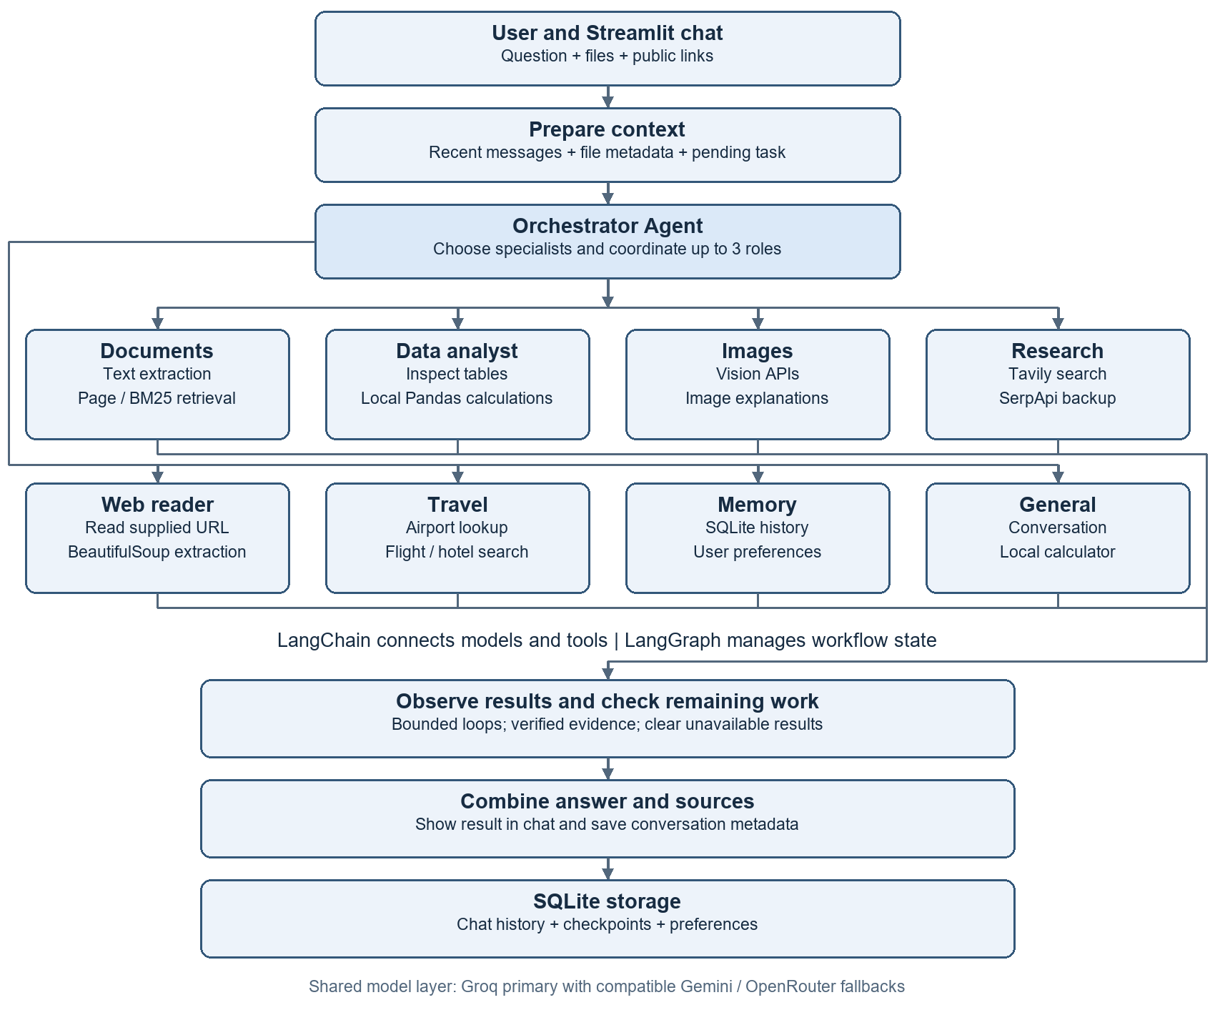
Routing is bounded, not an infinite autonomous loop. The orchestrator chooses the required roles; workflow code enforces evidence, limits and supported actions. Arrows summarize execution; not every branch runs for every request.

Pipeline and specialist responsibilities
User input -> prepare context -> orchestrator delegation -> specialist tools -> observe results -> check remaining work -> combine answer and sources -> persist history.
Specialist | Responsibility
General | Answers ordinary chat; uses the local calculator for arithmetic.
Documents | Retrieves actual uploaded text. Exact PDF page requests use page lookup; relevant passages use local BM25. This is not a vector database pipeline.
Data analyst | Inspects worksheet/column metadata, plans a supported operation, and executes it through Pandas. The LLM does not invent totals.
Images | Sends normalized images to a compatible vision model; observations may be imperfect.
Research | Searches the web with Tavily and SerpApi backup; returns evidence and source links.
Web reader | Reads up to two supplied public URLs. Extracts HTML/text/readable PDF evidence and summarizes selected excerpts.
Travel | Plans trips and accesses airport/flight/hotel search tools. Quotes are observations, not guaranteed bookings.
Memory | Retrieves relevant saved conversations and preferences; supports explicit preference save/delete tools.

Example compound request
Example request: Return the PDF page 1 title and the Excel total for Tax (USD) in two lines.
The orchestrator assigns the Document and Data specialists. Document retrieval reads page 1; the Data specialist inspects the actual tax column and performs a local sum. Verified results are combined. An ambiguous column or unreadable page must produce an explicit limitation rather than an inferred result.

Workflow state history and preferences
Workflow state contains messages, tool results and execution progress. Chat history persists transcripts across conversations. Preferences store selected user facts or settings. Relevant records are retrieved into bounded context; the entire history is not transmitted for every request. Raw attachments are session-local and may require reattachment after a restart.

Frameworks and libraries
Package or module | Implementation role
LangChain core | AIMessage, HumanMessage, SystemMessage and ToolMessage represent conversation/tool data. @tool defines tool schemas; bind_tools exposes them to models.
LangGraph | StateGraph, nodes, conditional edges and START/END coordinate agent/tool loops. langgraph-checkpoint-sqlite persists checkpoints.
Streamlit | Chat UI, uploader, session state, previous chats, sources and tool activity. Its browser frontend internally uses JavaScript.
langchain-groq | ChatGroq model integration.
langchain-google-genai | ChatGoogleGenerativeAI integration for Gemini.
langchain-openai | ChatOpenAI connects to OpenRouter through an OpenAI-compatible URL. This does not imply a paid OpenAI API.
python-dotenv | Loads local environment configuration from .env.
pandas and openpyxl | Tabular processing/calculations and XLSX reading.
xlrd, pyxlsb, odfpy | Readers for legacy XLS, XLSB and OpenDocument spreadsheets.
pypdf | Readable PDF text extraction; image-only scans need OCR, which this pipeline does not guarantee.
python-docx and python-pptx | Extract text from supported Word documents and PowerPoint slides.
Pillow and pillow-heif | Read/normalize images and support HEIF/HEIC decoding where available.
beautifulsoup4 | BeautifulSoup parses HTML and extracts useful webpage text.

Python built in modules
sqlite3 stores local data; json serializes API/tool payloads; pathlib/os handle paths and environment settings; re matches patterns. unittest and unittest.mock verify behavior. These are standard-library modules and do not require separate pip installation.
LangGraph and Streamlit provide workflow and user-interface structure. Supporting libraries provide reusable model, parsing and calculation components. Models perform inference through external providers. SQLite provides local persistence; VS Code, pip and virtual environments support development and installation.

Models services and webpage processing
Role | Configured model or service
Main text and orchestration | Groq: openai/gpt-oss-20b
Text fallback | Google: gemini-3.1-flash-lite, then OpenRouter free routing when configured and compatible
Spreadsheet planning | OpenRouter: openrouter/free first, with text-provider backups. Actual calculation is local Pandas.
Image understanding | Groq: qwen/qwen3.8-27b
Image backups | OpenRouter: google/gemma-4-26b-a4b-it:free, then compatible Gemini vision
Web search | Tavily primary; SerpApi backup
Travel results | SerpApi flight/hotel search and airport lookup
Model names above are the project configuration snapshot, not a guarantee of current provider availability. openrouter/free is a router and can select different underlying models. Limits, eligibility and prices depend on providers. Configure valid keys and check provider dashboards; no unlimited free quota is promised.

Webpage processing pipeline
Given URL -> public address validation -> robots.txt policy -> bounded HTTP request -> optional gzip decompression -> HTML/text/PDF extraction -> selected excerpts -> LLM summary and source. It does not execute JavaScript or bypass login, CAPTCHA or paywalls.
Built in modules | Purpose
http.client, socket, ssl | HTTP transport, DNS and HTTPS certificate verification. Public IP validation and pinned connections reduce unsafe local-network access.
ipaddress, urllib.parse | Block private/local addresses; parse/normalize URLs and check redirects.
RobotFileParser | Read robots.txt automated-access policy.
gzip and io.BytesIO | Decompress bounded compressed bytes in memory without saving a temporary download.
time, datetime, timezone, re | Timeout/cache timing, fetch timestamps and relevant text patterns.
Efficiency: five-minute webpage cache; at most two supplied URLs per message; up to about 4,200 excerpt characters per page; 2 MB response limit. The reader is not a whole-site crawler. Failure after fetching can return verified excerpts instead of a generated explanation.

Install and run on Windows
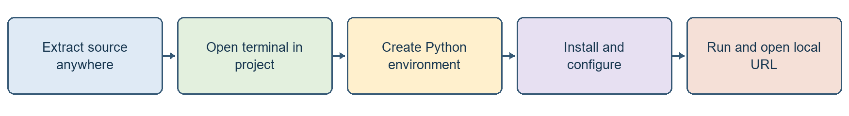
Windows installation and execution sequence
Requirements: Windows, Python 3.11 or newer, internet access and valid API credentials. VS Code is optional. Run the following commands from the directory containing requirements.txt. Dependency versions may vary because the requirements are not fully pinned.

1 Copy the project
Extract the source package to any chosen location. Include app, tests, .streamlit, main.py, requirements.txt and .env.example. Do not copy an existing virtual environment, private .env, credentials or personal databases.

2 Open a terminal in the extracted project
py --version
py -3 -m venv .venv
Confirm that py --version reports Python 3.11 or newer. The .venv directory is created by the command; it is not a required name for the project folder.

3 Install dependencies
.\.venv\Scripts\python.exe -m pip install --upgrade pip
.\.venv\Scripts\python.exe -m pip install -r requirements.txt
Direct executable paths avoid PowerShell activation-policy issues. In VS Code, select .venv\Scripts\python.exe as the interpreter.

4 Create configuration
Copy-Item -LiteralPath .env.example -Destination .env
notepad .env
Run this only on a fresh installation; preserve an existing .env. Add valid credentials as described in the configuration section, one VARIABLE=value per line.

5 Start the app
.\.venv\Scripts\python.exe -m streamlit run app/ui/streamlit_app.py
Open the local URL printed by Streamlit. The included configuration defaults to http://127.0.0.1:8502/. If occupied, append --server.port 8503. Stop with Ctrl+C.
# Optional terminal interface
.\.venv\Scripts\python.exe main.py

Configuration and functional validation
Use placeholders below as names only; replace locally with your own credentials. Keys are secrets. Never paste them into chat, screenshots or source control. Restart the app after changing .env.
LLM_PROVIDER=groq
GROQ_API_KEY=your_real_groq_key
GROQ_MODEL=openai/gpt-oss-20b
GOOGLE_API_KEY=your_real_google_key
GEMINI_MODEL=gemini-3.1-flash-lite
OPENROUTER_API_KEY=your_real_openrouter_key
EXCEL_MODEL=openrouter/free
CHAT_BACKUP_MODEL=openrouter/free
TAVILY_API_KEY=your_real_tavily_key
SERPAPI_API_KEY=your_real_serpapi_key
Default startup requires Groq credentials. Gemini and OpenRouter add compatible backups. To use Gemini as the primary instead, set LLM_PROVIDER=gemini and provide a valid GOOGLE_API_KEY. Search/travel require their respective optional keys. Scraping itself needs no new API key; generated summaries still use the existing LLM layer.

Functional validation cases
Validation input | Expected verification
Calculate 125 * 37 + 450 / 9. | Calculator tool result should be 4675.
Upload a readable PDF and ask for page 1 title. | Answer is grounded in the actual first page; no random-page example.
Upload Excel and ask for the total of an exact numeric column. | Tool activity shows inspection/calculation; compare against Excel SUM.
Upload an image and ask for a one-line description. | Vision result refers to the real image; no unsupported certainty.
https://www.python.org/doc/ Summarize in one line. | Actual webpage evidence and source URL appear, or a clear access failure.
Open a previous chat from the sidebar. | Saved transcript loads. Reattach raw files if the session has restarted.

Run automated checks
.\.venv\Scripts\python.exe -B -m unittest discover -s tests -q
The last recorded scraper integration test run passed 97 tests. Execute the test suite on each target installation. This result is a historical verification record, not a guarantee of external-service availability or compatibility on another machine.

Source file map
Paths below are relative to the project root. Start with streamlit_app.py for UI and multi_agent/system.py for active orchestration.
File or folder | Implementation responsibility
app/ui/streamlit_app.py | Changing chat layout, uploader, chat history selection or session wiring.
app/multi_agent/system.py | Changing specialist delegation, active tool loops, completion checks or evidence handling.
app/multi_agent/requests.py | Changing page/length/request interpretation helpers.
app/llm/client.py | Changing text models, model construction and fallback order.
app/llm/fallback.py | Changing cooldown, compatible retry/fallback handling and provider events.
app/config/settings.py | Checking environment variables and required configuration.
app/attachments/store.py | Changing file normalization, supported extensions or current-chat file state.
app/attachments/vision.py | Changing vision models and image API calls.
app/rag/documents.py | Changing document extraction, exact-page lookup or BM25 retrieval.
app/spreadsheet/analysis.py | Changing header detection, table reading or local operations.
app/spreadsheet/planner.py | Changing the Excel planning model or allowed plan handling.
app/integrations/web_search.py | Changing Tavily/SerpApi requests, limits and search caching.
app/integrations/web_reader.py | Changing URL checks, HTML extraction, robots policy or webpage cache.
app/integrations/travel_prices.py | Changing airport/flight/hotel API integration.
app/history/store.py and app/memory/store.py | Changing persistent transcripts or preference storage.
app/agent/ and app/tools/ | Shared conversation graph, state, tool wrappers and execution helpers.
main.py and tests/ | Terminal entry point and automated regression checks.
.streamlit/config.toml | Theme, local host, port 8502 and upload setting.

Troubleshooting and operational considerations
Problem | Recommended action
ModuleNotFoundError | Install requirements using .venv\Scripts\python.exe and run Streamlit with that same executable.
API key or configuration error | Check one VARIABLE=value per line. Model variables contain model IDs, not keys. Avoid duplicate variables and restart after edits.
Quota or rate limit | Check provider dashboard and wait for reset or configure a compatible independent backup. Switching keys in one quota pool may not add quota.
Failed to fetch dynamically imported module | Restart server, close stale tabs and hard-refresh. Verify current port 8502; if cached assets remain, use a fresh port such as 8503.
Uploaded PDF has no usable text | Use a text-based PDF. Scans need a separate OCR capability.
Excel has Unnamed columns or ambiguous tax | Check sheet and header row; select the actual column. Never accept a guessed total.
Website blocked or empty | Login, robots policy, CAPTCHA or JavaScript-only content may prevent reading. Use a readable public source or upload supported content.
Old chat opens but files unavailable | Raw attachments are session-local. Reattach them; transcript history is a separate persistent store.

Storage and sharing
data/chat_history.sqlite3 stores transcripts; data/chat_checkpoints.sqlite3 stores graph checkpoints; data/memory.sqlite3 stores preferences. Stop the app before copying databases for backup. A clean handover should exclude data/ unless the user intentionally transfers their own history. The app is a local prototype: profiles are not authenticated accounts and it should not be exposed publicly as a secure multi-user service.

Implementation scope
The current application is a general AI assistant. Gmail integration, email approval and sending, automatic bookings, universal file support and unrestricted website access are outside the implemented scope. Store credentials privately and rotate any exposed keys through the corresponding provider.

10 File Routing and Local Processing
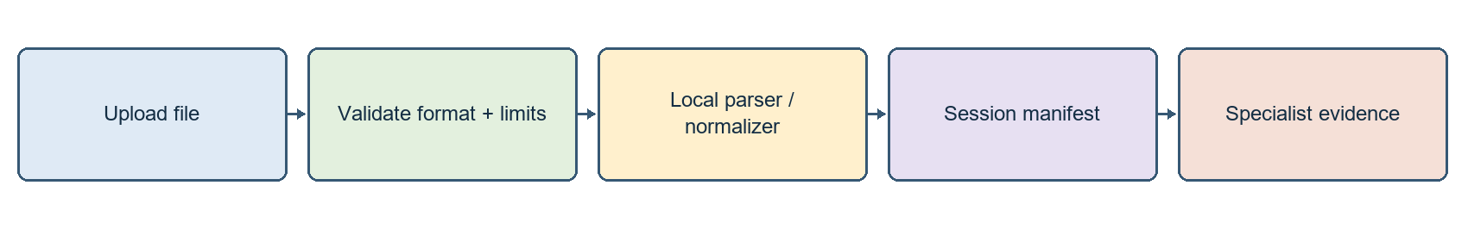
File routing keeps extraction separate from model interpretation
The unified upload interface routes each supported attachment to an appropriate local reader. Extension, size and content checks determine whether the file becomes document evidence, a loaded table or normalized image data. Extraction is local; only task-relevant content is supplied to a model. Uploaded code and macros are not executed.
Input | Actual reader | Coverage
PDF | pypdf | Readable text; physical PDF page numbers
DOCX / PPTX | python-docx / python-pptx | Paragraphs, slide text and tables; embedded pictures are not automatically analyzed
XLSX / CSV | pandas + openpyxl and header detection | Loads first worksheet for workbook ingestion
XLS / XLSB / ODS / TSV | pandas with xlrd / pyxlsb / odfpy or TSV parsing | Other spreadsheet formats use their supported engine and initial header defaults
Images | Pillow + pillow-heif | EXIF orientation, first frame, RGB JPEG conversion and resizing
Text / code | Local text extraction | Read supported text formats as content, never execute uploaded code

Processing limits
Attachments: up to 10 items per chat and 10 MB per file. PDF index: up to 5 documents, 50 pages per PDF and bounded extracted text. Tables: 50,000 rows / 100 columns. Images: 20 megapixels maximum and normalized to fit 1600 x 1600. Archive-based documents have expanded-size/entry checks.
Legacy DOC/PPT, SVG/RAW/PSD, audio/video, executables and generic archives are unsupported. Damaged/encrypted files can fail even with a supported extension. Raw uploads remain in RAM for the current chat/browser session; they are not a permanent source corpus in data/.
app/attachments/store.py # format routing and session state
app/attachments/migration.py # upgrade live session objects
app/rag/documents.py # PDF extraction limits and index

11 Orchestration and Tool Selection
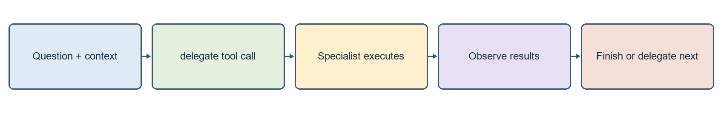
LLM coordination is combined with explicit workflow checks
Active entry point handle_multi_agent() prepares current question, recent messages, file metadata and pending user details. The LLM receives the delegate tool schema and chooses an agent name and task. Required file roles are also identified by code, so a PDF-plus-Excel request needs both parts rather than a fluent generic response.

Tool binding and execution
bound = model.bind_tools(tools)
response = bound.invoke(messages)
# response.tool_calls may ask Python to execute a registered tool
bind_tools exposes tool names, descriptions and argument schemas to the model. It does not execute a function. The model returns structured calls; Python validates the arguments, executes a registered tool and records a ToolMessage observation. Subsequent decisions can use the recorded result.
LangGraph concept | How it appears in the project
State | Messages, call count and dispatch/finalization flags
Node | agent invokes a model; tools executes selected tools
Conditional edge | Routes to tool execution, another model call or END
START / END | Explicit workflow entry and termination
Loop | Agent -> tool -> observation -> agent, within configured bounds

Call and handoff control
Default shared model-call budget is 12. Role loops normally allow up to 4 model calls; the orchestrator coordinates up to 3 handoffs and accepts at most 2 tools per response. Completed roles are reused within a turn. Economy mode can end after enough verified evidence, reducing redundant calls. These are bounds, not a guarantee every task finishes.
Multiple specialists can use the same model with different instructions/tools. Some short tool sequences are intentionally enforced by code. Tool activity lists observable actions, not hidden model reasoning. Inspect app/multi_agent/system.py and app/multi_agent/requests.py for these decisions.

12 Document Retrieval and Grounded Answers
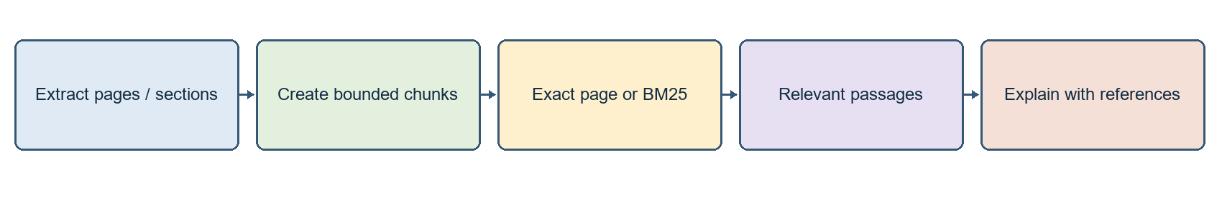
Document evidence is retrieved before an explanation is generated
The Document Agent retrieves actual passages from uploaded material. PDF content retains physical page numbers; Word, slide and text files use section or slide locations. An explicit page request is scoped to that page rather than a loosely related passage.
Question | Retrieval path | Purpose
Return the title on PDF page 1 | Exact page lookup and title-focused rendering | Avoids explaining a random page
Explain Python lists using the PDF | Local lexical BM25 passages | Focused evidence without sending entire PDF
Summarize the document | Overview/relevant excerpts | Bounded description of loaded content
Locate the tax example in the PDF | Search actual extracted evidence | Absence of evidence must not become an invented tax example

Retrieval implementation
The document workflow uses retrieval-augmented generation: retrieve source evidence, then generate an explanation. Retrieval is implemented with local BM25 and exact-page lookup. Embedding models, FAISS, MinerU, Ollama and knowledge-graph components are not part of this implementation.

Extraction limitations
Image-only scans need separate OCR. A page can be empty or extraction can be imperfect. Embedded images inside DOCX/PPTX are not automatically sent through the image agent. Source references indicate retrieved evidence; they do not prove every word of a generated explanation is correct.

Verification
Validate an exact-page response against the source file and its reported location. If the relevant evidence is unavailable, the application should report the limitation rather than substitute a plausible general-knowledge answer.
app/rag/documents.py # extract_pdf, chunks and page/BM25 retrieval
app/tools/document_search.py # search_documents wrapper
app/multi_agent/system.py # Document Agent and evidence rendering

13 Spreadsheet Planning and Reproducible Maths
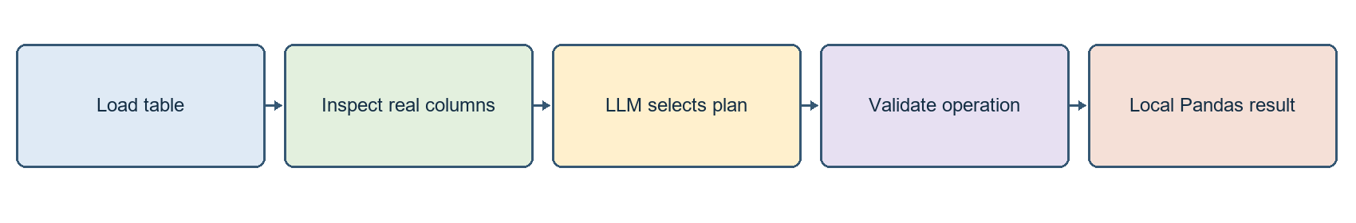
The model plans; Python executes the calculation
The Data Agent uses inspect_table and calculate_table. A model selects an allowed operation from the request; Pandas executes that operation over the loaded table. Summary requests use metadata, while numeric totals must originate from the selected source column.
Operation | Meaning | Example
sum | Add values | Calculate total Tax (USD)
mean | Arithmetic average | Calculate average sales
min / max | Smallest / largest value | Find the maximum bill
count | Supported non-null column count behavior | Count values in the selected column
group_by | Apply an operation per category | Calculate total tax by branch

Header and worksheet handling
Some reports start with a title and blank rows above the actual header. XLSX/CSV header detection helps identify the real names. A wrong header can create Unnamed columns or ambiguous tax names. Inspect the sheet and numeric column; compare the result to Excel SUM over the same rows. The attachment path currently loads the first workbook worksheet.

Safe operation boundaries
Plans choose allowed operations and columns rather than executing arbitrary generated Python. The tool does not recalculate arbitrary Excel formulas. Formula-heavy files may require recalculation and saving in Excel before ingestion. Macros/code are not executed. More complex analysis must be implemented and tested as an explicit supported operation.
app/spreadsheet/analysis.py # read_table, detect_header_row, calculate
app/spreadsheet/planner.py # separate OpenRouter planning model
app/multi_agent/system.py # inspect_table / calculate_table evidence

14 Image Understanding and Vision Routing
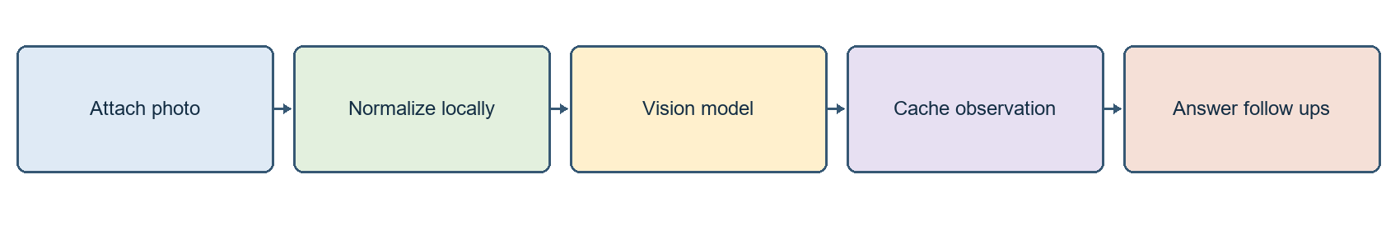
Image understanding is separate from text-only generation
Pillow and Pillow-HEIF decode supported images, apply EXIF orientation and normalize content to API-compatible RGB JPEG. Only the first image frame is used. A separate vision-capable model interprets the content; ordinary text requests retain their configured text-model path.
Stage | Current behavior
Primary vision | Groq qwen/qwen3.8-27b
Vision backups | OpenRouter google/gemma-4-26b-a4b-it:free; compatible Gemini vision
Cache | Repeated image/question can reuse a cached answer
Follow-up context | Short recent image notes may support follow-up questions
Persistence | Raw image is session-local, not automatically restored from SQLite transcript

Example validation inputs
Explain this screenshot in one line.
What are the visible labels and trend in this chart?
Which step comes after the decision box in this flowchart?

Limitations
Small text, low resolution and dense tables can be misread. Vision is not a substitute for verified spreadsheet maths. If every compatible vision API fails, a text-only backend cannot truthfully claim it analyzed the image. Dedicated similar-image search and image generation are not implemented features.

Implementation modules
app/attachments/store.py # image_url, normalization and cache
app/attachments/vision.py # describe_image and compatible providers
When no compatible vision service is available, the application must report that no visual result was verified. Provider availability, image support and quotas require validation for each deployment.

15 Web Search Versus Actual Page Reading
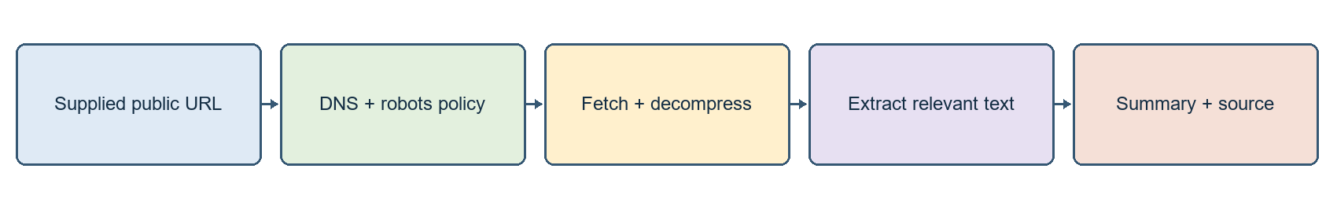
Web Reader Agent uses real page text rather than search snippets
Capability | Input | Source of evidence
Web search | Query words | Tavily primary or SerpApi backup snippets and URLs
Web reader | A public HTTP/HTTPS URL | Actual fetched page text and selected excerpts
Document retrieval | Uploaded document | Local extracted pages/sections
Search finds candidate sources; scraping reads a supplied page. In this implementation read_webpage is a LangChain tool in the active multi-agent system; WebPageClient in app/integrations/web_reader.py owns network validation, policy, extraction and cache.

Network and parsing components
Module | Purpose
http.client / socket / ssl | HTTP transport, DNS connection, TLS certificate checks
ipaddress / urllib.parse | Public/private IP validation; URL parsing and safe redirect handling
RobotFileParser | Read robots.txt policy before automated page access
gzip / io.BytesIO | Decode compressed response bytes safely in memory
BeautifulSoup | Extract title/useful text; remove markup and noisy HTML elements
time / datetime / re | Timeout, cache age, fetch timestamps and focus terms
Only public URLs are permitted. Local/private addresses, unsafe redirects, credential-bearing URLs and custom ports are blocked. Limits include at most two supplied URLs per message, about 4,200 excerpt characters per page, a 2 MB response cap, bounded redirects/timeouts and a five-minute page cache. It does not crawl all linked pages or the whole website.
Login, CAPTCHA, paywalls and JavaScript-only sites are not bypassed. If generation fails after a successful fetch, verified excerpts can still be displayed. If fetching fails, no successful-read claim should appear. USER_AGENT = AIResearchAssistant/1.0 identifies the HTTP client; it is not an LLM model.

16 Research Travel and Memory Workflows
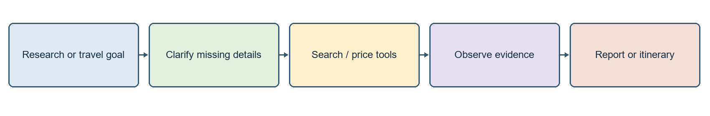
External results support a bounded specialist task

Research Report Assistant
The Research Agent selects focused queries, observes retrieved snippets and produces findings with source references and stated limitations. Tavily Basic is the primary search API, with SerpApi as backup. Requests use Python HTTP facilities rather than separate provider SDK packages. A run shares a maximum of two web searches.

Trip Planner
Travel Agent can gather origin, destination, future dates, adults and budget; resolve airport codes; and request flight/hotel listings via SerpApi. City lookup reduces memorized IATA-code input, but ambiguous airport choices and missing details still need clarification. The user budget is an allowance; a retrieved quote is an observation at search time. Neither is a guaranteed booking price.
Bookings, reservations, payments and automatic external transactions are not performed. A suggested itinerary should distinguish verified listings from assumptions. Failed price lookup must not become an invented quote. Code lives in app/integrations/travel_prices.py and the active specialist orchestration.

Memory and recall
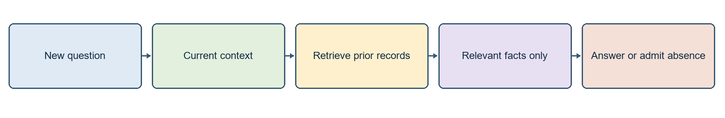
Persisted history must still be retrieved into a bounded context
Chat history, workflow state and preferences are distinct layers. Relevant earlier records may be retrieved, but the model does not receive every previous message automatically. Preference tools have explicit save/delete behavior; a user statement is not automatically a permanent verified fact. Raw attachments remain session-local even when transcripts persist.
Local profiles are not authenticated accounts. Do not expose this prototype as a secure public multi-user app. Retrieved text/preferences may be sent to whichever configured external LLM processes the request.

17 Models Fallback and Token Control
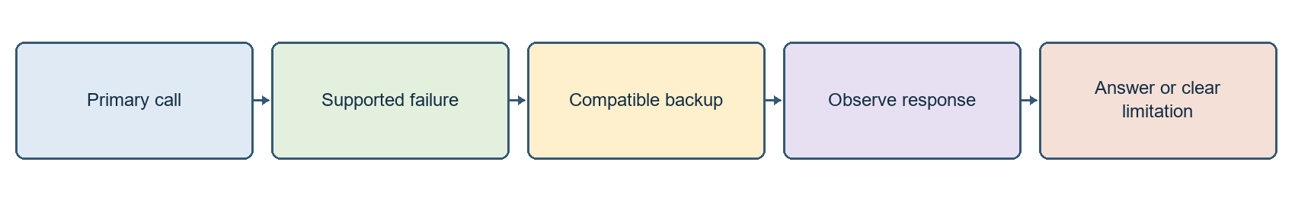
Provider switching improves availability but does not remove quotas
Task | Primary | Compatible configured backup
Text / orchestration | Groq openai/gpt-oss-20b | Gemini gemini-3.1-flash-lite; OpenRouter free routing
Spreadsheet planning | OpenRouter openrouter/free | Other text providers; Pandas executes maths locally
Vision | Groq qwen/qwen3.8-27b | OpenRouter Gemma vision then Gemini vision
openrouter/free is a router, not one fixed model. Actual provider/model availability and free eligibility can change. Multiple keys in one provider project may share quota. All configured models are not called for every request, and a text-only model cannot replace a required vision call.

Token consumption controls
Mechanism | Effect
Short context / metadata | Model sees relevant context and file manifest before large content
Passage / page retrieval | Only relevant document evidence is sent
Web excerpt cap and cache | Avoids sending full websites or repeatedly fetching the same URL
Local Pandas and calculator | No model-generated arithmetic needed for actual numeric results
Completed-role reuse | Avoids repeated handoffs for the same task
Economy mode and call budget | Stops unnecessary loops once evidence is sufficient
Cooldown and bounded retry | Avoids repeatedly hammering an unavailable provider

Workflow failure handling
Irrelevant page retrieval, ambiguous columns and incorrect routing require workflow or data corrections. Model switching alone does not resolve these issues. Source-based rendering and regression tests support reliability. If all compatible APIs fail, verified evidence can be retained, but a generated answer cannot be guaranteed.
app/llm/client.py # text model construction and order
app/llm/fallback.py # compatible switching and cooldown
app/attachments/vision.py # image-specific configuration

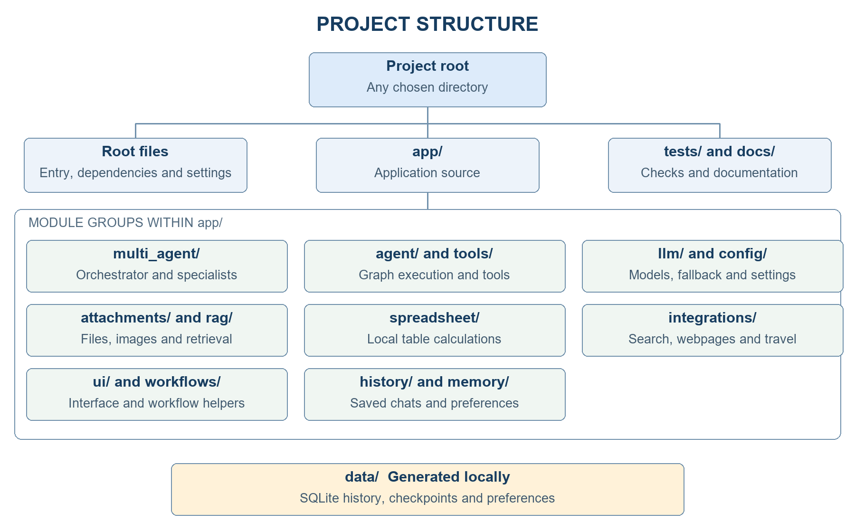

18 Final Folder Structure and Generated Outputs
./ # extracted project location; name is unrestricted
main.py
requirements.txt
README.md
.env.example
.env # local secrets; exclude from sharing
.streamlit/config.toml
app/
agent/
graph.py, loop.py, nodes.py, session.py, state.py, tool_execution.py
attachments/
migration.py, store.py, vision.py
config/
settings.py
history/
store.py
integrations/
travel_prices.py, web_reader.py, web_search.py
llm/
client.py, fallback.py
memory/
store.py
multi_agent/
errors.py, requests.py, system.py
rag/
documents.py
spreadsheet/
analysis.py, planner.py
tools/
calculator.py, document_search.py, memory.py, web_search.py
ui/
assistant_panel.py, excel_panel.py, presentation.py, streamlit_app.py, table_upload.py
workflows/
assistants.py, chat_router.py
docs/ # guides and diagram assets
data/ # generated local databases
chat_history.sqlite3
chat_checkpoints.sqlite3
memory.sqlite3
This source tree excludes package initializers and bytecode caches. No FAISS index, embedding store or knowledge-graph HTML is generated. The data directory stores application databases. Earlier panel and workflow modules remain in the repository; the active unified path is streamlit_app.py to handle_multi_agent().

19 Operational Validation and Distribution
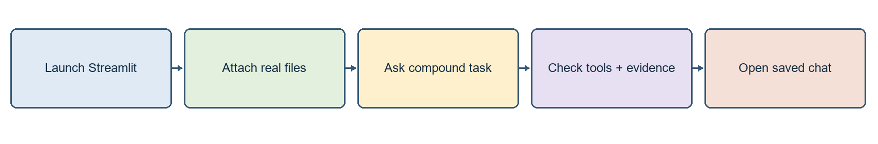
Validation sequence across core capabilities
Step | Action | Verification
1 | Calculate 125 * 37 + 450 / 9. | Expected calculator result: 4675
2 | Upload PDF; request first-page title | Compare actual physical page 1
3 | Upload Excel; request exact-column total | Compare with Excel SUM over same rows
4 | Ask PDF title and Excel total in two lines | Both required specialist tasks should be attempted
5 | Describe an image or summarize a public URL | Actual vision/page evidence or a clear failure
6 | Open previous chat | Transcript persists; raw files may need reattachment

Distribution requirements
Distribute source code, tests, requirements.txt, README.md, .env.example, .streamlit configuration and this guide. Exclude local credentials, virtual environments, caches and personal databases unless an authorized data transfer is intended. The recipient creates a new environment and supplies independent credentials. Stop the application before database backup and preserve existing working configuration.

20 Deployment and Data Boundaries
The application runs locally and sends selected content to configured external services. This separation identifies the runtime components, persistence locations and network boundaries.
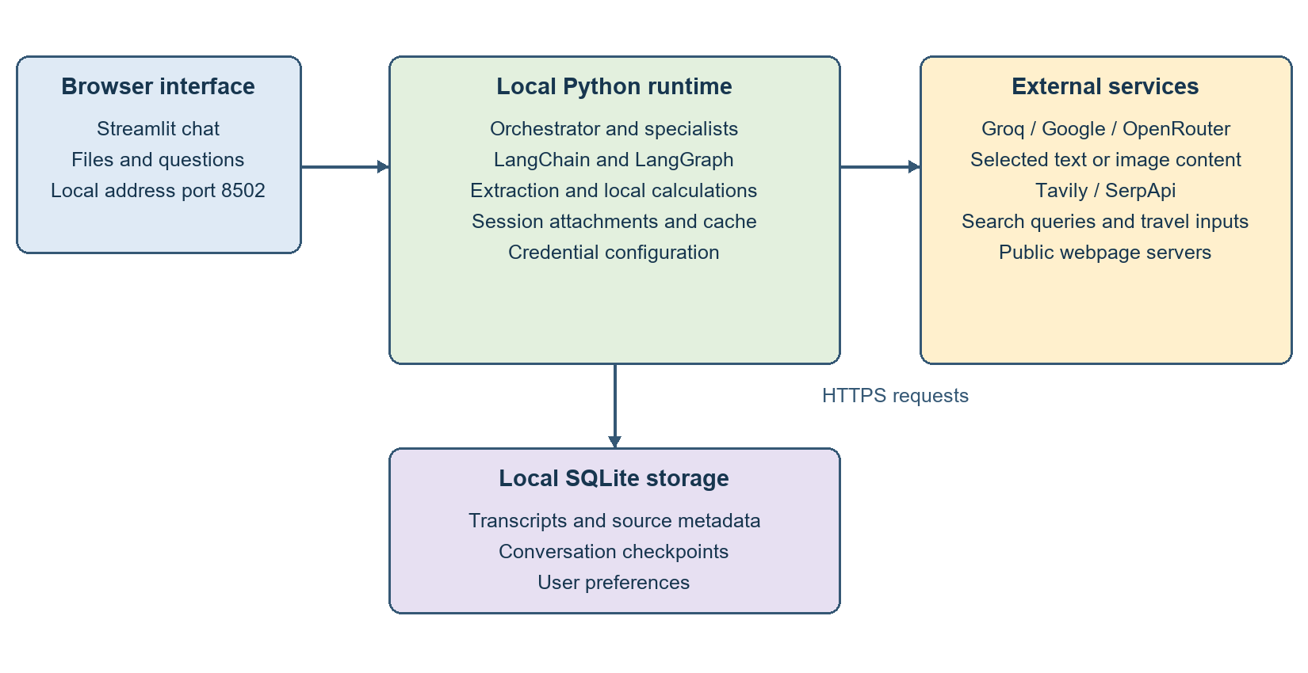
Deployment components and application data boundaries

Data transmitted to services
Depending on the selected workflow, requests may include the current question, relevant conversation records, retrieved document excerpts, table metadata or calculation results, normalized images, search queries and travel parameters. Raw attachment persistence is separate from the source excerpts retained in transcripts. External-provider processing is governed by the corresponding service configuration and terms.

Deployment controls
The default host is 127.0.0.1. Local profile identifiers do not provide authentication or tenant isolation. Public deployment requires a separate review of authentication, authorization, secrets management, data retention, request limits and logging. The current local configuration should not be treated as a production security boundary.

