AI Agent Complete Project Guide
Architecture, implementation and Windows setup
Prepared for Nimish Yadav and internship mentors | 22 October 2026
Yeh guide existing project ko samajhne, demo dene aur doosre Windows computer par run karne ke liye hai. Project ab ek general AI assistant hai: user ek hi chat mein questions, documents, tables, images aur public links de sakta hai.

What we built
A goal-based, tool-using multi-agent assistant. An orchestrator delegates work to specialist agents. LangChain connects models and tools; LangGraph controls the agent/tool workflow and state. Local processing handles calculations and file extraction. External APIs provide language generation, vision, search and travel results.

Project snapshot
Item | Current implementation
User interfaces | Streamlit unified chat and a terminal entry point
Main model | Groq openai/gpt-oss-20b; compatible configured backups
Persistence | Local SQLite chat history, graph checkpoints and preferences
File handling | Session attachments; multiple supported formats, not every file type
Web capability | Search results plus actual reading of supplied public URLs
Not implemented | Gmail sending, email approval workflow, bookings and payments

Read this guide in order
2 Architecture 3 Pipeline 4 Libraries 5 Models 6 Windows setup
7 Configuration 8 File map 9 Troubleshooting
10 to 19 Detailed workflows, folder structure and mentor demonstration
Project location on the development machine:
E:\PROJECT\Internship Projects\ai-research-agent
Another computer may use any suitable folder; run commands from that project root.

Architecture diagram
One chat coordinates specialists. The same underlying LLM can serve several roles; each role has its own instructions and tools.
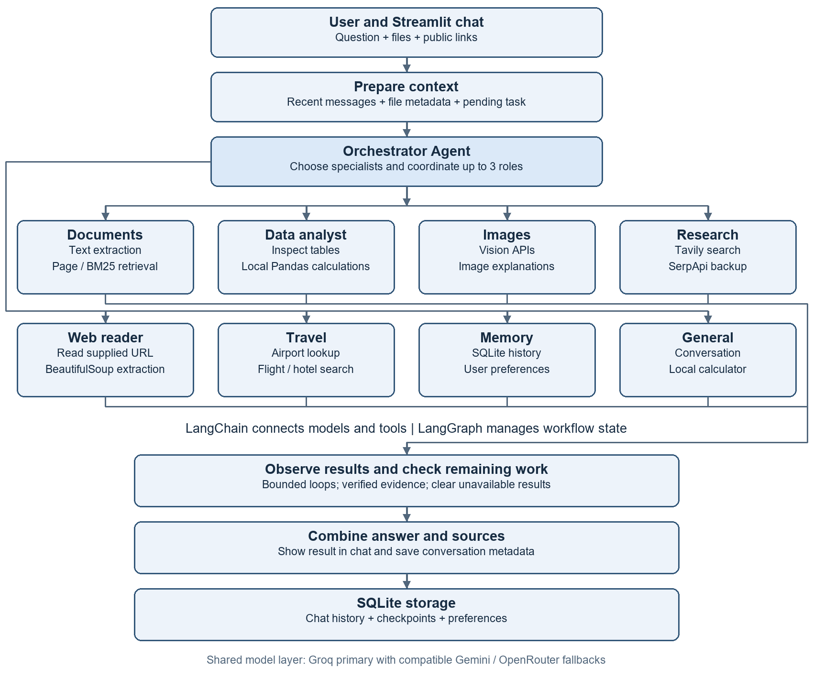
Routing is bounded, not an infinite autonomous loop. The orchestrator chooses the required roles; workflow code enforces evidence, limits and supported actions. Arrows summarize execution; not every branch runs for every request.

Pipeline and specialist responsibilities
User input -> prepare context -> orchestrator delegation -> specialist tools -> observe results -> check remaining work -> combine answer and sources -> persist history.
Specialist | What happens and why
General | Answers ordinary chat; uses the local calculator for arithmetic.
Documents | Retrieves actual uploaded text. Exact PDF page requests use page lookup; relevant passages use local BM25. This is not a vector database pipeline.
Data analyst | Inspects worksheet/column metadata, plans a supported operation, and executes it through Pandas. The LLM does not invent totals.
Images | Sends normalized images to a compatible vision model; observations may be imperfect.
Research | Searches the web with Tavily and SerpApi backup; returns evidence and source links.
Web reader | Reads up to two supplied public URLs. Extracts HTML/text/readable PDF evidence and summarizes selected excerpts.
Travel | Plans trips and accesses airport/flight/hotel search tools. Quotes are observations, not guaranteed bookings.
Memory | Retrieves relevant saved conversations and preferences; supports explicit preference save/delete tools.

Example compound request
Question: PDF page 1 ka title aur Excel ka total Tax (USD) batao, sirf 2 lines mein.
Orchestrator assigns Documents and Data. Document retrieval reads page 1; Data inspects the actual tax column and performs a local sum. Results are combined with evidence. If the column is ambiguous or a page has no text, the app should explain the limitation instead of guessing.

State and memory are different
State = current workflow messages, tool results and progress. History = saved transcripts across conversations. Preferences = useful user facts/settings. Relevant prior information is retrieved; every old message is not sent on every request. Raw attachments live in the current browser session and may need reattachment after restart.

Frameworks and libraries
Package or module | How and why it is used
LangChain core | AIMessage, HumanMessage, SystemMessage and ToolMessage represent conversation/tool data. @tool defines tool schemas; bind_tools exposes them to models.
LangGraph | StateGraph, nodes, conditional edges and START/END coordinate agent/tool loops. langgraph-checkpoint-sqlite persists checkpoints.
Streamlit | Chat UI, uploader, session state, previous chats, sources and tool activity. Its browser frontend internally uses JavaScript.
langchain-groq | ChatGroq model integration.
langchain-google-genai | ChatGoogleGenerativeAI integration for Gemini.
langchain-openai | ChatOpenAI connects to OpenRouter through an OpenAI-compatible URL. This does not imply a paid OpenAI API.
python-dotenv | Loads local environment configuration from .env.
pandas and openpyxl | Tabular processing/calculations and XLSX reading.
xlrd, pyxlsb, odfpy | Readers for legacy XLS, XLSB and OpenDocument spreadsheets.
pypdf | Readable PDF text extraction; image-only scans need OCR, which this pipeline does not guarantee.
python-docx and python-pptx | Extract text from supported Word documents and PowerPoint slides.
Pillow and pillow-heif | Read/normalize images and support HEIF/HEIC decoding where available.
beautifulsoup4 | BeautifulSoup parses HTML and extracts useful webpage text.

Python built in modules
sqlite3 stores local data; json serializes API/tool payloads; pathlib/os handle paths and environment settings; re matches patterns. unittest and unittest.mock verify behavior. These are standard-library modules and do not require separate pip installation.
Framework = structure for an application. Library = reusable functions/classes. Model = trained inference system. API provider = external service hosting a capability. SQLite = database. VS Code = editor; pip = installer; virtual environment = isolated dependencies.

Models services and webpage reading
Role | Configured model or service
Main text and orchestration | Groq: openai/gpt-oss-20b
Text fallback | Google: gemini-3.1-flash-lite, then OpenRouter free routing when configured and compatible
Spreadsheet planning | OpenRouter: openrouter/free first, with text-provider backups. Actual calculation is local Pandas.
Image understanding | Groq: qwen/qwen3.8-27b
Image backups | OpenRouter: google/gemma-4-26b-a4b-it:free, then compatible Gemini vision
Web search | Tavily primary; SerpApi backup
Travel results | SerpApi flight/hotel search and airport lookup
Model names above are the project configuration snapshot, not a guarantee of current provider availability. openrouter/free is a router and can select different underlying models. Limits, eligibility and prices depend on providers. Configure valid keys and check provider dashboards; no unlimited free quota is promised.

How the scraper works
Given URL -> public address validation -> robots.txt policy -> bounded HTTP request -> optional gzip decompression -> HTML/text/PDF extraction -> selected excerpts -> LLM summary and source. It does not execute JavaScript or bypass login, CAPTCHA or paywalls.
Built in modules | Purpose
http.client, socket, ssl | HTTP transport, DNS and HTTPS certificate verification. Public IP validation and pinned connections reduce unsafe local-network access.
ipaddress, urllib.parse | Block private/local addresses; parse/normalize URLs and check redirects.
RobotFileParser | Read robots.txt automated-access policy.
gzip and io.BytesIO | Decompress bounded compressed bytes in memory without saving a temporary download.
time, datetime, timezone, re | Timeout/cache timing, fetch timestamps and relevant text patterns.
Efficiency: five-minute webpage cache; at most two supplied URLs per message; up to about 4,200 excerpt characters per page; 2 MB response limit. The reader is not a whole-site crawler. Failure after fetching can return verified excerpts instead of a generated explanation.

Install and run on Windows
Prerequisites: Windows, Python 3.11 or newer, internet, VS Code if desired, and a valid Groq key for the default configuration. The development environment used Python 3.13. A new dependency installation can differ because many packages are not pinned.

1 Copy the project
Copy the source folders, main.py, requirements.txt, .env.example and .streamlit folder. Do not copy .venv-standard, .venv, .env, API credentials or personal data by default. The recipient creates a new environment and their own keys.

2 Open a PowerShell terminal in the project root
Set-Location -LiteralPath 'E:\PROJECT\Internship Projects\ai-research-agent'
py --version
py -3.13 -m venv .venv-standard
If Python 3.13 is not installed, replace -3.13 with an installed supported version such as -3.11. Folder names containing spaces must stay quoted.

3 Install dependencies
.\.venv-standard\Scripts\python.exe -m pip install --upgrade pip
.\.venv-standard\Scripts\python.exe -m pip install -r requirements.txt
Using the environment executable directly avoids PowerShell activation-policy problems. In VS Code, choose this executable with Python Select Interpreter.

4 Create configuration
Copy-Item -LiteralPath .env.example -Destination .env
notepad .env
Only run the copy command on a fresh setup; preserve any existing working .env. Fill in the required key and optional services using the next page. Every variable must occupy one complete line.

5 Start the app
.\.venv-standard\Scripts\python.exe -m streamlit run app/ui/streamlit_app.py
Open http://127.0.0.1:8502/ . The project config uses port 8502. If it is busy, append --server.port 8503 and open that address. Stop the server with Ctrl+C.
# Optional terminal interface
.\.venv-standard\Scripts\python.exe main.py

Configuration and demo checks
Use placeholders below as names only; replace locally with your own credentials. Keys are secrets. Never paste them into chat, screenshots or source control. Restart the app after changing .env.
LLM_PROVIDER=groq
GROQ_API_KEY=your_real_groq_key
GROQ_MODEL=openai/gpt-oss-20b
GOOGLE_API_KEY=your_real_google_key
GEMINI_MODEL=gemini-3.1-flash-lite
OPENROUTER_API_KEY=your_real_openrouter_key
EXCEL_MODEL=openrouter/free
CHAT_BACKUP_MODEL=openrouter/free
TAVILY_API_KEY=your_real_tavily_key
SERPAPI_API_KEY=your_real_serpapi_key
Default startup requires Groq credentials. Gemini and OpenRouter add compatible backups. To use Gemini as the primary instead, set LLM_PROVIDER=gemini and provide a valid GOOGLE_API_KEY. Search/travel require their respective optional keys. Scraping itself needs no new API key; generated summaries still use the existing LLM layer.

Short functional demo
Try this | What to verify
Calculate 125 * 37 + 450 / 9. | Calculator tool result should be 4675.
Upload a readable PDF and ask for page 1 title. | Answer is grounded in the actual first page; no random-page example.
Upload Excel and ask for the total of an exact numeric column. | Tool activity shows inspection/calculation; compare against Excel SUM.
Upload an image and ask for a one-line description. | Vision result refers to the real image; no unsupported certainty.
https://www.python.org/doc/ Summarize in one line. | Actual webpage evidence and source URL appear, or a clear access failure.
Open a previous chat from the sidebar. | Saved transcript loads. Reattach raw files if the session has restarted.

Run automated checks
.\.venv-standard\Scripts\python.exe -B -m unittest discover -s tests -q
The last verified scraper integration run passed 97 tests. Rerun on the recipient machine; this historical result is not a fresh verification of their installation.

Source file map
Paths below are relative to the project root. Start with streamlit_app.py for UI and multi_agent/system.py for active orchestration.
File or folder | Change or inspect here when
app/ui/streamlit_app.py | Changing chat layout, uploader, chat history selection or session wiring.
app/multi_agent/system.py | Changing specialist delegation, active tool loops, completion checks or evidence handling.
app/multi_agent/requests.py | Changing page/length/request interpretation helpers.
app/llm/client.py | Changing text models, model construction and fallback order.
app/llm/fallback.py | Changing cooldown, compatible retry/fallback handling and provider events.
app/config/settings.py | Checking environment variables and required configuration.
app/attachments/store.py | Changing file normalization, supported extensions or current-chat file state.
app/attachments/vision.py | Changing vision models and image API calls.
app/rag/documents.py | Changing document extraction, exact-page lookup or BM25 retrieval.
app/spreadsheet/analysis.py | Changing header detection, table reading or local operations.
app/spreadsheet/planner.py | Changing the Excel planning model or allowed plan handling.
app/integrations/web_search.py | Changing Tavily/SerpApi requests, limits and search caching.
app/integrations/web_reader.py | Changing URL checks, HTML extraction, robots policy or webpage cache.
app/integrations/travel_prices.py | Changing airport/flight/hotel API integration.
app/history/store.py and app/memory/store.py | Changing persistent transcripts or preference storage.
app/agent/ and app/tools/ | Shared conversation graph, state, tool wrappers and execution helpers.
main.py and tests/ | Terminal entry point and automated regression checks.
.streamlit/config.toml | Theme, local host, port 8502 and upload setting.

Troubleshooting and project handover
Problem | What to do
ModuleNotFoundError | Install requirements using .venv-standard\Scripts\python.exe and run Streamlit with that same executable.
API key or configuration error | Check one VARIABLE=value per line. Model variables contain model IDs, not keys. Avoid duplicate variables and restart after edits.
Quota or rate limit | Check provider dashboard and wait for reset or configure a compatible independent backup. Switching keys in one quota pool may not add quota.
Failed to fetch dynamically imported module | Restart server, close stale tabs and hard-refresh. Verify current port 8502; if cached assets remain, use a fresh port such as 8503.
Uploaded PDF has no usable text | Use a text-based PDF. Scans need a separate OCR capability.
Excel has Unnamed columns or ambiguous tax | Check sheet and header row; select the actual column. Never accept a guessed total.
Website blocked or empty | Login, robots policy, CAPTCHA or JavaScript-only content may prevent reading. Use a readable public source or upload supported content.
Old chat opens but files unavailable | Raw attachments are session-local. Reattach them; transcript history is a separate persistent store.

Storage and sharing
data/chat_history.sqlite3 stores transcripts; data/chat_checkpoints.sqlite3 stores graph checkpoints; data/memory.sqlite3 stores preferences. Stop the app before copying databases for backup. A clean handover should exclude data/ unless the user intentionally transfers their own history. The app is a local prototype: profiles are not authenticated accounts and it should not be exposed publicly as a secure multi-user service.

How to explain the project to a mentor
Humne ek goal-based multi-agent assistant banaya hai. User ek chat mein request deta hai. Orchestrator relevant specialist ko kaam deta hai. LangChain models aur tools connect karta hai; LangGraph workflow aur state handle karta hai. Tools real evidence fetch karte hain aur Pandas calculations locally karta hai. Results sources ke saath combine hote hain. History SQLite mein save hoti hai, aur compatible model failure par backup try hota hai.

Current boundary
This handover documents the current general assistant. Gmail integration, approved email sending, automatic bookings, unlimited recall, all-site scraping and all-file-format support are not implemented guarantees. Keep .env private; rotate any previously exposed credentials through provider dashboards.

10 File Routing and Local Processing
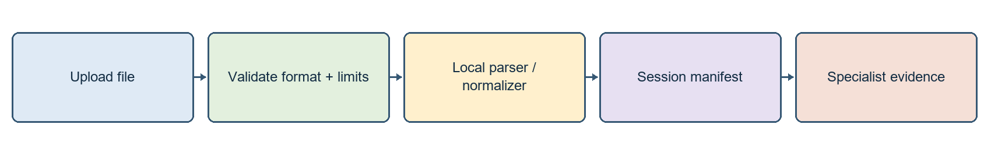
File routing keeps extraction separate from model interpretation
Ek upload button ke peeche different readers hain. Extension, size aur content checks decide karte hain ki file document index, table store ya image store mein jayegi. Actual extraction locally hoti hai; LLM ko sirf task ke liye relevant content diya jata hai. Uploaded code aur macros execute nahi hote.
Input | Actual reader | Coverage
PDF | pypdf | Readable text; physical PDF page numbers
DOCX / PPTX | python-docx / python-pptx | Paragraphs, slide text and tables; embedded pictures are not automatically analyzed
XLSX / CSV | pandas + openpyxl and header detection | Loads first worksheet for workbook ingestion
XLS / XLSB / ODS / TSV | pandas with xlrd / pyxlsb / odfpy or TSV parsing | Other spreadsheet formats use their supported engine and initial header defaults
Images | Pillow + pillow-heif | EXIF orientation, first frame, RGB JPEG conversion and resizing
Text / code | Local text extraction | Read supported text formats as content, never execute uploaded code

Actual limits
Attachments: up to 10 items per chat and 10 MB per file. PDF index: up to 5 documents, 50 pages per PDF and bounded extracted text. Tables: 50,000 rows / 100 columns. Images: 20 megapixels maximum and normalized to fit 1600 x 1600. Archive-based documents have expanded-size/entry checks.
Legacy DOC/PPT, SVG/RAW/PSD, audio/video, executables and generic archives are unsupported. Damaged/encrypted files can fail even with a supported extension. Raw uploads remain in RAM for the current chat/browser session; they are not a permanent source corpus in data/.
app/attachments/store.py # format routing and session state
app/attachments/migration.py # upgrade live session objects
app/rag/documents.py # PDF extraction limits and index

11 How the Orchestrator Chooses Work
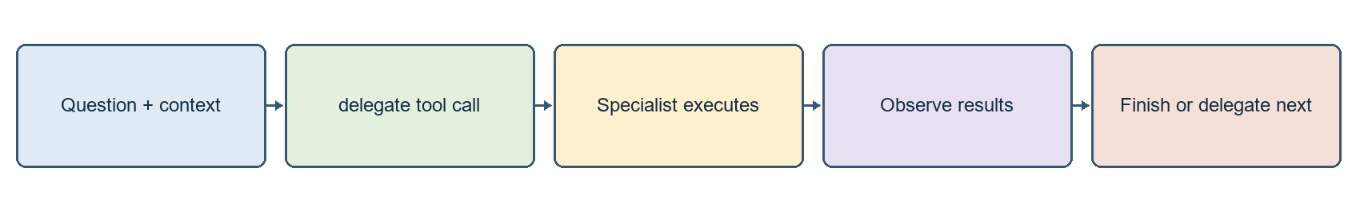
LLM coordination is combined with explicit workflow checks
Active entry point handle_multi_agent() prepares current question, recent messages, file metadata and pending user details. The LLM receives the delegate tool schema and chooses an agent name and task. Required file roles are also identified by code, so a PDF-plus-Excel request needs both parts rather than a fluent generic response.

bind_tools in simple language
bound = model.bind_tools(tools)
response = bound.invoke(messages)
# response.tool_calls may ask Python to execute a registered tool
bind_tools model ko tools ka menu deta hai: name, purpose aur argument schema. It does not run functions. The model returns structured calls; Python validates arguments, executes a registered tool and records a ToolMessage. Model ko observation milti hai, phir next action ya final answer choose hota hai.
LangGraph concept | How it appears in the project
State | Messages, call count and dispatch/finalization flags
Node | agent invokes a model; tools executes selected tools
Conditional edge | Routes to tool execution, another model call or END
START / END | Explicit workflow entry and termination
Loop | Agent -> tool -> observation -> agent, within configured bounds

Call and handoff control
Default shared model-call budget is 12. Role loops normally allow up to 4 model calls; the orchestrator coordinates up to 3 handoffs and accepts at most 2 tools per response. Completed roles are reused within a turn. Economy mode can end after enough verified evidence, reducing redundant calls. These are bounds, not a guarantee every task finishes.
Multiple specialists can use the same model with different instructions/tools. Some short tool sequences are intentionally enforced by code. Tool activity lists observable actions, not hidden model reasoning. Inspect app/multi_agent/system.py and app/multi_agent/requests.py for these decisions.

12 Document Retrieval and Grounded Answers
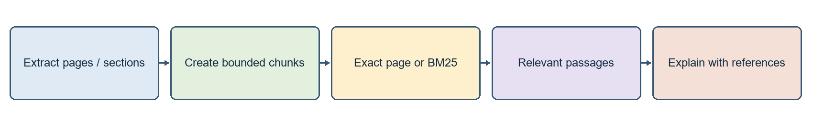
Document evidence is retrieved before an explanation is generated
Document Agent uploaded material ke actual passages use karta hai. PDF content preserves physical page numbers; Word/slides/text use their own section/slide locations. A request for page 1 must use page 1, rather than whichever paragraph seems semantically related.
Question | Retrieval path | Why
PDF page 1 ka title batao | Exact page lookup and title-focused rendering | Avoids explaining a random page
Python lists ko PDF se samjhao | Local lexical BM25 passages | Focused evidence without sending entire PDF
What is this document about | Overview/relevant excerpts | Bounded description of loaded content
PDF mein tax example kaha hai | Search actual extracted evidence | Absence of evidence must not become an invented tax example

Where RAG fits
Broadly this is retrieval-augmented generation: retrieve evidence, then explain it. Our implementation uses local BM25/exact page retrieval. It does not currently require embeddings, FAISS, MinerU, Ollama or a knowledge graph. Do not copy those claims from the reference project into this project explanation.

What can fail
Image-only scans need separate OCR. A page can be empty or extraction can be imperfect. Embedded images inside DOCX/PPTX are not automatically sent through the image agent. Source references indicate retrieved evidence; they do not prove every word of a generated explanation is correct.

Verification
Ask for one exact page and compare with the source file. Use a short output and verify the referenced location. When evidence is missing, the response should say it was not found, not produce a plausible example from general knowledge.
app/rag/documents.py # extract_pdf, chunks and page/BM25 retrieval
app/tools/document_search.py # search_documents wrapper
app/multi_agent/system.py # Document Agent and evidence rendering

13 Spreadsheet Planning and Reproducible Maths
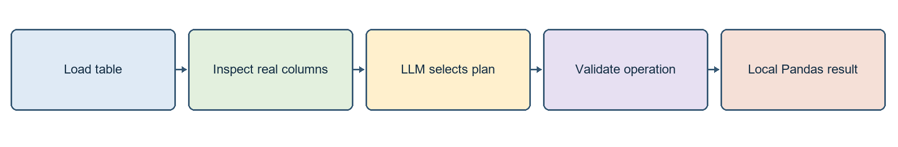
The model plans; Python executes the calculation
Data Agent ke paas inspect_table aur calculate_table tools hain. The LLM identifies an allowed operation from the question; Pandas applies that operation to the loaded table. A table summary should use metadata instead of inventing a calculation, and a tax total should come from the actual tax column.
Operation | Meaning | Example
sum | Add values | Total Tax (USD) batao
mean | Arithmetic average | Average sales batao
min / max | Smallest / largest value | Maximum bill batao
count | Supported non-null column count behavior | Is column ka count batao
group_by | Apply an operation per category | Branch-wise total tax batao

Why headers matter
Some reports start with a title and blank rows above the actual header. XLSX/CSV header detection helps identify the real names. A wrong header can create Unnamed columns or ambiguous tax names. Inspect the sheet and numeric column; compare the result to Excel SUM over the same rows. The attachment path currently loads the first workbook worksheet.

Safe operation boundaries
Plans choose allowed operations and columns rather than executing arbitrary generated Python. The tool does not recalculate arbitrary Excel formulas. Formula-heavy files may require recalculation and saving in Excel before ingestion. Macros/code are not executed. More complex analysis must be implemented and tested as an explicit supported operation.

Mentor explanation
LLM ko calculation ka intent samajhne ke liye use kiya; actual arithmetic Pandas karta hai. Isse result repeatable rehta hai, tokens bachhte hain aur unsupported operations ko clear reject kar sakte hain.
app/spreadsheet/analysis.py # read_table, detect_header_row, calculate
app/spreadsheet/planner.py # separate OpenRouter planning model
app/multi_agent/system.py # inspect_table / calculate_table evidence

14 Image Understanding and Vision Routing
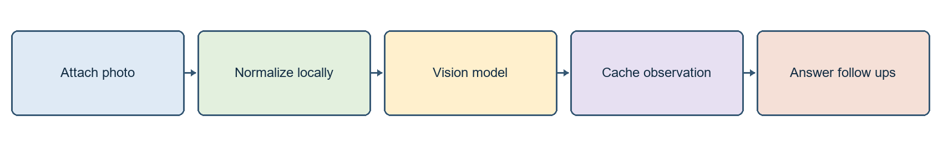
Image understanding is separate from text-only generation
Pillow/Pillow-HEIF image ko decode karte hain, EXIF rotation apply karte hain aur browser/API-friendly RGB JPEG banate hain. The first image frame is used, not all animated frames. A separate vision-capable model interprets visible content; this does not change the primary text model for ordinary chat.
Stage | Current behavior
Primary vision | Groq qwen/qwen3.8-27b
Vision backups | OpenRouter google/gemma-4-26b-a4b-it:free; compatible Gemini vision
Cache | Repeated image/question can reuse a cached answer
Follow-up context | Short recent image notes may support follow-up questions
Persistence | Raw image is session-local, not automatically restored from SQLite transcript

Useful demo questions
Explain this screenshot in one line.
What are the visible labels and trend in this chart?
Which step comes after the decision box in this flowchart?

Limitations
Small text, low resolution and dense tables can be misread. Vision is not a substitute for verified spreadsheet maths. If every compatible vision API fails, a text-only backend cannot truthfully claim it analyzed the image. Dedicated similar-image search and image generation are not implemented features.

Where to change
app/attachments/store.py # image_url, normalization and cache
app/attachments/vision.py # describe_image and compatible providers
A clear user-visible failure is better than a confident invented image description. Model availability, vision support and free quotas must be checked with the provider when deploying on another machine.

15 Web Search Versus Actual Page Reading
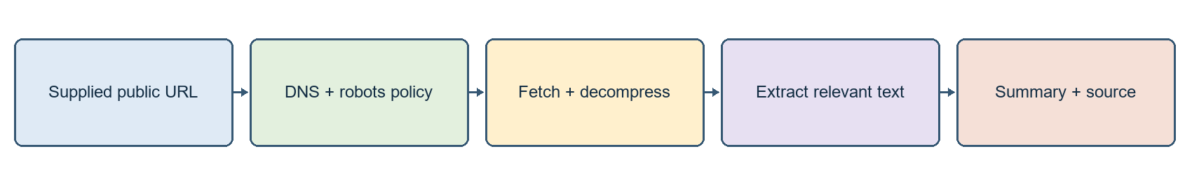
Web Reader Agent uses real page text rather than search snippets
Capability | Input | Source of evidence
Web search | Query words | Tavily primary or SerpApi backup snippets and URLs
Web reader | A public HTTP/HTTPS URL | Actual fetched page text and selected excerpts
Document retrieval | Uploaded document | Local extracted pages/sections
Search finds candidate sources; scraping reads a supplied page. In this implementation read_webpage is a LangChain tool in the active multi-agent system; WebPageClient in app/integrations/web_reader.py owns network validation, policy, extraction and cache.

Imports and their actual jobs
Module | Purpose
http.client / socket / ssl | HTTP transport, DNS connection, TLS certificate checks
ipaddress / urllib.parse | Public/private IP validation; URL parsing and safe redirect handling
RobotFileParser | Read robots.txt policy before automated page access
gzip / io.BytesIO | Decode compressed response bytes safely in memory
BeautifulSoup | Extract title/useful text; remove markup and noisy HTML elements
time / datetime / re | Timeout, cache age, fetch timestamps and focus terms
Only public URLs are permitted. Local/private addresses, unsafe redirects, credential-bearing URLs and custom ports are blocked. Limits include at most two supplied URLs per message, about 4,200 excerpt characters per page, a 2 MB response cap, bounded redirects/timeouts and a five-minute page cache. It does not crawl all linked pages or the whole website.
Login, CAPTCHA, paywalls and JavaScript-only sites are not bypassed. If generation fails after a successful fetch, verified excerpts can still be displayed. If fetching fails, no successful-read claim should appear. USER_AGENT = AIResearchAssistant/1.0 identifies the HTTP client; it is not an LLM model.

16 Research Travel and Memory Workflows
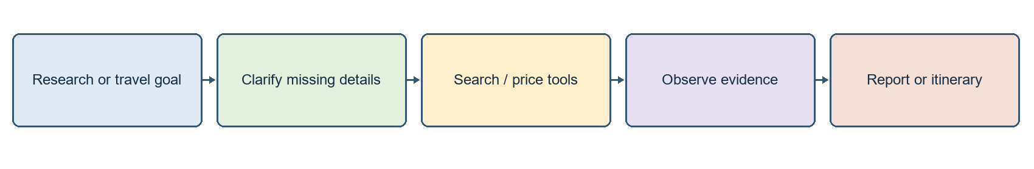
External results support a bounded specialist task

Research Report Assistant
Research Agent focused queries choose karta hai, source snippets observe karta hai aur findings/source IDs/limitations ke saath explanation deta hai. Tavily Basic is the main search API, SerpApi is backup. Search requests use Python HTTP calls; separate provider SDK packages are not required. The run shares a maximum of two web searches, so it is not unlimited deep research.

Trip Planner
Travel Agent can gather origin, destination, future dates, adults and budget; resolve airport codes; and request flight/hotel listings via SerpApi. City lookup reduces memorized IATA-code input, but ambiguous airport choices and missing details still need clarification. The user budget is an allowance; a retrieved quote is an observation at search time. Neither is a guaranteed booking price.
Bookings, reservations, payments and automatic external transactions are not performed. A suggested itinerary should distinguish verified listings from assumptions. Failed price lookup must not become an invented quote. Code lives in app/integrations/travel_prices.py and the active specialist orchestration.

Memory and recall
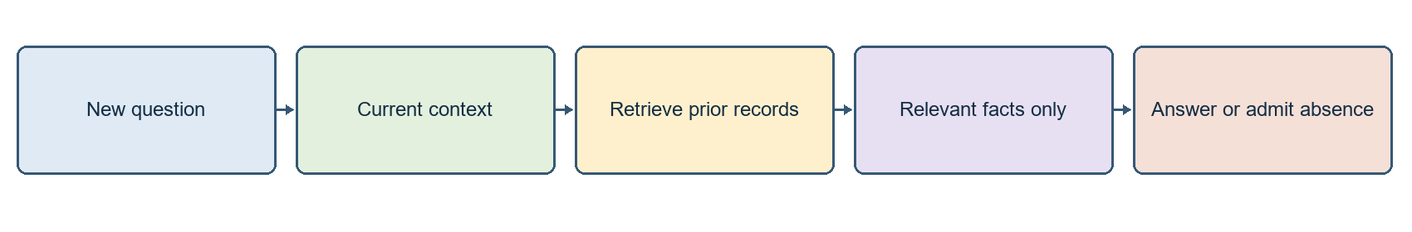
Persisted history must still be retrieved into a bounded context
Chat history, workflow state and user preferences are different. Relevant prior conversation can be retrieved, but the model does not receive every previous message automatically. Preference save/delete tools have their own behavior; do not promise every user statement becomes a permanent verified fact. Raw attachments are session-local even when the transcript persists.
Local profiles are not authenticated accounts. Do not expose this prototype as a secure public multi-user app. Retrieved text/preferences may be sent to whichever configured external LLM processes the request.

17 Models Fallback and Token Control
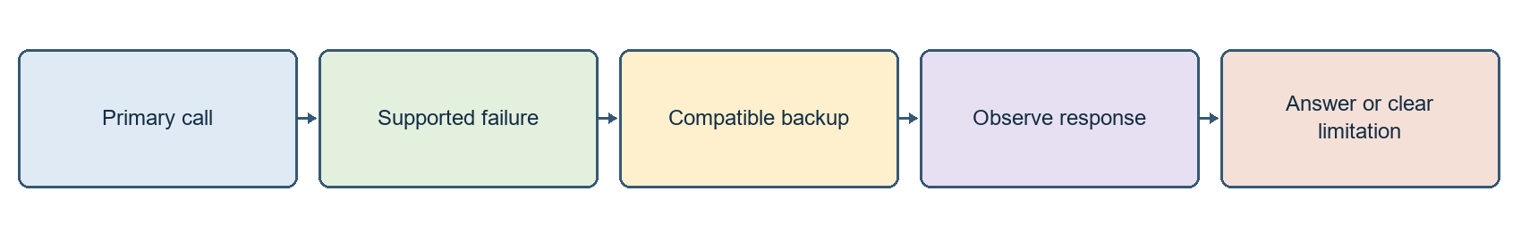
Provider switching improves availability but does not remove quotas
Task | Primary | Compatible configured backup
Text / orchestration | Groq openai/gpt-oss-20b | Gemini gemini-3.1-flash-lite; OpenRouter free routing
Spreadsheet planning | OpenRouter openrouter/free | Other text providers; Pandas executes maths locally
Vision | Groq qwen/qwen3.8-27b | OpenRouter Gemma vision then Gemini vision
openrouter/free is a router, not one fixed model. Actual provider/model availability and free eligibility can change. Multiple keys in one provider project may share quota. All configured models are not called for every request, and a text-only model cannot replace a required vision call.

What reduces token consumption
Mechanism | Why it helps
Short context / metadata | Model sees relevant context and file manifest before large content
Passage / page retrieval | Only relevant document evidence is sent
Web excerpt cap and cache | Avoids sending full websites or repeatedly fetching the same URL
Local Pandas and calculator | No model-generated arithmetic needed for actual numeric results
Completed-role reuse | Avoids repeated handoffs for the same task
Economy mode and call budget | Stops unnecessary loops once evidence is sufficient
Cooldown and bounded retry | Avoids repeatedly hammering an unavailable provider

Workflow bugs are separate
Irrelevant page retrieval, ambiguous tax columns or incorrect routing are workflow/data issues. Switching models does not automatically fix them. Tests and source-grounded rendering are needed. If every configured compatible API fails, the app can retain actual evidence but cannot promise a generated answer for every task.
app/llm/client.py # text model construction and order
app/llm/fallback.py # compatible switching and cooldown
app/attachments/vision.py # image-specific configuration

18 Final Folder Structure and Generated Outputs
ai-research-agent/
main.py
requirements.txt
README.md
.env.example
.env # local secrets; exclude from sharing
.streamlit/config.toml
app/
agent/
graph.py, loop.py, nodes.py, session.py, state.py, tool_execution.py
attachments/
migration.py, store.py, vision.py
config/
settings.py
history/
store.py
integrations/
travel_prices.py, web_reader.py, web_search.py
llm/
client.py, fallback.py
memory/
store.py
multi_agent/
errors.py, requests.py, system.py
rag/
documents.py
spreadsheet/
analysis.py, planner.py
tools/
calculator.py, document_search.py, memory.py, web_search.py
ui/
assistant_panel.py, excel_panel.py, presentation.py, streamlit_app.py, table_upload.py
workflows/
assistants.py, chat_router.py
tests/ # regression tests
docs/ # guides and diagram assets
data/ # generated local databases
chat_history.sqlite3
chat_checkpoints.sqlite3
memory.sqlite3
Compact tree excludes package initializer files and bytecode caches. No FAISS index, embedding store or knowledge-graph HTML is generated in this project. data/ contains generated application storage rather than the reference document's ingestion corpus. Earlier UI panel/workflow modules remain; the active unified route is streamlit_app.py -> handle_multi_agent().

19 Mentor Demo and Handover Checklist
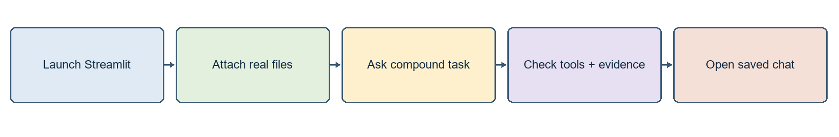
Five minute demonstration of actual capabilities
Step | Action | Verification
1 | Calculate 125 * 37 + 450 / 9. | Expected calculator result: 4675
2 | Upload PDF; request first-page title | Compare actual physical page 1
3 | Upload Excel; request exact-column total | Compare with Excel SUM over same rows
4 | Ask PDF title and Excel total in two lines | Both required specialist tasks should be attempted
5 | Describe an image or summarize a public URL | Actual vision/page evidence or a clear failure
6 | Open previous chat | Transcript persists; raw files may need reattachment

Questions your mentor may ask
How does it choose tools? bind_tools exposes schemas; the model returns a structured call and Python validates/executes it.
Why LangGraph? Explicit state, conditional edges and bounded agent/tool loops.
Why multiple agents? Each role has its own instructions, tools and evidence checks; models can be shared.
Why local Excel calculations? Reproducible arithmetic and lower token usage.
Is document retrieval vector RAG? No, this implementation uses lexical BM25/exact-page retrieval.
Does memory recall every chat? No; persistence and retrieval into a bounded context are different.

Sharing the project
Share source, tests, requirements, README, .env.example, .streamlit configuration and this guide. Exclude .env, API credentials/tokens, .venv-standard, caches and personal data/ by default. The recipient creates a new environment and uses their own keys. Stop the app before an intentional database backup. Do not overwrite working configuration while copying example settings.

What changed for this document
This expanded document follows the reference guide's practical section, diagram, table and command pattern. Only documentation assets were added. Application code, provider settings, API keys and user history were not changed. The earlier shorter handover guide remains available.

