AI Agent Demo Overview
One chat for documents, spreadsheets, images, research and travel.
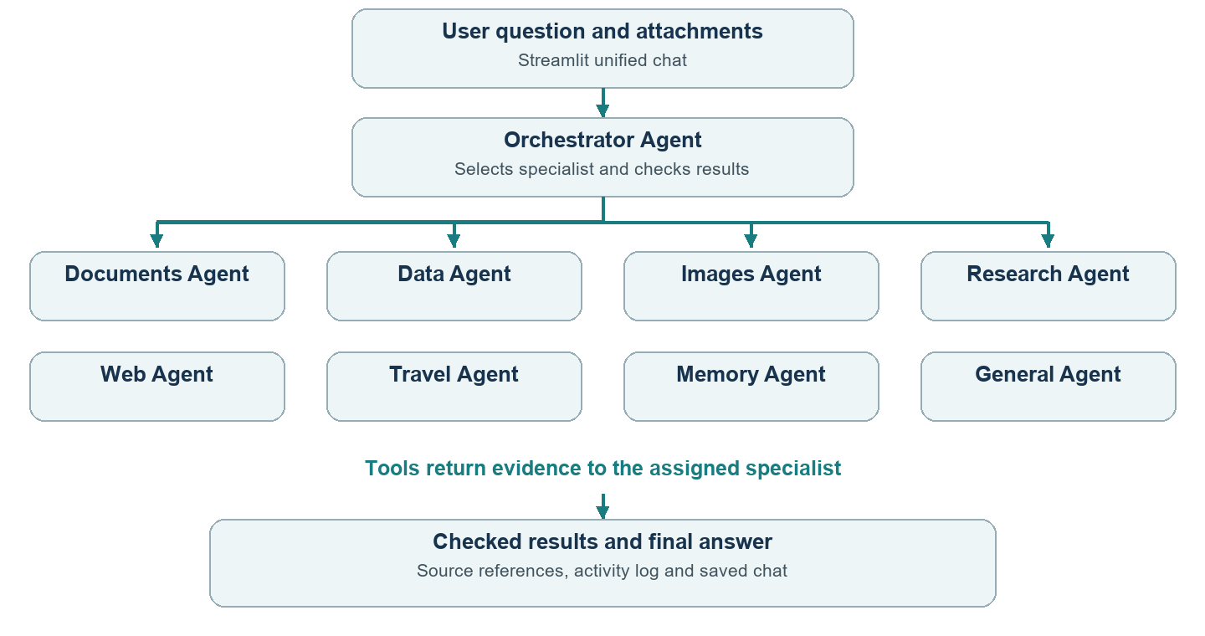

How the agent chooses the next step
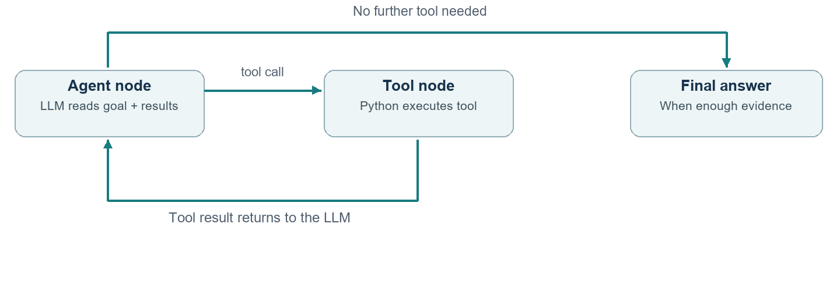
LangChain exposes tools. LangGraph runs the model → tool → result loop. Specialists can share the same underlying model.

2 How documents become answers
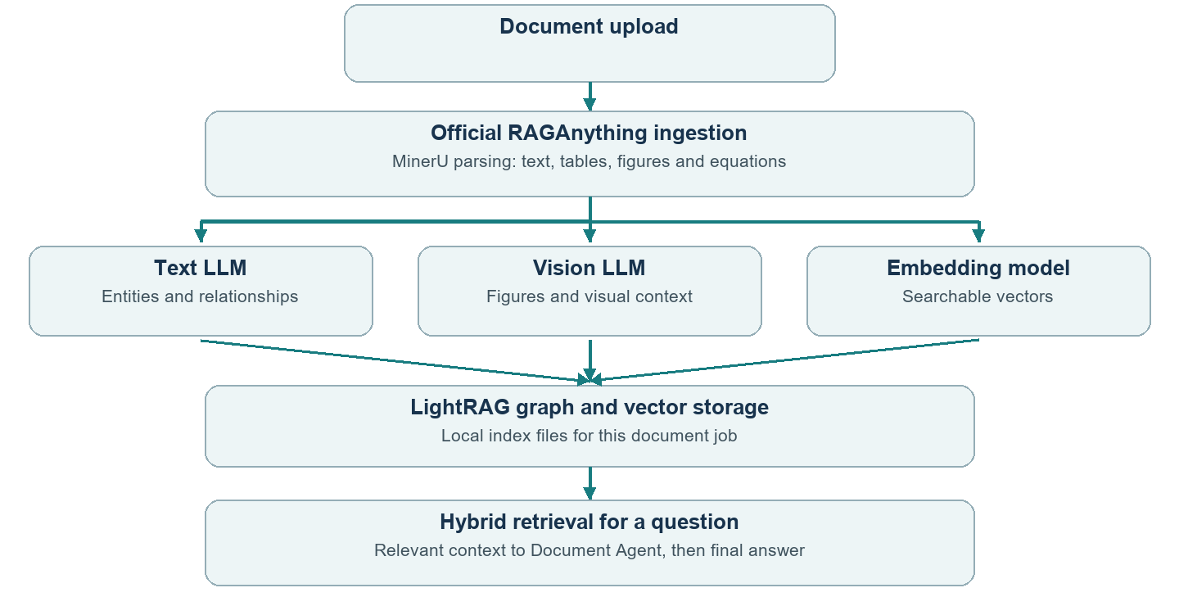

Two stages

Example: “Explain the document in short.” Relevant evidence is retrieved; the whole file does not need to be sent for every question.
Exact-page questions use page lookup. If hybrid retrieval fails, activity shows the actual local fallback.

3 Which models and APIs are used
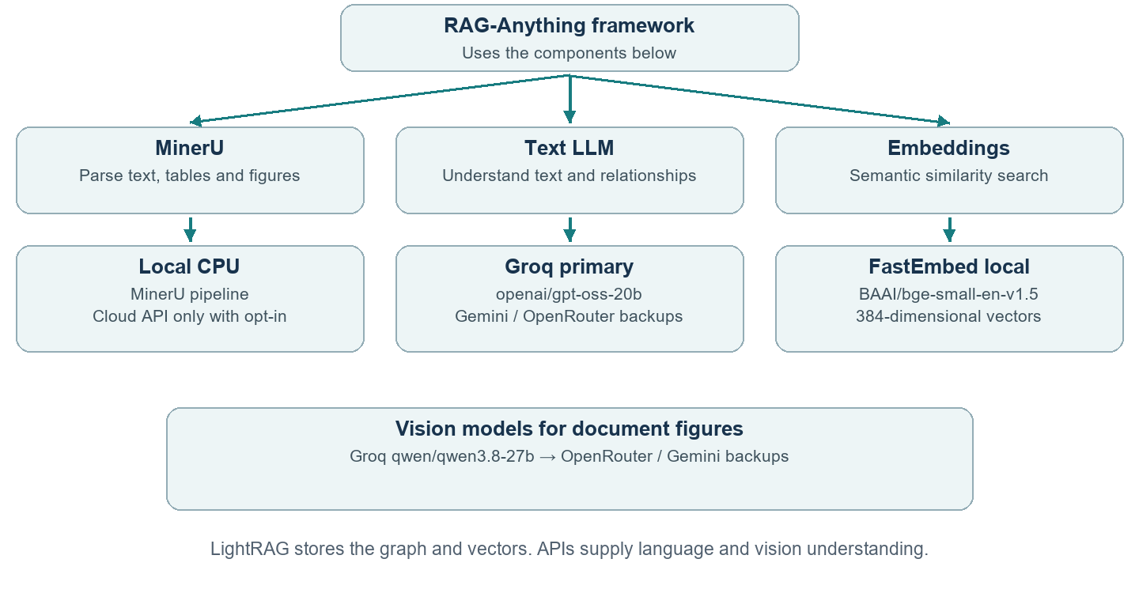

Other capabilities
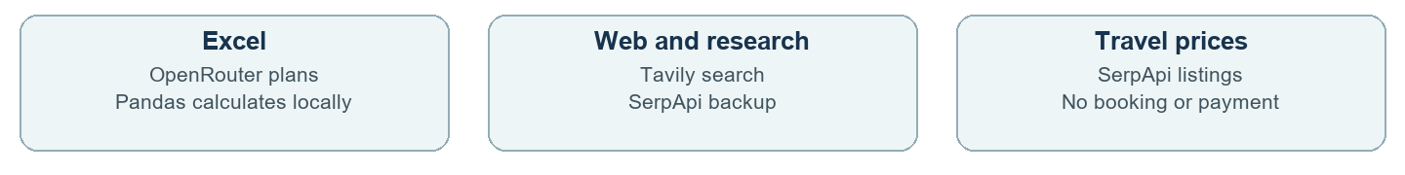
Configured models are tried only when required. Quotas and availability can affect results; backups do not guarantee unlimited service.

4 Important files at a glance
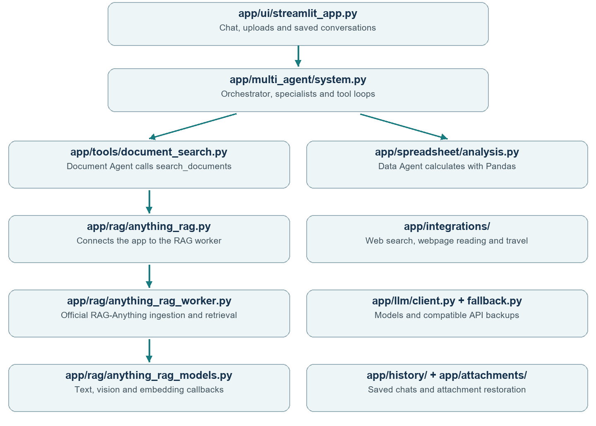

Quick demo sequence
1 Upload a PDF and ask for its first-page title.
2 Upload Excel and ask for the total Tax column.
3 Open “Agents and tools used” to show the actual execution path.
Change UI in streamlit_app.py; delegation in system.py; RAG model callbacks in anything_rag_models.py. Keys remain in local .env.

