AI Agent Easy Code Notes
Short learning guide with diagrams, real code references and simple Hinglish explanations.
Scope: active flow ki selected important lines detail mein samjhayi gayi hain. Yeh poore repository ki har source line ka exhaustive explanation nahi hai. Line numbers current source snapshot ke hain.
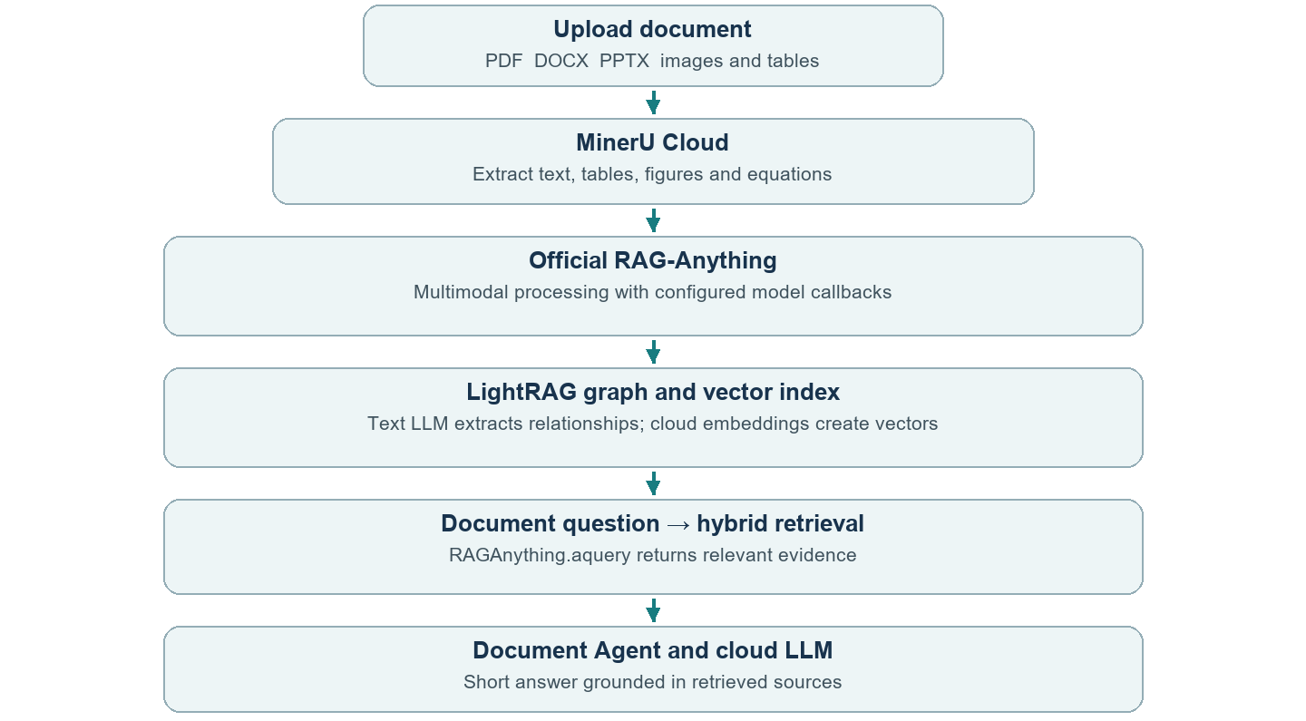
Remember | Simple meaning
LLM sochta hai | Instructions aur evidence dekhkar next action/answer choose karta hai.
Tool kaam karta hai | Python actual search, retrieval ya calculation execute karta hai.
Graph flow chalata hai | LangGraph state aur next step manage karta hai.

Revision sentence: Upload → Parse → Index → Retrieve → Answer. RAG-Anything framework hai; connected LLM aur embedding models uske components hain.

2 Python basics and the entry point
Syntax | How to read it
import / from | Library ya function ko current file mein available karna.
def / async def | Reusable function; async function awaited work ko coordinate kar sakta hai.
await / asyncio.to_thread | Result ka wait; blocking work ko thread mein run karna. Yeh automatically CPU work ko cloud nahi banata.
dict / list / if / return | Named data / collection / condition / function ka result.

app/config/settings.py
Line | Actual code | Meaning and purpose
25 | load_dotenv(Path(__file__).resolve().parents[2] / ".env", override=False) | .env se settings load hoti hain. API key source code mein hard-code nahi karni.
43 | return Settings(api_key=key, model=model.strip(), provider=provider, | Validated provider/model/key ko Settings object mein pack karta hai.

app/ui/streamlit_app.py
Line | Actual code | Meaning and purpose
311 | submission = st.chat_input( | Chat input widget banata hai; user message aur supported uploads leta hai.
324 | attachments.add(upload.name, upload.getvalue()) | Uploaded bytes file reader ko deta hai. getvalue() file ke bytes laata hai.
363 | answer, next_pending = handle_multi_agent( | Question orchestrator ko bhejta hai; result aur pending details wapas milte hain.
371 | st.markdown(public_answer(answer)) | Formatted final answer screen par display karta hai.

Read it aloud: UI input leta hai → attachment reader file samajhta hai → orchestrator task chalata hai → UI answer dikhata hai.

3 Why this is an agent
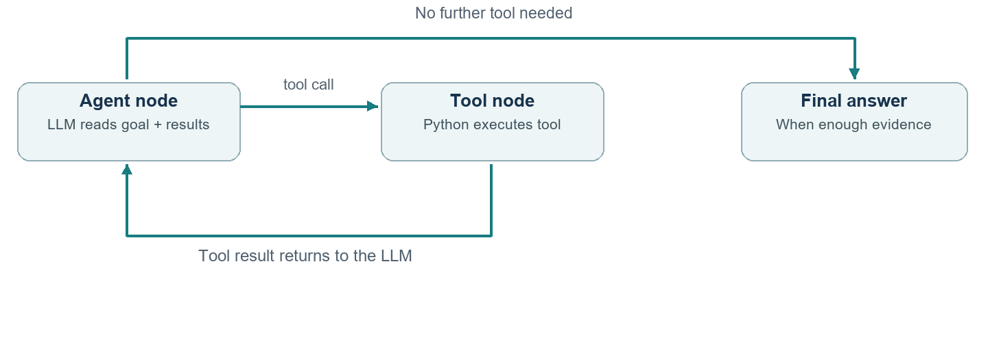

app/multi_agent/system.py
Line | Actual code | Meaning and purpose
53 | bound = model.bind_tools(tools) | LLM ko tools ke names, descriptions aur argument schemas dikhata hai; tools abhi execute nahi hote.
59 | registry = {t.name: t for t in tools} | Tool name ko real Python tool object se map karta hai.
140 | graph = StateGraph(RunState) | Messages/call counters carry karne wala workflow banata hai.
143 | graph.add_edge(START,"agent") | Workflow ka pehla processing step agent node hota hai.
142 | graph.add_node("tools",perform) | Tool node actual registered function execute karta hai.

app/agent/state.py
Line | Actual code | Meaning and purpose
9 | messages: Annotated[list[BaseMessage], add_messages] | Messages state mein rehte hain; add_messages naye messages ko conversation mein merge karta hai.
10 | model_calls: int | Model calls ka count integer ke roop mein track hota hai.

LLM tool request deta hai; ToolMessage observation laata hai; conditional edge next node choose karti hai. END loop ko finish karta hai. Hidden chain-of-thought activity log mein show nahi hoti.

4 Actual RAG Anything code

app/rag/anything_rag_models.py
Line | Actual code | Meaning and purpose
14 | from raganything import RAGAnything, RAGAnythingConfig | Official installed library import hoti hai; framework ka naam sirf label nahi hai.
102 | config = RAGAnythingConfig( | Parser aur image/table/equation processing options set hote hain.
113 | rag = RAGAnything( | Configured official engine object banta hai.
115 | llm_model_func=text_model_callback, | Text understanding aur graph extraction ke liye cloud LLM callback connect hota hai.
116 | vision_model_func=vision_model_callback, | Figures/images ke liye compatible vision callback connect hota hai.
117 | embedding_func=EmbeddingFunc( | Text-to-vector function aur dimensions ka contract register hota hai.

app/rag/anything_rag_worker.py
Line | Actual code | Meaning and purpose
193 | await rag.insert_content_list(blocks, file_path=name, display_stats=False) | MinerU Cloud ka structured output official RAG-Anything indexing pipeline mein insert hota hai.
209 | context = await rag.aquery( | Official query API se relevant evidence milta hai. Following mode="hybrid" graph/vector retrieval choose karta hai.
212 | only_need_context=True, | Is app path mein RAG context deta hai; Document Agent ka LLM final answer word karta hai.

Important difference: insert_content_list() pre-parsed cloud content leta hai. process_document_complete() supported local end-to-end parsing path hai. Dono official APIs hain. Current cloud path pehle wala use karta hai.

5 Models retrieval and internet routing
Role | Current component
Document parsing | MinerU Cloud API; uploads require approval.
Text and graph extraction | Groq openai/gpt-oss-20b; Gemini/OpenRouter compatible backups.
Vision | Groq qwen/qwen3.8-27b; configured OpenRouter/Gemini backups.
Embeddings | Google gemini-embedding-001, 768 dimensions.
Framework and retrieval | Official RAG-Anything + internal LightRAG graph/vector index.
External information | Internet Agent → Tavily / SerpApi search; webpage reader for supplied URLs.

app/rag/embeddings.py
Line | Actual code | Meaning and purpose
30 | key = configured_key('GOOGLE_API_KEY', 'GEMINI_API_KEY') | Key environment se read hoti hai; key ka naam model ka naam nahi hota.
49 | values=np.asarray(rows,dtype=np.float32) | API se aaye vectors ko numeric array mein convert karta hai.
54 | return values/lengths | Vectors normalize karta hai, taaki similarity comparison consistent rahe.

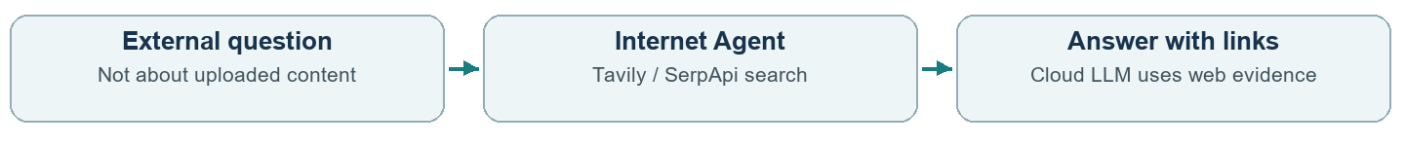
Document question → Documents Agent. External factual question → Internet Agent. Document evidence missing ho toh web follow-up clearly label hota hai; “only PDF” web fallback rokta hai.
Quick recall: RAG ka matlab retrieve karke generate karna. Embedding answer nahi likhta; LLM answer likhta hai. Ollama configured nahi hai. UI, SQLite aur storage abhi bhi local hain.

6 File locator and revision
Folder or file | What to remember
app/ui/ | streamlit_app: screen; presentation/runtime: readable output and reload helpers. Earlier separate panels also remain.
app/multi_agent/ | system: active coordination/tool loops; requests: source/length rules; errors: controlled exceptions.
app/rag/anything_rag.py | App-to-worker connection, source chunks, caching and retrieval status.
app/rag/anything_rag_worker.py | Runs actual parsing/index/query operations in the isolated runtime.
app/rag/anything_rag_models.py | Official engine configuration and text/vision/embedding callbacks.
app/rag/embeddings.py + mineru_cloud.py | Cloud vector requests and cloud file parsing respectively.
app/rag/documents.py + intents.py + retrieval_status.py | Exact-page/local source lookup, summary intent and honest activity labels.
app/attachments/ | File routing, image preparation, snapshots and restoration.
app/llm/ + app/config/ | API model clients, backups and environment settings.
app/tools/ + app/spreadsheet/ + app/integrations/ | Callable tools, verified Pandas math, web reading/search and travel APIs.
app/agent/ + app/history/ + app/memory/ | Conversation state, saved chat answers/checkpoints and preferences.
main.py + scripts/setup_rag.ps1 | Terminal entry point and optional RAG runtime installation.

Five questions to practise
1 bind_tools() execute karta hai? Nahi, tool schema expose karta hai.
2 Actual calculation kaun karta hai? Pandas/calculator tool.
3 RAG-Anything model hai? Nahi, multimodal framework.
4 Answer kahan save hota hai? chat_history.sqlite3 mein.
5 Model train ho raha hai? Nahi; saved data retrieve/context ke liye use hota hai.

Twenty second explanation
Mera assistant question ka goal samajhkar specialist choose karta hai. Documents ko MinerU parse karta hai aur official RAG-Anything index/retrieve karta hai. Cloud LLM evidence se answer banata hai. External questions internet agent search karta hai; LangGraph workflow aur SQLite history manage karte hain.

