AI Agent Project Guide
  - Architecture workflows and file map
A simple structured explanation of the current Python application. Prepared 27 October 2026.

What the project does
Yeh ek goal-based multi-agent assistant hai. Ek chat se document questions, Excel calculations, image understanding, public webpage reading, research, travel planning aur saved-history recall handle karta hai.
Orchestrator kaam specialist ko deta hai. Specialist tool chalakar evidence leta hai. Answer us evidence ke basis par banta hai. Services unavailable hon toh bounded recovery/fallback try hota hai; har task ka successful answer guaranteed nahi hai.
Capability | How it works
Documents | MinerU and official RAG-Anything where enabled; local page/text lookup as a clearly labeled fallback.
Spreadsheets | LLM creates a restricted plan; Pandas performs the actual calculation.
Images and web | Vision API reads visible content; search and webpage tools supply external evidence.
Persistence | SQLite stores chats, checkpoints, preferences and readable attachment snapshots.

How to read this guide
Sections 2 to 6 explain the system. Sections 7 to 10 map the source files. Sections 11 to 17 cover storage, setup, examples and maintenance. Paths are relative to the extracted project folder, so the guide works on another PC.

2 Overall architecture
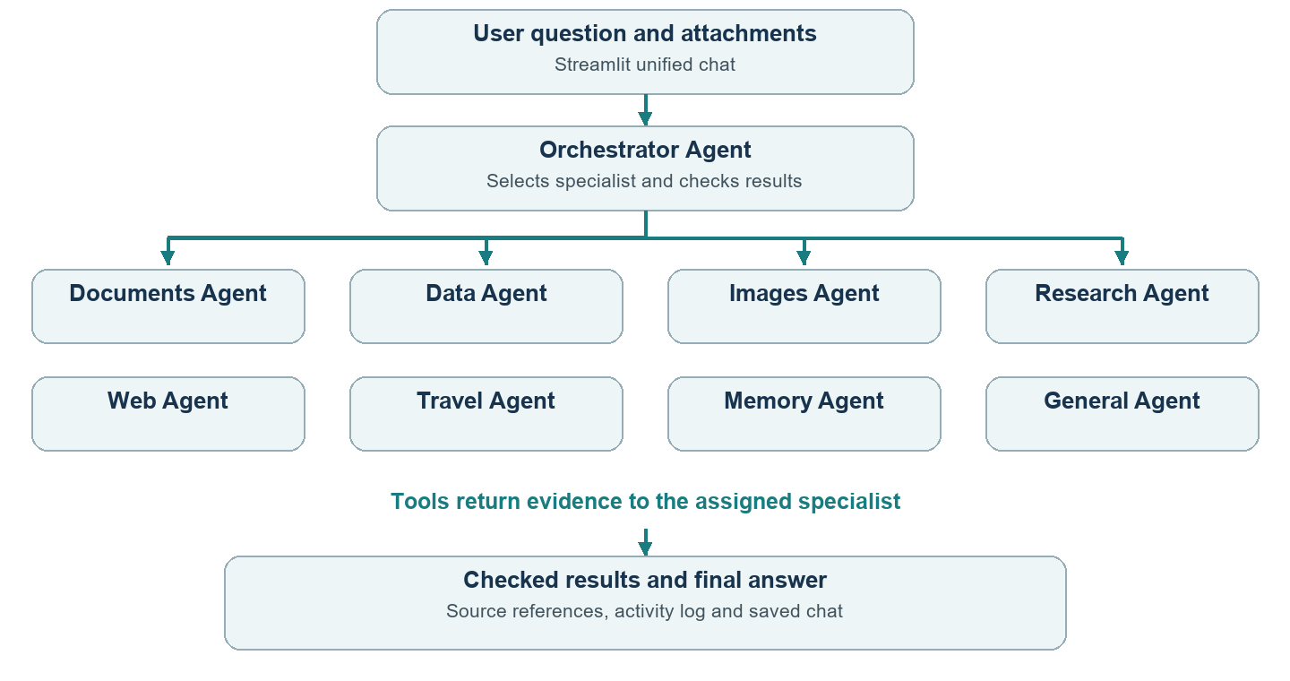
Same underlying LLM alag specialist roles mein reuse ho sakta hai. Multiple agents ka matlab har role ke liye separate API key ya separate model hona zaroori nahi.
Active entry point: app/ui/streamlit_app.py. Main orchestration: app/multi_agent/system.py. Terminal entry point: main.py. Earlier panels/workflows remain as supporting or legacy code.

3 How a question becomes an answer
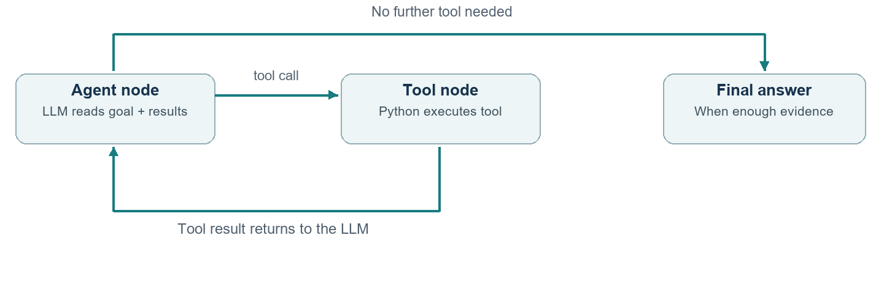
Step | What happens
Context | Question, files, selected history and saved preferences are prepared.
Delegate | Orchestrator selects specialists through delegate. Compound tasks may use more than one role.
Tool call | bind_tools exposes tool names, descriptions and argument schemas. The LLM proposes a call; Python executes it.
Observation | ToolMessage carries the result. The LLM uses this observation to continue or answer.
Check and save | Source evidence and calculated results are checked; activity and answer are saved.

LangGraph state carries messages and call counts. Nodes run model/tool steps; conditional edges choose tools or END. Loops are bounded to prevent repeated handoffs and runaway usage.

4 RAG Anything document pipeline
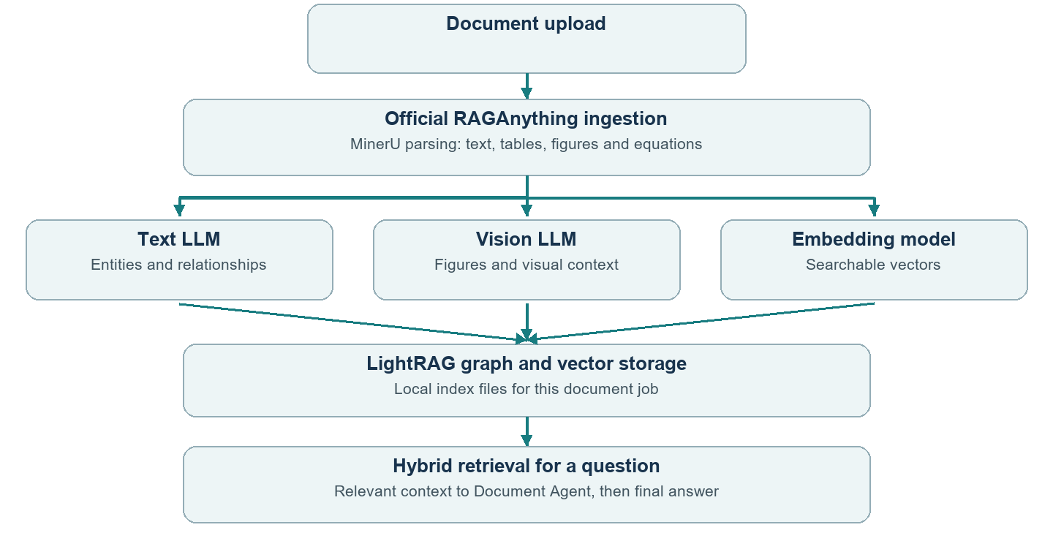
RAG-Anything framework hai, single model nahi. MinerU, LightRAG, a text LLM, a vision LLM and an embedding function are dependencies. Actual raganything package indexing/query algorithms use hote hain.
Local ingestion uses parse_document() and process_document_complete(). Approved cloud output enters insert_content_list(). Hybrid context comes from aquery(mode="hybrid").
Unified chat retrieves context; Document Agent words the answer. The direct example lets RAG-Anything generate the answer. Exact-page lookup and local fallbacks are labeled separately.

5 Models APIs and local components
Configured roles neeche hain. Har request mein saare models call nahi hote. Primary unavailable ho toh compatible backups try hote hain; availability and quotas provider par depend karte hain.
Purpose | Configured model or component | Where it runs
Text and graph extraction | Groq openai/gpt-oss-20b | API primary
Text backups | Gemini gemini-3.1-flash-lite; OpenRouter openrouter/free | APIs; router model can vary
Vision | Groq qwen/qwen3.8-27b; OpenRouter google/gemma-4-26b-a4b-it:free; Gemini | Compatible image APIs
Embeddings | BAAI/bge-small-en-v1.5 through FastEmbed; 384 dimensions | Local after weights download
Parsing and OCR | MinerU pipeline and its OCR/layout/table/formula models | Local CPU by default
Optional parsing | MinerU Cloud API using MINERU_API_TOKEN | Explicit UI opt-in required
Excel planning | OpenRouter free model with normal text backups | API planning; math stays local
External information | Tavily search; SerpApi backup and flight/hotel listings | Separate APIs

MODEL settings contain model IDs. API_KEY/TOKEN settings contain secrets. New keys do not remove rate limits. The upstream example defaults to paid OpenAI models; this app connects its existing providers and local embeddings to the official framework.

Local MinerU model roles
The installed pipeline includes PP-DocLayoutV2 for layout, PaddleOCR-based text recognition, SLANet Plus/UNet table components and PP-FormulaNet Plus M as the formula default. These are parser internals, not extra specialist agents. Not every model is needed for every file.

6 Libraries and frameworks
Library or framework | Why it is used
LangChain integrations | langchain-groq, langchain-google-genai and langchain-openai connect providers; core supplies messages and tools.
LangGraph | Stateful agent/tool loops, conditional routing and conversation orchestration.
Streamlit | Python chat UI, uploads, sidebar controls and activity display.
raganything 1.4.3 | Official multimodal processing, ingestion and query APIs.
LightRAG 1.4.16 | Knowledge graph and vector retrieval inside RAG-Anything.
MinerU 3.4.5 | Document parsing and OCR; owns internal parsing-model selection.
FastEmbed 0.9.1 and NumPy | Local embeddings and numerical vector arrays.
Pandas and openpyxl | Table loading, XLSX support and local calculations.
xlrd pyxlsb odfpy | Additional XLS, XLSB and ODS reading support.
pypdf python-docx python-pptx | Local PDF, Word and PowerPoint text extraction/support paths.
Pillow and pillow-heif | Image orientation, resizing, normalization and additional formats.
BeautifulSoup4 | Readable text extraction from downloaded public HTML.
python-dotenv and requests | Load local settings; requests supports the optional cloud parser.
SQLite and checkpoint extension | sqlite3 saves app data; langgraph-checkpoint-sqlite persists graph state.

Standard-library helpers handle URLs, HTTP/TLS, robots.txt, archives, hashing, JSON and subprocesses. Separate .venv-rag isolates optional heavy dependencies from the UI.

7 Entry points UI and agent files
All paths are relative to the project root. Open the indicated file to inspect or change the behavior.
File | Role and when to open it
main.py | Terminal startup and command loop; shared orchestration and terminal errors.
app/ui/streamlit_app.py | Active unified chat: models, uploads, restored attachments, profiles, cloud opt-in and orchestrator wiring.
app/ui/presentation.py | Formats public answers, activity and errors. Hides provider telemetry from Streamlit.
app/ui/assistant_panel.py | Earlier separate research/travel panel; not the main unified-chat route.
app/ui/excel_panel.py | Earlier separate spreadsheet panel and local controls.
app/ui/table_upload.py | Table-upload widgets for panel-based flows.
app/agent/session.py | Conversation lifecycle, context, tools, history and checkpoint state. Saves workflow results.
app/agent/graph.py | Builds and invokes the shared conversation graph.
app/agent/nodes.py | Shared model/tool nodes and conditional next-step routing.
app/agent/state.py | Defines the shared graph state schema.
app/agent/loop.py | Earlier direct tool loop and shared model interface/limits.
app/agent/tool_execution.py | Executes registered tools and applies memory-write rules.
app/agent/activity.py | Converts actual tool results into safe activity messages.

8 Coordination models attachments and storage files
File | Role and when to open it
app/multi_agent/system.py | Active Orchestrator and specialists; LangGraph loops, delegation, budgets, evidence checks and recovery.
app/multi_agent/requests.py | Recognizes file roles, calculation/short-answer requests and page-title intent; compacts completed results.
app/multi_agent/errors.py | Shared AgentExecutionError type for controlled failures.
app/llm/client.py | Creates text/data clients, selects provider order and prepares model messages.
app/llm/fallback.py | Compatible provider switching, cooldowns and malformed-output handling.
app/config/settings.py | Loads and validates local settings and provider keys.
app/attachments/store.py | Routes file formats; normalizes images, loads tables and extracts document text.
app/attachments/vision.py | Creates compatible vision clients and describes attached images.
app/attachments/persistence.py | Saves/restores document chunks, tables, normalized images and RAG job references.
app/attachments/migration.py | Refreshes cached attachment objects after Streamlit code reloads.
app/history/store.py | SQLite chats, messages, attachment snapshots, exports and relevant-history lookup.
app/history/migration.py | Refreshes older HistoryStore objects without resetting the chat.
app/memory/store.py | SQLite profile facts/preferences and identifier validation.

9 RAG Anything file map
File | Role and when to open it
app/rag/anything_rag.py | App adapter and isolated-worker client. Tracks jobs, source chunks, backend status and hybrid context.
app/rag/anything_rag_worker.py | Runs parsing, official ingestion and aquery in .venv-rag. Preserves locations and checks media paths.
app/rag/anything_rag_models.py | Creates RAGAnythingConfig/RAGAnything and connects text, vision and embedding callbacks.
app/rag/mineru_cloud.py | Approved cloud uploads, polling and bounded downloads; safe archive/media paths and sanitized errors.
app/rag/documents.py | DocumentIndex, chunks, exact PDF pages, sampled overviews and BM25 source search.
app/rag/intents.py | Recognizes summary requests and supplies labeled extractive summaries if model prose is unavailable.
app/rag/retrieval_status.py | Reports actual hybrid use, exact-page lookup, standard search or fallback reason.
app/tools/document_search.py | LangChain search_documents wrapper exposing document evidence with source locations.
examples/anything_rag_example.py | Direct official-style process_document_complete() and aquery(mode="hybrid") using project callbacks.

Why an adapter exists
Streamlit ko file status, saved-chat restoration aur source references chahiye. Adapter yeh app-level work karta hai. Actual multimodal indexing/query algorithms upstream package se aate hain. Local source search remains a labeled fallback, not a replacement advertised as successful graph retrieval.

10 Tools data web and supporting workflows
File | Role and when to open it
app/tools/calculator.py | Safe arithmetic expression tool using allowlisted AST operations, not arbitrary Python execution.
app/tools/web_search.py | LangChain tool wrapper around the search integration.
app/tools/memory.py | Exposes save, retrieve and delete memory tools.
app/spreadsheet/analysis.py | Reads tables, detects headers and executes allowlisted Pandas calculations.
app/spreadsheet/planner.py | Validated question-to-calculation plans, local tax-column planning and API errors.
app/integrations/web_search.py | Tavily primary search, SerpApi backup and safe source URLs.
app/integrations/web_reader.py | Reads explicit public URLs; address/redirect/robots checks, bounds, cache and HTML extraction.
app/integrations/travel_prices.py | SerpApi flight/hotel listings and offer formatting; no booking/payment execution.
app/workflows/chat_router.py | Earlier research/travel request extraction. Airport mappings are reused by active orchestration.
app/workflows/assistants.py | Earlier research/travel graph. Request validation is reused in current flows.
scripts/setup_rag.ps1 | Creates .venv-rag, installs optional dependencies and checks conflicts.

Package __init__.py files mark Python packages. __pycache__ holds generated bytecode, not business logic. Change the source file rather than editing a cache.

11 What is saved and what is remembered
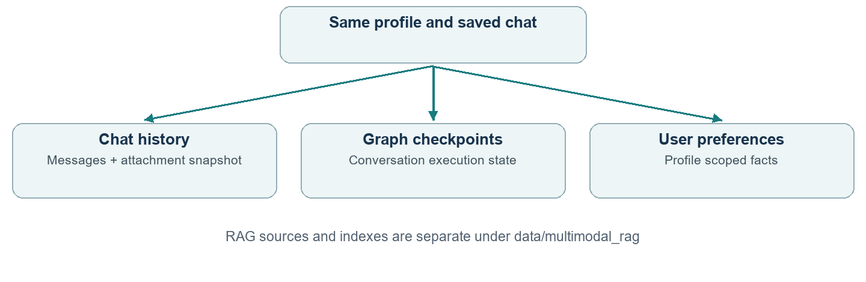
Storage | Content and scope
data/chat_history.sqlite3 | Messages, tool activity, sources and readable attachment snapshots associated with profile/chat.
data/chat_checkpoints.sqlite3 | LangGraph conversation execution state.
data/memory.sqlite3 | Profile preferences/facts. Relevant history is another context source.
data/multimodal_rag/ | Optional RAG source files, parser output and graph/vector artifacts.
data/rag_models/ | Cached local embedding weights.

History, memory aur attachments alag concepts hain. Same saved chat reopen karne se its attachments restore hote hain; a new chat automatically every old file access nahi karta. Relevant history select hoti hai, all past text har request par nahi bheja jaata.
Clear attachments removes the current snapshot. Deleting a chat removes its history and attachment snapshot; RAG artifacts may remain separately. Old lost attachments need one-time reupload. Profiles are local identifiers, not authenticated accounts.

12 Windows installation and startup
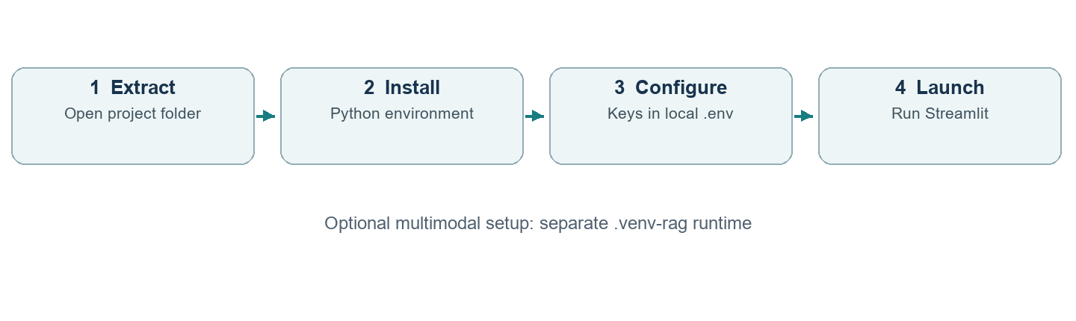
Extract anywhere. Open PowerShell in the folder containing requirements.txt. No fixed drive, username or folder name is required.
py --version
py -3 -m venv .venv
.\.venv\Scripts\python.exe -m pip install --upgrade pip
.\.venv\Scripts\python.exe -m pip install -r requirements.txt
Python 3.11+ chahiye. Fresh setup only: copy the example and add your own keys locally.
Copy-Item -LiteralPath .env.example -Destination .env
notepad .env
Existing .env overwrite mat karo. Each setting uses a separate NAME=value line. Never publish .env or include it in a shared ZIP.
.\.venv\Scripts\python.exe -m streamlit run app/ui/streamlit_app.py
Open the printed local URL. Current project config selects http://127.0.0.1:8502/. Ctrl+C stops the server. On the existing development setup, .venv-standard can replace .venv in the command.

13 Multimodal setup and configuration
Base chat aur optional RAG runtime separate hain. MinerU/RAG-Anything dependencies .venv-rag mein install hote hain.
powershell -ExecutionPolicy Bypass -File scripts/setup_rag.ps1
The setup script reuses .venv-standard or .venv when available; otherwise it requests Python 3.13. Local model weights download on first use. CPU parsing can take time.
Setting | Purpose
DOCUMENT_RAG_BACKEND | Set to raganything for the multimodal backend; standard selects local text/page lookup.
MINERU_DEVICE=cpu | CPU for local MinerU pipeline.
RAG_MAX_MODEL_CALLS=16 | Default per-worker model-attempt cap, not a usage guarantee.
MINERU_API_TOKEN | Optional cloud token. Explicit Streamlit checkbox approval is also required.
GROQ_API_KEY / GOOGLE_API_KEY | Text/vision provider credentials.
OPENROUTER_API_KEY | Data planning and compatible text/vision backups.
TAVILY_API_KEY / SERPAPI_API_KEY | Search and travel credentials.
RAG_PYTHON | Optional isolated-runtime interpreter override.

Restart Streamlit after settings/dependency changes. Cloud opt-in sends complete new files to MinerU. Without approval, parsing remains local. Cached results are reused. Office conversion may require LibreOffice; local text fallback has narrower visual coverage.

Direct framework example
.\.venv-rag\Scripts\python.exe examples/anything_rag_example.py "document.pdf"
Local MinerU parses; configured LLM callbacks process extracted content and answer the query. This example directly uses official framework APIs.

14 Example questions and activity logs
Question | Expected path
Explain the document in short | Documents → search_documents → available RAG evidence → concise answer.
PDF page 1 ka title batao | Exact physical page lookup; hybrid ranking is skipped to keep scope.
Excel ka total Tax batao | Inspect real column names, then calculate_table sums the numeric tax column.
Describe this image in one line | Images → compatible vision service; visible details only.
Summarize this public URL | Web specialist fetches that page. Login/CAPTCHA restrictions may prevent reading.
Research rooftop solar benefits | Research specialist gathers bounded evidence and writes a sourced response.
Plan a Delhi to Goa trip | Travel specialist collects missing dates/travelers/budget and may query listings.

Read the trace correctly
Orchestrator selected tool: delegate
Orchestrator assigned documents specialist
Document Agent selected tool: search_documents
Document knowledge: file.pdf — parser: MinerU; index: RAG-Anything
Document retrieval: Anything RAG hybrid graph/vector context
Document Agent completed its response
Yeh illustrative successful trace hai. Actual logs can instead report exact-page lookup, missing evidence, query failure or index-not-ready fallback. Upload success alone does not prove hybrid retrieval ran.

Small verification
A known sheet with Tax values 10 and 20 must total 30. A page-title answer must match that exact physical page. A summary must reflect the uploaded evidence and its correct source location.

15 Troubleshooting and practical limits
Symptom | What to check
No document evidence | Open the correct saved chat and its attachment list. Old lost files need reupload.
Index is not ready | Parsing may succeed while indexing fails. Check runtime, backend status, provider quota and retry control.
Old object has no method | Migration helpers handle known cached-object changes; restart Streamlit when necessary.
Quota or malformed output | Check local keys/model access and compatible backups. All providers can be unavailable.
Wrong spreadsheet header | Inspect detected headers and exact columns before calculating.
Frontend JavaScript error | Restart the correct server and refresh the browser; Streamlit requires browser JavaScript.
Office parsing fails | Check file integrity and conversion dependencies. Text fallback has narrower coverage.

Current application limits
Uploads: 10 MB/file, 10 attachments/chat, 5 indexed text documents and at most 50 PDF pages. Tables: 50,000 rows and 100 columns; standard loading uses the first worksheet. Images: first frame, resized for vision. Damaged/encrypted files may fail.
The earlier 200,000-character extracted-text cap is removed. Large text is chunked; file/page/time/model limits remain. A spreadsheet preview index is not a verified total. Formula cells use available cached values rather than arbitrary Excel recalculation.
Gmail sending, bookings, payments, image generation and dedicated similar-image search are not implemented. LangSmith tracing is not configured. Free APIs do not guarantee unlimited operation.

16 Where to change things and how to verify
If you want to change | Start here
UI title uploads or cloud opt-in | app/ui/streamlit_app.py
Delegation and agent selection | app/multi_agent/system.py and requests.py
Models and fallback order | app/llm/client.py, fallback.py and local .env
RAG callbacks or embeddings | app/rag/anything_rag_models.py
Official ingestion/query calls | app/rag/anything_rag_worker.py
Attachment read/restore | app/attachments/store.py and persistence.py
Table calculations | app/spreadsheet/analysis.py and planner.py
Search scraping or travel | app/integrations/ and corresponding tool wrapper
History and memory | app/history/store.py, app/memory/store.py and Conversation

Root and support files
requirements.txt lists base dependencies; requirements-rag.txt pins optional components. .env.example documents settings without keys. .gitignore excludes secrets/data/environments. .streamlit/config.toml selects theme, local address, port and upload limit. README.md explains operation. docs/ contains guides and diagrams.

Regression checks
.\.venv\Scripts\python.exe -B -m unittest discover -s tests -q
Last checked suite: 137 tests, 135 passed and 2 optional fixture tests skipped. These local/mocked checks do not prove every external service is currently available. Use a small known document for live verification.
tests/ covers orchestration, budgets, source grounding, exact pages, attachment restoration, model fallbacks, official RAG APIs, cloud consent/archive safety, Pandas math, web/travel, history and memory. tests/fixtures/README.md explains optional skips.

17 Simple glossary and reading order
Term | Simple meaning
LLM | Language model jo instructions/context se text aur tool requests generate karta hai.
Tool | A Python function/API capability. Model requests it; Python performs the action.
Agent | Goal follow karke tools/results ke basis par next action choose karne wala loop.
Orchestrator | Specialist select aur coordinate karne wala agent.
LangChain | Model, message aur tool interfaces ka framework.
LangGraph | Stateful nodes, edges, conditions and loops ka orchestration.
State node edge | State = carried data; node = step; edge = next-step connection.
RAG | Relevant stored evidence retrieve karke answer generation support karna.
Embedding | Numeric text representation for semantic similarity search.
Knowledge graph | Entities aur relationships ka structured representation.
Memory | Selected saved facts/history; model retraining nahi.
Human approval | User consent before an action; cloud parsing has an explicit upload checkbox.

Recommended reading order
streamlit_app.py → handle_multi_agent() in system.py → document_search.py → anything_rag.py → anything_rag_worker.py → anything_rag_models.py. Then read calculation, fallback and persistence modules for the feature of interest.

Implementation references
Official framework: https://github.com/HKUDS/RAG-Anything
Official example: examples/raganything_example.py in that repository.
Project mapping: docs/Anything_RAG_Official_Alignment.md.
Current source is the authority for app-specific limits and behavior.

